An integrated pharmacokinetic-pharmacodynamic-pharmacoeconomic modelling method to evaluate treatments for adults with schizophrenia
PharmacoEconomics
Marjanne A. Piena,¹ ORCID: 0000-0001-6707-6796
Natalie Houwing,¹
Carla Kraan,¹ ORCID: 0000-0003-1617-5158
Xiaofeng Wang, ² ORCID: 0000-0002-0890-3197
Heidi Waters, ² ORCID: 0000-0002-5671-3558
Ruth A. Duffy, ²
Suresh Mallikaarjun,^{2, 3}
Craig Bennison⁴, ORCID: 0000-0001-8658-5510
Affiliations:
¹ OPEN Health, Rotterdam, the Netherlands
² Otsuka Pharmaceutical Companies, Princeton, United States of America
³ Virginia Commonwealth University, Richmond, United States of America
⁴ OPEN Health, York, United Kingdom
Corresponding author: Marjanne Piena, MarjannePiena@openhealthgroup.com

PK models and model equations
The AM PK model is a 3-compartment model (see Fig. 1), with one central compartment ($V_{3}$) and two peripheral compartments ($V_{4}$ and $V_{5}$). Absorption of oral dosing is described by a sigmoid absorption model, where the oral dose enters the oral depot via a zero order process with rate R1 and then transfers to the central compartment via a first-order process with rate $Ka_{oral}$. Absorption of IM depot dosing is described by a first-order process with rate $Ka_{IM}$.The differential equations below describe the pharmacokinetics of amounts of aripiprazole $A_{i}$ in each depot ($i ∈1, 2)$and compartment ($i ∈3,4,5)$:
$$\frac{{dA}_{1}}{dt}=-Ka_{oral}∙ A_{1}$$
$$\frac{{dA}_{2}}{dt}=-Ka_{IM}∙ A_{2}$$
$$\frac{{dA}_{3}}{dt}=Ka_{oral}∙ A_{1}+Ka_{IM}∙ A_{2}∙F_{IM}-\frac{(CL+Q1+Q2)}{V_{3}} ∙A_{3}+\frac{Q1}{V_{4}}∙A_{4}+\frac{Q2}{V_{5}}∙A_{5}$$
$$\frac{{dA}_{4}}{dt}=\frac{Q1}{V_{3}}∙A_{3}- \frac{Q1}{V_{4}}∙A_{4}$$
$$\frac{{dA}_{5}}{dt}=\frac{Q2}{V_{3}}∙A_{3}- \frac{Q2}{V_{5}}∙A_{5}$$
Where $A_{1}$and $A_{2}$ denote the amounts of aripiprazole in the oral and IM depots, and $A_{3}$, $A_{4}$and $A_{5}$ the amounts in the central, first peripheral and second peripheral compartment, respectively. The relationship between amount and concentration within a compartment $c_{i}$, also in the Aristada PK model, is described by:
$$c_{i}= \frac{A_{i}}{V_{i}}$$
Where $V_{i}$ is the apparent volume in compartment $i$.
$F_{IM}$ denotes the relative bioavailability for the IM depot; $Q1$and $Q2$ denote the intercompartmental clearance (L/h) between respectively the central and first peripheral and central and second peripheral compartments; $CL$ denotes the apparent clearance (L/h) from the central compartment.
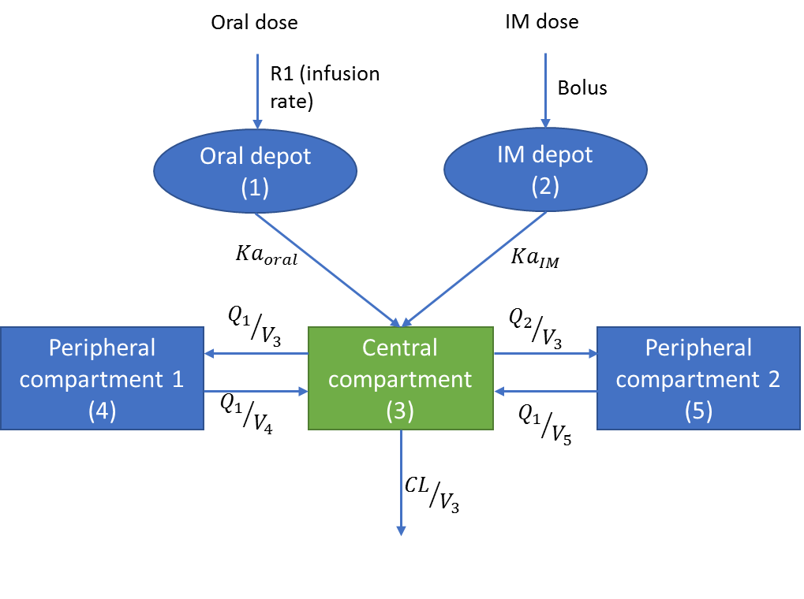
Fig. 1 Diagram of the AM PK model Numbers between brackets indicate the number of the compartment or depot

The AL model is a 2-compartment model with one central compartment ($V_{3}$) and one peripheral compartment ($V_{4}$) AM (see Fig. 2. The enzymatic conversion of (IM) aripiprazole lauroxil to aripiprazole and the absorption of aripiprazole are described by a zero-order process with a lag time: the zero-order process from the IM depot to the central compartment is modelled with a duration $D$ and a lag time. To allow the incorporation of inter-occasion variability, each IM depot is modelled separately, i.e. for each injection an IM depot is included. The differential equations below describe the pharmacokinetics of amounts of aripiprazole $A_{i}$ in the oral and first IM depot ($i ∈1, 2),$ central and peripheral compartment ($i ∈3,4)$ and additional IM depots ($i =n+4, n∈1, 2, …, z)$ with $z$ the number of modelled IM injections after the first.
$$\frac{{dA}_{1}}{dt}=-Ka_{oral}∙ A_{1}$$
$$\frac{{dA}_{2}}{dt}=-\frac{1}{D_{1}}∙ A_{2}$$
$$\frac{{dA}_{3}}{dt}=Ka_{oral}∙ A_{1}+\frac{1}{D_{1}}∙ A_{2}∙F_{IM}-\frac{\left(CL+Q\right)}{V_{3}} ∙A_{3}+\frac{Q}{V_{4}}∙A_{4}+\frac{1}{D_{n+1}}∙ A_{n+4}∙F_{IM}$$
$$\frac{{dA}_{4}}{dt}=\frac{Q}{V_{3}}∙A_{3}- \frac{Q}{V_{4}}∙A_{4}$$
$$\frac{{dA}_{n+4}}{dt}=-\frac{1}{D_{n+1}}∙ A_{n+4}$$
$F_{IM}$denotes the IM bioavailability of aripiprazole with respect to the bioavailability of oral aripiprazole; $CL$ denotes the clearance from the central compartment and $Q$ the intercompartmental flow rate.
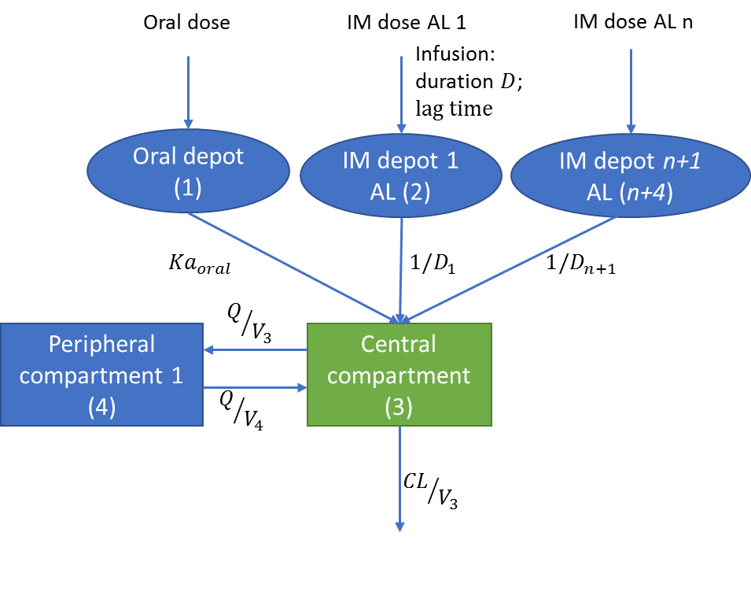
Fig. 2 Diagram of the AL PK model. Numbers between brackets indicate the number of the compartment or depot

