An integrated pharmacokinetic-pharmacodynamic-pharmacoeconomic modelling method to evaluate treatments for adults with schizophrenia
PharmacoEconomics
Marjanne A. Piena,¹ ORCID: 0000-0001-6707-6796
Natalie Houwing,¹
Carla Kraan,¹ ORCID: 0000-0003-1617-5158
Xiaofeng Wang, ² ORCID: 0000-0002-0890-3197
Heidi Waters, ² ORCID: 0000-0002-5671-3558
Ruth A. Duffy, ²
Suresh Mallikaarjun,^{2, 3}
Craig Bennison⁴, ORCID: 0000-0001-8658-5510
Affiliations:
¹ OPEN Health, Rotterdam, the Netherlands
² Otsuka Pharmaceutical Companies, Princeton, United States of America
³ Virginia Commonwealth University, Richmond, United States of America
⁴ OPEN Health, York, United Kingdom
Corresponding author: Marjanne Piena, MarjannePiena@openhealthgroup.com

Validation of the AM PK model
The AOM PK model in R was validated against the AOM PK model in NONMEM to assess the internal validity of the R model. PK outcomes were generated with both the R and the NONMEM model for a sample of 8 subjects with different covariates. The population PK profiles including covariate effects, but excluding parameter uncertainty were compared. Visually, they seemed to overlap perfectly. The average deviation of the R model compared to the NONMEM model varied from 0.05% for a subject to 0.09% for another simulated patient, where the average is calculated as the average of the difference in concentrations between the R and NONMEM models over time divided by the concentrations of the NONMEM model over time. When parameter uncertainty was included, 500 C_{min,ss}, C_{max,ss} and C_{avg,ss} were simulated with both models for each of the 8 subjects. The variance of the distributions of the 3 outcomes was comparable, and no structural deviation in median, percentiles and outliers was observed. A two-sided Student’s t-test was performed to test the assumption that the distributions of values does not differ between the two models. None of the p-values were below 0.05, with the majority well above it, indicating that the outcomes between the NONMEM and R model are not significantly different. The observations indicate that the PK model, including parameter uncertainty, is correctly implemented R.

Validation results of the AL PK model
The median PK profiles of 500 simulations presented by Hard et al.[19] and ten median profiles of 500 simulates generated using the AL PK model in R are presented in Fig. 6. In general, the median profiles are comparable between the two models. The profiles presented by Hard et al. fall within the range of the ten median profiles generated using R, except for the 662 mg q4wk dose which shows lower steady-state values using the R model than presented by Hard et al. This is expected to be caused by a too small number of iterations (N=500) used in [19] to reach convergence. Consequently, the observed differences do not indicate an invalidity of the PK profile of the 662mg dose.
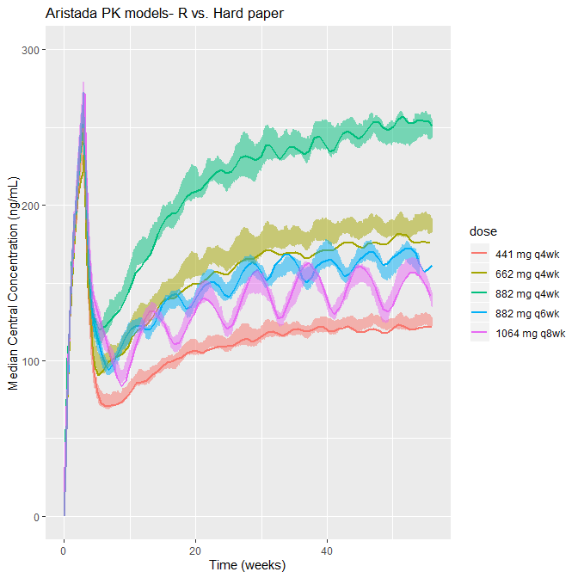
Fig. 1 Median PK profile of AL as published by Hard et al. (opaque) compared to ten median PK profiles generated using the R model (shaded area)

SAS and R PD curves and landmark analyses
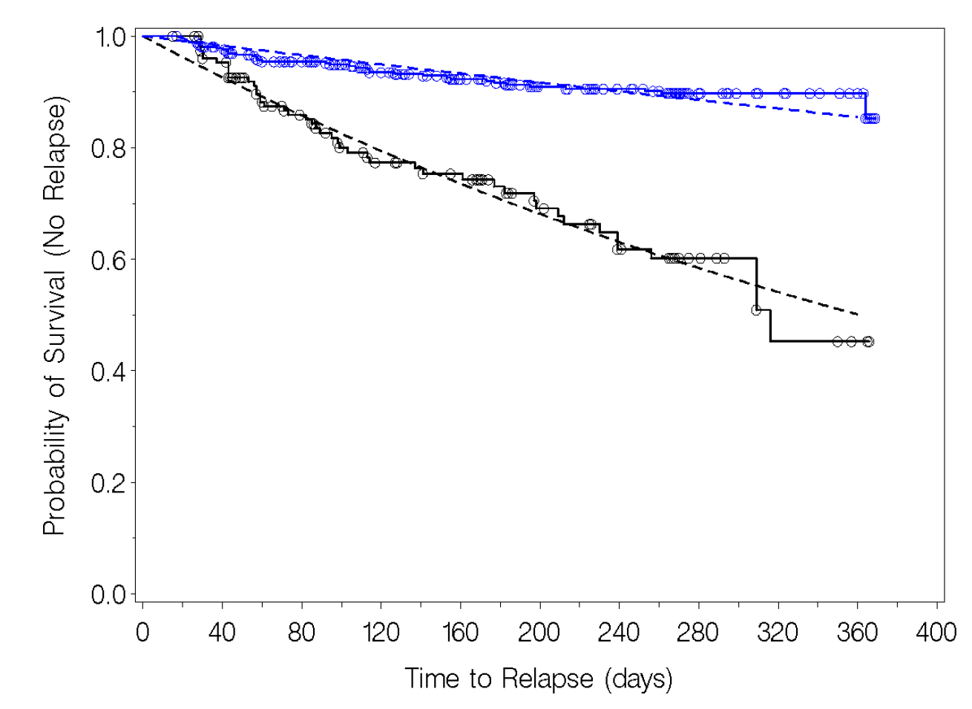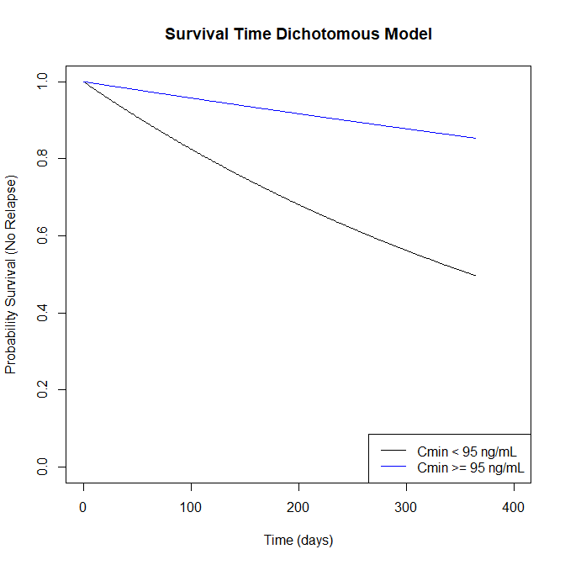
Fig. 2 Survival outcomes observed vs. predicted by the SAS-PD model [23] (left), and predicted by the R-PD model (right)
The values of these survival curves at distinct time points (182 and 364 days) are equal to the values predicted by the R model.

