An integrated pharmacokinetic-pharmacodynamic-pharmacoeconomic modelling method to evaluate treatments for adults with schizophrenia
PharmacoEconomics
Marjanne A. Piena,¹ ORCID: 0000-0001-6707-6796
Natalie Houwing,¹
Carla Kraan,¹ ORCID: 0000-0003-1617-5158
Xiaofeng Wang, ² ORCID: 0000-0002-0890-3197
Heidi Waters, ² ORCID: 0000-0002-5671-3558
Ruth A. Duffy, ²
Suresh Mallikaarjun,^{2, 3}
Craig Bennison⁴, ORCID: 0000-0001-8658-5510
Affiliations:
¹ OPEN Health, Rotterdam, the Netherlands
² Otsuka Pharmaceutical Companies, Princeton, United States of America
³ Virginia Commonwealth University, Richmond, United States of America
⁴ OPEN Health, York, United Kingdom
Corresponding author: Marjanne Piena, MarjannePiena@openhealthgroup.com

Distribution of C-min values per LAI dose regimen
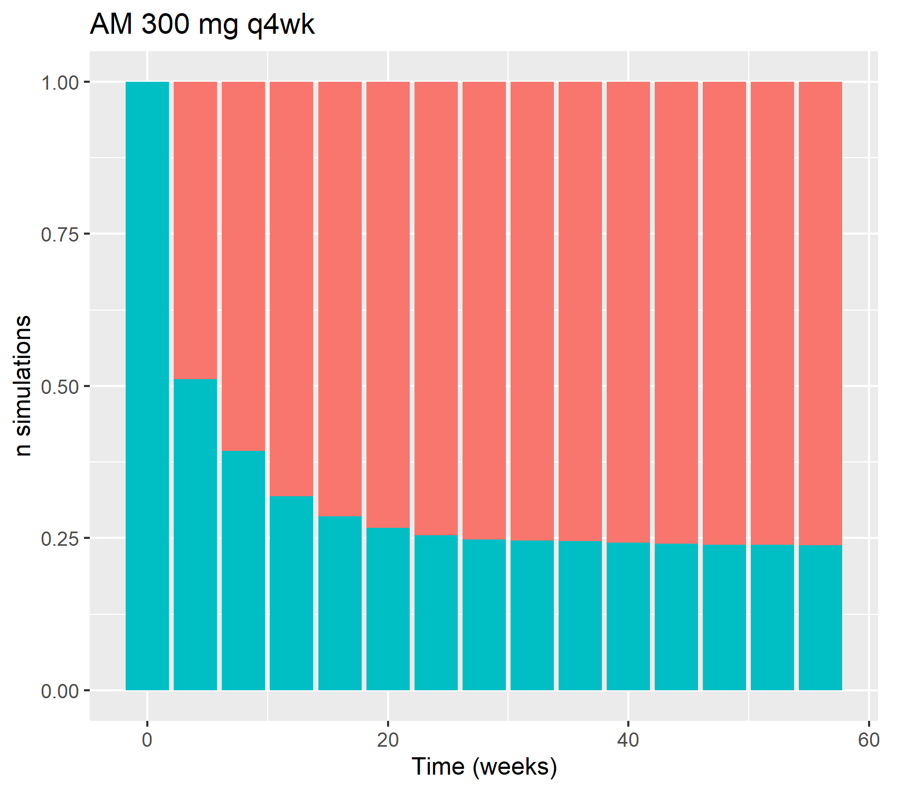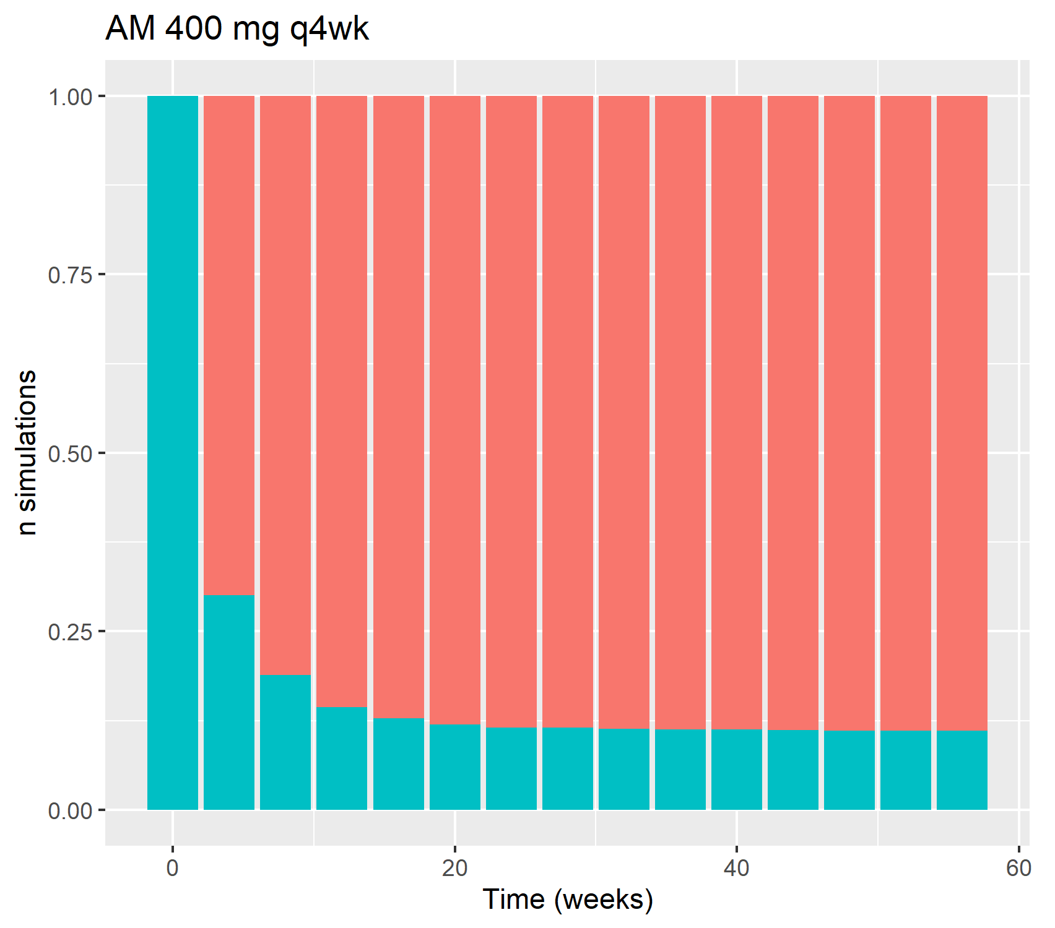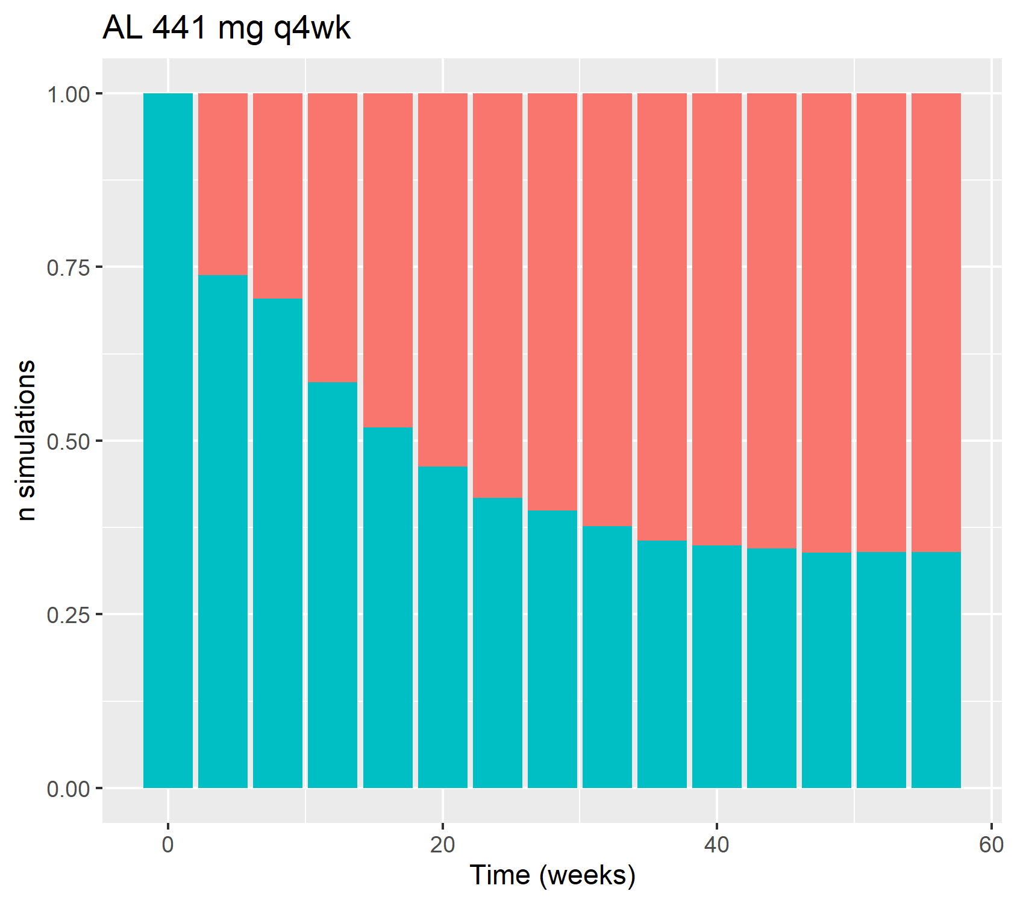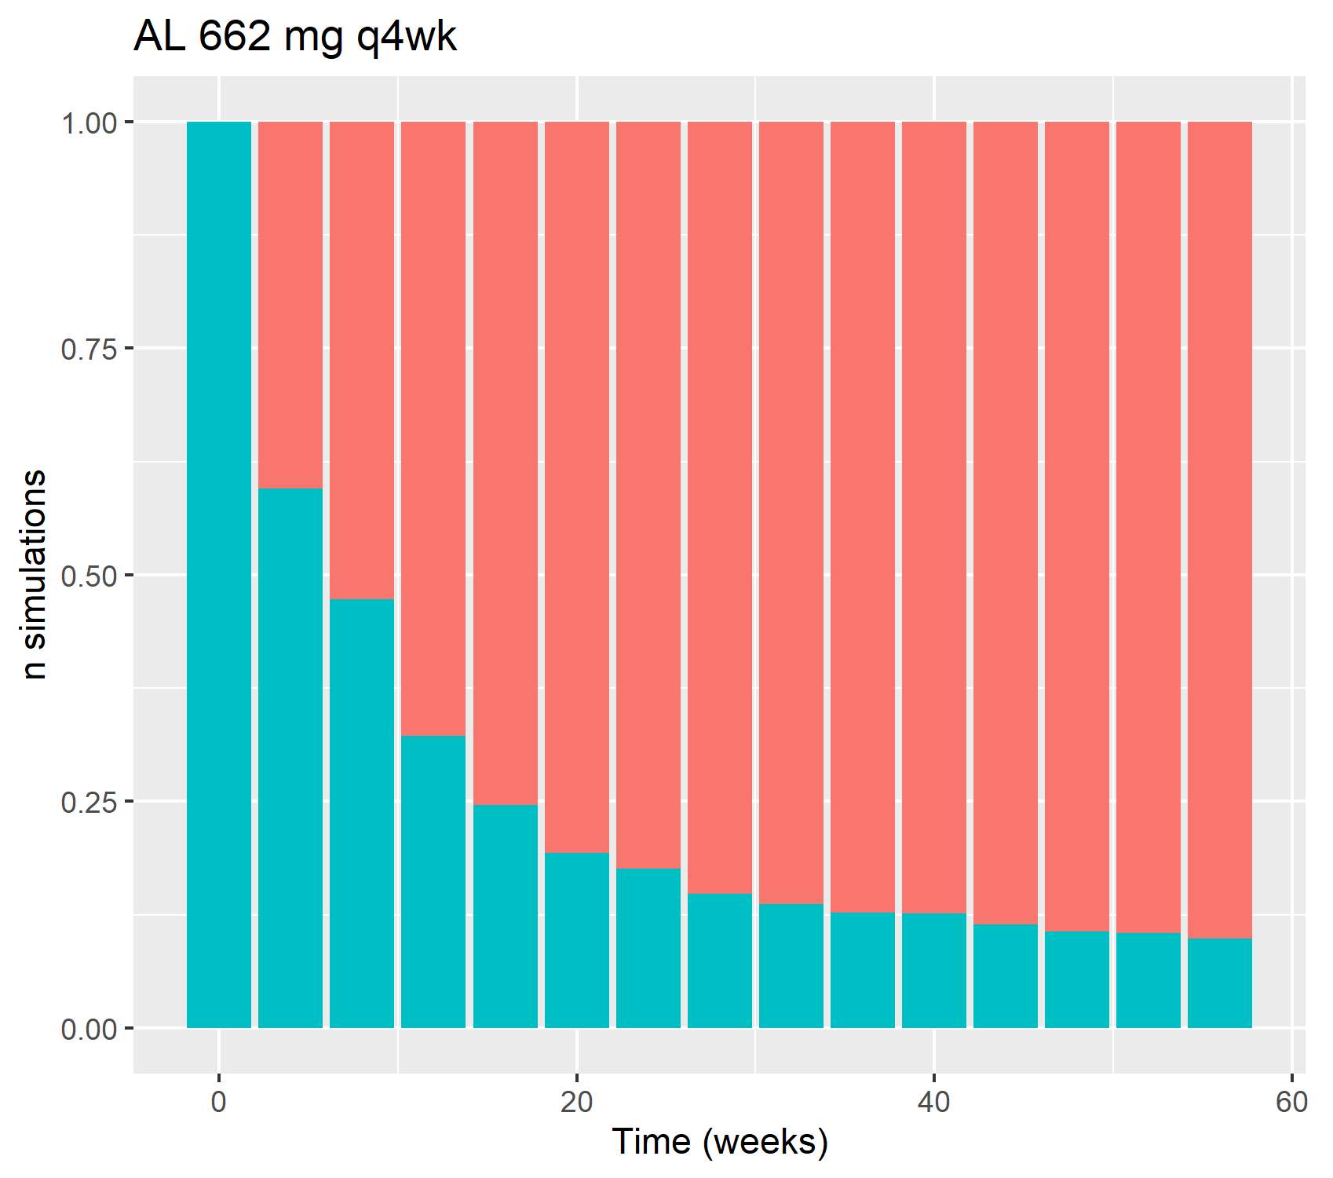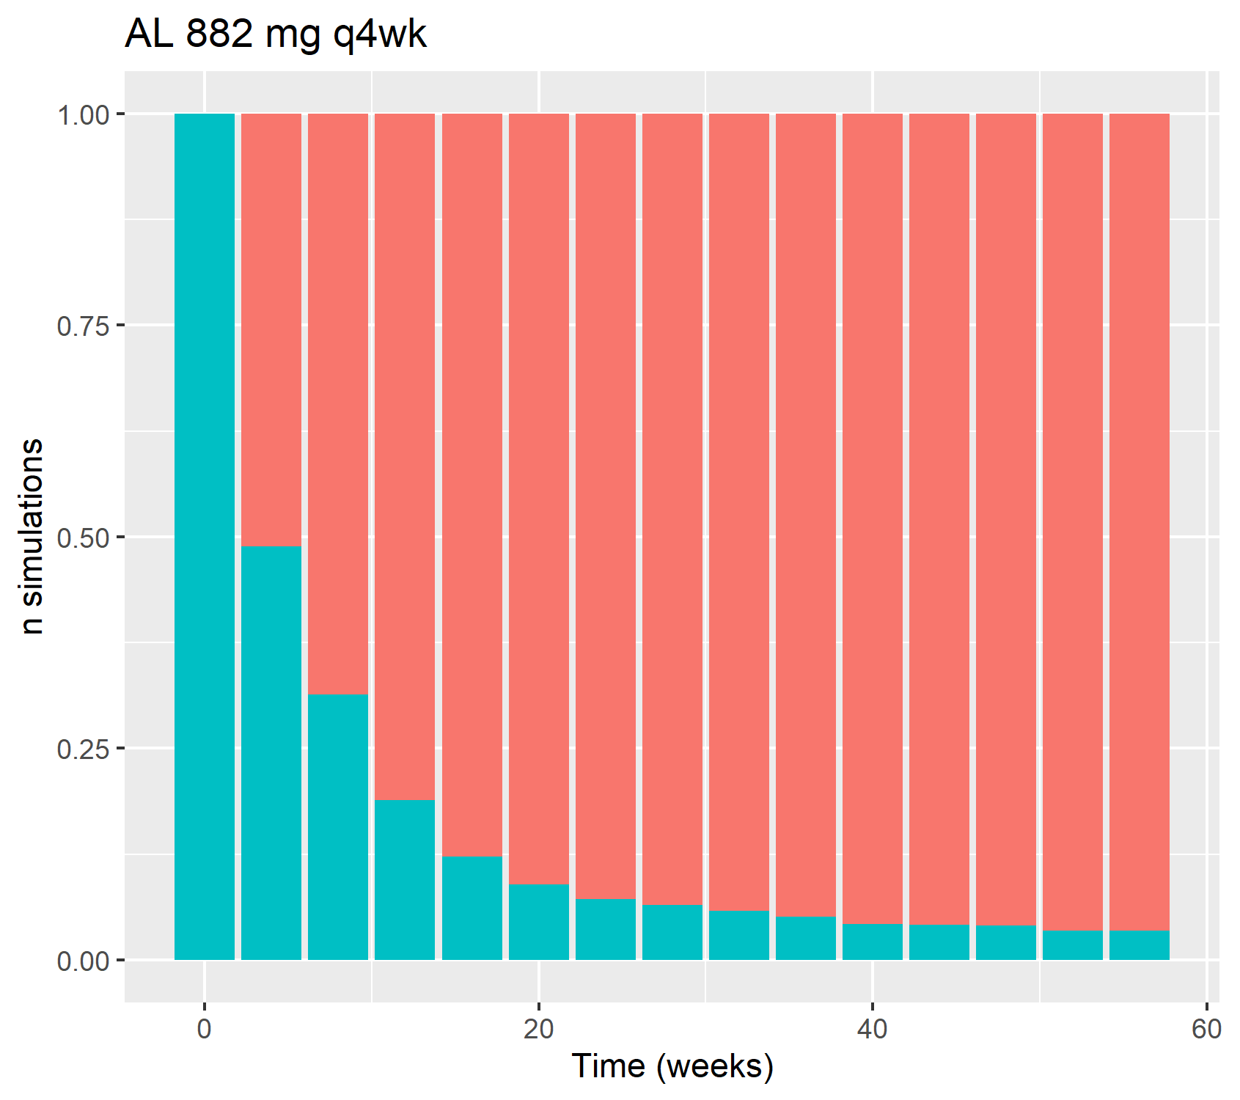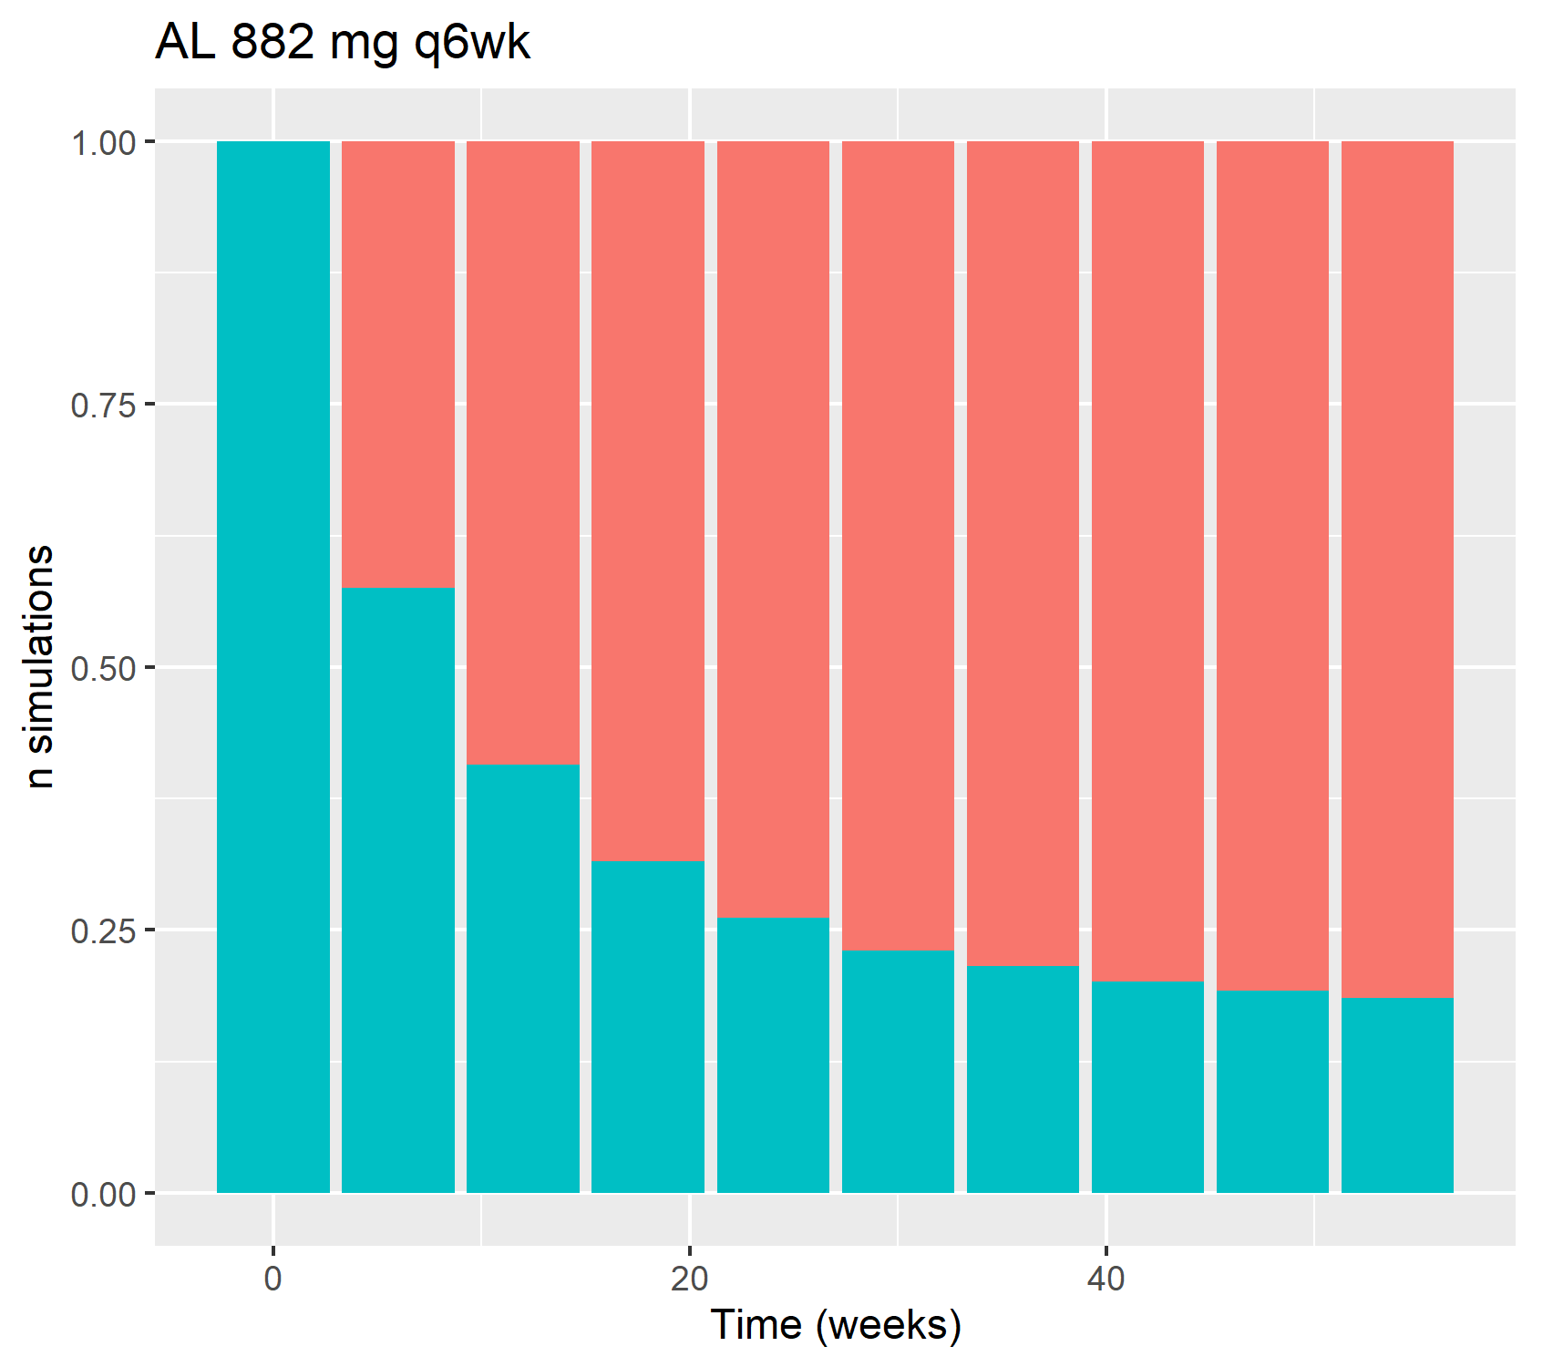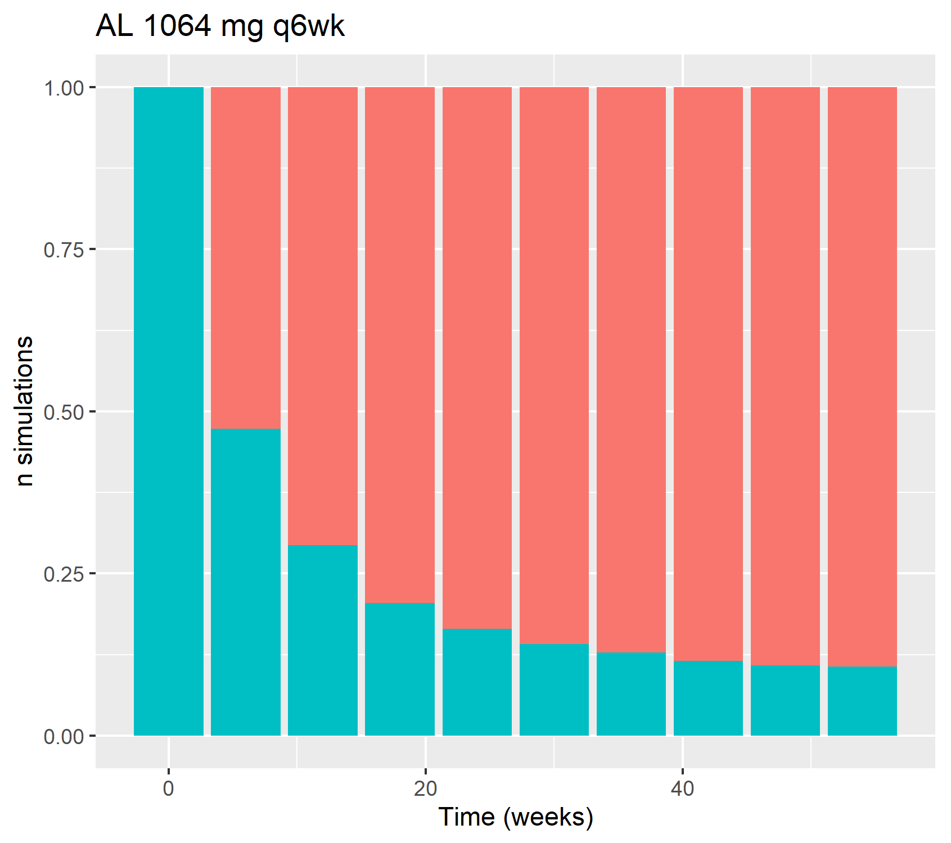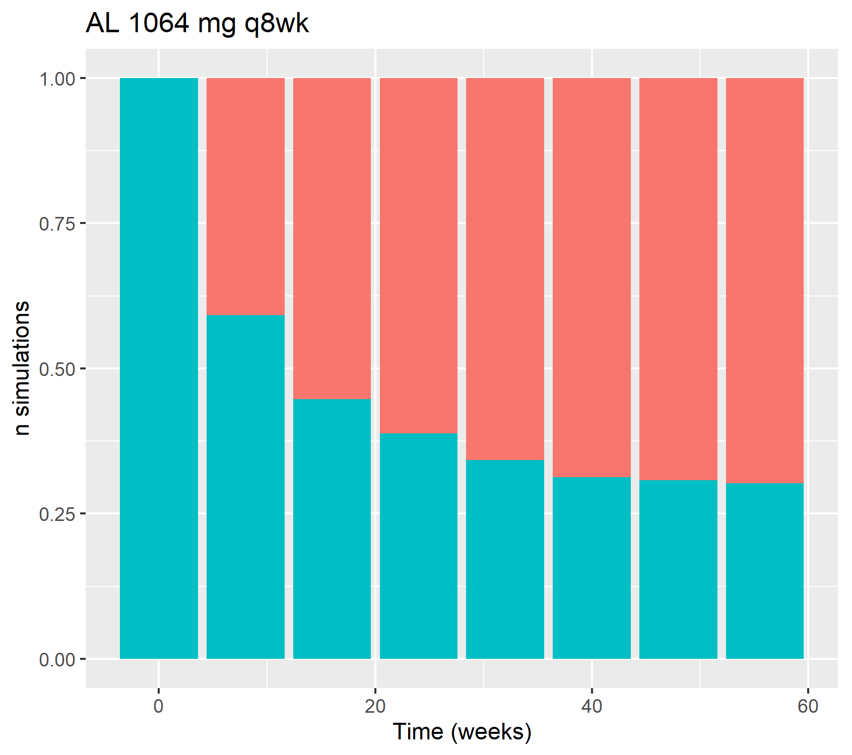
Fig. 1 Distribution of C-min values per LAI dose regimen over time. Green bars indicate the proportion of patients with Cmin< 95 ng/mL and a transition probability of 2.65% per cycle, red bars indicate the proportion of patients with Cmin> 95 ng/mL and a transition probability of 0.61% per cycle. AL aripiprazole lauroxil, AM aripiprazole monohydrate

