Supplementary material to “Biased survival predictions when appraising health technologies in heterogeneous populations”
Authors
Daniel Gallacher¹ ORCID: 0000-0003-0506-9384 (corresponding author)
Peter Kimani¹ ORCID: 0000-0001-8200-3173
Nigel Stallard¹ ORCID: 0000-0001-7781-1512
¹ Warwick Medical School, University of Warwick

Appendix 1 – Proof
Let $n$ denote the total number of patients in the population
Let $p$ denote the proportion of n that are in the subgroup, and $1-p$ the proportion I the complement
The subgroup have survival times from an exponential distribution with hazard rate $y$, and the complement have survival times from an exponential distribution with hazard rate $z$.
Since exponentially distributed, the mean survival times of each group are $\frac{1}{y}$ and $\frac{1}{z}$ respectively.
Hence the mean survival time for the combined population is given by $\frac{\left( np\frac{1}{y} + n\left(1-p\right) \frac{1}{z} \right)}{n}$
We can flip back to get the hazard rate for combined population (i.e. exponential rate parameter):
$$λ=\frac{n}{\frac{np}{y} +\frac{n(1-p)}{z} }=\frac{1}{\frac{pz}{yz} +\frac{y(1-p)}{yz} }=\frac{1}{\frac{pz+y(1-p)}{yz} }=\frac{yz}{pz+y(1-p)}$$

At time $t$, we estimate the hazard rate as the number of observed events divided by the total risk time observed in the follow-up. Assuming all patients begin follow-up at the same time, and are thus censored at the same time if they remain event free, at time $t$ the:
Number alive in $y=$ $np\exp\left(-yt\right)$ implies number of events in $y=np(1-exp⁡(-yt)$
Number alive in $z=$ $n(1-p)\exp{(-z}t)$ implies number of events in $z=n(1-p)(1-exp⁡(-zt)$
At-risk time in $y=np \left(1-\exp\left(-yt\right)\right) \frac{1}{y}$ (= number of patients * CDF(t) * mean)
At-risk time in $z=n(1-p)(1-\exp\left(-zt\right))$ $\frac{1}{z}$
Meaning the estimated hazard is given by:
$$\hat{λ}(t)=\frac{yz\left(1-p\exp\left(-yt\right)-\left(1-p\right)\exp{(-z}t)\right)}{zp(1-exp⁡(-yt))+y\left(1-p\right)\left(1-\exp\left(-zt\right)\right)}$$
$$⇒\frac{1}{\hat{λ}}=\frac{zp(1-exp⁡(-yt))+y\left(1-p\right)\left(1-\exp\left(-zt\right)\right) }{yz\left(1-p\exp\left(-yt\right)-\left(1-p\right)\exp{(-z}t)\right)}$$
The numerator is therefore
$$zp(1-exp⁡(-yt))+y\left(1-p\right)\left(1-\exp\left(-zt\right)\right)$$
This is equal to
$$\left(zp+y\left(1-p\right)\right)\left(1-p\exp\left(-yt\right)-(1-p)\exp{(-zt})\right)+ (exp\left(-yt\right)-exp⁡(-zt)) (p \left(1-p) (y-z)\right)$$
We can put this back into the fraction to get:
$$\frac{1}{\hat{λ}}=\frac{zp+y\left(1-p\right)}{yz}+\frac{(exp\left(-yt\right)-exp⁡(-zt)) (p \left(1-p) (y-z)\right)}{yz\left(1-p\exp\left(-yt\right)-(1-p)\exp{(-zt})\right)}$$
$$⇒\frac{1}{\hat{λ}}=\frac{1}{λ}+\frac{(exp\left(-yt\right)-exp⁡(-zt)) (p \left(1-p) (y-z)\right)}{yz\left(1-p\exp\left(-yt\right)-(1-p)\exp{(-zt})\right)}$$
If z ≠ y then the numerator of the second component is always negative, and tends to 0 as $t→∞$.
Meanwhile the denominator is always positive:
$$1-p\exp\left(-yt\right)-(1-p)\exp{(-zt})>1-p-(1-p)=0$$
since exp(-yt) and exp(-zt) are both < 1 for t > 0.
This means
$$\frac{1}{\hat{λ}}<\frac{1}{λ}⇒\hat{λ}> λ ∀ t :(exp\left(-yt\right),exp⁡(-zt))>0 \& t≠0.$$
We now consider relaxing the assumption of patients being recruited and censored at the same times.
$$h\left(t\right)=\frac{\left(1-\exp\left(-λt\right)\right)p+\left(1-\exp{(\left(x-λ\right)}t\right)\left(1-p\right)}{\frac{p(1-\exp\left(-λt\right))}{λ}+\frac{\left(1-p\right)\left(1-\exp\left(\left(x-λ\right)t\right)\right)}{λ-x}}=\frac{A\left(t\right)}{B\left(t\right)}$$
Let an individual $i$ be censored at time $t_{i}$, with probability $p$ of being in the subgroup, with $t_{i}$ random with density $f(t)$ .
$$h\left(t\right)=\frac{\int{A\left(t\right) f\left(t\right) dt }}{\int{B\left(t\right) f\left(t\right) dt}}$$
We know from above, that $A\left(t\right)≥B\left(t\right)λ$, and integrating both sides gives us:
$$⇒\int{A\left(t\right) f\left(t\right)dt}≥λ\int{B\left(t\right) f\left(t\right)dt}$$
$$⇒\frac{\int{A\left(t\right) f\left(t\right) dt }}{\int{B\left(t\right) f\left(t\right) dt}}≥λ$$

Appendix 2
Table A1: Detailed version of Table 2 for appendix
 |  | AIC – Independent | BIC – Independent | AIC – Combined | BIC – Combined | Average of all models | Complete KM follow-up
Scenario 0  True Inc LY = 1.69 | Mean  (5%, 95%)  Median  MSE  MCSE  EmpSE  % within 10% | 1.67 [-0.01, -1%]  (0.86, 2.48)  1.67 [-0.02, -1%]  0.24  0.00  0.49  25% | 1.68 [-0.01, -1%]  (0.91, 2.42)  1.68 [-0.01, -1%]  0.21  0.00  0.46  27% | 1.67 [-0.02, -1%]  (0.89, 2.46)  1.67 [-0.02, -1%]  0.23  0.00  0.48  27% | 1.68 [-0.01, -1%]  (0.91, 2.42)  1.68 [-0.01, -1%]  0.21  0.00  0.46  27% | 1.65 [-0.03, -2%]  (0.89, 2.41)  1.65 [-0.03, -2%]  0.22  0.00  0.46  27% | 1.64 [-0.04, -3%]  (1.13, 2.17)  1.64 [-0.05, -3%]  0.10  0.00  0.32  39%
Scenario 1  True Inc LY = 0.84 | Mean  (5%, 95%)  Median  MSE  MCSE  EmpSE  % within 10% | 0.76 [-0.09, -10%]  (0.03, 1.52)  0.74 [-0.10, -12%]  0.21  0.00  0.45  14% | 0.74 [-0.10, -12%]  (0.08, 1.42)  0.73 [-0.11, -13%]  0.18  0.00  0.41  15% | 0.75 [-0.09, -11%]  (0.05, 1.47)  0.74 [-0.11, -13%]  0.19  0.00  0.43  15% | 0.74 [-0.11, -13%]  (0.08, 1.41)  0.73 [-0.12, -14%]  0.18  0.00  0.41  15% | 0.75 [-0.09, -11%]  (0.08, 1.45)  0.74 [-0.10, -12%]  0.18  0.00  0.41  15% | 0.83 [-0.02, -2%]  (0.34, 1.31)  0.82 [-0.02, -3%]  0.09  0.00  0.29  23%
Scenario 2  True Inc LY = 0.43 | Mean  (5%, 95%)  Median  MSE  MCSE  EmpSE  % within 10% | 0.46 [+0.04, +8%]  (-0.29, 1.06)  0.50 [+0.07, +16%]  0.16  0.00  0.40  9% | 0.55 [+0.12, +29%]  (0.11, 0.99)  0.55 [+0.13, +29%]  0.09  0.00  0.27  11% | 0.52 [+0.09, +22%]  (0.00, 1.01)  0.54 [+0.11, +25%]  0.12  0.00  0.33  11% | 0.56 [+0.13, +30%]  (0.13, 0.99)  0.56 [+0.13, +30%]  0.09  0.00  0.26  12% | 0.46 [+0.03, +8%]  (-0.03, 0.97)  0.46 [+0.03, +6%]  0.09  0.00  0.30  11% | 0.43 [-0.00, -0%]  (0.07, 0.79)  0.43 [+0.00, +0%]  0.05  0.00  0.22  16%
Scenario 3  True Inc LY = 1.27 | Mean  (5%, 95%)  Median  MSE  MCSE  EmpSE  % within 10% | 1.15 [-0.13, -10%]  (0.42, 1.87)  1.15 [-0.13, -10%]  0.21  0.00  0.44  24% | 1.16 [-0.11, -9%]  (0.67, 1.69)  1.15 [-0.12, -9%]  0.11  0.00  0.31  30% | 1.17 [-0.10, -8%]  (0.64, 1.76)  1.16 [-0.11, -9%]  0.13  0.00  0.35  28% | 1.16 [-0.11, -9%]  (0.68, 1.67)  1.15 [-0.12, -9%]  0.10  0.00  0.30  30% | 1.14 [-0.14, -11%]  (0.57, 1.74)  1.12 [-0.15, -12%]  0.14  0.00  0.35  24% | 1.26 [-0.01, -1%]  (0.84, 1.68)  1.26 [-0.01, -1%]  0.06  0.00  0.25  38%
Scenario 4  True Inc LY = 0.84 | Mean  (5%, 95%)  Median  MSE  MCSE  EmpSE  % within 10% | 0.74 [-0.11, -13%]  (-0.18, 2.02)  0.63 [-0.22, -26%]  0.42  0.01  0.64  10% | 0.57 [-0.28, -33%]  (0.05, 1.17)  0.53 [-0.31, -37%]  0.22  0.00  0.38  11% | 0.65 [-0.19, -23%]  (0.06, 1.56)  0.58 [-0.27, -32%]  0.25  0.00  0.46  11% | 0.54 [-0.30, -36%]  (0.09, 1.03)  0.52 [-0.33, -39%]  0.20  0.00  0.33  10% | 0.61 [-0.23, -28%]  (0.09, 1.13)  0.61 [-0.24, -28%]  0.15  0.00  0.31  15% | 0.83 [-0.02, -2%]  (0.43, 1.23)  0.82 [-0.02, -3%]  0.06  0.00  0.24  27%
Scenario 5  True Inc LY = 0.92 | Mean  (5%, 95%)  Median  MSE  MCSE  EmpSE  % within 10% | 0.88 [-0.04, -5%]  (0.15, 1.54)  0.90 [-0.03, -3%]  0.18  0.00  0.42  21% | 0.93 [+0.00, +0%]  (0.45, 1.41)  0.92 [-0.00, -0%]  0.09  0.00  0.29  25% | 0.92 [-0.00, -0%]  (0.38, 1.47)  0.92 [-0.01, -1%]  0.11  0.00  0.34  24% | 0.93 [+0.01, +1%]  (0.47, 1.40)  0.92 [+0.00, +0%]  0.08  0.00  0.28  26% | 0.87 [-0.05, -6%]  (0.34, 1.44)  0.86 [-0.06, -7%]  0.11  0.00  0.34  20% | 0.92 [-0.01, -1%]  (0.52, 1.32)  0.92 [-0.00, -0%]  0.06  0.00  0.24  29%
Scenario 6  True Inc LY = 0.25 | Mean  (5%, 95%)  Median  MSE  MCSE  EmpSE  % within 10% | 0.31 [+0.06, +24%]  (-0.43, 0.89)  0.34 [+0.09, +37%]  0.16  0.00  0.39  5% | 0.40 [+0.15, +62%]  (-0.03, 0.84)  0.40 [+0.15, +61%]  0.09  0.00  0.27  7% | 0.36 [+0.11, +45%]  (-0.19, 0.85)  0.38 [+0.13, +53%]  0.13  0.00  0.34  6% | 0.41 [+0.16, +65%]  (-0.01, 0.84)  0.41 [+0.16, +64%]  0.09  0.00  0.26  7% | 0.32 [+0.07, +27%]  (-0.16, 0.82)  0.31 [+0.06, +23%]  0.09  0.00  0.29  7% | 0.25 [+0.00, +1%]  (-0.11, 0.61)  0.25 [+0.00, +1%]  0.05  0.00  0.22  9%
EmpSE: Empirical standard error; Inc LY: Incremental life-years; MCSE: Monte Carlo standard error; MSE: Mean squared error.

Table A2: Life-year estimates by parametric model for control arm
 |  | Exponential | Weibull | Log-normal | Log-logistic | Gamma | Generalised gamma | Gompertz | Generalised F
Scenario 1  True LY = 4.00 | Mean  (5%, 95%)  Median  MSE  MCSE  EmpSE  % within 10% | 4.01 [+0.01, +0%]  (3.60, 4.46)  4.00 [+0.00, +0%]  0.07  0.00  0.26  88% | 4.00 [+0.01, +0%]  (3.52, 4.55)  3.99 [-0.01, -0%]  0.10  0.00  0.31  79% | No plausible extrapolations | No plausible extrapolations | 3.97 [-0.03, -1%]  (3.54, 4.45)  3.95 [-0.04, -1%]  0.08  0.00  0.28  85% | 4.04 [+0.04, +1%]  (3.46, 4.67)  4.01 [+0.01, +0%]  0.14  0.01  0.37  66% | 4.01 [+0.01, +0%]  (3.45, 4.79)  3.94 [-0.06, -1%]  0.17  0.01  0.41  63% | 5.01 [+1.01, +25%]  (4.25, 5.78)  4.97 [+0.97, +24%]  1.27  0.01  0.50  12%
Scenario 2  True LY = 3.00 | Mean  (5%, 95%)  Median  MSE  MCSE  EmpSE  % within 10% | 2.82 [-0.18, -6%]  (2.56, 3.09)  2.81 [-0.19, -6%]  0.06  0.00  0.16  76% | 2.87 [-0.13, -4%]  (2.57, 3.21)  2.86 [-0.14, -5%]  0.05  0.00  0.20  78% | No plausible extrapolations | 3.86 [+0.86, +29%]  (3.83, 3.88)  3.86 [+0.86, +29%]  0.73  0.02  0.03  0% | 2.84 [-0.16, -5%]  (2.56, 3.14)  2.83 [-0.17, -6%]  0.06  0.00  0.18  77% | 2.97 [-0.03, -1%]  (2.53, 3.53)  2.93 [-0.06, -2%]  0.09  0.00  0.30  66% | 3.07 [+0.07, +2%]  (2.52, 3.90)  2.98 [-0.02, -1%]  0.18  0.00  0.41  53% | 3.56 [+0.56, +19%]  (2.98, 4.18)  3.55 [+0.55, +18%]  0.45  0.01  0.37  27%
Scenario 3  True LY = 3.00 | Mean  (5%, 95%)  Median  MSE  MCSE  EmpSE  % within 10% | 2.81 [-0.18, -6%]  (2.56, 3.09)  2.81 [-0.19, -6%]  0.06  0.00  0.16  75% | 2.87 [-0.13, -4%]  (2.57, 3.22)  2.86 [-0.14, -5%]  0.06  0.00  0.20  78% | No plausible extrapolations | 3.80 [+0.80, +27%]  (3.56, 4.04)  3.80 [+0.80, +27%]  0.66  0.03  0.12  0% | 2.84 [-0.16, -5%]  (2.57, 3.14)  2.83 [-0.17, -6%]  0.06  0.00  0.18  77% | 2.97 [-0.03, -1%]  (2.53, 3.52)  2.94 [-0.06, -2%]  0.09  0.00  0.30  66% | 3.08 [+0.08, +3%]  (2.52, 3.88)  3.00 [-0.00, -0%]  0.18  0.01  0.41  53% | 4.40 [+1.40, +47%]  (3.69, 5.22)  4.38 [+1.38, +46%]  2.21  0.01  0.48  0%
Scenario 4  True LY = 3.00 | Mean  (5%, 95%)  Median  MSE  MCSE  EmpSE  % within 10% | 2.82 [-0.18, -6%]  (2.56, 3.09)  2.81 [-0.19, -6%]  0.06  0.00  0.16  76% | 2.87 [-0.13, -4%]  (2.57, 3.22)  2.86 [-0.14, -5%]  0.05  0.00  0.19  78% | 3.66 [+0.67, +22%]  (3.35, 3.80)  3.70 [+0.70, +23%]  0.46  0.06  0.15  0% | 3.81 [+0.81, +27%]  (3.63, 3.95)  3.82 [+0.83, +28%]  0.66  0.01  0.10  0% | 2.84 [-0.16, -5%]  (2.56, 3.14)  2.83 [-0.17, -6%]  0.06  0.00  0.18  77% | 2.97 [-0.03, -1%]  (2.53, 3.52)  2.93 [-0.07, -2%]  0.09  0.00  0.30  65% | 3.07 [+0.07, +2%]  (2.52, 3.90)  2.98 [-0.01, -0%]  0.18  0.01  0.42  53% | 4.01 [+1.01, +34%]  (3.26, 4.91)  3.96 [+0.96, +32%]  1.28  0.01  0.51  7%
Scenario 5  True LY = 3.00 | Mean  (5%, 95%)  Median  MSE  MCSE  EmpSE  % within 10% | 2.81 [-0.18, -6%]  (2.56, 3.09)  2.81 [-0.19, -6%]  0.06  0.00  0.16  76% | 2.87 [-0.13, -4%]  (2.57, 3.21)  2.86 [-0.14, -5%]  0.06  0.00  0.20  78% | No plausible extrapolations | 3.75 [+0.75, +25%]  (3.66, 3.97)  3.69 [+0.69, +23%]  0.58  0.07  0.15  0% | 2.84 [-0.16, -5%]  (2.56, 3.15)  2.83 [-0.17, -6%]  0.06  0.00  0.18  77% | 2.96 [-0.03, -1%]  (2.53, 3.52)  2.93 [-0.07, -2%]  0.09  0.00  0.30  65% | 3.07 [+0.07, +2%]  (2.52, 3.90)  2.99 [-0.01, -0%]  0.18  0.01  0.42  53% | 4.06 [+1.06, +35%]  (3.40, 4.78)  4.04 [+1.04, +35%]  1.32  0.01  0.44  2%
Scenario 6  True LY = 3.00 | Mean  (5%, 95%)  Median  MSE  MCSE  EmpSE  % within 10% | 2.81 [-0.18, -6%]  (2.56, 3.08)  2.81 [-0.19, -6%]  0.06  0.00  0.16  76% | 2.87 [-0.13, -4%]  (2.57, 3.21)  2.85 [-0.14, -5%]  0.05  0.00  0.19  79% | No plausible extrapolations | 3.82 [+0.82, +27%]  (3.81, 3.84)  3.82 [+0.82, +27%]  0.68  0.02  0.02  0% | 2.84 [-0.16, -5%]  (2.57, 3.14)  2.83 [-0.17, -6%]  0.06  0.00  0.17  77% | 2.96 [-0.03, -1%]  (2.53, 3.52)  2.93 [-0.07, -2%]  0.09  0.00  0.30  67% | 3.06 [+0.06, +2%]  (2.52, 3.85)  2.98 [-0.02, -1%]  0.17  0.00  0.40  54% | 3.39 [+0.39, +13%]  (2.83, 4.00)  3.37 [+0.37, +12%]  0.28  0.01  0.36  42%
EmpSE: Empirical standard error; LY: Life-years; MCSE: Monte Carlo standard error; MSE: Mean squared error.
Table A3 – LY estimates by parametric model for intervention arm
 |  | Exponential | Weibull | Log-normal | Log-logistic | Gamma | Generalised gamma | Gompertz | Generalised F
Scenario 1  True LY = 4.84 | Mean  (5%, 95%)  Median  MSE  MCSE  EmpSE  % within 10% | 4.75 [-0.09, -2%]  (4.25, 5.30)  4.74 [-0.11, -2%]  0.11  0.00  0.31  85% | 4.78 [-0.06, -1%]  (4.21, 5.44)  4.75 [-0.09, -2%]  0.14  0.00  0.37  77% | No plausible extrapolations | No plausible extrapolations | 4.72 [-0.12, -2%]  (4.19, 5.34)  4.70 [-0.14, -3%]  0.13  0.00  0.35  79% | 4.89 [+0.05, +1%]  (4.22, 5.64)  4.86 [+0.02, +0%]  0.20  0.01  0.44  66% | 4.89 [+0.05, +1%]  (4.20, 5.83)  4.81 [-0.03, -1%]  0.27  0.01  0.51  61% | 5.01 [+0.17, +3%]  (4.25, 5.78)  4.97 [+0.13, +3%]  0.27  0.01  0.50  61%
Scenario 2  True LY = 3.43 | Mean  (5%, 95%)  Median  MSE  MCSE  EmpSE  % within 10% | 3.37 [-0.05, -2%]  (3.05, 3.72)  3.37 [-0.06, -2%]  0.05  0.00  0.21  89% | 3.39 [-0.03, -1%]  (3.01, 3.83)  3.37 [-0.05, -2%]  0.06  0.00  0.25  82% | No plausible extrapolations | 4.25 [+0.82, +24%]  (4.15, 4.35)  4.25 [+0.82, +24%]  0.69  0.10  0.14  0% | 3.37 [-0.05, -2%]  (3.02, 3.76)  3.36 [-0.06, -2%]  0.05  0.00  0.23  86% | 3.42 [-0.00, -0%]  (2.91, 4.03)  3.40 [-0.03, -1%]  0.11  0.00  0.34  65% | 3.42 [-0.00, -0%]  (2.89, 4.18)  3.35 [-0.08, -2%]  0.16  0.00  0.40  57% | 3.56 [+0.13, +4%]  (2.98, 4.18)  3.55 [+0.12, +3%]  0.16  0.01  0.37  59%
Scenario 3  True LY = 4.27 | Mean  (5%, 95%)  Median  MSE  MCSE  EmpSE  % within 10% | 3.98 [-0.29, -7%]  (3.59, 4.40)  3.96 [-0.31, -7%]  0.15  0.00  0.25  69% | 4.07 [-0.20, -5%]  (3.61, 4.65)  4.04 [-0.23, -5%]  0.14  0.00  0.32  70% | No plausible extrapolations | 5.27 [+1.00, +23%]  (5.07, 5.42)  5.33 [+1.06, +25%]  1.01  0.03  0.12  0% | 4.00 [-0.27, -6%]  (3.60, 4.48)  3.98 [-0.29, -7%]  0.15  0.00  0.27  68% | 4.27 [-0.01, -0%]  (3.66, 4.99)  4.23 [-0.05, -1%]  0.17  0.00  0.42  63% | 4.36 [+0.08, +2%]  (3.66, 5.34)  4.26 [-0.01, -0%]  0.29  0.01  0.53  54% | 4.40 [+0.13, +3%]  (3.69, 5.22)  4.38 [+0.11, +2%]  0.25  0.01  0.48  56%
Scenario 4  True LY = 3.84 | Mean  (5%, 95%)  Median  MSE  MCSE  EmpSE  % within 10% | 3.35 [-0.49, -13%]  (3.14, 3.63)  3.33 [-0.52, -13%]  0.27  0.00  0.15  23% | 3.48 [-0.36, -9%]  (3.15, 3.91)  3.45 [-0.39, -10%]  0.19  0.00  0.24  48% | 4.74 [+0.90, +23%]  (4.67, 4.82)  4.73 [+0.89, +23%]  0.81  0.02  0.05  0% | 4.79 [+0.95, +25%]  (4.47, 5.01)  4.81 [+0.97, +25%]  0.93  0.02  0.17  0% | 3.41 [-0.43, -11%]  (3.13, 3.78)  3.39 [-0.45, -12%]  0.22  0.00  0.20  37% | 3.77 [-0.08, -2%]  (3.21, 4.53)  3.70 [-0.14, -4%]  0.17  0.00  0.40  59% | 4.10 [+0.26, +7%]  (3.25, 5.20)  4.00 [+0.16, +4%]  0.45  0.01  0.62  42% | 4.01 [+0.17, +4%]  (3.26, 4.91)  3.96 [+0.12, +3%]  0.29  0.01  0.51  50%
Scenario 5  True LY = 3.92 | Mean  (5%, 95%)  Median  MSE  MCSE  EmpSE  % within 10% | 3.74 [-0.18, -5%]  (3.38, 4.15)  3.73 [-0.19, -5%]  0.09  0.00  0.23  81% | 3.80 [-0.13, -3%]  (3.35, 4.33)  3.77 [-0.15, -4%]  0.10  0.00  0.30  75% | No plausible extrapolations | 4.85 [+0.93, +24%]  (4.77, 4.89)  4.88 [+0.95, +24%]  0.86  0.03  0.06  0% | 3.76 [-0.16, -4%]  (3.36, 4.21)  3.74 [-0.18, -5%]  0.09  0.00  0.26  78% | 3.92 [-0.00, -0%]  (3.35, 4.61)  3.89 [-0.04, -1%]  0.15  0.00  0.38  64% | 3.96 [+0.04, +1%]  (3.34, 4.85)  3.88 [-0.04, -1%]  0.22  0.01  0.47  55% | 4.06 [+0.14, +4%]  (3.40, 4.78)  4.04 [+0.12, +3%]  0.21  0.01  0.44  57%
Scenario 6  True LY = 3.25 | Mean  (5%, 95%)  Median  MSE  MCSE  EmpSE  % within 10% | 3.22 [-0.02, -1%]  (2.92, 3.56)  3.22 [-0.03, -1%]  0.04  0.00  0.20  90% | 3.24 [-0.01, -0%]  (2.87, 3.65)  3.22 [-0.03, -1%]  0.06  0.00  0.24  83% | No plausible extrapolations | 3.95 [+0.71, +22%]  (3.81, 4.09)  3.95 [+0.71, +22%]  0.52  0.14  0.20  0% | 3.23 [-0.02, -1%]  (2.88, 3.60)  3.21 [-0.03, -1%]  0.05  0.00  0.22  86% | 3.25 [+0.01, +0%]  (2.76, 3.83)  3.22 [-0.03, -1%]  0.10  0.00  0.32  66% | 3.25 [+0.00, +0%]  (2.75, 3.98)  3.19 [-0.06, -2%]  0.13  0.00  0.37  60% | 3.39 [+0.14, +4%]  (2.83, 4.00)  3.37 [+0.13, +4%]  0.15  0.01  0.36  58%
EmpSE: Empirical standard error; LY: Life-years; MCSE: Monte Carlo standard error; MSE: Mean squared error.
Table A4: Detailed version of Table 4 in main paper.
 |  | AIC – Independent | BIC – Independent | AIC – Combined | BIC – Combined | Average of all models | Complete KM follow-up
Scenario 2 – Original  True Inc LY = 0.43 | Mean  (5%, 95%)  Median  MSE  MCSE  EmpSE  % within 10% | 0.46 [+0.04, +8%]  (-0.29, 1.06)  0.50 [+0.07, +16%]  0.16  0.00  0.40  9% | 0.55 [+0.12, +29%]  (0.11, 0.99)  0.55 [+0.13, +29%]  0.09  0.00  0.27  11% | 0.52 [+0.09, +22%]  (0.00, 1.01)  0.54 [+0.11, +25%]  0.12  0.00  0.33  11% | 0.56 [+0.13, +30%]  (0.13, 0.99)  0.56 [+0.13, +30%]  0.09  0.00  0.26  12% | 0.46 [+0.03, +8%]  (-0.03, 0.97)  0.46 [+0.03, +6%]  0.09  0.00  0.30  11% | 0.43 [-0.00, -0%]  (0.07, 0.79)  0.43 [+0.00, +0%]  0.05  0.00  0.22  16%
Scenario 2 – Increased sample size  True Inc LY = 0.43 | Mean  (5%, 95%)  Median  MSE  MCSE  EmpSE  % within 10% | 0.42 [-0.01, -1%]  (-0.36, 1.00)  0.48 [+0.05, +11%]  0.16  0.00  0.40  11% | 0.55 [+0.12, +28%]  (0.23, 0.87)  0.55 [+0.12, +29%]  0.06  0.00  0.21  14% | 0.47 [+0.05, +11%]  (-0.25, 0.91)  0.52 [+0.10, +22%]  0.12  0.00  0.34  13% | 0.56 [+0.13, +31%]  (0.26, 0.87)  0.56 [+0.13, +30%]  0.05  0.00  0.19  14% | 0.44 [+0.01, +2%]  (0.05, 0.87)  0.43 [-0.00, -0%]  0.06  0.00  0.25  14% | 0.43 [+0.00, +0%]  (0.17, 0.68)  0.43 [+0.00, +0%]  0.02  0.00  0.16  22%
Scenario 2 – Separate models when significant interaction term is detected  True Inc LY = 0.43 | Mean  (5%, 95%)  Median  MSE  MCSE  EmpSE  % within 10% | 0.43 [+0.00, +0%]  (-0.17, 1.00)  0.44 [+0.01, +3%]  0.13  0.00  0.36  10% | 0.46 [+0.04, +8%]  (-0.02, 0.95)  0.46 [+0.04, +8%]  0.09  0.00  0.29  12% | 0.45 [+0.02, +5%]  (-0.07, 0.96)  0.46 [+0.03, +6%]  0.10  0.00  0.32  11% | 0.46 [+0.04, +8%]  (-0.02, 0.94)  0.47 [+0.04, +9%]  0.08  0.00  0.29  12% | 0.42 [-0.01, -3%]  (-0.07, 0.92)  0.41 [-0.02, -5%]  0.09  0.00  0.30  11% | 0.43 [+0.00, +0%]  (0.07, 0.79)  0.43 [+0.00, +0%]  0.05  0.00  0.22  16%
Scenario 2 – Increased sample size and separate models when significant interaction term is detected  True Inc LY = 0.43 | Mean  (5%, 95%)  Median  MSE  MCSE  EmpSE  % within 10% | 0.42 [-0.01, -3%]  (-0.02, 0.84)  0.42 [-0.01, -2%]  0.08  0.00  0.27  14% | 0.43 [+0.01, +1%]  (0.08, 0.79)  0.44 [+0.01, +2%]  0.05  0.00  0.22  16% | 0.42 [-0.00, -1%]  (0.02, 0.82)  0.43 [-0.00, -0%]  0.06  0.00  0.25  15% | 0.44 [+0.01, +2%]  (0.09, 0.79)  0.44 [+0.01, +2%]  0.05  0.00  0.21  16% | 0.39 [-0.04, -9%]  (0.02, 0.78)  0.38 [-0.05, -11%]  0.05  0.00  0.23  14% | 0.43 [+0.00, +0%]  (0.18, 0.69)  0.43 [+0.00, +0%]  0.02  0.00  0.16  23%
EmpSE: Empirical standard error; LY: Life-years; MCSE: Monte Carlo standard error; MSE: Mean squared error.

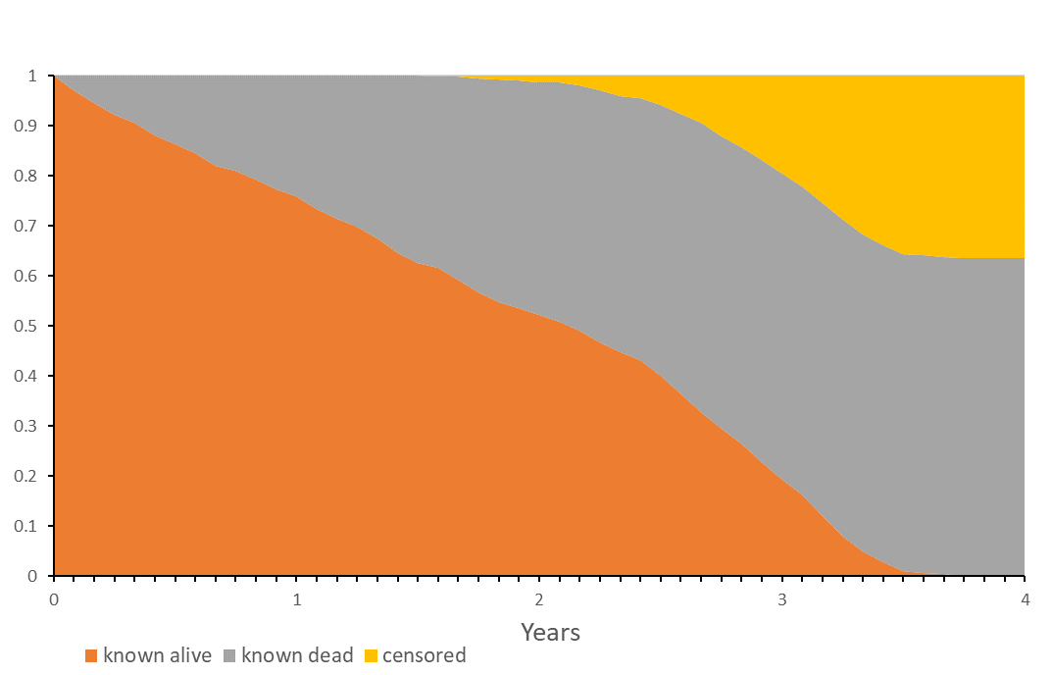
Figure A1: Influence of censoring on a simulation run for the control arm of scenario two.
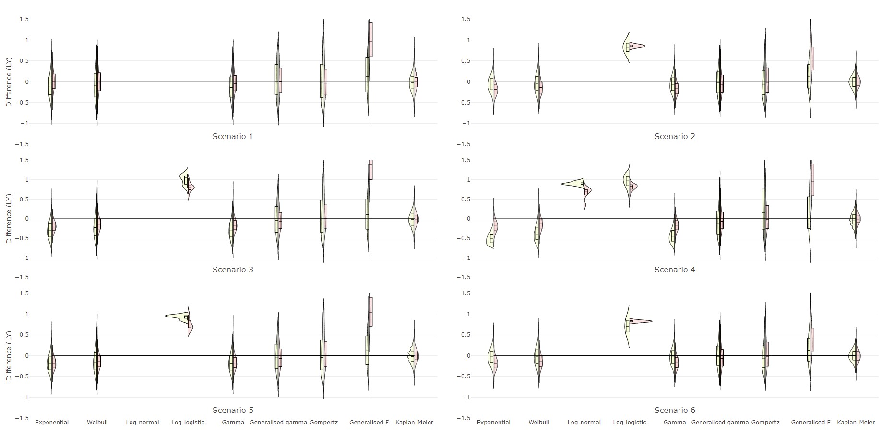
Figure A2: Violin plot of difference in life-year estimation for each parametric model fitted to censored follow-up and of complete Kaplan-Meier follow-up, by arm where estimates for the intervention are on the left of each violin, and control on the right.
LY: Life-years

