SUPPLEMENTAL MATERIAL

Supplemental Fig 1 Kaplan–Meier curve of EFS for venetoclax + azacitidine based on the VIALE-A trial
Abbreviations: EFS, event-free survival

Supplemental Fig 2 Parametric models of OS for venetoclax + azacitidine
 | Parameter estimates |  |  | Goodness of fit
 | A | B | C | AICª | BIC^{b}
Exponential | 0.04 | - | - | 1,342.79 | 1,346.45
Weibull | 25.65 | 0.80 | - | 1,333.87 | 1,341.18
Log-Logistic | 15.53 | 0.97 | - | 1,330.65 | 1,337.96
Log-Normal | 2.74 | 1.77 | - | 1,326.39 | 1,333.70
Gompertz | −0.04 | 0.06 | - | 1,331.98 | 1,339.29
Generalized Gamma | 2.71 | 1.79 | −0.05 | 1,328.37 | 1,339.34
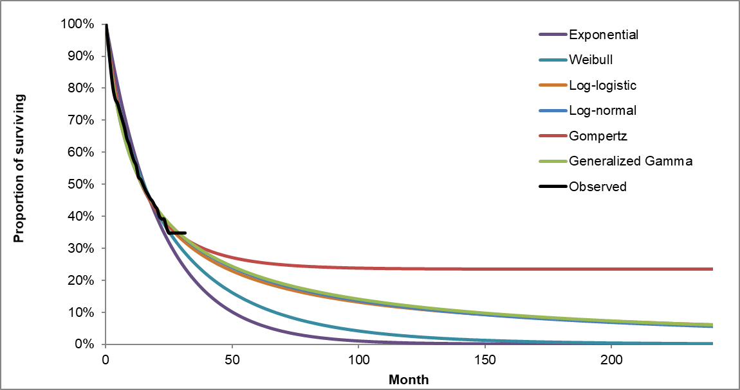

Abbreviations: AIC, Akaike information criterion; BIC, Bayesian information criterion; OS, overall survival
Notes:
ª A smaller AIC value represents a better goodness of fit
^{b} A smaller BIC value represents a better goodness of fit

Supplemental Fig 3 Parametric models of EFS for venetoclax + azacitidine
 | Parameter estimates |  |  | Goodness of fit
 | A | B | C | AICª | BIC^{b}
Exponential | 0.06 | - | - | 1,466.87 | 1,470.53
Weibull | 17.19 | 0.92 | - | 1,467.00 | 1,474.31
Log-Logistic | 10.70 | 1.17 | - | 1,465.41 | 1,472.72
Log-Normal | 2.34 | 1.49 | - | 1,465.16 | 1,472.47
Gompertz | −0.02 | 0.07 | - | 1,464.95 | 1,472.26
Generalized Gamma | 2.57 | 1.34 | 0.41 | 1,464.97 | 1,475.94
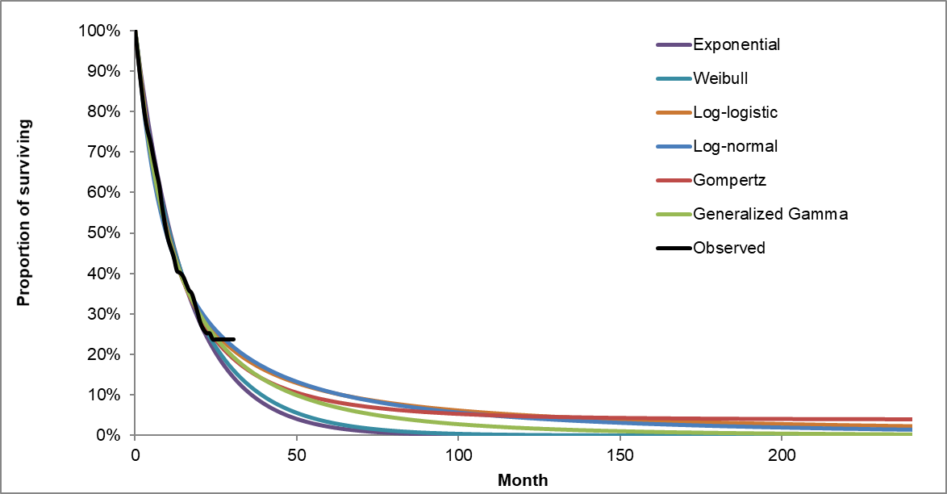

Abbreviations: AIC, Akaike information criterion; BIC, Bayesian information criterion; EFS, event-free survival
Notes:
ª A smaller AIC value represents a better goodness of fit
^{b} A smaller BIC value represents a better goodness of fit

Supplemental Fig 4 Parametric models of OS for azacitidine
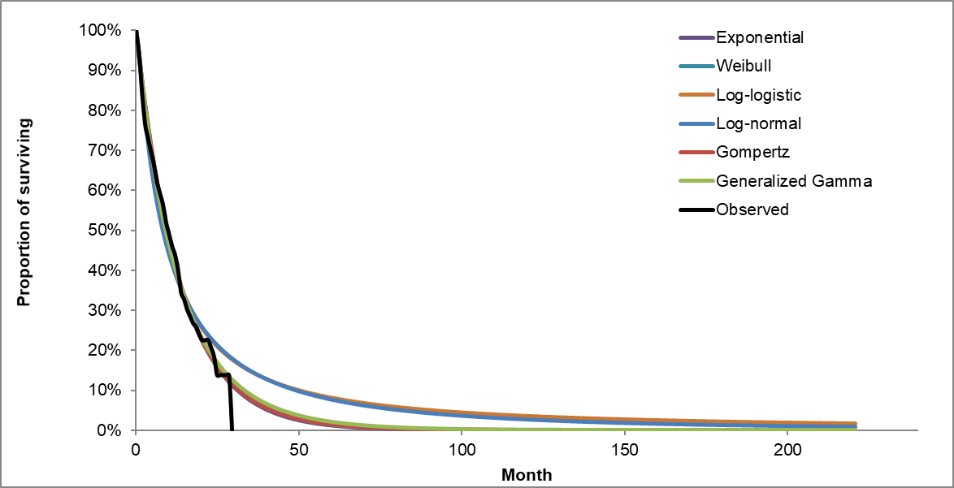
 | Parameter estimates |  |  | Goodness of fit
 | A | B | C | AICª | BIC^{b}
Exponential | 0.07 | - | - | 805.28 | 808.25
Weibull | 14.65 | 0.98 | - | 807.19 | 813.14
Log-Logistic | 9.35 | 1.25 | - | 811.63 | 817.58
Log-Normal | 2.18 | 1.40 | - | 812.01 | 817.96
Gompertz | 0.00 | 0.07 | - | 807.26 | 813.22
Generalized Gamma | 2.61 | 1.09 | 0.84 | 809.05 | 817.98

Abbreviations: AIC, Akaike information criterion; BIC, Bayesian information criterion; OS, overall survival
Notes:
ª A smaller AIC value represents a better goodness of fit
^{b} A smaller BIC value represents a better goodness of fit

Supplemental Fig 5 Parametric models of EFS for azacitidine
 | Parameter estimates |  |  | Goodness of fit
 | A | B | C | AICª | BIC^{b}
Exponential | 0.10 | - | - | 814.85 | 817.83
Weibull | 10.38 | 1.05 | - | 816.38 | 822.33
Log-Logistic | 6.71 | 1.37 | - | 828.74 | 834.70
Log-Normal | 1.83 | 1.26 | - | 827.14 | 833.09
Gompertz | 0.02 | 0.08 | - | 815.35 | 821.30
Generalized Gamma | 2.46 | 0.85 | 1.29 | 817.99 | 826.92
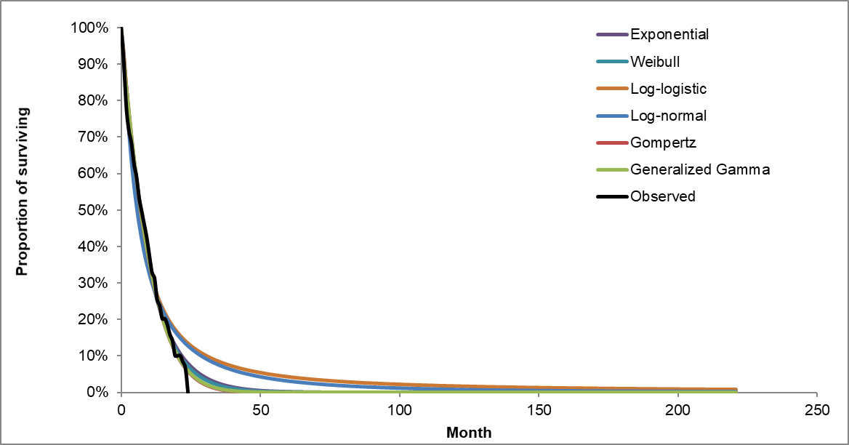

Abbreviations: AIC, Akaike information criterion; BIC, Bayesian information criterion; EFS, event-free survival
Notes:
ª A smaller AIC value represents a better goodness of fit
^{b} A smaller BIC value represents a better goodness of fit

Supplemental Table 1 AE rates, costs, and disutility inputs

Grade 3/4 AEsª | AE rates (%) |  | AE cost per event (2021 USD)^{b} | AE disutility per event^{c}
Grade 3/4 AEsª | Venetoclax + azacitidine | Azacitidine | AE cost per event (2021 USD)^{b} | AE disutility per event^{c}
Anemia | 26.1 | 20.1 | $7,587.77 | −0.090
Atrial fibrillation | 5.7 | 2.1 | $10,103.43 | −0.121
Febrile neutropenia | 41.7 | 18.8 | $13,690.15 | −0.090
Hypertension | 6.0 | 4.2 | $6,912.29 | −0.020
Hypokalemia | 10.6 | 10.4 | $7,301.27 | −0.121
Hypophosphatemia | 7.4 | 7.6 | $7,301.27 | −0.121
Leukopenia | 20.5 | 11.8 | $6,709.54 | −0.090
Neutropenia | 42.0 | 28.5 | $13,690.15 | −0.090
Pneumonia | 17.7 | 25.0 | $10,930.97 | −0.218
Sepsis | 5.7 | 6.9 | $18,462.53 | 0.000
Thrombocytopenia | 44.5 | 38.2 | $10,583.86 | −0.090
Urinary tract infection | 3.9 | 5.6 | $7,678.12 | −0.218

Abbreviations: AE, adverse event; USD, United States dollars
Notes:
ª The AE rate inputs were obtained from the VIALE-A trial (data on file, Genentech). Only grade 3/4 AEs with a ≥5% rate in either arm were considered.
^{b} The AE costs were estimated based on the 2016 Healthcare Cost and Utilization (HCUP) Project. As atrial fibrillation and hypophosphatemia do not have associated HCUP costs, their associated costs were assumed to be the same as other AEs within the same category (i.e., cardiac failure and hypokalemia, respectively). Costs were inflated to 2021 USD based on the Personal Consumption Expenditure Price Index for health care.
^{c} AE disutilities are obtained from Wehler et al. (2008) [1]. For AEs in that publication without an associated disutility, the disutility values were assumed to be the same as other AEs within the same category.

Supplemental Table 2 PSA inputs
Parameter | Base-Case Input | PSA Input
Efficacyª
EFS: Venetoclax + azacitidine – Gompertz | Parameter A: −0.022  Parameter B: 0.071 | Multivariate normal distribution with covariance matrix obtained from VIALE-A
EFS: Azacitidine – Exponential | 0.097 | Normal distribution; SE = 0.009
OS: Venetoclax + azacitidine – Log-normal | Parameter A: 2.739  Parameter B: 1.775 | Multivariate normal distribution with covariate matrix obtained from VIALE-A
OS: Azacitidine – Exponential | 0.068 | Normal distribution; SE = 0.007
CR/CRi rates – venetoclax + azacitidine | 66.4% | Beta distribution; SE = 0.028
CR/CRi rates – azacitidine | 28.3% | Beta distribution; SE = 0.037
Patient characteristicsª
Age | 75.43 | Normal distribution; SE = 0.398
Proportion of females | 41% | Beta distribution; SE = 0.033
Body weight | 73.84 | Normal distribution; SE = 1.399
BSA | 1.81 | Normal distribution; SE = 0.018
Costs^{b}
Event-free with CR/CRi cost | $196.67 | Gamma distribution; SEs assumed to be equal to 25% of the base-case inputs
Event-free without CR/CRi cost | $731.48
Post-progression cost | $769.74
Terminal care cost | $15,868.30
Subsequent HSCT cost: Venetoclax + azacitidine | $1,752.82
Subsequent HSCT cost: Azacitidine | $1,728.64
Post-progression therapy cost: Venetoclax + azacitidine | $583.64
Post-progression therapy cost: Azacitidine | $1,621.03
AE cost: Venetoclax + azacitidine | $25,115.79
AE cost: Azacitidine | $19,088.69
Utilities/disutilities^{a,b}
Utility: EFS with CR/CRi | 0.796 | Beta distribution; SE = 0.011
Utility: EFS without CR/CRi | 0.787 | Beta distribution; SE = 0.011
Utility: PD/RL | 0.723 | Beta distribution; SE = 0.015
Disutility due to AEs: Venetoclax + azacitidine | 0.008 | Beta distribution; SEs assumed to be equal to 25% of the base-case inputs
Disutility due to AEs: Azacitidine | 0.006 | Beta distribution; SE = 0.011

Abbreviations: AE, adverse event; BSA, body surface area; CR, complete remission; CRi, complete remission with incomplete marrow recovery; EFS, event-free survival; HSCT, hematopoietic stem cell transplantation; OS, overall survival; PD/RL, progressive disease/relapse; PSA, probabilistic sensitivity analysis; SE, standard error
Notes:
ª SEs for the CR/CRi rates, patient characteristics, and utilities by health state were estimated based on the VIALE-A trial (data on file, Genentech, Inc.).
^{b} SEs for the costs and disutilities were assumed equal to 25% of the absolute value of the means.

REFERENCES
1. Wehler E, Storm M, Kowal S, Campbell C, Boscoe A. A health state utility model estimating the impact of ivosidenib on quality of life in patients with relapsed/refractory acute myeloid leukemia. Presented at the 23rd Congress of the European Hematology Association meeting during June 14-17, 2018 in Stockholm, Sweden. 2018; Available from: https://investor.agios.com/static-files/25de7161-9a10-4d8c-8a03-8bd5e7d0a5d3

