Mapping the Patient-Reported Outcomes Measurement Information System (PROMIS-29) to EQ-5D-5L

Electronic Supplementary Material Index

INDEX: Tables included in the online resource
Table A1: Mapping onto Preference-based measures reporting Standards (MAPS) checklist
Table A2: Mapping to Estimate Health-State Utility from Non-Preference-Based Outcome Measures: An ISPOR Good Practices for Outcomes Research Task Force Report. Summary of reporting of mapping studies recommendations
Figure A1: Scatterplots of the observed versus predicted utilities for direct and indirect methods
Table A3: Survey data demographics vs general population
Table A4: Coefficients and standard errors from the best performing econometric model (ALVDMM)
Table A5: Performance of mapping function compared to other studies
Figure A2: Distribution of the observed and predicted utilities using different mapping functions Table A: Figure A3: Predictive performance of PROPr vs Mapping algorithm

References

Table A1: Mapping onto Preference-based measures reporting Standards (MAPS) checklist
Section/topic | Item No. | Recommendation | Reported on page  No.
Title and abstract
Title | 1 | Identify the report as a study mapping between outcome measures. State the source measure(s) and generic, preference-based target measure(s) used in the study. | 1
Abstract | 2 | Provide a structured abstract including, as applicable: objectives; methods, including data sources and their key characteristics, outcome measures used and estimation and validation strategies; results, including indicators of model performance; conclusions; and implications of key findings. | 1
Introduction
Study rationale | 3 | Describe the rationale for the mapping study in the context of the broader evidence base. | 2-3
Study objective | 4 | Specify the research question with reference to the source and target measures used and the disease or population context of the study. | 3-4
Methods
Estimation sample | 5 | Describe how the estimation sample was identified, why it was selected, the methods of recruitment and data collection, and its location(s) or setting(s). | 4
External validation sample | 6 | If an external validation sample was used, the rationale for selection, the methods of recruitment and data collection, and its location(s) or setting(s) should be described. | NA
Source and target measures | 7 | Describe the source and target measures and the methods by which they were applied in the mapping study. | 4
Exploratory data analysis | 8 | Describe the methods used to assess the degree of conceptual overlap between the source and target measures. | 8-9
Missing data | 9 | State how much data were missing and how missing data were managed in the sample(s) used for the analyses. | NA
Modelling approaches | 10 | Describe and justify the statistical model(s) used to develop the mapping algorithm. | 5-6
Estimation of predicted scores or utilities | 11 | Describe how predicted scores or utilities are estimated for each model specification. | 5-6
Validation methods | 12 | Describe and justify the methods used to validate the mapping algorithm. | 6
Measures of model performance | 13 | State and justify the measure(s) of model performance that determine the choice of the preferred model(s) and describe how these measures were estimated and applied. | 6
Results
Final sample size(s) | 14 | State the size of the estimation sample and any validation sample(s) used in the analyses (including both number of individuals and number of observations). | 7
Descriptive information | 15 | Describe the characteristics of individuals in the sample(s) (or refer back to previous publications giving such information). Provide summary scores for source and target measures, and summarize results of analyses used to assess overlap between the source and target measures. | 8-9
Model selection | 16 | State which model(s) is(are) preferred and justify why this(these) model(s) was(were) chosen. | 10-15
Model coefficients | 17 | Provide all model coefficients and standard errors for the selected model(s). Provide clear guidance on how a user can calculate utility scores based on the outputs of the selected model(s). | ESM
Uncertainty | 18 | Report information that enables users to estimate standard errors around mean utility predictions and individual-level variability. | ESM
Model performance and face validity | 19 | Present results of model performance, such as measures of prediction accuracy and fit statistics for the selected model(s) in a table or in the text. Provide an assessment of face validity of the selected model(s). | Tables 3-4
Discussion
Comparisons with previous studies | 20 | Report details of previously published studies developing mapping algorithms between the same source and target measures and describe differences between the algorithms, in terms of model performance, predictions and coefficients, if applicable. | ESM
Study limitations | 21 | Outline the potential limitations of the mapping algorithm. | 16-17
Scope of applications | 22 | Outline the clinical and research settings in which the mapping algorithm could be used. | 16-17
Other
Additional information | 23 | Describe the source(s) of funding and non-monetary support for the study, and the role of the funder(s) in its design, conduct and report. Report any conflicts of interest surrounding the roles of authors and funders. | Separately included in the submission
NA: Not applicable

Table A2: Mapping to Estimate Health-State Utility from Non-Preference-Based Outcome Measures: An ISPOR Good Practices for Outcomes Research Task Force Report. Summary of reporting of mapping studies recommendations
Recommendation | Reported
1. Describe relevant differences between data sets that are candidates for mapping estimation. | One only dataset was used, which was collected for the purpose of this mapping study.
2. Give full details of the selected data set. Describe how the study was run and patients were sampled. Provide baseline and follow up characteristics including the distribution of patients’ disease severity. Missingness in the longitudinal pattern of responses should be described. | How the study was conducted and the patients sampled are provided in Section 2 (Data), and patient characteristics are provided in Table 1.  Data were cross-sectional with all questions mandatory, except for the Charlson Comorbidity Index (CCI), which was not used in the mapping study. Hence there was no missing data.
3. Plot the distribution of the utility data. | Distribution of the observed versus predicted utilities presented in Figure 1.
4. Justify the type of model(s) selected with reference to the characteristics of the target utility distribution and the proposed use of the mapping function. | The justification of the models selected is presented in Section 3.2.
5. Compare the dimensions of health covered by the target utility instrument and those covered by the explanatory clinical measure(s). | Description of instrument dimensions provided in Section 2.1 Spearman’s rank correlation coefficients are presented in Section 3.1.
6. Describe the approach to determining the final model. Include tests conducted and judgments made. | Described in Section 3.2
7. Summary measures of fit are of limited value for the total sample. Provide information on fit conditional on disease severity as measured by the clinical outcome measure(s). A plot of mean predicted versus mean observed utility conditional on the clinical variable(s) should be included. | A range of summary measures are presented in Table 3. Distribution of the observed versus predicted utilities presented in Figure 1.
8. Coefficient values, error term(s) distributions(s), variances, and covariances are required. | Presented in Appendix B and D.
9. Provide an example predicted value for some sets of covariates. Consider providing a program that calculates predictions for user-defined inputs. | Example of how to estimate predicted utility value presented in Appendix B.
10. Parameter uncertainty in a mapping regression should be reflected using standard methods for PSA. Assessment of model suitability for use in cost-effectiveness analysis should also consider the distribution of utility values for PSA, with particular focus on whether these lie outside the feasible utility range for the PBM. | Table 2 presents the range for predicted utilities by each model.
11. When imputing data from a mapping function, individual-level variability should be incorporated using simulation methods and information about the distribution of the error term(s). These simulated data can be compared with the raw observed data, including an assessment of the range of values compared with the feasible range for the PBM. | Not applicable – no imputation conducted.
12. Re-estimation of mapping results in a separate data set or other forms of validation are not routinely required. | Due to the lack of data on the five-level version of EQ-5D-5L, no external dataset was available, and only internal cross validation was applied in this study (mentioned in Section 2.5).

Figure A1: Scatterplots of the observed versus predicted utilities for direct and indirect methods
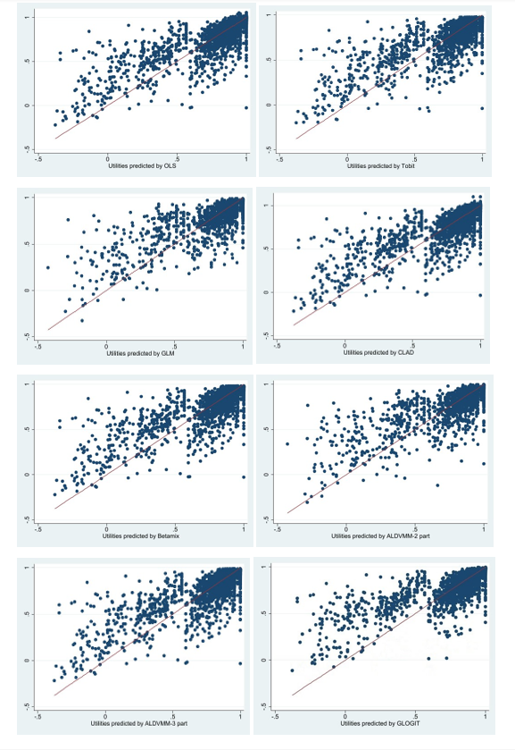The 45˚ line represents observed utilities drawn against themselves. Results were obtained using the explanatory variables set 5: the PROMIS-29 (as categorical variables), age, age squared, and sex. Acronyms: OLS: Ordinary Least Square, GLM: Generalised Linear Model, CLAD: Censored Least Absolute Deviation, Betamix: Mixture beta regression model, ALDVMM: Adjusted Limited Dependent Variable Mixture Model, GLOGIT: Generalised Logistic Regression

Table A3: Survey data demographics vs general population
 | Survey data (%) | Australian general population (%)
Age, (years)
20-29 | 18.75 | 14.46
30-39 | 16.75 | 14.48
40-49 | 15.01 | 12.91
50-59 | 13.93 | 12.14
60-69 | 12.12 | 10.3
70 and over | 15.63 | 15.91
Gender
Female | 50.81 | 50.40
Male | 49.19 | 49.60
States and territories
New south Wales | 31.46 | 31.8
Victoria | 25.89 | 25.8
Queensland | 20.28 | 20.4
Western Australia | 10.45 | 10.4
South Australia | 7.77 | 6.9
Tasmania | 2.12 | 2.1
Australian Capital Territory | 1.56 | 1.7
Northern Territory | 0.46 | 1

Table A4: Coefficients and standard errors from the best performing econometric model (ALVDMM)
Predictor variables | Component one coefficients | Standard errors | Component two coefficients | Standard errors
PROMIS-29 Q1
Level-1 | -0.0153759 | 0.0166341 | -0.2512246 | 0.0612404
Level-2 | -0.0193242 | 0.0136008 | -0.0453108 | 0.0491082
Level-3 | -0.0188596 | 0.0083070 | -0.0281365 | 0.0388215
Level-4 | -0.0159325 | 0.0046297 | -0.0536585 | 0.0300170
PROMIS-29 Q2
Level-1 | -0.0557843 | 0.0187254 | -0.0997954 | 0.0691582
Level-2 | -0.0432512 | 0.0107050 | -0.1628856 | 0.0507016
Level-3 | -0.0345741 | 0.0076413 | -0.0686172 | 0.0401323
Level-4 | -0.0175525 | 0.0046187 | -0.0694935 | 0.0300873
PROMIS-29 Q3
Level-1 | -0.0443153 | 0.0185473 | -0.2416466 | 0.0610727
Level-2 | -0.0257281 | 0.0126856 | -0.1215304 | 0.0519784
Level-3 | -0.0158961 | 0.0104600 | -0.1216325 | 0.0451106
Level-4 | -0.0329266 | 0.0063853 | -0.0404878 | 0.0336762
PROMIS-29 Q4
Level-1 | -0.0332496 | 0.0177134 | 0.0219102 | 0.0716142
Level-2 | -0.0426359 | 0.0136200 | -0.1153443 | 0.0534173
Level-3 | -0.0949913 | 0.0119982 | -0.0692443 | 0.0434006
Level-4 | -0.0142045 | 0.0062476 | 0.0050907 | 0.0345728
PROMIS-29 Q7
Level-1 | -0.0046505 | 0.0141610 | 0.1742726 | 0.0545499
Level-2 | -0.0127371 | 0.0138531 | 0.1464218 | 0.0507701
Level-3 | -0.0191060 | 0.0135909 | 0.1377876 | 0.0478465
Level-4 | -0.0250385 | 0.0138341 | -0.025423 | 0.0451478
PROMIS-29 Q9
Level-1 | -0.0139241 | 0.0157475 | -0.0710160 | 0.0638857
Level-2 | -0.0178909 | 0.0155086 | -0.0323388 | 0.0608446
Level-3 | -0.0260631 | 0.0151453 | -0.0667134 | 0.0574813
Level-4 | -0.0352814 | 0.0147697 | -0.0449966 | 0.0527821
PROMIS-29 Q11
Level-1 | 0.0505476 | 0.0169766 | 0.1517303 | 0.0667251
Level-2 | 0.0268208 | 0.0166327 | 0.1242341 | 0.0638517
Level-3 | 0.0253035 | 0.0162174 | 0.0578845 | 0.0583242
Level-4 | 0.0068267 | 0.0150913 | 0.0037468 | 0.0529150
PROMIS-29 Q12
Level-1 | -0.0440054 | 0.0156918 | 0.1098159 | 0.0663174
Level-2 | -0.0354621 | 0.0152313 | 0.1097141 | 0.0624306
Level-3 | -0.0349879 | 0.0145917 | 0.0422851 | 0.0561740
Level-4 | -0.0199566 | 0.0142258 | 0.095138 | 0.0510256
PROMIS-29 Q15
Level-1 | 0.0345600 | 0.0132840 | 0.2547519 | 0.0661108
Level-2 | 0.0263120 | 0.0118898 | 0.2245602 | 0.0551879
Level-3 | 0.0291155 | 0.0111279 | 0.1177162 | 0.0480409
Level-4 | 0.0035409 | 0.0096253 | 0.1788318 | 0.0432734
PROMIS-29 Q16
Level-1 | 0.0046022 | 0.0135439 | -0.0582178 | 0.0706915
Level-2 | 0.0008163 | 0.0120706 | -0.0823277 | 0.0576132
Level-3 | -0.004828 | 0.0113140 | -0.0579528 | 0.0503284
Level-4 | 0.0041111 | 0.0098099 | -0.0955967 | 0.0443711
PROMIS-29 Q19
Level-1 | 0.0176295 | 0.0081090 | 0.0203526 | 0.0376144
Level-2 | 0.0099470 | 0.0077295 | 0.0509588 | 0.0328939
Level-3 | 0.0063671 | 0.0076840 | 0.0264668 | 0.0328616
Level-4 | 0.0072207 | 0.0078400 | 0.0456120 | 0.0318069
PROMIS-29 Q21
Level-1 | -0.0041183 | 0.0139121 | -0.0133203 | 0.0713697
Level-2 | -0.0201998 | 0.0082184 | 0.0034346 | 0.0517287
Level-3 | -0.0018165 | 0.0061998 | -0.0481868 | 0.0457993
Level-4 | -0.0038582 | 0.0053099 | -0.0556713 | 0.0416784
PROMIS-29 Q22
Level-1 | -0.0130268 | 0.0148896 | -0.0569499 | 0.0691966
Level-2 | 0.0029360 | 0.0083664 | -0.0440736 | 0.0514198
Level-3 | -0.0006445 | 0.0064345 | 0.0410927 | 0.0450160
Level-4 | -0.0039552 | 0.0055247 | 0.0326475 | 0.0412483
PROMIS-29 Q23
Level-1 | -0.0171607 | 0.0144776 | -0.1534076 | 0.0608520
Level-2 | -0.0069444 | 0.0081598 | -0.0997347 | 0.0485689
Level-3 | -0.0037200 | 0.0054580 | -0.0883849 | 0.0419523
Level-4 | -0.0022135 | 0.0047793 | -0.0528193 | 0.0403377
PROMIS-29 Q24
Level-1 | -0.0076683 | 0.0135460 | 0.0004670 | 0.0669562
Level-2 | -0.0020127 | 0.0081141 | -0.047008 | 0.0495050
Level-3 | -0.0043973 | 0.0066036 | -0.0524846 | 0.0432965
Level-4 | -0.0003337 | 0.0054832 | -0.0133414 | 0.0411253
PROMIS-29 Q29
Level-1 | -0.036139 | 0.0047154 | -0.0647765 | 0.0418553
Level-2 | -0.0516845 | 0.0046437 | -0.1416216 | 0.0395966
Level-3 | -0.0540479 | 0.0048026 | -0.1988222 | 0.0404908
Level-4 | -0.0697036 | 0.0060776 | -0.2575629 | 0.0439801
Level-5 | -0.0805960 | 0.0062774 | -0.2421089 | 0.0403540
Level-6 | -0.0945755 | 0.0063765 | -0.2391289 | 0.0418458
Level-7 | -0.0925336 | 0.0070040 | -0.2933663 | 0.0406351
Level-8 | -0.0559952 | 0.0114176 | -0.4467049 | 0.0434310
Level-9 | -0.0146449 | 0.0176463 | -0.3925480 | 0.0491618
Level-10 | 0.0909062 | 0.0337702 | -0.3493769 | 0.0728387
Age | -0.000442 | 0.0004842 | -0.0647765 | 0.0418553
Age squared | 7.90E-07 | 4.86E-060 | -0.1416216 | 0.0395966
Female | -0.0002433 | 0.0028219 | -0.1988222 | 0.0404908
Constant | 0.9991067 | 0.0221974 | -0.2575629 | 0.0439801
Probability -Component 1
Constant | 0.4086450 | 0.0656626
/lns_1 | -3.113806 | 0.0314861
/lns_2 | -1.465621 | 0.0312680
sigma1 | 0.0444315 | 0.0013990
sigma2 | 0.2309346 | 0.0072209
PROMIS-29 Q n = n^{th} question of PROMIS-29. The algorithm is based on ALVDMM set (5) that included PROMIS-29 questions as items, age, age squared and sex (Female=1) as explanatory variables. For PROMIS-29, Q1 to Q28, reference levels are level 5 and for PROMIS-29 Q29 reference level is level 0.

Calculation of utilities

Utilities are calculated from PROMIS-29 by matching responses to question and level specific coefficients reported in Table A4 using the following formula:

$EQ-5D-5L Utility=$ (Component one expected EQ-5D-5L utility× Component one probability) + (Component two expected EQ-5D-5L utility× Component two probability)
where:
Component (n) expected EQ-5D-5L utility= ∑ $Q_{i,k(n)}+β_{1(n)}*\left(Age\right)+β_{2\left(n\right)}* \left(age squared\right)+β_{3(n})*$Female +Constant
Where:
$Q_{i,k(n)} :$ Coefficient Q for PROMIS-29 question i and level k in component n
$β_{1(n)}$ $:$Age coefficient in component n
$β_{2(n)}$ : Age squared coefficient in component n
$β_{3(n)}$ : Female coefficient in component n

and,
Component one probability= $\left(\frac{\exp\left(Probability constant1 \right)}{\exp\left(Probability constant 1 \right)+1}\right)$
Component two probability= $\left(\frac{1}{\exp\left(Probability constant 1)+1\right)}\right)$

Comparison to other studies

We compared the predictive performance between our mapping algorithm and the other two mapping algorithms, one from the US using a limited number of PROMIS-29 domains to map to EQ-5D-3L by Revicki et al. (2009) [1] and one from the UK mapping PROMIS-29 to EQ-5D-5L crosswalk utilities by Klapproth et al. (2020)[2]. Lacking external datasets, we undertook the comparison using the Australian data, which certainly would favour our mapping algorithm. In this sense, our comparison was more about checking how the other two algorithms would perform when applied to an Australian sample. Also, it is reported that UK population preferences are similar to Australian population preferences and applying a UK mapping algorithm to Australian data is not uncommon[3, 4].

The comparison results are reported in Table A5 and Figure A2. Both Revicki et al. (2009) and Klapproth et al. (2020) predicted the utilities to be over one, so their performance before and after truncation were both considered. Table A5 suggests that while our mapping algorithm was able to predict the exact observed mean, the other two algorithms over predicted the mean. The US one performed very poorly in predicting the minimum utility. This was understandable as the algorithm was developed to map to EQ-5D-3L utilities which are less sensitive to ill health. Figure A2 suggests that both algorithms perform poorly in predicting higher utilities while the UK algorithm performed better in predicting lower utilities compared to the US one.

Revicki et al. (2009) did not report MAE or MSE related metrics while Klapproth et al. (2020) reported nRMSE and nMAE results. For comparison, we also estimated nRMSE and nMAE using our mapping algorithm and found a 31.6 per cent reduction (from 0.076 to 0.052) for nRMSE and a 34.0 per cent reduction (from 0.053 to 0.035) for nMAE, a substantial improvement over those for the UK.

Table A5: Performance of mapping function compared to other studies
Models | Predicted mean |  | Predicted minimum | Predicted maximum |  | nRMSE | nMAE
Models | BT | AT | Predicted minimum | BT | AT | nRMSE | nMAE
Actual observations | 0.8279 |  | -0.3770 | 1 |  | - | -
Utilities obtained by Revicki et al. (2009) | 0.8635 | 0.8588 | 0.3789 | 1.0447 | 1 | - | -
Utilities obtained by Klapproth et al. (2020)-UK algorithm | 0.8549 | 0.8445 | -0.2182 | 1.1002 | 1 | 0.076* | 0.053*
ALDVMM-2 part (set 5) | 0.8279 |  | -0.3246 | 0.9972 |  | 0.0524 | 0.0347
* nRMSE and nMAE are reported in Klapproth et al. (2020), Table 2, BT: Before truncation, AT: After truncation, ALDVMM: Adjusted Limited Dependent Variable Mixture Model, nRMSE normalized root mean squared error, nMAE normalized mean absolute error
Figure A2: Distribution of the observed and predicted utilities using different mapping functions
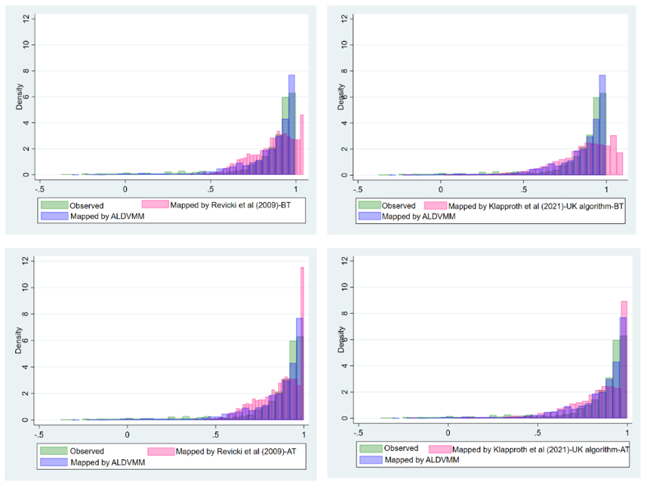BT: Before truncation, AT: After truncation, ALDVMM: Adjusted Limited Dependent Variable Mixture Model, explanatory variables set 5

Comparison to PROPr

PROPr weights from Dewitt et al. (2018) were applied to our dataset to compare utilities predicted with the mapping algorithm with those calculated with PROPr [5, 6](See Fig A3).
The utility values predicted by the best performing model from this mapping study resulted in the mean utility of 0.8279, ranging from -0.3535 to 0.9971. Applying PROPr in our study sample resulted in predicted utility values with a mean of 0.4488, ranging from -0.0210 to 0.904.
Figure A3: Predictive performance of PROPr vs Mapping algorithm
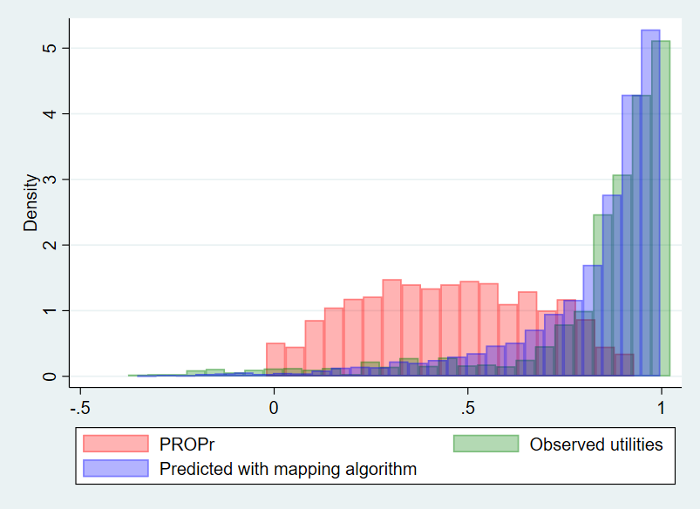

References

1. Revicki DA, Kawata AK, Harnam N, Chen WH, Hays RD, Cella D. Predicting EuroQol (EQ-5D) scores from the patient-reported outcomes measurement information system (PROMIS) global items and domain item banks in a United States sample. Quality of Life Research. 2009;18(6):783-91. doi: 10.1007/s11136-009-9489-8.
2. Klapproth CP, van Bebber J, Sidey-Gibbons C, Valderas J, Leplege A, Rose M, et al. Predicting EQ-5D-5L crosswalk from the PROMIS-29 profile for the United Kingdom, France, and Germany. Health and Quality of Life Outcomes. 2020;18(1):1-13.
3. Clemens S, Begum N, Harper C, Whitty JA, Scuffham PA. A comparison of EQ-5D-3L population norms in Queensland, Australia, estimated using utility value sets from Australia, the UK and USA. Quality of Life Research. 2014;23(8):2375-81.
4. Stavropoulos V, Beard C, Griffiths MD, Buleigh T, Gomez R, Pontes HM. Measurement invariance of the internet gaming disorder scale–short-form (IGDS9-SF) between Australia, the USA, and the UK. International journal of mental health and addiction. 2018;16(2):377-92.
5. Dewitt B, Feeny D, Fischhoff B, Cella D, Hays RD, Hess R, et al. Estimation of a preference-based summary score for the Patient-Reported Outcomes Measurement Information System: The PROMIS®-Preference (PROPr) scoring system. Medical decision making : an international journal of the Society for Medical Decision Making. 2018;38(6):683-98.
6. Dewitt B, Jalal H, Hanmer J. Computing PROPr utility scores for PROMIS® profile instruments. Value in health : the journal of the International Society for Pharmacoeconomics and Outcomes Research. 2020;23(3):370-8.

