Electronic supplementary material
To assess the quality of responses in the DCE survey, we estimated several conditional logit models, each time using different exclusion criteria. The results are reported in table 5. Failing a number of dominant choice pairs and completing the DCE task in less than 150 seconds are strongly correlated (polychoric correlation of 0.825). This is also seen in the results of table 5; any exclusion of respondents based on failing dominant choice tasks, or completing the survey in an unreasonable amount of time results in a dramatic increase in Pseudo $R^{2}$ and AIC per respondent (AIC/n). Excluding respondents that failed 1 or more dominant choice task or completed the survey in less than 150 seconds yielded the best AIC per respondent and Pseudo $R^{2}$ and was therefore chosen as the final exclusion criterion.
Table 6: conditional logit models with different exclusion criteria.
 | Model 1 | Model 2 | Model 3 | Model 4 | Model 5 | Model 6
mo2 | -0.222 | -0.323 | -0.349 | -0.405 | -0.357 | -0.390
mo3 | -1.001 | -1.607 | -1.599 | -1.845 | -1.755 | -1.894
sc2 | -0.146 | -0.243 | -0.259 | -0.303 | -0.272 | -0.324
sc3 | -0.711 | -1.137 | -1.103 | -1.263 | -1.222 | -1.320
ua2 | -0.480 | -0.573 | -0.651 | -0.683 | -0.618 | -0.684
ua3 | -1.245 | -1.817 | -1.839 | -2.057 | -1.959 | -2.119
pd2 | -0.697 | -0.967 | -0.990 | -1.099 | -1.022 | -1.130
pd3 | -1.845 | -2.844 | -2.824 | -3.189 | -3.049 | -3.347
ad2 | -0.458 | -0.751 | -0.733 | -0.824 | -0.800 | -0.847
ad3 | -1.654 | -2.383 | -2.411 | -2.654 | -2.550 | -2.701
Pseudo $R^{2}$ | 30.07% | 45.93% | 46.40% | 50.68% | 48.83% | 52.17%
Observations | 19500 | 15465 | 15885 | 15165 | 15135 | 14385
Respondents | 1300 | 1031 | 1059 | 1011 | 1009 | 959
AIC | 18925 | 11612 | 11823 | 10389 | 10756 | 9559
AIC/n | 14.56 | 11.26 | 11.16 | 10.28 | 10.66 | 9.97
Model 1: no exclusions.
Model 2: Respondents that completed the 18 choice pairs in less than 150 seconds are excluded.
Model 3: Respondents that failed at least one dominant pair are excluded.
Model 4: Respondents that completed the 18 choice pairs in less than 180 seconds are excluded.
Model 5: Respondents that completed the 18 choice pairs in less than 150 seconds or failed at least two dominant pairs are excluded.
Model 6: Respondents that completed the 18 choice pairs in less than 150 seconds or failed at least one dominant pair are excluded.

Table 7: Means by health state for all states valued in the cTTO task.
State | Mean | SD
11112 | 0.91 | 0.26
11121 | 0.95 | 0.09
11122 | 0.86 | 0.16
11211 | 0.96 | 0.07
11313 | 0.33 | 0.65
12111 | 0.97 | 0.05
12212 | 0.86 | 0.16
12331 | 0.40 | 0.62
13133 | -0.04 | 0.68
13221 | 0.83 | 0.18
21111 | 0.95 | 0.12
21133 | 0.07 | 0.64
21211 | 0.91 | 0.15
21323 | 0.38 | 0.54
21332 | 0.36 | 0.58
22121 | 0.88 | 0.15
22222 | 0.81 | 0.22
22233 | 0.05 | 0.61
23112 | 0.84 | 0.15
23323 | 0.22 | 0.58
31131 | 0.45 | 0.62
31223 | 0.35 | 0.56
32113 | 0.37 | 0.60
32232 | 0.33 | 0.59
32322 | 0.63 | 0.39
33232 | 0.27 | 0.58
33311 | 0.77 | 0.36
33333 | -0.37 | 0.65

Fig.4: Example cTTO question
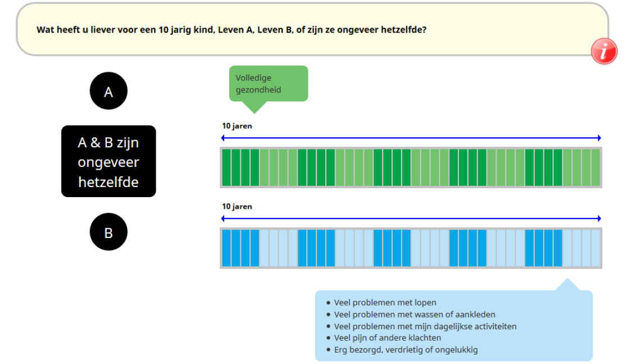
Fig.5: Example cTTO question (lead time)
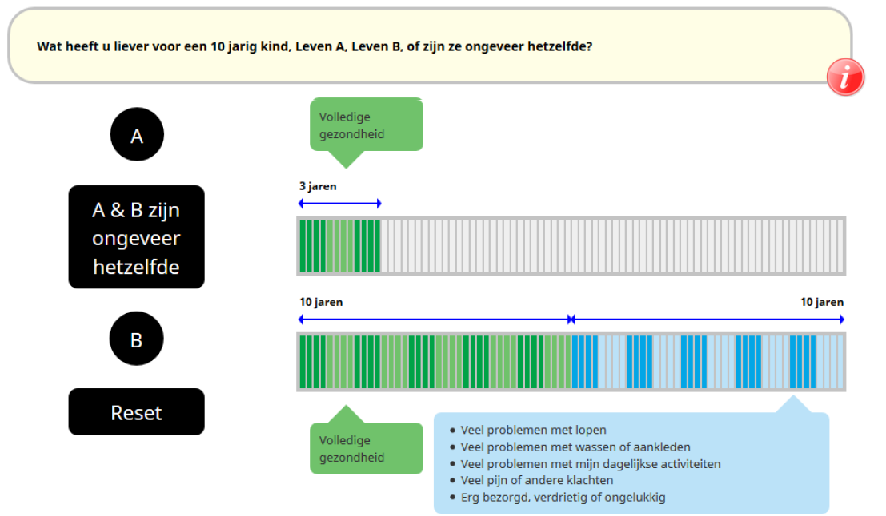

Fig.6: Example DCE question
