Supplementary Figure 1: Difference between observed and predicted probabilities for Van Hout et al and Hernández et al [DSU(EEPRU)] in FORWARD and IP datasets.
Differnce between predicted and observed probability | 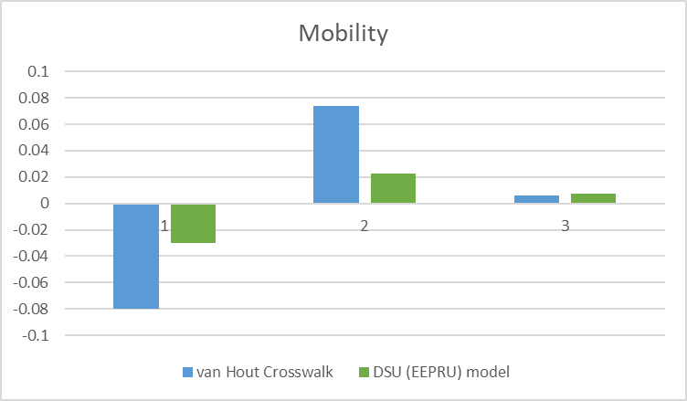 | 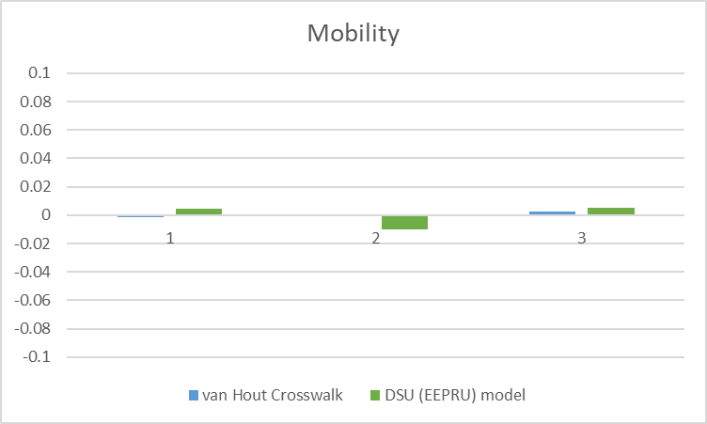
Differnce between predicted and observed probability | 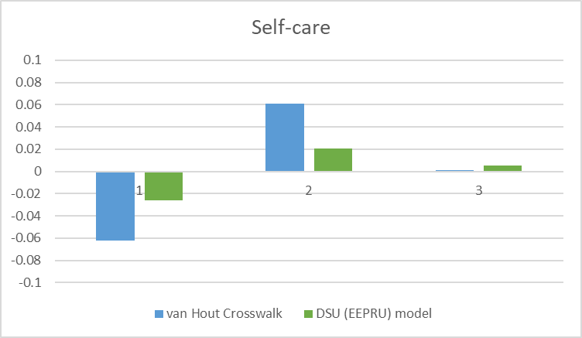 | 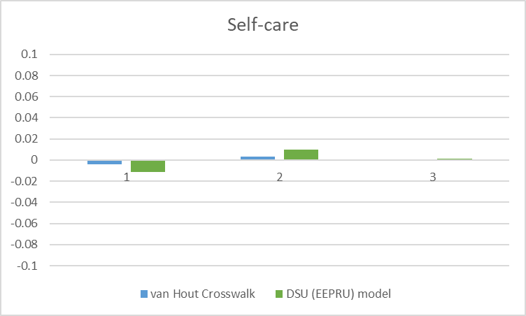
Differnce between predicted and observed probability | 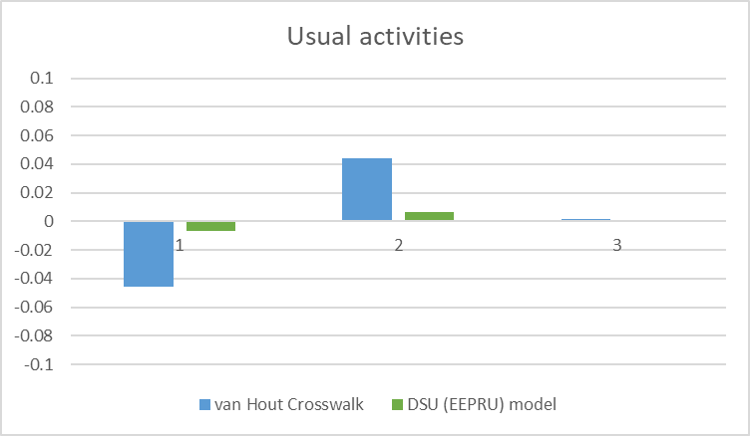 | 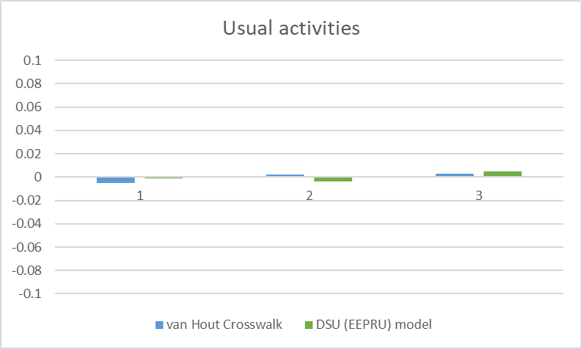
Differnce between predicted and observed probability | 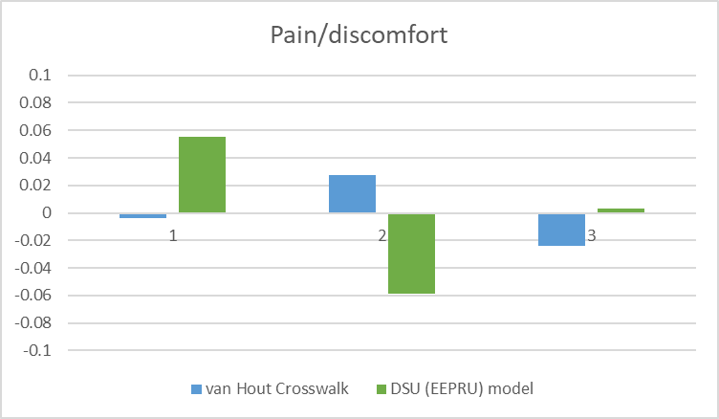 | 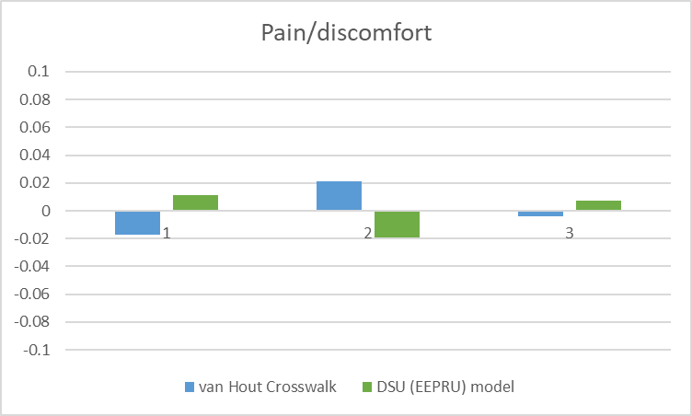
Differnce between predicted and observed probability | 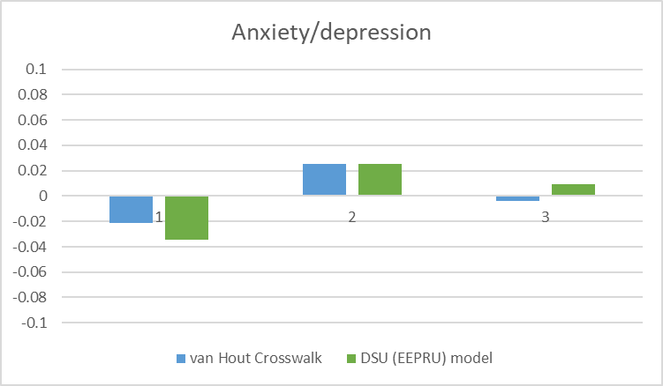 | 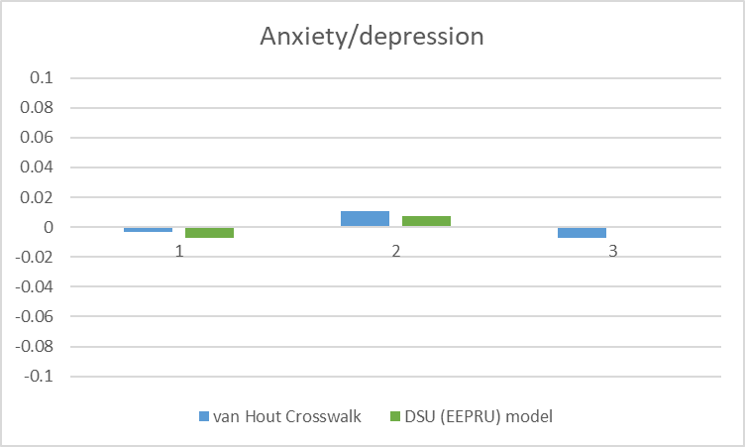
 | (a) FORWARD dataset | (b) IP dataset

