Supplementary Figure 2: Observed and predicted cumulative distribution functions in the FORWARD and IP datasets, for the Crosswalk and Hernández et al [DSU(EEPRU)] mappings

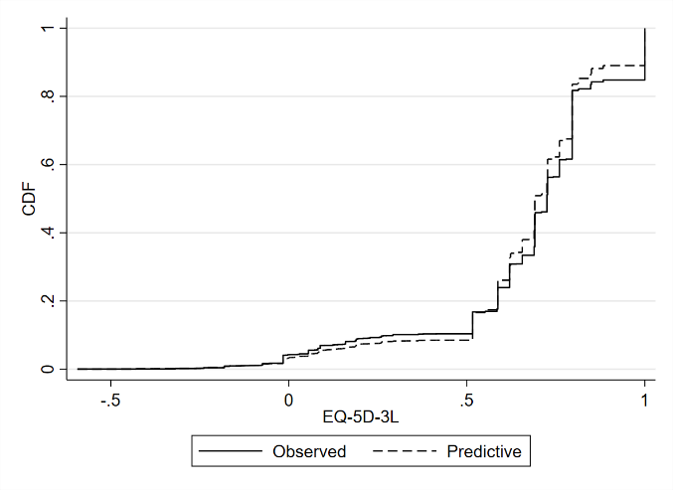  FORWARD dataset: Crosswalk | 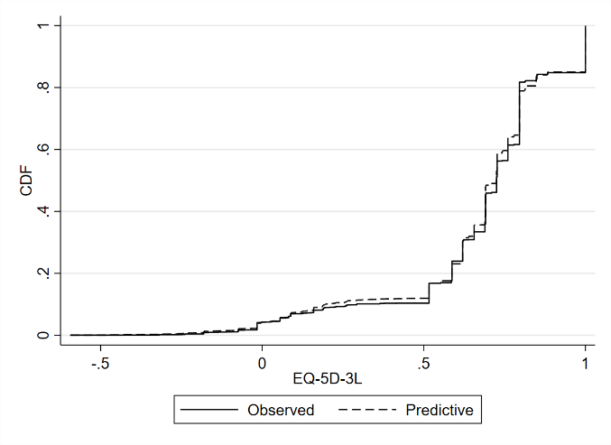  FORWARD dataset: DSU(EEPRU)
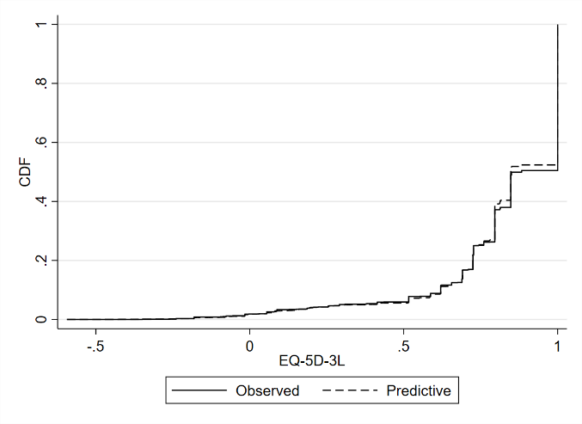  IP dataset: Crosswalk | 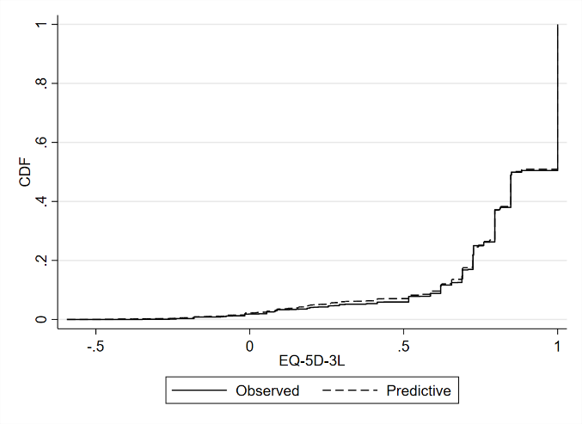  IP dataset: DSU(EEPRU)

