APPENDIX

Figure S1. Equally distributed equivalent quality-adjusted life expectancy (EDE QALE) by sex and level of social inequality aversion
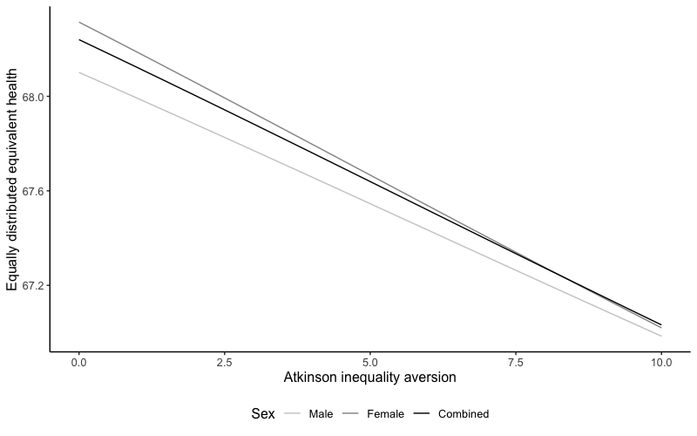

Table S1: Quality-adjusted life expectancy estimates by sex, index of multiple deprivation quintile (IMD) group and annual discount rate
 | IMD quintile group
 | 1 | 2 | 3 | 4 | 5
Females
Life expectancy
0% | 79.67 | 82.15 | 83.57 | 84.62 | 85.76
1.5% | 46.46 | 47.29 | 47.75 | 48.1 | 48.44
3.5% | 27.17 | 27.49 | 27.63 | 27.35 | 27.6
Quality-adjusted life expectancy
0% | 62.36 (0.68) | 65.52 (0.58) | 69.49 (0.62) | 70.64 (0.51) | 73.02 (0.51)
1.5% | 37.65 (0.44) | 38.42 (0.56) | 40.68 (0.41) | 41.51 (0.44) | 42.07 (0.51)
3.5% | 24.1 (0.4) | 24.34 (0.24) | 24.05 (0.32) | 24.62 (0.36) | 24.39 (0.27)
Males
Life expectancy
0% | 77.39 | 80.2 | 81.89 | 83.07 | 84.36
1.5% | 44.89 | 45.98 | 46.64 | 47.07 | 47.52
3.5% | 27.73 | 27.46 | 27.69 | 27.8 | 27.57
Quality-adjusted life expectancy
0% | 62.17 (0.72) | 65.28 (0.6) | 69.55 (0.57) | 71.59 (0.65) | 73.42 (0.65)
1.5% | 38.32 (0.4) | 39.61 (0.47) | 41.23 (0.44) | 41.39 (0.48) | 42.57 (0.37)
3.5% | 24.39 (0.35) | 24.41 (0.38) | 24.74 (0.24) | 24.4 (0.41) | 25.07 (0.29)
Combined
Life expectancy
0% | 75.18 | 78.23 | 80.17 | 81.45 | 82.87
1.5% | 45.66 | 46.63 | 47.2 | 47.59 | 47.99
3.5% | 27.07 | 27.29 | 26.86 | 27.34 | 27.52
Quality-adjusted life expectancy
0% | 62.19 (0.43) | 65.54 (0.49) | 69.54 (0.42) | 71.12 (0.44) | 73.27 (0.41)
1.5% | 37.94 (0.29) | 39.16 (0.37) | 40.96 (0.3) | 41.45 (0.34) | 42.34 (0.31)
3.5% | 23.25 (0.22) | 22.96 (0.31) | 23.62 (0.3) | 23.55 (0.31) | 22.73 (0.46)

Table S2: Equally distributed equivalent quality-adjusted life expectancy (QALE) by sex and Atkinson inequality aversion level
 | Equally distributed equivalent QALE
Atkinson inequality aversion (ε) | Male | Female | Combined
0 | 68.1 (0.27) | 68.31 (0.29) | 68.24 (0.2)
0.5 | 68.05 (0.27) | 68.25 (0.29) | 68.18 (0.2)
1 | 67.99 (0.27) | 68.19 (0.29) | 68.12 (0.2)
1.5 | 67.94 (0.27) | 68.12 (0.29) | 68.06 (0.2)
2 | 67.88 (0.27) | 68.06 (0.3) | 68 (0.2)
2.5 | 67.83 (0.27) | 67.99 (0.3) | 67.94 (0.2)
3 | 67.77 (0.27) | 67.93 (0.3) | 67.88 (0.2)
3.5 | 67.71 (0.28) | 67.86 (0.3) | 67.82 (0.21)
4 | 67.66 (0.28) | 67.8 (0.31) | 67.76 (0.21)
4.5 | 67.6 (0.28) | 67.73 (0.31) | 67.7 (0.21)
5 | 67.55 (0.28) | 67.67 (0.31) | 67.64 (0.21)
5.5 | 67.49 (0.29) | 67.6 (0.32) | 67.58 (0.21)
6 | 67.43 (0.29) | 67.54 (0.32) | 67.52 (0.22)
6.5 | 67.38 (0.29) | 67.47 (0.32) | 67.46 (0.22)
7 | 67.32 (0.29) | 67.41 (0.33) | 67.39 (0.22)
7.5 | 67.26 (0.3) | 67.34 (0.33) | 67.33 (0.23)
8 | 67.21 (0.3) | 67.28 (0.34) | 67.27 (0.23)
8.5 | 67.15 (0.31) | 67.21 (0.34) | 67.21 (0.23)
9 | 67.1 (0.31) | 67.15 (0.35) | 67.15 (0.24)
9.5 | 67.04 (0.31) | 67.08 (0.35) | 67.09 (0.24)
10 | 66.98 (0.32) | 67.02 (0.36) | 67.03 (0.24)
Note: Standard errors given in parentheses

Table S3: Relative decomposition of inequality in quality-adjusted life expectancy (QALE) between the most (IMD1) and least (IMD5) deprived quintiles
 | At birth | At age 16 | At age 40 | At age 65
Male
Absolute QALE difference | 10.66 | 10.24 | 9.49 | 4.80
Decomposition
Mortality | 72.1% | 72.8% | 73.9% | 89.7%
Anxiety/Depression | 2.8% | 4.8% | 4.6% | 0.0%
Mobility | 8.0% | 6.8% | 5.6% | 4.0%
Pain/Discomfort | 10.7% | 9.4% | 10.6% | 4.5%
Self-care | 5.4% | 4.4% | 3.6% | 2.0%
Usual activities | 0.6% | 1.8% | 1.7% | 0.0%
Female
Absolute QALE difference | 11.25 | 11.19 | 10.11 | 5.59
Decomposition
Mortality | 54.3% | 52.6% | 56.1% | 73.0%
Anxiety/Depression | 10.8% | 9.3% | 7.3% | 3.0%
Mobility | 5.1% | 5.5% | 5.9% | 4.0%
Pain/Discomfort | 20.1% | 22.1% | 19.5% | 11.8%
Self-care | 6.3% | 6.5% | 6.7% | 4.6%
Usual activities | 3.5% | 4.0% | 4.5% | 3.7%
Combined
Absolute QALE difference | 11.08 | 10.79 | 9.86 | 5.25
Decomposition
Mortality | 63.0% | 62.5% | 64.9% | 81.0%
Anxiety/Depression | 7.6% | 7.2% | 5.9% | 1.2%
Mobility | 5.8% | 5.8% | 5.6% | 3.8%
Pain/Discomfort | 15.6% | 16.2% | 15.1% | 8.5%
Self-care | 5.6% | 5.4% | 5.2% | 3.4%
Usual activities | 2.3% | 2.9% | 3.2% | 2.1%
Note: IMD = Index of multiple deprivation

Table S4: Contribution of EQ-5D dimensions to average quality-adjusted life expectancy (QALE) lost to health-related quality of life loss (HRQoL) and to inequality in QALE between top and bottom IMD quintiles
 | Proportion of average QALE HRQoL loss | Proportion of QALE HRQoL inequality
Male
Anxiety/Depression | 26.4% | 10.3%
Mobility | 13.7% | 29.0%
Pain/Discomfort | 48.0% | 38.9%
Self-care | 5.6% | 19.5%
Usual activities | 6.4% | 2.3%
Female
Anxiety/Depression | 28.2% | 23.7%
Mobility | 11.8% | 11.1%
Pain/Discomfort | 47.9% | 44.0%
Self-care | 5.1% | 13.7%
Usual activities | 7.0% | 7.6%
Combined
Anxiety/Depression | 27.3% | 20.6%
Mobility | 12.7% | 15.8%
Pain/Discomfort | 47.9% | 42.3%
Self-care | 5.4% | 15.2%
Usual activities | 6.7% | 6.2%
Note: IMD = Index of multiple deprivation

