Supplementary Information
Article title: De novo cost-effectiveness model framework for non-alcoholic steatohepatitis – modeling approach and validation
Journal: PharmacoEconomics
Authors: Peter Gal, Gyorgyi Feldmajer, Margarida Augusto, Ray Gani, Emma Hook, Ash Bullement, Zoe Philips, Inger Smith
Corresponding author: Margarida Augusto, Novo Nordisk A/S, Denmark
Email: vmga@novonordisk.com

Supplementary Methods
Cost-effectiveness Model Structure: Key Disease States and Clinical Outcomes
Composite outcomes were used for obesity and type 2 diabetes (T2D). The composite outcome for obesity includes colorectal cancer, breast cancer, and endometrial cancer, and the composite outcome for T2D includes microvascular complications (nephropathy, retinopathy, and neuropathy). Myocardial infarction (MI) and stroke were included as the key cardiovascular outcomes, in alignment with the Institute for Clinical and Economic Review model [1].
Cost-effectiveness Model Prototype Analysis Inputs: Comorbidities
MI and stroke were included as the key cardiovascular outcomes. Choice of cardiovascular disease (CVD) risk prediction model depends on the presence of T2D. While there are data describing the association between non-alcoholic fatty liver disease and an increased risk of fatal and non-fatal CVD events [2], no data were available to quantify this risk for non-alcoholic steatohepatitis (NASH). Therefore, an assumption was made for the relative risk of CVD in patients with NASH, relative to CVD risk in patients without NASH (Supplementary Table 11).
The weights used for each of the microvascular outcomes of T2D in the calculation of costs associated with the T2D health state, weights for each of the cancer outcomes of obesity, and input parameters that inform annual body mass index progression for patients with and without T2D, are presented in Supplementary Table 3. Obesity disease progression was modeled through changes in body mass index that in turn could lead to the development of obesity-related cancers.
Deterministic Sensitivity Analyses (DSAs)
All major model variables were tested in a one-way DSA to identify model drivers and examine key areas of uncertainty. Where possible, confidence intervals or published ranges were used as alternative values. In the absence of such data, upper and lower bounds were calculated as ±20% of the mean base-case value. The willingness-to-pay threshold was set to $100,000. Further DSAs, with potentially different low and high values, can be conducted in the model. DSA results are presented in Tornado diagrams, which provide a visual summary of the impact of changes in input parameters on key model outputs.

Probabilistic Sensitivity Analyses (PSAs)
To account for the joint uncertainty of model parameters, PSAs were performed for 500 iterations. PSA results show the overall effect of the uncertainty in model parameters on outcomes. Results were stored for life years, quality-adjusted life years, and total costs.
Distributions built in the PSA for model parameters are beta, gamma, log-normal and normal, as per convention in economic analyses. The beta distribution is confined by the interval 0–1 and is typically used for inputs such as proportions and health state utility values. The gamma distribution is confined by the interval 0–∞ and is typically used for costs, and the log-normal distribution is a normal distribution on the log scale, and is typically used for sampling relative risks, odds ratios, and hazard ratios. All inputs with parameter uncertainty were included in the PSA. As with the DSA, published or estimated confidence intervals, when available, were used to parameterize the distributions, otherwise conventional assumptions about the parameters’ standard error were used.

Supplementary Results

DSA and PSA Results
For the DSA, changes in the utility values for F0–2 stages and the transition probabilities from F2 to F3 stages (worsening) and the reverse (improvement) were the parameters shown to have highest impact on the incremental cost-utility ratio. Changes in the drug acquisition cost of obeticholic acid, the discontinuation rate of obeticholic acid and the transition probability of worsening to compensated cirrhosis were the parameters shown to have highest impact on the incremental net benefit (Supplementary Figure 1). Obeticholic acid was found to be more effective and more costly than standard of care for 100% of PSA iterations (Supplementary Figure 2).

Supplementary Table 1 Common and distinct features of the patient level simulation and Markov cohort model
Feature | PLS | CLM
Model population | Common subgroups of interest defined based on the same sources  (e.g., trial population)
Model population | Sample of individual patients representing subgroup | One profile with the mean values of the subgroup of interest
Health states | Unlimited combinations of continuous and categorical variable values;  Health state membership is represented by individual values | Reduced number of health states defined as set combinations of variable values;  Continuous variables are reduced to ranges;  Health state membership is represented by proportion of cohort
Risk equations | Common equations describing transition probabilities between health states
Risk equations | Individual patients transition between health states according to risk equations | Proportions of cohort in each health state changes according to equations
Interface, inputs, data and structure | Common between PLS and CLM
Engine and outputs | Common engine with some parts specific to PLS and CLM
CLM cohort-level Markov, PLS patient-level simulation

Supplementary Table 2 Comorbidity risk equation models included in the cost-effectiveness model
 | USª | UK
CVD events in patients with T2D | BRAVO study [3] | UKPDS study [4]
First CVD event in non-diabetic patients | Framingham Heart Study [5] | Qrisk3 study [6]
Recurrent CVD events in non-diabetic patients | Framingham Heart Study [5]
T2D onset | Framingham Offspring study [7] | Qdiabetes [8]

 | Colorectal | Post-menopausal breast | Post-menopausal endometrial
Obesity-related cancer | [9] | [10] | [11]
CVD cardiovascular disease, T2D type 2 diabetes, UKPDS United Kingdom Prospective Diabetes Study
ªIn this analysis, the US was used in the prototype analysis and thus the US risk equations are used

Supplementary Table 3 Health state model input parameters
Health state | Input parameters | Source
Microvascular complications of T2D, prevalence / weights
Nephropathy  Retinopathy  Neuropathy | 0.06 / 0.38  0.04 / 0.25  0.06 / 0.36 | [12]
BMI progression for patients with and without T2D, annual rate (men / women)
With T2D  Without T2D | 0.04 / 0.04  0.14 / 0.17 | [13]
Prevalence of obesity-related cancer outcomes, new cases in 2020 / weights
Colorectal cancer  Post-menopausal endometrial cancer  Post-menopausal breast cancer | 104,610 / 0.23  65,620 / 0.15  279,100 / 0.62 | [14]
Liver disease-related mortality, annual probability of death
CC  DCC  HCC (1st year)  HCC (2nd year)  HCC (3rd year)  HCC (4th year)  HCC (5th year and beyond)  Liver transplant (1st yearª)  Liver transplant (2nd year and beyond) | 0.021  0.13  0.144  0.044  0.012  0.009  0.008  0.21  0.06 | [1]  [1]  [15]  [15]  [15]  [15]  [15]  [15]  [15]
Cardiovascular-related mortality, proportion (male / female)
Fatal MIs (US setting)  Fatal strokes (US setting)  Fatal MIs (UK setting)  Fatal strokes (UK setting) | 24.0% / 24.0%  21.0% / 21.0%  32.0% / 30.0%  17.1% / 24.7% | [1]  [1]  [16]  [16]
Cancer-related mortality
First-year average^{b}  Colorectal (year 1)  Post-menopausal breast cancer (year 1)  Post-menopausal endometrial cancer (year 1)  Follow-up years (years 2+) | 0.142  0.301  0.041  0.105  0.043 | Liraglutide 3 mg NICE submission [17]
BMI body mass index, CC, compensated cirrhosis, DCC, decompensated cirrhosis, HCC hepatocellular carcinoma, MI myocardial infarction, NICE National Institute for Health and Care Excellence,T2D type 2 diabetes
ªInput value is the mean of mortality of liver transplant due to DCC and hepatocellular carcinoma
^{b}Input value is a weighted average of the first-year mortality reported for colorectal cancer, breast cancer and endometrial cancer

Supplementary Table 4 Health state utilities
Health state | Utility value | Lower boundª | Upper boundª
Liver disease (source: [18])
NASH fibrosis stages F0 | 0.85 | 0.77 | 0.94
NASH fibrosis stages F1–F2 | 0.84 | 0.76 | 0.92
NASH fibrosis stage F3 | 0.84 | 0.76 | 0.92
CC | 0.80 | 0.72 | 0.88
DCC | 0.60 | 0.54 | 0.66
HCC | 0.72 | 0.65 | 0.79
Liver transplant | 0.73 | 0.66 | 0.80
Post-liver transplant | 0.80 | 0.72 | 0.88
CVD (source: [1])
Post-MI | –0.034 | –0.0272 | –0.0408
Post-stroke | –0.034 | –0.0272 | –0.0408
T2D (source: liraglutide 3 mg NICE submission [17])
T2D | –0.037 | –0.0296 | –0.0444
Obesity-related cancers (source: liraglutide 3 mg NICE submission [17])
Obesity-related cancers | –0.078 | –0.0624 | –0.0936
CC compensated cirrhosis, CVD cardiovascular disease, DCC decompensated cirrhosis, F fibrosis stage, HCC hepatocellular carcinoma, MI myocardial infarction, NASH non-alcoholic steatohepatitis, NICE National Institute for Health and Care Excellence, T2D type 2 diabetes
ªFor CVD, upper and lower bound values represent ±20%

Supplementary Table 5 Event disutilities
 | Disutility value | Lower bound^{b} | Upper bound^{b} | Source
CVDª
MI event  Stroke event | –0.041  –0.052 | –0.0328  –0.0416 | –0.0492  –0.0624 | [1]
Annual disutility from AEs (summary)
Obeticholic acid  Standard of care | –0.0006  –0.0002 | –0.0005  –0.0001 | –0.0008  –0.0002 | Calculated^{c}

 | Disutility value | Duration (days) | AE annual disutility | Source
Disutilities for individual AEs
Pruritus (grade 3)  LDL increased | –0.21  –0.1 | 10  10 | –0.006  –0.003 | Assumption/ calculated^{d,e}
AE adverse event, CVD cardiovascular disease, LDL low-density lipoprotein, MI myocardial infarction
ªCVD disutilities were derived from a published study that analyzed Medical Expenditure Panel Survey data to provide nationally representative EQ-5D index scores for chronic International Classification of Diseases, Ninth Revision (ICD-9) codes in the US [19]
^{b}For CVD, upper and lower bound values represent ±20%
^{c}The annual AE disutility values for obeticholic acid and standard of care were calculated by multiplying the annual disutility values for individual AEs by the individual AE frequencies, and then summing across all individual AEs
^{d}Annual disutilities for each individual AE are derived by multiplying the AE disutility by the AE duration
^{e}Placeholder inputs (source: assumption)

Supplementary Table 6 Health state and adverse event costs
Health state | Cost | Lower boundª | Upper boundª | Reference
Liver disease (source: [1])
Fibrosis stage F0–F2 | $447 | $358 | $536 | [20]
Fibrosis stage F3 | $551 | $441 | $661 | [20]
CC | $19,603 | $15,682 | $23,524 | [20]
DCC | $36,989 | $29,591 | $44,387 | [20]
HCC | $96,681 | $77,345 | $116,017 | [20]
Liver transplant  (year 1) | $368,148 | $294,519 | $441,778 | [20]
Liver transplant  (year 2+) | $50,645 | $40,516 | $60,774 | [20]
CVD (source: [1])
Post-MI | $2,728 | $2,182 | $3,274 | [21]
Post-stroke | $5,742 | $4,594 | $6,890 | [21]
T2D
T2D (weighted sum) | $35,763 |  |  | Weighted sum of microvascular complications^{b}
Nephropathy | $71,498 | NR | NR | [22]
Retinopathy | $2,993 | NR | NR | [22]
Neuropathy | $1,223 | NR | NR | [22]
Prediabetes | $653 |  |  | [23]
Obesity (source: liraglutide 3 mg NICE submission [17])
Obesity-related cancer  (year 1) | $22,336 |  |  | Inflation-adjusted, weighted average of obesity complications^{d}
Colorectal cancer  (year 1)^{e} | $55,845 | NR | NR | [24]
Post-menopausal breast cancer  (year 1)^{f} | $6,339 | NR | NR | [25]
Post-menopausal endometrial cancer  (year 1)^{g} | $6,852 | NR | NR | [26]
Obesity-related cancer  (subsequent years) | $8,361 |  |  | Inflation-adjusted, weighted average of obesity complications^{d}
Colorectal cancer  (subsequent years)^{e} | $5,313 | NR | NR | [24]
Post-menopausal breast cancer  (subsequent years)^{f} | $6,339 | NR | NR | [25]
Post-menopausal endometrial cancer  (subsequent years)^{g} | $6,852 | NR | NR | [26]
CVD event costs (source: [1])
MI | $55,316 | $44,253 | $66,379 | [21]
Stroke | $58,932 | $47,146 | $70,718 | [21]
CV death | $18,341 | $14,673 | $22,009 | [21]
AE summary: cost per year
Obeticholic acid | $30 | $24 | $36 | Calculated^{h}
Standard of care | $7 | $6 | $8 | Calculated^{h}
Cost per AE^{i}
Pruritus (grade 3) | $301 | $241 | $361 | [1]
LDL increased | $117 | $94 | $140 | [1]
AE adverse event, F fibrosis stage, CC compensated cirrhosis, CV cardiovascular, CVD cardiovascular disease, DCC decompensated cirrhosis, HCC hepatocellular carcinoma, LDL low-density lipoprotein, MI myocardial infarction, NR not reported, T2D type 2 diabetes
ªFor liver/CVD health states, and CVD events, upper and lower bound values represent ±20%
^{b}Cost applied for the T2D health state is a weighted sum of the costs of each microvascular complication (nephropathy, retinopathy, and neuropathy)
^{c}State annualized cost estimates per patient for diabetic microvascular complications reflect costs beyond the first year for the ongoing management of the complication
^{d}The cost applied for the obesity health state is a weighted sum of the costs of each obesity-related cancer included in the cost-effectiveness model (colorectal cancer, post-menopausal breast cancer and post-menopausal endometrial cancer)
^{e}Colorectal cancer costs represent average annualized cancer-attributable medical costs
^{f}Post-menopausal breast cancer costs represent average annual direct costs (controlled for demographics and comorbidities)
^{g}Post-menopausal endometrial cancer costs represent average annual medical expenditure for a patient with uterine cancer
^{h}Calculated by multiplying the annual cost of individual AEs by the individual AE frequencies and then summing across all individual AEs
^{i}Annual AE frequency was obtained from an interim analysis of the REGENERATE trial [27]. For obeticholic acid and standard of care, respectively, annual pruritus frequency was 0.05 and 0.00, and annual LDL increase frequency was 0.12 and 0.05

Supplementary Table 7 Treatment costs
 | Obeticholic acid | Standard of care | Source
Cost per doseª | $220 | $0 | [1]
Frequency (per year) | 365 | 0 | Assumption
Administration costs | $0 | $0
Annual treatment acquisition costs (lower bound–upper bound)^{b} | $80,340  ($64,272–$96,408) | 0 | Calculatedª
ªRind et al. [1] assumed the price to be the same as Ocaliva® (obeticholic acid, as indicated for the treatment of primary biliary cholangitis)
^{b}Derived from multiplying the cost per dose and frequency per year

Supplementary Table 8 Change in lipids for obeticholic acid applied in year 1 and subsequent years
Endpoint | Year 1 [27] | Year 2+ [27]
HDL-C (mg/dL) | –4.6 | –4.6
LDL-C (mg/dL) | 23.8 | 2.7
Total cholesterol (mg/dL) | 19.2 | –1.9
HDL-C high-density lipoprotein-cholesterol, LDL-C low-density lipoprotein-cholesterol

Supplementary Table 9 Occurrence of clinical outcomes for this analysis
Clinical outcome | Obeticholic acid | Standard of care
Treatment discontinuations | 0.673 | 0.000
Mean fibrosis stage (change from baseline) | –0.525 | 0.105
DCC | 0.108 | 0.180
HCC | 0.049 | 0.089
Liver transplant | 0.028 | 0.049
Obesity-related cancers | 0.182 | 0.172
T2D | 0.040 | 0.037
CV events | 0.752 | 0.715
MI | 0.474 | 0.449
Stroke | 0.278 | 0.266
CV death | 0.169 | 0.165

CV cardiovascular, DCC decompensated cirrhosis, HCC hepatocellular carcinoma, MI myocardial infarction, T2D type 2 diabetes

Supplementary Table 10 Costs for prototype analysis, disaggregated by outcome, health state, or comorbidities for this model
Costs, US $ | Obeticholic acid | Standard of care
Drug acquisition costs | 716,879 | 0
Administration costs | 0 | 0
Disease management costs | 194,504 | 244,159
Adverse event costs | 269 | 104
Costs by health states
Fibrosis stage F0–F2 | 5,489 | 4,209
Fibrosis stage F3 | 1,006 | 1,441
CC | 17,979 | 33,673
DCC | 11,193 | 20,380
HCC | 22,444 | 45,223
Liver transplant | 10,985 | 21,023
Costs by comorbidities
Obesity | 11,575 | 10,466
Colorectal cancer | 2,695 | 2,437
Post-menopausal endometrial cancer | 1,690 | 1,528
Post-menopausal breast cancer | 7,190 | 6,501
T2D | 61,246 | 58,052
CV disease | 41,013 | 39,227
MI | 20,840 | 19,891
MI event | 15,936 | 15,396
Post-MI | 4,904 | 4,495
Stroke | 18,319 | 17,490
Stroke event | 9,832 | 9,669
Post-stroke | 8,488 | 7,821
CV death | 1,853 | 1,845
CC compensated cirrhosis, CV cardiovascular, DCC decompensated cirrhosis, F fibrosis stage, HCC hepatocellular carcinoma, MI myocardial infarction, T2D type 2 diabetes

Supplementary Table 11 CVD risk in patients with NASH (relative risk vs no NASH; source: assumption)
CVD risk in patients with NASH (relative risk vs no NASH) | Risk ratio | Lower bound | Upper bound
Fibrosis stage F0–F2 | 1 | 1 | 1
Fibrosis stage F3 | 1.1 | 1 | 1.25
CC | 1.2 | 1 | 1.5
DCC | 1.5 | 1 | 2
HCC | 1.5 | 1 | 2
Liver transplantation | 1.5 | 1 | 2
CC compensated cirrhosis, CVD cardiovascular disease, DCC decompensated cirrhosis, F fibrosis stage, HCC hepatocellular carcinoma, NASH non-alcoholic steatohepatitis

Supplementary Fig. 1 Deterministic sensitivity analyses (DSAs); (a) ICUR, (b) Incremental net benefit. CC compensated cirrhosis, DCC decompensated cirrhosis, DM disease management, F fibrosis stage, ICUR incremental cost:utility ratio, RR risk ratio
a
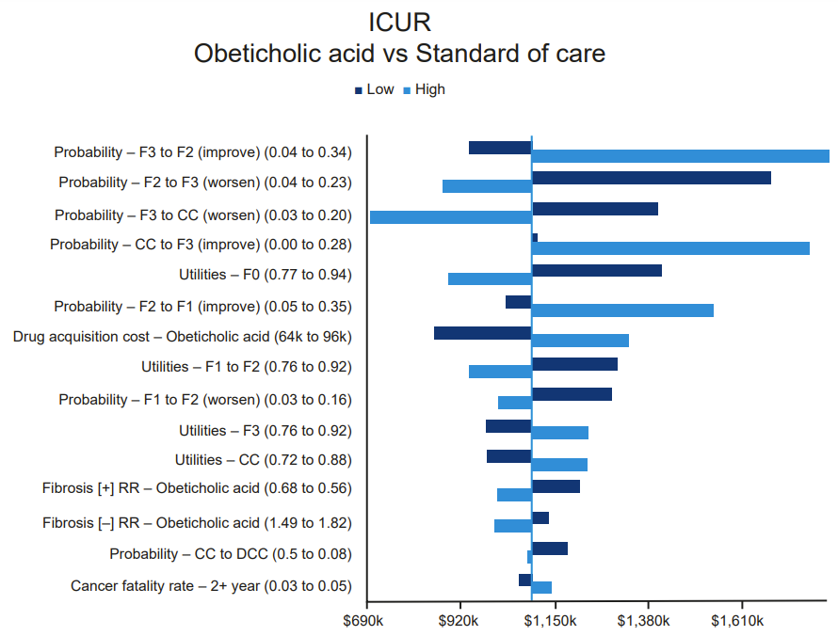
b
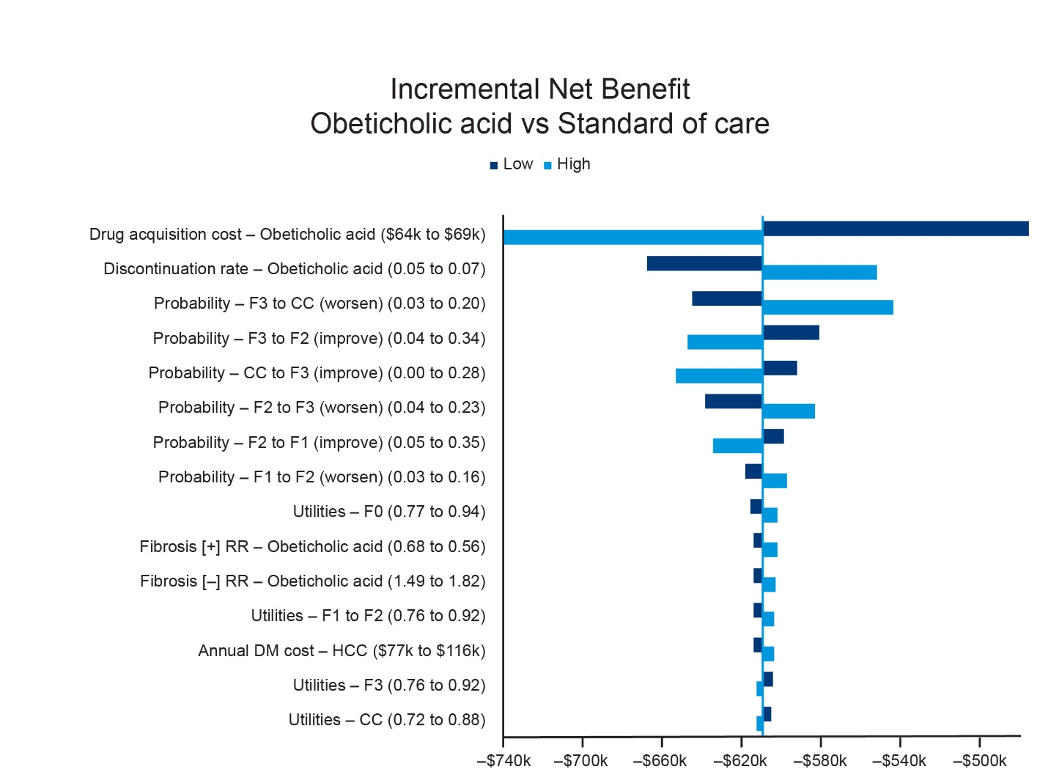

Supplementary Fig. 2 Probabilistic sensitivity analysis (PSA); (a) PSA scatter plot, (b) Cost-effectiveness plane. QALY quality-adjusted life-year
a
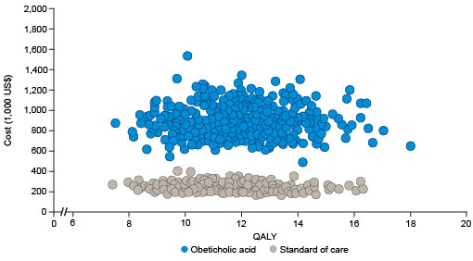
b
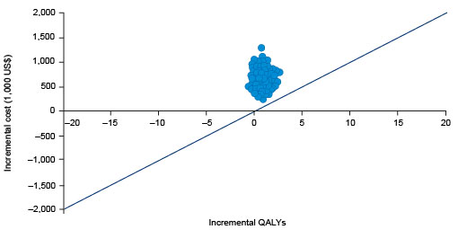
Cost-effectiveness threshold of $100,000/QALY, for obeticholic acid vs standard of care

Supplementary References
1. Rind DM, Hansen R, Guzauskas G, Beinfeld M, Chapman R, Bradt P, Pearson SD. Obeticholic Acid for the Treatment of Nonalcoholic Steatohepatitis with Fibrosis: Effectiveness and Value: Institute for Clinical and Economic Review; 2020.
2. Targher G, Byrne CD, Lonardo A, Zoppini G, Barbui C. Non-alcoholic fatty liver disease and risk of incident cardiovascular disease: A meta-analysis. J Hepatol. 2016 Sep;65(3):589-600.
3. Shao H, Fonseca V, Stoecker C, Liu S, Shi L. Novel Risk Engine for Diabetes Progression and Mortality in USA: Building, Relating, Assessing, and Validating Outcomes (BRAVO). Pharmacoeconomics. 2018 Sep;36(9):1125-34.
4. Hayes AJ, Leal J, Gray AM, Holman RR, Clarke PM. UKPDS outcomes model 2: a new version of a model to simulate lifetime health outcomes of patients with type 2 diabetes mellitus using data from the 30 year United Kingdom Prospective Diabetes Study: UKPDS 82. Diabetologia. 2013 Sep;56(9):1925-33.
5. D'Agostino RB, Sr., Vasan RS, Pencina MJ, Wolf PA, Cobain M, Massaro JM, et al. General cardiovascular risk profile for use in primary care: the Framingham Heart Study. Circulation. 2008 Feb 12;117(6):743-53.
6. Hippisley-Cox J, Coupland C, Brindle P. Development and validation of QRISK3 risk prediction algorithms to estimate future risk of cardiovascular disease: prospective cohort study. BMJ. 2017 May 23;357:j2099.
7. Wilson PW, Meigs JB, Sullivan L, Fox CS, Nathan DM, D'Agostino RB, Sr. Prediction of incident diabetes mellitus in middle-aged adults: the Framingham Offspring Study. Arch Intern Med. 2007 May 28;167(10):1068-74.
8. Hippisley-Cox J, Coupland C. Development and validation of QDiabetes-2018 risk prediction algorithm to estimate future risk of type 2 diabetes: cohort study. BMJ. 2017 Nov 20;359:j5019.
9. Adams KF, Leitzmann MF, Albanes D, Kipnis V, Mouw T, Hollenbeck A, et al. Body mass and colorectal cancer risk in the NIH-AARP cohort. Am J Epidemiol. 2007 Jul 1;166(1):36-45.
10. Ahn J, Schatzkin A, Lacey JV, Jr., Albanes D, Ballard-Barbash R, Adams KF, et al. Adiposity, adult weight change, and postmenopausal breast cancer risk. Arch Intern Med. 2007 Oct 22;167(19):2091-102.
11. Yang TY, Cairns BJ, Allen N, Sweetland S, Reeves GK, Beral V, et al. Postmenopausal endometrial cancer risk and body size in early life and middle age: prospective cohort study. Br J Cancer. 2012 Jun 26;107(1):169-75.
12. Kosiborod M, Gomes MB, Nicolucci A, Pocock S, Rathmann W, Shestakova MV, et al. Vascular complications in patients with type 2 diabetes: prevalence and associated factors in 38 countries (the DISCOVER study program). Cardiovasc Diabetol. 2018 Nov 28;17(1):150.
13. Ara R, Blake L, Gray L, Hernandez M, Crowther M, Dunkley A, et al. What is the clinical effectiveness and cost-effectiveness of using drugs in treating obese patients in primary care? A systematic review. Health Technol Assess. 2012;16(5):iii-xiv, 1-195.
14. Siegel RL, Miller KD, Goding Sauer A, Fedewa SA, Butterly LF, Anderson JC, et al. Colorectal cancer statistics, 2020. CA Cancer J Clin. 2020 May;70(3):145-64.
15. Javanbakht M, Fishman J, Moloney E, Rydqvist P, Ansaripour A. Early Cost-Effectiveness and Price Threshold Analyses of Resmetirom: An Investigational Treatment for Management of Nonalcoholic Steatohepatitis. Pharmacoecon Open. 2023 Jan;7(1):93-110.
16. Townsend N WK, Bhatnagar P, Smolina K, Nichols M, Leal J, Luengo-Fernandez R, Rayner M. Coronary heart disease statistics 2012 edition: British Heart Foundation: London; 2012.
17. National Institute for Health and Care Excellence. Liraglutide for managing overweight and obesity [ID740]. 2020; Available from: https://www.nice.org.uk/guidance/gid-ta10388/documents/committee-papers-2
18. Rustgi VK, Duff SB, Elsaid MI. Cost-effectiveness and potential value of pharmaceutical treatment of nonalcoholic fatty liver disease. J Med Econ. 2022 Jan-Dec;25(1):347-55.
19. Sullivan PW, Ghushchyan V. Preference-Based EQ-5D index scores for chronic conditions in the United States. Med Decis Making. 2006 Jul-Aug;26(4):410-20.
20. Younossi ZM, Koenig AB, Abdelatif D, Fazel Y, Henry L, Wymer M. Global epidemiology of nonalcoholic fatty liver disease-Meta-analytic assessment of prevalence, incidence, and outcomes. Hepatology. 2016 Jul;64(1):73-84.
21. Kazi DS, Moran AE, Coxson PG, Penko J, Ollendorf DA, Pearson SD, et al. Cost-effectiveness of PCSK9 Inhibitor Therapy in Patients With Heterozygous Familial Hypercholesterolemia or Atherosclerotic Cardiovascular Disease. JAMA. 2016 Aug 16;316(7):743-53.
22. Ward A, Alvarez P, Vo L, Martin S. Direct medical costs of complications of diabetes in the United States: estimates for event-year and annual state costs (USD 2012). J Med Econ. 2014 Mar;17(3):176-83.
23. Dall TM, Zhang Y, Chen YJ, Quick WW, Yang WG, Fogli J. The economic burden of diabetes. Health Aff (Millwood). 2010 Feb;29(2):297-303.
24. Mariotto AB, Warren JL, Zeruto C, Coughlan D, Barrett MJ, Zhao L, et al. Cancer-Attributable Medical Costs for Colorectal Cancer Patients by Phases of Care: What Is the Effect of a Prior Cancer History? J Natl Cancer Inst Monogr. 2020 May 1;2020(55):22-30.
25. Sasser AC, Rousculp MD, Birnbaum HG, Oster EF, Lufkin E, Mallet D. Economic burden of osteoporosis, breast cancer, and cardiovascular disease among postmenopausal women in an employed population. Womens Health Issues. 2005 May-Jun;15(3):97-108.
26. Yue X, Pruemer JM, Hincapie AL, Almalki ZS, Guo JJ. Economic burden and treatment patterns of gynecologic cancers in the United States: evidence from the Medical Expenditure Panel Survey 2007-2014. J Gynecol Oncol. 2020 Jul;31(4):e52.
27. Younossi ZM, Ratziu V, Loomba R, Rinella M, Anstee QM, Goodman Z, et al. Obeticholic acid for the treatment of non-alcoholic steatohepatitis: interim analysis from a multicentre, randomised, placebo-controlled phase 3 trial. Lancet. 2019 Dec 14;394(10215):2184-96.

