Supplementary materials:
Modelling health state utilities as a transformation of time to death in patients with NSCLC
Anthony J. Hatswell PhD^{1,2}, Mohammad A. Chaudhary PhD ³, Giles Monnickendam MSc⁴, Alejandro Moreno-Koehler MPH⁵, Katie Frampton MSc⁵, James W. Shaw PhD ³, John R. Penrod PhD ³, Rachael Lawrance BSc⁶
1: Delta Hat, Nottingham, UK ahatswell@deltahat.com
ORCID: 0000-0003-1129-326X
2: Department of Statistical Science, University College London, London, UK
3: Bristol Myers Squibb, Princeton, NJ, USA
4: Ceelos Consulting, London, UK
5: Adelphi Values Ltd, Macclesfield, UK
6: Adelphi Values LLP, Boston, MA, USA

Journal: Pharmacoeconomics

Supplementary Table 1: Model parameters for the fitted time to death models for all patients in pooled CheckMate-017 and CheckMate-057 data using the UK value set
Statistical model | Parameter | All patients*  n = 788, N = 4850
Statistical model | Parameter | Estimate | S.E.
$$TTD$$ | Intercept | 0.6586 | 0.0100
$$TTD$$ | TTD | 0.0001 | 0.0000
$$Log⁡(TTD)$$ | Intercept | 0.3459 | 0.0396
$$Log⁡(TTD)$$ | $$Log⁡(TTD)$$ | 0.0616 | 0.0068
$$1/\sqrt{TTD}$$ | Intercept | 0.7634 | 0.0162
$$1/\sqrt{TTD}$$ | $$1/\sqrt{TTD}$$ | -1.0314 | 0.1971
$$e^{-TTD}$$ | NA | NA | NA
$${TTD}^{2}$$ | NA | NA | NA
$${TTD}^{2}+TTD$$ | NA | NA | NA
Time to death grouping | Intercept | 0.4331 | 0.0383
Time to death grouping | >52 weeks | 0.3244 | 0.0397
Time to death grouping | 27–52 weeks | 0.2720 | 0.0392
Time to death grouping | 5–26 weeks | 0.1881 | 0.0385
Time to death grouping | ≤4 weeks | 0.0000 | 0.0000
Progression based utilities | Intercept | 0.6171 | 0.0128
Progression based utilities | Pre-progression | 0.0744 | 0.0108
Progression based utilities | Post-progression | 0.0000 | 0.0000
TTD = Time To Death (Days); NA = not applicable (model did not converge)
*date of last known alive used as date of death for continuous TTD models

Supplementary Figure 1: Reproduction of Figure 1 showing only the final 12 months of life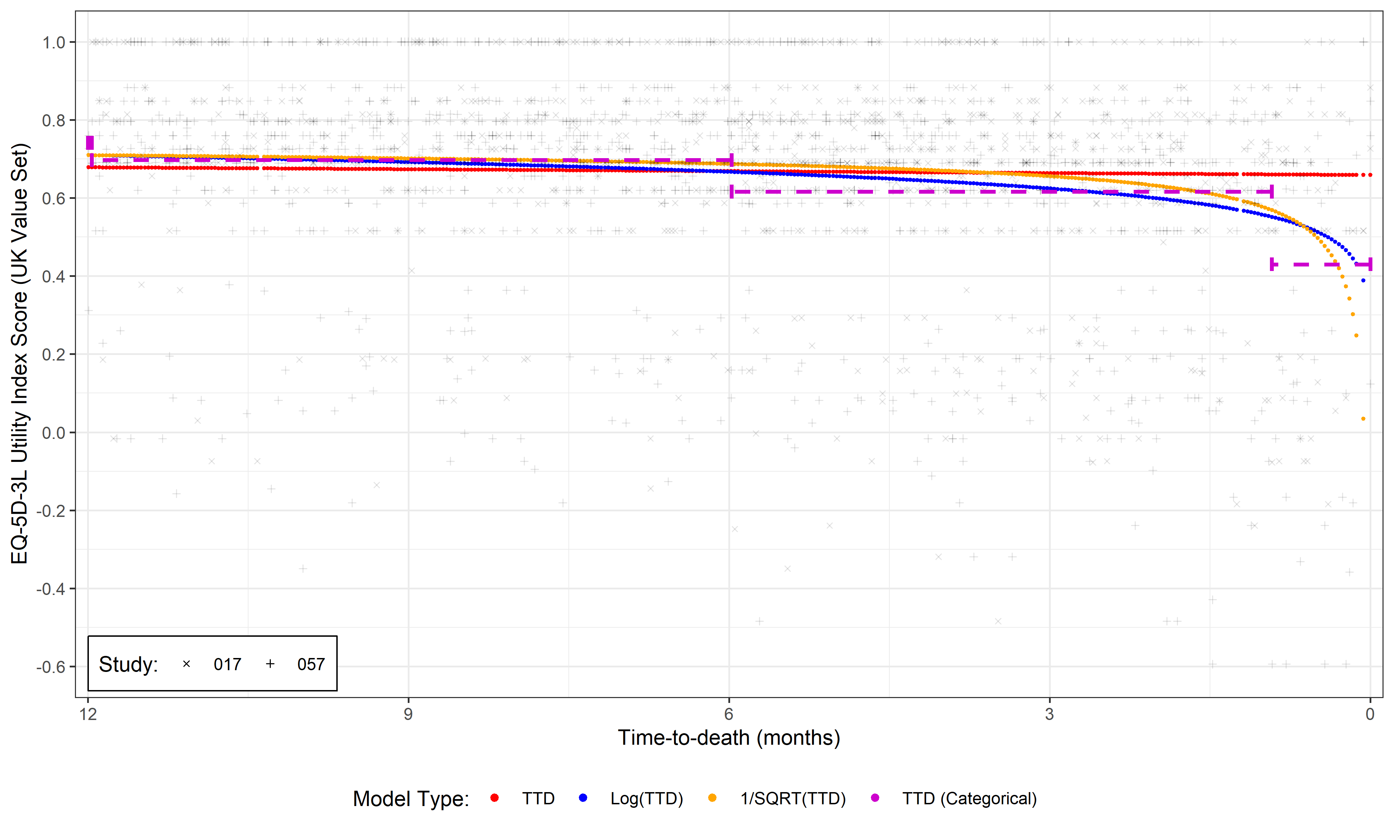
Supplementary Figure 2: Confirmatory analysis of EQ-5D-3L utility (UK value set) versus time to death by disease type
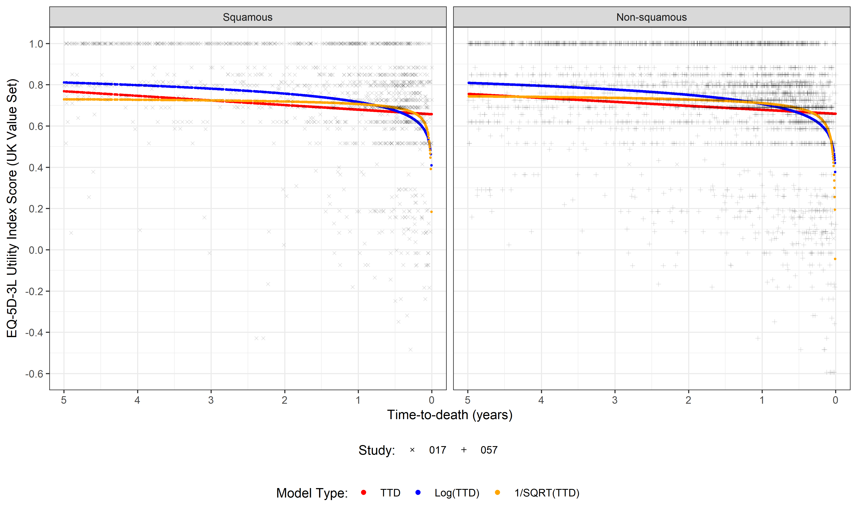
Supplementary Figure 3: Confirmatory analysis of EQ-5D-3L utility (UK value set) versus time to death by treatment arm
