Supplementary material: A reporting checklist for discrete choice experiments in health: the DIRECT checklist
Authors: Jemimah Ride, Ilias Goranitis, Yan Meng, Christine LaBond, Emily Lancsar
Corresponding author:
jemimah.ride@monash.edu
Monash University Health Economics Group, School of Public Health and Preventive Medicine, Monash University, Australia

Detailed elaboration of each item in the checklist with examples for each

Item 1. Describe the real-world context and decision maker that the hypothetical choice context seeks to replicate or inform
Describe the real-world choice at the heart of the research question, so that the reader can identify how well the DCE replicates this in the hypothetical context described in the survey, and whether appropriate respondents have been selected to represent the relevant decision maker.
Example: “The COVID-19 pandemic has brought questions of resource allocation into particular focus, as demand (or potential demand) for certain kinds of healthcare and health expenditure has increased significantly in a short period of time. One example of this is availability of ventilators in those regions most severely affected by COVID-19, particularly in the intensive care unit (ICU) context. As cases increase in a region, demand can spike beyond what is available, leading to difficult decisions being made around allocation of such resources, often with very real consequences.
…this paper explores how the general public would choose to allocate ventilators in ICUs if faced with such a decision, and whether they want a say in this process, or prefer for such decisions to be made by other parties (i.e. senior clinicians or health department officials).” [1]
Item 2. Provide a rationale for using a DCE to answer the research question
Explain why a DCE was a suitable approach to answer the research question, showing how the evidence produced by a DCE can be of use to decision makers [2]. This may include why quantifying preferences is useful and/or why a DCE is preferred over other methods.
Example: “This paper uses stated preference data from a discrete choice experiment (DCE) to evaluate consumers’ and providers’ preferences for attributes of alternative cervical screening tests, proposed changes to policy recommendations and potential new technologies. Stated preference data are useful when market (revealed preference) data are not available, or have limited variability. Both situations frequently arise for health programs, because of innovation or policy changes. Further, to predict demand for screening in different policy settings accurately, it is most valid to model both consumers’ and providers’ preferences. Revealed preference data provide information about the ultimate choice, but not about the consumer–provider context leading to this choice. A choice experiment provides the capacity to investigate these relationships.” [3]
Item 3. Describe how attributes and levels were derived (e.g. literature review, interviews, focus groups, expert input)
Not all DCEs need to include all of these steps in developing attributes and levels, but sufficient detail should be provided on the approach taken to attribute development for the reader to assess the validity of the methods. As noted in reviews of DCEs, this stage is often under-reported [4], leaving the reader uncertain as to why attributes were included or excluded, and whether this leaves the study open to concerns over bias. A footnote to the checklist points the reader to existing reporting guidelines on qualitative methods used to develop attributes [5], which this checklist did not seek to replicate. Where the development of attributes involved a systematic review or in-depth qualitative research, this may be published in a separate paper from the main DCE, in which case the reader should be pointed to that other paper for detail. Sources of data to inform the levels and their range is useful as it provides assurance that the levels are feasible and meaningful to respondents. It may be that attributes and levels have been selected to reflect clinical trial endpoints or to inform evaluation or design of a particular intervention, which is also useful information for the reader in interpreting the results.
Example: While the full description of development of attributes and levels can be lengthy (sometimes being published separately from the main DCE paper), Supplementary Figure 1 shows a summary of the approaches used to develop attributes and levels in the first stages of the study by Lancsar, Gu [6].
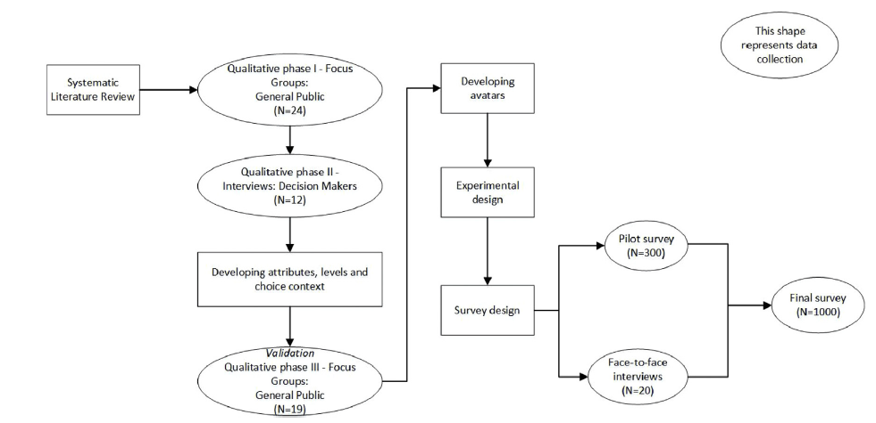
Supplementary Figure 1. Summary of methods used to develop attributes and levels from Lancsar, Gu [6]

Item 4. Provide the final list of attributes and levels
While the list of attributes and levels can be included in an appendix, such as in the survey text, Delphi study participants noted the importance of including this in the main paper wherever possible, as it is of fundamental importance for a reviewer or reader to understand the DCE. The reader should be shown the wording of each attribute as used in the DCE survey, however this level of detail could be included in the appendix.
Example: As shown in Supplementary Figure 2, a table of the attributes and levels in the experiment can convey several pieces of useful information for the reader, including any alternative-specific attributes or alternative-specific attribute levels and the wording of each attribute and level.
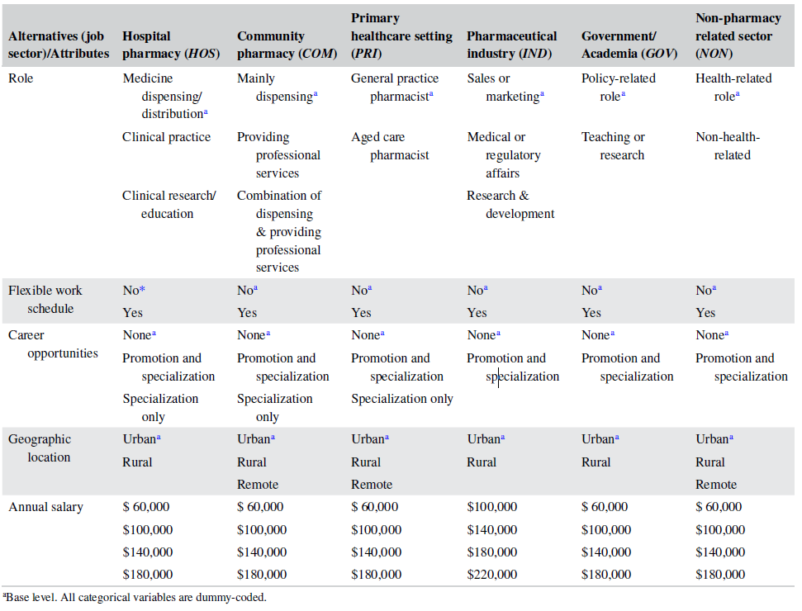
Supplementary Figure 2. Example of a table of attributes and levels from Thai, Bliemer [7]

Item 5. Report the number of alternatives per choice set and whether they were labelled or unlabelled
This item may be achieved by the inclusion of an exemplar choice set in the paper (such as a figure) that shows how many alternatives each choice set contains and their titles, and/or by describing the alternatives in words.
Example: As shown in Supplementary Figure 3, a well-labelled figure in the paper showing an exemplar choice set can demonstrate the number and type of alternatives and their titles.
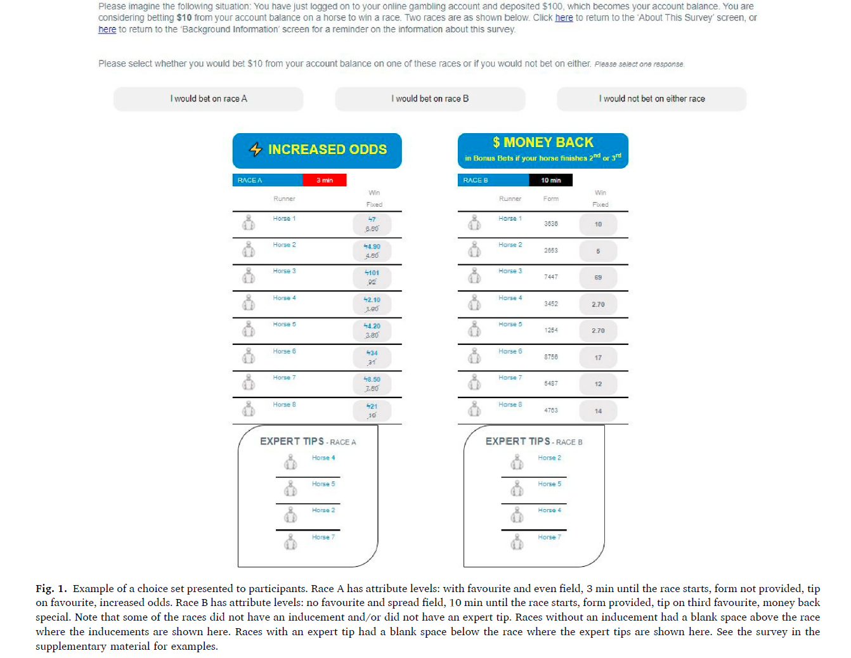
Supplementary Figure 3. Example of a choice set shown in Cameron and Ride [8]

Item 6. Describe response options (e.g. forced choice, opt-out, status quo)
It is important to convey clearly whether or not there is an opt-out/status quo option and, if so, how it was described to participants. An exemplar choice set could achieve this, provided that it shows the section where respondents make their choice (such as tick boxes with an indicative question e.g. ‘Which of these would you choose?’) and that it shows all alternatives.
Example: As shown in Supplementary Figure 3, an exemplar choice set shown in the paper can demonstrate the response options and the nature of any opt-out option as shown to participants.

Item 7. Describe the type of experimental design (e.g. orthogonal, D-efficient, Bayesian efficient, partial profile)
This item requires reporting of the approach used to develop the combinations of attributes levels that are presented to participants as choice sets. There are a number of approaches to this stage of a DCE, which can vary in the assumptions that they make and the limitations they impose [9]. Authors should make clear how they selected or developed the experimental design and nature of its assumptions and constraints.
Example: “We used a Bayesian D-efficient and explicit partial profile design developed with Ngene (ChoiceMetrics [2018] Ngene 1.2 User Manual & Reference Guide, Australia). The experimental design included 72 choice tasks split across six blocks based on the minimum correlation principle, with each participant required to complete 12 choice tasks. Choice tasks were drawn from a candidate set of all relevant attribute combinations using the modified Federov algorithm. Restrictions were applied to the algorithm to ensure fair representation of all attribute levels without imposing attribute level balance. Bayesian priors accommodate the uncertainty associated with parameter values using distributions that ensure minimal loss of statistical efficiency in the design in cases of prior parameter misspecification. Bayesian priors for the pilot survey were informed by published evidence, where available, and the expectations of the research team. Explicit partial profiles with three overlapping attributes were chosen to reduce task complexity and avoid dominancy issues. Different overlapping attributes or levels were used across choice tasks.” [10]
Item 8. Describe which effects are identified in the design (e.g. main effects, higher order interactions, functional form)
Note that this is not prescriptive in terms of the inclusion of specific effects in the design, nor that the design has to exactly match what is estimated in the model. Rather, this reporting will enable the reader to make a judgement about the validity of the model estimated from the choice data, in combination with the items on model specification and sample size. The goal of this item is that the reader can understand which types of effects are specified in the design as distinct from the model that is estimated. It is not necessary to include the utility function specified in the design. This item could be reported in combination with the model specification.
Example: “The resulting design was orthogonal and allowed for the estimation of all main effects and an interaction between the bleed risk and antidote.” [11]
Item 9. Describe the number of choice sets, number of blocks, number of choice sets per block
Report the overall size of the design (the number of choice sets), whether these were blocked into subsets (such as to reduce burden on participants) [9], how subsets were allocated to participants, and how many choice sets each participant completed.
Example: “Ngene software (v1.1.1) was used to generate a fractional factorial design that reduced the statistically required number of profiles down to 32, blocked into two versions of 16 choice sets. Participants were randomly assigned to answer one block of 16 choice-sets.” [11]
Item 10. Indicate how the experimental design was obtained (software, catalogue, other)
Specify the source of the design such as the program used to generate it, or a library of existing designs. There are a range of options available to generate or obtain existing experimental designs, including several software packages [9].
Example: “Applying the methods introduced by Huber and Zwerina, DCE macros for SAS (version 9.2) were used to select combinations for an orthogonal main effect design, and the selected profiles were organized into the most D-efficient choice designs, given the design parameters.” [12]
Item 11. Provide a sample choice set and the instructions and background information given to respondents (such as by providing the survey as an appendix)
Providing a sample choice set is a way of conveying multiple pieces of relevant information to the reader, including the number, labels, and wording of the alternatives, and the response options. Inclusion of the survey text (usually in an appendix) allows the interested reader to see the detail of how the information provided to respondents was framed and to make assessments of whether the background information was sufficient or likely to introduce any unintended biases.
Example: Supplementary Figure 3 shows an exemplar choice set as provided in Cameron and Ride [8]
Item 12. Report any randomisation (e.g. choice task order, attribute order, alternative order, framing effects)
It is not necessary that all DCEs involve randomisation in the presentation of the survey to respondents. However, it is important to be clear whether or not randomisation was used, as this can be assessed by the reader in terms of the potential to overcome issues such as left-right bias or ordering effects, and any impact on participant burden. Reporting of randomisation should include whether it was within or between individual respondents. Some DCEs test the effects of different framings (e.g. the wording of the choice scenario) and, if so, this may also include randomisation within or between individuals.
Example: “Initially, a randomization of participants to one of the six blocks was applied. Further randomization was applied (1) in the order of choice tasks within blocks, (2) in the order of the two GS situations to control for a left-to-right bias, and (3) to a survey version with or without pictogram for the attribute “number of children who receive a genetic diagnosis” to control for potential framing effect.” [10]
Item 13. Describe what was checked in piloting (e.g. understanding, respondent burden, timing, wording)
The term ‘piloting’ can be used differently, with some distinguishing pretesting from piloting and soft launch [e.g. 13]. A range of methods can be used, including different types of qualitative approach and quantitative analysis of DCE data collected from a small sample. Piloting is often under-reported, leaving readers unaware of key decisions and iterative processes that led to the final version of the survey that was used in the DCE [14].
Example: “As they completed the survey, respondents were encouraged to “think aloud,” and asked to describe their understanding of the product attributes and levels, as well as their understanding of the survey and DCE instructions. All pilot interviews were recorded on Zoom, with both audio and video of the screen sharing. After each respondent completed the pilot test, the researcher who conducted the pilot test (ATB) completed a qualitative assessment of the performance and comprehension of the respondent. This included a rating of whether and the extent to which the respondent required prompting to describe the choices in the DCE. Full details of this evaluation are included in the Appendix in the Electronic Supplementary Material (ESM).” [15]
Item 14. Report whether information from the pilot was used to update the experimental design (e.g. priors, functional form of attributes) or survey design
If information from pretesting or piloting is used to inform amendments to the survey or experimental design of the DCE, this should be reported so that the reader understands how the piloting influenced the final version.
Example: “The required prior preference information were obtained from previous EQ‐5D research and updated after a pilot run of 200 respondents per sample to maximize further improve statistical efficiency.” [16]
Item 15. Report inclusion/exclusion criteria
Provide the inclusion/exclusion criteria used to determine eligibility for the study (including any screening questions used) to allow the reader to assess how well the sample were selected to be good proxies and provide relevant preference information.
Example: “Respondents’ inclusion criteria were as follows: (1) Chinese ethnicity; (2) age 60 or above; (3) suffering from one or more chronic diseases which must have been formally diagnosed according to the medical record; (4) voluntary to participate in this survey. Exclusion criteria included the adults with cognitive impairment, mental diseases, and currently suffering from aphasia, deafness or other communication disorders that influenced the completion of investigations.” [17]
Item 16. Describe how data were collected (e.g. mail, personal interview, web survey)
This allows the reader to understand how the process of data collection may introduce potential biases or framing effects, such as via interaction with the interviewer or being conducted in a particular environment. Reporting of web-based surveys may be informed by the reporting checklist in Menegaki, Olsen [18].
Example: “Surveys with clinic participants were fielded on iPads; online participants accessed surveys via a web browser.” [19]
Item 17. Report the response rate, if known
The response rate may be a difficult piece of data to provide regarding a DCE, depending on the recruitment method [20]. It may not be possible to know how many people saw the invitation in total, such as advertising on a website or social media or via a third-party survey company. However, it may still be informative to provide what is known about the number of completed responses compared with the number of people who clicked a link, responded to an invite, opened the survey, declined to consent, and/or dropped out part way.
Example: “In total, 43,000 individuals were invited by email to take part in the survey, of whom 5308 clicked on the link to access the survey (response rate = 12.3%). Of the individuals who accessed the survey, 4008 completed the survey in full (completion rate = 75.5%). The remainder either did not give consent to take part, or began the survey but dropped out without completing all of the questions. Respondents who spent less than 3 min on the questions (n = 39) were excluded from the final data set, leaving 3969 respondents (39,690 pairwise observations).” [21]
Item 18. Report the final sample size and how the sample size was determined
This does not require reporting of formal sample size calculations but asks for information on how the sample size was reached to allow the reader to interpret the sample size. There are different approaches to determining the target sample size for DCEs [22]. It can be useful to describe how the sample size relates to the size of the target population (for example, if the entire target population is a small group of national decision makers versus all taxpayers in the country).
Example: “The DCE questionnaire was administered to sixty-six respondents during November 2007 through March 2008. All respondents were familiar with economic evaluation studies; all were given oral and written questionnaire instructions. Approximately 40 percent were policy makers, deciding or advising on health insurance packages, pharmaceutical reimbursement, or general matters concerning allocation of healthcare funds and governance of health care (Table 2). Because the group of people directly involved in the decision making process is small in practice, 60 percent of our sample consisted of other people having relevant knowledge of the decision-making process. One-third comprised master students in health economics who had finished a course in HTA studies. Approximately one-fifth of the respondents was engaged in performing HTA studies (see Table 3).” [23]
Item 19. Describe respondent characteristics and representativeness of target population, if known
Transparency regarding the characteristics of the respondents allows the reader to make some judgements about how well this sample represents the target population. Providing information on how characteristics compare to the target population may assist with this. However, characteristics relevant to the research question, such as attitudes or experiences, or factors indicating selection bias may not be known for the target population, making such comparison sometimes limited in usefulness. One Delphi study participant commented: “While I agree that it is key to be transparent about the sample characteristics, judgments about representativeness are potentially misleading. As we all know, preferences don't necessarily follow from biology. Thus, matching the epidemiology of a population doesn't necessarily imply representativeness in preferences.”
Example: “The sample was drawn from GB Kantar Fast Moving Consumer Goods (FMCG) panel of households. Annual panel size is approximately 32,000 households, and the panel is nationally representative with respect to geographical region, age of the main shopper, household size and occupational socio-economic status. … The panellists provide records on their day-to-day purchases of consumer goods, including foods and beverages for consumption at home (we refer to these data later as home-scan). Kantar regularly conducts market research surveys among this panel for their own research and when commissioned by clients. The sample for the DCE was restricted to households who had purchased at least 2 L of SSBs every month in 6 months preceding the survey (based on home-scan purchases) and who had at least one child under the age of 18. These criteria were set, first because, nationally, the policy direction in the UK is focused on preventing childhood obesity and therefore we considered households with children as a key population subgroup. Second, we wanted to capture in the sample households that were regular purchasers, regardless of being heavy consumers or not (again as key target to the policy), and the criteria of having purchased at least 2 L of SSBs monthly allowed us to exclude households who never purchase SSBs or do so irregularly. Participants meeting these two criteria were then randomly selected for invitation into the DCE. Although not necessarily representative of the whole population, this sample informs preferences of the population generally targeted by these policies.” [24]
Item 20. Indicate coding of data (effects/dummy/continuous) including definitions
Make it clear how variables in the model are defined so that the reader can interpret the coefficients correctly, such as when cut points or thresholds are used or variables are mean centred, and indicate the type of coding for categorical variables [25]. This information may be reported as a footnote or footnotes to a table of results, as in the example below.
Example: “In the estimation, stroke risk and bleed risk were modelled as decreasing continuous absolute risks; (more efficacious and safer medications are associated with lower risks); cost and income are modelled as continuous and increasing variables; other attributes are dummy coded.” [11]
Item 21. Report whether any respondents were removed and why (e.g. suspected fraudulent responses, rationality tests)
After data collection, in some DCEs respondents are removed from the dataset due to concerns about validity. Where participants receive financial incentives to participate, and particularly when the survey is advertised and collected online, there can be fraudulent responses either by humans or ‘bots’ [26]. There may also be concerns that respondents are insufficiently engaged and/or lack sufficient comprehension of the DCE, leading them to complete the survey in a meaningless way. A range of strategies may be used to investigate these possibilities, such as repeating demographic questions in different formats, hidden questions that are not visible to human respondents, dominance tests, analysis for straight lining, and examining how long it takes to complete the survey [27, 28]. This item does not suggest that all DCEs require these tests, nor does it state a position on the appropriateness of removing participants [27], but where they have been conducted and used to drop suspicious responses this should be reported.
Example: “Nineteen participants (4%) made the same choice (i.e., screening option A or B) for all 8 choice sets. As this is a relatively small number and the possibility exists that these responses could be logical preferences, they were not excluded from the analyses. To check the impact of ‘‘speeders’’ a sensitivity analysis was conducted by excluding 24% (n = 121) of participants who completed the survey in under the minimum completion time of 8 min (see S4). Excluding these responses had no significant impact on the strength or direction of preference weights, so all participants (N = 502) were included in the final analyses.” [29]
Item 22. Provide the rationale for model choice (e.g. conditional logit, mixed logit, latent class) and assumptions (e.g. error variance)
Report the reasons behind the selection of the type of model/s used for analysis and make clear any important assumptions inherent in the model type [30, 31]
Example: “A mixed logit model which accounts for preference (taste) heterogeneity was adopted to estimate the above equation where ASC_None is an alternative specific constant for choosing not to vaccinate (i.e. opt-out). Conditional on β, it is assumed ɛ is independent and identically distributed (IID) with Gumbel distribution. The utility associated with opt-out was normalised to zero. For the effect coded variables, the coefficients and standard errors of the base level were calculated following the approach recommended in the DCE handbook by Ryan et al. To allow for preference heterogeneity, the β is expressed as having both a mean (which represents the average preferences of the population) and a standard deviation (which captures the individual's specific preference components). In this study, it was assumed all coefficients of attribute levels were random with normal distribution and were independent.” [32]
Item 23. Report model specification
Report whether the main model in the analysis includes attribute main effects, interactions between attributes, the functional form of attributes, the inclusion of one or more alternative-specific constant/s, and any interactions between attributes and participant characteristics. For example, whether cost enters the model as a continuous linear variable, whether its quadratic term is also included, or whether it is coded as a series of categorical variables. It is not always necessary or appropriate to include the model equation in the paper, depending on the audience.
Example: “The attributes of start age, end age, intervals, and risk of overdiagnosis showed a nonlinear distribution and were modeled as categorical variables. By contrast, risk of dying from breast cancer was analyzed as a continuous variable. As the outcomes of the mixed logit models (S4) revealed no random effects (likelihood ratio tests P > 0.05), a fixed-effect conditional logit regression model was conducted to analyze the preference data, whereby the outcome variable was screening preference (options A or B, or no screening). The ‘‘no screening’’ option was included as the alternative specific constant term to reflect the average effect of the unobserved screening attributes on choosing not to participate in screening relative to the 2 screening alternatives.” [29]
Item 24. Report the model performance, goodness of fit if comparing models
When multiple model specifications are presented in the paper, authors may report measures such as log-likelihood, pseudo R-squared, likelihood ratio tests, Akaike information criteria (AIC), and/or Bayesian information criteria (BIC) to assist the reader in interpreting the choice of preferred model. However, these measures may not be the primary driver of model choice. [25] Goodness of fit measures may be reported within a table of model estimates.
Example: “For 3 of the 4 case studies, model fit measures (Table 2, Table 3, Table 4), including log likelihood–ratio test (P < .01), show clear support for the CSF model over both the single-stage utility model and the screening model (a reduced form of the CSF model). Only for the genetic testing for CRC the log likelihood–ratio test shows that model fit of CSF model is significantly (P < .01) improved compared with the utility only model, whereas the Bayesian information criterion indicates the opposite. Thus, taking account of model parsimony via the Bayesian information criterion measure, the case for CSF versus trade-off among all alternatives is less strong in this data set.” [33]
Item 25. Describe methods used for analysis of model results (e.g. calculation of marginal rate of substitution, attribute relative importance, welfare gain)
Apart from reporting model coefficients, DCE papers often report further analysis such as marginal rate of substitution, relative importance of the attributes, or welfare gain [25, 34]. The methods used to generate these outputs should be reported.
Example: “We also evaluate the welfare improvements resulting from changes to the design of home care services. In particular, we estimate the compensating variation or welfare impact of a move from the status quo (Z⁰) to an alternative home care service provision (Z¹). This can be derived using a variant of the standard compensating variation log-sum formula (Hanemann, 1984), such that [equation 6] With a WTP space model, the welfare measure must be integrated over the WTP distribution in the population, such that [equation 7]. This integral is also approximated by simulation from draws of the estimated distributions in our chosen model (Hynes et al., 2008; Norton and Hynes, 2014; Zhang and Sohngen, 2018). Applying Equation (7) therefore allows us to calculate the welfare impact of a change in the home care service attributes from the status quo scenario to various possible future scenarios.” [35]
Item 26. Report measures of precision for the output(s) of interest (e.g. confidence intervals) and how these were derived
Provide an estimate of the uncertainty or precision of outputs generated from the choice model (such as those outlined in Item 25), rather than only reporting the point estimate. There are different approaches to estimate measures of precision for the key outputs in a DCE [36], and the paper should report the approach taken.
Example: “To investigate the relative impact of each attribute on the utility respondents derived from the alternatives, we calculated WTP estimates on the basis of marginal rates of substitution between the “cost” attribute and all other attributes. Confidence intervals for WTP values were derived by using the Delta method.” [37]

References
1. Norman R, Robinson S, Dickinson H, Williams I, Meshcheriakova E, Manipis K, et al. Public Preferences for Allocating Ventilators in an Intensive Care Unit: A Discrete Choice Experiment. The Patient - Patient-Centered Outcomes Research. 2021 2021/05/01;14(3):319-30.
2. Bridges JF, de Bekker-Grob EW, Hauber B, Heidenreich S, Janssen E, Bast A, et al. A roadmap for increasing the usefulness and impact of patient-preference studies in decision making in health: A good practices report of an ISPOR task force. Value in Health. 2023;26(2):153-62.
3. Fiebig DG, Haas M, Hossain I, Street DJ, Viney R. Decisions about Pap tests: What influences women and providers? Social Science & Medicine. 2009 2009/05/01/;68(10):1766-74.
4. Coast J, Al-Janabi H, Sutton EJ, Horrocks SA, Vosper AJ, Swancutt DR, et al. Using qualitative methods for attribute development for discrete choice experiments: issues and recommendations. Health Economics. 2012;21(6):730-41.
5. Hollin IL, Craig BM, Coast J, Beusterien K, Vass C, DiSantostefano R, et al. Reporting Formative Qualitative Research to Support the Development of Quantitative Preference Study Protocols and Corresponding Survey Instruments: Guidelines for Authors and Reviewers. The Patient - Patient-Centered Outcomes Research. 2020 2020/02/01;13(1):121-36.
6. Lancsar E, Gu Y, Gyrd-Hansen D, Butler J, Ratcliffe J, Bulfone L, et al. The relative value of different QALY types. Journal of Health Economics. 2020:102303.
7. Thai T, Bliemer M, Chen G, Spinks J, de New S, Lancsar E. Comparison of a full and partial choice set design in a labeled discrete choice experiment. Health Economics. 2023.
8. Cameron L, Ride J. The role of mental health in online gambling decisions: A discrete choice experiment. Social Science & Medicine. 2023 2023/06/01/;326:115885.
9. Reed Johnson F, Lancsar E, Marshall D, Kilambi V, Mühlbacher A, Regier DA, et al. Constructing Experimental Designs for Discrete-Choice Experiments: Report of the ISPOR Conjoint Analysis Experimental Design Good Research Practices Task Force. Value in Health. 2013 2013/01/01/;16(1):3-13.
10. Goranitis I, Best S, Stark Z, Boughtwood T, Christodoulou J. The value of genomic sequencing in complex pediatric neurological disorders: a discrete choice experiment. Genetics in Medicine. 2021;23(1):155-62.
11. Ghijben P, Lancsar E, Zavarsek S. Preferences for oral anticoagulants in atrial fibrillation: a best–best discrete choice experiment. Pharmacoeconomics. 2014;32(11):1115-27.
12. Lee H-J, Bae E-Y. Eliciting preferences for medical devices in South Korea: A discrete choice experiment. Health Policy. 2017 2017/03/01/;121(3):243-9.
13. Campoamor NB, Guerrini CJ, Brooks WB, Bridges JFP, Crossnohere NL. Pretesting Discrete-Choice Experiments: A Guide for Researchers. Patient. 2024 Mar;17(2):109-20.
14. Soekhai V, de Bekker-Grob EW, Ellis AR, Vass CM. Discrete Choice Experiments in Health Economics: Past, Present and Future. Pharmacoeconomics. 2019 2019/02/01;37(2):201-26.
15. Barthold D, Brah AT, Graham SM, Simoni JM, Hauber B. Improvements to Survey Design from Pilot Testing a Discrete-Choice Experiment of the Preferences of Persons Living with HIV for Long-Acting Antiretroviral Therapies. The Patient - Patient-Centered Outcomes Research. 2022 2022/09/01;15(5):513-20.
16. Jonker MF, Donkers B, de Bekker-Grob E, Stolk EA. Attribute level overlap (and color coding) can reduce task complexity, improve choice consistency, and decrease the dropout rate in discrete choice experiments. Health Economics. 2019;28(3):350-63.
17. Peng Y, Jiang M, Shen X, Li X, Jia E, Xiong J. Preferences for Primary Healthcare Services Among Older Adults with Chronic Disease: A Discrete Choice Experiment. Patient preference and adherence. 2020;14:1625-37.
18. Menegaki AN, Olsen SB, Tsagarakis KP. Towards a common standard – A reporting checklist for web-based stated preference valuation surveys and a critique for mode surveys. Journal of Choice Modelling. 2016 2016/03/01/;18:18-50.
19. Ostermann J, Mühlbacher A, Brown DS, Regier DA, Hobbie A, Weinhold A, et al. Heterogeneous Patient Preferences for Modern Antiretroviral Therapy: Results of a Discrete Choice Experiment. Value in Health. 2020 2020/07/01/;23(7):851-61.
20. Watson V, Becker F, de Bekker-Grob E. Discrete Choice Experiment Response Rates: A Meta-analysis. Health Economics. 2017;26(6):810-7.
21. Shah KK, Tsuchiya A, Wailoo AJ. Valuing health at the end of life: A stated preference discrete choice experiment. Social Science & Medicine. 2015 2015/01/01/;124:48-56.
22. de Bekker-Grob EW, Donkers B, Jonker MF, Stolk EA. Sample Size Requirements for Discrete-Choice Experiments in Healthcare: a Practical Guide. The Patient - Patient-Centered Outcomes Research. 2015 October 01;8(5):373-84.
23. Koopmanschap MA, Stolk EA, Koolman X. Dear policy maker: have you made up your mind? A discrete choice experiment among policy makers and other health professionals. Int J Technol Assess Health Care. 2010;26(2):198-204.
24. Cornelsen L, Quaife M, Lagarde M, Smith RD. Framing and signalling effects of taxes on sugary drinks: A discrete choice experiment among households in Great Britain. Health Economics. 2020;n/a(n/a).
25. Lancsar E, Louviere J. Conducting Discrete Choice Experiments to Inform Healthcare Decision Making. Pharmacoeconomics. 2008 2008/08/01;26(8):661-77.
26. Gonzalez JM, Grover K, Leblanc TW, Reeve BB. Did a bot eat your homework? An assessment of the potential impact of bad actors in online administration of preference surveys. PLoS One. 2023;18(10):e0287766.
27. Lancsar E, Louviere J. Deleting ‘irrational’ responses from discrete choice experiments: a case of investigating or imposing preferences? Health Economics. 2006;15(8):797-811.
28. Pearce A, Harrison M, Watson V, Street DJ, Howard K, Bansback N, et al. Respondent Understanding in Discrete Choice Experiments: A Scoping Review. The Patient - Patient-Centered Outcomes Research. 2021 2021/01/01;14(1):17-53.
29. Kelley Jones C, Scott S, Pashayan N, Morris S, Okan Y, Waller J. Risk-Adapted Breast Screening for Women at Low Predicted Risk of Breast Cancer: An Online Discrete Choice Experiment. Medical Decision Making. 2024;44(5):586-600.
30. Hauber AB, González JM, Groothuis-Oudshoorn CG, Prior T, Marshall DA, Cunningham C, et al. Statistical methods for the analysis of discrete choice experiments: a report of the ISPOR conjoint analysis good research practices task force. Value in health. 2016;19(4):300-15.
31. Lancsar E, Fiebig DG, Hole AR. Discrete Choice Experiments: A Guide to Model Specification, Estimation and Software. Pharmacoeconomics. 2017 2017/07/01;35(7):697-716.
32. Marshall HS, Chen G, Clarke M, Ratcliffe J. Adolescent, parent and societal preferences and willingness to pay for meningococcal B vaccine: A Discrete Choice Experiment. Vaccine. 2016 2016/01/27/;34(5):671-7.
33. Veldwijk J, Swait JD. The Role of Attribute Screening and Choice Set Formation in Health Discrete Choice Experiments: Modeling the Impact of Benefit and Risk Attributes. Value in Health. 2022 2022/08/01/;25(8):1416-27.
34. Lancsar E, Louviere J, Flynn T. Several methods to investigate relative attribute impact in stated preference experiments. Social Science & Medicine. 2007 2007/04/01/;64(8):1738-53.
35. Walsh S, O'Shea E, Pierse T, Kennelly B, Keogh F, Doherty E. Public preferences for home care services for people with dementia: A discrete choice experiment on personhood. Social Science & Medicine. 2020 2020/01/01/;245:112675.
36. Hole AR. A comparison of approaches to estimating confidence intervals for willingness to pay measures. Health economics. 2007;16(8):827-40.
37. Alayli-Goebbels AFG, Dellaert BGC, Knox SA, Ament AJHA, Lakerveld J, Bot SDM, et al. Consumer Preferences for Health and Nonhealth Outcomes of Health Promotion: Results from a Discrete Choice Experiment. Value in Health. 2013 2013/01/01/;16(1):114-23.

