Electronic supplementary file for the manuscript title: Costs of care in relation Alzheimer’s disease severity in Sweden: a national registry-based cohort study
Authors and affiliations:
Sandar Aye¹, Oskar Frisell^{1,2}, Henrik Zetterberg^{3,4,5,6,7,8}, Tobias Borgh Skillbäck^{9,10}, Silke Kern^{9,10}, Maria Eriksdotter^{11,12}, Emil Aho¹, Xin Xia¹, Bengt Winblad^{1,12}, Anders Wimo¹, Linus Jönsson¹
¹ Division of Neurogeriatrics, Department of Neurobiology, Care Sciences and Society, Karolinska Institutet, BioClinicum, Akademiska stråket 171 64 Solna, Sweden
² The Swedish Institute of Health Economics (IHE), Stockholm, Sweden
³Department of Psychiatry and Neurochemistry, Institute of Neuroscience and Physiology, the Sahlgrenska Academy at the University of Gothenburg, Mölndal, Sweden
⁴Clinical Neurochemistry Laboratory, Sahlgrenska University Hospital, Mölndal, Sweden
⁵Department of Neurodegenerative Disease, UCL Institute of Neurology, Queen Square, London, UK
⁶UK Dementia Research Institute at UCL, London, UK
⁷Hong Kong Center for Neurodegenerative Diseases, Clear Water Bay, Hong Kong, China
⁸Wisconsin Alzheimer’s Disease Research Center, University of Wisconsin School of Medicine and Public Health, University of Wisconsin-Madison, Madison, WI, USA
⁹Neuropsychiatric Epidemiology Unit, Department of Psychiatry and neurochemistry, Sahlgrenska Academy, University of Gothenburg, Gothenburg Sweden
¹⁰ Region Västra Götaland, Sahlgrenska University Hospital, Department of Neuropsychiatry, Sweden
¹¹Division of Clinical Geriatrics, Department of Neurobiology, Care Sciences and Society, Karolinska Institutet, 171 77 Stockholm, Sweden
¹² Theme Inflammation and Aging, Karolinska University Hospital, 141 86 Stockholm, Sweden

Corresponding author: Sandar Aye, Email: sandar.aye@ki.se, Phone: +46 704347761
Address: Karolinska Institutet, BioClinicum, Akademiska stråket 171 64 Solna, Sweden

Table 1. Unit cost for social care (source: Kolada [1])
Type of cost | Unit | 2021 value (SEK)
Cost for institutionalization | Per year | 1056142
Homecare | Per hour | 592
Assistance for daily activity | Per year | 113800
Short-term care | Per day | 3300
Housing support for daily life | Per year | 62874

Table 2. Annual costs of care in AD by cognitive status and setting (95% confidence interval), 2021 SEK
State | N | Drug cost | Inpatient cost | Outpatient cost | Institutional care cost | Home care cost | Daytime activity cost | Short-term care cost | Housing support cost | Total cost
Community
MCI | 3630 | 7213 (6387 - 8099) | 25823 (23617 - 28457) | 25164 (24272 - 25841) | 0 (0 - 0) | 30075 (25138 - 37870) | 1803 (1467 - 2245) | 2831 (1589 - 4457) | 337 (204 - 515) | 93246 (82674 - 107484)
Mild | 18278 | 8569 (8354 - 8869) | 29677 (28906 - 30730) | 14949 (14681 - 15152) | 0 (0 - 0) | 101745 (98211 - 106348) | 13915 (13520 - 14349) | 14252 (13291 - 15365) | 214 (167 - 263) | 183321 (177130 - 191076)
Moderate | 15064 | 7798 (7570 - 8005) | 32958 (31742 - 33876) | 12608 (12289 - 12815) | 0 (0 - 0) | 176465 (168310 - 183818) | 19679 (19116 - 20368) | 32777 (31033 - 34666) | 229 (192 - 285) | 282514 (270252 - 293833)
Severe | 2008 | 7240 (6932 - 7675) | 34827 (32225 - 37835) | 11376 (10827 - 11847) | 0 (0 - 0) | 388826 (349375 - 442778) | 20741 (19120 - 22569) | 62576 (56463 - 68102) | 135 (36 - 267) | 525721 (474978 - 591073)
Institution
MCI | 56 | 10863 (6838 - 16394) | 57654 (31154 - 96266) | 26147 (19243 - 37677) | 1056142 (1056142 - 1056142) | 0 (0 - 0) | 0 (0 - 0) | 0 (0 - 0) | 0 (0 - 0) | 1150806 (1113377 - 1206479)
Mild | 4337 | 11584 (11164 - 12153) | 35679 (33505 - 37776) | 7579 (7249 - 7891) | 1056142 (1056142 - 1056142) | 0 (0 - 0) | 0 (0 - 0) | 0 (0 - 0) | 0 (0 - 0) | 1110984 (1108060 - 1113962)
Moderate | 6640 | 10866 (10402 - 11276) | 30917 (29346 - 32255) | 6487 (6249 - 6769) | 1056142 (1056142 - 1056142) | 0 (0 - 0) | 0 (0 - 0) | 0 (0 - 0) | 0 (0 - 0) | 1104412 (1102139 - 1106442)
Severe | 1634 | 9399 (9012 - 9714) | 25149 (22316 - 28098) | 5234 (4767 - 6055) | 1056142 (1056142 - 1056142) | 0 (0 - 0) | 0 (0 - 0) | 0 (0 - 0) | 0 (0 - 0) | 1095924 (1092237 - 1100009)

Table 3. Annual costs of care in AD by cognitive status and sex (95% confidence interval), 2021 SEK
State | N | Drug cost | Inpatient cost | Outpatient cost | Institutional care cost | Home care cost | Daytime activity cost | Short-term care cost | Housing support cost | Total cost
Male
MCI | 1487 | 8566 (7156 - 10412) | 25466 (22035 - 28568) | 24136 (23088 - 25038) | 6079 (2008 - 12448) | 21606 (17030 - 27972) | 1716 (1308 - 2323) | 3583 (1336 - 6735) | 414 (169 - 715) | 91566 (74130 - 114211)
Mild | 7760 | 9660 (9321 - 10150) | 32512 (31267 - 33544) | 15588 (15334 - 15989) | 97115 (90840 - 102857) | 65521 (59732 - 72886) | 11877 (11325 - 12500) | 15421 (14248 - 16806) | 161 (108 - 214) | 247855 (232175 - 264946)
Moderate | 5957 | 8802 (8468 - 9101) | 35648 (34294 - 37151) | 12588 (12106 - 12995) | 214815 (203988 - 226911) | 115759 (105965 - 125651) | 15864 (15006 - 16681) | 33627 (31405 - 36071) | 140 (85 - 215) | 437243 (411317 - 464776)
Severe | 1022 | 8733 (8308 - 9227) | 35277 (31919 - 39162) | 9786 (9230 - 10271) | 452389 (419337 - 487698) | 194030 (152865 - 246120) | 11883 (10052 - 13510) | 44415 (38410 - 51461) | 132 (10 - 329) | 756645 (670131 - 857778)
Female
MCI | 2165 | 6236 (5804 - 6664) | 26443 (24301 - 28923) | 25949 (24892 - 27084) | 7079 (3821 - 10711) | 36111 (29886 - 43761) | 1849 (1295 - 2463) | 2235 (1078 - 4154) | 275 (145 - 408) | 106177 (91222 - 124168)
Mild | 11030 | 8401 (8233 - 8637) | 28879 (27897 - 29847) | 13049 (12778 - 13405) | 140343 (134951 - 146630) | 107001 (101028 - 113362) | 12596 (12137 - 13112) | 10625 (9694 - 11469) | 209 (149 - 253) | 321103 (306867 - 336715)
Moderate | 9925 | 8378 (8160 - 8676) | 30630 (29448 - 31545) | 10303 (10060 - 10593) | 275337 (266758 - 283643) | 144812 (136840 - 153254) | 14440 (13792 - 15025) | 19884 (18698 - 21237) | 194 (141 - 248) | 503978 (483897 - 524221)
Severe | 1602 | 7997 (7672 - 8329) | 27418 (24781 - 29906) | 7728 (7258 - 8266) | 526614 (500418 - 556312) | 210826 (183161 - 241037) | 10384 (9050 - 11673) | 26517 (23087 - 30941) | 37 (3 - 103) | 817521 (755430 - 886567)

Table 4. Annual costs of care in AD by cognitive status, age group and setting (95% confidence interval), 2021 SEK
Age group | State | N | Drug cost | Inpatient cost | Outpatient cost | Institutional care cost | Home care cost | Daytime activity cost | Short-term care cost | Housing support cost | Total cost
Community
<65 | MCI | 316 | 5725 (4444 - 7464) | 13664 (7475 - 19885) | 22389 (20676 - 24767) | 0 (0 - 0) | 9876 (2688 - 18792) | 756 (124 - 1493) | 5186 (0 - 11675) | 1737 (754 - 2916) | 59333 (36161 - 86992)
<65 | Mild | 895 | 7343 (6497 - 8769) | 9061 (7183 - 11163) | 19171 (18034 - 20299) | 0 (0 - 0) | 17370 (12941 - 21295) | 7416 (6006 - 8938) | 3462 (2128 - 4816) | 722 (297 - 1098) | 64545 (53086 - 76378)
<65 | Moderate | 630 | 6955 (6134 - 7967) | 10577 (8256 - 13306) | 15263 (14265 - 16262) | 0 (0 - 0) | 90259 (68643 - 116459) | 15835 (13623 - 18766) | 19706 (12465 - 27193) | 653 (338 - 1072) | 159248 (123724 - 201025)
<65 | Severe | 176 | 6932 (5718 - 8180) | 18236 (11725 - 24399) | 16428 (14669 - 18848) | 0 (0 - 0) | 165971 (99678 - 236866) | 17712 (13891 - 24197) | 62643 (36072 - 83642) | 0 (0 - 0) | 287922 (181753 - 396132)
66-70 | MCI | 504 | 6612 (5350 - 8493) | 14765 (11224 - 18718) | 25027 (22640 - 28141) | 0 (0 - 0) | 6394 (4089 - 9490) | 884 (167 - 1910) | 3193 (0 - 11449) | 143 (41 - 272) | 57018 (43511 - 78473)
66-70 | Mild | 1495 | 8380 (7403 - 9093) | 18171 (15145 - 20449) | 18655 (17344 - 19844) | 0 (0 - 0) | 37495 (30477 - 46624) | 9454 (8144 - 10629) | 7780 (5713 - 9917) | 182 (40 - 296) | 100117 (84266 - 116852)
66-70 | Moderate | 1108 | 7132 (6567 - 8201) | 15993 (14161 - 18556) | 14748 (13906 - 15662) | 0 (0 - 0) | 100253 (81380 - 126357) | 19715 (17286 - 22275) | 28516 (22759 - 34238) | 218 (90 - 470) | 186575 (156149 - 225759)
66-70 | Severe | 192 | 7648 (5945 - 10419) | 19868 (13782 - 29184) | 13002 (11124 - 15161) | 0 (0 - 0) | 334735 (191839 - 487907) | 31113 (21447 - 37869) | 64425 (41373 - 93717) | 643 (0 - 1476) | 471434 (285510 - 675733)
71-75 | MCI | 880 | 8189 (6146 - 10547) | 17006 (12788 - 21932) | 23294 (21928 - 24688) | 0 (0 - 0) | 12384 (8531 - 18098) | 1399 (930 - 2021) | 829 (242 - 1603) | 269 (43 - 622) | 63370 (50608 - 79511)
71-75 | Mild | 3443 | 9497 (8627 - 10925) | 21545 (19664 - 23253) | 16539 (15887 - 17103) | 0 (0 - 0) | 51232 (44407 - 60065) | 10966 (10050 - 12007) | 10004 (8344 - 11730) | 163 (74 - 246) | 119946 (107053 - 135329)
71-75 | Moderate | 2383 | 7326 (6873 - 7754) | 23050 (20454 - 25100) | 14522 (13719 - 15737) | 0 (0 - 0) | 100231 (87746 - 115211) | 19797 (18460 - 21324) | 27912 (23932 - 31810) | 138 (59 - 252) | 192976 (171243 - 217188)
71-75 | Severe | 353 | 6716 (5711 - 7643) | 22602 (17481 - 27344) | 12067 (10627 - 13254) | 0 (0 - 0) | 148460 (102159 - 175744) | 28809 (24101 - 32982) | 51241 (38566 - 65793) | 26 (0 - 101) | 269921 (198645 - 322861)
76-80 | MCI | 1006 | 6338 (5603 - 7357) | 24486 (20505 - 27277) | 24783 (23575 - 26436) | 0 (0 - 0) | 22289 (17140 - 27531) | 1609 (1020 - 2289) | 1786 (619 - 3297) | 54 (9 - 124) | 81345 (68471 - 94311)
76-80 | Mild | 5062 | 8620 (8217 - 8924) | 26600 (25031 - 28184) | 14870 (14466 - 15283) | 0 (0 - 0) | 76108 (67179 - 84902) | 13392 (12576 - 14359) | 13211 (11532 - 14843) | 138 (92 - 205) | 152939 (139093 - 166700)
76-80 | Moderate | 3519 | 8170 (7676 - 8752) | 29561 (27408 - 31581) | 12359 (11883 - 12888) | 0 (0 - 0) | 136512 (120275 - 157688) | 20347 (19115 - 21938) | 27835 (23994 - 30993) | 177 (87 - 279) | 234961 (210438 - 264119)
76-80 | Severe | 418 | 7736 (7036 - 8628) | 37883 (31003 - 45747) | 11747 (10493 - 13250) | 0 (0 - 0) | 438532 (310439 - 568385) | 18430 (14959 - 22327) | 67298 (52670 - 84858) | 0 (0 - 0) | 581626 (426600 - 743195)
81-85 | MCI | 798 | 8489 (6099 - 10656) | 36562 (29814 - 43197) | 27538 (25646 - 29243) | 0 (0 - 0) | 50022 (41647 - 58679) | 2232 (1196 - 3278) | 2230 (713 - 3860) | 231 (26 - 548) | 127304 (105141 - 149461)
81-85 | Mild | 5055 | 8476 (8122 - 9018) | 33810 (32247 - 35666) | 13629 (13174 - 14070) | 0 (0 - 0) | 128727 (121824 - 138071) | 16588 (15502 - 17703) | 16397 (13971 - 18258) | 204 (121 - 288) | 217831 (204961 - 233074)
81-85 | Moderate | 4124 | 8070 (7648 - 8425) | 36092 (33761 - 38036) | 12037 (11365 - 12698) | 0 (0 - 0) | 195587 (177041 - 212747) | 20542 (19312 - 21945) | 37361 (33718 - 40505) | 306 (202 - 422) | 309995 (283047 - 334778)
81-85 | Severe | 446 | 7683 (7150 - 8266) | 38930 (32756 - 44068) | 10090 (9002 - 11212) | 0 (0 - 0) | 458351 (366032 - 571447) | 21593 (17144 - 25841) | 59820 (42421 - 77084) | 261 (0 - 685) | 596728 (474505 - 738603)
>85 | MCI | 476 | 7104 (6044 - 8370) | 77177 (64056 - 91838) | 31809 (28983 - 33679) | 0 (0 - 0) | 154942 (104971 - 211606) | 6337 (4056 - 9739) | 12148 (850 - 28776) | 580 (40 - 1357) | 290097 (209000 - 385365)
>85 | Mild | 3901 | 8138 (7784 - 8560) | 47541 (45201 - 49752) | 12484 (12063 - 12836) | 0 (0 - 0) | 204719 (190661 - 220057) | 17697 (16543 - 19045) | 22975 (20260 - 25636) | 260 (154 - 373) | 313814 (292666 - 336259)
>85 | Moderate | 4181 | 7853 (7461 - 8331) | 50823 (48150 - 53052) | 10817 (10388 - 11251) | 0 (0 - 0) | 296344 (278101 - 314225) | 18746 (17503 - 20207) | 40511 (37205 - 45399) | 171 (87 - 274) | 425265 (398895 - 452739)
>85 | Severe | 500 | 6772 (6196 - 7255) | 53959 (45422 - 66083) | 8360 (7513 - 9332) | 0 (0 - 0) | 617940 (507660 - 719500) | 11764 (8476 - 15057) | 69461 (55792 - 85454) | 55 (0 - 176) | 768311 (631059 - 902857)
Institution
<65 | MCI | 0 | 0 (0 - 0) | 0 (0 - 0) | 0 (0 - 0) | 0 (0 - 0) | 0 (0 - 0) | 0 (0 - 0) | 0 (0 - 0) | 0 (0 - 0) | 0 (0 - 0)
<65 | Mild | 30 | 9466 (7644 - 11852) | 24984 (5933 - 60753) | 8839 (5365 - 12775) | 1056142 (1056142 - 1056142) | 0 (0 - 0) | 0 (0 - 0) | 0 (0 - 0) | 0 (0 - 0) | 1099431 (1075084 - 1141522)
<65 | Moderate | 85 | 12850 (9306 - 18772) | 14167 (8053 - 19950) | 5755 (4254 - 7582) | 1056142 (1056142 - 1056142) | 0 (0 - 0) | 0 (0 - 0) | 0 (0 - 0) | 0 (0 - 0) | 1088914 (1077755 - 1102446)
<65 | Severe | 85 | 10295 (8945 - 12025) | 18641 (11072 - 28020) | 6303 (4881 - 8142) | 1056142 (1056142 - 1056142) | 0 (0 - 0) | 0 (0 - 0) | 0 (0 - 0) | 0 (0 - 0) | 1091381 (1081040 - 1104329)
66-70 | MCI | 2 | NA | NA | NA | NA | NA | NA | NA | NA | NA
66-70 | Mild | 116 | 12092 (10297 - 13542) | 40575 (27358 - 56425) | 9440 (7241 - 12186) | 1056142 (1056142 - 1056142) | 0 (0 - 0) | 0 (0 - 0) | 0 (0 - 0) | 0 (0 - 0) | 1118249 (1101038 - 1138295)
66-70 | Moderate | 244 | 10714 (9153 - 12115) | 18389 (13195 - 24148) | 6405 (5185 - 7703) | 1056142 (1056142 - 1056142) | 0 (0 - 0) | 0 (0 - 0) | 0 (0 - 0) | 0 (0 - 0) | 1091650 (1083675 - 1100108)
66-70 | Severe | 99 | 11985 (10163 - 14152) | 40272 (15138 - 77481) | 5715 (4311 - 7263) | 1056142 (1056142 - 1056142) | 0 (0 - 0) | 0 (0 - 0) | 0 (0 - 0) | 0 (0 - 0) | 1114114 (1085754 - 1155038)
71-75 | MCI | 2 | NA | NA | NA | NA | NA | NA | NA | NA | NA
71-75 | Mild | 381 | 12240 (10680 - 13595) | 39314 (30185 - 51938) | 9026 (7655 - 10739) | 1056142 (1056142 - 1056142) | 0 (0 - 0) | 0 (0 - 0) | 0 (0 - 0) | 0 (0 - 0) | 1116722 (1104662 - 1132414)
71-75 | Moderate | 659 | 10388 (9549 - 11328) | 22188 (18526 - 26415) | 6220 (5306 - 7245) | 1056142 (1056142 - 1056142) | 0 (0 - 0) | 0 (0 - 0) | 0 (0 - 0) | 0 (0 - 0) | 1094938 (1089523 - 1101130)
71-75 | Severe | 230 | 8995 (7904 - 9899) | 25356 (20179 - 32442) | 5501 (4690 - 6426) | 1056142 (1056142 - 1056142) | 0 (0 - 0) | 0 (0 - 0) | 0 (0 - 0) | 0 (0 - 0) | 1095994 (1088915 - 1104909)
76-80 | MCI | 13 | 18462 (7061 - 38025) | 107120 (26943 - 188953) | 33964 (17627 - 70399) | 1056142 (1056142 - 1056142) | 0 (0 - 0) | 0 (0 - 0) | 0 (0 - 0) | 0 (0 - 0) | 1215688 (1107773 - 1353519)
76-80 | Mild | 764 | 13561 (12218 - 15801) | 35052 (30263 - 42276) | 7964 (7142 - 8944) | 1056142 (1056142 - 1056142) | 0 (0 - 0) | 0 (0 - 0) | 0 (0 - 0) | 0 (0 - 0) | 1112719 (1105765 - 1123163)
76-80 | Moderate | 1182 | 12154 (11184 - 13145) | 30160 (26157 - 34022) | 6712 (6094 - 7214) | 1056142 (1056142 - 1056142) | 0 (0 - 0) | 0 (0 - 0) | 0 (0 - 0) | 0 (0 - 0) | 1105168 (1099577 - 1110523)
76-80 | Severe | 310 | 9545 (8832 - 10541) | 20095 (15570 - 24717) | 6059 (4404 - 8953) | 1056142 (1056142 - 1056142) | 0 (0 - 0) | 0 (0 - 0) | 0 (0 - 0) | 0 (0 - 0) | 1091841 (1084948 - 1100353)
81-85 | MCI | 18 | 8631 (4026 - 13587) | 7157 (0 - 30762) | 21293 (12291 - 40717) | 1056142 (1056142 - 1056142) | 0 (0 - 0) | 0 (0 - 0) | 0 (0 - 0) | 0 (0 - 0) | 1093223 (1072459 - 1141208)
81-85 | Mild | 1208 | 11843 (10786 - 13129) | 31066 (26838 - 35692) | 7055 (6333 - 7510) | 1056142 (1056142 - 1056142) | 0 (0 - 0) | 0 (0 - 0) | 0 (0 - 0) | 0 (0 - 0) | 1106106 (1100099 - 1112473)
81-85 | Moderate | 1718 | 11344 (10571 - 12321) | 34678 (31599 - 37513) | 6843 (6500 - 7449) | 1056142 (1056142 - 1056142) | 0 (0 - 0) | 0 (0 - 0) | 0 (0 - 0) | 0 (0 - 0) | 1109007 (1104812 - 1113425)
81-85 | Severe | 385 | 9679 (9032 - 10443) | 28109 (20777 - 33923) | 5358 (4684 - 6280) | 1056142 (1056142 - 1056142) | 0 (0 - 0) | 0 (0 - 0) | 0 (0 - 0) | 0 (0 - 0) | 1099288 (1090635 - 1106788)
>85 | MCI | 20 | 9762 (4861 - 14220) | 79901 (30371 - 149499) | 27987 (18911 - 38868) | 1056142 (1056142 - 1056142) | 0 (0 - 0) | 0 (0 - 0) | 0 (0 - 0) | 0 (0 - 0) | 1173792 (1110285 - 1258729)
>85 | Mild | 1855 | 10493 (10043 - 11160) | 38152 (34156 - 42729) | 7342 (6825 - 7830) | 1056142 (1056142 - 1056142) | 0 (0 - 0) | 0 (0 - 0) | 0 (0 - 0) | 0 (0 - 0) | 1112129 (1107166 - 1117861)
>85 | Moderate | 2786 | 10111 (9382 - 10940) | 32556 (30439 - 35061) | 6268 (5850 - 6589) | 1056142 (1056142 - 1056142) | 0 (0 - 0) | 0 (0 - 0) | 0 (0 - 0) | 0 (0 - 0) | 1105077 (1101813 - 1108732)
>85 | Severe | 576 | 8748 (8246 - 9385) | 24438 (19948 - 29046) | 4358 (3795 - 4919) | 1056142 (1056142 - 1056142) | 0 (0 - 0) | 0 (0 - 0) | 0 (0 - 0) | 0 (0 - 0) | 1093686 (1088131 - 1099492)
Overall
<65 | MCI | 317 | 5724 (4632 - 6908) | 13654 (8025 - 21264) | 22393 (20331 - 24214) | 783 (0 - 2395) | 9869 (2983 - 18473) | 755 (125 - 1540) | 5183 (487 - 12064) | 1736 (806 - 3042) | 60097 (37389 - 89900)
<65 | Mild | 899 | 7383 (6559 - 8847) | 9366 (7647 - 12226) | 18973 (17996 - 20062) | 20238 (12761 - 31234) | 17037 (12302 - 21066) | 7274 (5603 - 9185) | 3396 (1833 - 4986) | 708 (306 - 1153) | 84375 (65007 - 108759)
<65 | Moderate | 638 | 7416 (6597 - 8382) | 10857 (8622 - 13920) | 14521 (13737 - 15587) | 82448 (65003 - 97148) | 83213 (59684 - 106477) | 14598 (12981 - 17218) | 18167 (12256 - 25586) | 602 (326 - 894) | 231822 (179206 - 285212)
<65 | Severe | 183 | 7923 (6988 - 8850) | 18355 (13056 - 23898) | 13444 (11741 - 15359) | 311298 (265857 - 369484) | 117051 (72318 - 176131) | 12491 (9001 - 15593) | 44179 (26007 - 68037) | 0 (0 - 0) | 524741 (404968 - 677352)
66-70 | MCI | 505 | 6600 (5368 - 8768) | 14813 (11742 - 18878) | 24943 (22132 - 28699) | 5264 (0 - 16782) | 6362 (3958 - 10366) | 880 (202 - 2299) | 3177 (0 - 9168) | 142 (51 - 270) | 62181 (43453 - 95230)
66-70 | Mild | 1515 | 8541 (7791 - 9313) | 19146 (16592 - 22332) | 18254 (17078 - 19762) | 45961 (37211 - 55057) | 35864 (26795 - 49860) | 9042 (7740 - 10250) | 7442 (5308 - 9669) | 174 (51 - 333) | 144424 (118566 - 176576)
66-70 | Moderate | 1148 | 7599 (6921 - 8291) | 16305 (14228 - 18466) | 13660 (13066 - 14534) | 137672 (118031 - 157683) | 87184 (66551 - 108856) | 17145 (15018 - 19325) | 24799 (19951 - 30237) | 190 (57 - 332) | 304554 (253823 - 357724)
66-70 | Severe | 217 | 9004 (7440 - 10807) | 26247 (16495 - 38361) | 10724 (9320 - 11996) | 330210 (271138 - 397194) | 230078 (118720 - 402646) | 21386 (16135 - 27450) | 44282 (26968 - 64277) | 442 (0 - 1101) | 672373 (466216 - 953832)
71-75 | MCI | 881 | 8185 (6301 - 10495) | 16993 (12023 - 21005) | 23313 (22232 - 24426) | 780 (0 - 2202) | 12374 (8422 - 17798) | 1398 (819 - 2085) | 829 (225 - 1994) | 269 (24 - 720) | 64141 (50046 - 80725)
71-75 | Mild | 3535 | 9660 (8983 - 10632) | 22598 (20751 - 24260) | 16094 (15489 - 16733) | 62577 (56710 - 69591) | 48197 (41861 - 55906) | 10316 (9410 - 11373) | 9411 (7865 - 11844) | 154 (67 - 255) | 179007 (161136 - 200594)
71-75 | Moderate | 2526 | 7823 (7434 - 8250) | 22910 (21016 - 25239) | 13174 (12353 - 14098) | 171488 (154728 - 185310) | 83956 (72533 - 94645) | 16582 (15384 - 17859) | 23380 (21303 - 27095) | 115 (58 - 242) | 339428 (304809 - 372738)
71-75 | Severe | 427 | 7608 (6900 - 8371) | 23680 (19832 - 27453) | 9496 (8724 - 10554) | 413452 (368321 - 461390) | 90342 (66166 - 112295) | 17531 (14883 - 20698) | 31181 (22698 - 38657) | 16 (0 - 55) | 593306 (507524 - 679473)
76-80 | MCI | 1009 | 6413 (5575 - 7489) | 24994 (21144 - 29248) | 24839 (23526 - 26142) | 6496 (1995 - 14224) | 22152 (16654 - 28428) | 1599 (1114 - 2263) | 1775 (438 - 3273) | 54 (5 - 123) | 88322 (70451 - 111190)
76-80 | Mild | 5262 | 9008 (8731 - 9384) | 27263 (25784 - 29239) | 14328 (13907 - 14691) | 82908 (75492 - 89596) | 70134 (62722 - 78768) | 12340 (11519 - 13033) | 12174 (10975 - 13678) | 127 (72 - 189) | 228282 (209202 - 248578)
76-80 | Moderate | 3810 | 8916 (8477 - 9614) | 29673 (27951 - 31560) | 11302 (10899 - 11752) | 197649 (185879 - 212684) | 110965 (99429 - 123365) | 16539 (15530 - 17583) | 22626 (20374 - 24911) | 144 (58 - 226) | 397814 (368597 - 431695)
76-80 | Severe | 566 | 8577 (8009 - 9456) | 29613 (25945 - 33296) | 9102 (7580 - 10947) | 491015 (448580 - 534068) | 234653 (164502 - 290761) | 9862 (7868 - 11801) | 36010 (27693 - 42453) | 0 (0 - 0) | 818832 (690177 - 932782)
81-85 | MCI | 806 | 8491 (6492 - 11270) | 36259 (30697 - 42808) | 27474 (25870 - 29244) | 10863 (4751 - 18733) | 49507 (41845 - 59659) | 2209 (1370 - 3433) | 2207 (824 - 3896) | 228 (45 - 440) | 137238 (111894 - 169483)
81-85 | Mild | 5407 | 8910 (8521 - 9338) | 33456 (32059 - 35352) | 12783 (12317 - 13196) | 135952 (127552 - 143532) | 112157 (104280 - 124648) | 14453 (13818 - 15468) | 14286 (12657 - 16072) | 177 (124 - 237) | 332174 (311328 - 357843)
81-85 | Moderate | 4577 | 8865 (8533 - 9284) | 35749 (33841 - 37240) | 10776 (10258 - 11250) | 256389 (245280 - 267962) | 148106 (136455 - 159476) | 15555 (14556 - 16612) | 28291 (25523 - 30640) | 232 (124 - 337) | 503963 (474570 - 532801)
81-85 | Severe | 640 | 8716 (8143 - 9133) | 33329 (29002 - 37711) | 7641 (6756 - 8493) | 546689 (501006 - 588815) | 221095 (166451 - 269972) | 10416 (8252 - 12886) | 28855 (23995 - 35555) | 126 (0 - 351) | 856867 (743605 - 962916)
>85 | MCI | 485 | 7177 (5794 - 8904) | 77251 (65627 - 94243) | 31705 (29494 - 35060) | 28855 (11697 - 48779) | 150709 (96031 - 213761) | 6163 (3213 - 8259) | 11816 (1011 - 29594) | 564 (0 - 1680) | 314240 (212867 - 440280)
>85 | Mild | 4396 | 8702 (8420 - 8988) | 45294 (43601 - 47598) | 11253 (10930 - 11580) | 252785 (242531 - 264928) | 155720 (146328 - 165072) | 13462 (12516 - 14240) | 17476 (15082 - 19479) | 198 (114 - 283) | 504890 (479522 - 532168)
>85 | Moderate | 4889 | 8693 (8271 - 9054) | 44021 (42357 - 45875) | 9123 (8855 - 9432) | 393273 (379593 - 407475) | 185995 (172769 - 198172) | 11766 (10898 - 12734) | 25426 (22780 - 28567) | 107 (48 - 168) | 678404 (645571 - 711477)
>85 | Severe | 821 | 7936 (7473 - 8412) | 36579 (32522 - 40834) | 6003 (5606 - 6561) | 621789 (584512 - 656856) | 254137 (202665 - 314554) | 4838 (3857 - 6314) | 28567 (21421 - 34745) | 23 (0 - 70) | 959872 (858056 - 1068346)
Values were not presented (NA) for categories with ≤5 observations.

Table 5. Clinical characteristics of AD and control population matched (1:1) on age, sex, geographical region and number of comorbidities

Variable | Control |  | AD
Participants (N=52402) | 26201 |  | 26201
Female, n (%) | 16121 (61%) |  | 16121 (61%)
Baseline age, mean (SD) | 79.3 (7.1) |  | 79.3 (7.1)
Baseline MMSE, mean (SD) | NA |  | 21 (4.9)
Number of comorbidities, mean (SD) | 5.7 (3.4) |  | 5.7 (3.4)
Died, n (%) | 2384 (9%) |  | 4499 (17%)
Follow-up years, mean (SD) | 2.4 (1.4) |  | 2.4 (1.4)

Table 6. Annual cost of care in AD and control population matched by age, sex, geographical region and number of comorbidities
State | N | Drug cost | Inpatient cost | Outpatient cost | Institutional care cost | Home care cost | Daytime activity cost | Short-term care cost | Housing support cost | Total cost
AD patient
MCI | 2976 | 6685 (6014 - 7555) | 23773 (21126 - 25491) | 24633 (23810 - 25567) | 5622 (3156 - 8306) | 26900 (23292 - 30989) | 1641 (1218 - 2076) | 2366 (1234 - 3795) | 201 (115 - 316) | 91821 (79965 - 104095)
Mild | 15524 | 8527 (8262 - 8704) | 28738 (27998 - 29879) | 13761 (13509 - 14006) | 118550 (114371 - 122769) | 85845 (81349 - 89480) | 12380 (11974 - 12760) | 12182 (11431 - 13053) | 179 (140 - 220) | 280162 (269034 - 290871)
Moderate | 13047 | 8285 (8089 - 8573) | 31018 (30106 - 31999) | 10925 (10722 - 11147) | 245956 (239056 - 252012) | 130938 (124803 - 136546) | 15260 (14861 - 15685) | 24098 (22786 - 25359) | 169 (118 - 211) | 466649 (450541 - 481532)
Severe | 2213 | 8082 (7794 - 8366) | 29218 (27481 - 31719) | 8373 (7902 - 8873) | 499868 (479265 - 516946) | 200201 (177317 - 233434) | 11377 (10204 - 12282) | 32282 (27616 - 36224) | 58 (0 - 129) | 789459 (737579 - 847973)
Control to respective state of AD
MCI | 2976 | 8974 (8160 - 9917) | 21970 (19694 - 23925) | 13846 (13145 - 14822) | 13479 (10061 - 17917) | 17623 (13790 - 23657) | 361 (162 - 642) | 1567 (818 - 2506) | 38 (5 - 94) | 77858 (65835 - 93480)
Mild | 15500 | 8335 (8091 - 8746) | 27262 (26527 - 28274) | 11797 (11530 - 12112) | 34521 (31866 - 36788) | 23257 (21420 - 25246) | 262 (197 - 323) | 1452 (1229 - 1738) | 56 (34 - 79) | 106942 (100894 - 113306)
Moderate | 12927 | 8186 (7784 - 8634) | 26923 (25927 - 27973) | 11148 (10855 - 11430) | 44473 (41480 - 46554) | 20035 (18484 - 21640) | 264 (193 - 328) | 1508 (1240 - 1797) | 30 (15 - 49) | 112567 (105978 - 118405)
Severe | 2106 | 7437 (6637 - 8574) | 22877 (20696 - 24994) | 10172 (9503 - 10910) | 39424 (32417 - 47481) | 13151 (9348 - 17097) | 74 (7 - 154) | 761 (428 - 1092) | 27 (0 - 75) | 93923 (79036 - 110377)

Table 7. Annual cost of care in MCI with a different cut-off of MCI diagnosis dates from AD diagnosis
Date before AD diagnosis | N | Drug cost | Inpatient cost | Outpatient cost | Institutional care cost | Home care cost | Daytime activity cost | Short-term care cost | Housing support cost | Total cost
4 years | 3679 | 7261 (6587 - 8002) | 26196 (23953 - 28441) | 25399 (24837 - 26403) | 6824 (4432 - 10314) | 31166 (26141 - 36635) | 1835 (1464 - 2212) | 3097 (1285 - 5286) | 335 (188 - 473) | 102113 (88887 - 117766)
3 years | 3687 | 7404 (6643 - 8334) | 27658 (25811 - 30109) | 26106 (25355 - 27063) | 6658 (3561 - 9644) | 33823 (27257 - 39750) | 2064 (1671 - 2547) | 3258 (1602 - 5439) | 302 (183 - 441) | 107273 (92083 - 123327)
2 years | 3690 | 7623 (6715 - 8952) | 30399 (27573 - 32703) | 28086 (27300 - 29053) | 6734 (4264 - 9972) | 36001 (31415 - 39871) | 2350 (1901 - 2892) | 2470 (1387 - 3921) | 261 (173 - 378) | 113924 (100728 - 127742)
1 year | 3454 | 7449 (6316 - 8879) | 38301 (35059 - 42416) | 35004 (33994 - 36050) | 7584 (4725 - 11076) | 41237 (37011 - 45249) | 2818 (2284 - 3538) | 2901 (1346 - 4709) | 286 (151 - 407) | 135580 (120886 - 152324)

Table 8. Annual costs of care in amyloid-positive AD by cognitive status, age group and setting (95% confidence interval), 2021 SEK
Age group | State | N | Drug cost | Inpatient cost | Outpatient cost | Institutional care cost | Home care cost | Daytime activity cost | Short-term care cost | Housing support cost | Total cost
Community
<65 | MCI | 226 | 6117 (4294 - 8212) | 10845 (5541 - 15822) | 21603 (19420 - 24204) | 0 (0 - 0) | 7719 (1135 - 18571) | 577 (65 - 1252) | 2709 (0 - 7573) | 1525 (380 - 3286) | 51095 (30835 - 78920)
<65 | Mild | 614 | 6344 (5790 - 7005) | 7380 (5684 - 10272) | 18055 (16922 - 19479) | 0 (0 - 0) | 14025 (8849 - 20356) | 6994 (5356 - 8724) | 3869 (1695 - 6103) | 878 (364 - 1560) | 57545 (44660 - 73499)
<65 | Moderate | 420 | 5718 (5130 - 6326) | 9673 (6447 - 12496) | 14236 (13247 - 15175) | 0 (0 - 0) | 82862 (57832 - 106979) | 17066 (14462 - 20566) | 20593 (11870 - 30239) | 633 (318 - 1038) | 150781 (109306 - 192819)
<65 | Severe | 121 | 6656 (5379 - 7738) | 18498 (11386 - 28423) | 15618 (13084 - 18762) | 0 (0 - 0) | 178140 (88464 - 274083) | 23095 (16657 - 29711) | 82687 (38555 - 125795) | 0 (0 - 0) | 324694 (173525 - 484512)
66-70 | MCI | 265 | 5836 (4937 - 6720) | 9819 (5967 - 15061) | 21781 (20136 - 24670) | 0 (0 - 0) | 2731 (1451 - 4535) | 357 (35 - 859) | 0 (0 - 0) | 197 (57 - 367) | 40721 (32583 - 52212)
66-70 | Mild | 716 | 7611 (6627 - 8454) | 13975 (11417 - 17972) | 16273 (15204 - 17205) | 0 (0 - 0) | 29074 (16742 - 54545) | 9410 (7536 - 11400) | 6532 (3769 - 11820) | 121 (4 - 319) | 82996 (61299 - 121715)
66-70 | Moderate | 489 | 6210 (5726 - 6767) | 11821 (9550 - 15639) | 13606 (12646 - 14954) | 0 (0 - 0) | 93585 (61317 - 140337) | 19201 (16064 - 22618) | 22472 (14837 - 29046) | 117 (0 - 318) | 167012 (120140 - 229679)
66-70 | Severe | 93 | 6174 (5173 - 7684) | 13499 (6038 - 21182) | 11615 (9352 - 13876) | 0 (0 - 0) | 393256 (153953 - 663135) | 27298 (18374 - 39156) | 57906 (32343 - 90276) | 1264 (0 - 3240) | 511012 (225233 - 838549)
71-75 | MCI | 391 | 9496 (6365 - 13112) | 11095 (8359 - 15093) | 21890 (20527 - 23505) | 0 (0 - 0) | 5437 (2498 - 9193) | 1800 (790 - 3377) | 1169 (368 - 1957) | 106 (0 - 369) | 50993 (38907 - 66606)
71-75 | Mild | 1163 | 8741 (7354 - 10789) | 17273 (14264 - 20578) | 17341 (16264 - 18647) | 0 (0 - 0) | 36149 (30302 - 43717) | 11549 (9473 - 13105) | 7824 (5901 - 9770) | 154 (13 - 306) | 99031 (83571 - 116912)
71-75 | Moderate | 726 | 7011 (6552 - 7583) | 15424 (12273 - 18562) | 13840 (12791 - 14773) | 0 (0 - 0) | 60978 (51687 - 70764) | 21745 (18651 - 24053) | 25374 (18652 - 31997) | 69 (0 - 192) | 144441 (120606 - 167924)
71-75 | Severe | 130 | 6042 (4856 - 7115) | 20100 (12834 - 31245) | 11557 (9821 - 13512) | 0 (0 - 0) | 143742 (94177 - 221345) | 31392 (24806 - 38331) | 64721 (42555 - 90502) | 0 (0 - 0) | 277554 (189049 - 402050)
76-80 | MCI | 268 | 6488 (5015 - 8321) | 20992 (13583 - 29143) | 23232 (20880 - 25964) | 0 (0 - 0) | 12224 (6271 - 18667) | 2412 (1156 - 3634) | 903 (0 - 2436) | 0 (0 - 0) | 66251 (46905 - 88165)
76-80 | Mild | 1054 | 8553 (7687 - 9238) | 19366 (16604 - 21940) | 15281 (14400 - 16248) | 0 (0 - 0) | 55867 (42064 - 74839) | 14918 (13255 - 16701) | 13426 (10417 - 16336) | 0 (0 - 0) | 127411 (104427 - 155302)
76-80 | Moderate | 581 | 7344 (6779 - 8004) | 19299 (16366 - 23434) | 13062 (12105 - 14123) | 0 (0 - 0) | 109323 (81894 - 143086) | 22617 (18798 - 25471) | 26725 (19325 - 35286) | 47 (0 - 163) | 198417 (155267 - 249567)
76-80 | Severe | 89 | 8857 (7620 - 10304) | 46381 (32243 - 62208) | 15244 (13087 - 18455) | 0 (0 - 0) | 166928 (42400 - 395947) | 18802 (10513 - 25418) | 82972 (47572 - 110863) | 0 (0 - 0) | 339184 (153435 - 623195)
81-85 | MCI | 119 | 5337 (4409 - 6133) | 27810 (16230 - 43107) | 22152 (19160 - 25283) | 0 (0 - 0) | 30879 (16713 - 44766) | 1635 (0 - 4426) | 0 (0 - 0) | 0 (0 - 0) | 87813 (56512 - 123715)
81-85 | Mild | 519 | 8661 (7415 - 10151) | 24438 (19887 - 29425) | 13673 (12712 - 14641) | 0 (0 - 0) | 84307 (65545 - 103538) | 15969 (13241 - 18406) | 14644 (9194 - 20465) | 0 (0 - 0) | 161692 (127994 - 196626)
81-85 | Moderate | 290 | 9583 (7465 - 13618) | 33053 (26132 - 39334) | 14192 (12254 - 16115) | 0 (0 - 0) | 116063 (87055 - 157857) | 21013 (16692 - 25956) | 43752 (29723 - 59162) | 0 (0 - 0) | 237656 (179321 - 312042)
81-85 | Severe | 39 | 8027 (6533 - 9602) | 40495 (21327 - 72865) | 13449 (9791 - 17860) | 0 (0 - 0) | 458783 (169714 - 866024) | 34260 (18290 - 49919) | 52333 (25996 - 87846) | 1106 (0 - 3497) | 608453 (251651 - 1107613)
>85 | MCI | 23 | 6231 (4072 - 8716) | 104521 (53388 - 169820) | 22713 (16706 - 31972) | 0 (0 - 0) | 81562 (39792 - 172837) | 675 (0 - 2406) | 19022 (0 - 81082) | 746 (0 - 3076) | 235470 (113958 - 469909)
>85 | Mild | 134 | 8662 (7683 - 9937) | 48095 (37915 - 64722) | 14573 (12939 - 16523) | 0 (0 - 0) | 191852 (131519 - 261906) | 17177 (12104 - 22809) | 25045 (15319 - 38079) | 601 (0 - 1923) | 306005 (217479 - 415899)
>85 | Moderate | 106 | 8405 (6812 - 9881) | 47243 (35038 - 62348) | 13250 (11192 - 16139) | 0 (0 - 0) | 466790 (239491 - 775215) | 19994 (13129 - 29306) | 48512 (26442 - 81641) | 0 (0 - 0) | 604194 (332104 - 974530)
>85 | Severe | 14 | 5206 (3332 - 7795) | 36120 (6674 - 98582) | 8101 (2749 - 19727) | 0 (0 - 0) | 849918 (51419 - 2277374) | 19413 (0 - 47173) | 45727 (2161 - 128200) | 0 (0 - 0) | 964485 (66335 - 2578851)
Institution
<65 | MCI | 0 | 0 (0 - 0) | 0 (0 - 0) | 0 (0 - 0) | 0 (0 - 0) | 0 (0 - 0) | 0 (0 - 0) | 0 (0 - 0) | 0 (0 - 0) | 0 (0 - 0)
<65 | Mild | 19 | 7966 (5067 - 10702) | 7359 (0 - 15133) | 6943 (3053 - 11190) | 1056142 (1056142 - 1056142) | 0 (0 - 0) | 0 (0 - 0) | 0 (0 - 0) | 0 (0 - 0) | 1078410 (1064262 - 1093167)
<65 | Moderate | 55 | 8945 (7195 - 10560) | 15817 (8346 - 24017) | 6083 (4392 - 8437) | 1056142 (1056142 - 1056142) | 0 (0 - 0) | 0 (0 - 0) | 0 (0 - 0) | 0 (0 - 0) | 1086987 (1076075 - 1099156)
<65 | Severe | 64 | 9637 (7892 - 11299) | 19926 (11664 - 30411) | 6818 (5162 - 8992) | 1056142 (1056142 - 1056142) | 0 (0 - 0) | 0 (0 - 0) | 0 (0 - 0) | 0 (0 - 0) | 1092523 (1080860 - 1106844)
66-70 | MCI | 0 | 0 (0 - 0) | 0 (0 - 0) | 0 (0 - 0) | 0 (0 - 0) | 0 (0 - 0) | 0 (0 - 0) | 0 (0 - 0) | 0 (0 - 0) | 0 (0 - 0)
66-70 | Mild | 46 | 11546 (9073 - 14666) | 16783 (3342 - 32853) | 7976 (5274 - 10546) | 1056142 (1056142 - 1056142) | 0 (0 - 0) | 0 (0 - 0) | 0 (0 - 0) | 0 (0 - 0) | 1092447 (1073831 - 1114207)
66-70 | Moderate | 96 | 10571 (8629 - 12845) | 17409 (10515 - 26017) | 7389 (5602 - 10114) | 1056142 (1056142 - 1056142) | 0 (0 - 0) | 0 (0 - 0) | 0 (0 - 0) | 0 (0 - 0) | 1091511 (1080888 - 1105118)
66-70 | Severe | 51 | 10465 (8465 - 12550) | 57685 (16060 - 147259) | 6211 (4393 - 8401) | 1056142 (1056142 - 1056142) | 0 (0 - 0) | 0 (0 - 0) | 0 (0 - 0) | 0 (0 - 0) | 1130503 (1085060 - 1224352)
71-75 | MCI | 1 | NA | NA | NA | NA | NA | NA | NA | NA | NA
71-75 | Mild | 120 | 11480 (10108 - 13746) | 23406 (11745 - 42904) | 7516 (5495 - 9267) | 1056142 (1056142 - 1056142) | 0 (0 - 0) | 0 (0 - 0) | 0 (0 - 0) | 0 (0 - 0) | 1098544 (1083490 - 1122059)
71-75 | Moderate | 188 | 9892 (8961 - 11038) | 15189 (9222 - 21680) | 5569 (4500 - 6519) | 1056142 (1056142 - 1056142) | 0 (0 - 0) | 0 (0 - 0) | 0 (0 - 0) | 0 (0 - 0) | 1086792 (1078825 - 1095379)
71-75 | Severe | 76 | 9250 (7912 - 10989) | 26828 (16925 - 39765) | 6731 (5448 - 8651) | 1056142 (1056142 - 1056142) | 0 (0 - 0) | 0 (0 - 0) | 0 (0 - 0) | 0 (0 - 0) | 1098951 (1086427 - 1115547)
76-80 | MCI | 1 | NA | NA | NA | NA | NA | NA | NA | NA | NA
76-80 | Mild | 175 | 12870 (10902 - 15869) | 29793 (20200 - 42248) | 7527 (5804 - 9448) | 1056142 (1056142 - 1056142) | 0 (0 - 0) | 0 (0 - 0) | 0 (0 - 0) | 0 (0 - 0) | 1106332 (1093048 - 1123707)
76-80 | Moderate | 233 | 10746 (9649 - 11863) | 23472 (16633 - 29233) | 6303 (5068 - 7305) | 1056142 (1056142 - 1056142) | 0 (0 - 0) | 0 (0 - 0) | 0 (0 - 0) | 0 (0 - 0) | 1096663 (1087492 - 1104543)
76-80 | Severe | 82 | 11145 (8914 - 13616) | 23970 (12113 - 35318) | 6204 (4668 - 7832) | 1056142 (1056142 - 1056142) | 0 (0 - 0) | 0 (0 - 0) | 0 (0 - 0) | 0 (0 - 0) | 1097461 (1081837 - 1112908)
81-85 | MCI | 1 | NA | NA | NA | NA | NA | NA | NA | NA | NA
81-85 | Mild | 124 | 10970 (9664 - 12306) | 20011 (13684 - 32357) | 6599 (5104 - 8544) | 1056142 (1056142 - 1056142) | 0 (0 - 0) | 0 (0 - 0) | 0 (0 - 0) | 0 (0 - 0) | 1093722 (1084594 - 1109349)
81-85 | Moderate | 160 | 9889 (8824 - 11236) | 31019 (22349 - 44758) | 7611 (6045 - 9089) | 1056142 (1056142 - 1056142) | 0 (0 - 0) | 0 (0 - 0) | 0 (0 - 0) | 0 (0 - 0) | 1104661 (1093360 - 1121225)
81-85 | Severe | 37 | 10236 (8063 - 12864) | 25331 (10847 - 43393) | 6671 (4159 - 9655) | 1056142 (1056142 - 1056142) | 0 (0 - 0) | 0 (0 - 0) | 0 (0 - 0) | 0 (0 - 0) | 1098380 (1079211 - 1122054)
>85 | MCI | 2 | NA | NA | NA | NA | NA | NA | NA | NA | NA
>85 | Mild | 75 | 12258 (10574 - 14284) | 33583 (21273 - 53367) | 7887 (5794 - 9836) | 1056142 (1056142 - 1056142) | 0 (0 - 0) | 0 (0 - 0) | 0 (0 - 0) | 0 (0 - 0) | 1109870 (1093783 - 1133629)
>85 | Moderate | 69 | 9220 (8066 - 10562) | 31292 (15957 - 49826) | 6956 (4694 - 9955) | 1056142 (1056142 - 1056142) | 0 (0 - 0) | 0 (0 - 0) | 0 (0 - 0) | 0 (0 - 0) | 1103610 (1084859 - 1126485)
>85 | Severe | 17 | 8364 (5697 - 10531) | 13541 (4409 - 25706) | 4741 (3090 - 6863) | 1056142 (1056142 - 1056142) | 0 (0 - 0) | 0 (0 - 0) | 0 (0 - 0) | 0 (0 - 0) | 1082788 (1069338 - 1099242)
Overall
<65 | MCI | 226 | 6117 (4375 - 8161) | 10845 (5419 - 17280) | 21603 (19428 - 23738) | 0 (0 - 0) | 7719 (390 - 19078) | 577 (60 - 1308) | 2709 (0 - 6656) | 1525 (454 - 3133) | 51095 (30126 - 79354)
<65 | Mild | 616 | 6368 (5719 - 6865) | 7379 (5630 - 9475) | 17890 (16805 - 19029) | 15676 (6959 - 24995) | 13817 (9215 - 19593) | 6890 (5004 - 8711) | 3811 (2096 - 6139) | 865 (453 - 1378) | 72696 (51881 - 96185)
<65 | Moderate | 425 | 5958 (5325 - 6682) | 10131 (7728 - 12531) | 13628 (12619 - 14597) | 78734 (48254 - 98153) | 76684 (58254 - 98025) | 15794 (13609 - 18987) | 19058 (12920 - 29501) | 586 (357 - 937) | 220573 (159066 - 279413)
<65 | Severe | 127 | 7632 (6684 - 8500) | 18966 (14220 - 26412) | 12737 (10864 - 14525) | 345706 (276650 - 416208) | 119830 (66465 - 201615) | 15535 (10623 - 19795) | 55621 (26756 - 85533) | 0 (0 - 0) | 576027 (412262 - 772588)
66-70 | MCI | 265 | 5836 (4998 - 6877) | 9819 (5491 - 14066) | 21781 (20091 - 23837) | 0 (0 - 0) | 2731 (1388 - 4325) | 357 (37 - 798) | 0 (0 - 0) | 197 (67 - 380) | 40721 (32072 - 50283)
66-70 | Mild | 723 | 7762 (7033 - 8571) | 14083 (10504 - 17966) | 15954 (14854 - 17072) | 40583 (29942 - 53387) | 27957 (16037 - 46662) | 9048 (7879 - 10714) | 6281 (3413 - 10303) | 117 (0 - 349) | 121785 (89662 - 165024)
66-70 | Moderate | 507 | 6693 (6102 - 7234) | 12441 (9990 - 15358) | 12916 (12189 - 13809) | 117187 (92120 - 143334) | 83201 (46353 - 114594) | 17070 (14678 - 20575) | 19978 (13392 - 25893) | 104 (0 - 261) | 269590 (194824 - 341058)
66-70 | Severe | 108 | 7539 (6417 - 8606) | 27547 (11811 - 57604) | 9897 (8403 - 11770) | 335781 (273502 - 413335) | 268228 (109238 - 526712) | 18619 (10645 - 26685) | 39496 (25240 - 59640) | 862 (0 - 2000) | 707969 (445256 - 1106352)
71-75 | MCI | 391 | 9496 (5926 - 13605) | 11092 (7728 - 14884) | 21886 (20030 - 23731) | 234 (0 - 711) | 5436 (2904 - 9854) | 1800 (910 - 3175) | 1169 (209 - 2483) | 106 (0 - 389) | 51219 (37707 - 68832)
71-75 | Mild | 1199 | 8894 (7531 - 10785) | 17615 (14043 - 20951) | 16793 (15672 - 18694) | 58853 (45051 - 70825) | 34134 (27236 - 41926) | 10906 (9576 - 12801) | 7388 (5351 - 9920) | 145 (15 - 358) | 154728 (124475 - 186260)
71-75 | Moderate | 766 | 7401 (6933 - 7905) | 15392 (12561 - 18605) | 12721 (11601 - 13597) | 142907 (120878 - 164906) | 52727 (44214 - 61334) | 18803 (16770 - 21075) | 21940 (15410 - 27864) | 59 (0 - 168) | 271950 (228367 - 315454)
71-75 | Severe | 150 | 7102 (6201 - 8097) | 22324 (15602 - 27816) | 9962 (8614 - 11287) | 349085 (282420 - 437314) | 96231 (49454 - 157728) | 21016 (15495 - 27680) | 43329 (25972 - 66502) | 0 (0 - 0) | 549049 (403758 - 736424)
76-80 | MCI | 268 | 6484 (4882 - 8644) | 20961 (14055 - 30732) | 23197 (20371 - 28019) | 1559 (0 - 4871) | 12206 (5362 - 18857) | 2408 (1230 - 3836) | 902 (0 - 2773) | 0 (0 - 0) | 67717 (45900 - 97732)
76-80 | Mild | 1106 | 8880 (8186 - 9839) | 20156 (17712 - 22935) | 14694 (13917 - 15596) | 79951 (65761 - 91375) | 51638 (38331 - 67142) | 13789 (11787 - 15569) | 12409 (8909 - 16012) | 0 (0 - 0) | 201517 (164603 - 238468)
76-80 | Moderate | 640 | 8009 (7561 - 8509) | 20115 (16776 - 23587) | 11740 (10746 - 12354) | 206616 (179317 - 233770) | 87936 (66108 - 111199) | 18192 (15099 - 20472) | 21497 (15656 - 29885) | 38 (0 - 143) | 374143 (311263 - 439919)
76-80 | Severe | 129 | 10027 (8920 - 11740) | 34920 (26018 - 44073) | 10621 (8954 - 12989) | 540080 (447446 - 643215) | 81566 (26995 - 218723) | 9187 (5216 - 13856) | 40542 (23823 - 57079) | 0 (0 - 0) | 726943 (547372 - 1001675)
81-85 | MCI | 120 | 5343 (4709 - 6249) | 27731 (17747 - 41496) | 22250 (19734 - 25650) | 3019 (0 - 6968) | 30791 (18582 - 44862) | 1631 (0 - 6299) | 0 (0 - 0) | 0 (0 - 0) | 90765 (60772 - 131524)
81-85 | Mild | 558 | 8955 (8018 - 10951) | 23874 (20075 - 28362) | 12772 (11994 - 13603) | 134475 (106904 - 157765) | 73572 (56255 - 86953) | 13936 (11413 - 16121) | 12779 (8806 - 17640) | 0 (0 - 0) | 280363 (223465 - 331395)
81-85 | Moderate | 349 | 9670 (7998 - 11879) | 32474 (28708 - 37903) | 12317 (10988 - 13450) | 300886 (244293 - 356080) | 82998 (59295 - 114714) | 15027 (12349 - 18168) | 31288 (21543 - 43142) | 0 (0 - 0) | 484660 (385174 - 595336)
81-85 | Severe | 60 | 9170 (7906 - 11034) | 32652 (18486 - 47363) | 9943 (7373 - 12460) | 546291 (424769 - 653592) | 221477 (58264 - 391360) | 16539 (7178 - 23012) | 25263 (11641 - 45426) | 534 (0 - 1645) | 861869 (535617 - 1185892)
>85 | MCI | 23 | 6280 (4159 - 8398) | 105722 (52348 - 214963) | 22258 (16447 - 31694) | 32337 (0 - 120016) | 79065 (31378 - 136769) | 654 (0 - 2584) | 18440 (0 - 58330) | 723 (0 - 2689) | 265479 (104332 - 575443)
>85 | Mild | 163 | 9606 (8444 - 10821) | 44284 (34466 - 57744) | 12817 (11622 - 14314) | 277383 (214910 - 345076) | 141464 (96184 - 201291) | 12666 (7765 - 17552) | 18467 (11582 - 26659) | 443 (0 - 1512) | 517130 (384973 - 674969)
>85 | Moderate | 126 | 8684 (7711 - 9864) | 41782 (31826 - 54796) | 11095 (9628 - 13015) | 361555 (280915 - 456848) | 306991 (176590 - 486143) | 13149 (8853 - 17996) | 31905 (16907 - 48783) | 0 (0 - 0) | 775161 (532430 - 1087445)
>85 | Severe | 24 | 7280 (5655 - 9218) | 21289 (9789 - 41699) | 5894 (3687 - 9521) | 693723 (478312 - 837188) | 291652 (14350 - 888426) | 6661 (0 - 16368) | 15691 (911 - 38646) | 0 (0 - 0) | 1042190 (512704 - 1841066)
Values were not presented (NA) for categories with ≤ 5 observations.

Table 9. Clinical characteristics of the study population based on CSF examination

Variable | Total AD population
Variable | CSF | No CSF | P value*
Participant (N=31951), n(%) | 6059 (19%) | 25892 (81%)
Female, n(%) | 3469 (57.3%) | 15898 (61.4%) | <0.001
Baseline age, mean (SD) | 73.0 (7.6) | 81.3 (6.8) | <0.001
Baseline MMSE, mean (SD) | 22.2 (4.7) | 20.6 (4.8) | <0.001
Number of comorbidity, mean (SD) | 5.3 (3.3) | 6.3 (3.8) | <0.001
Followup years, mean (SD) | 2.7 (1.5) | 2.2 (1.3) | <0.001
Died, n(%) | 628 (10%) | 5157 (20%) | <0.001
* Chi-square test for categorical variable and independent t-test for numerical variable.

Figure 1. Annual costs of care in AD and control by cognitive status and sex

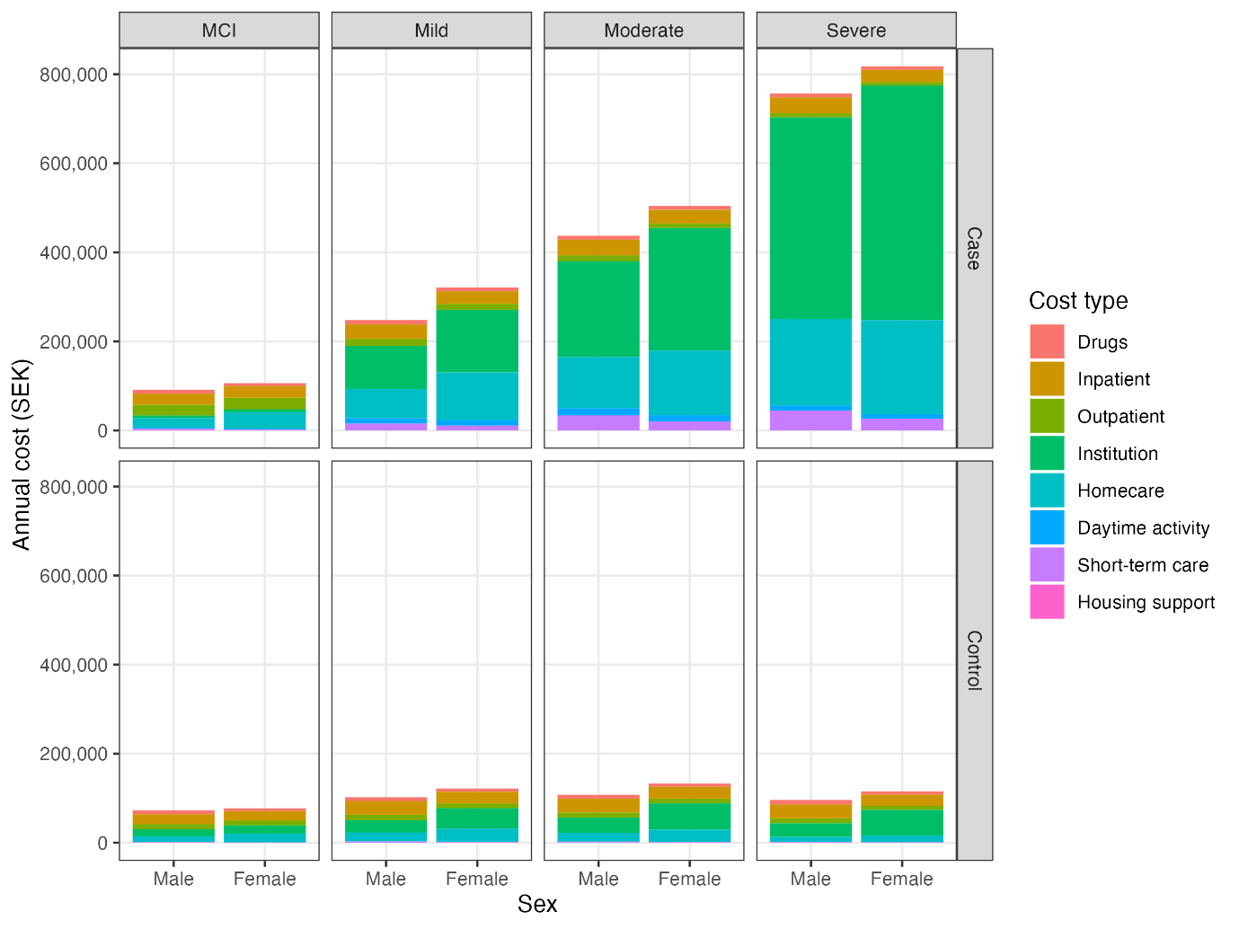

Figure 2. Annual costs of care in case and control by cognitive status and age group

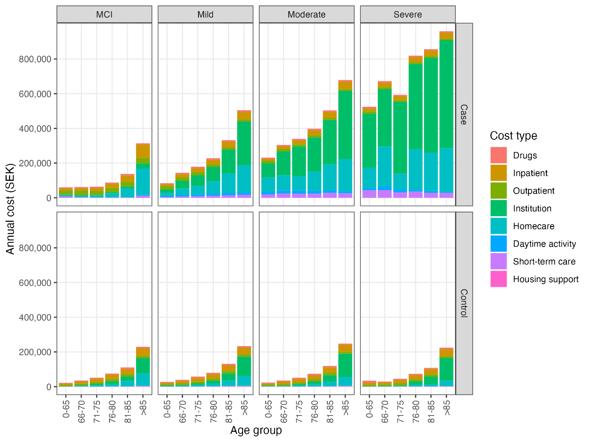

Figure 3. Annual cost in AD by cognitive status and cost component
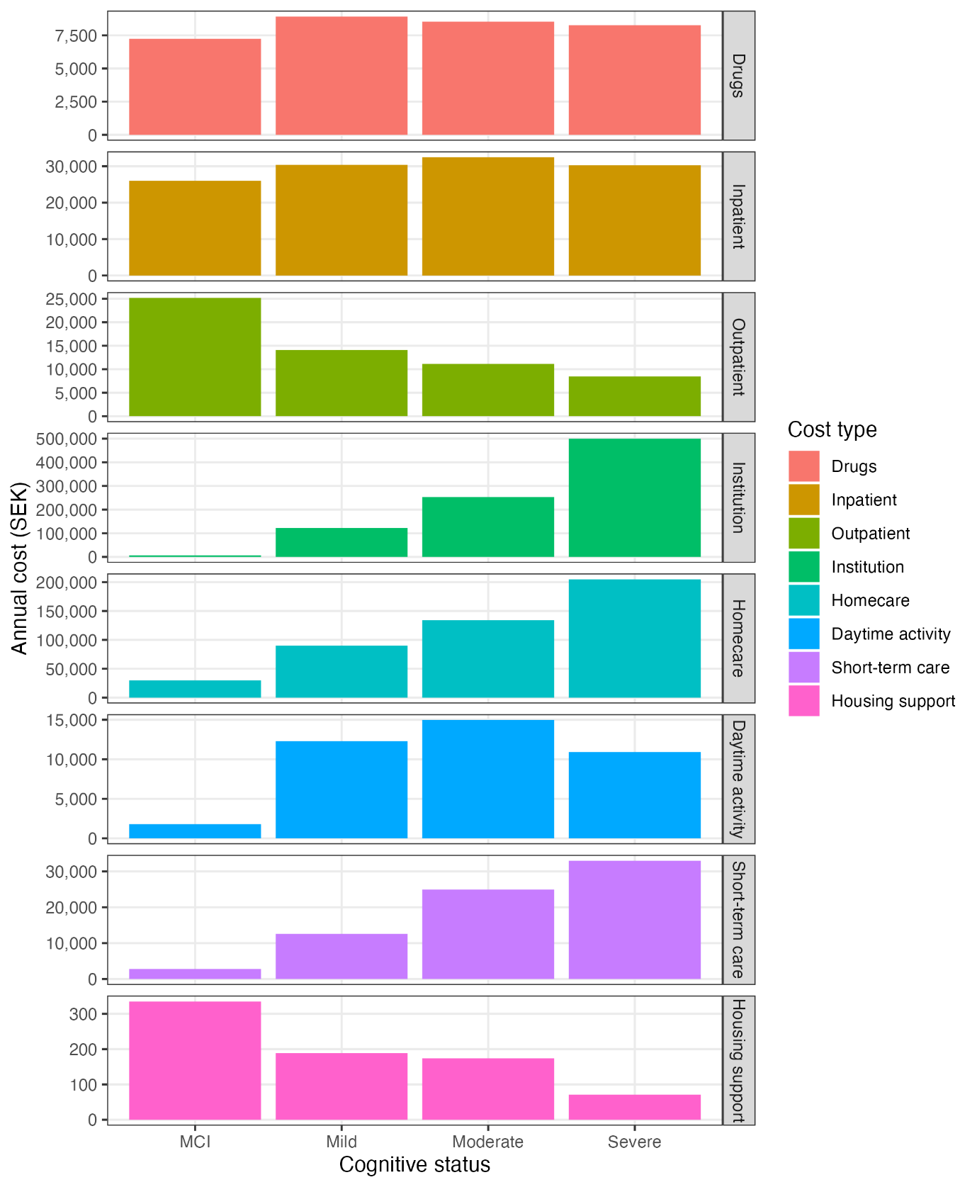

Figure 4. Annual cost in AD by cognitive status, sex and cost component

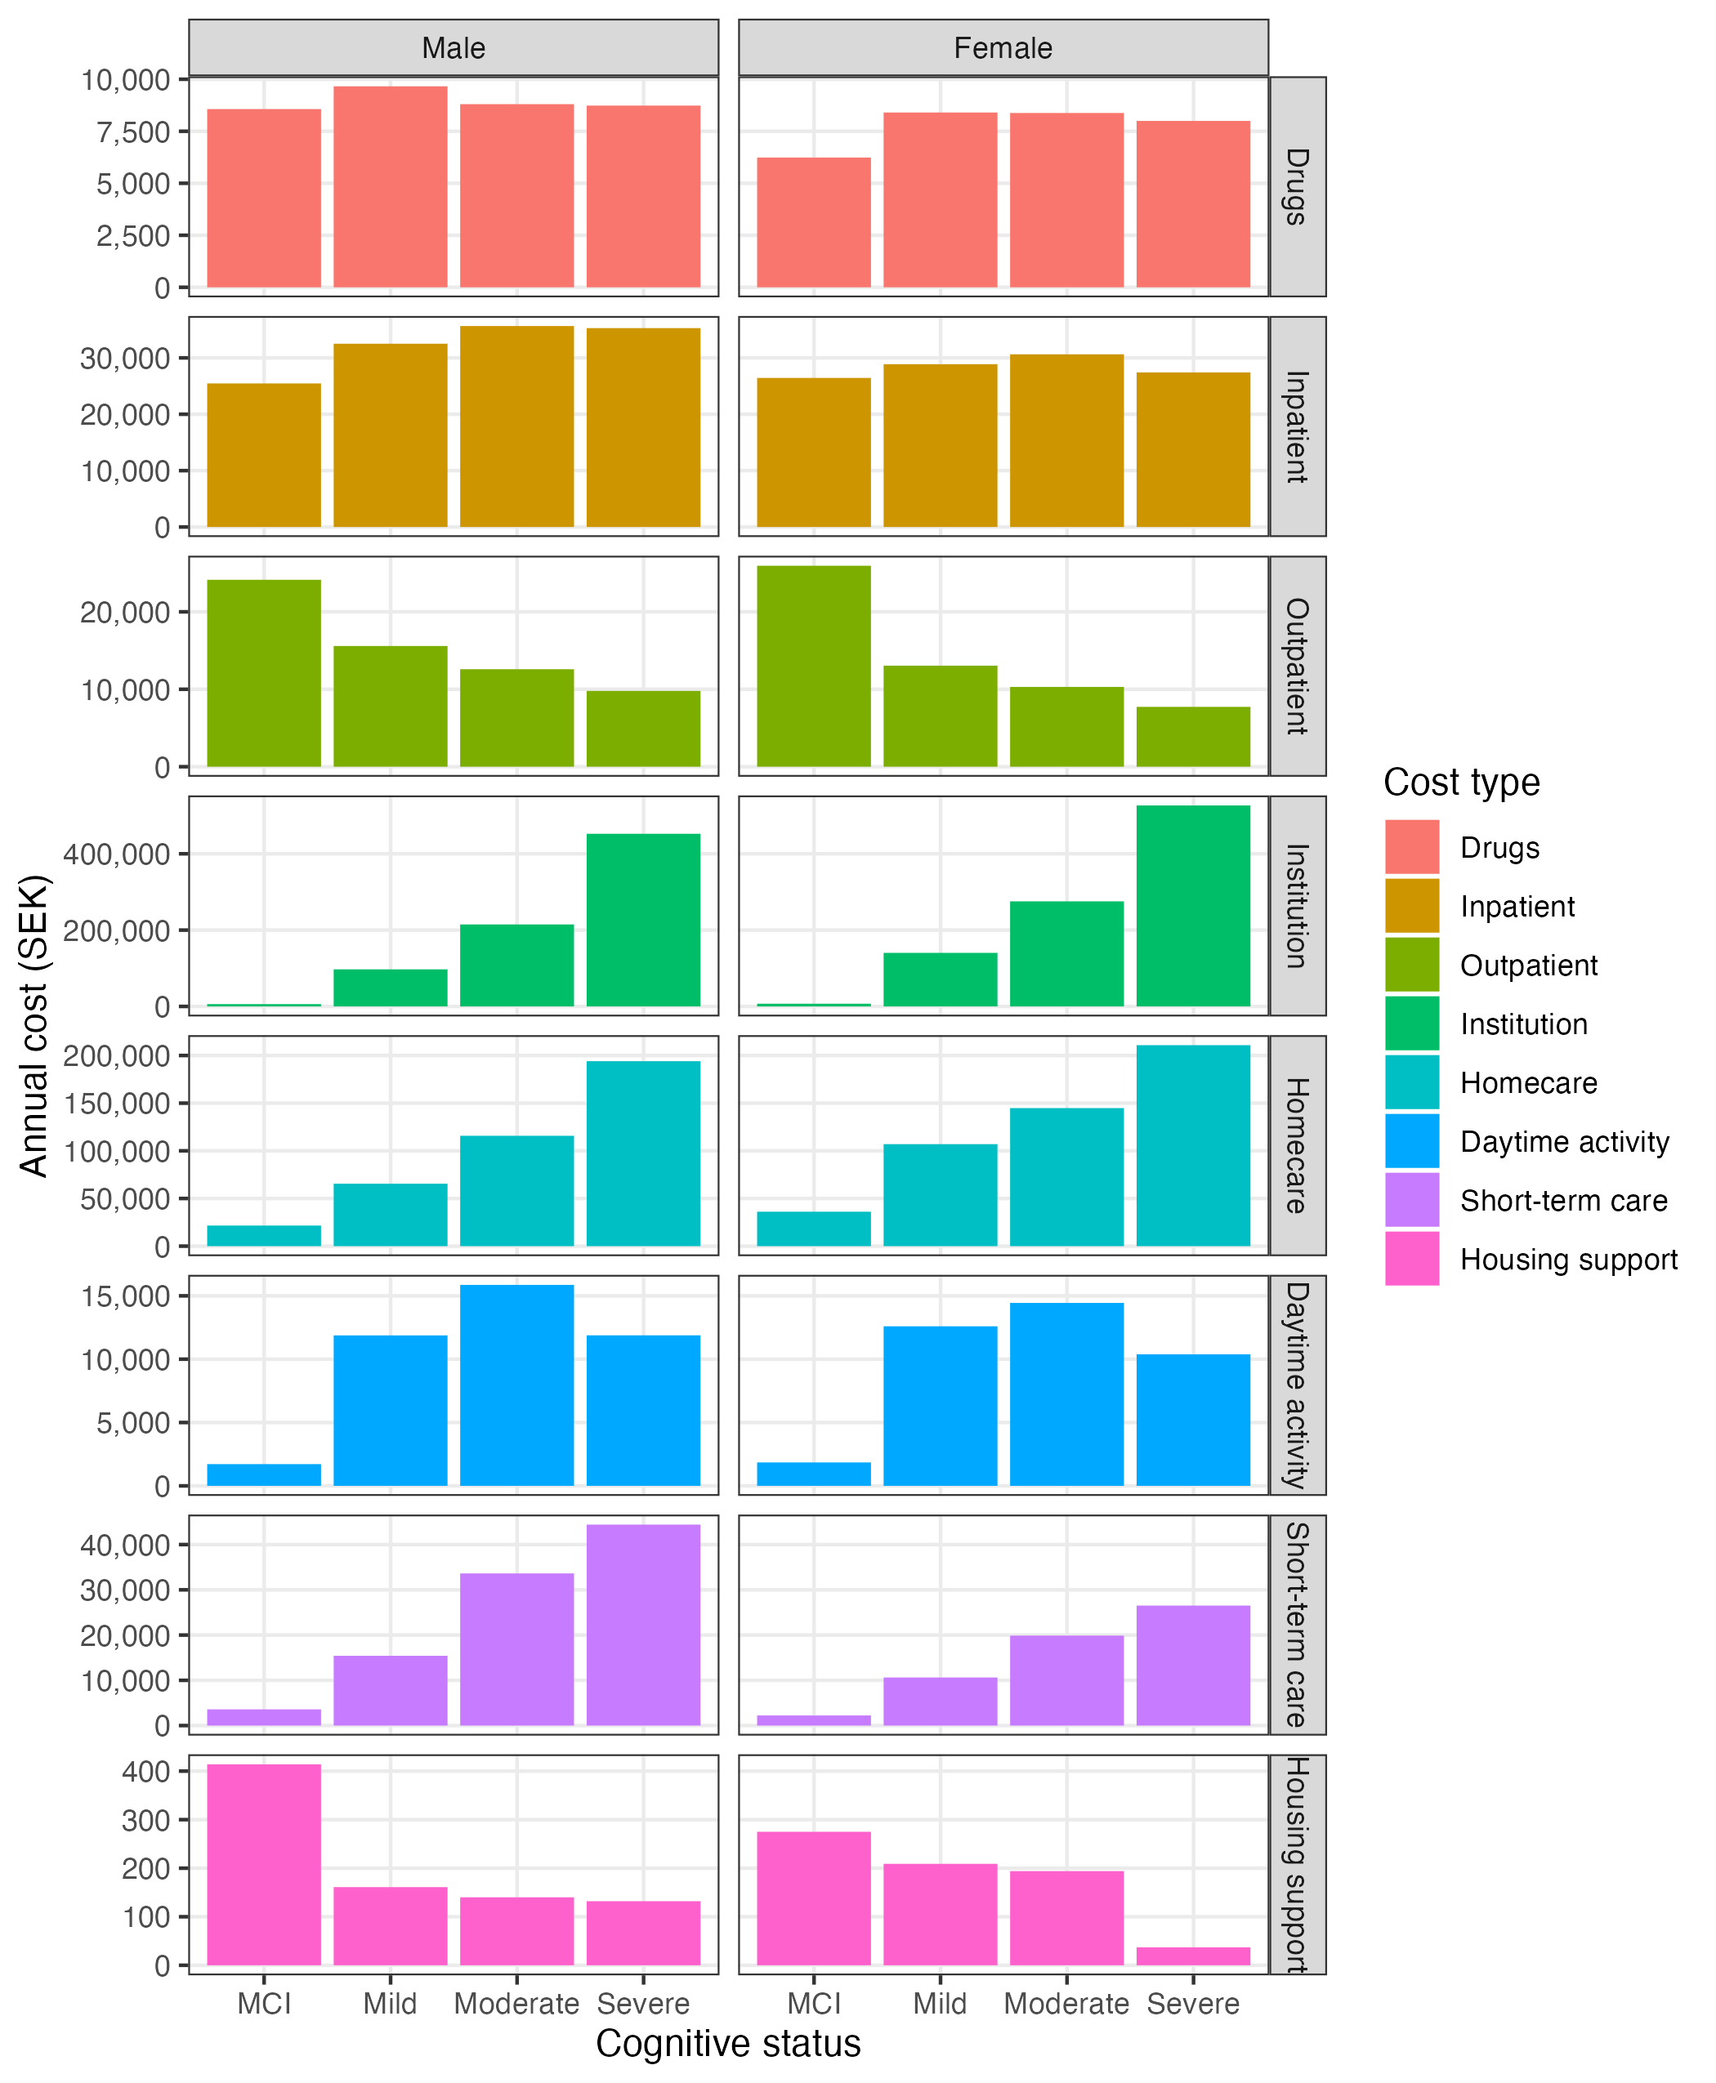

Figure 5. Annual costs in AD by cognitive status, age group, and cost component
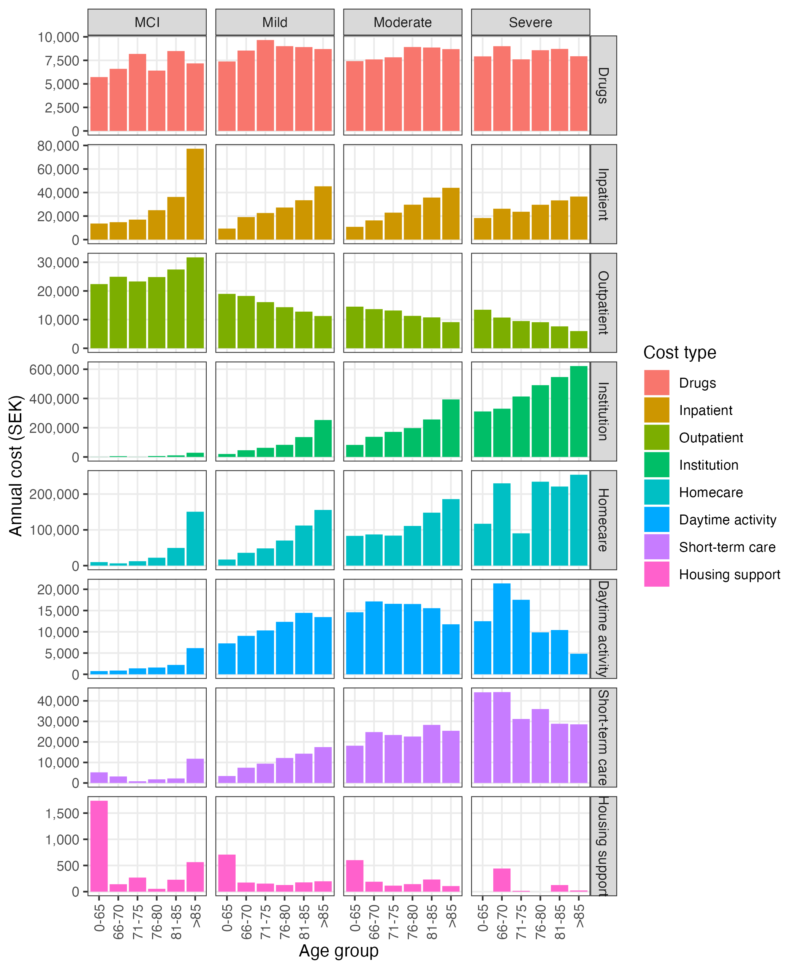

Reference
1. RKA. Kolada - en tjänst från RKA [Internet]. [cited 2024 Feb 26]. Available from: https://www.kolada.se/verktyg/fri-sokning/?kpis=35480,35484,41297,44440,76370,83908&years=30200,30199,30198&municipals=2328&rows=municipal,kpi&visualization=bar-chart

