Supplementary materials

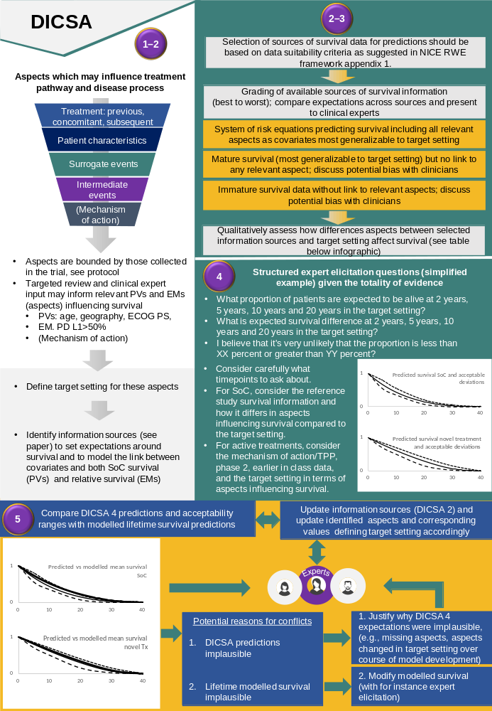
Supplementary figure 1: Overview of DICSA 5 step process for generating biological / clinical plausible survival extrapolations

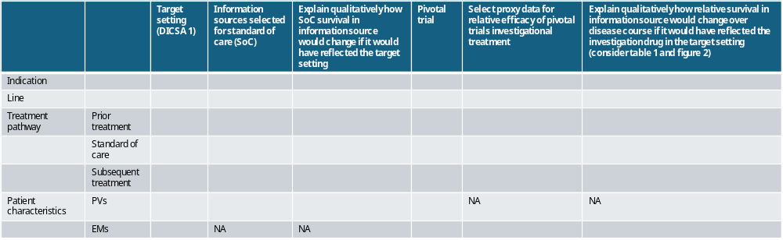
Supplementary Table 1: Table template for comparing differences in aspects between selected information sources and the target setting defined in DICSA 1 and for qualitative assessment of how these differences would have affected the observed survival in the selected information source.

Supplementary materials: Structured expert elicitation (SEE) approach
We encourage researchers to use a structured expert elicitation (SEE) approach to generate bounds for plausible survival extrapolations. When conducting SEE it is important to ensure that experts are presented with the full existing data package to inform their decision. It is also important to provide the experts feedback during the elicitation process as to what their selected values mean both in terms of the survival point estimates in comparison to existing data and general population mortality, and in terms of the implied hazard function the estimates dictate when multiple timepoints have been elicited.
Questions which should be considered during the feedback process prior to experts being given the opportunity to revise estimates could include:
- Are the corresponding mortality hazards at any point lower than general population mortality hazards?
- Is predicted survival longer than general population mortality?
- How do landmark survival estimates compare to clinical expectation and observed data for earlier timepoints?
- How does the predicted trend in hazards compare to clinical expectation and observed data for earlier timepoints?
- Where two or more treatments are considered what do the landmark estimates provided imply in terms of incremental survival and is this in line with clinical expectation?

