Supplementary materials
Title: Do child age and parental status matter in valuing the Child Health Utility 9D (CHU9D)?

Journal name: PharmacoEconomics

Xiuqin Xiong, PhD^{1#}, Li Huang, PhD¹, Natalie Carvalho, PhD¹, Kim Dalziel, PhD^{1*}, Nancy Devlin, PhD^{1*}
1 Melbourne Health Economics, School of Population and Global Health, The University of Melbourne, Melbourne, Australia
# corresponding author
* joint senior authors

Corresponding author:
Xiuqin Xiong
Research Fellow, PhD
Melbourne Health Economics
Melbourne School of Population and Global Health
The University of Melbourne
VIC, Australia
Email: xiuqin.xiong1@unimelb.edu.au
Phone: +61478328211

Contents
RETRIEVE checklist 3
Survey questionnaire 12
Detailed data quality control criteria 21
Supplementary methods and results 22

RETRIEVE checklist
The RETRIEVE checklist for studies reporting the elicitation of stated preferences for child health related quality of life. Bailey, Howell et al.

The RETRIEVE long checklist
LONG FORM:
This checklist is modular, not all sections will apply to all papers.
Section A - Stated preferences considered relevant to valuing child HRQoL and sample characteristics
A1 – Stated preferences
A1a | Whose preferences were sought?
A1a | - Adults [x]  - Children and young people (CYP) <18 years  - Mixed adults and CYP | A1b then A2  A1b then A3  A1b then A2 and A3
A1b | Did the authors provide a rationale for whose preference were sought?
A1b | - Yes [x]  - No
A2 Adults’ stated preferences
A2a | Which adults were the focus of preference elicitation?
A2a | - General population [x]  - Parent or caregiver of child [x]  - Health care professionals  - Adult with a health condition  - Other adults, please specify ______________________
A2b | What perspective were adults asked to take in considering the child states to be valued? e.g. thinking about the health states as experienced by:
A2b | - Own child (parent)  - Another child they know  - A hypothetical child [x]  - Their own health, thinking back to when they were a child  - Their own health, as if they were a child now  - Their own health, but blinded to the states under consideration being specific to children  - Person with a health condition (e.g. a health professional asked to take the person with a health condition’s perspective)  - Other, please specify: _________________________________
A2c | Was the age of the child, for whom respondents were asked to imagine health states to be valued, specified?
A2c | - Yes [x]  - No  - Not applicable | Go to A2d  Go to A4  Go to A4
A2d | If yes, what was the age of the child? 10 years, 2-4 years
A2e | Was the rationale for the choice of the age of child provided?
A2e | - Yes [x] Prior studies and following the EQ-5D-Y valuation protocol  - No
A3 Children and young people’s stated preferences
Section A3 is not relevant to the value set reported by this study.
A3a | From which child/young person were preferences elicited? [N/A]
A3a | - General population  - Person with a health condition  - Other children, please specify: ____________________
A3b | What perspective was the (child/young person) respondent asked to take? e.g. thinking about the health states as experienced by: [N/A]
A3b | - Themselves (i.e. their own perspective)  - Another known child  - A hypothetical child  - Other, please specify:_________________
A3c | Was the age of the child/young person, for whom respondents were asked to imagine health states to be valued, specified? [N/A]
A3c | - Not applicable (i.e. own perspective/themselves)  - It was applicable but not stated  - Yes | Go to A4  Go to A4
A3d | If the age was specified, what was the age? [N/A]
A3e | Was the rationale for the choice of the age of child/young person provided? [N/A]
A3e | - Yes  - No
A4 Sample
A4a | Was the population or sample frame defined from which the sample was drawn? (e.g., country, age, condition)
A4a | - Yes [x] Australian adults general population  DCE survey and VAS anchoring: Country (Australia) and representative of the general adult population (age, gender, region).  - No
A4b | Is information provided on how the sample was recruited (e.g., field-based recruitment, online panel, convenience sample)?  - Yes [x] Online panel.  - Partial  - No
A4c | If data were collected online, were efforts made to avoid on-line panel fraud? (eg, related to bots or automated software posing as participants and completing surveys)  - Yes [x]  - No  - Not applicable
A4d | Was there a target sample size (or sample sizes if by block – e.g. number of tasks per block (e.g. DCE) or health state (e.g. TTO))?
A4d | - Yes [x] Stated as 1200 for the DCE and VAS.  - No | Go to A4g
A4e | Was the target sample justified?
A4e | - Yes [x] Based on established guidelines and previous studies.  - No
A4f | Was the target sample achieved?
A4f | - Yes [x]  - No  - Unclear
A4g | Were the characteristics of the final sample described?
A4g | - Yes [x]  - No | Go to A4i
A4h | Did the sample characteristics match the intended population?
A4h | - Yes  - No [x] The sample of adults slightly under-represented adults aged>65 years and slightly over-represented adults from Aboriginal or Torress Strait Island origin. All other groups were well represented.  - Unclear
A4i | Was the year the data collected stated?  - Yes – what year(s) were the data collected? [x] Sep 2023 to Nov 2023 (may updated to March 2024 after all data colleced)  - No
A4j | Was information provided on missing data? (non-completion, withdrawals)?
A4j | - Yes [x] All included data based on data quality have no missing data. The DCE is designed to not allow skipping questions.  - Partial  - No

Section B - Child HRQoL states to be valued
B1 Type of study
B1 | Did the values reported in this paper comprise:
B1 | - A value set? [x]  - Values for a limited number of health states (e.g. vignette)? | Go to B2  Go to B3
B2 Value Sets
B2a | Which HRQoL instrument was valued? CHU9D
B2b | Were the domains and response options of the instrument clearly described?
B2b | - Yes [x]  - No
B2c | What experimental design approach was used to choose the health states (combination of dimension levels) to be valued? Bayesian D-efficient design with main effects, overlapping of health states in 4 dimensions levels. The randomly selected 204 pairs of health states were divided into 17 blocks of 12 DCE tasks.
B2d | How were the health states assigned to respondents? Each respondent was asked to complete 1 of the 17 blocks of 12 DCE tasks. Each of the 12 DCE tasks presented 2 health states and the respondent was asked to choose their preferred state (i.e. a forced choice). Respondents were randomly assigned to complete 1 out of the 17 blocks of 12 DCE tasks.
B3 Specific health states Section B3 is not relevant to this study.
B3a | How were the health states described? [N/A]
B3a | - Disease specific vignettes  - From a disease-specific HRQoL instrument  - Other, please specify _______________
B3b | How many health states were preferences elicited for? [N/A]
B3c | Was the rationale for the selection of these health states specified? [N/A]  - Yes – What was the rationale? ____________________________  - No

Section C – Methods used to elicit stated preferences for child HRQoL
C1 | Which method or methods were used to elicit stated preferences?  - DCE [x]  - TTO  - SG  - BWS  - VAS [x]  - Other, please specify________________________
C2 | Was a rationale for the choice of method(s) provided?  - Yes [x]  - No
C2a | If yes, what was the rationale? Refer to The International Valuation Protocol for the EQ-5D-Y-3L, and refer to previous similar studies valuing CHU9D, with specific considerations for valuing health for 2-4 years old. 2-4 years old is a narrow age range and thus valuation method with duration is not feasible. Therefore, DCE was used for valuation and VAS was used for anchoring. Consider the 9 attributes of CHU9D and respondents’ cognitive burden, partial DCE design with 4 overlapped dimensions were adopted.
C3 | Was the duration of the states to be valued reported (e.g ‘x years in this state, followed by death’)?  - Yes  - No [x] No duration for this study as 2-4 year old is a narrow age range and duration is not feasible. Go to C4
C3a | Was the duration fixed?
C3a | - Yes  - No
C3b | What duration(s) was used?
C4 | Did the method(s) allow values to be elicited that were < 0 (‘worse than dead’)?
C4 | - Yes [x]  - No | Go to C5
C4a | How were values < 0 elicited? Using a VAS. If the VAS value for health states is lower than the VAS value for “dead”, the values would be <0.
C4b | What was the minimum value possible? (may vary according to the method used so should be clearly stated) infinite. The minimum value can be a very large negative value using VAS to anchor. For example, if the sample value dead at 99, value worst state at 0, and full health at 100, then the anchored value for the worst state is (0-99)/(100-99)=-99
C4c | What determined how the task was terminated? This is not relevant with the VAS anchoring method which has no mechanism for termination.
C5 | How were the values anchored on a utility scale? Using VAS; All variable dummy coded and DCE coefficients divided by the overall utility range and re-scaled to the value of the pits state (555555555) obtained from VAS.
C6 | What was the mode of administration for the stated preference tasks?
C6 | - Online self-completion by the respondent [x] DCE and VAS  - Self-completion of mailed questionnaires  - Online computer assisted personal interview (CAPI)  - In person CAPI  - In person interview  - Other, please specify _____________
C7 | How was the quality of stated preference data assessed?  Several criteria were created to guarantee the quality of data used for the main analysis. See details in Appendix 3.
C8 | Were any exclusions made to the preference data (eg used to represent average preferences)?  - Yes [x] excluded data with poor quality based on criteria listed above.  - No  - Unclear |  | Go to C9  Go to C9
C8a | Were reasons for the exclusions provided?  - Yes [x]  - No  - Unclear
C9 | Were the health states randomly assigned?  - Yes [x]  - No  - Unclear
C10 | Was ethics approval for the study obtained from an appropriate research ethics committee?  - Yes [x]  - No  - Unclear  - Not stated
C11 | Were sources of funding and non-monetary support and the role of the funder(s) in the design described?  - Yes [x]  - No

Section D – Econometric modelling and statistical methods
D1 – Did the values reported comprise:
 | - A value set? [x]  - values for a limited number of health states (vignette or condition-specific)? | Go to D2  Go to D3
D2 Econometric modelling of value sets for HRQoL instruments
D2a | What was the theoretical model? OR What models were estimated? e.g. OLS, Tobit etc. Random utility model – Linear additive utility with all variables dummy coded. Conditional logit model was used to estimate the average preferences.
D2b | Were the main assumptions of the model stated? (e.g. assumptions about preference homogeneity/heterogeneity)  - Yes  - No [x] The aim is to obtain the population average preferences, and thus the heterogeneity of the preferences is not explored.  - Unclear
D2c | How was the constant term treated (if included)? The constant term was not included as this is a two option forced choice DCE, and no “status quo” or “opt out option” were provided.
D2d | How were missing data handled (e.g.: imputation, complete case analysis) No missing data as no skipping questions were allowed for the DCE and VAS.
D2e | Were subgroup analyses completed?
D2e | - Yes  - No  - Not applicable [x]
D2f | Were interaction terms included?
D2f | - Yes [x] Interactions were included to explore the preference difference between two age perspectives and parental status.  - No | If no, go to D2h
D2g | Were details of the interactions provided?
D2g | - Yes [x] E.g., For the exploration of the preference by child age, the interaction of each dimension level with the subgroups of child age were included.  - No  - Not applicable [x]
D2h | Were non-linear specifications considered?
D2h | - Yes  - No [x]
D2i | Was more than one model described?
D2i | - Yes [x] original model and consistent model were described.  - No | If no, go to D2m
D2j | Were goodness-of-fit statistics for each model reported?
D2j | - Yes [x]  - No
D2k | Was the preferred model clearly stated?
D2k | - Yes [x]  - No
D2l | Were the criteria used to select the preferred model described?  - Yes [x] Sensitivity analyses by relaxing data quality control criteria were conducted. Sensitivity analyses using mixed logit model were conducted. Model were chosen by research aim and AIC, BIC.  - No
D2m | Do the preference parameters for the health states follow a logical order (monotonic)?
D2m | - Yes  - No [x] | If yes, go to D2p
D2n | Was any post estimation undertaken to force monotonicity (e.g. collapsing levels)?
D2n | - Yes [x]  - No  - Unclear/not stated
D2o | How were insignificant differences between adjacent levels managed (e.g. collapsed/ forced to be different)? To produce a consistent model, adjacent inconsistent levels are to be merged (collapsed) or constrained to be the equal.
D2p | Were robustness checks conducted?  - Yes [x] sensitivity analysis by using different quality control criteria and different models.  - No
D2q | Was uncertainty around values reported?
D2q | - Yes [x] Standard errors  - No
D3 Analysis of values for specific HRQoL states Not relevant to the value set in this study.
D3a | Have the statistical methods been described? [N/A]
D3a | - Yes  - No | If no, go to D3c
D3b | Have the statistical methods been justified? [N/A]
D3b | - Yes  - No
D3c | How were missing data handled (e.g.: imputation, complete case analysis)? [N/A]
D3d | Have subgroup analyses and interactions been undertaken? [N/A]
D3d | - Yes  - No | If no, go to D3h
D3e | Were sub-groups and interaction variable chosen for assessment justified? [N/A]
D3e | - Yes  - No
D3f | Were sensitivity analyses undertaken? [N/A]
D3f | - Yes [x]  - No | If no, go to Section E
D3g | Were sensitivity analyses described? [N/A]
D3g | - Yes [x]  - No

Section E - Characteristics of values
E1 | Was qualitative or quantitative evidence reported that demonstrates the extent to which respondents engaged with and understood the valuation tasks?  - Yes [x]  - No
E2 | Where a value was reported, were the values generated by the final model logically consistent?  - Yes [x]  - No  - Unclear
E3 | Did authors report the distribution of values over all states defined by the HRQoL instrument (e.g. as per Figure 1 in Pan et al 2022.)  - Yes [x]  - No
E4 | Key characteristics of the values
E4a | How many percentage values less than zero were possible? 0
E4b | What was the maximum possible value less than one? 0.990
E4c | Where in the descriptive system does the biggest change in values occur, when shifting between adjacent states? Between the adjacent states in pain dimension, see Figure changes in utility between adjacent states.
E5 | Was the order of importance of dimensions (domains) suggested by the value set discussed?  - Yes [x]  - No

Survey questionnaire

(This is for one arm for 2-4 year old version; the survey for the other arm for the 10 year old version is mostly the same, only using the original CHU9D and changing 2-4y to 10y throughout.)

[Section 1: Initial screening questions – for participant quotas]
- What is your gender:
Male
Female
Other

- How old are you?
□ Under 18 (end of survey)
□ 18-24
□ 25-34
□ 35-44
□ 45-54
□ 55-64
□ 65+

- Where do you live?
□ NSW
□ VIC
□ QLD
□ SA
□ WA
□ ACT
□ TAS
NT

- Do you have any children?
Yes
No

- [If yes to above question] How old are these children now? (If you have more than one child, tick all that apply)
□ 0 - 1 years
2 - 4 years
□ 5 – 7 years
8- 10 years
11-18 years
□Over 18 years

Honesty oath:
Before we begin, do you promise to answer the following questions truthfully? (you will be allowed to continue with this survey regardless of your answer to this question)
Yes
No

Detect bot: traffic light
Please select the correct description of the colors in the traffic light from top to bottom:

Red; green; yellow
Yellow; green; red
Red; yellow; green (if not selected, end of survey)

[Section 2: Reporting health using CHU9D]
Think of a child aged 2-4 years old. The child can be your own child, or a child you know (for example, a child of your friend or relative), or any child you can imagine. You can make up the health situation if you are thinking of a hypothetical child. This section is for you to be familiar with the instrument we are valuing in this survey.

These questions ask about how the child is today. For each question, read all the choices and decide which one is most like the child today. Some questions have extra guidance with them as the child is under 5 years of age.

- Worried
My child doesn’t feel worried today
My child feels a little bit worried today
My child feels a bit worried today
My child feels quite worried today
My child feels very worried today

- Sad
My child doesn’t feel sad today
My child feels a little bit sad today
My child feels a bit sad today
My child feels quite sad today
My child feels very sad today

- Pain
My child doesn’t have any pain today
My child has a little bit of pain today
My child has a bit of pain today
My child has quite a lot of pain today
My child has a lot of pain today

- Tired
My child doesn’t feel tired today
My child feels a little bit tired today
My child feels a bit tired today
My child feels quite tired today
My child feels very tired today

- Annoyed
My child doesn’t feel annoyed today
My child feels a little bit annoyed today
My child feels a bit annoyed today
My child feels quite annoyed today
My child feels very annoyed today

- School Work/Homework (such as reading, writing, doing lessons)
If your child is at preschool/nursery/kindergarten then please think about that. If your child didn’t go today because of their health and they usually would have, please tick the last option “My child can’t do their schoolwork/homework today”. If today is not a day they usually would have gone, then please think about how you think they would have been had they gone. If your child does not go to preschool/nursery/kindergarten, then please think about whether they have had any problems with activities such as colouring, looking at books/reading, and concentrating, as appropriate for their age.
My child has no problems with their schoolwork/homework today
My child has a few problems with their schoolwork/homework today
My child has some problems with their schoolwork/homework today
My child has many problems with their schoolwork/homework today
My child can’t do their schoolwork/homework today

- Sleep
Last night my child had no problems sleeping
Last night my child had a few problems sleeping
Last night my child had some problems sleeping
Last night my child had many problems sleeping
Last night my child couldn’t sleep at all

- Daily routine (things like eating, having a bath/shower, getting dressed)
Please think about this question in terms of eating, drinking, toileting, washing and teeth cleaning, as appropriate for their age.
My child has no problems with their daily routine today
My child has a few problems with their daily routine today
My child has some problems with their daily routine today
My child has many problems with their daily routine today
My child can’t do their daily routine today

- Able to join in activities (things like playing out with their friends, doing sports, joining in things)
Please think about this question in terms of the activities your child would usually be doing today.
My child can join in with any activities today
My child can join in with most activities today
My child can join in with some activities today
My child can join in with a few activities today
My child can join in with no activities today

[Section 3: DCE tasks]
Instruction for DCE task

You will now be asked to complete 13 choice tasks (choosing between two health states).
In each of the task, two different health states 'A' and 'B' will be shown (example task below). Each health state describes 9 aspects of health and wellbeing (worried, sad, pain, tired, annoyed, sleep, daily routine, schoolwork/homework, and able to join in activities), with 5 levels of severity for each aspect.
Please assume that the child will have no other health problems besides what is indicated in the health states.
Please read the text carefully and imagine the health states described, as if they were being experienced by a 2-4 year old child, and then select the health state that you would prefer for a 2-4 year old child.

Only 5 of the 9 health dimensions vary in levels between health states 'A' and 'B', and the remaining 4 dimensions have the same levels between 'A' and 'B' (which are grey shaded).

When you click (or touch if using tablet) on each health dimension (Worried, Sad, ...), instructions for severity levels and further guidance notes will pop out to help you understand these dimensions for a 2-4 year old children and make a choice.

Example choice task (not displayed here)
Here is a summary of the severity levels for different dimensions; the deeper the cell color, the bigger the health problem.
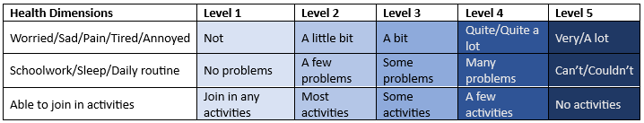
Before proceeding, please ensure that you are viewing the survey using the ‘full screen’ of your computer or tablet, so that the options display correctly. Note that once you have answered a question you will not be able to go back to the previous page and change your answers.

DCE choice tasks (in total 13 tasks; only showing 1 example task here)
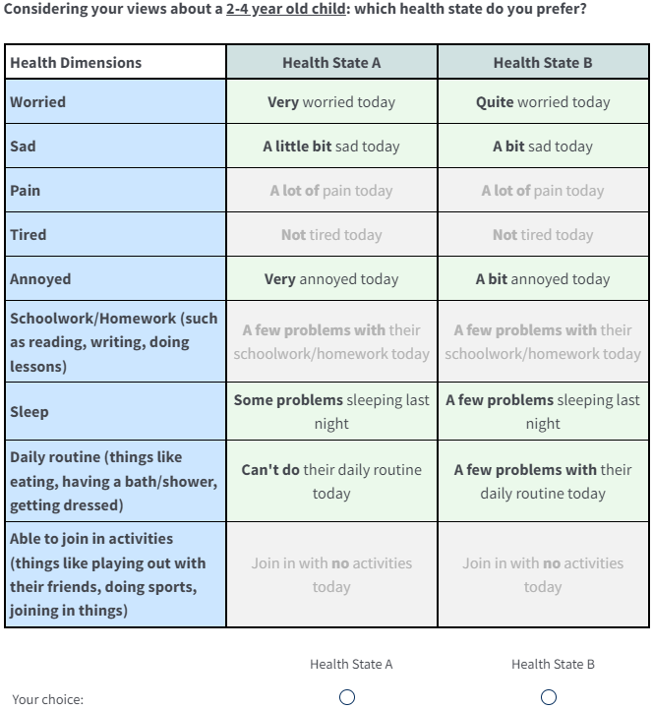

DCE Debrief question:
1. Please let us know what you thought of the DCE tasks (choosing between A and B) you just performed, by indicating how strongly you agree or disagree with the statement shown in bold.
 | Strongly disagree | Somewhat Disagree | Neither agree nor disagree | Somewhat Agree | Strongly agree
I found the tasks difficult
I found it difficult to tell the difference between the descriptions
I found it difficult to imagine the health problems described

2. Do you think your choices would have been different if you had been asked to imagine that the health problems were being experienced by a 10 year old child, rather than a 2-4 year old child?
□ Yes – at least some of my choices would have been different
□ No – my choice would have been exactly the same
□ Don’t know

Session 4: VAS task
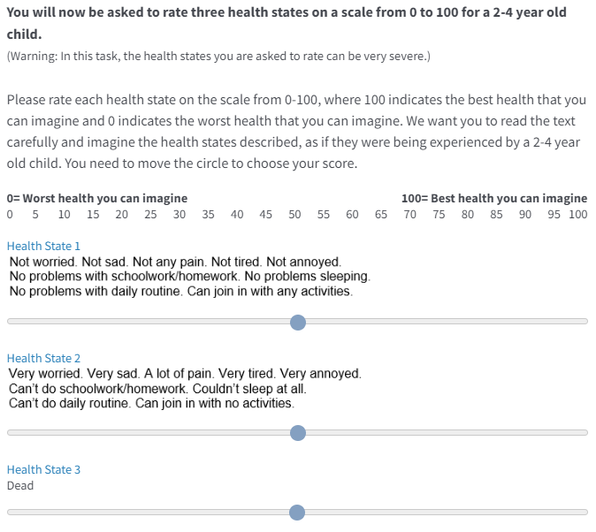

VAS Debrief question:
Do you think you understand the tasks (rating from 0-100 task) you just performed?
Fully understand,
Somewhat understand,
Not understand.

[Section 5: Demographic questions]
This is the last section of the survey, we will ask you 12 questions about simple background information or experience about illness.
- What is your age (in years)? ____

- What is the highest level of school you have completed?
Primary school
Some high school
Finished high school (Year 12 in Victoria)

- What is your highest post-school qualification?
None
Trade/Apprenticeship
Certificate, Diploma
Undergraduate degree (e.g., Bachelors, Honours)
Postgraduate degree (e.g., Masters, Doctorate)
Other_____

- What is your current employment status? If you had more than one job or business, please think about the one in which you usually work the most hours.
Full-time employment
Part-time employment
Away from work
Unemployed

- Which of the following categories best describes your individual income, from all sources, before taxes in 2022?

Less than $300 per week ($15,599 or less per year)
$300-$499 per week ($15,600-$25,999 per year)
$500-$999 per week ($26,000-$51,999 per year)
$1,000-$1,999 per week ($52,000-$103,999 per year)
$2,000-$2,999 per week ($104,000-$155,999 per year)
$3,000-$3,999 per week ($156,000-$207,999 per year)
$4,000 or more per week ($208,000 or more per year)

- Which of the following categories best describes your total household income, from all sources, before taxes in 2022?

Less than $300 per week ($15,599 or less per year)
$300-$499 per week ($15,600-$25,999 per year)
$500-$999 per week ($26,000-$51,999 per year)
$1,000-$1,999 per week ($52,000-$103,999 per year)
$2,000-$2,999 per week ($104,000-$155,999 per year)
$3,000-$3,999 per week ($156,000-$207,999 per year)
$4,000 or more per week ($208,000 or more per year)

- Have you ever been involved in (e.g., employed/volunteering) a role that involved working directly with young children under 5 years old in the last 5 years?
□ Yes
□ No

- Have you experienced serious illness?
a1. In yourself as an adult
□ Yes
□ No
a2. In yourself when you were a child
□ Yes
□ No
b. In your close family members or friends
□ Yes
□ No
c1. In caring for others- caring for an adult
□ Yes
□ No
c1. In caring for others- caring for a child
□ Yes
No

- In general, how would you rate your own health?
Excellent
Very good
Good
Fair
Poor

- Are you of Aboriginal or Torres Strait Islander origin?
Yes
No

- Are you:
□ Single
□ Married/Partner
□ Separated
□ Divorced
□ Widowed
Prefer not to say

- Please rate your engagement to the survey you just performed.
Fully engaged
Partially engaged
Not engaged

Free text page
Thank you for completing the survey. If you have any comments about the survey, e.g., how you felt about the task or whether you had any problems viewing or understanding the information presented, please enter them in the box below:

Please click “To finish the survey” to submit your responses!

Detailed data quality control criteria
Responses that failed any criteria in categories 1 and 2 were not included in the main analysis.
Category 1: Responses that failed these criteria were deleted (due to being classified as obviously illegitimate responses).
- Total completion time: completion time was recorded by Qualtrics. Responses with less than 1/3 of median completion time were deleted.
- Straight-liner: Responses that always chose A or B were deleted.
- Traffic lights test: This question asked respondents to describe the color of a traffic light picture. This is a test to ensure that the respondent is a real person and attentive respondent. Responses that failed the test were deleted.
- Dominant choice task: those who failed the dominant choice task were deleted.
- Age consistency: Age band multiple choice task was presented at the front of the survey and a free text age question was presented later in the survey. Those whose answers didn’t match were not included in the main analysis.
Category 2: Responses that failed this type of criteria were not included in the main analysis but could be used as sensitivity analysis.
- Completion time for individual choice tasks: From the pilot study, the median time was 12 seconds for each CHU9D choice task. If a participant had more than half of (>=7) the choice tasks with completion time less than 1/3 median (4 seconds), the quality of data for this person was deemed problematic and was not included in the main analysis.
- Respondent engagement: At the end of the survey, respondents were asked their engagement to the survey, with choices of “fully engaged”, “partially engaged”, and “not engaged”. Those reporting “not engaged” were not included in the main analysis.
Category 3: These categories were monitored but responses were included in the main analysis regardless.
- Honesty oath: A previous study indicated that use of an honesty oath improved results.[10] The question in this survey was: “Before we begin, do you promise to answer the following questions truthfully? (you will be allowed to continue with this survey regardless of your answer to this question)” with answers yes or no. All data was included in the main analysis.

Supplementary methods and results

Sample size for DCE
There is no single best approach to decide the sample size needed for a DCE for valuation studies. The sample size, i.e., the number of respondents needed, for a DCE is determined by three factors: 1) the number of choice pairs needed, 2) the number of observations needed for each choice pair and 3) the number of choice tasks each respondent can deal manage without unreasonable cognitive burden.
- There is no golden rule for the number of choice pairs needed to estimate the models. The practical minimum is that “The number of choice tasks for DCEs with two alternatives needs to be at least as large as the number of parameters to be estimated (Orme, 2010).” In our study, the linear utility function with only main effects need to estimate 9*(5-1) parameters, which is 36 as the minimum choice sets. If we need to include interaction effects, more choice sets are needed. We choose 204 choice sets according to a previous similar study valuing CHU9D using DCE with duration (10 dimensions, 37 parameters needed to be estimated).
- Regarding the number of choice pairs assigned to each respondent, it usually ranges from 10 to 15 according to similar previous DCE studies ^{2,4,7}. We decided to ask each respondent to do 12 choice tasks considering the cognitive burden for the respondent as our DCE partial design for CHU9D has 5 varied attributes for respondents to compare in each task. Thus, the DCE design for 204 choice tasks resulted in 17 blocks, with 12 choice pairs in each block. Each respondent will be randomly assigned to one block.
- There are two rules of thumb for a minimum sample size for the number of observations per pair: Lancsar and Louviere suggest a minimum of 20 observations per pair, and Hensher and colleagues recommended a minimum of 30 observations per pair. The international valuation protocol for the EQ-5D-Y doubled the average of the two rules and used 50 observations per pair as the minimum,² and we decided to follow this.
Because we have a design comprising 17 blocks, this would require a minimum of 17*50=850 individual respondents. However, previously published literature usually recruited a larger sample than the minimum required given the low marginal cost of including extra online respondents compared with the fixed cost of implementing the survey.² A similar study valuing CHU9D using DCE with duration use 1200 as the final sample size, ending up with 70 observations per choice pair.⁴
The analyses used for comparing samples (age framing and parental status), i.e., RAI, interaction terms, and Swait-Louviere tests, all require the estimation of a model. The sample size requirement for these analyses is the same with the requirement for estimating a model, i.e., recommended minimum of 850.
VAS anchoring
This study used VAS as the anchoring method,³⁷ as other anchoring methods such as DCE with duration or time-trade off includes time duration and can be difficult due to the framing of a young child. For example, a child aged 2-4 years old will be an adolescent with a 10-year duration, which may cause the health state description to no longer be appropriate.

Table S1: CHU9D Instrument (Dimension Levels)
Dimensions | Levels | Wording
Worried | 1 | Don't feel worried today
 | 2 | Feels a little bit worried today.
 | 3 | Feels a bit worried today.
 | 4 | Feels quite worried today.
 | 5 | Feels very worried today.
Sad | 1 | Don't feel sad today
 | 2 | Feels a little bit sad today.
 | 3 | Feels a bit sad today.
 | 4 | Feels quite sad today.
 | 5 | Feels very sad today.
Pain | 1 | Don't have any pain today.
 | 2 | Have a little bit of pain today.
 | 3 | Have a bit of pain today.
 | 4 | Have quite a lot of pain.
 | 5 | Have a lot of pain.
Tired | 1 | Don't feel tired today
 | 2 | Feels a little bit tired today.
 | 3 | Feels a bit tired today.
 | 4 | Feels quite tired today.
 | 5 | Feels very tired today.
Annoyed | 1 | Don't feel annoyed today
 | 2 | Feels a little bit annoyed today.
 | 3 | Feels a bit annoyed today.
 | 4 | Feels quite annoyed today.
 | 5 | Feels very annoyed today.
School work/homework¹ | 1 | Have no problems with schoolwork/homework today.
 | 2 | Have a few problems with schoolwork/homework today.
 | 3 | Have some problems of schoolwork/homework today.
 | 4 | Have many problems with their schoolwork/homework today.
 | 5 | Can't do schoolwork/homework today.
Sleep | 1 | Have no problems sleeping last night.
 | 2 | Have a few problems sleeping last night.
 | 3 | Have some problems sleeping last night.
 | 4 | Have many problems sleeping last night.
 | 5 | Couldn't sleep at all last night.
Daily routine² | 1 | Have no problems with daily routine today.
 | 2 | Have a few problems with daily routine today.
 | 3 | Have some problems with daily routine today.
 | 4 | Have many problems with daily routine today.
 | 5 | Can't do their daily routine today.
Able to join in activities³ | 1 | Can join in with any activities today.
 | 2 | Can join in with most activities today.
 | 3 | Can join in with some activities today.
 | 4 | Can join in with a few activities today.
 | 5 | Can join win with no activities today.
Source: https://licensing.sheffield.ac.uk/product/CHU-9D
Guidance notes for CHU9D for children under 5. 1: If your child is at preschool/nursery/kindergarten then please think about that. If your child didn’t go today because of their health and they usually would have, please tick the last option “My child can’t do their schoolwork/homework today”. If today is not a day they usually would have gone, then please think about how you think they would have been had they gone. If your child does not go to preschool/nursery/kindergarten, then please think about whether they have had any problems with activities such as colouring, looking at books/reading, and concentrating, as appropriate for their age. 2: Please think about this question in terms of eating, drinking, toileting, washing and teeth cleaning, as appropriate for their age. 3: Please think about this question in terms of the activities your child would usually be doing today.

Table S2: completion time
 |  | Completion time, Median (25th, 75th interquartile range)
Sample | N | Total survey (Minutes) | Average time for individual choice task (Seconds)
Total sample | 3,112 | 12.3(9.1, 17.2) | 13.9(8.9, 21.7)
2-4y arm | 1,568 | 12.2(9.3, 17.1) | 13.9(9.0, 21.5)
10y arm | 1,544 | 12.3(8.9, 17.2) | 14.0(8.9, 21.8)
Note: For time to complete individual choice tasks, N=number of participants*12 choice tasks.

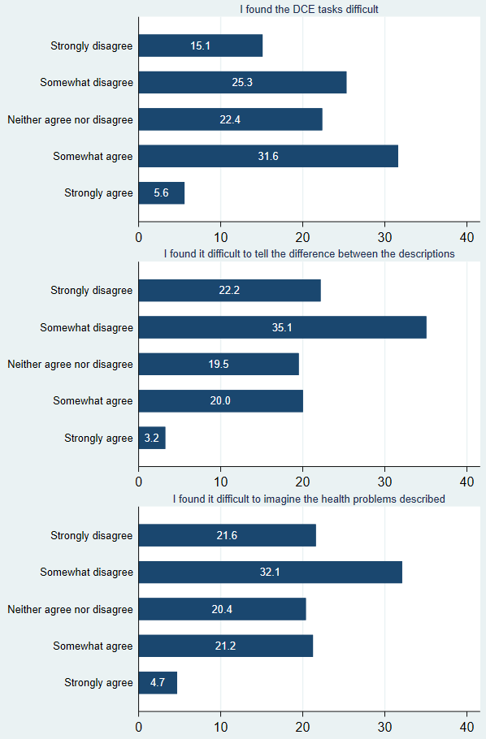
Figure S1: DCE task difficulty

Table S3 Discrete choice conditional logit modelling results by age framing and parental status
 | Age framing |  | Parental status
Mean of Coefficients | 2-4y arm  (n=1568) | 10y arm  (n=1544) | Parents of children aged 0-18 years  (n=953) | Non-parents of children aged 0-18 years (n=2159)
Worried level 2 | -0.214*** | -0.282*** | -0.289*** | -0.230***
Worried level 3 | -0.266*** | -0.389*** | -0.341*** | -0.324***
Worried level 4 | -0.638*** | -0.679*** | -0.672*** | -0.655***
Worried level 5 | -0.958*** | -0.948*** | -0.925*** | -0.970***
Sad level 2 | -0.342*** | -0.245*** | -0.291*** | -0.297***
Sad level 3 | -0.268*** | -0.207*** | -0.253*** | -0.228***
Sad level 4 | -0.679*** | -0.621*** | -0.600*** | -0.673***
Sad level 5 | -1.123*** | -0.995*** | -0.954*** | -1.106***
Pain level 2 | -0.685*** | -0.557*** | -0.628*** | -0.618***
Pain level 3 | -0.755*** | -0.728*** | -0.701*** | -0.762***
Pain level 4 | -1.944*** | -1.790*** | -1.734*** | -1.930***
Pain level 5 | -1.860*** | -1.548*** | -1.506*** | -1.795***
Tired level 2 | -0.091* | -0.133** | -0.042 | -0.143***
Tired level 3 | -0.138*** | -0.098* | -0.069 | -0.140***
Tired level 4 | -0.330*** | -0.331*** | -0.231*** | -0.375***
Tired level 5 | -0.533*** | -0.533*** | -0.482*** | -0.555***
Annoyed level 2 | -0.162*** | -0.154*** | -0.237*** | -0.123***
Annoyed level 3 | -0.106* | -0.113* | -0.08 | -0.125**
Annoyed level 4 | -0.240*** | -0.276*** | -0.283*** | -0.250***
Annoyed level 5 | -0.602*** | -0.568*** | -0.517*** | -0.618***
Schoolwork level 2 | -0.164** | -0.166** | -0.171** | -0.160***
Schoolwork level 3 | -0.281*** | -0.272*** | -0.274*** | -0.277***
Schoolwork level 4 | -0.768*** | -0.772*** | -0.734*** | -0.786***
Schoolwork level 5 | -0.806*** | -0.823*** | -0.752*** | -0.844***
Sleep level 2 | -0.326*** | -0.286*** | -0.356*** | -0.283***
Sleep level 3 | -0.331*** | -0.321*** | -0.348*** | -0.314***
Sleep level 4 | -0.886*** | -0.861*** | -0.880*** | -0.870***
Sleep level 5 | -1.175*** | -1.104*** | -1.155*** | -1.133***
Daily routine level 2 | -0.372*** | -0.429*** | -0.397*** | -0.403***
Daily routine level 3 | -0.304*** | -0.398*** | -0.316*** | -0.365***
Daily routine level 4 | -0.876*** | -0.872*** | -0.785*** | -0.916***
Daily routine level 5 | -1.013*** | -1.145*** | -1.086*** | -1.079***
Join in activities level 2 | 0.075 | 0.137** | 0.086 | 0.115**
Join in activities level 3 | -0.199*** | -0.116* | -0.196** | -0.144***
Join in activities level 4 | -0.231*** | -0.133* | -0.121 | -0.208***
Join in activities level 5 | -0.669*** | -0.671*** | -0.571*** | -0.719***
italic indicates insignificant or inconsistent estimates.

Table S4: Regression with interaction results including P values of interaction terms
 | Geneal population: Interaction by study arm or age framing (10y vs 2-4y) |  |  | General population: Interaction by parental status  (Parents vs non-parents)
Interaction terms | Coef. (Robust SE) | 95% CI | P values | Coef. (Robust SE) | 95% CI | P values
Worried#interaction variable
level 2# | -0.07(0.07) | -0.21 to 0.07 | 0.340 | -0.06(0.08) | -0.21 to 0.09 | 0.450
level 3# | -0.12(0.08) | -0.27 to 0.03 | 0.106 | -0.02(0.08) | -0.18 to 0.14 | 0.833
level 4# | -0.04(0.07) | -0.18 to 0.10 | 0.560 | -0.02(0.08) | -0.17 to 0.13 | 0.820
level 5# | 0.01(0.08) | -0.14 to 0.16 | 0.902 | 0.04(0.08) | -0.11 to 0.20 | 0.580
Sad#interaction variable
level 2# | 0.10(0.07) | -0.04 to 0.23 | 0.152 | 0.01(0.07) | -0.14 to 0.15 | 0.937
level 3# | 0.06(0.07) | -0.07 to 0.20 | 0.376 | -0.02(0.08) | -0.17 to 0.12 | 0.744
level 4# | 0.06(0.07) | -0.08 to 0.19 | 0.401 | 0.07(0.08) | -0.07 to 0.22 | 0.330
level 5# | 0.13(0.08) | -0.03 to 0.28 | 0.105 | 0.15(0.08) | -0.01 to 0.32 | 0.074
Pain#interaction variable
level 2# | 0.13(0.08) | -0.02 to 0.28 | 0.097 | -0.01(0.08) | -0.17 to 0.15 | 0.902
level 3# | 0.03(0.08) | -0.12 to 0.18 | 0.722 | 0.06(0.08) | -0.10 to 0.22 | 0.458
level 4# | 0.15(0.10) | -0.05 to 0.36 | 0.141 | 0.20(0.11) | -0.03 to 0.42 | 0.084
level 5# | 0.31(0.10) | 0.12 to 0.51 | 0.002 | 0.29(0.11) | 0.08 to 0.50 | 0.006
Tired#interaction variable
level 2# | -0.04(0.06) | -0.17 to 0.08 | 0.517 | 0.10(0.07) | -0.03 to 0.24 | 0.142
level 3# | 0.04(0.06) | -0.07 to 0.15 | 0.482 | 0.07(0.06) | -0.05 to 0.19 | 0.254
level 4# | 0.00(0.06) | -0.12 to 0.12 | 0.990 | 0.14(0.07) | 0.01 to 0.27 | 0.030
level 5# | 0.00(0.06) | -0.12 to 0.12 | 0.999 | 0.07(0.07) | -0.06 to 0.21 | 0.282
Annoyed#interaction variable
level 2# | 0.01(0.06) | -0.11 to 0.13 | 0.892 | -0.11(0.06) | -0.24 to 0.01 | 0.075
level 3# | -0.01(0.07) | -0.15 to 0.14 | 0.922 | 0.05(0.08) | -0.11 to 0.20 | 0.564
level 4# | -0.04(0.08) | -0.18 to 0.11 | 0.630 | -0.03(0.08) | -0.19 to 0.12 | 0.683
level 5# | 0.03(0.07) | -0.10 to 0.17 | 0.621 | 0.10(0.07) | -0.04 to 0.24 | 0.164
Schoolwork#interaction variable
level 2# | 0.00(0.07) | -0.14 to 0.14 | 0.981 | -0.01(0.08) | -0.16 to 0.14 | 0.886
level 3# | 0.01(0.07) | -0.12 to 0.14 | 0.894 | 0.00(0.07) | -0.14 to 0.15 | 0.976
level 4# | 0.00(0.07) | -0.14 to 0.13 | 0.957 | 0.05(0.08) | -0.10 to 0.20 | 0.487
level 5# | -0.02(0.07) | -0.15 to 0.11 | 0.797 | 0.09(0.07) | -0.05 to 0.23 | 0.198
Sleep#interaction variable
level 2# | 0.04(0.06) | -0.08 to 0.16 | 0.534 | -0.07(0.07) | -0.21 to 0.06 | 0.283
level 3# | 0.01(0.07) | -0.13 to 0.15 | 0.884 | -0.03(0.07) | -0.18 to 0.11 | 0.656
level 4# | 0.03(0.07) | -0.12 to 0.17 | 0.728 | -0.01(0.08) | -0.16 to 0.14 | 0.892
level 5# | 0.07(0.08) | -0.09 to 0.23 | 0.373 | -0.02(0.09) | -0.19 to 0.15 | 0.794
Routine#interaction variable
level 2# | -0.06(0.07) | -0.20 to 0.08 | 0.415 | 0.01(0.07) | -0.14 to 0.15 | 0.928
level 3# | -0.09(0.07) | -0.23 to 0.04 | 0.180 | 0.05(0.08) | -0.10 to 0.20 | 0.520
level 4# | 0.00(0.07) | -0.14 to 0.14 | 0.957 | 0.13(0.08) | -0.02 to 0.28 | 0.085
level 5# | -0.13(0.07) | -0.27 to 0.01 | 0.071 | -0.01(0.08) | -0.16 to 0.15 | 0.931
Activities#interaction variable
level 2# | 0.06(0.07) | -0.08 to 0.20 | 0.393 | -0.03(0.08) | -0.18 to 0.12 | 0.715
level 3# | 0.08(0.07) | -0.06 to 0.22 | 0.245 | -0.05(0.08) | -0.20 to 0.10 | 0.498
level 4# | 0.10(0.08) | -0.05 to 0.25 | 0.199 | 0.09(0.08) | -0.07 to 0.25 | 0.288
level 5# | 0.00(0.07) | -0.14 to 0.14 | 0.968 | 0.15(0.07) | 0.00 to 0.29 | 0.049

Table S5: Poolability test results for age framing and parental status.
General Population (2-4y vs 10y)
LL pooled model | -21242.679
LL group 1 | -10629.203
LL group 2 | -10590.374
Degrees of freedom b/w (grp 1 + grp 2) vs pooled | 37
Test statistic | 46.204
Critical value | 52.19231973
p value | 0.142685056
General Population (Parents vs non-parents)
LL pooled model |  | -21239.47
LL group 1 |  | -6661.9747
LL group 2 |  | -14547.858
Degrees of freedom b/w (grp 1 + grp 2) vs pooled |  | 37
Test statistic |  | 59.2746
Critical value |  | 52.19231973
p value |  | 0.011488477

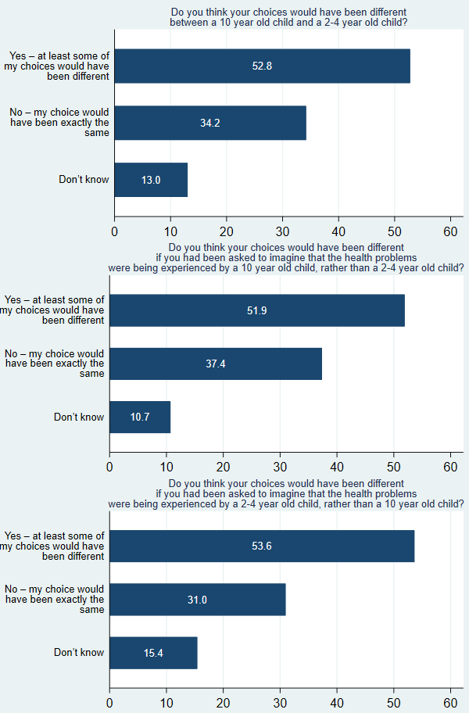
Figure S2: stated preferences: whether adults’ preferences differ by age
Note: question 2 (middle plot) is asked in study arm 2-4 year old; question 3 (bottom plot) is asked in study arm 10 year old; question 1 (top plot) is the combined results.

Table S6: Comparison between different CHU9D value sets
Country | Australia (current study general adult population value set) | Australia | China | UK | Netherlands | Australia (current study general parent population value set)
Preference elicitation method | DCE | BWS | BWS | SG | DCE with duration | DCE
Preference elicitation population | National representative general adults (age: 18y+), n=3112 | A community-based sample of adolescents (age: 11-17y), n=1982 | Students from primary and high schools (mean age: 13y), n=902 | A random street sample in Sheffield and Huddersfield, n=300 | A representative sample of Netherlands general adult population (n=1276) | National representative general parents of 0-18 years old, n=953
Perspective | Adults think of a child (age 2-4 versus 10) | Adolescent thinks of themselves | Adolescent thinks of themselves | Adults think of themselves | Adults think of themselves | Adults think of a child
Anchoring method | VAS | TTO | TTO | NA | NA | VAS
Anchoring population | Same population as preference elicitation | A convenient sample of undergraduate students (age: 18-29y), n=38 | A convenient sample of undergraduate students (mean age: 18y), n=38 | NA | NA | Same population as preference elicitation
Preference ranking of dimensions (ordered from highest to lowest utility loss at level 5) | Pain,  Sleep,  Daily routine,  Sad,  Worried,  Schoolwork,  Activities,  Annoyed,  Tired. | Sad,  Pain,  Daily routine,  Annoyed,  Sleep,  Schoolwork,  Worried,  Activities,  Tired. | Activities,  Tired,  Worried,  Schoolwork,  Sad,  Pain,  Sleep,  Daily routine,  Annoyed. | Pain,  Activities,  Daily routine,  Sleep,  Sad,  Schoolwork,  Tired,  Annoyed,  Worried. | Pain,  Sleep,  Activities,  Daily routine,  Worried,  Sad,  Tired, Annoyed,  Schoolwork. | Pain,  Sleep,  Daily routine,  Sad,  Worried,  Schoolwork,  Activities,  Annoyed,  Tired.
Example health state values
414355432 | 0.529 | 0.2505 | 0.5231 | 0.559 | 0.266 | 0.536
231345314 | 0.798 | 0.4250 | 0.5448 | 0.730 | 0.543 | 0.800
423141114 | 0.805 | 0.5606 | 0.7218 | 0.834 | 0.660 | 0.799
333333333 | 0.755 | 0.2536 | 0.5026 | 0.653 | 0.536 | 0.750
555555555 | 0.220 | -0.1059 | 0.0563 | 0.326 | -0.568 | 0.230
NA=not applicable
Example values were extracted from literature or calculated from the published value set.

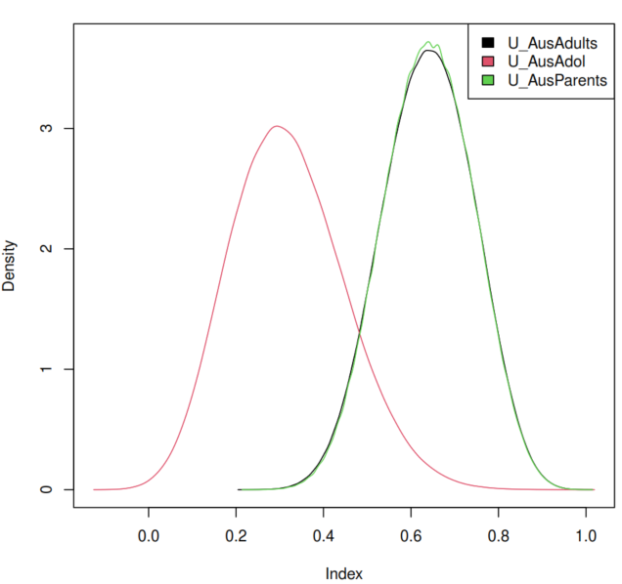
Figure S3 Kernel density plot: comparing the current CHU9D value sets (general population preferences, general parent preferences) with existing Australian CHU9D value set (adolescent preferences)
Note: Kernel density plots. Included all possible CHU9D health states: 1953125 health states. Kernel density plots refer to Tianxin Pan 2022 [12] and Nicolas Boukaert 2022 [13].

Sensitivity analyses (robustness check)
Table S7: Sensitivity analyses
 | Main model | Quality criteria |  | Model specifications
Variable | Conditional logit model | Add individual choice task speeders | Add not fully engaged responses | Mixed logit model
A_1dum2 | -0.248*** | -0.209*** | -0.251*** | -0.264***
A_1dum3 | -0.331*** | -0.285*** | -0.328*** | -0.350***
A_1dum4 | -0.659*** | -0.575*** | -0.656*** | -0.733***
A_1dum5 | -0.955*** | -0.828*** | -0.951*** | -1.117***
A_2dum2 | -0.295*** | -0.259*** | -0.296*** | -0.348***
A_2dum3 | -0.235*** | -0.183*** | -0.238*** | -0.260***
A_2dum4 | -0.650*** | -0.550*** | -0.646*** | -0.747***
A_2dum5 | -1.057*** | -0.903*** | -1.057*** | -1.230***
A_3dum2 | -0.620*** | -0.532*** | -0.613*** | -0.679***
A_3dum3 | -0.741*** | -0.638*** | -0.733*** | -0.838***
A_3dum4 | -1.865*** | -1.599*** | -1.848*** | -2.166***
A_3dum5 | -1.700*** | -1.446*** | -1.689*** | -1.994***
A_4dum2 | -0.111*** | -0.095** | -0.111*** | -0.136***
A_4dum3 | -0.118*** | -0.098*** | -0.116*** | -0.148***
A_4dum4 | -0.330*** | -0.300*** | -0.328*** | -0.370***
A_4dum5 | -0.531*** | -0.447*** | -0.518*** | -0.577***
A_5dum2 | -0.158*** | -0.152*** | -0.148*** | -0.164***
A_5dum3 | -0.111** | -0.120*** | -0.103** | -0.123**
A_5dum4 | -0.259*** | -0.256*** | -0.242*** | -0.283***
A_5dum5 | -0.586*** | -0.520*** | -0.575*** | -0.644***
A_6dum2 | -0.164*** | -0.148*** | -0.161*** | -0.228***
A_6dum3 | -0.276*** | -0.257*** | -0.275*** | -0.309***
A_6dum4 | -0.769*** | -0.663*** | -0.766*** | -0.874***
A_6dum5 | -0.814*** | -0.707*** | -0.807*** | -0.923***
A_7dum2 | -0.306*** | -0.269*** | -0.304*** | -0.340***
A_7dum3 | -0.325*** | -0.287*** | -0.328*** | -0.364***
A_7dum4 | -0.872*** | -0.758*** | -0.869*** | -1.006***
A_7dum5 | -1.138*** | -0.991*** | -1.124*** | -1.314***
A_8dum2 | -0.400*** | -0.351*** | -0.400*** | -0.433***
A_8dum3 | -0.349*** | -0.309*** | -0.347*** | -0.391***
A_8dum4 | -0.874*** | -0.766*** | -0.874*** | -0.966***
A_8dum5 | -1.080*** | -0.934*** | -1.082*** | -1.209***
A_9dum2 | 0.105** | 0.094** | 0.106** | 0.133**
A_9dum3 | -0.160*** | -0.121*** | -0.155*** | -0.158***
A_9dum4 | -0.179*** | -0.142*** | -0.176*** | -0.214***
A_9dum5 | -0.670*** | -0.568*** | -0.667*** | -0.767***
Sample size | N=3112 | N=3488 | N=3188 | N=3112
Observations | 74688 | 83712 | 76512 | 74688
Log likelihood | -21239.47 | -24879.75 | -21979.79 | -21040.61
AIC | 42550.94 | 49831.49 | 43667.58 | 42225.22
BIC | 42882.90 | 50167.56 | 44000.41 | 42889.14

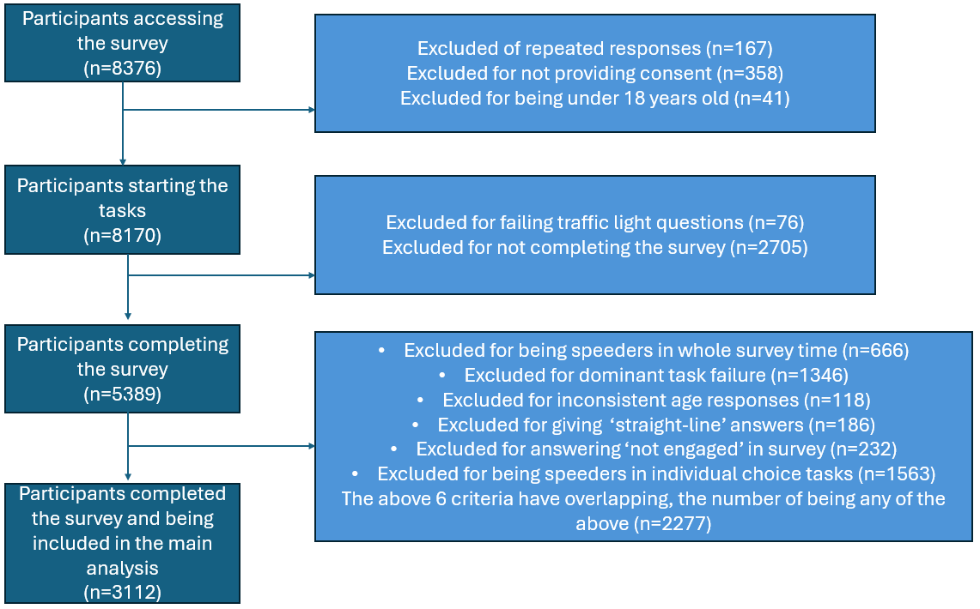
Figure S4: Flow diagram of the survey respondents from initiation to final inclusion in the analysis.

Table S8. demographic characteristics for those who completed the survey but not included in the final analysis
Baseline characteristics | Arm 1 (2-4y)  N=1284 | Arm 2 (10y)  N=993 | Pooled  (N=2277)
Gender
Female | 473(36.84) | 357(35.95) | 830(36.45)
Male | 808(62.93) | 631(63.54) | 1439(63.20)
Other | 3(0.23) | 5(0.50) | 8(0.35)
Age groups
18-24 years | 297(23.13) | 197(19.84) | 494(21.70)
25-34 years | 387(30.14) | 348(35.05) | 735(32.28)
35-44 years | 327(25.47) | 255(25.68) | 582(25.56)
45-54 years | 179(13.94) | 113(11.38) | 292(12.82)
55-64 years | 55(4.28) | 55(5.54) | 110(4.83)
65+ | 39(3.04) | 25(2.52) | 64(2.81)
Aboriginal or Torress Strait Island origin
No | 871(67.83) | 720(72.51) | 1591(69.87)
Yes | 413(32.17) | 273(27.49) | 686(30.13)
Region combined
NSW/ACT | 511(39.80) | 407(40.99) | 918(40.32)
VIC/TAS | 332(25.86) | 277(27.90) | 609(26.75)
QLD | 220(17.13) | 154(15.51) | 374(16.43)
SA/NT | 99(7.71) | 75(7.55) | 174(7.64)
WA | 122(9.50) | 80(8.06) | 202(8.87)
Employment
Full time | 839(65.34) | 656(66.06) | 1495(65.66)
Part time | 253(19.70) | 169(17.02) | 422(18.53)
Away from work | 43(3.35) | 36(3.63) | 79(3.47)
Unemployed | 149(11.60) | 132(13.29) | 281(12.34)
Marital status
Single | 395(30.76) | 321(32.33) | 716(31.44)
Married/Partner | 804(62.62) | 607(61.13) | 1411(61.97)
Separated | 24(1.87) | 18(1.81) | 42(1.84)
Divorced | 33(2.57) | 30(3.02) | 63(2.77)
Widowed | 13(1.01) | 6(0.60) | 19(0.83)
Prefer not to say | 15(1.17) | 11(1.11) | 26(1.14)
Qualification
None | 204(15.89) | 147(14.80) | 351(15.42)
Trade/Apprenticeship | 141(10.98) | 96(9.67) | 237(10.41)
Certificate/Diploma | 298(23.21) | 220(22.16) | 518(22.75)
Undergraduate degree | 420(32.71) | 350(35.25) | 770(33.82)
Postgraduate degree | 204(15.89) | 162(16.31) | 366(16.07)
Household weekly income before tax
Less than $300 per week ($15,999 or less per year) | 95(7.40) | 71(7.15) | 166(7.29)
$300-$499 per week ($15,600-$25,999 per year) | 80(6.23) | 79(7.96) | 159(6.98)
$500-$999 per week ($26,000-$51,999 per year) | 194(15.11) | 139(14.00) | 333(14.62)
$1,000-$1,999 per week ($52,000-$103,999 per year) | 331(25.78) | 258(25.98) | 589(25.87)
$2,000-$2,999 per week ($104,000-$155,999 per year) | 294(22.90) | 212(21.35) | 506(22.22)
$3,000-$3,999 per week ($156,000-$207,999 per year) | 171(13.32) | 144(14.50) | 315(13.83)
$4,000 or more per week ($208,000 or more per year) | 119(9.27) | 90(9.06) | 209(9.18)
General health status
Excellent | 348(27.10) | 283(28.50) | 631(27.71)
Very good | 456(35.51) | 340(34.24) | 796(34.96)
Good | 336(26.17) | 246(24.77) | 582(25.56)
Fair | 123(9.58) | 96(9.67) | 219(9.62)
Poor | 21(1.64) | 28(2.82) | 49(2.15)
Have children
No | 634(49.38) | 499(50.25) | 1133(49.76)
Yes | 650(50.62) | 494(49.75) | 1144(50.24)
Have experienced illness
No | 459(35.75) | 422(42.50) | 881(38.69)
Yes | 825(64.25) | 571(57.50) | 1396(61.31)

