Cost-Effectiveness Analysis of Aztreonam-Avibactam (ATM-AVI) versus Colistin + Meropenem (COL + MER) for the Treatment of Infections Caused by Metallo-β-Lactamase (MBL)-producing Enterobacterales in Italy

Cost-effectiveness analysis of ATM-AVI versus COL + MER

Marco Falcone¹, Xiyu Bao², Fionn Woodcock², Roberto Di Virgilio³, Maria Alejandra Vidal Pereira³, Michal Kantecki⁴, Maria Gheorghe⁵

- University of Pisa, Italy
- Source Health Economics, London, United Kingdom
- Pfizer Italy, Rome, Italy
- Pfizer International Operations, Paris, France
- Pfizer Inc., Sos. Bucuresti-Ploiesti, Nr. 172-176, 040291, Bucharest, Romania.
- Supplementary materials
  - Supplementary methods
    - Assumptions of model
Base-case model assumptions and the rationale for each assumption are in Supplementary Table 1. These were validated with clinical experts and, where appropriate, alternative assumptions explored in sensitivity/scenario analyses.
Supplementary Table 1: Model assumptions
Assumption | Rationale
Probability of cure and 28-day mortality for each treatment were applied equally at any line of treatment | Validated with clinical experts
Patients with resistant pathogen were considered to have a treatment failure and will switch to the next line of treatment after Day 3 | This assumption is validated with clinical experts
The probability of resistance to COL + MER is equal to resistance to COL monotherapy | There is no published data on the probability of resistance to combination therapy. This approach was validated with clinical experts
Patients with no response at TOC would start the next line of treatment | Clinical experts suggest that it is appropriate to assume that patients with no response at TOC switch to a next line of treatment
Patients who show no response in 2L would discontinue treatment | Clinical experts agreed that it is an appropriate simplification to assume patients with no response to discontinue treatment after 2L
After 2L of treatment, patients who show response would enter the long-term Markov model | Clinical experts suggest that it is appropriate to assume patients with response to enter the long-term Markov model after LFU
After exhausting all lines of treatment patients with no response would receive 1 week of BSC. The model assumed that all patients with no response at after 2L would die within a week | Clinical experts suggest that it is appropriate to assume patients with no response receive 1 week of BSC and will die within a month. Scenarios without BSC and where BSC is 3 weeks were analysed
Patients with pathogen(s) resistant to the empiric therapy were assumed to have higher mortality than susceptible patients | According to published literature an odds ratio of 1.84 probability of death increase for patients with resistant pathogen(s) to the empiric therapy when switching treatment lines [50]
Patients with pathogen(s) resistant to the empiric therapy were assumed to have higher in-hospital costs associated with an increased LOS | This is consistent with published literature, a recent meta-analysis has shown that, compared to susceptible infections, patients with resistant infections have a 40% increase in hospital LOS [50]
Compared to susceptible infections, patients with pathogen(s) resistant to the empiric therapy were assumed to have a higher risk of recurrence | This is consistent with published literature, which shows an OR of 1.49 for recurrence in patients with a resistant infection [50]
Patients in all arms are at risk of developing NTX. Patients with NTX will have a short -term cost and QALY loss, with a proportion requiring long-term RRT | There is a high risk of NTX for patients treated with COL + MER, however this is a risk in all arms. These assumptions have been validated with clinical experts.
Health state utilities were applied at the start of the model and held constant until the end of the decision tree model. For every year after this a multiplier is applied based on the ratio between the general population utility values for the current age and the starting age. General population utility values are taken from Hernandez-Alava et al. 2022 [64] | Consistent with the approach used in previous studies [80]
Recurrence disutility was assumed to be the difference between cured and uncured utilities for all indications | Assumption validated by clinical experts.
All patients with cIAI who did not achieve response at the end of treatment sequence receive secondary surgery | Clinical experts agreed that this was a reasonable assumption, stating that most patients will require a secondary surgery, with only those patients that were too frail not receiving surgery.
The one-off cost of secondary surgery to be the same as cost of recurrence of cIAI | Assumption validated by clinical experts.
Mortality in the long-term model is derived from Italian lifetables, with an adjustment applied for CCI score | This is consistent with the published literature and has been validated by clinical experts
Abbreviations: AMR, antimicrobial resistance; BSC, best supportive care; cIAI, complicated intra-abdominal infections; COL + MER, colistin + meropenem; HAP, hospital-acquired pneumonia; LFU, long-term follow-up; LOS, length of stay; Micro-ITT, microbiological intent-to-treat; NTX, nephrotoxicity; TOC, test of cure; VAP, ventilator-associated pneumonia; 2L, second-line.
    - Details of clinical expert elicitation
Clinical expert opinion was elicited to inform the development and validation of the economic models for ATM-AVI. Two infectious disease specialists with relevant clinical and academic experience participated in a structured expert meeting held on 22 February 2024: Professor Matteo Bassetti and Professor Marco Falcone. During the meeting, the experts were introduced to the aims of the economic analysis and the structure of the model, which included a short-term decision tree reflecting the REVISIT trial [26], followed by a long-term Markov model to capture lifetime outcomes. The decision problem and key model assumptions were discussed. Experts reviewed and validated the proposed model structure, discussed the relevant second-line treatments, and provided input on clinical outcomes such as assumptions on BSC, mortality rates, cure rates, resistance rates, recurrence, and the impact of side effects on costs (i.e. NTX). Their feedback was used to refine model inputs and ensure clinical validity.
    - Additional model inputs
Supplementary Table 2: Model inputs and data sources
Model input | Indication | Parameter | Cefiderocol
Treatment probability of cure and 28-day mortality | cIAI | Cure | 65.52
Treatment probability of cure and 28-day mortality | cIAI | Death | 15.00
Treatment probability of cure and 28-day mortality | HAP/VAP | Cure | 65.52
Treatment probability of cure and 28-day mortality | HAP/VAP | Death | 15.00
Source: CREDIBLE-CR trial [58].
Abbreviations: cIAI, complicated intra-abdominal infections; HAP/VAP, hospital-acquired pneumonia/ventilator-associated pneumonia.

    - Long-term mortality
Supplementary Table 3: Hazard ratio based on CCI score
CCI score | % of patients [41] | Hazard ratio [52]
0 | 0.00% | 1.00
1–2 | 10.64% | 2.00
3 | 4.26% | 2.50
4 | 6.38% | 2.50
5 | 25.53% | 4.70
≥6 | 53.19% | 4.70
Abbreviations: CCI, Charlson Comorbidity Index.
    - Costs data
Supplementary Table 4: Treatment costs
Drug | Cost per vial | Vial size | Information on dosing | Average Daily Dose | Daily cost  (excluding loading dose)
ATM-AVI | €200.41 [68] | 1.5 g ATZ  0.5 g  AVI | - A starting dose of 10 mL administered in solution via IV over 30 minutes immediately followed by  - An extended dose of 30 mL infused over 3 hours.  - This is then followed by a maintenance dose of 30 mL infused over 3 hours, q6h [26] | 6 g ATM  0.5 g AVI | €801.64
MTZ | €1.54 [68] | 500 mg | 500 mg 100 mL-1 MTZ IV infusion over 1hr (q8h) [7, 26] | 1,500 mg | €4.62
MER | €18.44 [68] | 1,000 mg | 1,000 mg meropenem by 180 min IV infusion q8h [26, 81] | 3,000 mg | €55.32
COL | €11.65 [68] | 1 million | 18 million IU on Day 1; 9 million IU daily on subsequent days [26, 67] | 9 million IU | €104.85
Cefiderocol | €135.38 [68] | 1,000 mg | 2 g q8h [33] | 6,000 mg | €812.28
Abbreviations: ATM-AVI, aztreonam-avibactam; COL, colistin; g, gram; IU, international units; IV, intravenous; mg, milligram; mL, millilitre; MER, meropenem; MTZ, metronidazole; q6h, every 6 hours; q8h, every 8 hours.

Supplementary Table 5: Length of hospital stay
 | Response | ICU (days)ª | General ward (days) | Source
cIAI | Cure | 0.60 | 8.87 | REVISIT [26]
cIAI | Failure | 2.19 | 12.30 | REVISIT [26]
HAP/VAP | Cure | 9.06 | 10.18 | REVISIT [26]
HAP/VAP | Failure | 15.33 | 9.13 | REVISIT [26]
ª ICU (days) is calculated as a difference between weighted total number of hospitalisation (days) by response and weighted average of general ward (days) by response. ^{b} General ward (days) is calculated as a weighted average of general ward (days) by response in the ATM-AVI ± MTZ arm and the COL + MER arm.
Abbreviations: cIAI, complicated intra-abdominal infections; CSR, clinical study report; HAP, hospital-acquired pneumonia; ICU, intensive care unit; VAP, ventilator-associated pneumonia.

Supplementary Table 6: Hospital per-diem costs
 | Cost per day | Source
ICU | €1, 696.07 | Tan et al [82]  World Bank inflation indices [66]
General ward | €925.62 | Ministero dell’Economia e delle Finanze 2007 [83]  World Bank inflation indices [66]
Abbreviations: ICU intensive care unit.

Supplementary Table 7: Additional LOS due to NTX
 | Additional LOS (days) | Source
Non-RRT | 2.3 | Simon et al [61]
RRT | 5.2 | Simon et al [61]
Abbreviations: LOS, length of stay; NTX, nephrotoxicity; RRT, renal replacement therapy.

Supplementary Table 8: Cost of in-hospital and long-term dialysis
 | Value | Source
Number of in-hospital dialysis sessions | 2.6 | Assumes dialysis every other day per duration of additional LOS
Cost per instance of in-hospital dialysis | €147.25 | Tariffe assistenza specialistica ambulatoriale [84]
Annual cost of long-term dialysis | €26,518 | Roggeri et al [71]
Abbreviations: LOS, length of stay.

Supplementary Table 9: Recurrence costs
Indication | Cost per event | Source
cIAI | €8,695.41 | LoS from REVISIT [28]  Cost per day of hospitalisation from Tan et al [82]  Ministero dell’Economia e delle Finanze 2007 [83]
HAP/VAP | €24,359.99
Abbreviations: ATM-AVI, aztreonam-avibactam; cIAI, complicated intra-abdominal infections; HAP, hospital-acquired pneumonia; LoS, length of stay VAP, ventilator-associated pneumonia.

Supplementary Table 10: BSC costs
 | Value | Source
Length of receiving BSC (weeks) | 1 | Assumption
General ward, cost per day | €925.62 | Ministero dell’Economia e delle Finanze 2007 [83]  World Bank inflation indices [66]
Total BSC cost (one week) | €6,479.35 | –
Abbreviations: BSC, best supportive care.
  - Supplementary results
    - Scenario analysis
Supplementary Table 11: Additional scenario analysis for suspected MBL-CRE; cIAI and HAP/VAP
Scenario | Indication | Incremental costs | Incremental QALYs | ICER | NMB
Time-horizon = 1 year | cIAI | € 281 | 0.08 | € 3,556 | € 2,090
Time-horizon = 1 year | HAP/VAP | € 613 | 0.07 | € 8,821 | € 1,472
Time-horizon = 5 years | cIAI | -€ 78 | 0.33 | -€ 239 | € 9,875
Time-horizon = 5 years | HAP/VAP | € 495 | 0.23 | € 2,170 | € 6,347
No discounting | cIAI | -€ 726 | 0.76 | -€ 954 | € 23,546
No discounting | HAP/VAP | € 427 | 0.32 | € 1,341 | € 9,120
Length of BSC = 0 weeks | cIAI | -€ 364 | 0.63 | -€ 575 | € 19,345
Length of BSC = 0 weeks | HAP/VAP | € 491 | 0.29 | € 1,700 | € 8,168
Length of BSC = 3 weeks | cIAI | -€ 875 | 0.63 | -€ 1,384 | € 19,851
Length of BSC = 3 weeks | HAP/VAP | € 364 | 0.29 | € 1,256 | € 8,342
No impact of AMR on mortality | cIAI | -€ 682 | 0.63 | -€ 1,080 | € 19,638
No impact of AMR on mortality | HAP/VAP | € 301 | 0.29 | € 1,043 | € 8,351
No impact of AMR on recurrence | cIAI | -€ 499 | 0.63 | -€ 791 | € 19,422
No impact of AMR on recurrence | HAP/VAP | € 549 | 0.29 | € 1,916 | € 8,050
No impact of AMR on LOS | cIAI | € 897 | 0.63 | € 1,419 | € 18,082
No impact of AMR on LOS | HAP/VAP | € 3,717 | 0.29 | € 12,855 | € 4,958
100% resistance to COL + MER | cIAI | -€ 1,136 | 1.81 | -€ 629 | € 55,327
100% resistance to COL + MER | HAP/VAP | € 3,292 | 0.31 | € 10,525 | € 6,092
NTX at 42% for COL | cIAI | -€ 1,090 | 0.64 | -€ 1,715 | € 20,148
NTX at 42% for COL | HAP/VAP | € 104 | 0.29 | € 360 | € 8,594
NTX for each treatment reduced by 20% | cIAI | -€ 160 | 0.63 | -€ 253 | € 19,086
NTX for each treatment reduced by 20% | HAP/VAP | € 681 | 0.29 | € 2,359 | € 7,977
NTX for each treatment increased by 20% | cIAI | -€ 909 | 0.63 | -€ 1,433 | € 19,942
NTX for each treatment increased by 20% | HAP/VAP | € 216 | 0.29 | € 747 | € 8,474
Length of BSC = 1 month | cIAI | -€ 1,105 | 0.63 | -€ 1,747 | € 20,079
Length of BSC = 1 month | HAP/VAP | € 308 | 0.29 | € 1,058 | € 8,420
Length of BSC = 3 months | cIAI | -€ 2,587 | 0.63 | -€ 4,093 | € 21,545
Length of BSC = 3 months | HAP/VAP | -€ 58 | 0.30 | -€ 197 | € 8,924
Length of BSC = 6 months | cIAI | -€ 4,810 | 0.63 | -€ 7,620 | € 23,745
Length of BSC = 6 months | HAP/VAP | -€ 607 | 0.30 | -€ 2,008 | € 9,679
Lowered COL + MER resistance by 10% | cIAI | -€ 328 | 0.59 | -€ 554 | € 18,091
Lowered COL + MER resistance by 10% | HAP/VAP | € 805 | 0.29 | € 2,795 | € 7,832
Lowered COL + MER resistance by 20% | cIAI | -€ 121 | 0.55 | -€ 220 | € 16,668
Lowered COL + MER resistance by 20% | HAP/VAP | € 1,161 | 0.29 | € 4,050 | € 7,438
No increased risk of mortality | cIAI | -€ 1,216 | 1.08 | -€ 1,127 | € 33,573
No increased risk of mortality | HAP/VAP | € 202 | 0.61 | € 330 | € 18,136
10% of BSC time in ICU | cIAI | -€ 549 | 0.63 | -€ 867 | € 19,528
10% of BSC time in ICU | HAP/VAP | € 445 | 0.29 | € 1,539 | € 8,229
20% of BSC time in ICU | cIAI | -€ 563 | 0.63 | -€ 890 | € 19,542
20% of BSC time in ICU | HAP/VAP | € 442 | 0.29 | € 1,527 | € 8,233
Disutility for chronic dialysis set to -0.177ª | cIAI | -€ 534 | 0.63 | -€ 848 | € 19,437
Disutility for chronic dialysis set to -0.177ª | HAP/VAP | € 449 | 0.29 | € 1,556 | € 8,203
ª Disutility calculated from Mozzi et al 2016 [85].
Abbreviations: AMR, antimicrobial resistance; BSC, best supportive care; cIAI, complicated intra-abdominal infections; COL, colistin; COL + MER, colistin + meropenem; ICU, intensive care unit; LOS, length of stay; NTX, nephrotoxicity; MBL-CRE, Metallo-β-lactamase-producing Carbapenem-resistant Enterobacterales.
    - Univariate sensitivity analysis
Supplementary Table 12: Univariate sensitivity analysis results for suspected MBL-CRE; cIAI
Parameter | NMB at lower value of parameter | NMB at upper value of parameter
Base-case | €19,514
Treatment Cure Probabilities - ATM-AVI | £3,899 | £35,129
Probability of resistance – COL + MER | £14,915 | £24,664
CCI score = 5 - Hazard ratio | £21,361 | £18,015
Treatment duration - ATM-AVI | £20,745 | £18,283
Death probabilities - ATM-AVI | £20,624 | £18,404
General ward (days) - Failure | £18,716 | £20,312
General ward (days) - Cure | £19,934 | £19,094
Unit Costs of ICU - cIAI | £19,117 | £19,911
Probability of resistance - ATM-AVI | £19,860 | £19,099
Unit Costs of General Ward | £19,135 | £19,893
Abbreviations: ATM-AVI, aztreonam-avibactam; BSC, best supportive care; CCI, Charlson Comorbidity Index; cIAI, complicated intra-abdominal infections; COL + MER, colistin + meropenem; ICU, intensive care unit; LOS, length of stay; NMB, net monetary benefit; MBL, metallo-β-lactamase; RRT, renal replacement therapy.

Supplementary Table 13: Univariate sensitivity analysis results for suspected MBL-CRE; HAP/VAP
Parameter | NMB at lower value of parameter | NMB at upper value of parameter
Base-case | €8,226
Treatment Cure Probabilities - ATM-AVI | £3,329 | £13,123
Treatment duration - ATM-AVI | £9,867 | £6,585
Treatment Cure Probabilities - Cefiderocol | £10,219 | £7,010
ICU (days) - Failure | £6,797 | £9,654
Probability of Resistance - Colistin + meropenem | £6,953 | £9,651
Death probabilities - ATM-AVI | £9,428 | £7,023
Unit Costs of ICU | £7,161 | £9,291
CCI score = 5 - Hazard ratio | £9,327 | £7,377
% Increase in hospital unit cost if resistant | £7,572 | £8,879
ICU (days) - Cure | £8,778 | £7,673
Abbreviations: ATM-AVI, aztreonam-avibactam; BSC, best supportive care; CCI, Charlson Comorbidity Index; COL + MER, colistin + meropenem; HAP/VAP, hospital-acquired pneumonia/ventilator-associated pneumonia; ICU, intensive care unit; LOS, length of stay; NMB, net monetary benefit; MBL, metallo-β-lactamase; RRT, renal replacement therapy.
Supplementary Table 14: Univariate sensitivity analysis upper and lower bounds
Parameter | In DSA
Parameter | Lower bound | Upper bound
Resistance rate for ATM-AVI ± MTZ, % | 0.010603935 | 0.022467586
Resistance rate for COL, % | 0.172590215 | 0.347279627
Requiring short-term RRT | 0.0416 | 0.0624
Requiring long-term RRT | 0.0192 | 0.0288
Utility value for uncured patients - cIAI | 0.58058395 | 0.870875925
Utility value for uncured patients - HAP/VAP | 0.561731821 | 0.842597732
Disutility for NTX | -0.084 | -0.056
Disutility for chronic dialysis | -0.3 | -0.2
ICU - cure - cIAI | 0.48 | 0.72
GW - cure - cIAI | 7.092544379 | 10.63881657
ICU - failure - cIAI | 1.751351351 | 2.627027027
GW - failure - cIAI | 9.84 | 14.76
ICU - cure - HAP/VAP | 7.245714286 | 10.86857143
GW - cure - HAP/VAP | 8.142857143 | 12.21428571
ICU - failure - HAP/VAP | 12.26666667 | 18.4
GW - failure - HAP/VAP | 7.306666667 | 10.96
ICU - cost per day | 694.2604804 | 1041.390721
GW - cost per day | 1272.135754 | 1908.203631
Non-RRT - Additional length of stay (days) | 1.84 | 2.76
RRT - Additional length of stay (days) | 4.16 | 6.24
Number of in-hospital dialysis sessions | 2.08 | 3.12
Cost per instance of in-hospital dialysis | 117.8 | 176.7
Annual cost of long-term dialysis | 21214.4 | 31821.6
Cost per event - cIAI | 6956.328158 | 10434.49224
Cost per event - HAP/VAP | 19487.99006 | 29231.98508
Note: Parameters not listed in the table are not varied in the DSA.
Abbreviations: ATM-AVI, aztreonam-avibactam; cIAI, complicated intra-abdominal infections; COL, colistin; DSA, deterministic sensitivity analysis; GW, general ward; HAP/VAP, hospital-acquired pneumonia/ventilator-associated pneumonia; ICU, intensive care unit; MTZ, metronidazole NTX, nephrotoxicity; RRT, renal-replacement therapy.
    - Probabilistic sensitivity analyses
Supplementary Table 15: Probabilistic sensitivity analysis; cIAI
Technology | Total costs | Total QALYs | Incremental costs | Incremental QALYs | ICER
Comparator arm | € 19,140 | 5.74 | - | - | -
Intervention arm | € 18,606 | 6.38 | -€535 | 0.64 | Dominant
Abbreviations: cIAI, complicated intra-abdominal infections; ICER, incremental cost-effectiveness ratio; QALY, quality-adjusted life year.

Supplementary Table 16: Probabilistic sensitivity analysis: HAP/VAP
Technology | Total costs | Total QALYs | Incremental costs | Incremental QALYs | ICER
Comparator arm | € 42,641 | 2.26 | - | - | -
Intervention arm | € 43,096 | 2.55 | € 455 | 0.29 | € 1,581
Abbreviations: HAP/VAP, hospital-acquired pneumonia/ventilator-associated pneumonia; ICER, incremental cost-effectiveness ratio; QALY, quality-adjusted life year.
Supplementary Table 17: Probabilistic sensitivity analysis distributions
Parameter | Distribution in PSA
Resistance rate for ATM-AVI ± MTZ, % | Beta
Resistance rate for COL, % | Beta
Treatment Cure Probabilities - ATM-AVI - cIAI | Dirichlet
Treatment Cure Probabilities -COL- cIAI | Dirichlet
28-mortality - ATM-AVI - cIAI | Dirichlet
28-mortality - COL - cIAI | Dirichlet
Treatment Cure Probabilities - ATM-AVI - HAP/VAP | Dirichlet
Treatment Cure Probabilities -COL- HAP/VAP | Dirichlet
28-mortality - ATM-AVI - HAP/VAP | Dirichlet
28-mortality - COL - HAP/VAP | Dirichlet
Requiring short-term RRT | Beta
Requiring long-term RRT | Beta
Utility value for uncured patients - cIAI | Beta
Utility value for uncured patients - HAP/VAP | Beta
Disutility for NTX | Beta
Disutility for chronic dialysis | Beta
Treatment Cure Probabilities - Cefiderocol - cIAI | Dirichlet
28-mortality - Cefiderocol - cIAI | Dirichlet
Treatment Cure Probabilities -Cefiderocol- HAP/VAP | Dirichlet
28-mortality - Cefiderocol - HAP/VAP | Dirichlet
ICU - cure - cIAI | Gamma
GW - cure - cIAI | Gamma
ICU - failure - cIAI | Gamma
GW - failure - cIAI | Gamma
ICU - cure - HAP/VAP | Gamma
GW - cure - HAP/VAP | Gamma
ICU - failure - HAP/VAP | Gamma
GW - failure - HAP/VAP | Gamma
ICU - cost per day | Gamma
GW - cost per day | Gamma
Non-RRT - Additional length of stay (days) | Gamma
RRT - Additional length of stay (days) | Gamma
Number of in-hospital dialysis sessions | Normal
Cost per instance of in-hospital dialysis | Gamma
Annual cost of long-term dialysis | Gamma
Cost per event - cIAI | Gamma
Cost per event - HAP/VAP | Gamma
Note: Parameters not listed in the table are not varied in the PSA.
Abbreviations: ATM-AVI, aztreonam-avibactam; cIAI, complicated intra-abdominal infections; COL, colistin; GW, general ward; HAP/VAP, hospital-acquired pneumonia/ventilator-associated pneumonia; ICU, intensive care unit; MTZ, metronidazole NTX, nephrotoxicity; PSA, probabilistic sensitivity analysis; RRT, renal-replacement therapy.
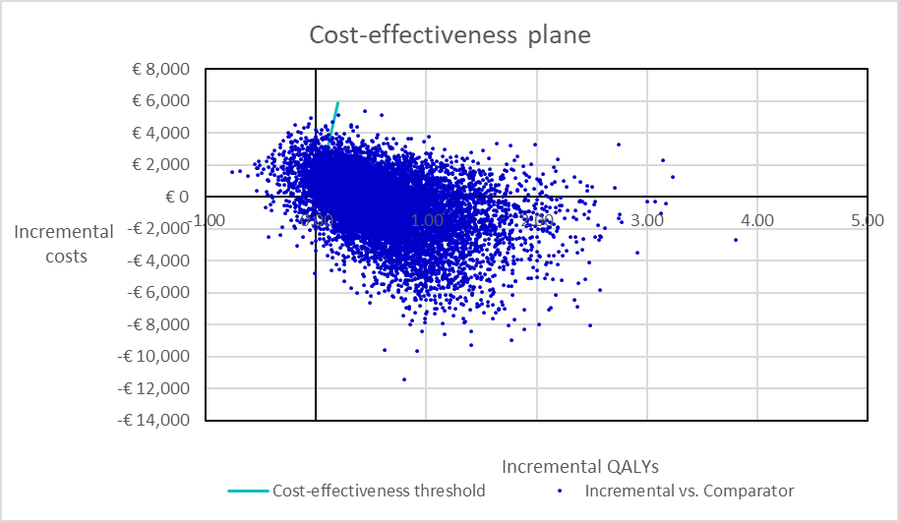

Supplementary Figure 1: Cost-effectiveness plane for cIAI.
Abbreviations: cIAI, complicated intra-abdominal infections; QALY, quality-adjusted life year.
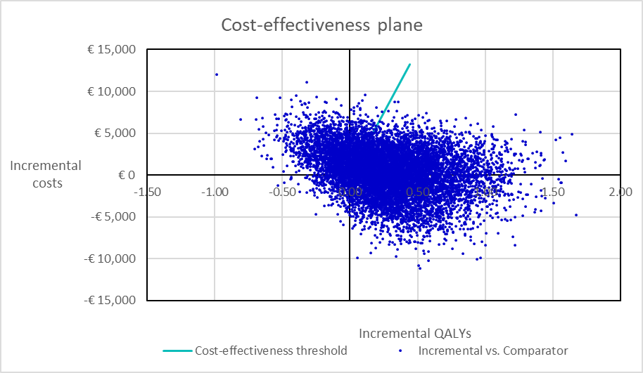

Supplementary Figure 2: Cost-effectiveness plane for HAP/VAP.
Abbreviations: HAP/VAP, hospital-acquired pneumonia/ventilator-associated pneumonia; QALY, quality-adjusted life year.

