Supplementary Materials

Table S1. Number and proportion of respondents dropped, by study arm
Survey Arm | Total | Dropped | Included
4-year-old child | 300 | 21 (7%) | 279 (93%)
10-year-old child | 1,000 | 54 (5%) | 946 (95%)
Child (unspec. age) | 300 | 16 (5%) | 284 (95%)
Other adult | 301 | 10 (3%) | 291 (97%)
Adult self | 300 | 20 (7%) | 280 (93%)
Respondents were dropped if they provided a value of 1 for either 33333 or ‘being dead’.

Table S2. OPUF dimension weighting
EQ-5D Dimension | Survey Arm | Mean | SD | Median | IQR
Mobility | 4-year-old child | 75.3 | 22.6 | 80 | 30
Mobility | 10-year-old child | 79.0 | 21.2 | 85 | 28
Mobility | Child (unspecified) | 77.9 | 21.8 | 83 | 31.5
Mobility | Other adult | 76.1 | 23.9 | 80 | 36
Mobility | Adult self | 75.2 | 26.1 | 80 | 24
Self-Care | 4-year-old child | 57.8 | 27.2 | 60 | 40.5
Self-Care | 10-year-old child | 65.4 | 25.6 | 70 | 35
Self-Care | Child (unspecified) | 65.9 | 26.3 | 70 | 38
Self-Care | Other adult | 72.2 | 26.8 | 78 | 44
Self-Care | Adult self | 70.6 | 30.0 | 79.5 | 46.5
Usual Activities | 4-year-old child | 74.7 | 20.9 | 79.5 | 24
Usual Activities | 10-year-old child | 76.8 | 21.3 | 80 | 29
Usual Activities | Child (unspecified) | 77.4 | 20.5 | 81 | 27.5
Usual Activities | Other adult | 75.5 | 23.2 | 80 | 33
Usual Activities | Adult self | 72.1 | 25.5 | 80 | 33.5
Pain / Discomfort | 4-year-old child | 94.1 | 16.1 | 100 | 0
Pain / Discomfort | 10-year-old child | 94.1 | 14.3 | 100 | 2
Pain / Discomfort | Child (unspecified) | 95.6 | 12.3 | 100 | 0
Pain / Discomfort | Other adult | 86.9 | 21.5 | 100 | 17
Pain / Discomfort | Adult self | 85.6 | 24.3 | 100 | 20
Worried, sad or unhappy | 4-year-old child | 81.6 | 22.6 | 90 | 27.5
Worried, sad or unhappy | 10-year-old child | 83.0 | 21.0 | 90 | 28
Worried, sad or unhappy | Child (unspecified) | 82.9 | 22.3 | 91 | 24
Worried, sad or unhappy | Other adult | 81.0 | 23.3 | 90 | 30
Worried, sad or unhappy | Adult self | 76.0 | 27.1 | 85 | 43
SD = Standard Deviation; IQR = Interquartile Range.

Table S3. OPUF level weighting
EQ-5D Level | Survey Arm | Mean | SD | Median | IQR
Mobility  (Level 2) | 4-year-old child | 53.1 | 22.9 | 53 | 34.5
Mobility  (Level 2) | 10-year-old child | 52.8 | 23.4 | 52 | 35
Mobility  (Level 2) | Child (unspecified) | 53.2 | 23.6 | 50.5 | 35
Mobility  (Level 2) | Other adult | 51.4 | 22.5 | 50 | 34
Mobility  (Level 2) | Adult self | 51.3 | 26.6 | 50 | 39
Self-Care  (Level 2) | 4-year-old child | 52.7 | 22.6 | 51 | 35
Self-Care  (Level 2) | 10-year-old child | 51.8 | 21.8 | 50 | 33
Self-Care  (Level 2) | Child (unspecified) | 52.7 | 21.9 | 52.5 | 28
Self-Care  (Level 2) | Other adult | 50.8 | 24.5 | 51 | 38
Self-Care  (Level 2) | Adult self | 48.4 | 26.9 | 50 | 39
Usual Activities  (Level 2) | 4-year-old child | 55.0 | 20.6 | 55 | 30
Usual Activities  (Level 2) | 10-year-old child | 53.3 | 21.7 | 51 | 30
Usual Activities  (Level 2) | Child (unspecified) | 54.4 | 21.7 | 52.5 | 30
Usual Activities  (Level 2) | Other adult | 52.3 | 20.6 | 50 | 27
Usual Activities  (Level 2) | Adult self | 51.0 | 24.4 | 50 | 36
Pain / Discomfort  (Level 2) | 4-year-old child | 50.9 | 27.2 | 50 | 42.5
Pain / Discomfort  (Level 2) | 10-year-old child | 51.7 | 25.5 | 50 | 41
Pain / Discomfort  (Level 2) | Child (unspecified) | 51.9 | 27.1 | 50 | 42.5
Pain / Discomfort  (Level 2) | Other adult | 52.5 | 23.0 | 50 | 35
Pain / Discomfort  (Level 2) | Adult self | 50.9 | 25.6 | 50 | 39
Worried, sad or unhappy  (Level 2) | 4-year-old child | 55.0 | 24.4 | 55 | 35.5
Worried, sad or unhappy  (Level 2) | 10-year-old child | 53.6 | 24.7 | 51.5 | 37
Worried, sad or unhappy  (Level 2) | Child (unspecified) | 51.7 | 24.9 | 50 | 40.5
Worried, sad or unhappy  (Level 2) | Other adult | 51.2 | 23.2 | 50 | 37
Worried, sad or unhappy  (Level 2) | Adult self | 53.5 | 25.2 | 50 | 40
SD = Standard Deviation; IQR = Interquartile Range. Level 1 is fixed at 100 and level 3 is fixed at 0.

Figure S1. Social utility functions by perspective
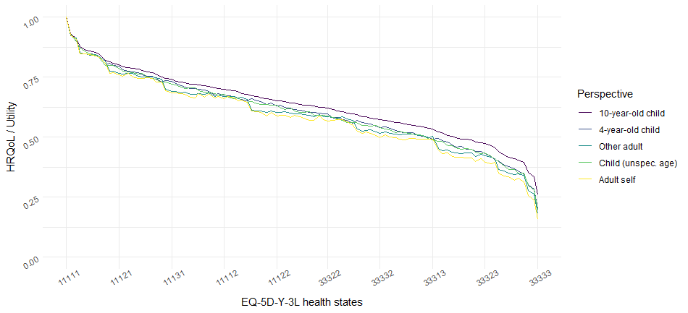
The 243 EQ-5D-Y health states have been ordered from best (11111) to worst (33333) according to the results for the 10-year-old child perspective, and the utility associated with each of these health states has been plotted for each of the perspectives.

Table S4. DCE interaction model
 | Baseline | Interaction Terms
 | 10-year-old child | 4-year-old child | Child (unspecified age) | Other adult | Adult self
Mobility  Level 2 | -0.496*** | 0.240* | 0.128 | 0.337*** | 0.188
Mobility  Level 2 | (0.0633) | (0.136) | (0.141) | (0.112) | (0.119)
Mobility  Level 3 | -1.266*** | 0.107 | 0.209 | 0.152 | -0.0814
Mobility  Level 3 | (0.106) | (0.242) | (0.240) | (0.184) | (0.195)
Looking after myself  Level 2 | -0.279*** | 0.184 | -0.0436 | -0.314*** | -0.187*
Looking after myself  Level 2 | (0.0503) | (0.117) | (0.109) | (0.0921) | (0.104)
Looking after myself  Level 3 | -1.048*** | 0.414** | 0.0914 | -0.438*** | -0.460***
Looking after myself  Level 3 | (0.0809) | (0.180) | (0.176) | (0.155) | (0.170)
Usual activities  Level 2 | -0.806*** | -0.0609 | 0.0725 | 0.226** | 0.249***
Usual activities  Level 2 | (0.0512) | (0.104) | (0.107) | (0.0924) | (0.0955)
Usual activities  Level 3 | -1.877*** | -0.0307 | 0.209 | 0.333** | 0.377**
Usual activities  Level 3 | (0.0899) | (0.186) | (0.187) | (0.151) | (0.164)
Pain or discomfort  Level 2 | -1.148*** | 0.0114 | -0.0106 | 0.574*** | 0.457***
Pain or discomfort  Level 2 | (0.0565) | (0.132) | (0.132) | (0.0986) | (0.108)
Pain or discomfort  Level 3 | -2.819*** | -0.201 | 0.0787 | 0.870*** | 0.745***
Pain or discomfort  Level 3 | (0.120) | (0.287) | (0.274) | (0.195) | (0.214)
Worried, sad or unhappy  Level 2 | -0.761*** | -0.191* | -0.0782 | 0.497*** | 0.215**
Worried, sad or unhappy  Level 2 | (0.0509) | (0.114) | (0.108) | (0.0871) | (0.0940)
Worried, sad or unhappy  Level 3 | -2.208*** | -0.261 | -0.0863 | 0.845*** | 0.431***
Worried, sad or unhappy  Level 3 | (0.0917) | (0.217) | (0.196) | (0.155) | (0.164)
N | 62,382
Log Likelihood | -12,337
Robust standard errors in parentheses. *** p<0.01, ** p<0.05, * p<0.1.

