External validation of the MicroSimulation Core Obesity Model (MS-COM) to predict cardiovascular outcomes, mortality, and Type 2 Diabetes Mellitus incidence and assess cost-effectiveness

Christopher G Fawsitt¹, Howard Thom^{1,2} David Aceituno^{1,3,4}, Alexander Jarde¹, Sara Larsen⁵, Christopher Lübker⁵, Edward Kayongo¹, Edna Keeney¹, Volker Foos⁶
¹ Clifton Insight, Bristol, UK
² Population Health Sciences, Bristol Medical School, University of Bristol, UK
³ King’s College, London, united Kingdom
⁴ Pontificia Universidad Católica de Chile, Chile
⁵ Novo Nordisk A/S, Søborg, Denmark
⁵ HEOR, Cardiff, UK

Corresponding author: Chris Lubker, Novo Nordisk A/S, Søborg, Denmark
Email: CJLU@novonordisk.com

Online resource 1 Summary of evidence reviews to inform external independent validation of the MicroSimulation Core Obesity Model (MS-COM)

Background
Novo Nordisk, working with Health Economics and Outcomes Research (HEOR), developed a Microsimulation Core Obesity Model (MS-COM) to assess the cost-effectiveness of semaglutide 2.4 mg in obesity. This model is an addition to the existing Core Obesity Model (COM), which is a cohort Markov model.¹ A microsimulation approach was adopted to address the challenge of representing interrelation of risk factors and nonlinearity of outcomes in obesity.² ³ Inputs were largely adapted from the COM model, utilising Qdiabetes risk equations and UKPDS. ⁴ ⁵ This evidence was supplemented with results from the pivotal STEP 1 study of semaglutide 2.4 mg for obesity, and the Qrisk3 and Framingham risk equations. ⁶⁻⁸ The latter were recommended improvements to COM by published commentaries.⁹
The model itself is illustrated in Figure 1. The time horizon was set to 80 years to allow evaluation in younger populations. Cycle length was variable, with the first eight cycles being quarterly and the latter cycles being annual. The intervention was semaglutide 2.4mg while control was diet and exercise.
Figure 1 Diagram of Microsimulation Core Obesity (MS-COM) obesity model, provided by Novo Nordisk and HEOR
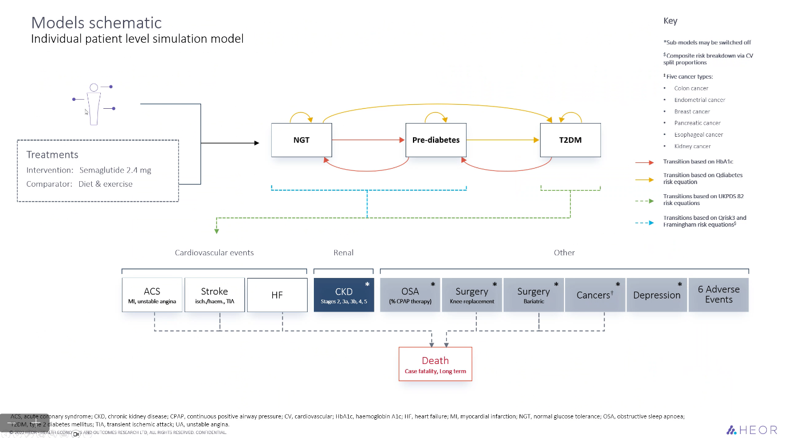

A lack of validation and transparency for cost-effectiveness models can be significant barrier to their acceptance by health technology assessment (HTA) payers and other decision makers.¹⁰ It is therefore recommended that validation be conducted of the MSM obesity model. External validation requires the comparison of model estimates with reports from dependent (i.e., used to inform the model) and independent external data. A systematic literature review (SLR) of previous obesity models (Schwander 2018) found that only 10 of 72 (14%) of identified obesity models had been validated using such external data.¹¹ Despite the general lack of validation of obesity models, a detailed external validation was conducted and published on the COM.¹²
The evidence for validation was provided by a 2017 validation of the ECHO-T2DM model and the previously noted SLR of obesity models from 2018.¹¹ ¹³ Targeted literature reviews were then used to supplement the studies identified in the ECHO-T2DM validation and systematic review.
The face validity of COM was evaluated by clinical expert feedback and presentations at conferences, while verification was performed by double-programming. However, a commentary argued that the face validity and verification should also have been published.⁹ Cross validation was not performed as programmers had access to only one model. The external validation considered 193 validation endpoints (162 CV and mortality outcomes, 10 T2DM incidence outcomes, and 21 OSA outcomes). Predicted outcomes by the model were compared against reported outcomes from the study, using visual assessment and statistical measures of concordance. The validation found only limited disagreement with reported studies, with the exception of an underestimation of CV disease and mortality, and T2DM.¹²
Novo Nordisk requested Clifton Insight to conduct a full external independent and dependent validation of the MS-COM model. They requested that methods follow those of the validation of COM.¹² It should be noted that two studies used to inform the review are now over 5 years old.¹¹ ¹³ Also, the latest study identified was published in 2016, with the oldest being published in 1996.¹⁴ ¹⁵ It included studies also had few obesity patients and one included patients with restricted lipid profiles.¹⁶ The age and limitations of previously identified studies strongly suggests that an update search would be required to repeat the validation on the new obesity MS-COM. Without such an update, it would likely prove challenging to publish the MSM validation in a peer reviewed journal.

Objectives
The overall objective of the evidence reviews was to identify published studies in populations with obesity or relevant patient populations against which predictions of the model could be compared.
Specific objectives were to:
- Update the 2018 Schwander SLR.¹¹
- Conduct a TLR for more recent T2DM model validations than the 2017 validation.¹³
- Conduct TLRs of Medline and Google to identify more recent and relevant evidence sources than used in the earlier validation, which had been limited to studies published before 2016.¹²
Studies were selected for the validation if they were in primary prevention of CVD or if less than 15% of patients had CVD, aligning with the target population of the model and the earlier validation.¹² Studies were also only included if sufficient baseline characteristics were reported so as to match with model predictions, and if they reported long-term risk factor trends. Endpoints of included studies also needed to be identical or reasonably close to those in the model.

Methods

Update of 2018 Schwander SLR (published since 2015)
A systematic literature review (SLR) was conducted following current methodological guidelines¹⁷ outlined in this protocol. The study followed the Preferred Reporting Items for Systematic review and Meta-Analysis Protocols extension (PRISMA-P) 2015 statement.¹⁸ The SLR also followed (as closely as possible) the PICOS and search terms used in Schwander 2018.¹¹
Schwander 2018 aimed to determine and describe the methodological variations in the event simulation approaches and the related external validations of published health economic decision models in the context of obesity. They stated their eligibility criteria as “original research articles on decision models for full health economic assessment in the context of obesity.” They applied definitions from Drummond et al.¹⁹ to define health economic assessments, from the International Society for Pharmacoeconomics and Outcomes Research (ISPOR) Task Force²⁰ to define health economic decision models, and the WHO criteria for obesity²¹ in order to define eligible studies. For our updated SLR, studies were therefore selected according to the PICOS criteria outlined in Table 1 and detailed below.

Eligibility criteria

Population
The population of interest was adults suffering from obesity according to the WHO criteria. For adults, WHO defines obesity as a BMI greater than or equal to 30.²¹

Interventions/comparators
All analyses comparing interventions targeted at obesity or obesity-related events including coronary heart disease (CHD), type 2 diabetes (T2D), stroke, cancer, osteoarthritis, hyperlipidemia, hypertension, peripheral artery disease.

Outcomes
The outcomes of interest were methods for event simulation e.g. risk equations and application of relative risk (RR) on the base risk. Methods for model validation were also of interest.

Study design
Only decision analytic models as defined by the ISPOR task force were included. This definition assumes that models account for events over time and across populations​, are based on data drawn from primary and/or secondary sources​, and aim to estimate effects of an intervention on health consequences and costs​ in order to aid decision making.²⁰​

Publication type
Only original research in the form of published research, conference abstracts or registered trials were included. Therefore, reviews, letter to the editor, and editorials were excluded.

Language
We did not exclude studies by language.
Table 1 PICOS for update of Schwander 2018
Population | Adults suffering from obesity according to the WHO criteria. For adults, WHO defines obesity as a BMI greater than or equal to 30​.
Interventions/  Comparators | All interventions targeted at obesity or obesity-related events including CHD, T2D, stroke, cancer, osteoarthritis, hyperlipidemia, hypertension, peripheral artery disease ​
Outcomes | Event simulation approaches​  Investigation of predictiveness and validity of models​
Study design | - Decision analytic models accounting for events over time and across populations​  - Based on data drawn from primary and/or secondary sources​  - Purpose to estimate effects of an intervention on health consequences and costs​  - Aim to aid decision making​  (ISPOR Task Force definition)​
Publication type | Original research​ in the form of journal publication, conference abstract or trial registration​  ​
Language | No language restriction​  ​
CHD=coronary heart disease; T2D=type 2 diabetes

Search strategy for SLR
A comprehensive search strategy was used to identify relevant literature. This included searching electronic databases, clinical trial registry, conference proceedings as well as hand searches on the reference lists of included studies and relevant systematic reviews.
Studies reporting decision analytic models were searched in the following databases: MEDLINE, and EMBASE, and National Health Service (NHS) Economic Evaluation Database (NHS EED). The search strategies are presented in Appendix A.

Study records

Data management
We searched MEDLINE and EMBASE through the Ovid® platform, and NHS EED. Records obtained were managed in an Endnote library and research information system (RIS) files were stored.

Selection process
Search results were uploaded into Rayyan²², a tool to increase the efficiency of systematic reviews, and screened by two reviewers independently. We used a two-stage process to select studies for inclusion. First, records that do not meet the eligibility criteria based on title and abstract were excluded. Second, full texts were retrieved for all records selected in stage 1 and checked against the eligibility criteria. The lead reviewer held regular meetings with reviewers to assure consistency in eligibility criteria and reconcile differences in the event of a conflict.
Reasons for exclusion were recorded at both the title/abstract screening stage and the full text screening stage. A list of excluded studies with reasons for exclusion were provided as recommended by systematic review methodological guidelines¹⁷ and quality checklists.²³ ²⁴

Data collection process
We developed standardized data extraction sheets (DES) in Microsoft Excel. These were tested on a few selected papers and adapted where necessary. Data extraction was performed by one reviewer and at least 10% of the studies were extracted, independently, by a second reviewer. Data extractions were checked by the lead reviewer and any discrepancies were resolved by discussion.

Risk of bias assessment
Risk of bias was not assessed as studies were expected to comprise a mixture of designs and extracted endpoints were unlikely to be primary endpoints of the studies.

Data items
In line with Schwander 2018, data to extract included:
- Obesity-associated events simulated, including CHD, T2D, stroke, cancer, osteoarthritis, hyperlipidemia, hypertension, peripheral artery disease
- Approach used to simulate incidence associated with CHD/T2D/stroke (i.e., incidence estimation approaches (such as potential impact fraction, BMI, age and gender)
- Approach used to simulate intervention effects associated with CHD/T2D/stroke (such as BMI or BMI group-specific RR)
- Approach used to simulate event-specific mortality associated with CHD/T2D/stroke
- External validation approach, along with quantitative measures used (e.g., measures on fit), and associated results for each reported endpoint

Targeted literature reviews

TLR 1: Recent T2D model validations (published since 2017)
A targeted review was conducted to identify more recent T2D model validations than Willis 2017 (ECHO-T2DM), which were published since 2017. For our TLR, studies were therefore selected according to the PICOS criteria outlined in Table 2 and detailed below.

Population
The population of interest was patients suffering from T2D.

Interventions/comparators
All analyses comparing interventions targeted at T2D were included.

Outcomes
The outcome of interest was investigations of the predictiveness and validity of models.

​Study design
Only decision analytic models as defined by the ISPOR task force were included. This definition assumes that models account for events over time and across populations​, are based on data drawn from primary and/or secondary sources​, and aim to estimate effects of an intervention on health consequences and costs​ in order to aid decision making.²⁰​

Publication type
Only original research in the form of published research, conference abstracts or registered trials were included. Therefore, reviews, letter to the editor, and editorials were excluded.

Language
We did not exclude studies by language.

Table 2. PICOS for TLR of T2D model validations
Population​ | Patients suffering from T2D
Interventions/Comparators | All interventions targeted at T2D​
Outcomes ​ | Investigation of predictiveness and validity of models​
Study design​ | - Decision analytic models accounting for events over time and across populations​  - Based on data drawn from primary and/or secondary sources​  - Purpose to estimate effects of an intervention on health consequences and costs​  - Aim to aid decision making​  (ISPOR Task Force definition)​
Publication type​ | Original research​ in the form of journal publication, conference abstract or trial registration
Language​ | No language restriction​
ISPOR=International Society for Pharmacoeconomics and Outcomes Research; T2D=type 2 diabetes

TLR 2: Recent evidence sources than those used in Lopes 2020 (published since 2016)
A targeted review was conducted to identify any additional evidence sources published since 2016 which provide data on baseline characteristics and long-term trends of risk factor progression, have a sufficiently long time horizon, include individuals who are overweight or obese, and report endpoints identical or reasonably close to those included in the MS-COM. For this TLR, studies were therefore selected according to the PICOS criteria outlined in Table 3 and detailed below.

Population
The population of interest is overweight or obese patients. As the MS-COM was designed to assess the long-term cost-effectiveness of weight management interventions for the primary prevention of CVD and other obesity-related complications, studies must also be in primary prevention (i.e. exclude patients with CVD history, or have a proportion of individuals with CVD less than 15%).

Interventions/comparators
All analyses comparing interventions targeted at weight management/preventing obesity-related events​ were included.

Outcomes
The outcomes of interest were endpoints identical or reasonably close to those included in the MS-COM. These must be reported alongside data on baseline characteristics​ and long-term trends of risk factor progression​.

​Study design
Regarding study designs, we included randomised and non-randomised evidence. Randomised evidence will include randomised controlled trials (RCTs) and Phase 2-3 trials, whereas non-randomised evidence will include interventional studies without randomised allocation and prospective observational studies. Other study designs, such as retrospective studies, case series and analysis of clinical records will be excluded due to higher risk of bias and limitations to establish causality from interventions.

Publication type
Only original research in the form of published research, conference abstracts or registered trials were included. Therefore, reviews, letter to the editor, and editorials were excluded.

Language
We will not exclude studies by language.

Table 3. PICOS for TLR of more recent evidence sources than used in the earlier validation
Population | Overweight or obese patients with CVD history as an exclusion criterion
Interventions/Comparators | All interventions targeted at weight management/preventing obesity-related events​
Outcomes ​ | All three of:​  - Data on baseline characteristics​  - Data on long-term trends of risk factor progression​  - Endpoints identical or similar to those included in the MS-COM
Study design​ | Randomized evidence:​  - Randomized controlled trials (RCTs)​  - Cluster RCTs​  - Phase 2/3 trials​  Real-world evidence:​  - Non-randomized trials ​  - Prospective observational studies​
Publication type​ | Original research​ in the form of journal publication, conference abstract or trial registration​
Language​ | No language restriction​

Search strategy for TLRs
A targeted search strategy was used to identify relevant literature. This included searching MEDLINE and Google, as well as target searching for relevant studies reporting relevant endpoints for the MS-COM.

Study records

Data management
We searched MEDLINE through the Ovid® platform and Google. Similar to the SLR, records obtained were managed in an Endnote library and research information system (RIS) files were stored.

Selection process
Search results were uploaded into Excel where screening was performed by one reviewer. We used a two-stage process to select studies for inclusion. First, records that did not meet the eligibility criteria based on title and abstract were excluded. Second, full texts were retrieved for all records selected in stage 1 and checked against the eligibility criteria.

Data collection process
For TLR 1, we listed and summarised all included studies in a slide deck. For TLR 2, we developed a simple DES in Microsoft Excel for TLR 2 that captures all relevant information on recent evidence sources and findings associated with endpoints of interest for MS-COM. Data extractions were performed by one reviewer and checked by a second reviewer for validation purposes.

Results

Overview of SLR findings
We identified 5,509 records through database searching, 2,555 records from EMBASE and 2,954 records from MEDLINE. After removing 778 duplicates, 4,731 titles and abstracts were screened for eligibility.
At the title and abstract screening stage, 4,602 records were excluded. Reasons for exclusion included wrong study design (n=4,091), wrong population (n = 445), wrong outcomes (n = 47), and wrong intervention (n = 19). As a result, a total of 129 records were assessed in full text, of which 74 fulfilled the inclusion criteria. Additional reasons for exclusion at this stage were wrong population (n = 26), wrong study design (n = 18), wrong outcome (n = 6), and wrong intervention (n = 3).
Three studies were mapped to primary publications, leaving 73 publications available for data extraction. The study selection process according to the PRISMA statement is shown in Figure 2.
An overview of the study characteristics and events simulated are provided in Table 3 and Table 4, respectively In Appendix B.
Figure 2 PRISMA flow chart systematic literature review
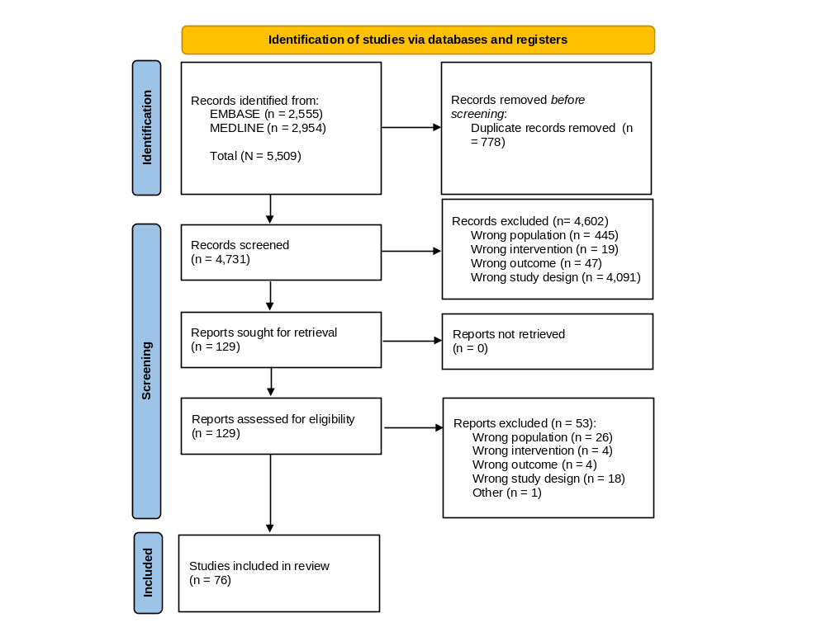

Overview of TLR findings

Summary findings from TLR1
We identified 259 records through database searching, which were screened in full. At the this stage (i.e., title and abstract screening), 246 records were excluded, leaving 13 records to be assessed as full-text. Each of these records fulfilled the inclusion criteria. The study selection process according to the PRISMA statement is shown in Figure 3.

Figure 3 PRISMA flow chart TLR1
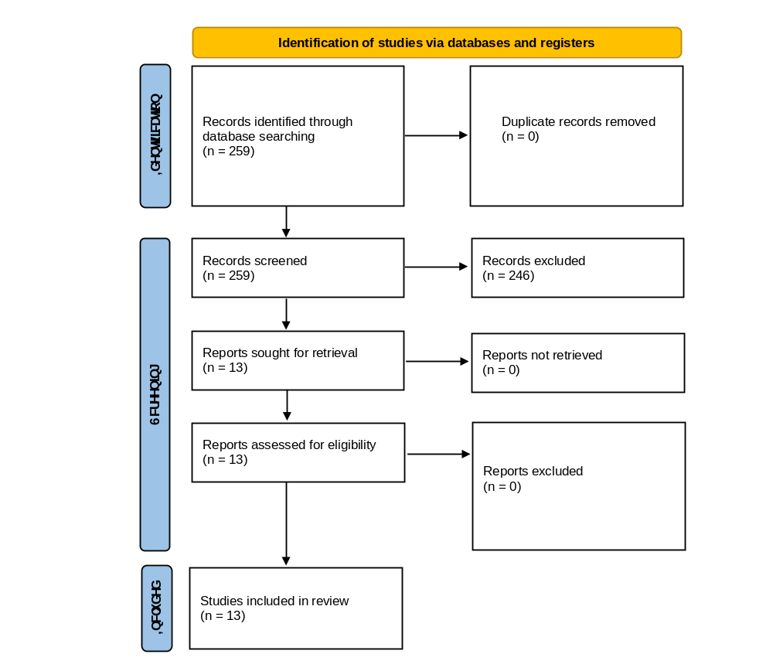

Summary findings from TLR2
We identified 1,391 records through PubMED Central, along with an additional nine records via grey literature searching, yielding 1,400 records to be screened.
At the title and abstract screening stage, 1,338 records were excluded. A total of 61 records were assessed in full text, of which 10 fulfilled the inclusion criteria. Reasons for exclusion at this stage were wrong population (n = 8), wrong outcomes (n = 41), and wrong study design (n = 2).
The study selection process according to the PRISMA statement is shown in Figure 4.

Figure 4 PRISMA flow chart TLR2
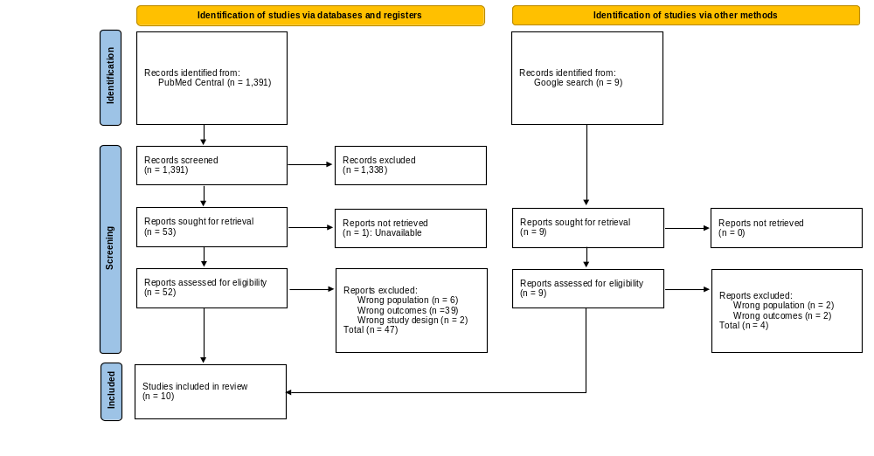

Selecting studies for inclusion in the external independent validation
We sought to validate approximately 100 endpoints using a mix of evidence from the Schwander 2018 review (that informed the external validation of COM by Lopes 2020),our updated SLR, and the TLRs.¹¹ Studies were prioritised if their endpoints were deemed identical or reasonably close to those included in the MS-COM. Where endpoints were simulated in studies included in the SLR, the primary source publication used to inform the event simulation was then checked to assess the closeness of the endpoint to those included in the MS-COM.
In total, 106 external independent endpoints were included in the external independent validation. Of the 73 records included in the SLR, four studies evaluated endpoints (that were based on primary publications) that closely matched those used in MS-COM, yielding 26 endpoints for validation.²⁵⁻²⁸ One study identified from the TLRs included outcomes that were sufficiently matched to MS-COM, yielding a total of 20 endpoints for validation.²⁹ Six studies used in Lopes 2020¹² included outcomes similarly matched to MS-COM and were included in the external independent validation, providing a total of 60 endpoints for validation.³⁰⁻³⁵

Scientific references
1. Lopes S, Meincke HH, Lamotte M, et al. A novel decision model to predict the impact of weight management interventions: The Core Obesity Model. Obes Sci Pract 2021;7(3):269-80. doi: 10.1002/osp4.495
2. Karnon J, Stahl J, Brennan A, et al. Modeling using discrete event simulation: a report of the ISPOR-SMDM Modeling Good Research Practices Task Force--4. Value Health 2012;15(6):821-7. doi: 10.1016/j.jval.2012.04.013
3. Davis S, Stevenson M, Tappenden P, et al. NICE DSU Technical Support Document 15: Cost-Effectiveness Modelling Using Patient-Level Simulation. London2014.
4. Hippisley-Cox J, Coupland C. Development and validation of QDiabetes-2018 risk prediction algorithm to estimate future risk of type 2 diabetes: cohort study. Bmj 2017;359:j5019. doi: 10.1136/bmj.j5019 [published Online First: 20171120]
5. Clarke PM, Gray AM, Briggs A, et al. A model to estimate the lifetime health outcomes of patients with type 2 diabetes: the United Kingdom Prospective Diabetes Study (UKPDS) Outcomes Model (UKPDS no. 68). Diabetologia 2004;47(10):1747-59. doi: 10.1007/s00125-004-1527-z [published Online First: 2004/11/02]
6. Wilding JPH, Batterham RL, Calanna S, et al. Once-Weekly Semaglutide in Adults with Overweight or Obesity. N Engl J Med 2021;384(11):989-1002. doi: 10.1056/NEJMoa2032183
7. Hippisley-Cox J, Coupland C, Brindle P. Development and validation of QRISK3 risk prediction algorithms to estimate future risk of cardiovascular disease: prospective cohort study. Bmj 2017;357:j2099. doi: 10.1136/bmj.j2099 [published Online First: 20170523]
8. Jahangiry L, Farhangi MA, Rezaei F. Framingham risk score for estimation of 10-years of cardiovascular diseases risk in patients with metabolic syndrome. J Health Popul Nutr 2017;36(1):36. doi: 10.1186/s41043-017-0114-0
9. Ramaekers BLT, Wijnen B, Armstrong N, et al. Comment on "External Validation of the Core Obesity Model to Assess the Cost-Effectiveness of Weight Management Interventions". Pharmacoeconomics 2021;39(1):133-35. doi: 10.1007/s40273-020-00985-5 [published Online First: 20201130]
10. Kent S, Becker F, Feenstra T, et al. The Challenge of Transparency and Validation in Health Economic Decision Modelling: A View from Mount Hood. Pharmacoeconomics 2019;37(11):1305-12. doi: 10.1007/s40273-019-00825-1
11. Schwander B, Nuijten M, Hiligsmann M, et al. Event simulation and external validation applied in published health economic models for obesity: a systematic review. Expert Rev Pharmacoecon Outcomes Res 2018;18(5):529-41. doi: 10.1080/14737167.2018.1501680 [published Online First: 20180724]
12. Lopes S, Johansen P, Lamotte M, et al. External Validation of the Core Obesity Model to Assess the Cost-Effectiveness of Weight Management Interventions. Pharmacoeconomics 2020;38(10):1123-33. doi: 10.1007/s40273-020-00941-3
13. Willis M, Johansen P, Nilsson A, et al. Validation of the Economic and Health Outcomes Model of Type 2 Diabetes Mellitus (ECHO-T2DM). Pharmacoeconomics 2017;35(3):375-96. doi: 10.1007/s40273-016-0471-3
14. Sasaki A, Uehara M, Horiuchi N, et al. A 15 year follow-up study of patients with non-insulin dependent diabetes mellitus (NIDDM) in Osaka, Japan. Long-term prognosis and causes of death. Diabetes Res Clin Pract 1996;34(1):47-55. doi: 10.1016/s0168-8227(96)01329-0
15. Yusuf S, Lonn E, Pais P, et al. Blood-Pressure and Cholesterol Lowering in Persons without Cardiovascular Disease. N Engl J Med 2016;374(21):2032-43. doi: 10.1056/NEJMoa1600177
16. Glynn RJ, Koenig W, Nordestgaard BG, et al. Rosuvastatin for primary prevention in older persons with elevated C-reactive protein and low to average low-density lipoprotein cholesterol levels: exploratory analysis of a randomized trial. Ann Intern Med 2010;152(8):488-96, W174. doi: 10.7326/0003-4819-152-8-201004200-00005
17. Higgins JPT, Thomas J, Chandler J, et al. Cochrane Handbook for Systematic Reviews of Interventions: John Wiley & Sons 2019.
18. Shamseer L, Moher D, Clarke M, et al. Preferred reporting items for systematic review and meta-analysis protocols (PRISMA-P) 2015: elaboration and explanation. BMJ 2015;350:g7647. doi: 10.1136/bmj.g7647 [published Online First: 2015/01/04]
19. Drummond MF, Sculpher MJ, Claxton K, et al. Methods for the economic evaluation of health care programmes: Oxford university press 2015.
20. Weinstein MC, O'Brien B, Hornberger J, et al. Principles of Good Practice for Decision Analytic Modeling in Health-Care Evaluation: Report of the ISPOR Task Force on Good Research Practices—Modeling Studies. Value in Health 2003;6(1):9-17. doi: https://doi.org/10.1046/j.1524-4733.2003.00234.x
21. WHO. Fact Sheet on Obesity 2003 [Available from: https://www.who.int/news-room/fact-sheets/detail/obesity-and-overweight.
22. Ouzzani M, Hammady H, Fedorowicz Z, et al. Rayyan-a web and mobile app for systematic reviews. Syst Rev 2016;5(1):210. doi: 10.1186/s13643-016-0384-4
23. Shea BJ, Reeves BC, Wells G, et al. AMSTAR 2: a critical appraisal tool for systematic reviews that include randomised or non-randomised studies of healthcare interventions, or both. BMJ 2017;358:j4008. doi: 10.1136/bmj.j4008 [published Online First: 2017/09/25]
24. Whiting P, Savovic J, Higgins JP, et al. ROBIS: A new tool to assess risk of bias in systematic reviews was developed. J Clin Epidemiol 2016;69:225-34. doi: 10.1016/j.jclinepi.2015.06.005 [published Online First: 2015/06/21]
25. Lincoff AM, Brown-Frandsen K, Colhoun HM, et al. Semaglutide and Cardiovascular Outcomes in Obesity without Diabetes. N Engl J Med 2023;389(24):2221-32. doi: 10.1056/NEJMoa2307563 [published Online First: 20231111]
26. Mørkedal B, Vatten LJ, Romundstad PR, et al. Risk of myocardial infarction and heart failure among metabolically healthy but obese individuals: HUNT (Nord-Trøndelag Health Study), Norway. J Am Coll Cardiol 2014;63(11):1071-8. doi: 10.1016/j.jacc.2013.11.035 [published Online First: 20131215]
27. Sjöström L, Lindroos AK, Peltonen M, et al. Lifestyle, diabetes, and cardiovascular risk factors 10 years after bariatric surgery. N Engl J Med 2004;351(26):2683-93. doi: 10.1056/NEJMoa035622
28. Sjöström L, Peltonen M, Jacobson P, et al. Bariatric surgery and long-term cardiovascular events. Jama 2012;307(1):56-65. doi: 10.1001/jama.2011.1914
29. Iyen B, Weng S, Vinogradova Y, et al. Long-term body mass index changes in overweight and obese adults and the risk of heart failure, cardiovascular disease and mortality: a cohort study of over 260,000 adults in the UK. BMC Public Health 2021;21(1):576. doi: 10.1186/s12889-021-10606-1 [published Online First: 20210415]
30. Intensive blood-glucose control with sulphonylureas or insulin compared with conventional treatment and risk of complications in patients with type 2 diabetes (UKPDS 33). UK Prospective Diabetes Study (UKPDS) Group. Lancet 1998;352(9131):837-53.
31. Colhoun HM, Betteridge DJ, Durrington PN, et al. Primary prevention of cardiovascular disease with atorvastatin in type 2 diabetes in the Collaborative Atorvastatin Diabetes Study (CARDS): multicentre randomised placebo-controlled trial. Lancet 2004;364(9435):685-96. doi: 10.1016/s0140-6736(04)16895-5
32. D'Agostino RB, Sr., Vasan RS, Pencina MJ, et al. General cardiovascular risk profile for use in primary care: the Framingham Heart Study. Circulation 2008;117(6):743-53. doi: 10.1161/circulationaha.107.699579 [published Online First: 20080122]
33. Dahlöf B, Sever PS, Poulter NR, et al. Prevention of cardiovascular events with an antihypertensive regimen of amlodipine adding perindopril as required versus atenolol adding bendroflumethiazide as required, in the Anglo-Scandinavian Cardiac Outcomes Trial-Blood Pressure Lowering Arm (ASCOT-BPLA): a multicentre randomised controlled trial. Lancet 2005;366(9489):895-906. doi: 10.1016/s0140-6736(05)67185-1
34. Bowman L, Mafham M, Wallendszus K, et al. Effects of Aspirin for Primary Prevention in Persons with Diabetes Mellitus. N Engl J Med 2018;379(16):1529-39. doi: 10.1056/NEJMoa1804988 [published Online First: 20180826]
35. Wing RR, Bolin P, Brancati FL, et al. Cardiovascular effects of intensive lifestyle intervention in type 2 diabetes. N Engl J Med 2013;369(2):145-54. doi: 10.1056/NEJMoa1212914 [published Online First: 20130624]
36. Alsumali A, Eguale T, Bairdain S, et al. Cost-Effectiveness Analysis of Bariatric Surgery for Morbid Obesity. Obes Surg 2018;28(8):2203-14. doi: 10.1007/s11695-017-3100-0
37. An S, Park HY, Oh SH, et al. Cost-effectiveness of Bariatric Surgery for People with Morbid Obesity in South Korea. Obes Surg 2020;30(1):256-66. doi: 10.1007/s11695-019-04122-w
38. Assumpção RP, Bahia LR, da Rosa MQM, et al. Cost-Utility of Gastric Bypass Surgery Compared to Clinical Treatment for Severely Obese With and Without Diabetes in the Perspective of the Brazilian Public Health System. Obes Surg 2019;29(10):3202-11. doi: 10.1007/s11695-019-03957-7
39. Avenell A, Robertson C, Skea Z, et al. Corrigendum: Bariatric surgery, lifestyle interventions and orlistat for severe obesity: the REBALANCE mixed-methods systematic review and economic evaluation. Health Technol Assess 2020;22(68):247-50. doi: 10.3310/hta22680-c202005
40. Bernard L, Kwon JS, Simpson AN, et al. The levonorgestrel intrauterine system for prevention of endometrial cancer in women with obesity: A cost-effectiveness study. Gynecol Oncol 2021;161(2):367-73. doi: 10.1016/j.ygyno.2021.02.020 [published Online First: 20210227]
41. Borisenko O, Lukyanov V, Ahmed AR. Cost-utility analysis of bariatric surgery. Br J Surg 2018;105(10):1328-37. doi: 10.1002/bjs.10857 [published Online First: 20180417]
42. Borisenko O, Lukyanov V, Debergh I, et al. Cost-effectiveness analysis of bariatric surgery for morbid obesity in Belgium. J Med Econ 2018;21(4):365-73. doi: 10.1080/13696998.2017.1419958 [published Online First: 20180110]
43. Borisenko O, Lukyanov V, Johnsen SP, et al. Cost analysis of bariatric surgery in Denmark made with a decision-analytic model. Dan Med J 2017;64(8)
44. Borisenko O, Mann O, Duprée A. Cost-utility analysis of bariatric surgery compared with conventional medical management in Germany: a decision analytic modeling. BMC Surg 2017;17(1):87. doi: 10.1186/s12893-017-0284-0 [published Online First: 20170803]
45. Borisenko O, Adam D, Funch-Jensen P, et al. Bariatric Surgery can Lead to Net Cost Savings to Health Care Systems: Results from a Comprehensive European Decision Analytic Model. Obes Surg 2015;25(9):1559-68. doi: 10.1007/s11695-014-1567-5
46. Chen G, Kusel J, Buguth B, et al. Cost-Effectiveness of Bariatric Surgery Compared to Conventional Treatment From A Societal Perspective In Germany, France, Italy And The UK. Value in Health 2017;20(9):A557. doi: 10.1016/j.jval.2017.08.900
47. Cohen RV, Luque A, Junqueira S, et al. What is the impact on the healthcare system if access to bariatric surgery is delayed? Surg Obes Relat Dis 2017;13(9):1619-27. doi: 10.1016/j.soard.2017.03.025 [published Online First: 20170331]
48. Davis JA, Saunders R. Comparison of Comorbidity Treatment and Costs Associated With Bariatric Surgery Among Adults With Obesity in Canada. JAMA Netw Open 2020;3(1):e1919545. doi: 10.1001/jamanetworkopen.2019.19545 [published Online First: 20200103]
49. Dottino JA, Hasselblad V, Secord AA, et al. Levonorgestrel Intrauterine Device as an Endometrial Cancer Prevention Strategy in Obese Women: A Cost-Effectiveness Analysis. Obstet Gynecol 2016;128(4):747-53. doi: 10.1097/aog.0000000000001616
50. Elliot L, Frew E, Mollan SP, et al. Cost-effectiveness of bariatric surgery versus community weight management to treat obesity-related idiopathic intracranial hypertension: evidence from a single-payer healthcare system. Surg Obes Relat Dis 2021;17(7):1310-16. doi: 10.1016/j.soard.2021.03.020 [published Online First: 20210330]
51. Galvain T, Bosut MP, Jamous N, et al. Cost-Effectiveness of Bariatric Surgery in Tunisia. Diabetes Metab Syndr Obes 2023;16:935-45. doi: 10.2147/dmso.S385110 [published Online First: 20230401]
52. Galvain T, Patel S, Kabiri M, et al. Cost-effectiveness of bariatric and metabolic surgery, and implications of COVID-19 in the United Kingdom. Surg Obes Relat Dis 2021;17(11):1897-904. doi: 10.1016/j.soard.2021.07.009 [published Online First: 20210727]
53. Gil-Rojas Y, Garzón A, Lasalvia P, et al. Cost-Effectiveness of Bariatric Surgery Compared With Nonsurgical Treatment in People With Obesity and Comorbidity in Colombia. Value Health Reg Issues 2019;20:79-85. doi: 10.1016/j.vhri.2019.01.010 [published Online First: 20190510]
54. Gómez Lumbreras A, Tan MS, Villa-Zapata L, et al. Cost-effectiveness analysis of five anti-obesity medications from a US payer's perspective. Nutr Metab Cardiovasc Dis 2023;33(6):1268-76. doi: 10.1016/j.numecd.2023.03.012 [published Online First: 20230325]
55. Gulliford MC, Charlton J, Booth HP, et al. Health Services and Delivery Research. Costs and outcomes of increasing access to bariatric surgery for obesity: cohort study and cost-effectiveness analysis using electronic health records. Southampton (UK): NIHR Journals Library
Copyright © Queen’s Printer and Controller of HMSO 2016. This work was produced by Gulliford et al. under the terms of a commissioning contract issued by the Secretary of State for Health. This issue may be freely reproduced for the purposes of private research and study and extracts (or indeed, the full report) may be included in professional journals provided that suitable acknowledgement is made and the reproduction is not associated with any form of advertising. Applications for commercial reproduction should be addressed to: NIHR Journals Library, National Institute for Health Research, Evaluation, Trials and Studies Coordinating Centre, Alpha House, University of Southampton Science Park, Southampton SO16 7NS, UK. 2016.
56. Hu Y, Zheng SL, Ye XL, et al. Cost-effectiveness analysis of 4 GLP-1RAs in the treatment of obesity in a US setting. Ann Transl Med 2022;10(3):152. doi: 10.21037/atm-22-200
57. James R, Salton RI, Byrnes JM, et al. Cost-utility analysis for bariatric surgery compared with usual care for the treatment of obesity in Australia. Surg Obes Relat Dis 2017;13(12):2012-20. doi: 10.1016/j.soard.2016.12.016 [published Online First: 20161226]
58. Kelly J, Menon V, O'Neill F, et al. UK cost-effectiveness analysis of endoscopic sleeve gastroplasty versus lifestyle modification alone for adults with class II obesity. Int J Obes (Lond) 2023;47(11):1161-70. doi: 10.1038/s41366-023-01374-6 [published Online First: 20230906]
59. Kent S, Aveyard P, Astbury N, et al. Is Doctor Referral to a Low-Energy Total Diet Replacement Program Cost-Effective for the Routine Treatment of Obesity? Obesity (Silver Spring) 2019;27(3):391-98. doi: 10.1002/oby.22407
60. Kostic AM, Leifer VP, Selzer F, et al. Cost-Effectiveness of Weight-Loss Interventions Prior to Total Knee Replacement for Patients With Class III Obesity. Arthritis Care Res (Hoboken) 2023;75(8):1752-63. doi: 10.1002/acr.25044 [published Online First: 20230201]
61. Kostic AM, Leifer VP, Gong Y, et al. Cost-Effectiveness of Surgical Weight-Loss Interventions for Patients With Knee Osteoarthritis and Class III Obesity. Arthritis Care Res (Hoboken) 2023;75(3):491-500. doi: 10.1002/acr.24967 [published Online First: 20221117]
62. Kovács G, Mohos E, Kis JT, et al. Cost-Effectiveness of Bariatric Surgery in Patients Living with Obesity and Type 2 Diabetes. J Diabetes Res 2023;2023:9686729. doi: 10.1155/2023/9686729 [published Online First: 20231216]
63. Lauren BN, Lim F, Krikhely A, et al. Estimated Cost-effectiveness of Medical Therapy, Sleeve Gastrectomy, and Gastric Bypass in Patients With Severe Obesity and Type 2 Diabetes. JAMA Netw Open 2022;5(2):e2148317. doi: 10.1001/jamanetworkopen.2021.48317 [published Online First: 20220201]
64. Lester ELW, Padwal RS, Birch DW, et al. The real-world cost-effectiveness of bariatric surgery for the treatment of severe obesity: a cost-utility analysis. CMAJ Open 2021;9(2):E673-e79. doi: 10.9778/cmajo.20200188 [published Online First: 20210618]
65. Lin J, Zhuo X, Bardenheier B, et al. Cost-effectiveness of the 2014 U.S. Preventive Services Task Force (USPSTF) Recommendations for Intensive Behavioral Counseling Interventions for Adults With Cardiovascular Risk Factors. Diabetes Care 2017;40(5):640-46. doi: 10.2337/dc16-1186 [published Online First: 20170217]
66. Lucchese M, Borisenko O, Mantovani LG, et al. Cost-Utility Analysis of Bariatric Surgery in Italy: Results of Decision-Analytic Modelling. Obes Facts 2017;10(3):261-72. doi: 10.1159/000475842 [published Online First: 20170610]
67. McGlone ER, Carey I, Veličković V, et al. Bariatric surgery for patients with type 2 diabetes mellitus requiring insulin: Clinical outcome and cost-effectiveness analyses. PLoS Med 2020;17(12):e1003228. doi: 10.1371/journal.pmed.1003228 [published Online First: 20201207]
68. McLawhorn AS, Southren D, Wang YC, et al. Cost-Effectiveness of Bariatric Surgery Prior to Total Knee Arthroplasty in the Morbidly Obese: A Computer Model-Based Evaluation. J Bone Joint Surg Am 2016;98(2):e6. doi: 10.2106/jbjs.N.00416
69. Mital S, Nguyen HV. Cost-effectiveness of procedure-less intragastric balloon therapy as substitute or complement to bariatric surgery. PLoS One 2021;16(7):e0254063. doi: 10.1371/journal.pone.0254063 [published Online First: 20210728]
70. Neff R, Havrilesky LJ, Chino J, et al. Bariatric surgery as a means to decrease mortality in women with type I endometrial cancer - An intriguing option in a population at risk for dying of complications of metabolic syndrome. Gynecol Oncol 2015;138(3):597-602. doi: 10.1016/j.ygyno.2015.07.002 [published Online First: 20150729]
71. Nuijten M, Dainelli L, Rasouli B, et al. A Meal Replacement Program for the Treatment of Obesity: A Cost-Effectiveness Analysis from the Swiss Payer's Perspective. Diabetes Metab Syndr Obes 2021;14:3147-60. doi: 10.2147/dmso.S284855 [published Online First: 20210708]
72. Nuijten M, Marczewska A, Araujo Torres K, et al. A health economic model to assess the cost-effectiveness of OPTIFAST for the treatment of obesity in the United States. J Med Econ 2018;21(9):835-44. doi: 10.1080/13696998.2018.1468334 [published Online First: 20180518]
73. Bariatric Surgery for Adults With Class I Obesity and Difficult-to-Manage Type 2 Diabetes: A Health Technology Assessment. Ont Health Technol Assess Ser 2023;23(8):1-151. [published Online First: 20231205]
74. Paranjape CS, Gentry RD, Regan CM. Cost-Effectiveness of Bariatric Surgery Prior to Posterior Lumbar Decompression and Fusion in an Obese Population with Degenerative Spondylolisthesis. Spine (Phila Pa 1976) 2021;46(14):950-57. doi: 10.1097/brs.0000000000003940
75. Premkumar A, Lebrun DG, Sidharthan S, et al. Bariatric Surgery Prior to Total Hip Arthroplasty Is Cost-Effective in Morbidly Obese Patients. J Arthroplasty 2020;35(7):1766-75.e3. doi: 10.1016/j.arth.2020.02.044 [published Online First: 20200313]
76. Retat L, Pimpin L, Webber L, et al. Screening and brief intervention for obesity in primary care: cost-effectiveness analysis in the BWeL trial. Int J Obes (Lond) 2019;43(10):2066-75. doi: 10.1038/s41366-018-0295-7 [published Online First: 20190131]
77. Rognoni C, Armeni P, Tarricone R, et al. Cost-benefit Analysis in Health Care: The Case of Bariatric Surgery Compared With Diet. Clin Ther 2020;42(1):60-75.e7. doi: 10.1016/j.clinthera.2019.12.001 [published Online First: 20200117]
78. Sanchez-Santos R, Padin EM, Adam D, et al. Bariatric surgery versus conservative management for morbidly obese patients in Spain: a cost-effectiveness analysis. Expert Rev Pharmacoecon Outcomes Res 2018;18(3):305-14. doi: 10.1080/14737167.2018.1407649 [published Online First: 20171130]
79. Sandhu H, Xu W, Olivieri AV, et al. Once-Weekly Subcutaneous Semaglutide 2.4 mg Injection is Cost-Effective for Weight Management in the United Kingdom. Adv Ther 2023;40(3):1282-91. doi: 10.1007/s12325-022-02423-8 [published Online First: 20230111]
80. Saumoy M, Gandhi D, Buller S, et al. Cost-effectiveness of endoscopic, surgical and pharmacological obesity therapies: a microsimulation and threshold analyses. Gut 2023;72(12):2250-59. doi: 10.1136/gutjnl-2023-330437 [published Online First: 20231124]
81. Viratanapanu I, Romyen C, Chaivanijchaya K, et al. Cost-Effectiveness Evaluation of Bariatric Surgery for Morbidly Obese with Diabetes Patients in Thailand. J Obes 2019;2019:5383478. doi: 10.1155/2019/5383478 [published Online First: 20190203]
82. Walter E, Langer FB, Beckerhinn P, et al. Impact of metabolic surgery on cost and long-term health outcome: a cost-effectiveness approach. Surg Obes Relat Dis 2022;18(2):260-70. doi: 10.1016/j.soard.2021.10.012 [published Online First: 20211018]
83. Wan B, Fang N, Guan W, et al. Cost-Effectiveness of Bariatric Surgery versus Medication Therapy for Obese Patients with Type 2 Diabetes in China: A Markov Analysis. J Diabetes Res 2019;2019:1341963. doi: 10.1155/2019/1341963 [published Online First: 20191219]
84. Yu JC, Wolfe B, Griffiths RI, et al. Cost-effectiveness analysis of vagal nerve blocking for morbid obesity. Am J Manag Care 2017;23(8):e245-e52. [published Online First: 20170801]

Appendix A: Search strategy – SLR: Update of 2018 Schwander review

Ovid MEDLINE (Search date: 2024-01-05)
# | Search terms | Hits
1 | exp Obesity/ | 265467
2 | exp Overweight/ | 277000
3 | exp Weight Loss/ | 50138
4 | exp Economics/ | 668005
5 | economic model*.ab,kw. | 4264
6 | economic evaluation.ti,ab. | 11984
7 | (cost* adj2 (effective* or utilit* or benefit* or analy* or outcome or outcomes)).ab,kw. | 209130
8 | markov.ti,ab,kw. | 28692
9 | (decision* adj2 (tree* or analy* or model*)).ti,ab,kw. | 39643
10 | ((Micro or Discrete or Agent) adj2 simulation).ti,ab,kw. | 1823
11 | 4 or 5 or 6 or 7 or 8 or 9 or 10 | 864350
12 | 1 or 2 or 3 | 302214
13 | 11 and 12 | 6400
14 | limit 13 to yr="2015 -Current" | 6158
15 | limit 14 to "all adult (19 plus years)" | 2986

Embase (Search date: 2024-01-05)
# | Search terms | Hits
1 | exp Obesity/ | 675344
2 | exp Overweight/ | 675344
3 | exp "Weight Loss"/ | 92854
4 | exp Economics/ | 249866
5 | economic model*.kw,ab. | 6283
6 | markov.kw,tw. | 37197
7 | "economic evaluation".tw. | 16626
8 | (cost* adj2 (effective* or utilit* or benefit* or analy* or outcome or outcomes)).ab,kw. | 286272
9 | (decision* adj2 (tree* or analy* or model*)).tw,kw. | 52815
10 | ((Micro or Discrete or Agent) adj2 simulation).tw,kw. | 2594
11 | 1 or 2 or 3 | 745992
12 | 4 or 5 or 6 or 7 or 8 or 9 or 10 | 590696
13 | 11 and 12 | 7555
14 | limit 13 to yr="2015 -Current" | 7442
15 | limit 14 to (adult <18 to 64 years> or aged <65+ years>) | 3468

NHS EED (Search date: 2024-01-05)
# | Search terms | Hits
1 | MeSH DESCRIPTOR Obesity EXPLODE ALL TREES | 1025
2 | (overweight) | 502
3 | #1 OR #2 | 1224
4 | * IN NHSEED FROM 1996 TO 2023 | 16965
5 | #3 AND #4 | 217

Appendix B: Overview of studies identified in SLR

Study characteristics
Table x
Study | Type of analysis | Model type | Setting | Population | Intervention
Alsumali, 2018³⁶ | CEA | MSM | USA | Adult aged 18 to 74 years with BMI ≥ 35 kg/m2. | Surgery
An, 2020³⁷ | CEA | Decision tree and Markov | South Korea | Morbidly obese people (BMI>=35) or people with BMI=30-34.9 + obersity-related comorbidities (hypertension, diabetes or hyperlipidemia) | Surgery
Assumpcao, 2019³⁸ | CUA | Hybrid Markov decision tree | Brazil | Severely obese with diabetes and severely obese without diabetes. | Surgery
Avenell, 2018³⁹ | CEA | MSM | UK | Severe obesity | Behavioural, surgery
Bernard 2021⁴⁰ | CEA | Markov | Canada | Obese | device
Borisenko, 2018a⁴¹ | CUA | Markov | England | Morbid obesity | Surgery
Borisenko, 2018b⁴² | CEA | Markov | Belgium | Unclear | Surgery
Borisenko, 2017a⁴³ | CEA | Markov | Denmark | Moderate (start BMI: 33 kg/m2), severe (start BMI: 37 kg/m2), morbid (start BMI: 42 kg/m2) and super obesity (start BMI: 52 kg/m2) | Surgery
Borisenko, 2017b⁴⁴ | CUA | Markov | Germany | Obese | Surgery
Borisenko, 2015⁴⁵ | CUA | Markov | Sweden | Obese | Surgery
Chen 2017⁴⁶ | CEA | Markov | Germany, France, Italy  And The UK | Mild, moderate or morbid obesity | Surgery
Cohen, 2017⁴⁷ | CEA | Markov | Brazil | Severe obesity | Surgery
Daniel 2022 | CEA | Decision model | USA (assumed) | Obese | Surgery
Davis, 2020⁴⁸ |  |  | Canada | Obese | policy
de 2018 | CEA | Markov | Europe? | Obese | NR
Dottino 2016⁴⁹ | CEA | Modified Markov |  | Obese | device
Elliot, 2021⁵⁰ | CEA | Markov | United Kingdom (assumed) | Severe obesity | Surgery
Galvain 2023⁵¹ | CEA | Markov | Tunisia | Severe obesity | Surgery
Galvain 2021⁵² | CEA | Markov | United Kingdom | Severe obesity | Surgery
Gil-Rojas, 2019⁵³ | CEA | Decision tree and Markov | Colombia | Severely obese | Surgery
Gomez 2023⁵⁴ | CEA | Markov | United States | Obese (assumed) | Drug
Gulliford, 2017⁵⁵ | CUA | Markov | United Kingdom | Obese | Surgery
Haseeb 2023a | CEA | Markov | US | Class II obesity | Drug
Haseeb 2023b | CEA | Markov | US | Class II obesity | Surgery
Haseeb 2023c | CEA | Markov | US | Class II obesity | Drug
Haseeb 2023d | CEA | Markov | US | Class II obesity | Surgery
Haseeb 2023e | CEA | Markov | US | Class II obesity | Drug
Hu 2022⁵⁶ | CEA | Decision-tree | US |  | Drug
Jacobsen 2019 | CEA | -- | UK | Severe obesity | Behavioural
James 2017⁵⁷ | CUA | Markov | Australia | Class II and II obesity | Surgery
Jirapinyo 2018 | CEA | decision analytic state-transition Monte Carlo microsimulation model | US | Unclear (BMI of 32.5 kg/m2, probably the mean) | Surgery
Jordan 2022 | CUA | Markov | Ireland | Obese | Surgery
Kelly, 2023⁵⁸ | CEA | Markov | England | Class II obesity | Surgery
Kent, 2019⁵⁹ | CEA | -- | UK | Obese | behavioural
Kostic 2023a⁶⁰ | CEA | state transition Monte Carlo computer simulation model | US | Class II obesity | Surgery
Kostic 2023b⁶¹ | CEA | state transition Monte Carlo computer simulation model |  | Class III obesity | Surgery
Kostic 2021 | CEA | microsimulation | US | Class III obesity | Surgery
Kovacs 2023⁶² | CUA | Markov (with patient-level simulation) | Hungary | Obese | Surgery
Lauren 2021⁶³ | CUA | Microsimulation | US | Severe obesity | Surgery
Lee 2018 | CUA | State-transition model | - | Mildly obese | Drug
Lester, 2021⁶⁴ | CUA | Markov | Canada | Severe obesity | Surgery
Lin, 2017⁶⁵ | CUA | Markov | US | Obese | Behavioural
Lucchese, 2017⁶⁶ | CUA | Markov | Italy | Moderate, severe, morbid, and super obese | Surgery
McGlone, 2020⁶⁷ | CUA | Microsimulation | UK | Severe obeseity | Surgery
McLawhorn, 2016⁶⁸ | CUA | Markov | US | Morbid obesity | Surgery
Mital, 2021⁶⁹ | CUA | Microsimulation | US | Obese class II or III | Surgery
Neff 2015⁷⁰ | CUA | Markov | US | Obese | Surgery
Nuijten 2021⁷¹ | CUA | Decision-analytic model | Switzerland | Obese class I and II | Behavioural, surgery, and drug
Nuijten 2019 | CUA | Decision-analytic model | Canada | - | Behavioural, surgery, and drug
Nuijten, 2018⁷² | CUA | Decision-analytic model | US | Obese class I-III | Behavioural, surgery, and drug
Olivieri 2022 | CUA | Markov | Canada | Obese | Drug and beheavioural
Ontario Health 2023⁷³ | CUA | Decision treeand MSM | Canada | Obese class I | Surgery
Paranjape 2021⁷⁴ | CUA | Markov | US | Obese | Surgery
Paw 2019 | CUA | Markov | US | Morbid obesity | Surgery
Pollack 2021 | CUA | Markov | US | Obese | Surgery
Premkumar, 2020⁷⁵ |  | --
Retat 2019b | CUA | Microsimulation | UK | Obese class I-III | Behavioural
Retat, 2019a⁷⁶ | CUA | Microsimulation | UK | Obese | Behavioural
Rieder 2016 | CUA | Markov | Canada | Obese | Surgery
Rognoni, 2020⁷⁷ | CUA | Markov | Italy | Obese | Surgery
Sanchez-Santos, 2018⁷⁸ | CUA | Markov | Spain | Morbid obesity | Surgery
Sandhu, 2023⁷⁹ | CUA | Markov | UK | Obese | Drug
Saumoy 2023a⁸⁰ | CUA | Markov | - | Obese | Surgery
Saumoy 2023b |  | --
Schmidt 2020 | CUA | Markov | Mexico | Obese | Drug
Shah 2023 | CUA | Markov | US | Obese | Drug
Sharaiha 2023 | CUA | Markov | US | Obese class I-III | Surgery
Tankou 2021 | CUA | Markov | US | Obese | Surgery
Valdez-Huerta 2022 | CEA | Discrete event simulation | US | Obese | Drug
Viratanapanu, 2019⁸¹ | CUA and CEA | Decision tree followed by Markov | Thailand | Morbid obesity | Surgery
Walter 2022⁸² | CUA and CEA | Markov | Austria | Obese | Surgery
Wan, 2019⁸³ | CUA | Markov | China | Obese | Surgery
Yu, 2017⁸⁴ | CUA | Markov | US | Obese class II-III | Medical device
CEA=cost-effectiveness analysis; CUA=costutility analysis; MSM=microsimulation model

Types of events simulated
Table 4 Summary of outcomes simulated
Study | Types of events simulated
Study | T2D | CHD | Stroke | Myocardial infarction | CVD death | Osteoarthritis | Hyperlipidemia | Hypertension
Alsumali, 2018³⁶ | No | No | No | No | No | No | No | No
An, 2020³⁷ | Yes | Yes | Yes | No | Yes | No | Yes | Yes
Assumpcao, 2019³⁸ | Yes | No | No | Yes | Yes
Avenell, 2018³⁹ | Yes | Yes | Yes | No | No | Yes | No | Yes
Bernard 2021⁴⁰ | No | No | No | No | No | No | No | No
Borisenko, 2018a⁴¹ | Yes | No | Yes | Yes | No | No | No | No
Borisenko, 2018b⁴² | Yes | No | Yes | Yes | No | No | No | No
Borisenko, 2017a⁴³ | Yes | No | Yes | Yes | No | No | No | No
Borisenko, 2017b⁴⁴ | Yes | No | Yes | Yes | No | No | No | No
Borisenko, 2015⁴⁵ | Yes | No | Yes | Yes | No | No | No | No
Chen 2017⁴⁶ | Yes | No | Yes | Yes | No | No | No | No
Cohen, 2017⁴⁷ | Yes | Unclear | Yes | No | No | No | No | No
Daniel 2022 | Yes | No | No | No | No | No | No | No
Davis, 2020⁴⁸ | Yes | No | No | No | No | No | Yes | Yes
de 2018 | Yes | No | Yes | No | No | Yes | No | No
Dottino 2016⁴⁹ | No | No | No | No | No |  | No | No
Elliot, 2021⁵⁰ | No | No | No | No | No | No | No | Unclear
Galvain 2023⁵¹ | Yes | No | Yes | Yes | Yes | No | Unclear | Unclear
Galvain 2021⁵² | Yes | No | Yes | Yes |  |  | Unclear | Unclear
Gil-Rojas, 2019⁵³ | Yes | No | Yes | Yes | Yes | No | Yes | Yes
Gomez 2023⁵⁴ | Yes | Yes | Yes | Yes | No | No | No | No
Gulliford, 2017⁵⁵ | Yes | Yes | Yes | No | No | No |  | No
Haseeb 2023a | No | No | No | No | No | No | No | No
Haseeb 2023b | No | No | No | No | No | No | No | No
Haseeb 2023c | No | No | No | No | No | No | No | No
Haseeb 2023d | Yes | No | No | No | No | No | No | No
Haseeb 2023e | No | No | No | No | No | No | No | No
Hu 2022⁵⁶ | No | No | No | No | No | No | No | No
Jacobsen 2019 | No | No | No | No | No | No | No | No
James 2017⁵⁷ | No | No | No | No | No | No | No | No
Jirapinyo 2018 | No | No | No | No | No | No | No | No
Jordan 2022 | Unclear | No | Yes | Yes | No | No | No | No
Kelly, 2023⁵⁸ | Yes | No | No | No | No | No | No | Yes
Kent, 2019⁵⁹ | Yes | Yes | Yes | No | No | No | No | No
Kostic 2023a⁶⁰ | Yes | No | No | No | No | No | No | No
Kostic 2023b⁶¹ | Yes | No | No | No | No | No | No | No
Kostic 2021 | Unclear | No | No | No | No | No | No | No
Kovacs 2023⁶² | No | Yes | Yes | Yes | No | No | No | No
Lauren 2021⁶³ | Yes | No | No | No | No | No | No | No
Lee 2018 | Unclear | Unclear | Unclear | Unclear | Unclear | Unclear | Unclear | Unclear
Lester, 2021⁶⁴ | Yes | No | No | No | No | No | No | Yes
Lin, 2017⁶⁵ | Yes | No | Yes | Yes | Unclear | No | No | No
Lucchese, 2017⁶⁶ | Yes | Yes | Yes | Yes | Yes | No | No | No
McGlone, 2020⁶⁷ | No | Yes | Yes | Yes | No | No | No | No
McLawhorn, 2016⁶⁸ | No | No | No | No | No | Yes | No | No
Mital, 2021⁶⁹ | No | No | No | No | No | No | No | No
Neff 2015⁷⁰ | No | No | No | No | No | No | No | No
Nuijten 2021⁷¹ | Yes | Yes | Yes | Yes | Unclear | No | No | Yes
Nuijten 2019 | Unclear | Unclear | Unclear | Unclear | Unclear | Unclear | Unclear | Unclear
Nuijten, 2018⁷² | Yes | Yes | Yes | Yes | Unclear | Yes | No | Yes
Olivieri 2022 | Unclear | Unclear | Unclear | Unclear | Unclear | Unclear | Unclear | Unclear
Ontario Health 2023⁷³ | Yes | Yes | Yes | Yes | No | No | No | No
Paranjape 2021⁷⁴ | Unclear | Unclear | Unclear | Unclear | Unclear | Unclear | Unclear | Unclear
Paw 2019 | Unclear | Unclear | Unclear | Unclear | Unclear | Unclear | Unclear | Unclear
Pollack 2021 | Yes | Yes | Yes | No | No | No | No | Yes
Premkumar, 2020⁷⁵ | No | No | No | No | No | Yes | No | No
Retat 2019b | Unclear | Unclear | Unclear | Unclear | Unclear | Unclear | Unclear | Unclear
Retat, 2019a⁷⁶ | Yes | Yes | Yes | No | No | Yes | No | Yes
Rieder 2016 | Unclear | Unclear | Unclear | Unclear | Unclear | Unclear | Unclear | Unclear
Rognoni, 2020⁷⁷ | Yes | No | Yes | Yes | Yes | No | No | No
Sanchez-Santos, 2018⁷⁸ | Yes | Yes | Yes | Yes | No | No | No | No
Sandhu, 2023⁷⁹ | Yes | Yes | Yes | Yes | Yes | Unclear | Unclear | Unclear
Saumoy 2023a⁸⁰ | No | No | No | No | No | No | No | No
Saumoy 2023b | Unclear | Unclear | Unclear | Unclear | Unclear | Unclear | Unclear | Unclear
Schmidt 2020 | Yes | Unclear | Unclear | Unclear | Unclear | Unclear | Unclear | Unclear
Shah 2023 | Yes | Yes | Yes | Yes | Unclear | Unclear | Unclear | Unclear
Sharaiha 2023 | Yes | Unclear | Unclear | Unclear | Unclear | Unclear | Unclear | Unclear
Tankou 2021 | Unclear | Unclear | Unclear | Unclear | Unclear | Unclear | Unclear | Unclear
Valdez-Huerta 2022 | Unclear | Unclear | Unclear | Unclear | Unclear | Unclear | Unclear | Unclear
Viratanapanu, 2019⁸¹ | Yes | No | No | No | No | No | No | No
Walter 2022⁸² | Yes | Yes | Yes | Yes | No | No | Yes | Yes
Wan, 2019⁸³ | Yes | No | No | No | No | No | No | No
Yu, 2017⁸⁴ | Yes | No | No | No | No | No | No | No
CHD=coronary heart disease; CVD=cardiovascular disease

