Public health impact and cost-effectiveness of revising the adolescent meningococcal vaccine schedule in the United States
Oscar Herrera-Restrepo (ORCID: 0000-0001-8193-999X)¹, Ginita Jutlla (ORCID: 0000-0001-6065-8574)^{2*}, Jonathan Graham (ORCID: 0000-0002-3227-5928)³, Justin Carrico (ORCID: 0000-0002-4659-9309)¹, Mei Grace (ORCID: 0009-0008-3862-8203)³, Zeki Kocaata (ORCID: 0000-0002-5231-3389)⁴, Diana E. Clements (ORCID: 0000-0002-2410-8951)^{1*}, Cindy Burman (ORCID: 0009-0000-2860-1500)¹, Anar Andani (ORCID: 0000-0003-0530-5340)⁴, Hiral Shah (ORCID: 0000-0003-0204-451X)²
¹GSK, Philadelphia, PA, USA
²GSK, London, UK
³RTI Health Solutions, Research Triangle Park, NC, USA
⁴GSK, Wavre, Belgium
*Affiliation at time of study
Correspondence to:
Justin Carrico
Email: justin.d.carrico@gsk.com
Director, US Health Economics & Outcomes Research, Vaccines
US Vaccines Medical Affairs
410 Blackwell Street, Durham, NC 27701
Journal: PharmacoEconomics
SUPPLEMENTARY APPENDIX

SUPPLEMENTARY MATERIALS
Supplemental Table 1: Epidemiological inputs, vaccine characteristic inputs, and health outcome inputsª
Category/input | Base-case value | Range^{b} |  | Distribution used for sensitivity analyses | Source(s)
Category/input | Base-case value | Lower bound | Upper bound | Distribution used for sensitivity analyses | Source(s)
Population size, n
Ages 0–9 years | 40,394,847 | – | – | – | US Census Bureau (2015) [3]
Ages 10–19 years | 41,685,397 | – | – | – | US Census Bureau (2015) [3]
Ages 20–29 years | 45,077,848 | – | – | – | US Census Bureau (2015) [3]
Ages 30–39 years | 41,933,700 | – | – | – | US Census Bureau (2015) [3]
Ages 40–49 years | 40,896,154 | – | – | – | US Census Bureau (2015) [3]
Ages 50–59 years | 43,985,220 | – | – | – | US Census Bureau (2015) [3]
Ages 60–69 years | 35,040,375 | – | – | – | US Census Bureau (2015) [3]
Ages 70–79 years | 19,566,470 | – | – | – | US Census Bureau (2015) [3]
Ages 80–89 years | 9,644,050 | – | – | – | US Census Bureau (2015) [3]
Ages 90–99 years | 2,335,653 | – | – | – | US Census Bureau (2015) [3]
Projected births per year  (average of 2025–2039) | 4,166,185 | – | – | – | US Census Bureau (2015) [3]
Annual probability of all-cause mortality, average of age range
Ages 0–9 years | 0.00075 | – | – | – | US Census Bureau (2015) [3]
Ages 10–19 years | 0.00031 | – | – | – | US Census Bureau (2015) [3]
Ages 20–29 years | 0.00098 | – | – | – | US Census Bureau (2015) [3]
Ages 30–39 years | 0.00141 | – | – | – | US Census Bureau (2015) [3]
Ages 40–49 years | 0.00257 | – | – | – | US Census Bureau (2015) [3]
Ages 50–59 years | 0.00611 | – | – | – | US Census Bureau (2015) [3]
Ages 60–69 years | 0.01253 | – | – | – | US Census Bureau (2015) [3]
Ages 70–79 years | 0.02956 | – | – | – | US Census Bureau (2015) [3]
Ages 80–89 years | 0.08272 | – | – | – | US Census Bureau (2015) [3]
Ages 90–99 years | 0.22162 | – | – | – | US Census Bureau (2015) [3]
Annual IMD cases without vaccination, ages 11–25 years
Serogroup B | 40 | – | – | – | CDC, National Notifiable Diseases Surveillance System, Annual Tables of Infectious Disease Data (2015–2019) [4-6]. Values were set to the average annual incidence reported in the NNDSS from 2015–2019.
Serogroups A, C, W, and Y | 47 | – | – | – | Values for serogroups C, W, and Y for ages 11–22 years were projected over the 2015–2019 using a regression presented by Mbaeyi et al. (2020) [7, 8]
CFR per IMD case across age groups
Serogroup B | 0.00–21.43% | 0.00–1.87% | 0.00–42.92% | – | MacNeil et al. (2018) [9]
Serogroups A, C, W, and Y | 4.00–19.27% | 0.00–9.65% | 11.68–32.63% | – | MacNeil et al. (2018) [9]
Other serogroups | 0.00–14.71% | 0.00–4.29% | 0.00–39.41% | – | MacNeil et al. (2018) [9]
Initial protection against IMD
Protection against IMD due to MenB
Dose 1 against MenB (from MenB-4C or MenABCWY) | 33.5% | 12.4% | 49.7% | Beta | Argante et al. (2021); Semmes et al. (2020); Simon et al. (2015) [10-12]
Dose 2 against MenB from MenB-4C | 78.7% | 77.2% | 80.1% | Beta | ClinicalTrials.gov, NCT04886154 [13]
Dose 2 against MenB from MenABCWY | 77.9% | 76.6% | 79.2% | Beta | ClinicalTrials.gov, NCT04886154 [13]
Protection against IMD due to MenACWY
Dose 1 against MenACWY (from MenACWY-CRM or MenABCWY) | 79.0% | 49.0% | 91.0% | Beta | Cohn et al. (2017) [14]
Dose 2 against MenACWY (from MenACWY-CRM and/or MenABCWY) | 100.0% | 98.7% | 100.0% | Beta | Tipton et al. (2019) [15]
Waning of vaccine protection^{c}
Average months of protection against IMD after vaccination to reflect vaccine protection waning
Protection against MenB | 60.0 | 48.0 | 72.0 | Normal | To estimate the average duration of protection for MenB and MenACWY vaccines, the exponential function was used to extrapolate the rate of vaccine protection, calculated using regression analysis considering the specific timepoints (in months) and persistence values (%) presented in studies. MenB duration of protection was found to range between 52 months and 148 months, for an average of 60.0 months: Papageorgiou et al. (2024) [16] and Wang et al. (2023) [17]
Protection against MenACWY | 81.6 | 65.28 | 97.92 | Normal | Cohn et al. (2017) [14]
Sequelae
Rate of developing sequelae^{d,e}
Anoxic brain damage | 4.10% | 1.15% | 7.05% | Beta | Base-case values for anoxic brain damage, obstructive hydrocephalus, and stroke were from Davis et al. (2011) [1]. All other values were from Shen et al. (2022) [2]. All values were also validated by a GSK advisory board on IMD sequelae held in 2023.^{f}  Standard errors for values sourced from Davis et al. (2011) [1] were estimated using event counts (n) and cohort size (N). Upper and lower bounds were then derived assuming a normal distribution around the mean. Upper and lower bounds of values sourced from Shen et al. (2022) [2] were based on the provided range. Standard errors were based on the assumption that the resulting range is a 95% CI assuming a normal distribution around the mean.
Blindness/severe visual impairment | 0.42% | 0.26% | 2.44% | Beta
Communication disorders | 4.18% | 0.39% | 12.17% | Beta
Depression | 0.26% | 0.00% | 5.83% | Beta
Generalized anxiety | 2.68% | 0.00% | 5.83% | Beta
Intellectual disabilities | 0.84% | 0.52% | 2.44% | Beta
Major amputation | 1.26% | 0.00% | 2.67% | Beta
Minor amputation | 2.09% | 1.74% | 3.84% | Beta
Motor deficits | 3.97% | 1.54% | 42.76% | Beta
Obstructive hydrocephalus | 1.20% | 0.00% | 2.82% | Beta
Renal condition | 7.32% | 0.79% | 8.92% | Beta
Scarring with/without grafting | 3.66% | 1.67% | 17.82% | Beta
Seizures | 2.09% | 0.92% | 7.06% | Beta
Severe hearing loss | 2.45% | 1.53% | 11.88% | Beta
Stroke | 12.10% | 7.25% | 16.95% | Beta
Unilateral/moderate bilateral hearing loss | 6.47% | 2.30% | 12.94% | Beta
Utility during acute IMD
Without sequelae | 0.799 | 0.770 | 0.830 | Beta | Christensen et al. (2014) [18]. Lower bound and upper bound values for acute care without sequelae were extrapolated based on lower and upper quartiles reported in Kennedy et al. (2017) [19]. Standard errors were calculated assuming that lower and upper bound values represented 95% confidence intervals.
With sequelae | 0.861 | 0.820 | 0.900 | Beta | Christensen et al. (2014) [18]
Utility for people with long-term IMD sequelae
Anoxic brain damage | 0.690 | 0.690 | 0.828 | Beta | Assumed to be the same as the utility value for stroke from Xie et al. (2006) [20]
Blindness/severe visual impairment | 0.260 | 0.190 | 0.330 | Beta | Brown et al. (2001) [21]
Communication disorders | 0.780 | 0.640 | 0.960 | Beta | Al-Janabi et al. (2016) [22]
Depression | 0.789 | 0.760 | 0.810 | Beta | Saarni et al. (2007) [23]
Generalized anxiety | 0.750 | 0.710 | 0.790 | Beta | Saarni et al. (2007) [23]
Intellectual disabilities | 0.620 | 0.580 | 0.660 | Beta | Oostenbrink et al. (2002) [24]
Major amputation | 0.690 | 0.490 | 0.740 | Beta | Erickson et al. (2001) [25]
Minor amputation | 0.792 | 0.490 | 0.834 | Beta | Ortega-Sanchez (2023); Erickson et al. (2001) [25, 26]. Due to lack of evidence for minor amputation, the utility value is anchored on the ratio between single and multiple amputation reported in Ortega-Sanchez (2023). The ratio of 0.7/0.61 was applied to the major amputation value of Erickson et al. (2001): 0.7/0.61*0.69=0.79.
Motor deficits | 0.670 | 0.630 | 0.710 | Beta | Oostenbrink et al. (2002) [24]
Obstructive hydrocephalus | 0.850 | 0.785 | 0.915 | Beta | Kulkarni et al. (2010) [27]
Renal condition | 0.820 | 0.740 | 0.900 | Beta | Wyld et al. (2012) [28]
Scarring with/without grafting | 1.000 | 1.000 | 1.000 | Beta | Blakeney et al. (1998) [29]
Seizures | 0.830 | 0.800 | 0.860 | Beta | Oostenbrink et al. (2002) [24]
Severe hearing loss | 0.810 | 0.750 | 0.860 | Beta | Oostenbrink et al. (2002) [24]
Stroke | 0.690 | 0.552 | 0.828 | Beta | Xie et al. (2006) [20]
Unilateral/moderate bilateral hearing loss | 0.910 | 0.880 | 0.940 | Beta | Oostenbrink et al. (2002) [24]
Utility for family and network of people with IMD
Utility losses experienced by family and network of patient | 0.48 | 0.17 | 0.79 | Beta | Utility losses experienced by family and network of patient were assumed to be 48% of the utility loss experienced by the patient due to acute disease and long-term sequelae, based on evidence from Al-Janabi et al. (2016) [22]and utilized by Christensen et al. (2014) [18]
Utility loss of bereaved family (assumed to be proportional to QALYs lost in fatal IMD cases) | 0.09 | 0.00 | 0.20 | Uniform | Utility loss of bereaved family was assumed to be proportional to QALYs lost in fatal IMD cases, estimated at 9%, based on evidence from Song et al. (2010) [30] and utilized by Christensen et al. (2014) [18]
Caregiver utility | 0.89 | 0.79 | 1.00 | Beta | Gani et al. (2008) [31]
Footnotes: ªFrom “Public Health Impact of Introducing a Pentavalent Vaccine Against Invasive Meningococcal Disease in the United States” by Shah et al., 2024, PharmacoEconomics 43, p. 311–329 (https://link.springer.com/article/10.1007/s40273-024-01439-y). CC BY-NC (http://creativecommons.org/licenses/by-nc/4.0/) [32]; ^{b}For the PSA, the beta distribution has been assumed for all utility values. The standard errors applied in the beta distribution parameters are consistent with the reported uncertainty ranges representing 95% confidence intervals. ^{c}The same waning rate for protection against IMD due to serogroup B was used for MenB and MenABCWY across all comparator and intervention strategies. The same waning rate for protection against IMD due to serogroups A, C, W, and Y was used for MenACWY and MenABCWY across all comparator and intervention strategies. Vaccine effectiveness waning rate was calculated to reflect average months of persistence, given exponential loss. ^{d}The model allows for sequelae incidence to vary across serogroups; however, because there is no known differentiation of sequelae incidence by serogroup, the same sequelae incidence rates per IMD case are assumed for serogroups B; A, C, W, and Y; and other serogroups. ^{e}For the PSA, the beta distribution has been assumed for the purpose of sampling values for all inputs. The standard errors applied in the beta distribution parameters are consistent with the reported uncertainty ranges representing 95% confidence intervals. ^{f}Twenty-two IMD sequelae were identified from previously published literature and assessed by the advisors for inclusion in a health economic model to determine the impact of meningococcal vaccination. The advisors found that a systematic literature review by Shen et al. 2022 provided valuable and comprehensive information on IMD sequelae by reviewing the most recent literature on IMD. In conjunction with other available evidence, the advisors suggested 16 sequelae were relevant to IMD, and have been included here. –: not varied in the sensitivity analyses.
Abbreviations: CI: confidence interval; IMD: invasive meningococcal disease; MenABCWY: meningococcal serogroups A, B, C, W, and Y; MenACWY: meningococcal serogroups A, C, W, and Y; MenB: meningococcal serogroup B; PSA: probabilistic sensitivity analysis.
Supplemental Table 2. Costs inputsª
Category/input | Base case value ($) | Range |  | Standard error ($)
Category/input | Base case value ($) | Lower bound ($) | Upper bound ($) | Standard error ($)
Direct medical IMD costs
Direct cost of acute care per IMD case
Ages 0–0 years | 30,332 | 16,506 | 44,159 | 7,054
Ages 1–4 years | 26,831 | 14,601 | 39,062 | 6,240
Ages 5–10 years | 26,831 | 14,601 | 39,062 | 6,240
Ages 11–12 years | 26,831 | 14,601 | 39,062 | 6,240
Ages 13–15 years | 26,831 | 14,601 | 39,062 | 6,240
Ages 16–22 years | 26,831 | 14,601 | 39,062 | 6,240
Ages 23–39 years | 20,772 | 10,799 | 30,746 | 5,089
Ages 40–64 years | 20,772 | 10,799 | 30,746 | 5,089
Ages 65–99 years | 25,618 | 18,212 | 33,024 | 3,779
Sources: Hall et al., 2021 [33]; US BLS, 2025 [34]; AHRQ, 2024 [35].
Direct IMD sequelae costs during the first year after IMD case
Anoxic brain damage ^{b} | 0 | 0 | 0 | 0
Blindness/severe visual impairment ^{b} | 0 | 0 | 0 | 0
Communication disorders | 2,343 | 1,874 | 2,811 | 239
Depression | 7,200 | 6,866 | 7,534 | 170
Generalized anxiety | 3,535 | 2,623 | 4,447 | 465
Intellectual disabilities | 7,550 | 6,040 | 9,060 | 770
Major amputation | 137,545 | 116,664 | 158,427 | 10,654
Minor amputation | 25,384 | 24,702 | 26,065 | 348
Motor deficits ^{b} | 0 | 0 | 0 | 0
Obstructive hydrocephalus | 18,260 | 17,808 | 18,712 | 231
Renal condition | ,658 | 28,526 | 42,789 | 3,639
Scarring with/without grafting | 14,150 | 12,863 | 15,437 | 657
Seizures | 14,835 | 14,327 | 15,343 | 259
Severe hearing loss | 112,148 | 78,562 | 145,733 | 17,136
Stroke | 0 | 0 | 0 | 0
Unilateral/moderate bilateral hearing loss | 351,471 | 1,177 | 1,765 | 150
Sources: Marshall et al., 2024 [36]; US BLS, 2025 [34]; AHRQ, 2024 [35]; ASHA, 2023 [37]; Armbrecht et al., 2021 [38]; Kim et al., 2020 [39]; Wanamaker et al., 2020 [40]; Golestaneh et al., 2017 [41]; Nassiri et al., 2022 [42].
Direct IMD sequelae costs ≥2 years after IMD case^{c}
Communication disorders | 2,343 | 1,874 | 2,811 | 239
Depression | 0 | 0 | 0 | 0
Generalized anxiety | 3,535 | 2,623 | 4,447 | 465
Intellectual disabilities | 7,550 | 6,040 | 9,060 | 770
Major amputation | 28,770 | 23,016 | 34,524 | 2,936
Minor amputation | 0 | 0 | 0 | 0
Obstructive hydrocephalus | 0 | 0 | 0 | 0
Renal condition | 35,658 | 28,526 | 42,789 | 3,639
Scarring with/without grafting | 0 | 0 | 0 | 0
Seizures | 0 | 0 | 0 | 0
Severe hearing loss | 3,117 | 2,494 | 3,740 | 318
Unilateral/moderate bilateral hearing loss | 718 | 575 | 862 | 73
Sources: Marshall et al., 2024 [36]; US BLS, 2025 [34]; ASHA, 2023 [37]; Armbrecht et al., 2021 [38]; Kim et al., 2020 [39]; Wanamaker et al., 2020 [40]; Golestaneh et al., 2017 [41]; Nassiri et al., 2022 [42]; ACIA, 2023 [43]; CMS, 2023 [44].
Direct costs of long-term caregiving
Percentage of cases among survivors requiring lifelong caregiving | 4% | 1% | 10% | 2%
Direct cost of caregiving per year ($) | 5,241 | 4,581 | 4,599 | 5
Sources: Davis et al., 2011 [1]; Beck et al., 2020 [45]; Beck et al., 2021 [46]; US BLS, 2025 [34]; US BEA, 2025 [47].
Direct nonmedical IMD costs
Annual special education costs for long-term sequelae (until age 21 years)^{c}
Blindness/severe visual impairment | 27,435 | 22,627 | 32,244 | 2,453
Communication disorders | 10,108 | 7,738 | 12,478 | 1,209
Depression | 17,328 | 14,581 | 20,074 | 1,401
Intellectual disabilities | 18,772 | 17,414 | 20,129 | 693
Obstructive hydrocephalus | 18,772 | 16,774 | 20,769 | 1,019
Severe hearing loss | 20,216 | 17,322 | 23,109 | 1,476
Unilateral/moderate bilateral hearing loss | 20,216 | 17,322 | 23,109 | 1,476
Sources: Marshall et al., 2024 [36]; US BEA, 2025 [47]; Chambers et al., 2003 [48]; NCES, 2021 [49].
Indirect costs due to IMD
Inputs for calculating cost of productivity loss in patients with IMD and caregivers (except relative productivity loss due to long-term sequelae)
Productivity losses for patients with IMD during acute care phase (market and nonmarket losses)
Productivity losses for patient (if working age), years
0−14 | 0 | 0 | 0 | 0
15−19 | 376 | 355 | 398 | 11
20−24 | 841 | 795 | 888 | 24
25−34 | 1,572 | 1,485 | 1,659 | 44
35−44 | 1,815 | 1,714 | 1,915 | 51
45−54 | 2,367 | 2,256 | 2,478 | 57
55−64 | 1,888 | 1,799 | 1,976 | 45
65−74 | 1,235 | 1,167 | 1,303 | 35
≥75 | 916 | 859 | 972 | 29
Productivity losses for family (if under working age), years
0−14 | 0 | 0 | 0 | 0
15−19 | 376 | 355 | 398 | 11
20−24 | 841 | 795 | 888 | 24
25−34 | 1,572 | 1,485 | 1,659 | 44
35−44 | 1,815 | 1,714 | 1,915 | 51
45−54 | 2,367 | 2,256 | 2,478 | 57
55−64 | 1,888 | 1,799 | 1,976 | 45
65−74 | 1,235 | 1,167 | 1,303 | 35
≥75 | 916 | 859 | 972 | 29
Patient’s average age at time of acute IMD (years) | 28 | – | – | –
Inputs for calculating productivity losses for patients with IMD due to long-term sequelae and premature death
Working age (years) | 16 | – | – | –
Retirement age (years) ^{d} | 100 | – | – | –
Months absent | 3 | – | – | –
Work hours per week | 34 | – | – | –
Percentage of survivors who cannot work due to IMD | 4% | – | – | –
Productivity losses for caregiving of patients with IMD
Percentage of survivors whose caregiver stays at home | 4% | – | – | –
Employment rate of caregiver (families with children with at least 1 parent employed without having a person with IMD to care for)^{d} | 100% | – | – | –
Average yearly market and nonmarket time costs, years
Age <15 | 0 | 0 | 0 | 0
Age 15−19 | 22,737 | 18,190 | 27,285 | 2,320
Age 20−24 | 50,807 | 40,646 | 60,968 | 5,184
Age 25−29 | 94,918 | 75,934 | 113,902 | 9,686
Age 30−34 | 94,918 | 75,934 | 113,902 | 9,686
Age 35−39 | 109,599 | 87,679 | 131,519 | 11,184
Age 40−44 | 109,599 | 87,679 | 131,519 | 11,184
Age 45−49 | 114,957 | 91,966 | 137,948 | 11,731
Age 50−54 | 114,957 | 91,966 | 137,948 | 11,731
Age 55−59 | 91,679 | 73,343 | 110,015 | 9,355
Age 60−64 | 91,679 | 73,343 | 110,015 | 9,355
Age 65−69 | 54,192 | 43,354 | 65,031 | 5,530
Age 70−74 | 54,192 | 43,354 | 65,031 | 5,530
Age 75−79 | 40,542 | 32,434 | 48,650 | 4,137
Age 80−84 | 40,542 | 32,434 | 48,650 | 4,137
Age ≥85 | 40,542 | 32,434 | 48,650 | 4,137
Sources: Hall et al., 2021 [33]; US BLS, 2025 [34]; AHRQ, 2024 [35]; US BEA, 2025 [47]; Grosse et al., 2019 [50].
Unit costs for resources used to treat vaccine-related adverse events ($)
Hospitalization | 9,173 | 7,169 | 10,636 | 747
Allergic reactions | 8,353 (weighted) | – | – | 680 (weighted)
Sources: US BLS, 2023 [51]; AHRQ, 2024 [35].
Footnotes: ªAll values rounded to the nearest whole value integer. For the probabilistic sensitivity analysis, the gamma distribution has been assumed for all costs with standard errors shown. The standard errors applied in the gamma distribution parameters are consistent with the reported uncertainty ranges representing 95% confidence intervals; ^{b}Costs were assumed to be captured in the direct cost of acute care per IMD case; therefore, additional costs per instance of this sequela were not also incurred; ^{c}Only sequelae with costs in year 1 after IMD case are included in this table. Year ≥2 costs for all other sequelae included in the model are $0.00; ^{d}Productivity cost used daily time use data by age. These data incorporate employment; therefore, the retirement age is set to 100 years and employment rate is set to 100%.
Abbreviations: CMS, Centers for Medicare and Medicaid Services; IMD, invasive meningococcal disease; US, United States.

Supplemental Table 3. Meningococcal vaccination cost inputs^{a,b}
Parameter | MenB-4C |  | MenACWY-CRM |  | GSK’s MenABCWY vaccine^{c}
Parameter | Bexsero | Trumenba | Menveo | MenQuadfi | GSK’s MenABCWY vaccine^{c}
Actual public sector cost for vaccine | $155 | $143 | $112 | $114 | $188
Public sector administration cost | $34 |  | $34 |  | $34
Actual private sector cost for vaccine | $237 | $207 | $167 | $172 | $250
Private sector administration cost | $34 |  | $34.00 |  | $34
Market share | 75% | 25% | 50% | 50% | 100%
% vaccine purchased at public sector price | 50% |  | 50% |  | 50%
% vaccine purchased at private sector price | 50% |  | 50% |  | 50%
% vaccinations obtained from public health clinics | 22% |  | 22% |  | 22%
% vaccinations obtained from private sector providers | 78% |  | 78% |  | 78%
% vaccine waste | 0% |  | 0% |  | 0%
Weighted acquisition cost per dose | $191 |  | $141 |  | $219
Weighted administration cost per dose | $34 |  | $34 |  | $34
Weighted acquisition and administration cost per dose | $225 |  | $175 |  | $253
Footnotes: ªThe model has separate inputs for vaccine administration costs for MenB-4C, MenACWY-CRM, and GSK’s MenABCWY vaccine and for multiple age categories. However, those inputs all hold the same values across all 3 types of vaccines and across ages; ^{b}All values rounded to the nearest whole value integer; ^{c}The public acquisition price for GSK’s MenABCWY vaccine is hypothetical and assumed 25% less than the private acquisition price.
Abbreviations: CDC, Centers for Disease Control and Prevention; GSK, GlaxoSmithKline; Men, meningococcal; MenABCWY, IMD caused by meningococcal bacteria serogroups A, B, C, W, and Y; MenACWY-CRM, GSK vaccine targeting MenACWY only; MenB-4C, GSK vaccine targeting MenB only.
Sources: GSK, 2024 [52]; GSK, 2024 [53]; CDC, 2024 [54]; Dong, 2024 [55].
Supplemental Table 4. US population IMD cases averted for intervention strategies under schedule options 1 and 2 versus NV, SoC: Q-Q-B-B, and SoC: Q-P-B, years 2025–2039ª
Outcome | SoC recommendations |  | 0,24-month dose interval between MenB-containing vaccines |  |  |  |  |  | 0,6-month dose interval between MenB-containing vaccines
Outcome | Q_{routine} at ages 11 and 16 years, B_{SCDM} with first dose at age 16 years and second at age 16 years and 6 months | Q_{routine} at ages 11 and 16 years, P_{SCDM} at age 16 years with B_{SCDM} at age 16 years and 6 months | Schedule option 1: Q_{routine} at ages 11 and 16 years, B_{routine} with first dose at age 16 years and second at age 18 years |  |  | Schedule option 2: Q_{routine} at ages 11 and 16 years, B_{risk-based} with first dose at age 16 years and second at age 18 years |  |  | Schedule option 1: Q_{routine} at ages 11 and 16 years, B_{routine} with first dose at age 16 years and second at age 16 years and 6 months |  |  | Schedule option 2: Q_{routine} at ages 11 and 16 years, B_{risk-based} with first dose at age 16 years and second at age 16 years and 6 months
Outcome | SoC:  Q-Q-B-B | SoC: Q-P-B | Q-Q-B-B (1a) | Q-P-P (1b) | Q-P-B (1c) | Q-Q-B-B (2a) | Q-P-P (2b) | Q-P-B (2c) | Q-Q-B-B (1d) | Q-P-P (1e) | Q-P-B (1f) | Q-Q-B-B (2d) | Q-P-P (2e) | Q-P-B (2f)
Cases averted versus NV
Total IMD cases averted | 2,035 | 2,035 | 2,063 | 2,063 | 2,063 | 2,047 | 2,047 | 2,047 | 2,074 | 2,074 | 2,074 | 2,056 | 2,056 | 2,056
MenACWY cases | 2,000 | 2,000 | 2,000 | 2,000 | 2,000 | 2,000 | 2,000 | 2,000 | 2,000 | 2,000 | 2,000 | 2,000 | 2,000 | 2,000
MenB cases | 35 | 35 | 63 | 63 | 63 | 47 | 47 | 47 | 74 | 74 | 74 | 56 | 56 | 56
Cases averted versus SoC: Q-Q-B-B and SoC: Q-P-B
Total IMD cases averted | Reference | Reference | 28 | 28 | 28 | 12 | 12 | 12 | 39 | 39 | 39 | 21 | 21 | 21
MenACWY cases | Reference | Reference | 0 | 0 | 0 | 0 | 0 | 0 | 0 | 0 | 0 | 0 | 0 | 0
MenB cases | Reference | Reference | 28 | 28 | 28 | 12 | 12 | 12 | 39 | 39 | 39 | 21 | 21 | 21
Footnotes: ªResults reflect recommendation types for intervention strategies (under schedule options), with green cells indicating improved incremental outcomes versus the comparator of interest, and red cells indicating worsened incremental outcomes.
Abbreviations: B, MenB vaccine; IMD, invasive meningococcal disease; MenACWY = IMD caused by meningococcal bacteria serogroups A, C, W, and Y; MenB, IMD caused by meningococcal bacteria serogroup B; Men, meningococcal; N, no vaccine given; NV, no vaccination; P, MenABCWY vaccine; Q, MenACWY vaccine; SCDM, shared clinical decision-making; SoC, standard of care; US, United States.

Supplemental Table 5. US population IMD deaths and QALY losses averted for intervention strategies under schedule options 1 and 2 versus NV, SoC: Q-Q-B-B and SoC: Q-P-B, years 2025–2039ª
Outcome | SoC recommendations |  | 0,24-month dose interval between MenB-containing vaccines |  |  |  |  |  |  |  |  |  |  |  |  |  |  |  |  |  | 0,6-month dose interval between MenB-containing vaccines
Outcome | Q_{routine} at ages 11 and 16 years, B_{SCDM} with first dose at age 16 years and second at age 16 years and 6 months | Q_{routine} at ages 11 and 16 years, P_{SCDM} at age 16 years with B_{SCDM} at 16 years and 6 months | Schedule option 1: Q_{routine} at ages 11 and 16 years, B_{routine} with first dose at age 16 years and second at age 18 years |  |  |  |  |  |  |  | Schedule option 2: Q_{routine} at ages 11 and 16 years, B_{risk-based} with first dose at age 16 years and second at age 18 years |  |  |  |  |  |  |  |  |  | Schedule option 1: Q_{routine} at ages 11 and 16 years, B_{routine} with first dose at age 16 years and second at age 16 years and 6 months |  |  |  |  |  |  |  |  |  |  |  | Schedule option 2: Q_{routine} at ages 11 and 16 years, B_{risk-based} with first dose at age 16 years and second at age 16 years and 6 months
Outcome | SoC:  Q-Q-B-B | SoC:  Q-P-B | Q-Q-B-B (1a) |  | Q-P-P (1b) | Q-P-B (1c) |  | Q-Q-B-B (2a) |  |  |  | Q-P-P (2b) |  |  | Q-P-B (2c) |  |  | Q-Q-B-B (1d) |  |  |  |  | Q-P-P (1e) |  | Q-P-B (1f) |  |  |  | Q-Q-B-B (2d) |  |  |  |  |  |  | Q-P-P (2e) |  |  | Q-P-B (2f)
Deaths averted
Total IMD deaths averted versus NV | 297 | 297 | 300 |  | 300 | 300 |  |  | 298 |  |  |  | 298 |  |  | 298 |  |  | 301 |  |  |  |  | 301 |  |  |  | 301 |  |  |  | 299 |  |  |  | 299 |  |  | 299
Total IMD deaths averted versus SoC: Q-Q-B-B and SoC: Q-P-B | Reference | Reference | 3 |  | 3 | 3 |  |  | 1 |  |  |  | 1 |  |  | 1 |  |  | 5 |  |  |  |  | 5 |  |  |  | 5 |  |  |  | 2 |  |  |  | 2 |  |  | 2
QALY losses averted
Total QALY lost versus NV | −12,709 | −12,709 | –12,874 | –12,874 |  |  | –12,874 |  |  | –12,780 |  |  |  | –12,780 |  |  | –12,780 |  |  | –12,936 |  |  | –12,936 |  |  |  | –12,936 |  |  |  | –12,832 |  |  |  | –12,832 |  |  | –12,832
Total QALY lost versus  SoC: Q-Q-B-B and SoC: Q-P-B | Reference | Reference | −165 | −165 |  |  | −165 |  |  | −70 |  |  |  | −70 |  |  | −70 |  | −226 |  |  | −226 |  |  |  | −226 |  |  |  | −123 |  |  |  | −123 |  |  | −123
Footnotes: ªResults reflect recommendation types for intervention strategies (under schedule options), with green cells indicating improved incremental outcomes versus the comparator of interest, and red cells indicating worsened incremental outcomes.
Abbreviations: B, MenB vaccine; Men, meningococcal; N, no vaccine given; NV, no vaccination; P, MenABCWY vaccine; Q, MenACWY vaccine; QALY, quality-adjusted life-year; SCDM, shared clinical decision-making; SoC, standard of care; US, United States.

Supplemental Table 6. US population incremental costs for intervention strategies under schedule options 1 and 2, versus SoC: Q-Q-B-B and SoC: Q-P-B, years 2025–2039ª
Incremental cost outcomes (in $ billion, discounted) | 0,24-month dose interval between MenB-containing vaccines |  |  |  |  |  |  |  |  |  | 0,6-month dose interval between MenB-containing vaccines
Incremental cost outcomes (in $ billion, discounted) | Schedule option 1: Q_{routine} at ages 11 and 16 years, B_{routine} with first dose at age 16 years and second at age 18 years |  |  |  |  | Schedule option 2: Q_{routine} at ages 11 and 16 years, B_{risk-based} with first dose at age 16 years and second at age 18 years |  |  |  | Schedule option 1: Q_{routine} at ages 11 and 16 years, B_{routine} with first dose at age 16 years and second at age 16 years and 6 months |  |  |  | Schedule option 2: Q_{routine} at ages 11 and 16 years, B_{risk-based} with first dose at age 16 years and second at age 16 years and 6 months
Incremental cost outcomes (in $ billion, discounted) | Q-Q-B-B (1a) |  | Q-P-P (1b) | Q-P-B (1c) |  | Q-Q-B-B (2a) | Q-P-P (2b) | Q-P-B (2c) |  | Q-Q-B-B (1d) |  | Q-P-P (1e) | Q-P-B (1f) | Q-Q-B-B (2d) |  | Q-P-P (2e) | Q-P-B (2f)
Costs versus SoC: Q-Q-B-B
Total vaccination costs | $4.04 |  | $0.05 | −$0.24 |  | $1.50 | −$1.39 | −$1.60 |  | $5.43 |  | $1.61 | $1.15 | $2.51 | −$0.09 |  | −$0.42
Total IMD disease costs | −$0.002 | −$0.002 |  | −$0.002 |  | −$0.001 | −$0.001 |  | −$0.001 | −$0.003 |  | −$0.003 | −$0.003 | −$0.002 | −$0.002 |  |  | −$0.002
Total IMD indirect costs | −$0.01 |  | −$0.01 | −$0.01 |  | −$0.01 | −$0.01 | −$0.01 |  | −$0.02 |  | −$0.02 | −$0.02 | −$0.01 | −$0.01 |  | −$0.01
Total societal costs | $4.02 |  | $0.03 | −$0.26 |  | $1.49 | −$1.40 | −$1.61 |  | $5.41 |  | $1.59 | $1.13 | $2.49 | −$0.27 |  | −$0.60
Costs versus SoC: Q-P-B
Total vaccination costs | $6.36 |  | $2.37 | $2.08 |  | $3.82 | $0.93 | $0.72 |  | $7.76 |  | $3.93 | $3.48 | $4.83 | $2.06 |  | $1.73
Total IMD disease costs | −$0.002 |  | −$0.002 |  | −$0.002 | −$0.001 | −$0.001 |  | −$0.001 | −$0.003 |  | −$0.003 | −$0.003 | −$0.002 | −$0.002 |  |  | −$0.002
Total IMD indirect costs | −$0.01 |  | −$0.01 | −$0.01 |  | −$0.01 | −$0.01 | −$0.01 |  | −$0.02 |  | −$0.02 | −$0.02 | −$0.01 | −$0.01 |  | −$0.01
Total societal costs | $6.35 |  | $2.35 | $2.07 |  | $3.81 | $0.92 | $0.72 |  | $7.73 |  | $3.91 | $3.45 | $4.82 | $2.05 |  | $1.72
Footnotes: ªResults reflect recommendation types for intervention strategies (under schedule options), with green cells indicating improved incremental outcomes versus the comparator of interest.
Abbreviations: B, MenB vaccine; IMD, invasive meningococcal disease; Men, meningococcal; N, no vaccine given; P, MenABCWY vaccine; Q, MenACWY vaccine; SoC, standard of care; US, United States.

Supplemental Table 7. Vaccine coverage rates for the meningococcal vaccine schedule options proposed by the ACIP and evaluated in the modelª
Assumed age at vaccination | Coverage | Vaccine_{recommendation type} | Rationale
11 years, 0 months | 88.4% | Q_{routine} | Current MenACWY vaccine ≥1 dose at age 13–17 years (95% CI, 87.3%–89.4%).[56, 57]
16 years, 0 months | 59.7% | B_{routine}, P_{routine}, Q_{routine} | Current MenACWY vaccine ≥2 doses at age 17 years (95% CI, 56.2%–63.2%).[56, 57]
16 years, 0 months | 32.4% | B_{SCDM}, P_{SCDM} | Current MenB vaccine ≥1 dose at age 17 years (95% CI, 29.3%–35.6%).[56]
16 years, 6 months | 12.8% | B_{SCDM} | Current MenB vaccine ≥2 doses at age 17 years (95% CI, 10.7%–15.3%).[56] The series completion coverage after the first dose is 40% (12.8%/32.4%).
16 years, 0 months | 59.7% | Q_{routine} | Current MenB vaccine ≥2 doses at age 17 years (95% CI, 10.7%–15.3%).[56] The series completion coverage after the first dose is 40% (12.8%/32.4%).
16 years, 0 months | 27.3% | Q_{routine} | Assumed equal to the difference between the current MenACWY vaccine ≥2 doses at age 17 years (59.7%) and the SCDM recommendation (32.4%).
18 years, 0 months | 20.9% | B_{routine}, P_{routine} | Current MenB vaccine initiation and completion coverage rates are 32.4% and 12.8%, respectively, and the MenB vaccine series completion coverage after 1 dose is 40%. Extending the dose interval of the second dose of MenB-containing vaccines to 24 months will have coverage implications that should factor in patterns of healthcare visits. These patterns of care show declining HCP visits as age increases, highlighting healthcare system limitations in providing preventative care to adolescents and young adults. Thus, the current MenB vaccine completion coverage needs to be adjusted. This adjustment is calculated based on the MenB vaccine completion coverage of 12.8% and the 11% relative decrement in patterns of healthcare visits from age 16 to 18 years. The adjusted 24-month MenB vaccine completion coverage is 11.4% (12.8%*[100%–11%]) for a MenB vaccine initiation coverage of 32.4%, with a 24-month MenB vaccine series completion coverage for the first dose of 35% (11.4%/32.4%). Because this intervention strategy assumes a MenB vaccine initiation coverage of 59.7%, the corresponding MenB vaccine completion coverage is 20.9% (product between the 59.7% initiation coverage and the 35% 24-month MenB vaccine series completion coverage after the first dose). The same rationale applies to the 95% CI, 19.7%–22.1%.
16 years, 0 months | 43.2% | B_{risk-based}, P_{risk-based} | Assumed equal to the overall coverage due to risk-based recommendation (including coverage for permissive use among those not deemed at risk). Regarding the 95% CI, given the uncertainty around the implementation of a risk-based recommendation in the adolescent meningococcal space, we conservatively assumed a range with a lower bound 20% less than the point estimate and an upper bound equal to the point estimate; resulting in a 95% CI of 34.6%–43.2%.
18 years, 0 months | 15.1% | B_{risk-based}, P_{risk-based} | Current MenB vaccine initiation and completion coverage rates are 32.4% and 12.8%, respectively, and the MenB vaccine series completion coverage after 1 dose is 40%. Extending the dose interval of the second dose of MenB-containing vaccines to 24 months will have coverage implications that should factor in patterns of healthcare visits. These patterns of care show declining HCP visits as age increases, highlighting healthcare system limitations in providing preventative care to adolescents and young adults. Thus, the current MenB vaccine completion coverage needs to be adjusted. This adjustment is calculated based on the MenB vaccine completion coverage of 12.8% and the 11% relative decrement in patterns of healthcare visits from age 16 to 18 years. The adjusted 24-month MenB vaccine completion coverage is 11.4% (12.8%*[100%-11%]) for a MenB vaccine initiation coverage of 32.4%, with a 24-month MenB vaccine series completion coverage the first dose of 35% (11.4%/32.4%). Because this intervention strategy assumes a MenB vaccine initiation coverage of 43.2%, the corresponding completion coverage will be 15.1% (product between the 43.2% initiation coverage and the 35% 24-month MenB vaccine series completion coverage after the first dose). The same rationale applies to the 95% CI, 12.1%–15.1%.
16 years, 0 months | 16.5% | Q_{routine} | Assumed equal to the difference between the current MenACWY vaccine ≥2 doses at age 17 years (59.7%) and the overall coverage due to risk-based recommendation (including coverage for permissive use among those not deemed at risk; 43.2%).
16 years, 6 months | 33.2% | B_{routine}, P_{routine} | MenB-FHbp (0–6 months) vaccine series completion coverage within 15 months among individuals receiving the first MenB vaccine dose at age 16 years was reported equal to 63.0% and 44.2% among commercially insured and Medicaid-insured individuals, respectively [58]. By weighing those estimates by insurance type distribution, the resulting completion coverage is 55.6%. By applying this percentage to the B or P vaccine initiation coverage of 59.7%, the B or P ≥2 doses coverage at age 16 years in the overall population is 33.2%. The same rationale applies to the 95% CI, 31.2%–35.1%.
16 years, 6 months | 24.0% | B_{risk-based}, P_{risk-based} | MenB-FHbp (0–6 months) vaccine series completion coverage within 15 months among individuals receiving the first MenB vaccine dose at age 16 years was reported equal to 63.0% and 44.2% among commercially insured and Medicaid-insured individuals, respectively [58]. By weighing those estimates by insurance type distribution, the resulting completion coverage is 55.6%. By applying this percentage to the B or P vaccine initiation coverage of 43.2%, the B or P ≥2 doses coverage at age 16 years in the overall population is 24.0%. The same rationale applies to the 95% CI, 19.2%–24.0%.
18 years, 0 months | 53.1% | B_{routine}, P_{routine}, Q_{routine} | Current MenACWY vaccine ≥2 doses coverage is 59.7%. Shifting the MenACWY booster dose from 16 to 18 years will have coverage implications that should factor in patterns of healthcare visits. These patterns of care show declining HCP visits as age increases, highlighting healthcare system limitations in providing preventative care to adolescents and young adults. Thus, the current MenACWY vaccine ≥2 doses coverage needs to be adjusted. This adjustment is calculated based on the MenACWY vaccine ≥2 doses coverage of 59.7% and the 11% relative decrement in patterns of healthcare visits from age 16 to 18 years. The resulting adjusted MenACWY vaccine ≥2 doses coverage at age 18 is 53.1% (59.7%*[100%-11%]). The same rationale applies to the 95% CI, 50.0%–56.2%.
18 years, 6 months | 14.9% | B_{routine}, P_{routine} | MenB-FHbp (0–6 months) vaccine series completion coverage within 15 months among individuals receiving the first MenB vaccine dose at age 18 years was reported equal to 39.6% and 10.1% among commercially insured and Medicaid-insured individuals, respectively.[56] By weighing those estimates by insurance type distribution, the resulting completion coverage is 28.1%. By applying this percentage to the B or P vaccine initiation coverage of 53.1% the B or P ≥2 doses coverage at age 18 years in the overall population is 14.9%. The same rationale applies to the 95% CI, 14.1%–15.8%.
Footnotes: ªThe sources and assumptions presented here pertain to the intervention strategies described in Table 2.
Abbreviations: B, MenB vaccine; CI, confidence interval; HCP, healthcare provider; IMD, invasive meningococcal disease; Men, meningococcal; MenACWY, IMD caused by meningococcal bacteria serogroup A, C, W, or Y; MenB, IMD caused by meningococcal bacteria serogroup B; MenB-FHbp, MenB vaccine targeting factor H binding protein; P, MenABCWY vaccine; Q, MenACWY vaccine; SCDM, shared clinical decision-making.

Supplemental Fig. 1 Structure of the epidemiological component of the model^{a, b}
Footnotes: ªFrom “Public Health Impact of Introducing a Pentavalent Vaccine Against Invasive Meningococcal Disease in the United States” by Shah et al., 2024, PharmacoEconomics 43, p. 311–329 (https://link.springer.com/article/10.1007/s40273-024-01439-y). CC BY-NC (http://creativecommons.org/licenses/by-nc/4.0/)[32]; ^{b}This is a simplified version of the full set of compartments used in the epidemiological component of the model, which has separate compartments for individuals protected against IMD due to receipt of MenB and/or MenACWY vaccines and individuals who are protected against IMD due to receipt of GSK’s MenABCWY vaccine. In total, there are 28 compartments to reflect 4 carrier states for each of the following 7 statuses in terms of protection against IMD: not protected against IMD due to serogroups A, B, C, W, or Y; protected against IMD due to serogroup B only from MenB vaccine; protected against IMD due to serogroup B only from GSK’s MenABCWY vaccine; protected against IMD due to serogroups A, C, W, and Y only from MenACWY vaccine; protected against IMD due to serogroups A, C, W, and Y only from GSK’s MenABCWY vaccine; protected against IMD due to serogroups A, B, C, W, and Y from MenB and MenACWY vaccines; protected against IMD due to serogroups A, B, C, W, and Y from GSK’s MenABCWY vaccine. The likelihood of carriage is the same between all susceptible compartments. Transmission of meningococcal carriage is modeled dynamically; however, vaccination is assumed not to affect carriage. Therefore, carriage stays essentially constant and the model functions like a static model.
Abbreviations: IMD, invasive meningococcal disease; Men, meningococcal; MenACWY, IMD caused by meningococcal bacteria serogroup A, C, W, or Y; MenB, IMD caused by meningococcal bacteria serogroup B; MenOther, IMD caused by meningococcal bacteria serogroup other than A, B, C, W, or Y.

Supplemental Fig. 2 US population IMD cases averted for intervention strategies and comparator strategies SoC: Q-Q-B-B and SoC: Q-P-B versus NV, years 2025–2039
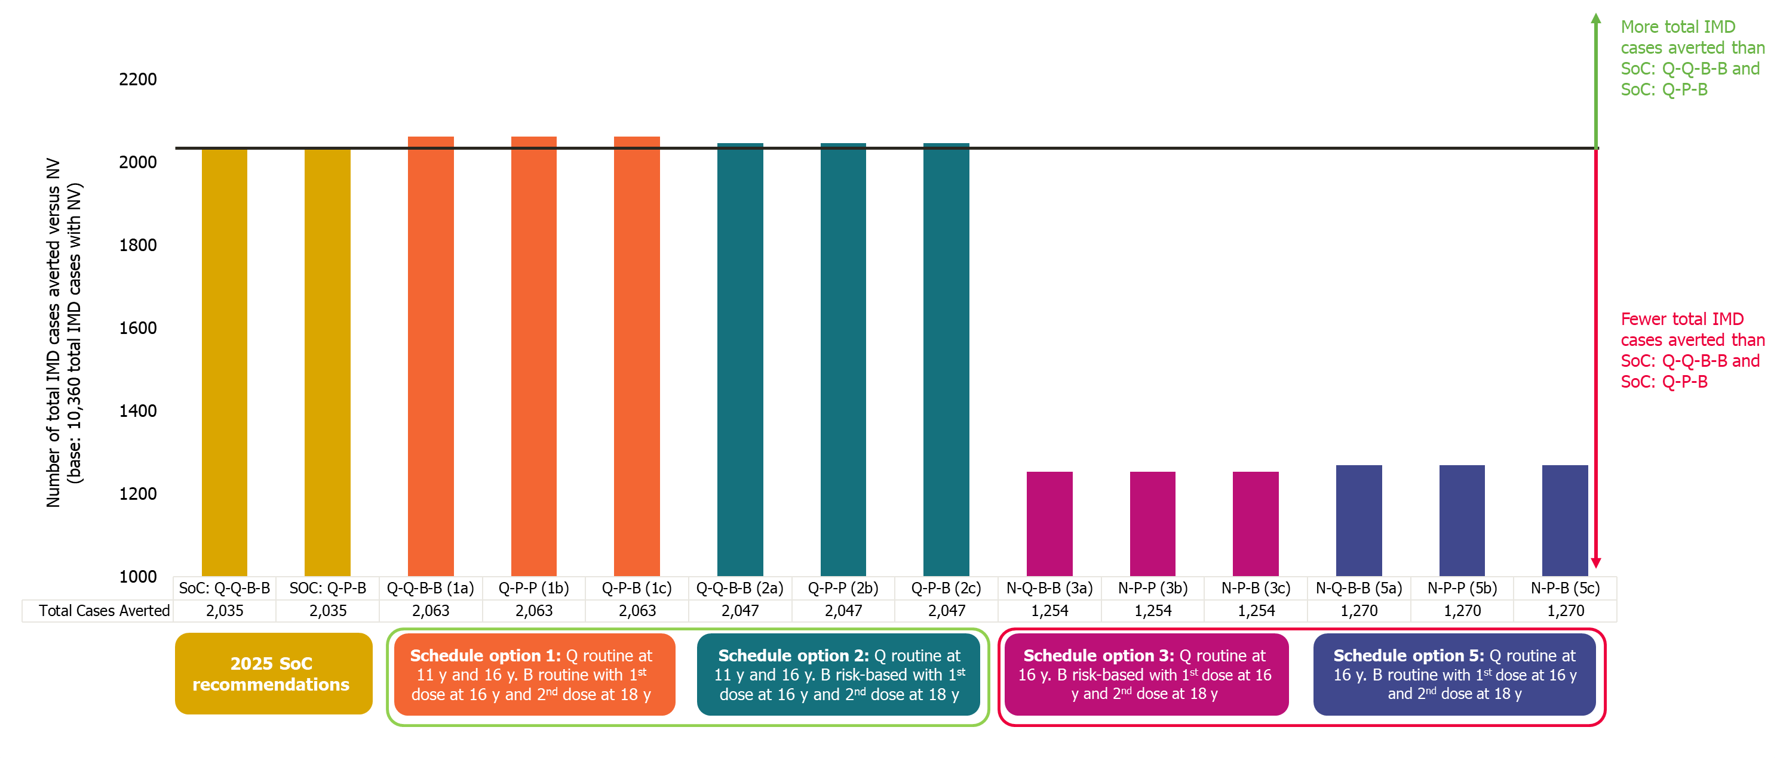
a. 0,24-month dose interval for MenB-containing vaccines

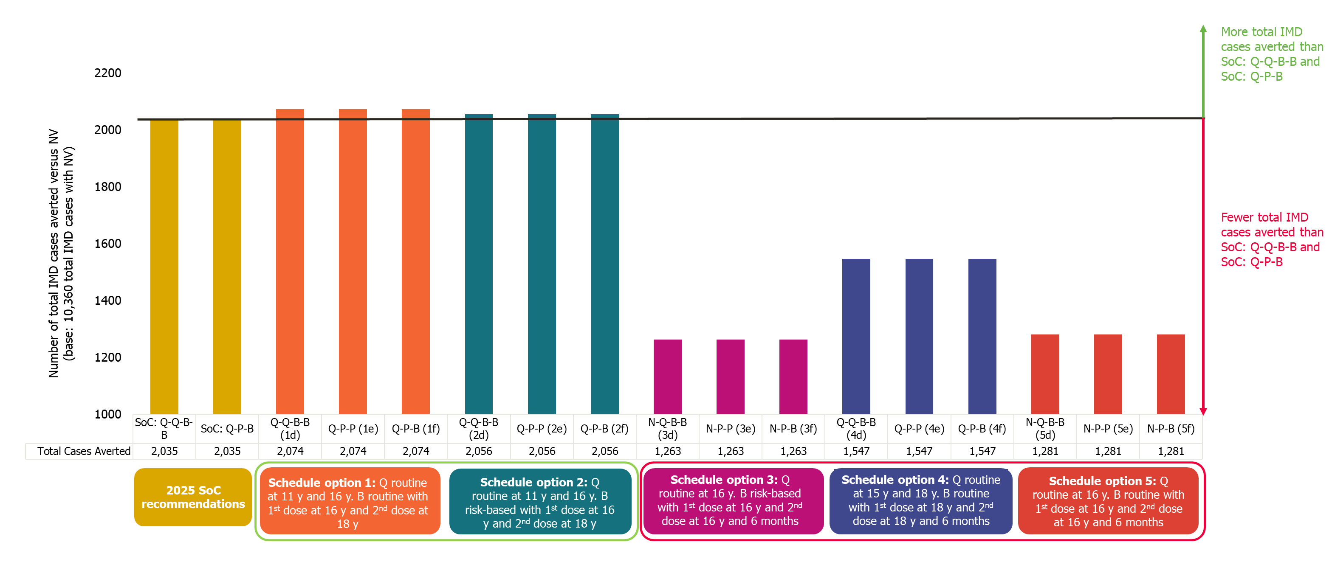
b. 0,6-month dose interval for MenB-containing vaccines
Abbreviations: B, MenB vaccine; IMD, invasive meningococcal disease; MenB, IMD caused by meningococcal bacteria serogroup B; Men, meningococcal; N, no vaccine given; NV, no vaccination; P, MenABCWY vaccine; Q, MenACWY vaccine; SoC, standard of care; US, United States.

Supplemental Fig. 3 US population ICERs of intervention strategies with a 0,24-month and 0,6-month dose intervals for MenB-containing vaccines under schedule options 1 and 2 versus SoC: Q-Q-B-B (a, b) and SoC: Q-P-B (c, d), years 2025–2039
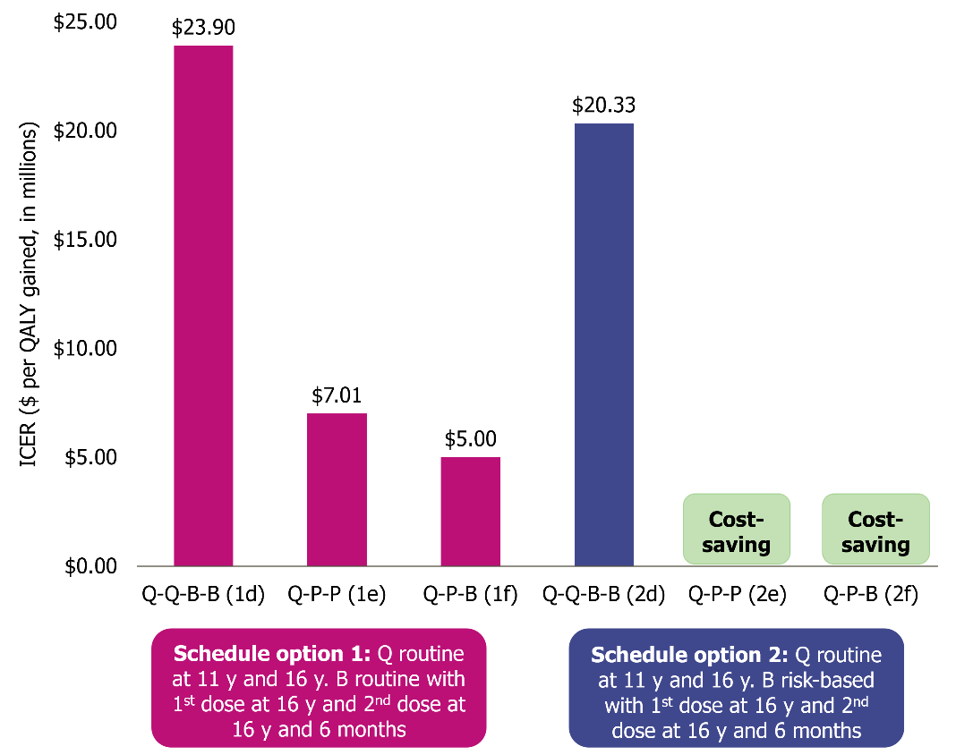
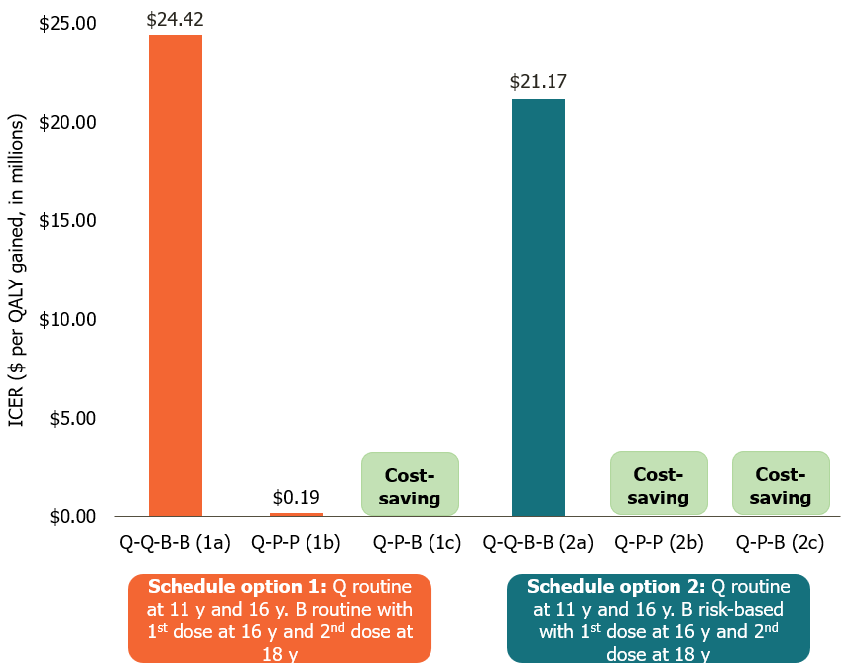
a. Versus Q-Q-B-B; 0,24-month dose interval b. Versus Q-Q-B-B; 0,6-month dose interval

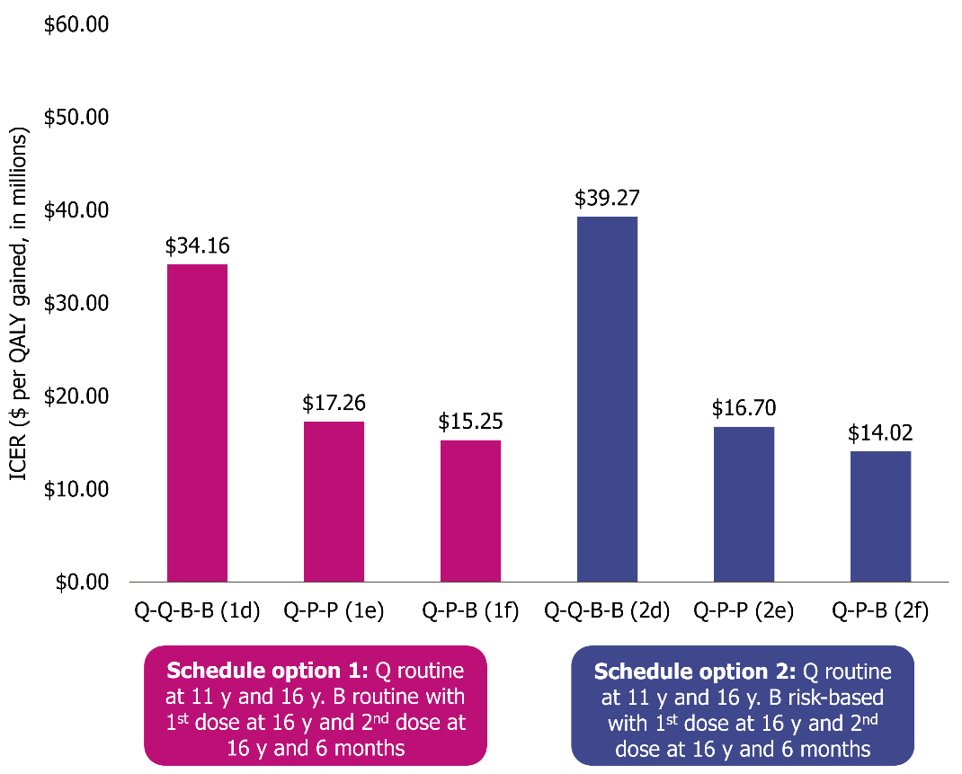
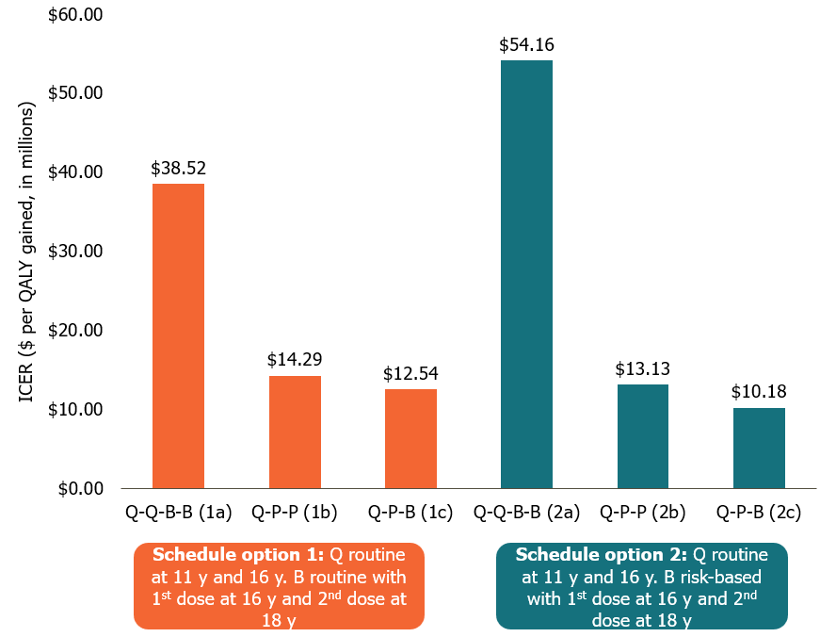
c. Versus Q-P-B; 0,24-month dose interval d. Versus Q-P-B; 0,6-month dose interval

Abbreviations: B, MenB vaccine; ICER, incremental cost-effectiveness ratio; Men, meningococcal; MenB, IMD caused by meningococcal bacteria serogroup B; N, no vaccine given; P, MenABCWY vaccine; Q, MenACWY vaccine; QALY, quality-adjusted life years; SoC, standard of care; US, United States.

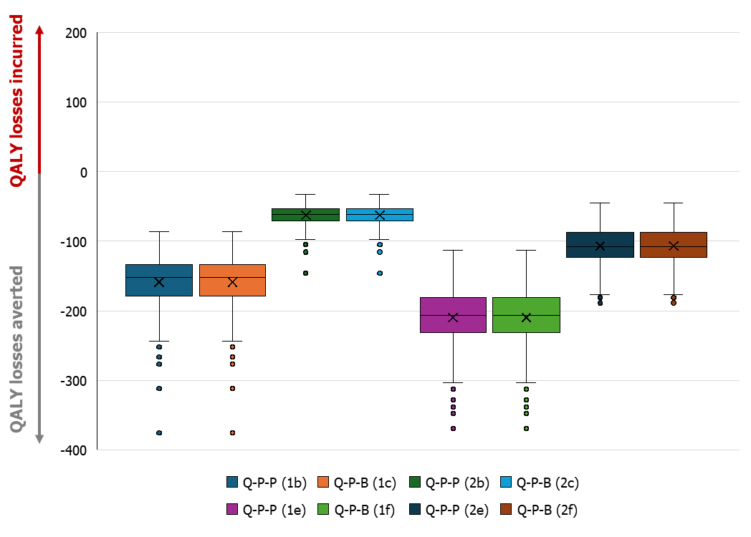
Supplemental Fig. 4 PSA of QALY losses averted and incurred versus SoC: Q-Q-B-B
Abbreviations: B, MenB vaccine; Men, meningococcal; MenB, IMD caused by meningococcal bacteria serogroup B; P, MenABCWY vaccine; PSA, probabilistic sensitivity analysis; Q, MenACWY vaccine; QALY, quality-adjusted life years; SoC, standard of care.
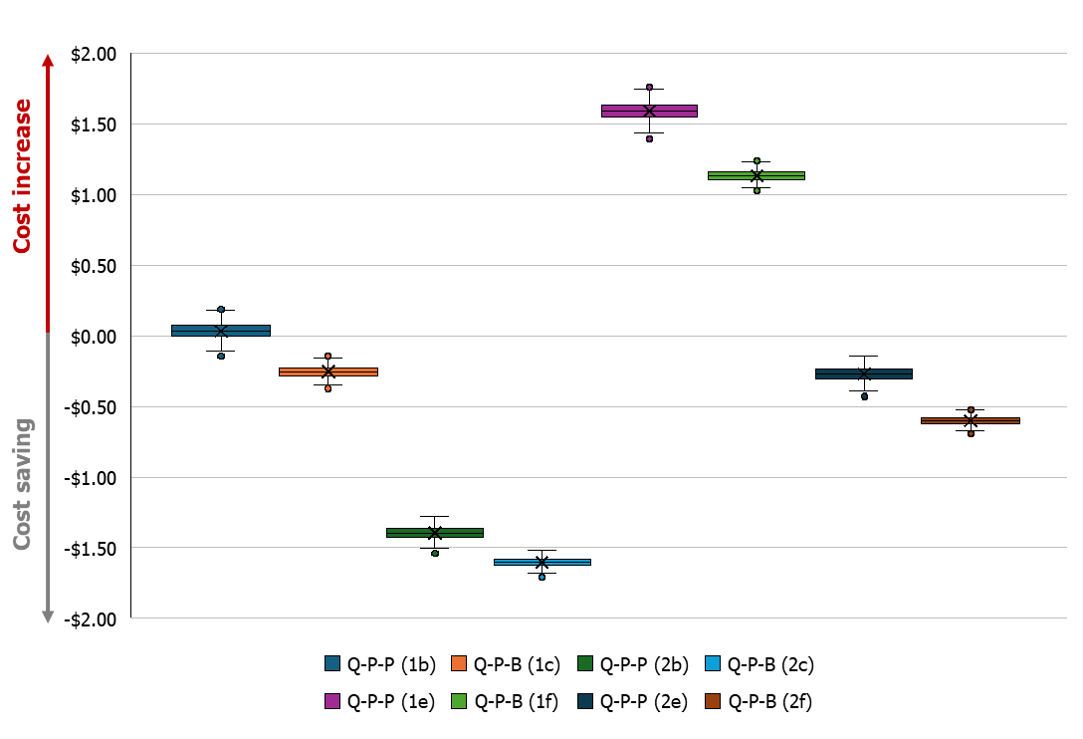
Supplemental Fig. 5 PSA of incremental cost (in $ billion, discounted) versus SoC: Q-Q-B-B
Abbreviations: B, MenB vaccine; Men, meningococcal; MenB, IMD caused by meningococcal bacteria serogroup B; P, MenABCWY vaccine; PSA, probabilistic sensitivity analysis; Q, MenACWY vaccine; SoC, standard of care.
REFERENCES
1. Davis KL, Misurski D, Miller J, Karve S. Cost impact of complications in meningococcal disease: evidence from a United States managed care population. Hum Vaccin. 2011;7(4):458–465.
2. Shen J, Begum N, Ruiz-Garcia Y, Martinon-Torres F, Bekkat-Berkani R, Meszaros K. Range of invasive meningococcal disease sequelae and health economic application - a systematic and clinical review. BMC Public Health. 2022;22(1):1078.
3. US Census Bureau. US population by age: Single year age groups. 2015. Available from: https://www.census.gov/data-tools/demo/idb/#/pop?COUNTRY_YR_ANIM=2021&COUNTRY_YEAR=2021&POP_YEARS=2015&menu=popViz&popPages=BYAGE&FIPS=US. Accessed 12 March 2024.
4. CDC. National Notifiable Diseases Surveillance System, 2019 annual tables of infectious disease data. Available from: https://wonder.cdc.gov/nndss/static/2019/annual/2019-table4-H.pdf. Accessed 12 March 2024.
5. CDC. National Notifiable Diseases Surveillance System, 2018 annual tables of infectious disease data. Available from: https://wonder.cdc.gov/nndss/static/2018/annual/2018-table4-H.pdf. Accessed 12 March 2024.
6. CDC. National Notifiable Diseases Surveillance System, 2017 annual tables of infectious disease data. Available from: https://wonder.cdc.gov/nndss/static/2017/annual/2017-table4-H.pdf. Accessed 12 March 2024.
7. Mbaeyi S, Pondo T, Blain A, Yankey D, Potts C, Cohn A, et al. Incidence of Meningococcal Disease Before and After Implementation of Quadrivalent Meningococcal Conjugate Vaccine in the United States. JAMA Pediatr. 2020;174(9):843–851.
8. Mbaeyi S, Bozio C, Duffy J, Rubin L, Hariri S, Stephens D, et al. Meningococcal vaccination: Recommendations of the Advisory Committee on Immunization Practices, United States, 2020. MMWR Recomm Rep. 2020;69(9):1–41.
9. MacNeil JR, Blain AE, Wang X, Cohn AC. Current Epidemiology and Trends in Meningococcal Disease-United States, 1996-2015. Clin Infect Dis. 2018;66(8):1276–1281.
10. Argante L, Abbing-Karahagopian V, Vadivelu K, Rappuoli R, Medini D. A re-assessment of 4CMenB vaccine effectiveness against serogroup B invasive meningococcal disease in England based on an incidence model. BMC Infect Dis. 2021;21(1):1244.
11. Semmes EC, Chen JL, Goswami R, Burt TD, Permar SR, Fouda GG. Understanding early-life adaptive immunity to guide interventions for pediatric health. Front Immunol. 2020;11:595297.
12. Simon AK, Hollander GA, McMichael A. Evolution of the immune system in humans from infancy to old age. Proc Biol Sci. 2015;282(1821):20143085.
13. ClinicalTrials.gov. NCT04886154: A study on the safety, effectiveness and immune response of meningococcal combined ABCWY vaccine in healthy adolescents and adults [online]. https://clinicaltrials.gov/ct2/show/NCT04886154. Accessed 12 March 2024.
14. Cohn AC, MacNeil JR, Harrison LH, Lynfield R, Reingold A, Schaffner W, et al. Effectiveness and Duration of Protection of One Dose of a Meningococcal Conjugate Vaccine. Pediatrics. 2017;139(2):e20162193.
15. Tipton M, Daly W, Senders S, Block SL, Lattanzi M, Mzolo T, et al. MenACWY-CRM conjugate vaccine booster dose given 4-6 years after priming: Results from a phase IIIb, multicenter, open label study in adolescents and adults. Vaccine. 2019;37(42):6171–6179.
16. Papageorgiou G, Ypma E, Callegaro A, et al. Modelling MenB antibody persistence over 5 years following a primary vaccination series with the MenABCWY vaccine. Presented at ESPID; May 20-24 2024; Copenhagen, Denmark.
17. Wang B, Giles L, Andraweera P, McMillan M, Almond S, Beazley R, et al. 4CMenB sustained vaccine effectiveness against invasive meningococcal B disease and gonorrhoea at three years post programme implementation. J Infect. 2023;87(2):95–102.
18. Christensen H, Trotter CL, Hickman M, Edmunds WJ. Re-evaluating cost effectiveness of universal meningitis vaccination (Bexsero) in England: modelling study. BMJ. 2014;349:g5725.
19. Kennedy ITR, van Hoek AJ, Ribeiro S, Christensen H, Edmunds WJ, Ramsay ME, et al. Short-term changes in the health state of children with group B meningococcal disease: A prospective, national cohort study. PLoS One. 2017;12(5):e0177082.
20. Xie J, Wu EQ, Zheng ZJ, Croft JB, Greenlund KJ, Mensah GA, et al. Impact of stroke on health-related quality of life in the noninstitutionalized population in the United States. Stroke. 2006;37(10):2567–2572.
21. Brown MM, Brown GC, Sharma S, Kistler J, Brown H. Utility values associated with blindness in an adult population. Br J Ophthalmol. 2001;85(3):327–331.
22. Al-Janabi H, Van Exel J, Brouwer W, Trotter C, Glennie L, Hannigan L, et al. Measuring Health Spillovers for Economic Evaluation: A Case Study in Meningitis. Health Econ. 2016;25(12):1529–1544.
23. Saarni SI, Suvisaari J, Sintonen H, Pirkola S, Koskinen S, Aromaa A, et al. Impact of psychiatric disorders on health-related quality of life: general population survey. Br J Psychiatry. 2007;190:326–332.
24. Oostenbrink R, HA AM, Essink-Bot ML. The EQ-5D and the Health Utilities Index for permanent sequelae after meningitis: a head-to-head comparison. J Clin Epidemiol. 2002;55(8):791–799.
25. Erickson LJ, De Wals P, McMahon J, Heim S. Complications of meningococcal disease in college students. Clin Infect Dis. 2001;33(5):737–739.
26. Ortega-Sanchez IR. The cost-effectiveness of a potential pentavalent meningococcal conjugate vaccine (Men ABCWY) versus the current Men ACWY and Men B vaccines for US adolescents. 2023. Available from: https://www.cdc.gov/vaccines/acip/meetings/downloads/slides-2023-06-21-23/02-Mening-Ortega-Sanchez-508.pdf. Accessed 12 March 2024.
27. Kulkarni AV, Hui S, Shams I, Donnelly R. Quality of life in obstructive hydrocephalus: endoscopic third ventriculostomy compared to cerebrospinal fluid shunt. Childs Nerv Syst. 2010;26(1):75–79.
28. Wyld M, Morton RL, Hayen A, Howard K, Webster AC. A systematic review and meta-analysis of utility-based quality of life in chronic kidney disease treatments. PLoS Med. 2012;9(9):e1001307.
29. Blakeney P, Meyer W, 3rd, Robert R, Desai M, Wolf S, Herndon D. Long-term psychosocial adaptation of children who survive burns involving 80% or greater total body surface area. J Trauma. 1998;44(4):625–634.
30. Song J, Floyd FJ, Seltzer MM, Greenberg JS, Hong J. Long-term Effects of Child Death on Parents' Health Related Quality of Life: A Dyadic Analysis. Fam Relat. 2010;59(3):269–282.
31. Gani R, Giovannoni G, Bates D, Kemball B, Hughes S, Kerrigan J. Cost-effectiveness analyses of natalizumab (Tysabri) compared with other disease-modifying therapies for people with highly active relapsing-remitting multiple sclerosis in the UK. Pharmacoeconomics. 2008;26(7):617–627.
32. Shah HA, Jutlla G, Herrera-Restrepo O, Graham J, Hicks KA, Carrico J, et al. Public health impact of introducing a pentavalent vaccine against invasive meningococcal disease in the United States. PharmacoEconomics. 2024;43(3):311–329.
33. Hall E, Wodi P, Hamborsky J, Morelli V, Schillie S. Pink Book. Epidemiology and Prevention of Vaccine-Preventable Diseases, 2021. Available from: https://www.cdc.gov/pinkbook/hcp/table-of-contents/front-matter.html. Accessed 30 Jun 2025. .
34. US Bureau of Labor Statistics (BLS), 2024. Available from: https://www.bls.gov/. Accessed 30 Jun 2025.
35. Agency for Healthcare Research and Quality. Healthcare Cost and Utilization Project, 2024. Available from: https://hcup-us.ahrq.gov/. Accessed 30 May 2025.
36. Marshall GS MZ, Johns JS, Verduzco-Gutierrez M, Herrera-Restrepo O, Harrison LH. Understanding the sequelae of invasive meningococcal disease in the United States. Infect Dis Ther. 2024;13(11):2213–2220.
37. American-Speech Language-Hearing Association (ASHA). Medicare Fee Schedule for Speech-Language Pathologists, 2023. Available from: www.asha.org/siteassets/reimbursement/2024-medicare-fee-schedule-for-speech-language-pathologists.pdf?srsltid=AfmBOooVJXEnGLqUZE28m_2coHtlJvPexFb1IGw_ZJOoNuNxci6G5D1o. Accessed 30 Jun 2025.
38. Armbrecht E, Shah R, Poorman GW, Luo L, Stephens JM, Li B, et al. Economic and Humanistic Burden Associated with Depression and Anxiety Among Adults with Non-Communicable Chronic Diseases (NCCDs) in the United States. J Multidiscip Healthc. 2021;14:887–896.
39. Kim J, Stevens P, Carbone PS, Jones KB. Health Care Use and Spending of Pediatric Patients With an Intellectual or Developmental Disability. Med Care. 2020;58(5):468–473.
40. Wanamaker AB, Andridge RR, Chaudhari AMW. Costs Associated with Lower- and Upper-Limb Amputation Over the First 4 Years with a Prosthesis. JPO: Journal of Prosthetics and Orthotics. 2020;32(2):81–92.
41. Golestaneh L, Alvarez PJ, Reaven NL, Funk SE, McGaughey KJ, Romero A, et al. All-cause costs increase exponentially with increased chronic kidney disease stage. Am J Manag Care. 2017;23(10 Suppl):S163–s172.
42. Nassiri AM, Sorkin DL, Carlson ML. Current Estimates of Cochlear Implant Utilization in the United States. Otol Neurotol. 2022;43(5):e558-e562.
43. American Cochlear Implant Alliance, 2023. Available from: https://www.acialliance.org/. Accessed 30 Jun 2025.
44. Centers for Disease Control and Prevention (CDC). CMS Durable Medical Equipment. 2023.
45. Beck E, Klint J, Garcia S, Abbing V, Abitbol V, Akerborg O, et al. Modelling the impact of 4CMenB and MenACWY meningococcal combined vaccination strategies including potential 4CMenB cross-protection: An application to England. Vaccine. 2020;38(47):7558–7568.
46. Beck E KJ, Neine M, Garcia S, Meszaros K. Cost-effectiveness of 4CMenB infant vaccination in England: A comprehensive valuation considering the broad impact of serogroup B invasive meningococcal disease. Value in Health. 2021;24(1):91–104.
47. US BEA. Federal Reserve Bank of St. Louis. Gross Domestic Product: Implicit Price Deflator [GDPDEF]. 2025. Available from: https://fred.stlouisfed.org/series/GDPDEF. Accessed 30 May 2025.
48. Chambers J, Shkolnik J, Perez M. Total Expenditures for Students with Disabilities, 1999-2000: Spending Variation by Disability, 2003. Available from: https://www.air.org/sites/default/files/SEEP5-Total-Expenditures.pdf. Accessed 30 Jun 2025.
49. National Center for Educational Statistics (NCES). Revenues and expenditures for public elementary and secondary education: FY 19, 2021. Available from: https://nces.ed.gov/pubs2021/2021302.pdf. Accessed 30 Jun 2025.
50. Grosse SD, Krueger KV, Pike J. Estimated annual and lifetime labor productivity in the United States, 2016: implications for economic evaluations. J Med Econ. 2019;22(6):501–508.
51. US Bureau of Labor Statistics (BLS), 2023. Available from: https://www.bls.gov/. Accessed 30 Jun 2025.
52. GSK. VFC (public) price for Bexsero and Menveo. 2024.
53. GSK. Midpoint 2025 hypothetical private price for MenABCWY. 2024.
54. Centers for Disease Control and Prevention (CDC). Current CDC Vaccine Price List. 2025. Available from: https://www.cdc.gov/vaccines-for-children/php/awardees/current-cdc-vaccine-price-list.html.
55. Dong X, Leidner AJ, Schillie SF, Alexandra McNamara L. Economic analyses of GSK MenABCWY vaccinations among adolescents in the United States, 2024. Available from: https://www.cdc.gov/acip/downloads/slides-2024-10-23-24/02-Mening-Dong-508.pdf. Accessed 21 Jul 2025.
56. Pingali C, Yankey D, Chen M, Elam-Evans LD, Markowitz LE, DeSisto CL, et al. National Vaccination Coverage Among Adolescents Aged 13-17 Years - National Immunization Survey-Teen, United States, 2023. MMWR Morb Mortal Wkly Rep. 2024;73(33):708–714.
57. Pingali C, Yankey D, Elam-Evans LD, Markowitz LE, Valier MR, Fredua B, et al. Vaccination Coverage Among Adolescents Aged 13-17 Years - National Immunization Survey-Teen, United States, 2022. MMWR Morb Mortal Wkly Rep. 2023;72(34):912–919.
58. Packnett ER, Zimmerman NM, Kim G, Novy P, Morgan LC, Chime N, et al. A Real-world Claims Data Analysis of Meningococcal Serogroup B Vaccine Series Completion and Potential Missed Opportunities in the United States. Pediatr Infect Dis J. 2022;41(4):e158–e165.

