Supplementary Information

Derivation and Validation of Charlson, Elixhauser and RxRisk cost-based comorbidity indices: a register-based study of 350,000 individuals over 11 years
Pharmacoeconomics

Camilla Nystrand PhD^{1,2}, Naimi Johansson PhD³, Johannes Blom MD PhD^{3,4}

¹ Department of Learning, Informatics, Management and Ethics, Karolinska Institutet, Stockholm, Sweden
² Center for Health Economics, Informatics and Healthcare Research, Health Care Services Stockholm County (SLSO), Region Stockholm, Stockholm, Sweden
³ Department of Clinical Science and Education, Karolinska Institutet, Stockholm, Sweden
⁴ Department of Surgery, Södersjukhuset, Stockholm, Sweden

Corresponding author:
Camilla Nystrand: Camilla.nystrand@ki.se

Table of contents

Tripod Statement 3
Unit costs 5
Total healthcare costs 6
Calibration curves 6
Tail predictions 7
Weights 8
Inpatient care costs 11
Weights 11
Prediction accuracy 14
Calibration curves 16
Sensitivity analyses 19
Sub-group analyses based on age-group 19
References 22

Tripod Statement
Table S1. TRIPOD Statement
Section  /Topic | Item | Checklist Item | Page
Title and abstract
Title | 1 | Identify the study as developing and/or validating a multivariable prediction model, the target population, and the outcome to be predicted. | 1
Abstract | 2 | Provide a summary of objectives, study design, setting, participants, sample size, predictors, outcome, statistical analysis, results, and conclusions. | 2
Introduction
Background and objectives | 3a | Explain the medical context (including whether diagnostic or prognostic) and rationale for developing or validating the multivariable prediction model, including references to existing models. | 4
Background and objectives | 3b | Specify the objectives, including whether the study describes the development or validation of the model or both. | 5
Methods
Source of data | 4a | Describe the study design or source of data (e.g., randomized trial, cohort, or registry data), separately for the development and validation data sets, if applicable. | 5
Source of data | 4b | Specify the key study dates, including start of accrual; end of accrual; and, if applicable, end of follow-up. | 5
Participants | 5a | Specify key elements of the study setting (e.g., primary care, secondary care, general population) including number and location of centres. | 6-7
Participants | 5b | Describe eligibility criteria for participants. | 5-6
Participants | 5c | Give details of treatments received, if relevant. | NR
Outcome | 6a | Clearly define the outcome that is predicted by the prediction model, including how and when assessed. | 6-7
Outcome | 6b | Report any actions to blind assessment of the outcome to be predicted. | NR
Predictors | 7a | Clearly define all predictors used in developing or validating the multivariable prediction model, including how and when they were measured. | 7-8
Predictors | 7b | Report any actions to blind assessment of predictors for the outcome and other predictors. | NR
Sample size | 8 | Explain how the study size was arrived at. | 6
Missing data | 9 | Describe how missing data were handled (e.g., complete-case analysis, single imputation, multiple imputation) with details of any imputation method. | 6
Statistical analysis methods | 10c | For validation, describe how the predictions were calculated. | 8-9
Statistical analysis methods | 10d | Specify all measures used to assess model performance and, if relevant, to compare multiple models. | 9-10
Statistical analysis methods | 10e | Describe any model updating (e.g., recalibration) arising from the validation, if done. | 9
Risk groups | 11 | Provide details on how risk groups were created, if done. | NR
Development vs. validation | 12 | For validation, identify any differences from the development data in setting, eligibility criteria, outcome, and predictors. | 8
Results
Participants | 13a | Describe the flow of participants through the study, including the number of participants with and without the outcome and, if applicable, a summary of the follow-up time. A diagram may be helpful. | 11
Participants | 13b | Describe the characteristics of the participants (basic demographics, clinical features, available predictors), including the number of participants with missing data for predictors and outcome. | 11
Participants | 13c | For validation, show a comparison with the development data of the distribution of important variables (demographics, predictors and outcome). | NR
Model performance | 16 | Report performance measures (with CIs) for the prediction model. | 12
Model-updating | 17 | If done, report the results from any model updating (i.e., model specification, model performance). | NR
Discussion
Limitations | 18 | Discuss any limitations of the study (such as nonrepresentative sample, few events per predictor, missing data). | 16
Interpretation | 19a | For validation, discuss the results with reference to performance in the development data, and any other validation data. | 15
Interpretation | 19b | Give an overall interpretation of the results, considering objectives, limitations, results from similar studies, and other relevant evidence. | 14-15
Implications | 20 | Discuss the potential clinical use of the model and implications for future research. | 16-17
Other information
Supplementary information | 21 | Provide information about the availability of supplementary resources, such as study protocol, Web calculator, and data sets. | 4-17
Funding | 22 | Give the source of funding and the role of the funders for the present study. | 1

Unit costs
Table S2. Unit costs in 2023 Euro
Item | Unit cost | Source
Inpatient care
Admission, overall mean cost per day | 1,318 | [1]
Admission, specialized home care per day | 715 | [1]
DRG cost (per DRG weight=1) | 6,571 | [1]
Outpatient care
Visit to specialist (physician) | 486 | [1]
Visit to specialist (nurse/other healthcare professional) | 342 | [1]
Advanced home care | 612 (starting fee), 94 (per day) | [2]
Contact (not in-person) with specialist | 278 | [1]
Contact (not in-person) with nurse/other healthcare professional | 203 | [1]
Primary care
Visit primary care physician | 172 | [3]
Visit nurse/other healthcare professional | 77 | [3]
Home visit by primary care physician | 209 | [3]
Home visit by assistant nurse | 114 | [3]
Contact (not in-person) with general practitioner | 44 | [3]
Contact (not in-person) with nurse / other healthcare prof in primary care | 30 | [3]

Total healthcare costs
Additional results for annual total healthcare costs as the main outcome.

Calibration curves
Figure below illustrate the calibration curves of the six prediction models, with results zoomed in on costs between €0-10,000.
Figure S1. Charlson (a) mortality-based and (b) cost-based calibration of index with 95% confidence intervals, predictions of values 0-10,000 Euro
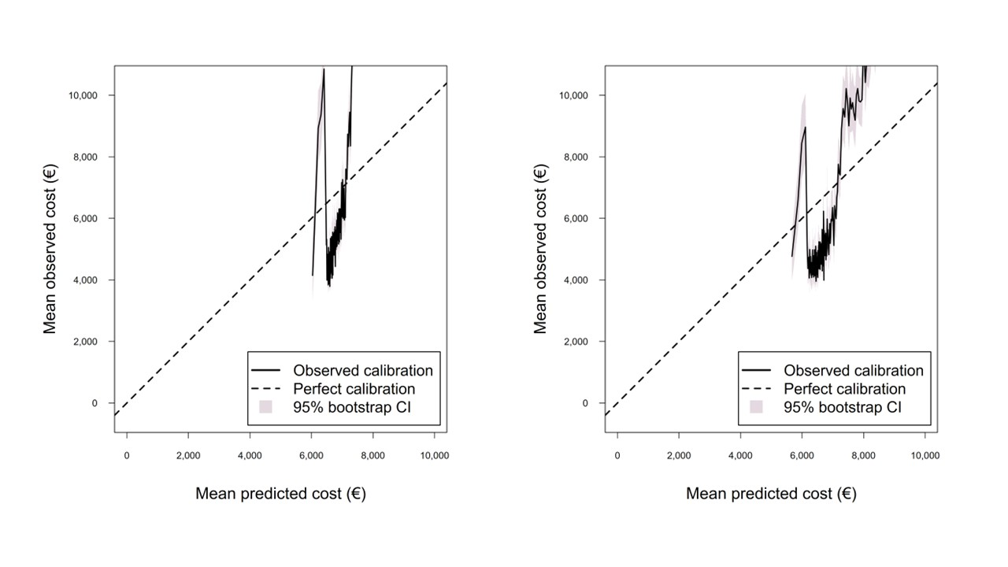
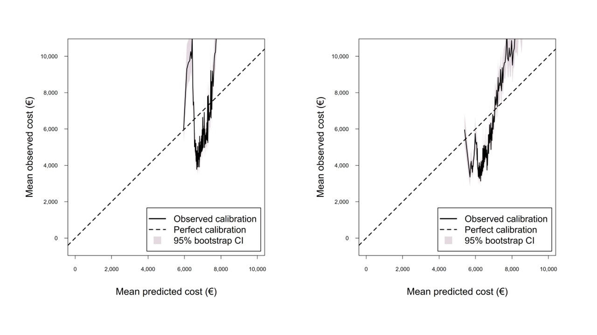
Figure S2. Elixhauser (a) mortality-based and (b) cost-based calibration of index with 95% confidence intervals, predictions of values 0-10,000 Euro
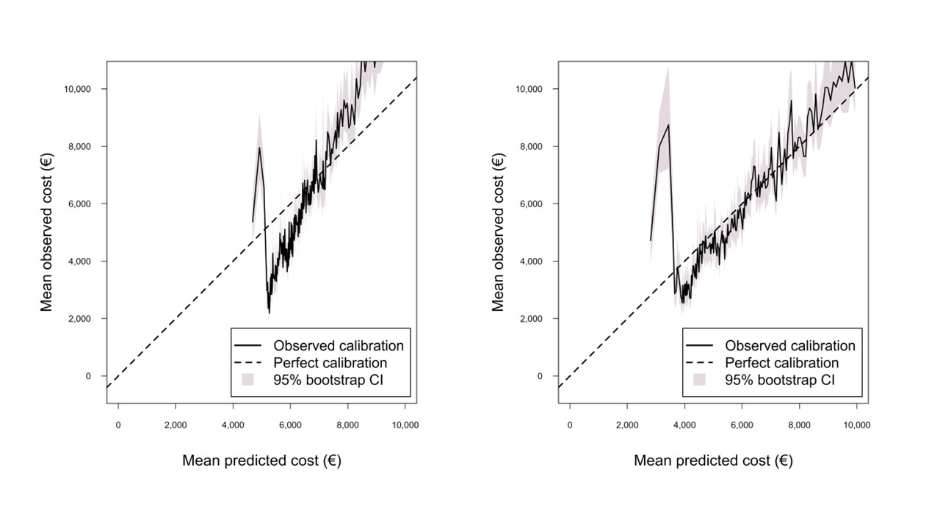
Figure S3. RxRisk (a) mortality-based and (b) cost-based calibration of index with 95% confidence intervals, predictions of values 0-10,000 Euro

Tail predictions
Table S3. Concentration of observed costs in the top 1%, 5% and 10% individuals with highest predicted costs
K% individuals | Charlson median  (95% CI) | Elixhauser median  (95% CI) | Rx-Risk median  (95% CI)
Original
1% | 7.121 (6.774; 7.534) | 5.761 (5.433; 6.085) | 5.076 (4.816; 5.345)
5% | 4.321 (4.214; 4.437) | 4.128 (4.031; 4.231) | 3.333 (3.254; 3.419)
10% | 3.194 (3.141; 3.247) | 3.136 (3.089; 3.187) | 2.664 (2.618; 2.714)
Reweighted
1% | 5.569 (5.311; 5.846) | 5.490 (5.205; 5.771) | 4.753 (4.500; 5.020)
5% | 4.116 (4.023; 4.215) | 3.873 (3.780; 3.960) | 3.182 (3.103; 3.269)
10% | 3.102 (3.052; 3.153) | 3.089 (3.040; 3.139) | 2.572 (2.524; 2.618)
% change between original and reweighted
1% | −21.87 (−26.49; −17.47) | −4.54 (−9.38; 0.41) | −6.37 (−11.03; −1.41)
5% | −4.71 (−6.38; −3.20) | −6.15 (−8.30; −4.12) | −6.16 (−8.16; −3.98)
10% | −2.85 (−3.85; −1.92) | −1.53 (−2.70; −0.39) | −4.48 (−5.97; −3.03)

Weights
Weights for the three indices, based on total healthcare cost as the main outcome.
Table S4. Original weights and reweighted estimates for Charlson Comorbidity Index (CCI) with annual healthcare cost as the main outcome
Comorbid condition | Charlson weights  derived from predicting mortality [4] | Prevalence of disease | Charlson regression weights derived from predicting annual healthcare costs (95% CI)
Myocardical infarction | 0 | 1.70 | 1.137 (1.075; 1.196)
Congestive heart failure | 2 | 1.82 | 1.248 (1.188; 1.309)
Peripheral vascular disease | 0 | 1.10 | 1.179 (1.094; 1.254)
Cerebrovascular disease | 0 | 2.25 | 1.478 (1.420; 1.532)
Dementia | 2 | 0.74 | 1.444 (1.366; 1.529)
Chronic pulmonary disease | 1 | 5.32 | 1.712 (1.676; 1.749)
Rheumatologic disease | 1 | 1.69 | 1.993 (1.940; 2.050)
Peptic ulcer disease | 0 | 0.31 | 1.374 (1.201; 1.542)
Mild liver disease | 2 | 0.74 | 2.052 (1.946; 2.156)
Diabetes without chronic complications | 0 | 6.75 | 1.776 (1.746; 1.807)
Diabetes with chronic complications | 1 | 2.06 | 2.128 (2.083; 2.175)
Hemiplegia or paraplegia | 2 | 0.30 | 1.437 (1.257; 1.618)
Renal disease | 1 | 1.29 | 1.490 (1.419; 1.566)
Any malignancy, including leukemia and lymphoma | 2 | 4.22 | 2.394 (2.355; 2.437)
Moderate or severe liver disease | 4 | 0.16 | 2.209 (1.964; 2.456)
Metastatic solid tumor | 6 | 1.28 | 4.171 (4.095; 4.245)
AIDS/HIV | 4 | 0.02 | 2.881 (2.387; 3.355)

Table S5. Original weights and reweighted estimates for Elixhauser Comorbidity Index (ECI) with annual healthcare cost as the main outcome
Comorbid condition | Elixhauser/van Walraven weights  derived from predicting mortality [5] | Prevalence of disease | Elixhauser regression weights derived from predicting annual healthcare costs (95% CI)
Congestive heart failure | 7 | 1.82 | 0.364 (0.301; 0.424)
Cardiac arrhythmias | 5 | 5.42 | 1.463 (1.427; 1.496)
Valvular disease | −1 | 0.92 | 0.908 (0.831; 0.991)
Pulmonary circulation disorders | 4 | 0.44 | 1.025 (0.894; 1.150)
Peripheral vascular disorders | 2 | 1.10 | 0.880 (0.795; 0.957)
Hypertension, uncomplicated | 0 | 24.06 | 1.503 (1.478; 1.527)
Hypertension, complicated |  | 0.33 | 1.540 (1.405; 1.666)
Paralysis | 7 | 0.30 | 1.299 (1.116; 1.477)
Other neurological disorders | 6 | 1.66 | 2.156 (2.092; 2.222)
Chronic pulmonary disease | 3 | 5.32 | 1.363 (1.325; 1.405)
Diabetes, uncomplicated | 0 | 5.05 | 1.199 (1.166; 1.232)
Diabetes, complicated | 0 | 3.76 | 1.599 (1.558; 1.640)
Hypothyroidism | 0 | 3.83 | 0.815 (0.778; 0.854)
Renal failure | 5 | 1.28 | 1.091 (1.016; 1.166)
Liver disease | 11 | 0.91 | 1.480 (1.382; 1.580)
Peptic ulcer disease excluding bleeding | 0 | 0.09 | 1.351 (1.119; 1.566)
AIDS/HIV | 0 | 0.02 | 2.946 (2.505; 3.385)
Lymphoma | 9 | 0.53 | 2.440 (2.316; 2.572)
Metastatic cancer | 12 | 1.28 | 3.937 (3.854; 4.018)
Solid tumor without metastasis | 4 | 3.52 | 2.111 (2.064; 2.158)
Rheumatoid arthritis/collagen vascular diseases | 0 | 2.03 | 1.849 (1.798; 1.902)
Coagulopathy | 3 | 0.30 | 1.217 (1.046; 1.395)
Obesity | −4 | 1.64 | 0.590 (0.528; 0.653)
Weight loss | 6 | 0.28 | 0.750 (0.564; 0.916)
Fluid and electrolyte disorders | 5 | 0.61 | 0.150 (0.022; 0.267)
Blood loss anemia | −2 | 0.06 | 0.315 (-0.041; 0.685)
Deficiency anemia | −2 | 0.53 | 0.498 (0.371; 0.613)
Alcohol abuse | 0 | 1.62 | 1.157 (1.050; 1.263)
Drug abuse | −7 | 0.24 | 1.605 (1.375; 1.808)
Psychosis | 0 | 0.72 | 2.630 (2.520; 2.750)
Depression | −3 | 3.34 | 1.633 (1.582; 1.680)

Table S6. Original weights and reweighted estimates for RxRisk Comorbidity Index (RxRisk) with annual healthcare as the main outcome
Comorbid condition | RxRisk weights  derived from predicting mortality [6] | Prevalence of disease | RxRisk regression weights derived from predicting annual healthcare costs (95% CI)
Alcohol dependency | 6 | 0.58 | 0.536 (0.407; 0.658)
Allergies | −1 | 13.75 | 0.699 (0.674; 0.729)
Anticoagulants | 1 | 7.98 | 0.870 (0.835; 0.903)
Antiplatelets | 2 | 15.83 | 0.224 (0.201; 0.248)
Anxiety | 1 | 6.08 | 0.259 (0.218; 0.298)
Arrhythmia | 2 | 1.42 | 0.151 (0.091; 0.213)
Benign prostatic hyperplasia | 0 | 3.89 | 1.071 (1.024; 1.117)
Bipolar disorder | −1 | 0.40 | 1.182 (1.053; 1.315)
Chronic airways disease | 2 | 11.71 | 0.548 (0.520; 0.575)
Congestive heart failure | 2 | 35.82 | 0.723 (0.702; 0.746)
Dementia | 2 | 0.59 | 0.756 (0.663; 0.844)
Depression | 2 | 10.77 | 0.561 (0.534; 0.591)
Diabetes | 2 | 9.62 | 0.360 (0.334; 0.385)
Epilepsy | 0 | 1.80 | 1.020 (0.955; 1.085)
Glaucoma | 0 | 3.17 | 1.362 (1.322; 1.401)
Gastroesophageal reflux disease | 0 | 16.25 | 0.548 (0.525; 0.572)
Gout | 1 | 2.11 | 0.042 (-0.014; 0.094)
Hepatitis B | NA | 0.01 | 1.089 (0.524; 1.691)
Hepatitis C | NA | 0.04 | 1.657 (1.266; 2.022)
HIV | 0 | 2.37 | 0.881 (0.817; 0.941)
Hyperkalaemia | 4 | 0.12 | 0.153 (-0.075; 0.374)
Hyperlipidaemia | −1 | 23.94 | 0.593 (0.573; 0.613)
Hypertension | −1 | 24.69 | 0.429 (0.411; 0.450)
Hyperthyroidism | 2 | 8.54 | 0.581 (0.553; 0.609)
Hypothyroidism | 0 | 0.008 | 0.532 (-0.338; 1.405)
Irritable bowel syndrome | 0 | 0.88 | 1.147 (1.068; 1.228)
Isch. Heart disease: angina | 2 | 3.97 | -0.631 (-0.671; -0.590)
Isch. Heart disease: hypertension | −1 | 28.50 | 0.579 (0.560; 0.599)
Incontinence | 0 | 2.32 | 0.547 (0.494; 0.600)
Inflammation/pain | –1 | 18.12 | 0.971 (0.943; 1.000)
Liver failure | 3 | 2.08 | 0.080 (0.016; 0.144)
Malignancies | 2 | 0.67 | 1.830 (1.729; 1.943)
Malnutrition | 0 | 0.02 | 1.921 (1.373; 2.470)
Migraine | −1 | 1.36 | 0.804 (0.727; 0.875)
Osteoporosis/Paget’s | −1 | 2.59 | 0.765 (0.712; 0.816)
Pain | 3 | 13.18 | 0.279 (0.248; 0.309)
Pancreatic insufficiency | 0 | 0.49 | 0.768 (0.639; 0.884)
Parkinson’s disease | 3 | 1.56 | 0.837 (0.775; 0.904)
Psoriasis | 0 | 1.01 | 0.936 (0.851; 1.021)
Psychotic illness | 6 | 1.97 | 0.594 (0.533; 0.659)
Pulmonary hypertension | 6 | 0.01 | 1.130 (0.472; 1.726)
Renal disease | 6 | 0.65 | 0.250 (0.148; 0.344)
Smoking cessation | 6 | 0.99 | -0.135 (-0.230; -0.035)
Steroid-responsive disease | 2 | 7.46 | 0.538 (0.501; 0.571)
Transplant | 0 | 0.26 | 0.115 (-0.023; 0.252)
Tuberculosis | NA | 0.01 | 1.114 (0.290; 1.931)

Inpatient care costs
Results presented below are for annual inpatient care as the main outcome variable.

Weights
Table S7. Original weights and reweighted estimates for Charlson Comorbidity Index (CCI) with annual inpatient care cost as the main outcome
Comorbid condition | Charlson weights  derived from predicting mortality [4] | Prevalence of disease |  | Charlson regression weights derived from predicting annual inpatient care costs (95% CI)
Myocardical infarction | 0 | 1.70 | 2.552 (2.27; 2.832)
Congestive heart failure | 2 | 1.82 | 4.397 (4.121; 4.675)
Peripheral vascular disease | 0 | 1.10 | 3.625 (3.292; 3.968)
Cerebrovascular disease | 0 | 2.25 | 2.943 (2.696; 3.181)
Dementia | 2 | 0.74 | 2.96 (2.567; 3.364)
Chronic pulmonary disease | 1 | 5.32 | 2.64 (2.495; 2.782)
Rheumatologic disease | 1 | 1.69 | 2.152 (1.906; 2.406)
Peptic ulcer disease | 0 | 0.31 | 4.706 (4.022; 5.34)
Mild liver disease | 2 | 0.74 | 3.868 (3.457; 4.267)
Diabetes without chronic complications | 0 | 6.75 | 1.061 (0.944; 1.183)
Diabetes with chronic complications | 1 | 2.06 | 2.38 (2.138; 2.629)
Hemiplegia or paraplegia | 2 | 0.30 | 4.347 (3.673; 5.042)
Renal disease | 1 | 1.29 | 4.246 (3.917; 4.585)
Any malignancy, including leukemia and lymphoma | 2 | 4.22 | 3.984 (3.808; 4.163)
Moderate or severe liver disease | 4 | 0.16 | 9.242 (8.312; 10.15)
Metastatic solid tumor | 6 | 1.28 | 11.962 (11.603; 12.307)
AIDS/HIV | 4 | 0.02 | 3.306 (0.688; 6.072)

Table S8. Original weights and reweighted estimates for Elixhauser Comorbidity Index (ECI) with annual inpatient care cost as the main outcome
Comorbid condition | Elixhauser/van Walraven weights  derived from predicting mortality [5] | Prevalence of disease |  | Elixhauser regression weights derived from predicting annual inpatient care costs (95% CI)
Congestive heart failure | 7 | 1.82 | 3.337 (3.058; 3.633)
Cardiac arrhythmias | 5 | 5.42 | 1.867 (1.719; 2.021)
Valvular disease | −1 | 0.92 | 1.75 (1.39; 2.122)
Pulmonary circulation disorders | 4 | 0.44 | 2.412 (1.869; 2.954)
Peripheral vascular disorders | 2 | 1.10 | 3.61 (3.28; 3.966)
Hypertension, uncomplicated | 0 | 24.06 | 0.341 (0.272; 0.41)
Hypertension, complicated |  | 0.33 | 0.769 (0.193; 1.371)
Paralysis | 7 | 0.30 | 4.025 (3.374; 4.714)
Other neurological disorders | 6 | 1.66 | 4.905 (4.614; 5.2)
Chronic pulmonary disease | 3 | 5.32 | 2.238 (2.1; 2.38)
Diabetes, uncomplicated | 0 | 5.05 | 0.704 (0.573; 0.852)
Diabetes, complicated | 0 | 3.76 | 1.929 (1.748; 2.092)
Hypothyroidism | 0 | 3.83 | 0.061 (-0.087; 0.204)
Renal failure | 5 | 1.28 | 3.993 (3.664; 4.323)
Liver disease | 11 | 0.91 | 2.872 (2.482; 3.223)
Peptic ulcer disease excluding bleeding | 0 | 0.09 | 4.321 (3.252; 5.495)
AIDS/HIV | 0 | 0.02 | 3.084 (0.411; 5.867)
Lymphoma | 9 | 0.53 | 4.399 (3.859; 4.88)
Metastatic cancer | 12 | 1.28 | 11.508 (11.149; 11.861)
Solid tumor without metastasis | 4 | 3.52 | 3.655 (3.471; 3.839)
Rheumatoid arthritis/collagen vascular diseases | 0 | 2.03 | 2.013 (1.781; 2.221)
Coagulopathy | 3 | 0.30 | 3.191 (2.564; 3.897)
Obesity | −4 | 1.64 | 0.99 (0.743; 1.234)
Weight loss | 6 | 0.28 | 3.641 (2.926; 4.326)
Fluid and electrolyte disorders | 5 | 0.61 | 3.628 (3.107; 4.091)
Blood loss anemia | −2 | 0.06 | 2.512 (1.112; 4.05)
Deficiency anemia | −2 | 0.53 | 1.931 (1.425; 2.365)
Alcohol abuse | 0 | 1.62 | 4.886 (4.583; 5.179)
Drug abuse | −7 | 0.24 | 4.697 (3.954; 5.448)
Psychosis | 0 | 0.72 | 3.478 (3.058; 3.888)
Depression | −3 | 3.34 | 1.619 (1.439; 1.791)

Table S9. Original weights and reweighted estimates for RxRisk Comorbidity Index (RxRisk) with annual inpatient care cost as the main outcome
Comorbid condition | RxRisk weights  derived from predicting mortality [6] | Prevalence of disease | RxRisk regression weights derived from predicting annual inpatient care costs (95% CI)
Alcohol dependency | 6 | 0.58 | 1.719 (1.27; 2.168)
Allergies | −1 | 13.75 | -0.168 (-0.248; -0.084)
Anticoagulants | 1 | 7.08 | 1.446 (1.328; 1.583)
Antiplatelets | 2 | 15.83 | 0.557 (0.466; 0.646)
Anxiety | 1 | 6.08 | 1.196 (1.051; 1.356)
Arrhythmia | 2 | 1.42 | 1.444 (1.151; 1.758)
Benign prostatic hyperplasia | 0 | 3.89 | 0.405 (0.252; 0.564)
Bipolar disorder | −1 | 0.40 | 1.639 (1.112; 2.169)
Chronic airways disease | 2 | 11.71 | 0.22 (0.127; 0.313)
Congestive heart failure | 2 | 35.82 | 0.002 (-0.067; 0.076)
Dementia | 2 | 0.59 | 0.598 (0.186; 1.008)
Depression | 2 | 10.77 | 0.304 (0.2; 0.405)
Diabetes | 2 | 9.62 | 0.451 (0.344; 0.553)
Epilepsy | 0 | 1.80 | 2.632 (2.365; 2.885)
Glaucoma | 0 | 3.17 | 0.005 (-0.154; 0.161)
Gastroesophageal reflux disease | 0 | 16.25 | 1.143 (1.056; 1.231)
Gout | 1 | 2.11 | 0.78 (0.554; 1.006)
Hepatitis B | NA | 0.01 | 1.678 (-1.401; 4.846)
Hepatitis C | NA | 0.04 | 1.217 (-0.365; 2.923)
HIV | 0 | 2.37 | 0.186 (0.011; 0.374)
Hyperkalaemia | 4 | 0.12 | 3.9 (2.862; 5.012)
Hyperlipidaemia | −1 | 23.94 | -0.472 (-0.546; -0.404)
Hypertension | −1 | 24.69 | 0.299 (0.231; 0.375)
Hyperthyroidism | 2 | 8.54 | -0.627 (-0.724; -0.533)
Hypothyroidism | 0 | 0.008 | 3.466 (-0.379; 7.483)
Irritable bowel syndrome | 0 | 0.88 | 0.4 (0.074; 0.723)
Isch. Heart disease: angina | 2 | 3.97 | 0.727 (0.551; 0.893)
Isch. Heart disease: hypertension | −1 | 28.50 | 0.054 (-0.021; 0.123)
Incontinence | 0 | 2.32 | 0.572 (0.353; 0.78)
Inflammation/pain | –1 | 18.12 | 0.263 (0.197; 0.333)
Liver failure | 3 | 2.08 | 1.687 (1.447; 1.936)
Malignancies | 2 | 0.67 | 5.456 (5.004; 5.946)
Malnutrition | 0 | 0.02 | 9.009 (6.307; 11.443)
Migraine | −1 | 1.36 | -0.527 (-0.74; -0.316)
Osteoporosis/Paget’s | −1 | 2.59 | 0.731 (0.533; 0.921)
Pain | 3 | 13.18 | 1.251 (1.158; 1.347)
Pancreatic insufficiency | 0 | 0.49 | 2.876 (2.372; 3.375)
Parkinson’s disease | 3 | 1.56 | 1.109 (0.836; 1.387)
Psoriasis | 0 | 1.01 | 0.201 (-0.096; 0.469)
Psychotic illness | 6 | 1.97 | 0.42 (0.175; 0.691)
Pulmonary hypertension | 6 | 0.01 | 3.058 (-0.54; 6.559)
Renal disease | 6 | 0.65 | 3.858 (3.361; 4.348)
Smoking cessation | 6 | 0.99 | -0.087 (-0.422; 0.209)
Steroid-responsive disease | 2 | 7.46 | 1.684 (1.558; 1.811)
Transplant | 0 | 0.26 | 0.987 (0.206; 1.696)
Tuberculosis | NA | 0.01 | 1.356 (-1.629; 4.663)

Prediction accuracy
Table S10. Patient-level prediction accuracy, explained variation and systematic bias and scale of predictions of inpatient care costs, using the original and re-weighted CCI, ECI and Rx-Risk respectively. Cost estimates in 2023 Euro.
 | Medians (95% CI) for inpatient care costs
 | Original CCI | Reweighted CCI | Original ECI | Reweighted ECI | Original Rx-Risk | Reweighted Rx-Risk
RMSE (€) | 17,777 (16,784; 18,971) | 17,859 (16,844; 19,058) | 17,966 (16,949; 19,180) | 17,871 (16,854; 19,063) | 18,022 (17,009; 19,219) | 17,877 (16,873; 19,072)
MAE (€) | 5,085 (5,030; 5,138) | 5,089 (5,035; 5,144) | 5,158 (5,105; 5,214) | 5,086 (5,032; 5,141) | 5,152 (5,098; 5,206) | 5,062 (5,008; 5,115)
R² | 0.0488 (0.0415; 0.0571) | 0.0395 (0.0329; 0.0464) | 0.0283 (0.0221; 0.0350) | 0.0387 (0.0312; 0.0462) | 0.0237 (0.0203; 0.0274) | 0.0395 (0.0334; 0.0456)
Calibration slope | 0.993 (0.887; 1.112) | 0.991 (0.867; 1.128) | 0.990 (0.861; 1.133) | 0.988 (0.853; 1.132) | 1.005 (0.931; 1.080) | 1.000 (0.924; 1.084)
Calibration intercept | 20.81 (-318.20; 344.60) | 26.98 (-381.08; 403.68) | 28.62 (-391.61; 436.32) | 41.85 (-392.26; 455.12) | -18.99 (-240.39; 190.61) | -1.36 (-245.72; 224.56)

Table S11. Change in main outcome measures between the original and reweighted versions of CCI, ECI and Rx-Risk for inpatient care as the main outcome
 | CCI Δ (95% CI) | ECI Δ (95% CI) | Rx-Risk Δ (95% CI)
RMSE | 89.20 (44.04; 142.65) | -97.83 (-142.83; -46.81) | -147.25 (-184.91; -110.96)
MAE | 4.95 (-2.23; 12.25) | -71.67 (-78.97; -64.09) | -90.19 (-97.78; -82.63)
R² (percent points) | -0.95 (-1.51; -0.46) | 1.05 (0.49; 1.55) | 1.58 (1.19; 1.99)

Table S12. Proportion of Top 1%, 5% and 10% of observed inpatient care costs
K | CCI median (95% CI) | ECI median (95% CI) | Rx-Risk median (95% CI)
Original
1% | 12.37 (11.45; 13.37) | 10.28 (9.51; 11.11) | 7.11 (6.54; 7.71)
5% | 6.42 (6.21; 6.64) | 6.00 (5.81; 6.22) | 4.47 (4.29; 4.67)
10% | 4.22 (4.12; 4.32) | 4.21 (4.11; 4.31) | 3.44 (3.34; 3.54)
Reweighted
1% | 9.09 (8.43; 9.74) | 8.74 (8.11; 9.42) | 7.08 (6.47; 7.72)
5% | 6.02 (5.82; 6.23) | 5.75 (5.54; 5.96) | 4.25 (4.07; 4.44)
10% | 4.18 (4.08; 4.29) | 4.16 (4.06; 4.26) | 3.22 (3.12; 3.32)
Percent change between original and reweighted
1% | -26.42 (-33.00; -20.49) | -14.86 (-21.15; -8.42) | -0.49 (-7.21; 7.88)
5% | -6.17 (-7.99; -4.44) | -4.31 (-6.56; -1.95) | -5.07 (-8.26; -1.54)
10% | -0.81 (-2.08; 4.21) | -1.34 (-2.84; 0.22) | -6.14 (-8.20; -4.03)

Calibration curves
Results below are for the outcome inpatient care costs.

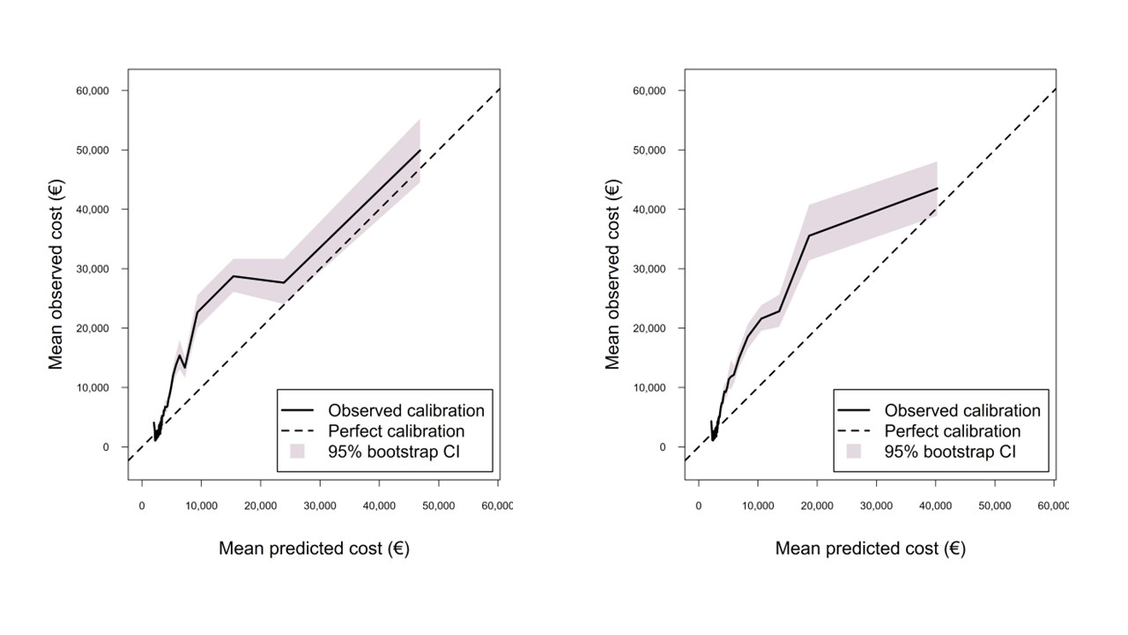
Figure S4. Charlson (a) mortality-based and (b) cost-based calibration of index with 95% confidence intervals

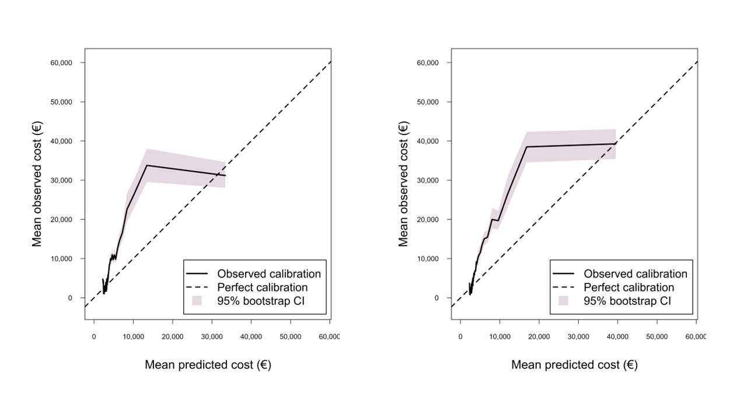
Figure S5. Elixhauser (a) mortality-based and (b) cost-based calibration of index with 95% confidence intervals

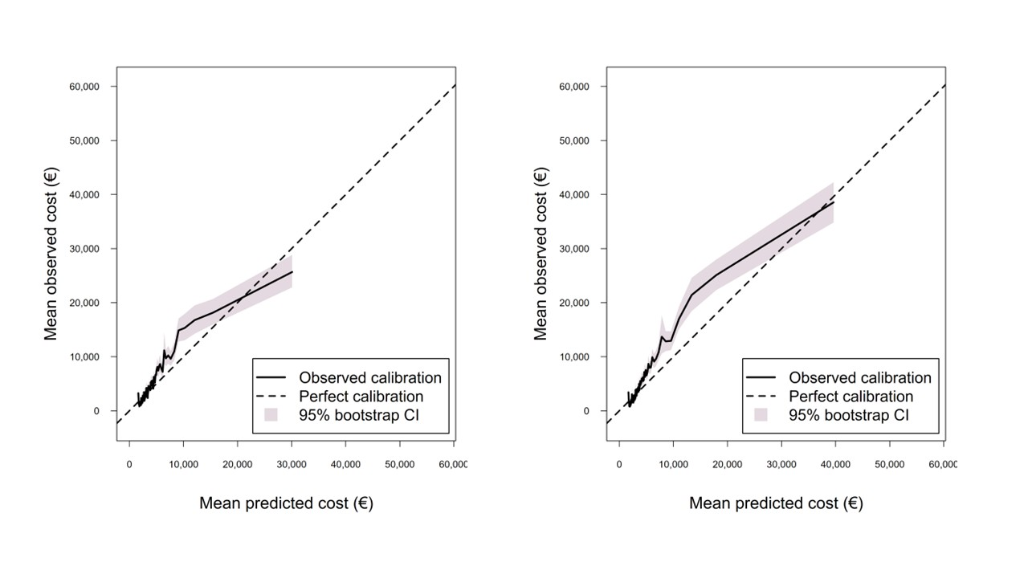
Figure S6. RxRisk (a) mortality-based and (b) cost-based calibration of index with 95% confidence intervals

The results below show calibration curves for inpatient care costs ranging from zero to € 10,000.
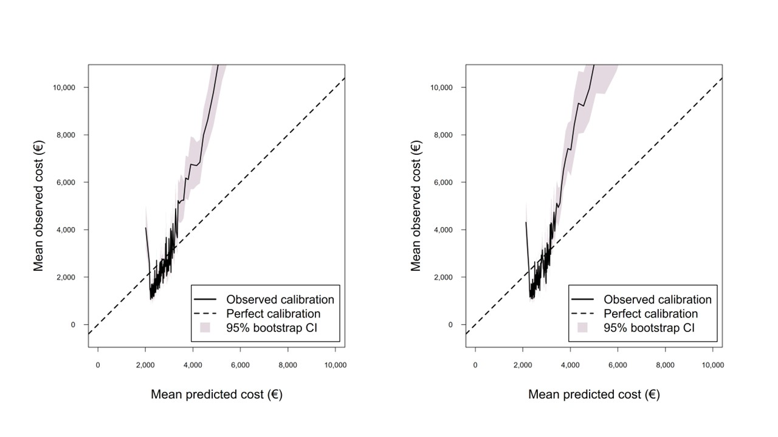
Figure S7. Charlson (a) mortality-based and (b) cost-based calibration of index with 95% confidence intervals, predictions of values 0-10,000 Euro

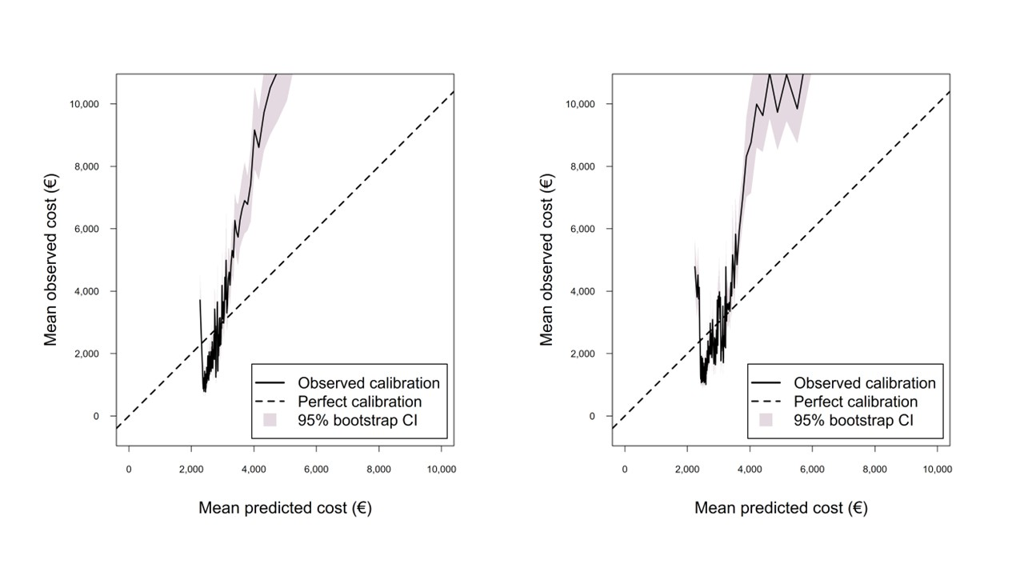
Figure S8. Elixhauser (a) mortality-based and (b) cost-based calibration of index with 95% confidence intervals, predictions of values 0-10,000 Euro

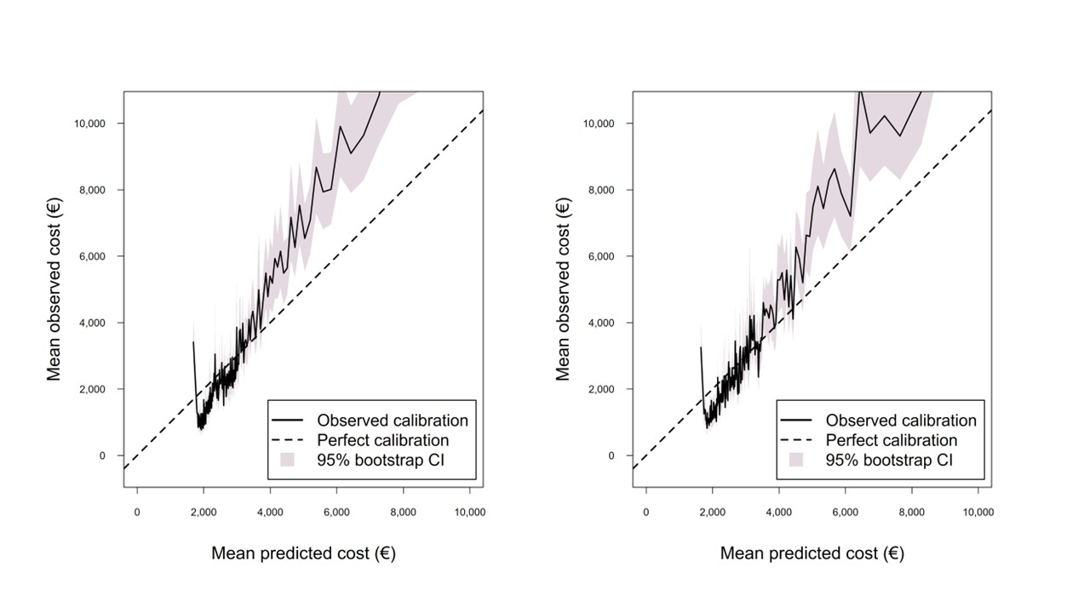
Figure S9. RxRisk (a) mortality-based and (b) cost-based calibration of index with 95% confidence intervals, predictions of values 0-10,000 Euro

Sensitivity analyses
Table S13. Prediction accuracy of the three cost-based models, using an elastic-net instead of ridge for tuning hyperparameters.
 | Charlson | Elixhauser | RxRisk
RMSE | 21210.44 | 21228.86 | 21062.68
MAE | 8026.665 | 7984.334 | 7810.609
R2 | 0.03418490 | 0.03250594 | 0.04759370
Calibration intercept | 363.7309186 | 893.6329079 | 0.6906139
Calibration slope | 0.9502532 | 0.8776780 | 0.9997535

Sub-group analyses based on age-group
Table S14. Sub-group analyses for mortality-based Charlson index (total healthcare costs as the main outcome)
Subgroup | n | RMSE | MAE | R² | Calibration intercept | Calibration slope
Age
55–59 | 46,371 | 21,013 | 7,902 | 0.05886091 | -7,870 | 1.9996767
60–64 | 99,490 | 22,854 | 8,006 | 0.03536207 | 66.6 | 0.9355529
65–69 | 111,660 | 20,863 | 8,115 | 0.05534580 | -1,204 | 1.1817868
70–74 | 73,579 | 19,756 | 8,041 | 0.03898536 | 2,062 | 0.8089973
75–79 | 23,816 | 16,728 | 7,934 | 0.01429067 | 4,994 | 0.4559915
80+ | 1,004 | 15,120 | 8,049 | 0.05699533 | 1,394 | 0.9475861
Overall | 358,546 | 21,098 | 8,041 | 0.04435634 | 120 | 0.9835163
Male | 175,641 | 20,465 | 8,336 | 0.03921328 | 861 | 0.8783837
Female | 182,903 | 21,688 | 7,757 | 0.04870958 | -670 | 1.0966531

Table S15. Sub-group analyses for cost-based Charlson index (total healthcare costs as the main outcome)
Subgroup | n | RMSE | MAE | R² | Calibration intercept | Calibration slope
Age
55–59 | 46,371 | 21,192 | 7,885 | 0.042720830 | -8,302 | 2.0825128
60–64 | 99,490 | 22,801 | 7,971 | 0.039756168 | -6,305 | 1.8508639
65–69 | 111,660 | 21,064 | 8,112 | 0.037076846 | -226 | 1.0495600
70–74 | 73,579 | 20,085 | 8,035 | 0.006700997 | 4,040 | 0.5403084
75–79 | 23,816 | 16,372 | 7,981 | 0.028422059 | 3,262 | 0.6615112
80+ | 1,004 | 16,122 | 8,458 | 0.072165399 | 6,216 | 0.3139245
Overall | 358,546 | 21,217 | 8,031 | 0.033580483 | 382 | 0.9477178
Male | 175,641 | 20,360 | 8,317 | 0.049090241 | -1,361 | 1.1716009
Female | 182,903 | 22,009 | 7,757 | 0.020449719 | 1,763 | 0.7674286

Table S16. Sub-group analyses for mortality-based Elixhauser index (total healthcare costs as the main outcome)
Subgroup | n | RMSE | MAE | R² | Calibration intercept | Calibration slope
Age
55–59 | 46,371 | 21,358 | 8,083 | 0.0277557700 | -1,4153 | 2.8621851
60–64 | 99,490 | 22,941 | 8,131 | 0.0279794384 | -3,247 | 1.4017769
65–69 | 111,660 | 21,108 | 8,221 | 0.0330228726 | -3,068 | 1.4411595
70–74 | 73,579 | 20,157 | 8,110 | -0.000400575 | 4,373 | 0.5041680
75–79 | 23,816 | 16,644 | 7,974 | -0.004115949 | 4,730 | 0.4893548
80+ | 1,004 | 15,563 | 8,173 | 0.0009072822 | 4,518 | 0.5484790
Overall | 358,546 | 21,321 | 8,151 | 0.0240206906 | 575 | 0.9215292
Male | 175,641 | 20,563 | 8,432 | 0.0299782540 | 174 | 0.9680727
Female | 182,903 | 22,025 | 7,881 | 0.0189764915 | 983 | 0.8726184

Table S17. Sub-group analyses for cost-based Elixhauser index (total healthcare costs as the main outcome)
Subgroup | n | RMSE | MAE | R² | Calibration intercept | Calibration slope
Age
55–59 | 46,371 | 21,906 | 7,825 | -0.022814308 | 3,416 | 0.3924887
60–64 | 99,490 | 22,792 | 7,900 | 0.040582954 | -5,880 | 1.8006311
65–69 | 111,660 | 21,016 | 8,084 | 0.041440876 | -953 | 1.1455677
70–74 | 73,579 | 19,698 | 8,026 | 0.044679750 | 723 | 0.9708977
75–79 | 23,816 | 16,632 | 7,947 | -0.002666024 | 4,601 | 0.4936347
80+ | 1,004 | 15,381 | 8,130 | 0.024191968 | 2,716 | 0.7493426
Overall | 358,546 | 21,229 | 7,988 | 0.032403986 | 850 | 0.8836661
Male | 175,641 | 20,584 | 8,271 | 0.028025960 | 1,957 | 0.7263482
Female | 182,903 | 21,832 | 7,717 | 0.036109561 | -1,441 | 1.2075110

Table S18. Sub-group analyses for mortality-based RxRisk index (total healthcare costs as the main outcome)
Subgroup | n | RMSE | MAE | R² | Calibration intercept | Calibration slope
Age
55–59 | 46,371 | 21,298 | 7,942 | 0.03318155 | -401 | 0.8910395
60–64 | 99,490 | 22,790 | 7,818 | 0.04072681 | -1,444 | 1.1692156
65–69 | 111,660 | 21,006 | 8,043 | 0.04240790 | 414 | 0.9637427
70–74 | 73,579 | 19,704 | 7,969 | 0.04404214 | 270 | 1.0494185
75–79 | 23,816 | 16,266 | 7,907 | 0.04098722 | 1,782 | 0.8752590
80+ | 1,004 | 15,270 | 8,252 | 0.03818846 | 1,554 | 0.8949473
Overall | 358,546 | 21,135 | 7,960 | 0.04097501 | -10.99 | 1.0014234
Male | 175,641 | 20,361 | 8,221 | 0.04895153 | -489 | 1.0687955
Female | 182,903 | 21,853 | 7,709 | 0.03422164 | 435 | 0.9385259

Table S19. Sub-group analyses for cost-based RxRisk index (total healthcare costs as the main outcome)
Subgroup | n | RMSE | MAE | R² | Calibration intercept | Calibration slope
Age
55–59 | 46,371 | 21,143 | 7,710 | 0.04715635 | -1,143 | 1.0113932
60–64 | 99,490 | 22,770 | 7,582 | 0.04243167 | -671 | 1.0868935
65–69 | 111,660 | 20,923 | 7,904 | 0.04987818 | 340 | 0.9717688
70–74 | 73,579 | 19,627 | 7,910 | 0.05150927 | 664 | 0.9719352
75–79 | 23,816 | 16,207 | 7,903 | 0.04798507 | 1,602 | 0.8604772
80+ | 1,004 | 15,155 | 8,171 | 0.05267434 | 1,700 | 0.8363056
Overall | 358,546 | 21,059 | 7,808 | 0.04784521 | 1.25 | 0.9996761
Male | 175,641 | 20,385 | 8,111 | 0.04672849 | 362 | 0.9513504
Female | 182,903 | 21,687 | 7,517 | 0.04878987 | -353 | 1.0471728

References
[1] Kostnad per patient databasen. Swed Assoc Reg Munic SALAR 2025. https://skr.se/halsaochsjukvard/ekonomiochavgiftersjukvard/kostnadperpatientkpp.7873.html (accessed November 20, 2025).
[2] Förfrågningsunderlag ASIH. Vårdgivarguiden n.d. https://vardgivarguiden.se/globalassets/avtal/avtalsomrade/lov-vardval-stockholm/asih/ffu-vv-asih.pdf (accessed November 20, 2025).
[3] Utomlänspatienter – ersättning. Vårdgivarguiden n.d. https://vardgivarguiden.se/administration/patientadministration/remittering/vard-av-utomlanspatienter/ersattning-for-utomlanspatienter/ (accessed November 20, 2025).
[4] Quan H, Li B, Couris CM, et al. Updating and Validating the Charlson Comorbidity Index and Score for Risk Adjustment in Hospital Discharge Abstracts Using Data From 6 Countries. Am J Epidemiol 2011;173:676–82. https://doi.org/10.1093/aje/kwq433.
[5] van Walraven C, Austin PC, Jennings A, et al. A modification of the Elixhauser comorbidity measures into a point system for hospital death using administrative data. Med Care 2009;47:626–33. https://doi.org/10.1097/MLR.0b013e31819432e5.
[6] Pratt NL, Kerr M, Barratt JD, et al. The validity of the Rx-Risk Comorbidity Index using medicines mapped to the Anatomical Therapeutic Chemical (ATC) Classification System. BMJ Open 2018;8:e021122. https://doi.org/10.1136/bmjopen-2017-021122.

