Patient-centered value elements in the economic evaluation of chronic obstructive pulmonary disease (COPD): A targeted review of cost-effectiveness analysis

Journal: PharmacoEconomics

Authors: Poudel N¹, Leah L², Oh J², Victoria L², Ricci S¹, Slejko JF¹
¹ Practice, Sciences, and Health Outcomes Research UMB,
² School of Pharmacy UMB

Nabin Poudel, PhD (Corresponding Author)
Patient-Driven Values in Healthcare Evaluation (PAVE) Center
Practice, Sciences, and Health Outcomes Research (P-SHOR)
University of Maryland School of Pharmacy
Saratoga Building, 220 Arch Street, 12th Floor
Baltimore, MD 21201
Email: npoudel@rx.umaryland.edu
Phone: 410-706-7513

List of Appendices
Appendix I: Search Strategy and Database (Search Conducted on December 21, 2023).
Appendix II: Coding Framework Used for Data Extraction and Value Element Classification.
Appendix III: Tufts Cost-Effectiveness Analysis Registry Quality Assessment Criteria.
Appendix IV: Linear Regression Model To Estimate The Association Between Patient Informed Value Elements Or ISPOR Value Flower Elements (VFEs) And Economic Outcomes.
Appendix V: Characteristics of Included Chronic Obstructive Pulmonary Disease (COPD) Economic Evaluation Studies (n = 46).
Appendix VI: Methodological Quality Assessment Results of Included Economic Evaluation Studies (n = 27).
Appendix VII: Patient-Informed Value Elements (PIVEs) Incorporated In The Economic Evaluation Of Chronic Obstructive Pulmonary Disease (COPD) Studies.
Appendix VIII: Illustrative Patient Quotes Corresponding to Patient-Informed Value Elements (PIVE).
Appendix IX: ISPOR value flower elements (VFEs) incorporated in the economic evaluation of Chronic Obstructive Pulmonary Disease (COPD) studies.
Appendix X: Illustrative Patient Quotes Corresponding to value flower elements (VFEs) as defined by the International Society for Pharmacoeconomics and Outcomes Research Special Task Force.
Appendix XI: CER Estimates, Cost-Effectiveness Quadrant Classification, and Cost-Effectiveness Plane Distribution by Patient-Informed Value Elements (PIVE) Group.
Appendix XII: CER Estimates, Cost-Effectiveness Quadrant Classification, and Cost-Effectiveness Plane Distribution by ISPOR Value Flower Elements (VFEs) Group.
Appendix XIII: Linear Regression Model Results for Patient-Informed Value Elements (PIVEs).
Appendix XIV: Linear Regression Model Results for Value Flower Elements (VFEs).
Appendix I: Search Strategy and Database (Search Conducted on December 21, 2023)
PUBMED
#1 | CEA | "Cost-Effectiveness Analysis"[MeSH Terms] | 622
#2 |  | "Cost-Benefit Analysis"[MeSH Terms] | 93,627
#3 |  | #1 OR #2 | 93,846
#4 |  | "pulmonary disease, chronic obstructive"[MeSH Terms] | 68,157
#5 |  | COPD[tiab] | 60,263
#6 |  | #4 OR #5 | 89,269
#7 |  | #3 AND #6 | 590
#8 |  | "Patients"[Mesh] OR Patient[tiab] | 2,996,381
#9 |  | #7 AND #8 | 255

EMBASE
#1 |  | 'cost benefit analysis'/exp OR 'cost benefit analysis'/mj | 95,468
#2 |  | 'cost control' | 78,123
#3 |  | #1 OR #2 | 166,533
#4 |  | 'chronic obstructive lung disease'/exp/mj OR 'chronic obstructive lung disease'/mj | 85,177
#5 |  | COPD:ti,ab.kw | 114361
#6 |  | #4 OR #5 | 135578
#7 |  | #3 AND #6 | 874
#8 |  | 'patient'/exp OR patient:ti,ab,kw | 6,917,382
#9 |  | #7 AND #8 | 479

Tufts CEA registry 12/21/2023.
#1 |  | Keyword is COPD | 126
#2 |  | Keyword is “Chronic Obstructive Pulmonary disease” | 115
#3 |  | #1 OR #2 | 144

Updated Search Strategy and Database (Search Conducted on July 8, 2026)

PUBMED
#1 | CEA | "Cost-Effectiveness Analysis"[MeSH Terms] | 2,695
#2 |  | "Cost-Benefit Analysis"[MeSH Terms] | 101,804
#3 |  | #1 OR #2 | 102,356
#4 |  | "pulmonary disease, chronic obstructive"[MeSH Terms] | 75,855
#5 |  | COPD[tiab] | 72,650
#6 |  | #4 OR #5 | 102,713
#7 |  | #3 AND #6 | 652
#8 |  | "Patients"[Mesh] OR Patient[tiab] | 3,548,750
#9 |  | #7 AND #8 | 282
#10 |  | #7 AND #8 Filters: from 23/12/21-3000/12/12 | 27

EMBASE
#1 |  | 'cost benefit analysis'/exp OR 'cost benefit analysis'/mj | 105,390
#2 |  | 'cost control' | 86,450
#3 |  | #1 OR #2 | 184,047
#4 |  | 'chronic obstructive lung disease'/exp/mj OR 'chronic obstructive lung disease'/mj | 105,309
#5 |  | COPD:ti,ab,kw | 144,042
#6 |  | #4 OR #5 | 166,768
#7 |  | #3 AND #6 | 990
#8 |  | 'patient'/exp OR patient:ti,ab,kw | 8,206,074
#9 |  | #7 AND #8 | 548
#10 |  | #7 AND #8 AND [21-12-2023]/sd NOT [02-01-2027]/sd | 73

Tufts CEA registry 07/08/2023.
#1 |  | Keyword: COPD | 157
#2 |  | keyword:("Chronic" AND "Obstructive" AND "Pulmonary" AND "Disease") | 147
#3 |  | keyword:"COPD" OR keyword:("Chronic" AND "Obstructive" AND "Pulmonary" AND "Disease") | 124
#4 |  | Publication year: 2023-2026 | 19

Appendix II: Coding Framework Used for Data Extraction and Value Element Classification.
Study characteristics
Author
Year
Country
Intervention
Comparator
Study type
 | Cost-Effectiveness Analysis (CEA)
 | Cost-Utility analysis (CUA)
 | Cost-Benefit Analysis (CBA)
 | Cost-Minimization Analysis (CMA)
Model types | Decision Tree
 | Economic evaluation alongside RCT
 | GALAXY COPD disease progression model
 | Markov Model
 | Microsimulation model
 | Others (list types)
Heterogeneity
 | Sensitivity Analysis
 | Yes
 | No
 | N/A
 | Subgroup Analysis
 | Yes
 | No
 | N/A
Perspectives | Healthcare system
 | Patient
 | Societal
 | Others (list types)
Patient-informed value elements identified from our previous study
Patient informed value elements | Original definition based on our previously published study | Expanded definition for our study | Classification | Summary/Exact quote from the study
Side Effects | How patients manage their side effects: Making no change to their medications, lowering the medication dose, adding other medications | Adverse events or side effects were considered in the economic evaluation | Yes/No | Summary/exact quote from paper
Willingness to Pay | What patients pay out-of-pocket? | Patients' out-of-pocket costs (e.g., copayment) were considered in the economic evaluation | Yes/No | Summary/exact quote from paper
Access to Care | Timeliness of contacting a care provider | Transportation cost, travel cost, travel time, and access (e.g., rurality) to treatment were considered in the economic evaluation | Yes/No | Summary/exact quote from paper
New Therapeutic Options | How frequently is the medicine taken? | Treatment frequencies, such as the number of consultations, the number of times the drug was administered, and convenience related to treatment frequency were considered in the economic evaluation | Yes/No | Summary/exact quote from paper
Explanation of Benefit and Risk | How do patients learned about the treatment? | Includes how patients receive information or education regarding medication or consultation sessions | Yes/No | Summary/exact quote from paper
Physical Endurance | Symptom control measured by CAT symptom score improvement | Includes exacerbation rate/ratio, symptom control, CAT score improvement, EQ-5D/SGRQ score and other HRQOL measures improvements in the economic evaluation | Yes/No | Summary/exact quote from paper
Others | N/A | Includes other aspects of the patient-informed value elements such as preference, expert opinion/input, model parameter validation by clinical experts in the economic evaluation | Yes/No | Summary/exact quote from paper
ISPOR value flower elements
ISPOR value flower elements | Original definition | Expanded definition for this study | Classification | Summary/ Exact quote from the study
Quality-adjusted life-years (QALYs) gained | Health benefit of any technology measured in terms of QALY | Health benefit of any technology measured in terms of QALY | Yes/No | Summary/exact quote from paper
Net Cost | Net cost | Net Cost measured in monetary terms (e.g. dollars) | Yes/No | Summary/exact quote from paper
Labor Productivity | Gain/Loss in productivity, absenteeism, presenteeism | Treatment impact on productivity such as Absenteeism/Presenteeism, hours lost/gained, travel time, caregivers productivity loss etc. were considered in the economic evaluation | Yes/No | Summary/exact quote from paper
Adherence Improving Factors | Adherence improving factors such as simpler dosing schedules, alternate routes of administration, or combination treatments | Treatment related characteristics such as simpler dose/route of administration, improvement in adherence, side/adverse effect, discontinuation rate etc. were considered in the economic evaluation | Yes/No | Summary/exact quote from paper
Reduction in Uncertainty | Diagnostics test to predict treatment effectiveness | Treatment accompanied by additional diagnostic test such as value of additional information, targeted therapy, accuracy etc. were considered in the economic evaluation | Yes/No | Summary/exact quote from paper
Fear of Contagion | Reducing anxiety associated with the risk of future spread | Includes positive/negative externality and behavior related factors such as anxiety in the economic evaluation | Yes/No | Summary/exact quote from paper
Insurance Value | Physical risk protection and financial risk protection | Includes physical risk protection and/or financial risk protection and willingness to pay for insurance in the economic evaluation | Yes/No | Summary/exact quote from paper
Severity of Disease | Health is more valuable to a consumer with poorer baseline prognosis | Includes proportional QALY shortfall or value of improvement in health states in the economic evaluation. | Yes/No | Summary/exact quote from paper
Value of hope | Willingness to take risks that do not focus solely on maximizing expected QALYs | Willingness to take medicine with uncertain benefit or risk considered in the economic evaluation | Yes/No | Summary/exact quote from paper
Real Option Value | Health technology that extends life creates opportunities for the patient to benefit  from other future advances in medicine | Technology advancement creates opportunities for patients to benefit from future advancement | Yes/No | Summary/exact quote from paper
Equity | Equal outcomes across various groups such as rich and poor groups, or across healthy and sick groups | Equal outcome across groups such as rarity of disease and treatment, unmet need, distributional impact etc. considered in the economic evaluation | Yes/No | Summary/exact quote from paper
Scientific Spillover | First discovery unlocked the value of the later innovation | Impact of new technology on future generation or scientific novelty was considered in the economic evaluation | Yes/No | Summary/exact quote from paper

Yes=Incorporated in the study, No=Not included, N/A=Not any

Appendix III: Tufts Cost-Effectiveness Analysis Registry Quality Assessment Criteria.

Overall quality of the analysis: A subjective rating score by reviewers from 1 (lowest quality) to 7 (highest quality). Scores should be aligned with these 7 principles of economic evaluations:

1 | Methods and results were communicated clearly and transparently to enable easy interpretation
2 | Time horizon was of sufficient length & discount rate appropriate
3 | Detailed disaggregated cost and QALY information was provided & recalculated ICER was correct (or did not differ by more than 10%).
4 | Comprehensive characterization of uncertainty (sensitivity analyses are present and comprehensive)
5 | Explicit reporting of utility weights (includes utility weight value and estimation method)
6 | Subgroup analysis performed
7 | Non-health effects and/or spillover effects were quantified

Adopted from: The Cost-Effectiveness Analysis (CEA) Registry User Manual, Center for the Evaluation of Value and Risk in Health, Institute for Clinical Research & Health Policy Studies, Tufts Medical Center, 800 Washington Street, #063, Boston, MA 02111

Appendix IV: Linear Regression Model To Estimate The Association Between Patient Informed Value Elements Or ISPOR Value Flower Elements (VFEs) And Economic Outcomes.

ln(|ΔCost_{i}​|) =β0​+β₁​ValueElementCount_{i} (i)
ln(|ΔCost_{i}​|) =β0​+ β₁Covariate_{i} + ϵ_{i} (ii)
ln(|ΔCost_{i}​|) =β0​+β₁​ValueElementCount_{i} ​+ β₂Covariate_{i} + ϵ_{i} (iii)

ΔQALY_{i}​=β0​+β₁​ ValueElementCount_{i} (iv)
ΔQALY_{i}​=β0​+ β₁Covariate_{i} + ϵ_{i} (v)
ΔQALY_{i}​=β0​+β₁​ ValueElementCount_{i} ​+ +β_{2​}Covariate_{i}​ +ϵ_{i​} (vi)

ln(|ICER_{i}​|) =β0​+β₁​ValueElementCount_{i​} (vii)
ln(|ICER_{i}​|) =β0​+ β₁Covariate_{i} + ϵ_{i} (viii)
ln(|ICER_{i}​|) =β0​+β₁​ValueElementCount_{i} ​+ β_{2​}Covariate_{i} + ϵ_{i} (ix)
where,
- ValueElementCount_{i} = the number of PIVEs or number of VFEs included in study i, and
- Covariate_{i} =either funding source, analytical perspective, or quality of the included studies.

Appendix V Characteristics of Included Chronic Obstructive Pulmonary Disease (COPD) Economic Evaluation Studies (n = 58).

Author | Year | Country | Intervention | Comparator | Model | Model Types | Heterogeneity |  |  | Perspectives
 |  |  |  |  |  |  | Sensitivity Analysis | Subgroup analysis | Scenario analysis | Perspectives
Buendía et.al. | 2026 | Colombia | Umeclidinium/Vilanterol (UMEC/VI) dual bronchodilation | Fluticasone/Salmeterol (FSC) | CUA | Markov model | Yes | No | Yes | Healthcare System
Parsekar et.al. | 2026 | United Kingdom | Budesonide/glycopyrronium/formoterol fumarate dihydrate (BGF) 320/14.4/10 μg | Fluticasone furoate/umeclidinium/vilanterol (FF/UMEC/VI) 100/62.5/25 μg | CUA | Semi-Markov model | Yes | N/A | Yes | Healthcare System
Beeh et.al. | 2025 | Germany | Single-inhaler triple therapy (SITT) with fluticasone furoate/umeclidinium/vilanterol (FF/UMEC/VI) | Non-ELLIPTA multiple-inhaler triple therapy (MITT) | CUA | GALAXY COPD disease progression model | Yes | N/A | Yes | Healthcare System
Cai et.al. | 2025 | United Kingdom | Fluticasone furoate/umeclidinium/vilanterol (FF/UMEC/VI) single-inhaler triple therapy | Budesonide/glycopyrrolate/formoterol fumarate (BUD/GLY/FOR; 320 µg and 160 µg doses) and beclometasone dipropionate/formoterol fumarate/glycopyrrolate (BDP/FOR/GLY) | CUA | GALAXY-COPD disease progression model | Yes | N/A | Yes | Healthcare System
Khan et.al. | 2025 | United Kingdom | Self-management Programme of Activity, Coping and Education (SPACE) maintenance programme following pulmonary rehabilitation | Best usual care following pulmonary rehabilitation | CUA | Economic evaluation alongside RCT | Yes | N/A | N/A | Healthcare System and societal
Borge et.al. | 2024 | Norway | Motivational interviewing (MI) and tailored health literacy (HL) follow-up delivered by COPD nurses | Usual care | CEA | Economic evaluation alongside RCT | N/A | N/A | N/A | Not clear
Hwang et.al. | 2024 | South Korea | Transitional Care Services (TCS) for older COPD inpatients | Usual care | CUA | Markov model | Yes | Yes | No | Healthcare System
Kuwornu et.al. | 2024 | Canada | COPD clinical care pathway program implemented in Regina, Saskatchewan | Usual care/control group receiving standard COPD care in Saskatoon, Saskatchewan | CEA | Economic evaluation alongside observational trail | Yes | Yes | N/A | Healthcare System
Risebrough et.al. | 2024 | Canada | Fluticasone furoate/umeclidinium/vilanterol (FF/UMEC/VI) single-inhaler triple therapy | Fluticasone furoate/vilanterol (FF/VI) and umeclidinium/vilanterol (UMEC/VI) dual therapies | CUA | GALAXY COPD disease progression model | Yes | Yes | Yes | Societal
Zhou et.al. | 2024 | China | Fluticasone furoate/umeclidinium bromide/vilanterol (FF/UMEC/VI) triple therapy | Umeclidinium bromide/vilanterol (UMEC/VI) dual therapy | CUA | Markov model | Yes | N/A | N/A | Societal
Groessl et.al. | 2023 | United States | Humidified High-Flow Therapy (HHFT) + Long-Term Oxygen Therapy (LTOT) | Standard LTOT alone | CUA | Markov model | Yes | No | No | Healthcare System
Johnston et.al. | 2023 | Canada | Budesonide/glycopyrronium/formoterol fumarate dihydrate (BGF) triple therapy | ICS/LABA dual therapy and LAMA/LABA dual therapy | CUA | Semi-Markov model | Yes | No | Yes | Healthcare System
Kendall et.al. | 2023 | United Kingdom | Fluticasone furoate, umeclidinium, and vilanterol (once daily) | Once-daily tiotropium (TIO) | CUA | GALAXY COPD disease progression model | Yes | N/A | Yes | Healthcare System
Lan et.al. | 2023 | China | Tiotropium/Olodaterol | Tiotropium | CEA | Markov model | Yes | N/A | N/A | Healthcare System
Murphy et.al. | 2023 | United Kingdom | Home non-invasive mechanical ventilation (HMV) with home oxygen therapy (HOT) | Home oxygen therapy (HOT) | CUA | Economic evaluation alongside RCT | Yes | N/A | N/A | Healthcare System
Toubes-Navarro et.al. | 2023 | Spain | Pulmonary Rehabilitation |  | CUA | Economic evaluation within a quasi-experimental study | N/A | N/A | N/A | Not Clear
Chen et.al. | 2022 | China | Nebulized Levalbuterol | Nebulized Albuterol | CUA | Decision tree | Yes | N/A | Yes | Societal
Gong et.al. | 2022 | China | Umeclidinium/vilanterol 62.5ug/25ug | Tiotropium | CUA | Markov model | Yes | N/A | N/A | Healthcare System
Hall et.al. | 2022 | United Kingdom | Domiciliary Non-Invasive Ventillation | Usual Care | CUA | Markov model | Yes | Yes | N/A | Healthcare System
Halpin et.al. | 2022 | United Kingdom | Fluticasone furoate, umeclidinium, and vilanterol (single inhaler) | non-ELLIPTA multiple-inhaler triple therapy (MITT)/dual therapy (ICS/LABA or LAMA/LABA) | CUA | GALAXY COPD disease progression model | Yes | N/A | Yes | Healthcare System
Lan et.al. | 2022 | China | Umeclidium/vilanterol (UMEC/VIL) | Salmeterol/fluticasone (FSC) | CEA | Markov model | Yes | N/A | N/A | Societal
Mosher et.al. | 2022 | United States | Pulmonary rehabilitation (PR) after hospitalization | No pulmonary rehabilitation | CUA | Markov Model | Yes | N/A | Yes | Societal
Paly et.al. | 2022 | Spain | Fluticasone furoate/umeclidinium/vilanterol (FF/UMEC/VI) | Fluticasone furoate/vilanterol (FF/VI) and Umeclidinium/Vilanterol (FF/UMEC/VI) | CUA | GALAXY COPD disease progression model | Yes | Yes | Yes | Healthcare System
Robinson et.al. | 2022 | United States | Pedometer-based, web-mediated physical activity intervention | Pedometer alone | CBA | Economic evaluation alongside RCT | Yes | N/A | N/A | Healthcare System
Scarffe et.al. | 2022 | Canada | "Best Care" integrated disease management (IDM) program | Usual Care | CUA/CEA | Economic evaluation alongside RCT | N/A | N/A | Yes | Healthcare System
Trigueros et.al. | 2022 | Spain | Budesonide/Glycopyrronium/Formoterol | LAMA/LABA and ICS/LABA, respectively | CEA | Semi-Markov model | Yes | N/A | Yes | Healthcare System
Esteban et.al. | 2021 | Spain | Telemonitoring system (the telEPOC program) |  | CUA | Economic evaluation alongside RCT | N/A | Yes | N/A | Not Clear
Fenwick et.al. | 2021 | United Kingdom | Fluticasone furoate/umeclidinium/vilanterol | Budesonide/formoterol | CEA | Decision tree followed by Markov | Yes | Yes | Yes | Healthcare System
Fenwick et.al. | 2021 | United Kingdom | (FF/UMEC/VI 100/62.5/25 µg)
Gong et.al. | 2021 | China | Indacaterol/Glycopyrronium(IND/GLY) 110/50 ug | Salmeterol/ fluticasone (SAL/FLU) | CEA | Patient-level discrete event simulation model | Yes | N/A | N/A | Healthcare System
Hoogendoorn et.al. | 2021 | Finland, Sweden, Netherlands | Tiotropium and Olodaterol | Triotropium monotherapy, long-acting beta 2 agonist/inhaled corticosteroid (LABA/ICS) | CUA | Patient-level discrete event simulation model | Yes | N/A | Yes | - Finland: Limited healthcare system
 |  |  |  |  |  |  |  |  |  | - Sweden: Societal
 |  |  |  |  |  |  |  |  |  | - Netherlands: Societal
Ney et.al. | 2021 | United States | Active monitoring+Web-based physical activity | Active monitoring alone | CUA | Economic evaluation alongside RCT | Yes | N/A | N/A | Healthcare system
Shukla et.al. | 2021 | United Kingdom | Umeclidinium/Vilanterol | Umeclidinium and Salmeterol | CUA | GALAXY COPD disease progression model | Yes | N/A | Yes | Healthcare System
Sørensen et.al. | 2021 | Denmark | Usual care + Long-term domiciliary high flow nasal cannula (HFNC) | Usual care | CUA | Economic evaluation alongside RCT | Yes | N/A | Yes | Healthcare system
Zhou et.al. | 2021 | China | Fluticasone/umeclidinium/vilanterol (FF/UMEC/VI) (once daily) | Budesonide/formoterol (twice daily) | CUA | Markov model | Yes | N/A | N/A | Healthcare System
Burge et.al. | 2020 | Australia | Home-based pulmonary rehabilitation program | Center-based pulmonary rehabilitation program | CEA | Economic evaluation alongside RCT | Yes | N/A | Yes | Healthcare System
Lakhotia et.al. | 2020 | Sweden | Indacaterol/glycopyrronium | Salmeterol/fluticasone propionate | CEA | Markov model | Yes | N/A | N/A | Healthcare System
Miravitlles et.al. | 2020 | Spain | Single-Inhaler triple therapy (SITT) | Multiple-Inhaler triple therapy (MITT) | CUA | Markov model | Yes | N/A | Yes | Healthcare System
Schroeder et.al. | 2020 | Spain | Fluticasone/umeclidinium/vilanterol (FF/UMEC/VI) | Budesonide/formoterol | CUA | GALAXY COPD disease progression model | Yes | N/A | Yes | Healthcare System
Van Beers et.al. | 2020 | Netherlands | Nutritional Intervention | Placebo | CUA | Economic evaluation alongside RCT | Yes | N/A | N/A | Healthcare System and Societal
Bourbeau et.al. | 2019 | EU (France, Germany, Spain) | Home-based disease management (DM) | Usual management (UM) | CEA | Economic evaluation alongside RCT | Yes | Yes | N/A | Healthcare system
Hoogendoorn et.al. | 2019 | France | Tiotropium + olodaterol (LAMA+LABA) (5/5 mcg) | Tiotropium monotherapy | CUA | Patient-level discrete event simulation model | Yes | N/A | N/A | Healthcare system & Societal
Maricoto et.al. | 2019 | Portugal | Educational program (Inhaler technique review) | No intervention | CEA | Decision tree | Yes | N/A | Yes | Healthcare System
Moayeri et.al. | 2019 | Australia | Telephone-based cognitive behavioral therapy (TB-CBT) | Placebo-befriending | CUA | Economic evaluation alongside RCT | Yes | N/A | N/A | Healthcare system
Ramos et.al. | 2019 | United Kingdom | Physical Activity (PA) | Sedentary lifestyle | CEA | Markov Model | Yes | N/A | Yes | Healthcare system
Thanh et.al. | 2019 | Canada | Aerobika oscillating positive expiratory pressure (OPEP) | No Aerobika use | CUA | Markov model | Yes | N/A | Yes | Healthcare System/Government
Yu et.al. | 2019 | China | Traditional Chinese Medicine (TCM) | Western medicine, a combined group | CUA | Markov Model | Yes | N/A | N/A | Not Clear
Capel et.al. | 2018 | Spain | Aclidinium/formoterol (ACL/FF) 400/12 ug | Tiotropium/ Olodaterol (TIO/OLO) | CEA | Markov model | Yes | N/A | N/A | Healthcare System
Chan et.al. | 2018 | Taiwan | Indacaterol/Glycopyrronium | Tiotropium or salmeterol/fluticasone combination | CEA | Patient-level discrete event simulation model | Yes | N/A | N/A | Healthcare System
Driessen et.al. | 2018 | United Kingdom | Umeclinidium bromide (UMEC 62.5 μg, LAMA) + fluticasone furoate/vilanterol 100/25 μg (FF/VI) or fluticasone propionate/salmeterol 250/50 μg (FP/SAL) or several alternative choices of inhaled corticosteroid/long-acting β2-agonist (ICS/LABA) | Inhaled corticosteroid/long-acting β2-agonist (ICS/LABA) alone (luticasone furoate/vilanterol 100/25 μg (FF/VI) or fluticasone propionate/salmeterol 250/50 μg (FP/SAL) or several alternative choices of inhaled corticosteroid/long-acting β2-agonist (ICS/LABA)) | CEA | GALAXY COPD disease progression model | Yes | N/A | Yes | Healthcare System
Driessen et.al. | 2018 | Spain | Umeclidinium Bromide/Vilanterol | Tiotropium/Olodaterol | CEA | GALAXY COPD disease progression model | Yes | N/A | Yes | Healthcare System
Echevarria et.al. | 2018 | United Kingdom | Hospital at home (HAH) | Usual care | CUA | Economic evaluation alongside RCT | Yes | N/A | N/A | Healthcare System and Societal
Kiff et.al. | 2018 | United Kingdom | Roflumilast 500 ug+ triple inhaled therapy | Triple inhaled therapy | CUA | Markov model | Yes | N/A | Yes | Healthcare System and Personal Social Service
Poder et.al. | 2018 | Canada | An automated oxygen-titration and oxygen-weaning technology (Free O2) | Manual oxygen titration using the standard flowmeter | CEA | Economic evaluation alongside RCT | N/A | N/A | N/A | Healthcare System
Shah et.al. | 2018 | United Kingdom | Umeclidinium bromide (UMEC) | Glycopyrronium (GLY) | CEA | GALAXY COPD disease progression model | Yes | N/A | Yes | Healthcare system
Skoupa et.al. | 2018 | CzechRepublic | Indacaterol/Glycopyrronium | Salmeterol/fluticasone propionate | CUA | Microsimulation model | Yes | N/A | Yes | Healthcare System
Sørensen et.al. | 2018 | Denmark | Patient-tailored complex interventions | Usual care | CUA | Economic evaluation alongside RCT | Yes | Yes | N/A | Healthcare System
Tee et.al. | 2018 | Singapore | Indacaterol/Glycopyrronium | Salmeterol/fluticasone combination | CEA | Patient-level discrete event simulation model | Yes | N/A | N/A | Healthcare System
vanBoven et.al. | 2018 | Ireland | Enhanced adherence: good adherence (Cluster 1) | Poor adherence (Cluster 2,3,4) | CUA | Markov Model | No | No | No | Healthcare System

CBA=Cost Benefit Analysis; CEA=Cost Effectiveness Analysis; CUA=Cost Utility Analysis

Appendix VI: Methodological Quality Assessment Results of Included Economic Evaluation Studies (n = 33).

Appendix VII: Patient-Informed Value Elements (PIVEs) Incorporated In The Economic Evaluation Of Chronic Obstructive Pulmonary Disease (COPD) Studies.

Author | Year | Patient-centered value elements
Author | Year | Side Effects | Willingness to Pay | Access to Care | New Therapeutic Option | Explanation of Benefits and Risks | Physical Endurance | Others
Buendía et.al. | 2026 | NO | NO | NO | YES | NO | YES | NO
Parsekar et.al. | 2026 | YES | NO | NO | NO | NO | YES | YES
Beeh et.al. | 2025 | NO | NO | NO | YES | NO | YES | NO
Cai et.al. | 2025 | NO | NO | NO | YES | NO | YES | NO
Khan et.al. | 2025 | NO | YES | NO | NO | YES | YES | YES
Borge et.al. | 2024 | NO | NO | YES | NO | YES | YES | NO
Hwang et.al. | 2024 | YES | NO | YES | YES | YES | YES | YES
Kuwornu et.al. | 2024 | NO | NO | NO | NO | NO | YES | NO
Risebrough et.al. | 2024 | NO | YES | YES | YES | NO | YES | NO
Zhou et.al. | 2024 | YES | NO | YES | NO | NO | YES | NO
Groessl et.al. | 2023 | NO | NO | NO | NO | YES | YES | NO
Johnston et.al. | 2023 | YES | NO | NO | YES | NO | YES | NO
Kendall et.al. | 2023 | NO | NO | NO | NO | NO | YES | NO
Lan et.al. | 2023 | YES | NO | NO | NO | NO | YES | NO
Murphy et.al. | 2023 | NO | NO | NO | NO | NO | YES | YES
Toubes-Navarro et.al. | 2023 | NO | NO | YES | YES | NO | YES | NO
Chen et.al. | 2022 | NO | NO | NO | NO | NO | YES | YES
Gong et.al. | 2022 | YES | NO | NO | NO | NO | YES | YES
Hall et.al. | 2022 | NO | NO | NO | NO | NO | YES | NO
Halpin et.al. | 2022 | NO | NO | NO | NO | NO | YES | YES
Lan et.al. | 2022 | NO | NO | YES | NO | NO | YES | YES
Mosher et.al. | 2022 | NO | YES | YES | YES | NO | YES | NO
Paly et.al. | 2022 | YES | NO | NO | NO | NO | YES | YES
Robinson et.al. | 2022 | NO | NO | NO | NO | NO | YES | NO
Scarffe et.al. | 2022 | NO | NO | YES | NO | YES | YES | NO
Trigueros et.al. | 2022 | YES | NO | NO | NO | NO | YES | YES
Esteban et.al. | 2021 | NO | NO | YES | NO | YES | YES | NO
Fenwick et.al. | 2021 | YES | NO | NO | NO | NO | YES | NO
Gong et.al. | 2021 | YES | NO | NO | NO | NO | YES | NO
Hoogendoorn et.al. | 2021 | YES | NO | YES | NO | NO | YES | YES
Ney et.al. | 2021 | NO | NO | NO | NO | NO | YES | NO
Shukla et.al. | 2021 | NO | NO | NO | NO | NO | YES | NO
Sørensen et.al. | 2021 | NO | NO | NO | NO | NO | YES | NO
Zhou et.al. | 2021 | NO | NO | NO | NO | NO | YES | NO
Burge et.al. | 2020 | NO | NO | YES | NO | YES | YES | NO
Lakhotia et.al. | 2020 | NO | NO | NO | NO | NO | YES | NO
Miravitlles et.al. | 2020 | NO | NO | NO | YES | NO | YES | YES
Schroeder et.al. | 2020 | NO | NO | NO | NO | NO | YES | YES
Van Beers et.al. | 2020 | NO | NO | YES | NO | YES | YES | NO
Bourbeau et.al. | 2019 | NO | NO | YES | NO | YES | YES | NO
Hoogendoorn et.al. | 2019 | YES | YES | NO | NO | NO | YES | NO
Maricoto et.al. | 2019 | NO | NO | NO | NO | YES | YES | YES
Moayeri et.al. | 2019 | NO | NO | YES | NO | YES | YES | NO
Ramos et.al. | 2019 | NO | NO | NO | NO | NO | YES | NO
Thanh et.al. | 2019 | NO | NO | NO | NO | NO | YES | NO
Yu et.al. | 2019 | NO | YES | YES | NO | NO | YES | NO
Capel et.al. | 2018 | YES | NO | NO | NO | NO | YES | NO
Chan et.al. | 2018 | YES | NO | NO | NO | NO | YES | NO
Driessen et.al. | 2018b | NO | NO | NO | NO | NO | YES | YES
Driessen et.al. | 2018a | NO | NO | NO | NO | NO | YES | NO
Echevarria et.al. | 2018 | NO | NO | YES | NO | YES | YES | NO
Kliff et.al. | 2018 | YES | NO | NO | NO | NO | YES | NO
Poder et.al. | 2018 | NO | NO | NO | YES | NO | YES | NO
Shah et.al. | 2018 | NO | NO | NO | NO | NO | YES | NO
Skoupa et.al. | 2018 | YES | NO | NO | NO | NO | YES | NO
Sørensen et.al. | 2018 | NO | NO | YES | NO | YES | YES | YES
Tee et.al. | 2018 | YES | NO | NO | NO | NO | YES | YES
vanBoven et.al. | 2018 | NO | NO | NO | YES | NO | YES | NO

Yes=Incorporated in the economic evaluation; No=Not incorporated in the economic evaluation
Appendix VIII: Illustrative Patient Quotes Corresponding to Patient-Informed Value Elements (PIVEs).
PIVE | Example quote
Side effects | Side effects/Adverse event-related cost integrated in the economic evaluation  “The estimation of the total cost included the drug acquisition cost, management cost per health state and the cost of events (exacerbations and pneumonia)” [1]  “Costs included treatment-specific costs (drug acquisition and subsequent treatment, rescue medication, and adverse events)…” [2]  Side effects/Adverse event-related risk ratio integrated in the economic evaluation  “We used exacerbation and pneumonia ratios, which is exacerbation and pneumonia rates of divided by exacerbation and pneumonia rates of placebo to represent treatment effect of adverse event-avoiding.” [3]
Willingness to pay | Patient out-of-pocket cost is integrated in the economic evaluation  “We used Centers for Medicare & Medicaid Services reimbursement for COPD PR (billing code G0424) and assumed each PR session would last 2 hours at $44.52/h, and also included patient copayments of $22.28 for each 2-hour PR session”[4]
Access to care | Transportation related to cost is integrated into the economic evaluation  “Transportation costs for patients in the intervention group attending coaching group sessions were added to the variable costs.”[5]
New therapeutic option | The frequency of administration costs is integrated into the economic evaluation  “The cost of the PR program was calculated as a function of: (i) number of consultations needed…”[6]
Explanation of benefits and risks | Communication related cost integrated in the economic evaluation  Variable costs were EUR 34,136 in total and included patient calls (EUR 9,855), call durations (EUR 8,278), call-back by nurses (EUR 1,166), sending of SMS (EUR 1,971), sending of faxes (EUR 1,971), and variable costs of printing (EUR 10,894)” [5]
Physical endurance | The CAT score is used to assess physical endurance  SGRQ scores were not collected in the INTREPID trial; for the base-case analysis, exploratory regression equations were used to convert INTREPID trial-observed CAT scores into SGRQ scores using data from the IMPACT trial [7]  Physical endurance measure integrated into the economic evaluation  Using modifiers that reflect treatment effects (increased lung function, reduction in exacerbation risk, and improved SGRQ score with FF/UMEC/VI vs BUD/ FOR), the model predicts disease progression, patient survival, and HRQoL, measured as quality-adjusted life years (QALYs) for each comparator treatment” [8]  Exacerbation and dyspnea related cost integrated in the economic evaluation  “Two types of costs were calculated, the intervention costs and the exacerbation costs, which were assigned to the decision tree analysis.” [9]
Others | Expert opinion/consultation as the source of model input  All characteristics used for the base case analysis were validated by three clinical experts from Spain …”[10]

Appendix IX: ISPOR value flower elements (VFEs) incorporated in the economic evaluation of Chronic Obstructive Pulmonary Disease (COPD) studies.

Author | Year | ISPOR flower value elements
Author | Year | QALY gained | Net costs | Productivity | Adherence-improving factors | Reduction in uncertainty | Fear of Contagion | Insurance Value | Severity of disease | Value of hope | Real option value | Equity | Scientific spillovers
Buendía et.al. | 2026 | YES | YES | NO | YES | NO | NO | NO | NO | NO | NO | NO | NO
Parsekar et.al. | 2026 | YES | YES | NO | YES | NO | NO | NO | NO | NO | NO | NO | NO
Beeh et.al. | 2025 | YES | YES | YES | YES | NO | NO | NO | NO | NO | NO | NO | NO
Cai et.al. | 2025 | YES | YES | YES | YES | NO | NO | NO | NO | NO | NO | NO | NO
Khan et.al. | 2025 | YES | YES | NO | NO | NO | NO | NO | NO | NO | NO | NO | NO
Borge et.al. | 2024 | YES | YES | NO | NO | NO | NO | NO | NO | NO | NO | NO | NO
Hwang et.al. | 2024 | YES | YES | NO | NO | NO | NO | NO | NO | NO | NO | NO | NO
Kuwornu et.al. | 2024 | NO | YES | NO | NO | NO | NO | NO | NO | NO | NO | NO | NO
Risebrough et.al. | 2024 | YES | YES | YES | YES | NO | NO | NO | NO | NO | NO | NO | NO
Zhou et.al. | 2024 | YES | YES | YES | NO | NO | NO | NO | NO | NO | NO | NO | NO
Groessl et.al. | 2023 | YES | YES | NO | NO | NO | NO | NO | NO | NO | NO | NO | NO
Johnston et.al. | 2023 | YES | YES | NO | YES | NO | NO | NO | NO | NO | NO | NO | NO
Kendall et.al. | 2023 | YES | YES | YES | NO | NO | NO | NO | NO | NO | NO | NO | NO
Lan et.al. | 2023 | YES | YES | NO | NO | NO | NO | NO | NO | NO | NO | NO | NO
Murphy et.al. | 2023 | YES | YES | NO | NO | NO | NO | NO | NO | NO | NO | NO | NO
Toubes-Navarro et.al. | 2023 | YES | YES | YES | NO | NO | NO | NO | NO | NO | NO | NO | NO
Chen et.al. | 2022 | YES | YES | YES | NO | NO | NO | NO | NO | NO | NO | NO | NO
Gong et.al. | 2022 | YES | YES | NO | NO | NO | NO | NO | NO | NO | NO | NO | NO
Hall et.al. | 2022 | YES | YES | NO | YES | YES | NO | NO | NO | NO | NO | NO | NO
Halpin et.al. | 2022 | YES | YES | YES | YES | NO | NO | NO | NO | NO | NO | NO | NO
Lan et.al. | 2022 | YES | YES | YES | NO | NO | NO | NO | NO | NO | NO | NO | NO
Mosher et.al. | 2022 | YES | YES | NO | NO | NO | NO | NO | NO | NO | NO | NO | NO
Paly et.al. | 2022 | YES | YES | NO | YES | NO | NO | NO | NO | NO | NO | NO | NO
Robinson et.al. | 2022 | YES | YES | NO | NO | YES | NO | NO | NO | NO | NO | NO | NO
Scarffe et.al. | 2022 | YES | YES | NO | NO | YES | NO | NO | NO | NO | NO | NO | NO
Trigueros et.al. | 2022 | YES | YES | NO | YES | NO | NO | NO | NO | NO | NO | NO | NO
Esteban et.al. | 2021 | YES | YES | NO | NO | NO | NO | NO | NO | NO | NO | NO | NO
Fenwick et.al. | 2021 | YES | YES | YES | YES | NO | NO | NO | NO | NO | NO | NO | NO
Gong et.al. | 2021 | YES | YES | NO | YES | NO | NO | NO | NO | NO | NO | NO | NO
Hoogendoorn et.al. | 2021 | YES | YES | YES | NO | NO | NO | NO | NO | NO | NO | NO | NO
Ney et.al. | 2021 | YES | YES | NO | NO | NO | NO | NO | NO | NO | NO | NO | NO
Shukla et.al. | 2021 | YES | YES | YES | YES | NO | NO | NO | NO | NO | NO | NO | NO
Sørensen et.al. | 2021 | YES | YES | NO | NO | NO | NO | NO | NO | NO | NO | NO | NO
Zhou et.al. | 2021 | YES | YES | NO | NO | NO | NO | NO | NO | NO | NO | NO | NO
Burge et.al. | 2020 | YES | YES | NO | NO | NO | NO | NO | NO | NO | NO | NO | NO
Lakhotia et.al. | 2020 | YES | YES | NO | NO | NO | NO | NO | NO | NO | NO | NO | NO
Miravitlles et.al. | 2020 | YES | YES | NO | YES | NO | NO | NO | NO | NO | NO | NO | NO
Schroeder et.al. | 2020 | YES | YES | NO | YES | NO | NO | NO | NO | NO | NO | NO | NO
Van Beers et.al. | 2020 | YES | YES | YES | NO | NO | NO | NO | YES | NO | NO | NO | NO
Bourbeau et.al. | 2019 | YES | YES | NO | NO | NO | NO | NO | NO | NO | NO | NO | NO
Hoogendoorn et.al. | 2019 | YES | YES | YES | NO | NO | NO | NO | NO | NO | NO | NO | NO
Maricoto et.al. | 2019 | NO | NO | NO | NO | NO | NO | NO | NO | NO | NO | NO | NO
Moayeri et.al. | 2019 | YES | YES | NO | NO | NO | NO | NO | NO | NO | NO | NO | NO
Ramos et.al. | 2019 | YES | YES | NO | NO | NO | NO | NO | NO | NO | NO | NO | NO
Thanh et.al. | 2019 | YES | YES | NO | NO | NO | NO | NO | NO | NO | NO | NO | NO
Yu et.al. | 2019 | YES | YES | NO | NO | NO | NO | NO | NO | NO | NO | NO | NO
Capel et.al. | 2018 | YES | YES | NO | NO | NO | NO | NO | NO | NO | NO | NO | NO
Chan et.al. | 2018 | YES | YES | NO | NO | NO | NO | NO | NO | NO | NO | NO | NO
Driessen et.al. | 2018b | YES | YES | NO | YES | NO | NO | NO | NO | NO | NO | NO | NO
Driessen et.al. | 2018a | YES | YES | NO | YES | NO | NO | NO | NO | NO | NO | NO | NO
Echevarria et.al. | 2018 | YES | YES | NO | NO | NO | NO | NO | NO | NO | NO | NO | NO
Kliff et.al. | 2018 | YES | YES | NO | NO | NO | NO | NO | NO | NO | NO | NO | NO
Poder et.al. | 2018 | NO | YES | NO | NO | NO | NO | NO | NO | NO | NO | NO | NO
Shah et.al. | 2018 | YES | YES | NO | NO | NO | NO | NO | NO | NO | NO | NO | NO
Skoupa et.al. | 2018 | YES | YES | NO | NO | NO | NO | NO | NO | NO | NO | NO | NO
Sørensen et.al. | 2018 | YES | YES | NO | NO | NO | NO | NO | NO | NO | NO | NO | NO
Tee et.al. | 2018 | YES | YES | NO | NO | NO | NO | NO | NO | NO | NO | NO | NO
vanBoven et.al. | 2018 | YES | YES | NO | YES | NO | NO | NO | NO | NO | NO | NO | NO

Yes=Incorporated in the economic evaluation; No=Not incorporated in the economic evaluation
Appendix X: Illustrative Patient Quotes Corresponding to value flower elements (VFEs) as defined by the International Society for Pharmacoeconomics and Outcomes Research Special Task Force.
VFE | Example quote
QALY gained | Non-QALY effectiveness measure for economic evaluation  An example quotes for SpO₂-based effectiveness measure includes, “the main effectiveness variable was the proportion of time spent by the patient at the target SpO2 (±2%).”[11]
Net-Cost
Productivity | Productivity is integrated into the economic evaluation  “The human capital approach was used to calculate the indirect medical costs, which consisted of family members or guardians’ productivity loss.”[12]
Adherence-improving factors | Discontinuation rate integrated in the economic evaluation  “TIO discontinuation rates from the UPLIFT [23] trial were applied to UMEC + ICS/LABA arms (14% in the first year and 8.5% in each subsequent year) and placebo discontinuation rates (19% in the first year, 10% in each subsequent year) were applied to ICS/LABA arms.”[13]
Reduction in uncertainty | Expected value of perfect information integrated in the economic evaluation.  “We calculated net benefit observed for each strategy for all 10,000 simulations using a single-loop Monte Carlo scheme for computing the EVPI…”[14]
Fear of Contagion | N/A
Insurance Value | N/A
Severity of disease | Severity of disease as a proportional shortfall is integrated into the economic evaluation.  “In the Netherlands this threshold depends on disease burden (defined as proportional shortfall). A higher threshold applies for conditions with a higher disease burden. There are three categories, defining a low burden (proportional shortfall of 0.1e0.4 QALYs), medium (0.41e0.7) and high burden of disease (0.71e1), corresponding to thresholds of EUR 20,000, EUR 50,000, and EUR 80,000 per QALY, respectively.”[15]
Value of hope | N/A
Real option value | N/A
Equity | N/A
Scientific spillovers | N/A

N/A=Not Any

Appendix XI: Incremental Cost-Effectiveness Ratio Estimates, Cost-Effectiveness Quadrant Classification, and Cost-Effectiveness Plane Distribution by Patient-Informed Value Elements (PIVEs) Group.
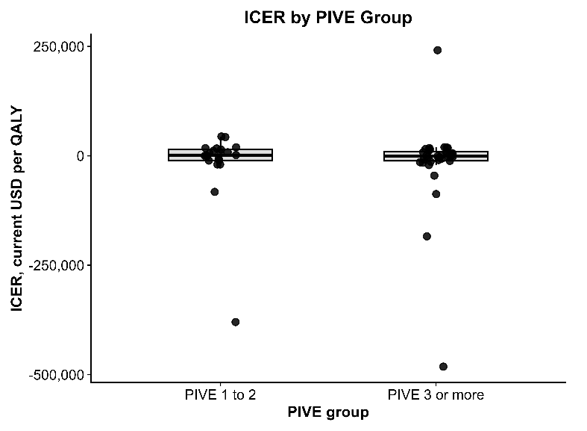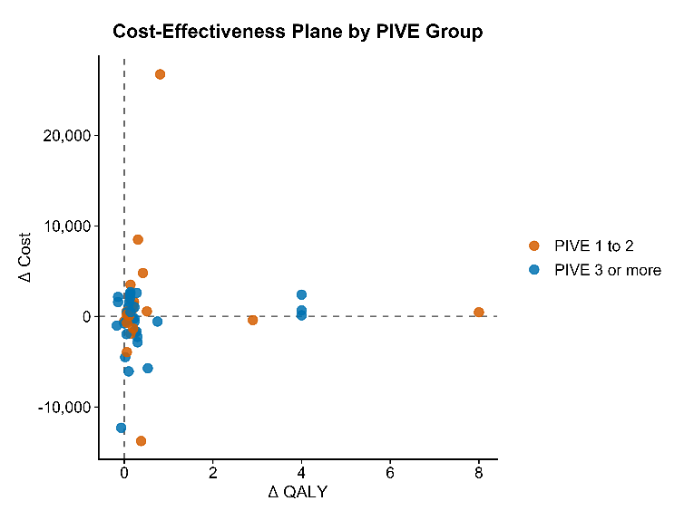
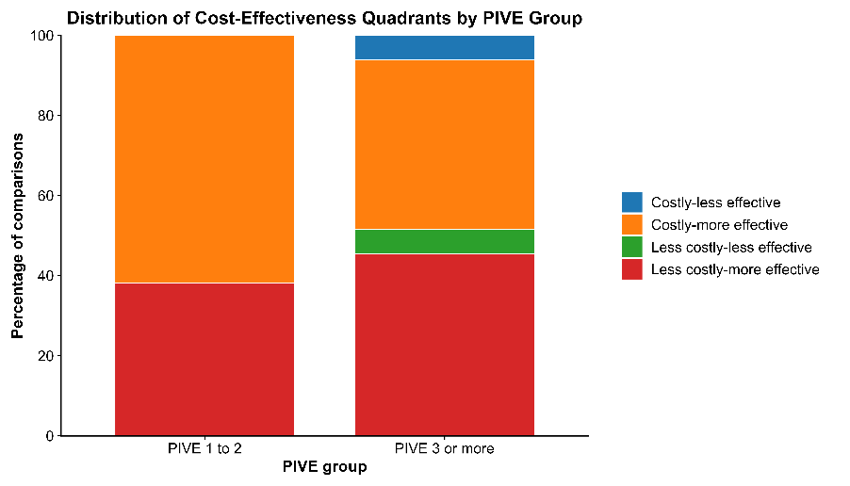
Appendix XII: Incremental Cost-Effectiveness Ratio Estimates, Cost-Effectiveness Quadrant Classification, and Cost-Effectiveness Plane Distribution by ISPOR Value Flower Elements (VFEs) Group.
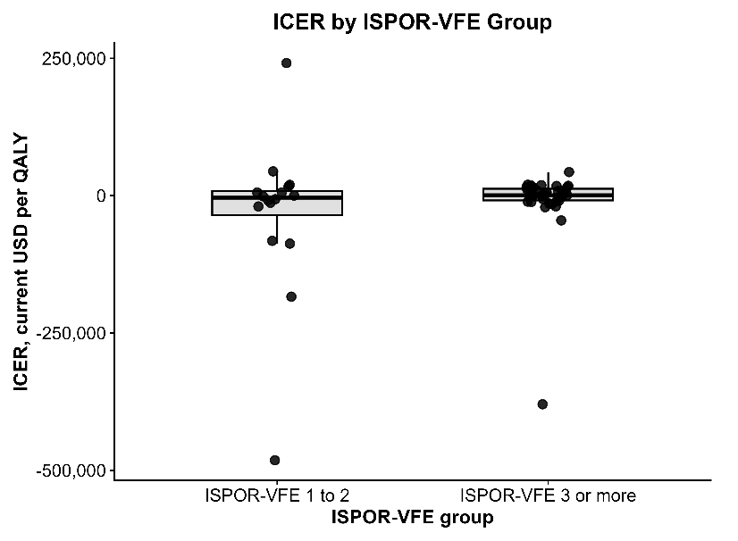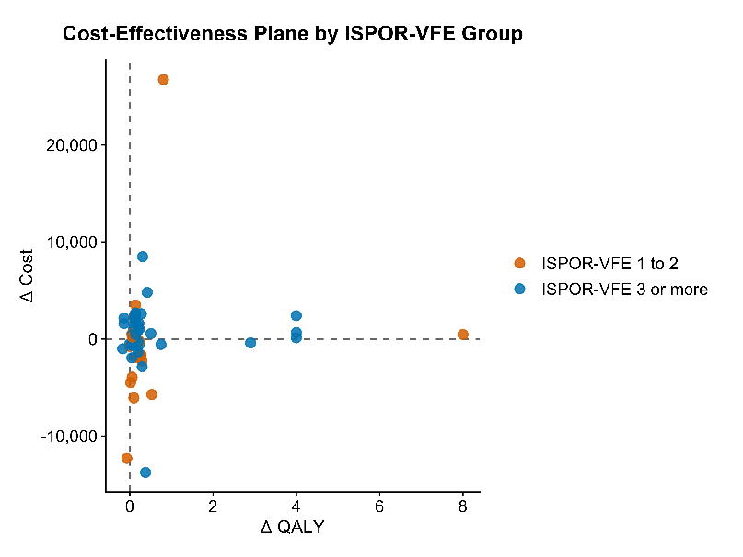
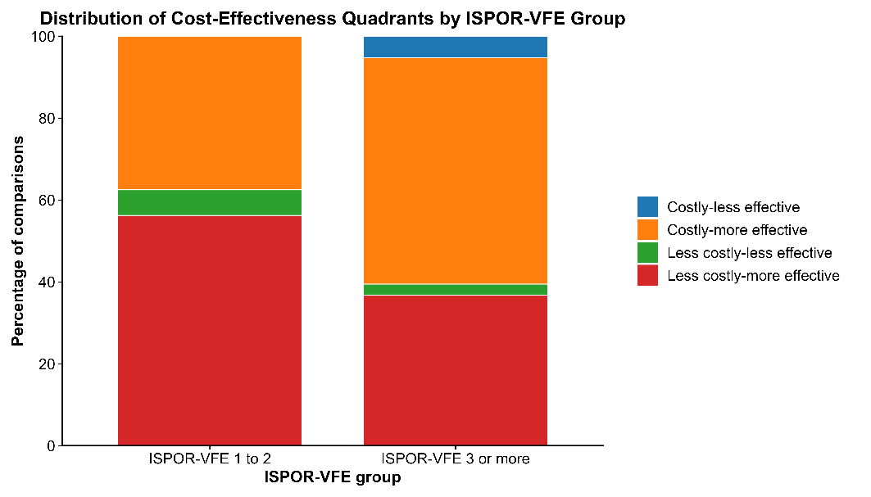

Appendix XIII: Linear Regression Model Results for Value Flower Elements (VFEs).

Model | Outcome.x | Covariate_Set | Specification | Outcome.y | Predictor | Estimate | Std_Error | Test_Statistic | P_value
Model 1 | log(abs(ICER)) | Quality Score | CountISPOR + covariate | log_abs_ICER | Intercept | 8.71 | 1.29 | 6.76 | 1.29E-08
Model 1 | log(abs(ICER)) | Quality Score | CountISPOR + covariate | log_abs_ICER | CountISPOR | -1.03 | 0.43 | -2.35 | 0.022
Model 1 | log(abs(ICER)) | Quality Score | CountISPOR + covariate | log_abs_ICER | QualityScore | 0.69 | 0.32 | 2.13 | 0.037

R-Squared=0.109
Adjusted R-squared=0.074

Note:

CountISPOR is the total number of value flower elements included in a study, which can range from a minimum of 0 to a maximum of 12.

QualityScore is the overall quality of the study based on Tufts Cost-Effectiveness Analysis Registry Quality Assessment Criteria: A subjective rating score by reviewers from 1 (lowest quality) to 7 (highest quality).

QualityScore
References
1. Capel M, Mareque M, Álvarez CJ, Lindner L, Oyagüez I. Cost-Effectiveness of Fixed-Dose Combinations Therapies for Chronic Obstructive Pulmonary Disease Treatment. Clin Drug Investig. 2018 Jul;38(7):611–20.
2. Trigueros JA, Garin N, Baloira A, Aceituno S, Calvo A, Prades M, et al. Cost-Effectiveness Analysis of Triple Therapy with Budesonide/ Glycopyrronium/ Formoterol Fumarate versus Dual Therapy in Patients with Chronic Obstructive Pulmonary Disease in Spain. Int J Chron Obstruct Pulmon Dis. 2022;17:2905–17.
3. Gong S, Hu H, Zhao K, Yang T. Cost-Effectiveness of Dual Bronchodilator Indacaterol/Glycopyrronium for COPD Treatment in China. Int J Chron Obstruct Pulmon Dis. 2021;16:433–41.
4. Mosher CL, Nanna MG, Jawitz OK, Raman V, Farrow NE, Aleem S, et al. Cost-effectiveness of Pulmonary Rehabilitation Among US Adults With Chronic Obstructive Pulmonary Disease. JAMA Network Open. 2022;5(6):e2218189–e.
5. Bourbeau J, Granados D, Roze S, Durand-Zaleski I, Casan P, Köhler D, et al. Cost-effectiveness of the COPD Patient Management European Trial home-based disease management program. Int J Chron Obstruct Pulmon Dis. 2019;14:645–57.
6. Toubes-Navarro ME, Gude-Sampedro F, Álvarez-Dobaño JM, Reyes-Santias F, Rábade-Castedo C, Rodríguez-García C, et al. A pulmonary rehabilitation program reduces hospitalizations in chronic obstructive pulmonary disease patients: A cost-effectiveness study. Ann Thorac Med. 2023 Oct–Dec;18(4):190–8.
7. Halpin DMG, Kendall R, Shukla S, Martin A, Shah D, Midwinter D, et al. Cost-Effectiveness of Single- versus Multiple-Inhaler Triple Therapy in a UK COPD Population: The INTREPID Trial. Int J Chron Obstruct Pulmon Dis. 2022;17:2745–55.
8. Schroeder M, Benjamin N, Atienza L, Biswas C, Martin A, Whalen JD, et al. Cost-Effectiveness Analysis of a Once-Daily Single-Inhaler Triple Therapy for Patients with Chronic Obstructive Pulmonary Disease (COPD) Using the FULFIL Trial: A Spanish Perspective. Int J Chron Obstruct Pulmon Dis. 2020;15:1621–32.
9. Maricoto T, Marques-Gomes J, Correia-de-Sousa J, Taborda-Barata L. Inhaler Review in Older Adults with Asthma or COPD: A Cost-Effectiveness Study and a Perspective in Portugal. J Am Geriatr Soc. 2019 Jul;67(7):1430–6.
10. Driessen MT, Whalen J, Seewoodharry Buguth B, Vallejo-Aparicio LA, Naya IP, Asukai Y, et al. Cost-effectiveness analysis of umeclidinium bromide/vilanterol 62.5/25 mcg versus tiotropium/olodaterol 5/5 mcg in symptomatic patients with chronic obstructive pulmonary disease: a Spanish National Healthcare System perspective. Respiratory Research. 2018 2018/11/20;19(1):224.
11. Poder TG, Kouakou CRC, Bouchard P-A, Tremblay V, Blais S, Maltais F, et al. Cost-effectiveness of FreeO2 in patients with chronic obstructive pulmonary disease hospitalised for acute exacerbations: analysis of a pilot study in Quebec. BMJ Open. 2018;8(1):e018835.
12. Chen L, Chen X, Zhi C, Li X, Hu Y. Levalbuterol vs. albuterol for hospitalized patients with COPD in China: cost-utility and budget impact analysis. J Med Econ. 2022 Jan–Dec;25(1):966–73.
13. Driessen M, Shah D, Risebrough N, Baker T, Naya I, Briggs A, et al. Cost-effectiveness of umeclidinium as add-on to ICS/LABA therapy in COPD: A UK perspective. Respir Med. 2018 Dec;145:130–7.
14. Robinson SA, Moy ML, Ney JP. Value of Information Analysis of a Web-Based Self-Management Intervention for Chronic Obstructive Pulmonary Disease. Telemed J E Health. 2024 Feb;30(2):518–26.
15. van Beers M, Rutten-van Mölken M, van de Bool C, Boland M, Kremers SPJ, Franssen FME, et al. Clinical outcome and cost-effectiveness of a 1-year nutritional intervention programme in COPD patients with low muscle mass: The randomized controlled NUTRAIN trial. Clin Nutr. 2020 Feb;39(2):405–13.

