Electronic Supplementary Material Appendix S1

Full electronic search strategy for SPORTDiscus

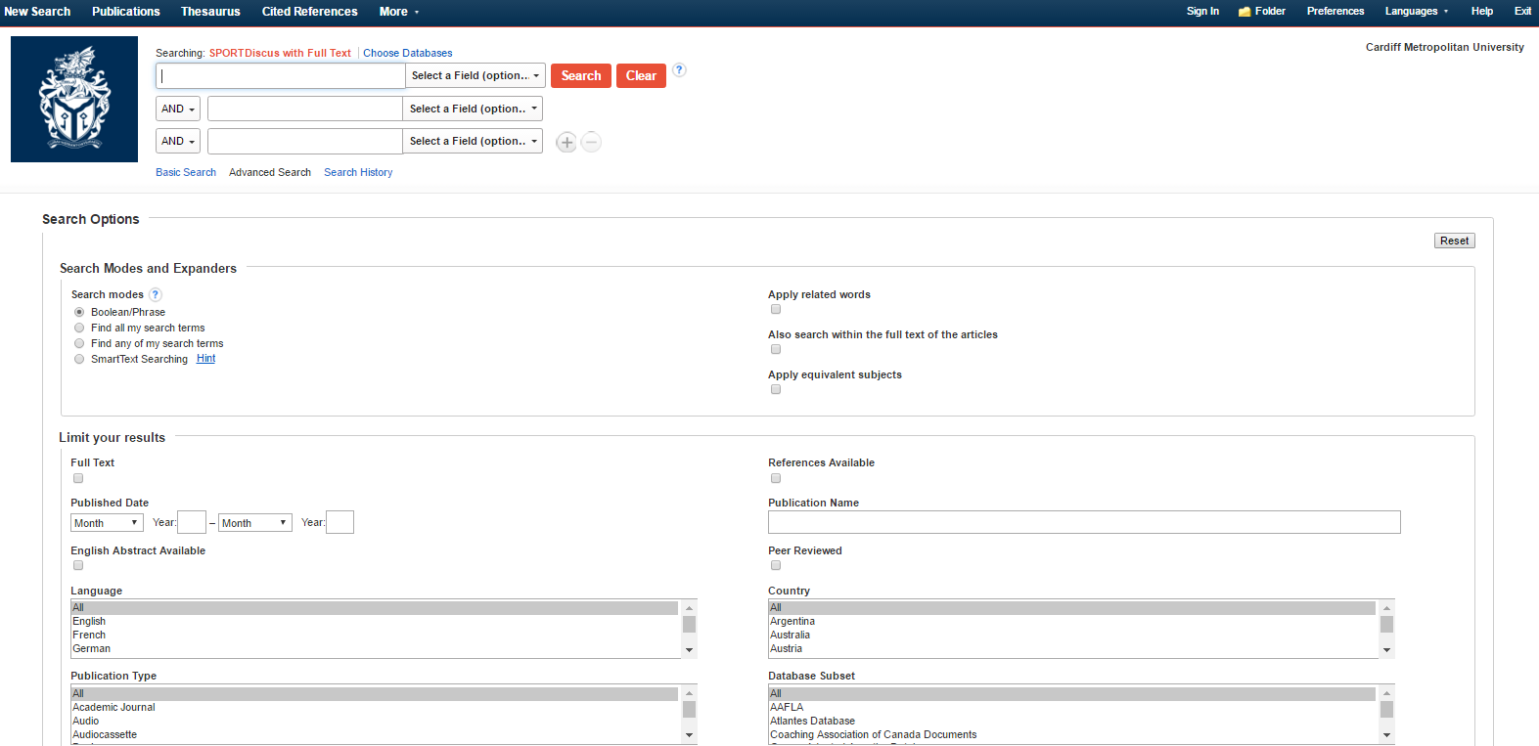
- Log into database (SPORTDiscus).

- Insert keywords into search field (i.e. “physical literacy”). Ensure inverted commas are inserted to the term “physical literacy”.
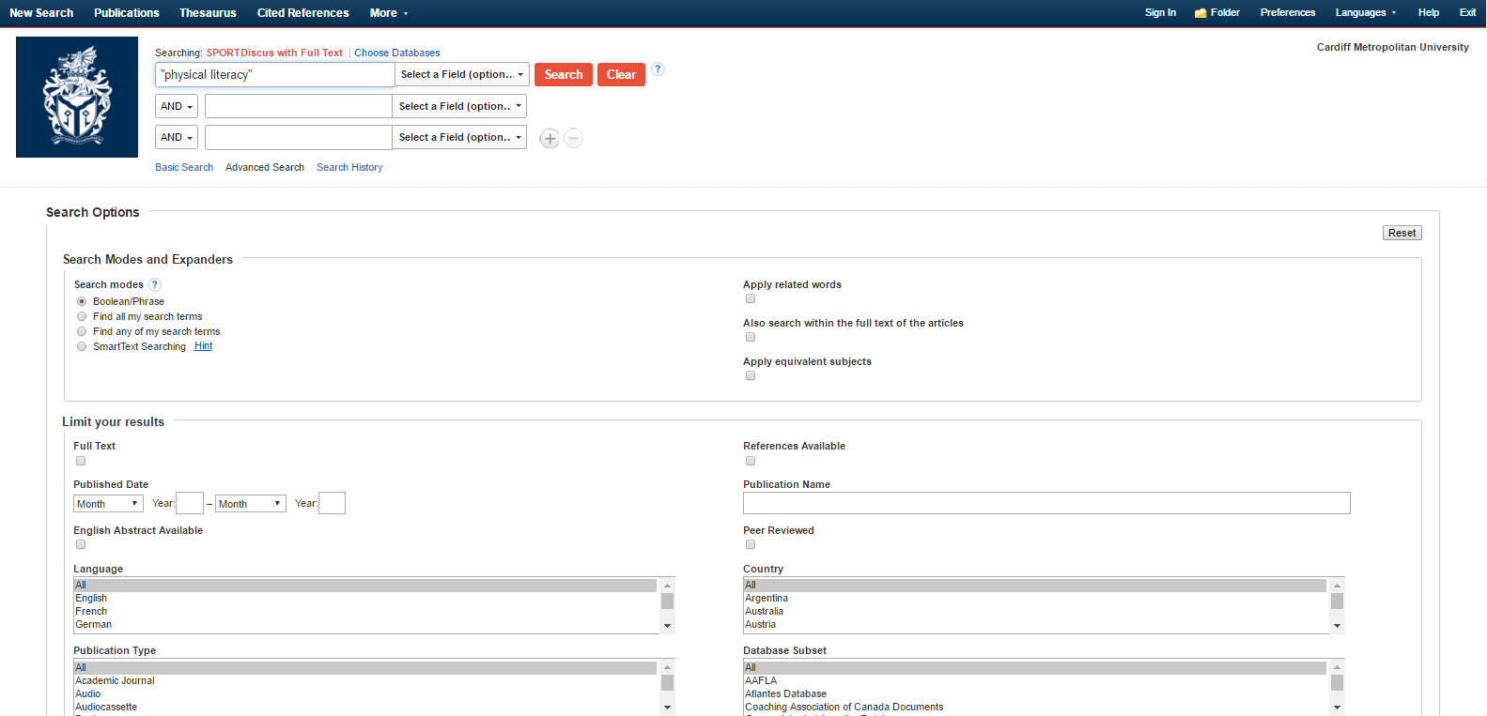

- Select the ‘Peer reviewed’ and ‘English language’ limits. Press search to view results.

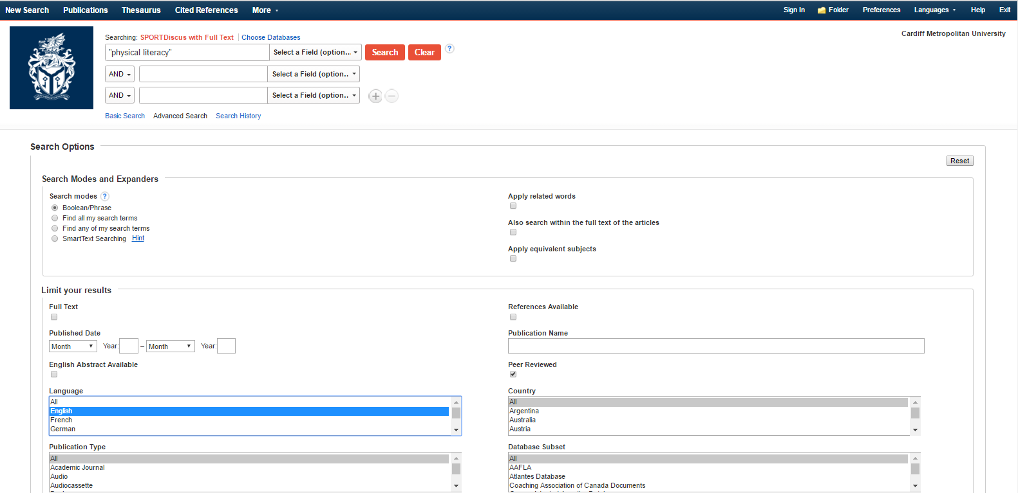

- The number of results will appear (i.e. 114 results). 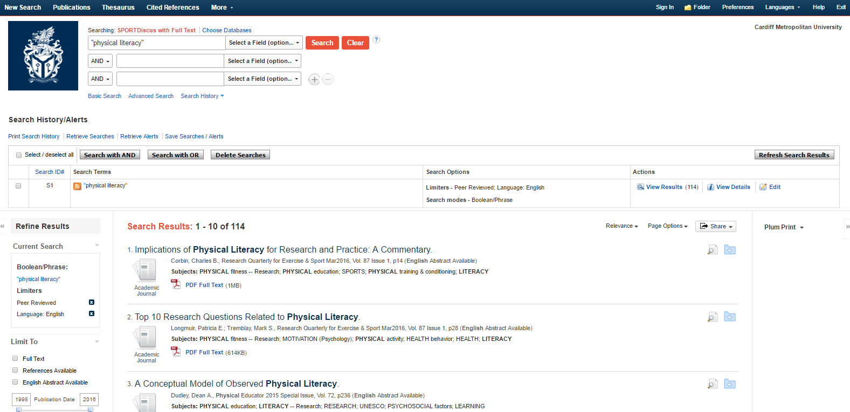

- Copy and paste each result (reference) into a Microsoft Word document.
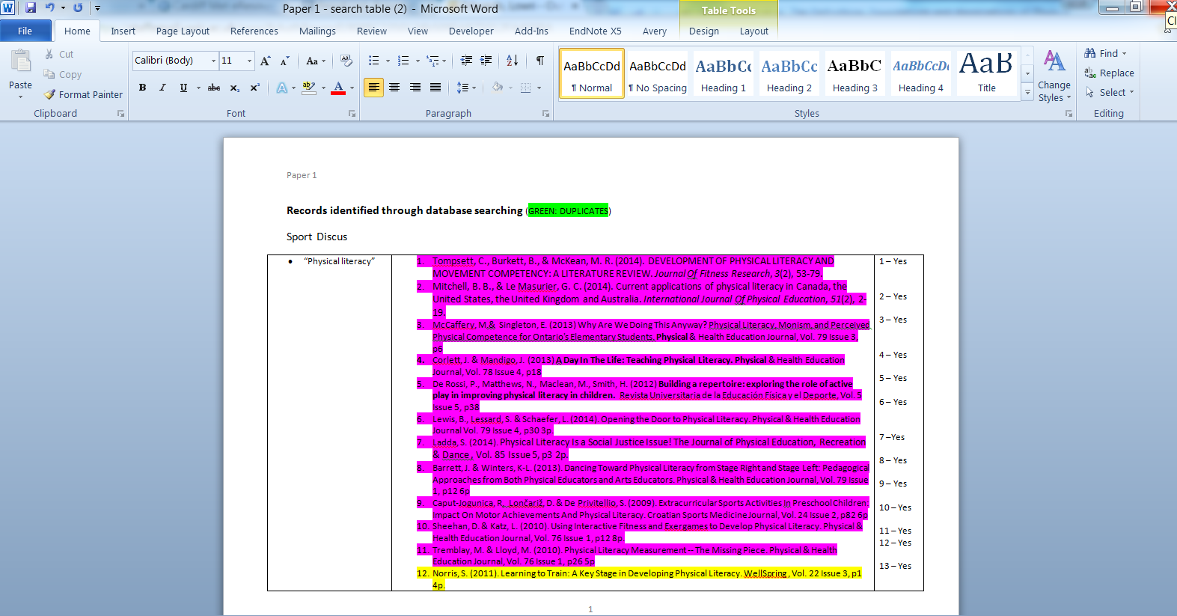
- Repeat the same procedure with all key search terms (i.e. “physical literacy” AND physical education).
- Ensure the duplicated papers are highlighted in a different color in the Word document.
- After duplicate papers are removed, use the eligibility criteria (inclusion and exclusion criteria) to select papers for the analysis.
- Repeat process consistently with other databases (MEDLINE [via PubMed], Scopus, ScienceDirect, and Education Research Complete).

