Article title: Strategies for reducing the impact of cycling on the perineum in healthy males: systematic review and meta-analysis.
Journal name: Sports Medicine
Author names: Kamil Litwinowicz, Marcin Choroszy, Anna Wróbel
Corresponding author:
Kamil Litwinowicz*, MD
Department of Medical Biochemistry,
Wroclaw Medical University,
ul. Chalubińskiego 10,
50-368 Wroclaw
E-mail: kamil.litwinowicz@student.umed.wroc.pl

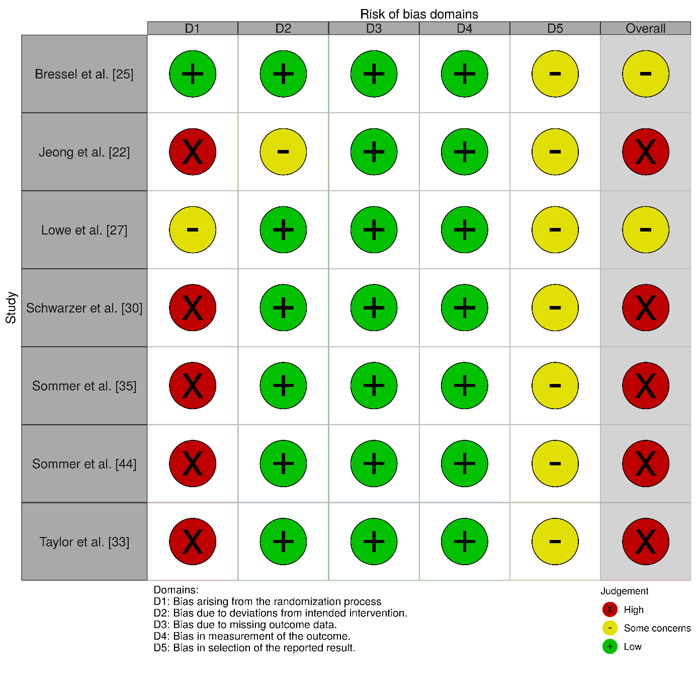
Electronic Supplementary Material Fig. S1. Risk of bias assessment of cross-over and randomized trials

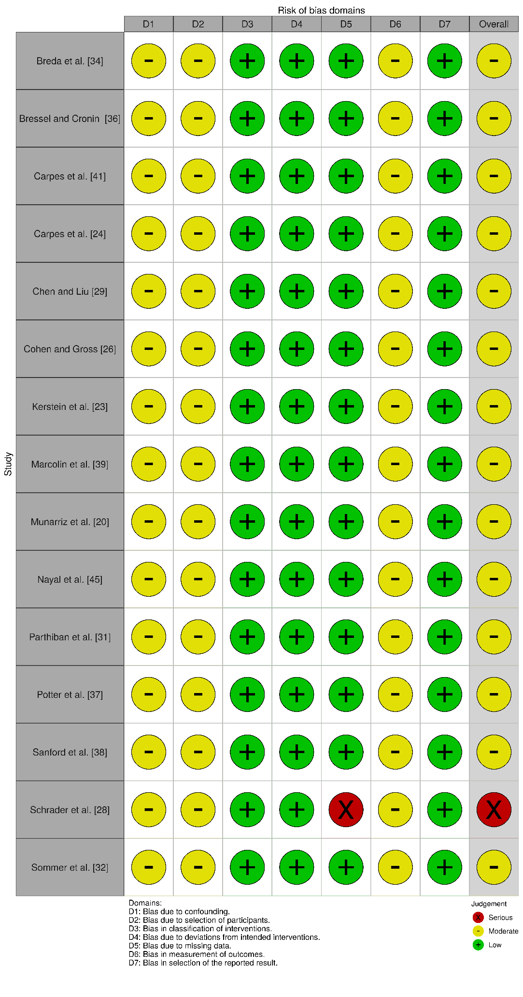
Electronic Supplementary Material Fig. S2. Risk of bias assessment of before and after studies
Declarations:
Availability of data and material: Not applicable
Code availability: Not applicable
Authors' contributions: All authors contributed to the study conception and design. Literature search and data analysis were performed by Kamil Litwinowicz, Marcin Choroszy and Anna Wróbel. The first draft of the manuscript was written by Kamil Litwinowicz and all authors commented on previous versions of the manuscript. All authors read and approved the final manuscript.
Compliance with ethical standards
Ethics approval: Not applicable
Consent to participate: Not applicable
Consent for publication: Not applicable
Funding: The authors received no specific funding for this work.
Conflict of interest: Kamil Litwinowicz, Marcin Choroszy and Anna Wróbel declare that they have no conflict of interest.

