Supplementary material

Supplementary Table S1: Original search breakdown

Database search | Date | Search terms | Restriction | Records Identified
Web of Science | 25.08.2020 | TS=((sleep restriction or sleep deprivation or sleep loss or wakefulness) and (exercis* or performance) not (animal* or rat* or mice)) | Restricted to LANGUAGES: (ENGLISH) AND DOCUMENT TYPES: (ARTICLE) | 3787
SCOPUS | 25.08.2020 | TITLE-ABS-KEY ("sleep restriction" OR "sleep deprivation" OR "sleep loss" OR wakefulness AND exercis* OR performance AND NOT animal* OR rat* OR mice) | (LIMIT-TO (DOCTYPE, "ar")) AND (LIMIT-TO (LANGUAGE, "English")) | 3457
PsycInfo | 25.08.2020 | (((Sleep restriction or sleep deprivation or wakefulness or Sleep loss) and (exercis* or performance)) not (animal* or rat* or mice)) | mp. [mp=title, abstract, heading word, table of contents, key concepts, original title, tests & measures, mesh] | 1695
 |  |  | Total | 8939

Supplementary Table S2: Origin of included publications
Lead author | Year | Title | Source
Abedelmalek | 2014 | Effect of partial sleep deprivation and racial variation on short-term maximal performance | Original search
Abedelmalek | 2013 | Effect of time of day and partial sleep deprivation on plasma concentrations of IL-6 during a short-term maximal performance | Original search
Bambaeichi | 2005 | The influence of time of day and partial sleep loss on muscle strength in eumenorrheic females | Original search
Brodan and Kuhn | 1967 | Physical performance in man during sleep deprivation | Original search
Bulbulian | 1996 | The effect of sleep deprivation and exercise load on isokinetic leg strength and endurance | Original search
Chase | 2017 | One night of sleep restriction following heavy exercise impairs 3-km cycling time-trial performance in the morning | Original search
Cook | 2012 | Acute Caffeine Ingestion’s Increase of Voluntarily Chosen Resistance-Training Load After Limited Sleep | Original search
Cook | 2011 | Skill execution and sleep deprivation: effects of acute caffeine or creatine supplementation - a randomized placebo-controlled trial | Original search
Cullen | 2019 | The effects of a single night of complete and partial sleep deprivation on physical and cognitive performance: A Bayesian analysis | Original search
Daaloul | 2019 | Effects of Napping on Alertness, Cognitive, and Physical Outcomes of Karate Athletes | Original search
Daviaux | 2014 | Effects of total sleep deprivation on the perception of action capabilities | Original search
Edwards | 2009 | Effects of One Night of Partial Sleep Deprivation upon Diurnal Rhythms of Accuracy and Consistency in Throwing Darts | Original search
Goh | 2001 | Effects of one night of sleep deprivation on hormone profiles and performance efficiency | Original search
Gonçalves | 2020 | Effects of acute sleep deprivation on H reflex and V wave | Original search
Goto | 2020 | Partial sleep deprivation after an acute exercise session does not augment hepcidin levels the following day | Original search
Khcharem | 2020 | Effects of caffeine ingestion on 8-km run performance and cognitive function after 26 hours of sleep deprivation | Original search
Kujawa | 2020 | The Influence of 24-Hour Sleep Deprivation on the Strength of Lower Limb Muscles in Young and Physically Fit Women and Men | Original search
Martin | 1981 | Effect of sleep-deprivation on tolerance of prolonged exercise | Original search
Moore | 2018 | Effects of acute sleep deprivation and caffeine supplementation on anaerobic performance | Original search

Supplementary Table S2: continued
Lead author | Year | Title | Source
Mougin | 2001 | Hormonal responses to exercise after partial sleep deprivation and after a hypnotic drug-induced sleep deprivation and after a hypnotic drug-induced sleep | Original search
Mougin | 1996 | Effects of a selective sleep deprivation on subsequent anaerobic performance | Original search
Ozturk | 2007 | Effects of sleep deprivation on anaerobic exercise-induced changes in auditory brainstem evoked potentials | Original search
Racinais | 2004 | Effect of sleep deprivation on shuttle run score in middle-aged amateur athletes: Influence of initial score | Original search
Rae | 2017 | One night of partial sleep deprivation impairs recovery from a single exercise training session | Original search
Roberts | 2019 | Extended Sleep Maintains Endurance Performance Better than Normal or Restricted Sleep | Original search
Romdhani | 2020 | Improved Physical Performance and Decreased Muscular and Oxidative Damage With Post-lunch Napping After Partial Sleep Deprivation in Athletes | Original search
Romdhani | 2019 | Sleep deprivation affects post-lunch dip performances, biomarkers of muscle damage and antioxidant status | Original search
Skein | 2013 | The effect of overnight sleep deprivation following competitive rugby league matches 2 on post-match physiological and perceptual recovery | Original search
Skurvydas | 2020 | One night of sleep deprivation impairs executive function but does not affect psychomotor or motor performance | Original search
Souissi | 2014 | The effects of caffeine ingestion on the reaction time and short-term maximal performance after 36 h of sleep deprivation | Original search
Souissi | 2019 | The effects of caffeine on the diurnal variation of the reaction time and short-term maximal performance after one night of sleep deprivation | Original search
Souissi | 2003 | Effects of one night’s sleep deprivation on anaerobic performance the following day | Original search
Souissi | 2008 | Effect of Time of Day and Partial Sleep Deprivation on Short-Term, High-Power Output | Original search
Souissi | 2015 | Morning caffeine ingestion increases cognitive function and short-term maximal performance in footballer players after partial sleep deprivation | Original search
Souissi | 2018 | Caffeine reversal of sleep deprivation effects on alertness, mood and repeated sprint performances in physical education students | Original search

Supplementary Table S2: continued
Lead author | Year | Title | Source
Souissi | 2020 | Effects of a 30-min nap opportunity on cognitive and short-duration high-intensity performances and mood states after a partial sleep deprivation night | Original search
Souissi | 2013 | Effects of time-of-day and partial sleep deprivation on short-term maximal performances of judo competitors | Original search
Sweeney | 2020 | Impaired Insulin ProFiles Following a Single Night of Sleep Restriction: The Impact of Acute Sprint Interval Exercise | Original search
Taheri | 2012 | The effect of sleep deprivation on choice Reaction time and anaerobic power of college student athletes | Original search
Vardar | 2007 | Sleep deprivation induced anxiety and anaerobic performance | Original search
Azboy | 2009 | Effects of sleep deprivation on cardiorespiratory functions of the runners and volleyball players during rest and exercise | Fullagar back citation
Froberg | 1974 | Circadian rhythms of catecholamine excretion, shooting range performance and self-ratings of fatigue during sleep deprivation | Fullagar back citation
HajSalem | 2013 | Effects of partial sleep deprivation at the end of the night on anaerobic performances in judokas | Fullagar back citation
Hill | 1994 | Aerobic and anaerobic contributions to exhaustive high-intensity exercise after sleep deprivation | Fullagar back citation
Mejri | 2013 | Effect of two types of partial sleep deprivation on Taekwondo players’ performance during intermittent exercise | Fullagar back citation
Oliver | 2009 | One night of sleep deprivation decreases treadmill endurance performance | Fullagar back citation
Reilly | 1994 | The effect of partial sleep deprivation on weight-lifting performance | Fullagar back citation
Reyner | 2013 | Sleep restriction and serving accuracy in performance tennis players, and effects of caffeine | Fullagar back citation
Skein | 2011 | Intermittent-sprint performance and muscle glycogen after 30 h of sleep deprivation | Fullagar back citation
Temesi | 2012 | Does central fatigue explain reduced cycling after complete sleep deprivation? | Fullagar back citation
Ajjimaporn | 2020 | Effects of a 20-min Nap after Sleep Deprivation on Brain Activity and Soccer Performance | Forward citation Fullagar - Google Scholar
Arazi | 2019 | Effects of Overnight Sleep Deprivation on Appetite and Physical Performance in Elite Female Soccer Players | Forward citation Fullagar - Google Scholar

Supplementary Table S2: continued
Lead author | Year | Title | Source
Dáttilo | 2020 | Effects of Sleep Deprivation on Acute Skeletal Muscle Recovery after Exercise | Forward citation Fullagar - Google Scholar
Blumert | 2007 | The acute effects of twenty-four hours of sleep loss on the performance of national-caliber male collegiate weightlifters | Knowles back citation
Chen | 1991 | Effects of 30-h sleep loss on cardiorespiratory functions at rest and in exercise. | Azboy 2009
Omiya | 2009 | Heart-Rate Response to Sympathetic Nervous Stimulation, Exercise, and Magnesium Concentration in Various Sleep Conditions | Chase et al
Mejri | 2016 | Does one night of partial sleep deprivation affect the evening performance during intermittent exercise in Taekwondo players? | Chase et al
Mougin | 1991 | Effects of sleep disturbances on subsequent physical performance | Chase et al
Roberts | 2019 | Effects of total sleep deprivation on endurance cycling performance and heart rate indices used for monitoring athlete readiness | Goto et al. 2020
Holland | 1967 | Effects of Limited Sleep Deprivation on Performance of Selected Motor Tasks | Mougin et al. 1996
Romdhani | 2021 | Total sleep deprivation and recovery sleep affect the diurnal variation of agility performance: the gender differences | Romdhani et al. 2020
Baati | 2020 | Effect of Angle of View and Partial Sleep Deprivation on Distance Perception | Souissi et al. 2020
Baati | 2015 | Effect of total sleep deprivation on egocentric distance estimation following a fatiguing task | Souissi et al. 2020
Arnal | 2016 | Sleep Extension before Sleep Loss: Effects on Performance and Neuromuscular Function | Skurvydas et al. 2020
Khemila | 2021 | Listening to motivational music during warming- up attenuates the negative effects of partial sleep deprivation on cognitive and short-term maximal performance: Effect of time of day | Updated search
Filipas | 2021 | Single and Combined Effect of Acute Sleep Restriction and Mental Fatigue on Basketball Free-Throw Performance | Updated search
Romdhani | 2021 | Caffeine Use or Napping to Enhance Repeated Sprint Performance After Partial Sleep Deprivation: Why Not Both? | Updated search
Rodrigues | 2021 | Combined and isolated effects of alcohol consumption and sleep deprivation on maximal strength, muscle endurance and aerobic exercise performance in healthy men: a cross‐over randomized controlled trial | Updated search
Paryab | 2021 | Melatonin supplementation improves psychomotor and physical performance in collegiate student-athletes following a sleep deprivation night | Updated search

Supplementary Table S3: Reason for full-text publication exclusion
Lead author | Year | Title | Reason for exclusion
Abedelmalek | 2013 | Effects of Partial Sleep Deprivation on Proinflammatory Cytokines, Growth Hormone, and Steroid Hormone Concentrations During Repeated Brief Sprint Interval Exercise | No exercise performance measured
Ablin | 2013 | Effects of sleep restriction and exercise deprivation on somatic symptoms and mood in healthy adults | No exercise performance measured
Bunnell | 1984 | Sleep interruption and exercise | No exercise performance measured
Goodman | 1990 | Moderate exercise and hemodilution during sleep-deprivation | No exercise performance measured
Kojima | 2020 | Acute moderate-intensity exercise improves 24-h sleep deprivation-induced cognitive decline and cerebral oxygenation: A near-infrared spectroscopy study | No exercise performance measured
Mejri | 2015 | One night of partial sleep deprivation affects biomarkers of cardiac damage, but not cardiovascular and lipid profiles, in young athletes | No exercise performance measured
Strausba | 1970 | Ego strength, skin conductance, sleep deprivation, and performance | No exercise performance measured
Vgontzas | 2007 | Daytime napping after a night of sleep loss decreases sleepiness, improves performance, and causes beneficial changes in cortisol and interleukin-6 secretion | No exercise performance measured
Webb | 1973 | Effects of performance of high and low energy expenditure during sleep deprivation | No exercise performance measured
Buck | 1975 | Sleep loss effects on movement time | No exercise performance measured
Daftuar | 1972 | Sleep deprivation and human performance | No exercise performance measured
Kondo | 1990 | Effects of exercise and sleep deprivation on serum zinc | No exercise performance measured
LeDuc | 2000 | The effects of exercise as a countermeasure for fatigue in sleep-deprived aviators | No exercise performance measured
Martin | 1982 | Self-selected exercise intensity is unchanged by sleep loss | No exercise performance measured
Martin | 1986 | Stress hormonal response to exercise after sleep loss | No exercise performance measured
McMurray | 1984 | The effect of sleep loss on high-intensity exercise and recovery | No exercise performance measured
McMurray | 1988 | The endorphin response of women to sleep loss and exercise | No exercise performance measured

Supplementary Table S3: continued
Lead author | Year | Title | Reason for exclusion
Mougin | 1992 | Met-enkephalin, β-endorphin and cortisol responses to sub-maximal exercise after sleep disturbances | No exercise performance measured
Plyley | 1987 | Sleep-deprivation and cardiorespiratory function - influence of intermittent submaximal exercise | No exercise performance measured
Sawka | 1984 | Effects of sleep-deprivation on thermoregulation during exercise | No exercise performance measured
McNeil | 2016 | The effects of sleep restriction and altered sleep timing on energy intake and energy expenditure | No exercise performance measured
Tajiri | 2018 | Effect of sleep curtailment on dietary behavior and physical activity: A randomized crossover trial | No exercise performance measured
Jarraya | 2013 | The effect of partial sleep deprivation on the reaction time and the attentional capacities of the handball goalkeeper | No exercise performance measured
Jarraya | 2014 | Effect of time of day and partial sleep deprivation on the reaction time and the attentional capacities of the handball goalkeeper | No exercise performance measured
Ingram | 2015 | Sleep disruption and its effect on lymphocyte redeployment following an acute bout of exercise | No exercise performance measured
Martin | 1981 | Exercise after sleep-deprivation | No exercise performance measured
Kolka | 1988 | Exercise thermoregulation after prolonged wakefulness | No exercise performance measured
Chen | 1989 | Sleep loss impairs inspiratory muscle endurance | No exercise performance measured
Wilkinson | 1961 | Performance under sleep-deprivation | No exercise performance measured
Akazawa | 2019 | Effect of sleep efficiency on salivary metabolite profile and cognitive function during exercise in volleyball athletes | No sleep intervention
Antunes | 2017 | Sleep quality and duration are associated with performance in maximal incremental test | No sleep intervention
Auyeung | 2015 | Sleep Duration and Disturbances Were Associated With Testosterone Level, Muscle Mass, and Muscle Strength-A Cross-Sectional Study in 1274 Older Men | No sleep intervention
Bonnet | 1995 | The use of caffeine versus prophylactic naps in sustained performance | No sleep intervention
Bougard | 2009 | Effects of Waking Time and Breakfast Intake Prior to Evaluation of Physical Performance in the Early Morning | No sleep intervention
de Mello | 2020 | Duration and quality of sleep in sprint and recovery performances among elite swimmers | No sleep intervention

Supplementary Table S3: continued
Lead author | Year | Title | Reason for exclusion
Driller | 2019 | The influence of night-time electronic device use on subsequent sleep and propensity to be physically active the following day | No sleep intervention
Ito | 2007 | Acute effects of zolpidem on daytime alertness, psychomotor and physical performance | No sleep intervention
Jarraya | 2014 | Diurnal variations on cognitive performances in handball goalkeepers | No sleep intervention
Kline | 2007 | Circadian variation in swim performance | No sleep intervention
Matsumoto | 2002 | Physical activity increases the dissociation between subjective sleepiness and objective performance levels during extended wakefulness in human | No sleep intervention
Souissi | 2013 | Effects of three types of chronobiotics on anaerobic performances and their diurnal variations | No sleep intervention
Taheri | 2020 | Morning exercise improves cognitive performance decrements induced by partial sleep deprivation in elite athletes | No sleep intervention
Hammouda | 2018 | Diurnal napping after partial sleep deprivation affected hematological and biochemical responses during repeated sprint | No sleep intervention
Pierce | 1993 | The effects of an acute bout of sleep on running economy and VO2 max | No sleep intervention
Petit | 2014 | A 20-min nap in athletes changes subsequent sleep architecture but does not alter physical performances after normal sleep or 5-h phase-advance conditions | No sleep intervention
Angus | 1985 | Effects of prolonged sleep deprivation, with and without chronic physical exercise, on mood and performance | >1 day sleep loss
Tharion | 2003 | Caffeine effects on marksmanship during high-stress military training with 72 hour sleep deprivation | >1 day sleep loss
Bond | 1986 | Effects of sleep-deprivation on performance during submaximal and maximal exercise | >1 day sleep loss
Keramidas | 2018 | A brief pre-exercise nap may alleviate physical performance impairments induced by short-term sustained operations with partial sleep deprivation - A field-based study | >1 day sleep loss
Myles | 1985 | Sleep-deprivation, physical fatigue, and the perception of exercise intensity | >1 day sleep loss
Kolka | 1984 | Exercise in a cold environment after sleep-deprivation | >1 day sleep loss
Goodman | 1989 | Maximal aerobic exercise following prolonged sleep-deprivation | >1 day sleep loss
Martin | 1984 | Sleep loss and the sympathoadrenal response to exercise | >1 day sleep loss
Supplementary Table S3: continued
Lead author | Year | Title | Reason for exclusion
Symons | 1988 | Physical performance and physiological responses following 60 hours of sleep deprivation | >1 day sleep loss
Takeuchi | 1985 | Sleep deprivation, chronic exercise and muscular performance | >1 day sleep loss
Chen | 2017 | Relationship between sleep and muscle strength among Chinese university students: a cross-sectional study | Observational
Facer-Childs | 2015 | Circadian phenotype composition is a major predictor of diurnal physical performance in teams | Observational
Facer-Child | 2018 | The effects of time of day and chronotype on cognitive and physical performance in healthy volunteers | Observational
Daniel | 2019 | Effect of the intake of high or low glycemic index high carbohydrate-meals on athletes' sleep quality in pre-game nights | Observational
Buman | 2011 | Moderators and mediators of exercise-induced objective sleep improvements in midlife and older adults with sleep complaints | Observational
Carazo-Vargas | 2020 | The association between sleep efficiency and physical performance in taekwondo athletes | Observational
Brandt | 2017 | Perceived Sleep Quality, Mood States, and Their Relationship With Performance Among Brazilian Elite Athletes During a Competitive Period | Observational
Hong | 2018 | Sleep and Performance | Review
Martin | 1988 | Sleep loss and subsequent exercise performance | Review
Erich | 2011 | Dead tired. There's no question sleep deprivation and fatigue can harm performance. How bad is it in EMS, and what can we do about it? | Review
Brodan | 1969 | Changes of mental and physical performance in sleep deprivated healthy volunteers | Review
Cheikh | 2017 | Effects of one-night sleep deprivation on selective attention and isometric force in adolescent karate athletes | Children
Cheikh | 2020 | Melatonin ingestion after exhaustive late-evening exercise attenuate muscle damage, oxidative stress, and inflammation during intense short term effort in the following day in teenage athletes | Children
Suppiah | 2016 | Restricted and unrestricted sleep schedules of Asian adolescent, high-level student athletes: effects on sleep durations, marksmanship and cognitive performance | Children
Pallesen | 2017 | The Effects of Sleep Deprivation on Soccer Skills | Children
Mah | 2019 | Sleep restriction impairs maximal jump performance and joint coordination in elite athletes | Consecutive nights of sleep restriction

Supplementary Table S4: Location of sleep protocol and method used to monitor sleep duration/quality
Exercise category | Location of sleep trials
Exercise category | Lab for both Int and Con | Lab, only Int, Con - home | Lab, only Int, Con not described | Home unsupervised | Not described
All categories | 113 | 53 | 19 | 28 | 14
Anaerobic power | 41 | 12 | 1 | 1 | 3
Speed/power endurance | 23 | 8 | 0 | 1 | 0
HIIE | 17 | 2 | 0 | 5 | 3
Strength | 22 | 21 | 13 | 4 | 6
Endurance | 7 | 7 | 3 | 3 | 2
Strength-endurance | 3 | 3 | 0 | 3 | 0
Skill | 0 | 0 | 2 | 11 | 0
Exercise category | Method of sleep monitoring
Exercise category | Polysomnography | Actigraphy | Diary/questionnaire | Not reported
All tasks | 5 | 72 | 11 | 139 (54% sleep restriction)
Anaerobic power | 0 | 22 | 0 | 36 (58% sleep restriction)
Speed/power endurance | 0 | 11 | 0 | 21 (62% sleep restriction)
HIIE | 0 | 11 | 2 | 14 (57% sleep restriction)
Strength | 1 | 15 | 1 | 49 (59% sleep restriction)
Endurance | 3 | 8 | 2 | 9 (0% sleep restriction)
Strength-endurance | 1 | 0 | 4 | 4 (0% sleep restriction)
Skill | 0 | 5 | 0 | 6 (67% sleep restriction)
Abbreviations: HIIE: high-intensity interval exercise; Int: Intervention (sleep loss protocol – either deprivation or restriction); Con: control (normal sleep). Lab for both Int and Con: sleep was monitored in the lab for both conditions; Lab, only Int, Con - home: only the intervention (sleep loss) condition was monitored in the lab and control (normal sleep) were permitted to sleep at home; Lab, only Int, Con not described: intervention condition were monitored in the lab and control was not described; Home unsupervised: both conditions slept at home unsupervised; Not described: no description provided. Sleep restriction: total sleep time ≤6 h in any 24 h period – this category is a combination of early-restriction, late-restriction, fragmented sleep and sleep restriction protocols not specified.

Supplementary Table S5: Mode of exercise and time of day tasks were undertaken
Exercise category | Mode of exercise task performed
Exercise category | Cycling (n) | Running (n) | Resistance (n) | Body-weight (n) | Walking (n) | Step (n) | Karate (n) | Skill (n)
All categories | 92 | 37 | 69 | 13 | 1 | 1 | 1 | 13
Anaerobic power | 35 | 11 | 0 | 12 | 0 | 0 | 0 | 0
Speed/power endurance | 28 | 3 | 0 | 1 | 0 | 0 | 0 | 0
HIIE | 8 | 18 | 0 | 0 | 0 | 0 | 1 | 0
Strength | 6 | 0 | 60 | 0 | 0 | 0 | 0 | 0
Endurance | 15 | 5 | 0 | 0 | 1 | 1 | 0 | 0
Strength-endurance | 0 | 0 | 9 | 0 | 0 | 0 | 0 | 0
Skill | 0 | 0 | 0 | 0 | 0 | 0 | 0 | 13
Exercise category | Time of day exercise task was performed
Exercise category | 0001-0600 (n) | 0601-1200 (n) | 1201-1800 (n) | 1801-2400 (n) | Not reported (n)
All categories | 10 | 107 | 96 | 8 | 6
Anaerobic power | 2 | 25 | 29 | 1 | 1
Speed/power endurance | 1 | 13 | 15 | 0 | 3
HIIE | 0 | 11 | 16 | 0 | 0
Strength | 7 | 32 | 25 | 1 | 1
Endurance | 0 | 12 | 5 | 3 | 1
Strength-endurance | 0 | 8 | 0 | 1 | 0
Skill | 0 | 5 | 6 | 2 | 0
Abbreviations/definitions: HIIE: high-intensity interval exercise; n: number of outcome measures; time of exercise task was performed: tasks were sub-categorised into 6 h blocks based on what time of the day the task was undertaken; Not reported: no time of day specified when task was performed.

Exercise category | # Participants | # male | # female | Age (y) | Height (cm) | BM (kg) | $\dot{V}$O_{2peak}
All categories | 959 | 855 | 104 | 22.6 ± 3.47 | 176 ± 5.10 | 73.1 ± 9.26 | 53.4 ± 9.29
Anaerobic power | 368 | 339 | 29 | 21.6 ± 2.14 | 177 ± 4.37 | 73.4 ± 6.86 | 52.1 ± 12.4
Speed/power endurance | 261 | 254 | 7 | 21.4 ± 1.66 | 177 ± 3.45 | 73.7 ± 5.94 | 69.3*
HIIE | 207 | 184 | 23 | 20.8 ± 2.69 | 175 ± 5.55 | 69.1 ± 7.31 | 54.9 ± 2.76
Endurance | 237 | 216 | 21 | 25.1 ± 3.89 | 176 ± 5.90 | 733 ± 11.0 | 52.2 ± 9.55
Strength | 289 | 253 | 36 | 23.3 ± 3.93 | 173 ± 7.14 | 73.7 ± 9.68 | 54.3 ± 7.11
Strength-endurance | 62 | 62 | 0 | 22.4 ± 3.58 | 181 ± 3.96 | 91.1 ± 12.2 | 44.8#
Skill | 146 | 116 | 30 | 22.4 ± 3.76 | 180 ± 4.58 | 82.0 ± 8.00 | NS
Supplementary Table S5 continued: Participant characteristics (mean ± SD)
Abbreviations: HIIE: high-intensity interval exercise; BM: body mass; kg: kilogram; y: year; cm: centimetre; $\dot{V}$O_{2peak}: peak oxygen consumption; #: number; NS: Not specified. *value from one study (Mougin et al. 1996) [93]; # value from one study (Rodrigues al. 2021 [101] )

Supplementary Table S6: Study quality assessment
Citation | A clear description of the inclusion and exclusion criteria was provided | The trials were randomized | Treatment order was counterbalanced | The method used to generate the random allocation sequence was described | Sample size was justified | Attempts were made to control and/or monitor pre-trial conditions | Design incorporated measures of important baseline variables | Subjects were blinded | Investigators were blinded | Methods and successfulness of blinding were described | Details were provided regarding the inability of a subject to complete study requirements | Statistical methods described | Primary outcome measurement and variability reported | Results of statistical comparisons reported | Methods used to assess adverse effects described | Reproducibility of the primary outcome measure(s) was reported | A familiarization of the performance test was conducted | Total Score (%)
Studies investigating the influence of acute sleep loss on physical performance
Abedelmalek et al. 2014 [116] | 1 | 1 | 0 | 0 | 0 | 1 | 1 | NA | NA | NA | NA | 1 | 1 | 1 | NA | 0 | 0 | 58
Abedelmalek et al. 2013 [62] | 1 | 1 | 0 | 0 | 0 | 1 | 1 | NA | NA | NA | NA | 1 | 1 | 1 | NA | 0 | 0 | 58
Ajjimaporn et al. 2020 [56] | 1 | 1 | 0 | 1 | 1 | 1 | 1 | NA | NA | NA | NA | 1 | 1 | 1 | NA | 0 | 0 | 75
Arazi et al. 2019 [85] | 1 | 0 | 0 | 0 | 0 | 1 | 1 | NA | NA | NA | NA | 1 | 1 | 1 | NA | 0 | 0 | 50
Arnal et al. 2016 [86] | 1 | 1 | 1 | 0 | 0 | 1 | 1 | NA | NA | NA | NA | 1 | 1 | 1 | NA | 0 | 1 | 75
Azboy et al. 2009 [120] | 1 | 0 | 0 | 0 | 0 | 1 | 1 | NA | NA | NA | NA | 1 | 1 | 1 | NA | 0 | 1 | 58
Baati et al. 2020 [87] | 1 | 1 | 0 | 0 | 0 | 0 | 1 | NA | NA | NA | NA | 1 | 1 | 1 | NA | 0 | 1 | 58
Baati et al. 2015 [88] | 1 | 1 | 0 | 0 | 0 | 0 | 1 | NA | NA | NA | NA | 1 | 1 | 1 | NA | 0 | 1 | 58
Bambaeichi et al. 2005 [53] | 1 | 1 | 1 | 0 | 0 | 1 | 1 | NA | NA | NA | NA | 1 | 1 | 1 | NA | 0 | 1 | 75
Blumert et al. 2007 [75] | 1 | 1 | 1 | 0 | 0 | 1 | 1 | NA | NA | NA | NA | 1 | 1 | 1 | NA | 1 | 1 | 83
Brodan and Kuhn 1967 [130] | 1 | 0 | 0 | NA | 0 | 1 | 1 | NA | NA | NA | NA | 1 | 1 | 1 | NA | 0 | 1 | 64
Bulbulian et al. 1996 [83] | 1 | 0 | 0 | NA | 0 | 0 | 1 | NA | NA | NA | NA | 1 | 1 | 1 | NA | 0 | 0 | 45
Chase et al. 2017 [41] | 1 | 1 | 1 | 0 | 0 | 1 | 1 | NA | NA | NA | 1 | 1 | 1 | 1 | NA | 1 | 1 | 85
Chen 1991 [126] | 1 | 1 | 0 | 1 | 0 | 1 | 1 | NA | NA | NA | NA | 1 | 1 | 1 | NA | 0 | 1 | 75
Cook et al. 2012 [84] | 1 | 1 | 1 | 0 | 0 | 1 | 1 | NA | NA | NA | NA | 1 | 1 | 1 | NA | 0 | 1 | 75
Cook et al. 2011 [63] | 1 | 1 | 0 | 0 | 0 | 1 | 1 | NA | NA | NA | NA | 1 | 1 | 1 | NA | 1 | 1 | 75
Cullen et al. 2019 [57] | 1 | 1 | 1 | 0 | 0 | 1 | 1 | NA | NA | NA | NA | 1 | 1 | 1 | NA | 0 | 1 | 75
Daaloul et al. 2019 [58] | 1 | 1 | 0 | 0 | 0 | 1 | 1 | NA | NA | NA | NA | 1 | 1 | 1 | NA | 0 | 1 | 67
Dáttilo et al. 2020 [127] | 1 | 1 | 0 | 0 | 0 | 1 | 1 | NA | NA | NA | NA | 1 | 1 | 1 | NA | 0 | 1 | 67
Daviaux et al. 2014 [100] | 1 | 1 | NA | 0 | 0 | 0 | 1 | NA | NA | NA | NA | 1 | 1 | 1 | NA | 0 | 0 | 55
Edwards and Waterhouse 2009 [45] | 0 | 1 | 0 | 0 | 0 | 1 | 1 | NA | NA | NA | NA | 1 | 1 | 1 | NA | 1 | 1 | 67
Filipas et al.2021 [109] | 1 | 1 | 1 | 1 | 0 | 1 | 1 | NA | NA | NA | NA | 1 | 1 | 1 | NA | 1 | 1 | 92
Froberg et al. 1975 [121] | 1 | 0 | 0 | NA | 0 | 1 | 1 | NA | NA | NA | 1 | 1 | 1 | 1 | NA | 0 | 1 | 67
Goh et al. 2001 [55] | 1 | 1 | NA | 0 | 0 | 1 | 1 | NA | NA | NA | NA | 1 | 1 | 1 | NA | 0 | 0 | 64
Goncalves et al. 2020 [76] | 1 | 1 | 1 | 0 | 1 | 1 | 1 | NA | NA | NA | NA | 1 | 1 | 1 | NA | 0 | 1 | 83

Supplementary Table S6: continued
Citation | A clear description of the inclusion and exclusion criteria was provided | The trials were randomized | Treatment order was counterbalanced | The method used to generate the random allocation sequence was described | Sample size was justified | Attempts were made to control and/or monitor pre-trial conditions | Design incorporated measures of important baseline variables | Subjects were blinded | Investigators were blinded | Methods and successfulness of blinding were described | Details were provided regarding the inability of a subject to complete study requirements | Statistical methods described | Primary outcome measurement and variability reported | Results of statistical comparisons reported | Methods used to assess adverse effects described | Reproducibility of the primary outcome measure(s) was reported | A familiarization of the performance test was conducted | Total Score (%)
Studies investigating the influence of acute sleep loss on physical performance
Goto et al. 2020 [54] | 1 | 1 | 0 | 0 | 0 | 1 | 1 | NA | NA | NA | NA | 1 | 1 | 1 | NA | 0 | 1 | 67
HajSalem et al. 2013 [89] | 1 | 1 | 0 | 0 | 0 | 0 | 1 | NA | NA | NA | NA | 1 | 1 | 1 | NA | 0 | 1 | 58
Hill et al. 1994 [122] | 0 | 0 | 0 | NA | 0 | 1 | 1 | NA | NA | NA | NA | 1 | 1 | 1 | NA | 1 | 1 | 64
Holland 1968 [111] | 1 | 0 | 0 | NA | 0 | 1 | 1 | NA | NA | NA | NA | 0 | 1 | 1 | NA | 0 | 1 | 55
Khcharem et al. 2020 [131] | 1 | 1 | 0 | 0 | 0 | 1 | 1 | NA | NA | NA | NA | 1 | 1 | 1 | NA | 0 | 1 | 67
Khemila et al. 2021 [43] | 1 | 1 | 0 | 0 | 1 | 1 | 1 | NA | NA | NA | NA | 1 | 1 | 1 | NA | 0 | 1 | 75
Kujawa et al. 2020 [82] | 1 | 1 | NA | 0 | 0 | 1 | 1 | NA | NA | NA | NA | 1 | 1 | 1 | NA | 0 | 1 | 73
Martin et al. 1981 [132] | 0 | 0 | 1 | 0 | 0 | 1 | 1 | NA | NA | NA | NA | 1 | 1 | 1 | NA | 0 | 1 | 58
Mejri et al. 2014 [139] | 1 | 1 | 1 | 0 | 0 | 1 | 1 | NA | NA | NA | NA | 1 | 1 | 0 | NA | 0 | 1 | 67
Mejri et al. 2016 [124] | 1 | 1 | 1 | 0 | 0 | 1 | 1 | NA | NA | NA | NA | 1 | 1 | 1 | NA | 0 | 1 | 75
Moore et al. 2018 [59] | 1 | 0 | 0 | NA | 0 | 1 | 1 | NA | NA | NA | 1 | 1 | 1 | 1 | NA | 0 | 1 | 67
Mougin 1991 [49] | 1 | 0 | 0 | NA | 0 | 1 | 1 | NA | NA | NA | NA | 1 | 1 | 1 | NA | 0 | 0 | 55
Mougin et al. 2001 [67] | 1 | 0 | 0 | NA | 0 | 0 | 1 | NA | NA | NA | NA | 1 | 1 | 1 | NA | 0 | 1 | 55
Mougin et al. 1996 [93] | 1 | 1 | 0 | 0 | 0 | 1 | 1 | NA | NA | NA | NA | 1 | 1 | 1 | NA | 0 | 1 | 67
Oliver et al. 2009 [110] | 0 | 1 | 0 | 0 | 0 | 1 | 1 | NA | NA | NA | NA | 1 | 1 | 1 | NA | 1 | 1 | 67
Omiya et al. 2009 [128] | 1 | 0 | 0 | NA | 0 | 1 | 1 | NA | NA | NA | NA | 1 | 1 | 1 | NA | 0 | 0 | 55
Ozturk et al. 2007 [94] | 1 | 0 | 0 | NA | 0 | 1 | 1 | NA | NA | NA | NA | 1 | 1 | 1 | NA | 0 | 1 | 64
Paryab et al. 2021 [125] | 1 | 1 | 0 | 1 | 0 | 1 | 1 | 1 | 1 | 0 | NA | 1 | 1 | 1 | NA | 0 | 0 | 67
Racinais et al. 2004 [129] | 1 | 0 | 0 | NA | 0 | 1 | 1 | NA | NA | NA | NA | 1 | 1 | 1 | NA | 0 | 0 | 55
Rae et al. 2017 [50] | 1 | 1 | 0 | 0 | 1 | 1 | 1 | NA | NA | NA | NA | 1 | 1 | 1 | NA | 0 | 1 | 75
Reilly and Piercy 1994 [40] | 1 | 0 | 1 | NA | 0 | 1 | 1 | NA | NA | NA | NA | 1 | 1 | 1 | NA | 0 | 1 | 73
Reyner and Horne 2013 [123] | 1 | 0 | 1 | NA | 0 | 1 | 1 | NA | NA | NA | NA | 1 | 1 | 1 | NA | 0 | 0 | 64
Roberts et al. 2019 [51] | 1 | 0 | 1 | NA | 0 | 1 | 1 | NA | NA | NA | NA | 1 | 1 | 1 | NA | 0 | 1 | 73
Roberts et al. 2019 [52] | 1 | 1 | 1 | 0 | 0 | 1 | 1 | NA | NA | NA | NA | 1 | 1 | 1 | NA | 0 | 1 | 75
Rodrigues et al. 2021 [101] | 1 | 1 | 0 | 0 | 0 | 1 | 1 | 0 | 1 | 0 | NA | 1 | 1 | 1 | NA | 0 | 1 | 60å
Romdhani et al. 2020 [95] | 1 | 1 | 1 | 0 | 0 | 1 | 1 | NA | NA | NA | 1 | 1 | 1 | 1 | NA | 0 | 1 | 77
Romdhani et al. 2019 [44] | 1 | 1 | 1 | 0 | 0 | 1 | 1 | NA | NA | NA | NA | 1 | 1 | 1 | NA | 0 | 1 | 75

Supplementary Table S6: continued
Citation | A clear description of the inclusion and exclusion criteria was provided | The trials were randomized | Treatment order was counterbalanced | The method used to generate the random allocation sequence was described | Sample size was justified | Attempts were made to control and/or monitor pre-trial conditions | Design incorporated measures of important baseline variables | Subjects were blinded | Investigators were blinded | Methods and successfulness of blinding were described | Details were provided regarding the inability of a subject to complete study requirements | Statistical methods described | Primary outcome measurement and variability reported | Results of statistical comparisons reported | Methods used to assess adverse effects described | Reproducibility of the primary outcome measure(s) was reported | A familiarization of the performance test was conducted | Total Score (%)
Studies investigating the influence of acute sleep loss on physical performance
Romdhani et al. 2021 [90] | 1 | 1 | 0 | 0 | 0 | 1 | 1 | NA | NA | NA | NA | 1 | 1 | 1 | NA | 0 | 1 | 67
Romdhani et al. 2021 [102] | 1 | 1 | 1 | 0 | 0 | 1 | 1 | NA | NA | NA | 0 | 1 | 1 | 1 | NA | 0 | 1 | 69
Skein et al. 2011 [91] | 1 | 0 | 1 | NA | 0 | 1 | 1 | NA | NA | NA | NA | 1 | 1 | 1 | NA | 1 | 1 | 82
Skein et al. 2013 [96] | 1 | 1 | 0 | 0 | 0 | 1 | 1 | NA | NA | NA | NA | 1 | 1 | 1 | NA | 0 | 0 | 58
Skurvydas et al. 2020 [60] | 1 | 1 | 0 | 1 | 0 | 1 | 1 | NA | NA | NA | NA | 1 | 1 | 1 | NA | 0 | 1 | 75
Souissi et al. 2014 [78] | 1 | 1 | 0 | 0 | 0 | 1 | 1 | NA | NA | NA | NA | 1 | 1 | 1 | NA | 0 | 0 | 58
Souissi et al. 2019 [79] | 1 | 1 | 0 | 0 | 0 | 1 | 1 | NA | NA | NA | NA | 1 | 1 | 1 | NA | 0 | 1 | 67
Souissi et al. 2003 [80] | 1 | 1 | 0 | 0 | 0 | 1 | 1 | NA | NA | NA | NA | 1 | 1 | 1 | NA | 0 | 0 | 58
Souissi et al. 2008 [81] | 1 | 1 | 0 | 0 | 0 | 1 | 1 | NA | NA | NA | NA | 1 | 1 | 1 | NA | 0 | 1 | 67
Souissi et al. 2015 [77] | 1 | 0 | 0 | NA | 0 | 1 | 1 | NA | NA | NA | NA | 1 | 1 | 1 | NA | 0 | 0 | 55
Souissi et al. 2018 [97] | 1 | 0 | 0 | NA | 0 | 1 | 1 | NA | NA | NA | NA | 1 | 1 | 1 | NA | 1 | 0 | 64
Souissi et al. 2020 [98] | 1 | 0 | 1 | NA | 0 | 1 | 1 | NA | NA | NA | 1 | 1 | 1 | 1 | NA | 0 | 1 | 75
Souissi et al. 2013 [64] | 1 | 1 | 0 | 0 | 0 | 1 | 1 | NA | NA | NA | NA | 1 | 1 | 1 | NA | 1 | 1 | 75
Sweeney et al. 2020 [61] | 1 | 1 | 0 | 0 | 1 | 1 | 1 | NA | NA | NA | NA | 1 | 1 | 1 | NA | 0 | 1 | 75
Taheri and Arabameri 2012 [99] | 1 | 0 | 0 | NA | 0 | 1 | 1 | NA | NA | NA | NA | 1 | 1 | 1 | NA | 0 | 0 | 55
Temesi et al. 2013 [92] | 1 | 1 | 1 | 0 | 0 | 1 | 1 | NA | NA | NA | NA | 1 | 1 | 1 | NA | 0 | 1 | 75
Vardar et al. 2007 [65] | 1 | 0 | 0 | NA | 1 | 1 | 1 | NA | NA | NA | NA | 1 | 1 | 1 | NA | 0 | 1 | 73

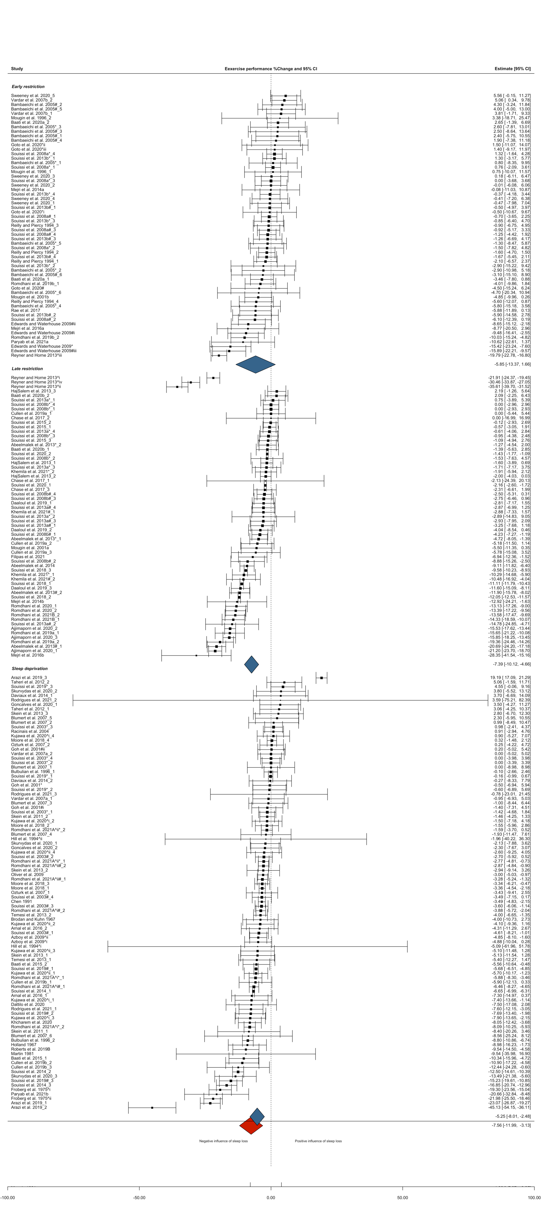
Supplementary Figure S1: Forest plot displaying the effect of sleep loss vs. normal sleep on the percentage change in exercise performance. The size of the squares are proportional to the weight of the study. A negative effect estimate indicates a decrease in exercise performance under the intervention condition (‘sleep loss’). Note, trials from Mougin 1991 [49] (fragmented sleep), Omiya et al. 2009 [128], Cook et al. 2011 [63], Cook et al. 2012 [84] and Roberts et al. 2019 [51] (type of sleep restriction protocol not stated) are included in overall effect estimate. Individual participant pools from a single study are denoted by the addition of a caret followed by a roman numeral (i.e., ^i, ^ii, ^iii etc.) to the citation; different sleep loss protocols (i.e., deprivation and late-restriction or early-restriction) from a single research study are denoted by the addition of a lower-case letter (i.e., a, b) to the citation; * or # indicates task performed in the AM or PM, respectively. * or # followed by a roman numeral value (i.e., *i, *ii, *iii) indicates that the same task was performed at multiple times during AM or PM; underscore numerical value (i.e., _1, _2, _3 etc.) identifies the different tasks performed at a given time; studies conducted by the same lead author in the same year are denoted by the addition of a capital ‘a or ‘b’ (i.e., A, B) to the citation. Deprivation: participants did not sleep for an extended period of time (i.e., whole night); restriction: total sleep time ≤6 h in any 24 h period – this category is a combination of early-restriction, late-restriction, fragmented sleep and sleep restriction protocols not specified; Early restriction: participants delayed sleep (i.e., went to sleep at a later time); Late restriction; participants awakened earlier than normal.

Supplementary Table S7: Sensitivity analysis of alternative levels of correlation coefficient (R) on overall exercise performance meta-analysis results
 |  |  | Exercise performance % change |  | Heterogeneity |  |  |  |  | Sensitivity analysis – one out
 | Outcomes, n | R | Mean (95% CI) | p | I²-value | p | σ² effect | σ²mode | σ²study | Range (EP%_{Δ}) | CI crossed (y or n)
All tasks
Overall | 227 | 0.71 | -7.56 (-11.9 to -3.13) | 0.001 | 98.1 | <0.001 | 21.2 | 32.1 | 14.5 | -7.91 to -7.28 | n
 |  | 0.80 | -7.56 (-11.9 to -3.18) | 0.001
 |  | 0.30 | -7.69 (-12.3 to -3.07) | 0.001
Sleep condition
Deprivation | 97 | 0.71 | -5.25 (-8.01 to -2.48) | <0.001 | 96.5 | <0.001 | 37.5 | 8.53 | <0.001 | -5.64 to -4.34 | n
 |  | 0.80 | -5.19 (-7.77 to -2.61) | 0.001
 |  | 0.30 | -5.52 (-8.84 to -2.20) | 0.001
Restriction | 130 | 0.71 | -8.59 (-13.6 to -3.61) | 0.001 | 98.3 | <0.001 | 7.43 | 35.1 | 34.0 | -8.96 to -8.12 | n
 |  | 0.80 | -8.57 (-13.5 to -3.63) | 0.001
 |  | 0.30 | -8.68 (-13.8 to -3.55) | 0.001
Early restriction | 62 | 0.71 | -5.85 (-13.4 to 1.66) | 0.125 | 93.5 | <0.001 | <0.001 | 73.5 | 28.0 | -6.12 to -5.20 | y
 |  | 0.80 | -5.90 (-13.4 to 1.57) | 0.119
 |  | 0.30 | -5.63 (-13.3 to 2.06) | 0.148
Late restriction | 60 | 0.71 | -7.39 (-10.1 to -4.66) | <0.001 | 98.3 | <0.001 | 9.65 | <0.001 | 30.8 | -7.57 to -6.91 | n
 |  | 0.80 | -7.47 (-10.2 to -4.71) | <0.001
 |  | 0.30 | -7.15 (-9.84 to -4.46) | <0.001
AM vs. PM
Overall AM | 115 | 0.71 | -5.42 (-9.66 to -1.17) | 0.013 | 93.5 | <0.001 | 27.2 | 28.1 | 2.18 | -5.77 to -5.04 | n
 |  | 0.80 | -5.40 (-9.53 to -1.27) | 0.011
 |  | 0.30 | -5.58 (-10.3 to -0.82) | 0.022
Overall PM | 106 | 0.71 | -8.31 (-13..2 to -3.37) | 0.001 | 98.9 | <0.001 | 7.06 | 35.8 | 26.2 | -8.72 to -7.98 | n
 |  | 0.80 | -8.33 (-13.2 to -3.44) | 0.001
 |  | 0.30 | -8.31 (-13.4 to -3.22) | 0.002

Supplementary Table S7: continued
 |  |  | Exercise performance % change |  | Heterogeneity |  |  |  |  | Sensitivity analysis – one out
 | Outcomes, n | R | Mean (95% CI) | p | I²-value | p | σ² effect | σ²mode | σ²study | Range (EP%_{Δ}) | CI crossed (y or n)
Sleep condition
Deprivation AM | 59 | 0.71 | -3.48 (-5.89 to -1.08) | 0.005 | 94.2 | <0.001 | 50.6 | 1.77 | <0.001 | -4.91 to -2.83 | n
 |  | 0.80 | -3.54 (-5.91 to -1.17) | 0.004
 |  | 0.30 | -3.31 (-5.83 to -0.79) | 0.011
Deprivation PM | 35 | 0.71 | -6.85 (-11.3 to -2.39) | 0.004 | 97.5 | <0.001 | 8.34 | 26.5 | 6.20 | -71.9 to -5.33 | n
 |  | 0.80 | -6.89 (-11.3 to -2.44) | 0.003
 |  | 0.30 | -6.96 (-11.4 to -2.49) | 0.003
Restriction AM | 56 | 0.71 | -5.96 (-11.5 to -0.43) | 0.035 | 90.7 | <0.001 | <0.001 | 48.2 | 7.66 | -6.45 to -5.67 | n
 |  | 0.80 | -5.96 (-11.4 to -0.51) | 0.033
 |  | 0.30 | -6.02 (-11.9 to 0.11) | 0.046
Restriction PM | 71 | 0.71 | -9.50 (-14.9 to -4.12) | 0.001 | 99.0 | <0.001 | 5.53 | 32.1 | 45.4 | -9.69 to -8.83 | n
 |  | 0.80 | -9.50 (-14.9 to -4.15) | 0.001
 |  | 0.30 | -9.51 (-14.9 to -4.04) | 0.001
Early restriction AM | 27 | 0.71 | -1.55 (-4.66 to 1.56) | 0.315 | 55.1 | 0.437 | <0.001 | <0.001 | 12.0 | -1.79 to -0.26 | y
 |  | 0.80 | -2.24 (-6.17 to 1.69) | 0.252
 |  | 0.30 | -0.23 (-2.08 to 1.62) | 0.800
Early restriction PM | 35 | 0.71 | -6.23 (-13.9 to 1.44) | 0.108 | 94.7 | <0.001 | <0.001 | 67.7 | 36.8 | -6.93 to -5.57 | y
 |  | 0.80 | -6.25 (-13.9 to 1.35) | 0.104
 |  | 0.30 | -6.12 (-14.0 to 1.73) | 0.122
Late restriction AM | 23 | 0.71 | -2.48 (-4.36 to -0.60) | 0.012 | 46.1 | 0.048 | <0.001 | 0.51 | 3.42 | -2.97 to -1.71 | n
 |  | 0.80 | -2.57 (-4.46 to -0.68) | 0.010
 |  | 0.30 | -2.18 (-3.92 to -0.44) | 0.016
Late restriction PM | 34 | 0.71 | -9.67 (-13.1 to -6.24) | <0.001 | 99.1 | <0.001 | 5.43 | <0.001 | 36.5 | -9.97 to -9.04 | n
 |  | 0.80 | -9.77 (-13.3 to -6.28) | <0.001
 |  | 0.30 | -9.39 (-12.7 to -6.06) | <0.001
Abbreviations/definitions: AM: ante meridiem; PM: post meridiem; Deprivation: participants did not sleep for an extended period of time (i.e., whole night); restriction: total sleep time ≤6 h in any 24 h period – this category is a combination of early-restriction, late-restriction, fragmented sleep and sleep restriction protocols not specified; Early restriction: participants delayed sleep (i.e., went to sleep at a later time); Late restriction; participants awakened earlier than normal.

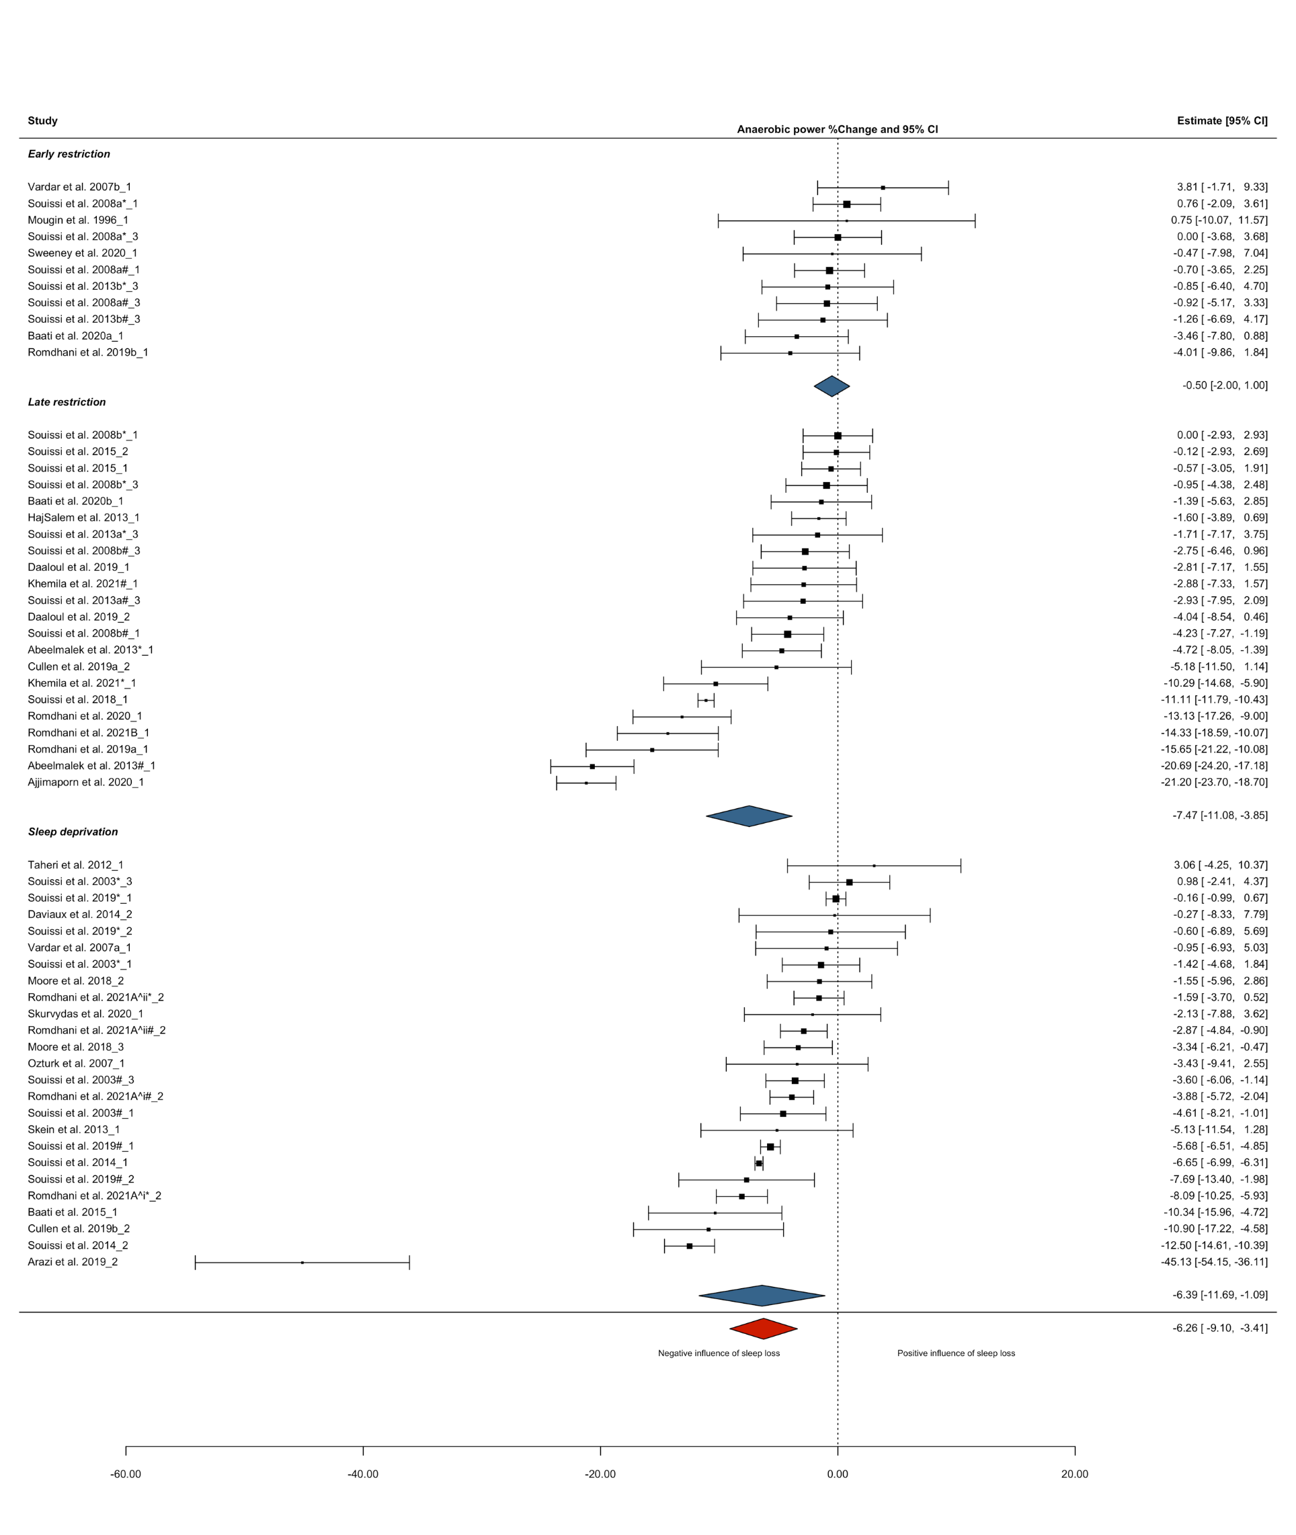Supplementary Figure S2: Forest plot displaying the effect of sleep loss vs. normal sleep on the percentage change in anaerobic power performance. The size of the squares are proportional to the weight of the study. A negative effect estimate indicates a decrease in anaerobic power performance under the intervention condition (‘sleep loss’). Individual participant pools from a single study are denoted by the addition of a caret followed by a roman numeral (i.e., ^i, ^ii, ^iii etc.) to the citation; different sleep loss protocols (i.e., deprivation and late-restriction or early-restriction) from a single research study are denoted by the addition of a lower-case letter (i.e., a, b) to the citation; * or # indicates task performed in the AM or PM, respectively. * or # followed by a roman numeral value (i.e., *i, *ii, *iii) indicates that the same task was performed at multiple times during AM or PM; underscore numerical value (i.e., _1, _2, _3 etc.) identifies the different tasks performed at a given time. Deprivation: participants did not sleep for an extended period of time (i.e., whole night); restriction: total sleep time ≤6 h in any 24 h period – this category is a combination of early-restriction, late-restriction, fragmented sleep and sleep restriction protocols not specified; Early restriction: participants delayed sleep (i.e., went to sleep at a later time); Late restriction; participants awakened earlier than normal.

Supplementary Table S8: Sensitivity analysis of alternative levels of correlation coefficient (R) on anaerobic power performance meta-analysis results
 |  |  | Exercise performance |  | Heterogeneity |  |  |  | Sensitivity analysis – one out
 |  |  | % change
Exercise category | Outcomes, n | R | Mean (95% CI) | p | I²-value | p | σ²effect | σ²study | Range (EP%_{Δ}) | CI crossed (y or n)
Anaerobic power
Overall | 58 | 0.71 | -6.26 (-9.10 to -3.41) | <0.001 | 98.1 | <0.001 | 9.47 | 49.2 | -6.59 to -5.24 | n
 |  | 0.80 | -6.27 (-9.15 to -3.38) | <0.001
 |  | 0.30 | -6.18 (-8.72 to -3.64) | <0.001
Sleep condition
Deprivation | 25 | 0.71 | -6.39 (-11.7 to -1.09) | 0.020 | 99.2 | <0.001 | 7.10 | 86.7 | -7.01 to -4.16 | n
 |  | 0.80 | -6.43 (-11.8 to -1.06) | 0.021
 |  | 0.30 | -6.07 (-10.5 to -1.61) | 0.009
Restriction | 33 | 0.71 | -5.99 (-9.22 to -2.77) | 0.001 | 94.1 | <0.001 | 11.7 | 30.2 | -6.61 to -5.05 | n
 |  | 0.80 | -5.95 (-9.17 to -2.74) | 0.001
 |  | 0.30 | -6.18 (-9.46 to -2.89) | 0.001
Early restriction | 11 | 0.71 | -0.50 (-2.00 to 1.00) | 0.477 | 0.04 | 0.770 | 0.001 | 0.001 | -0.92 to -0.20 | y
 |  | 0.80 | -0.62 (-2.29 to 1.05) | 0.428
 |  | 0.30 | -0.52 (-2.80 to 1.76) | 0.620
Late restriction | 22 | 0.71 | -7.47 (-11.1 to -3.85) | <0.001 | 95.4 | <0.001 | 18.9 | 25.6 | -8.42 to -6.36 | n
 |  | 0.80 | -7.49 (-11.1 to -3.88) | <0.001
 |  | 0.30 | -7.40 (-11.1 to -3.75) | <0.001
Am vs. PM
Overall AM | 27 | 0.71 | -4.58 (-9.14 to -0.24) | 0.049 | 97.0 | <0.001 | <0.001 | 81.3 | -5.00 to -2.65 | y
 |  | 0.80 | -4.61 (-9.24 to 0.03) | 0.052
 |  | 0.30 | -4.28 (-8.09 to -0.47) | 0.029
Overall PM | 30 | 0.71 | -7.37 (-10.3 to -4.40) | <0.001 | 97.8 | <0.001 | 5.13 | 33.3 | -7.64 to -6.56 | n
 |  | 0.80 | -7.36 (-10.3 to -4.42) | <0.001
 |  | 0.30 | -7.42 (-10.4 to -4.44) | <0.001

Supplementary Table S8: continued
 |  |  | Exercise performance |  | Heterogeneity |  |  |  | Sensitivity analysis – one out
 |  |  | % change
Exercise category | Outcomes, n | R | Mean (95% CI) | p | I²-value | p | σ²effect | σ²study | Range (EP%_{Δ}) | CI crossed (y or n)
Sleep condition
Deprivation AM | 14 | 0.71 | -6.38 (-14.5 to 1.73) | 0.113 | 98.5 | <0.001 | <0.001 | 147 | -7.30 to -2.83 | y
 |  | 0.80 | -6.41 (-14.6 to 1.77) | 0.114
 |  | 0.30 | -6.07 (-13.6 to 1.44) | 0.105
Deprivation PM | 11 | 0.71 | -5.49 (-7.93 to -3.04) | <0.001 | 93.5 | <0.001 | 5.37 | 3.14 | -5.89 to -4.86 | n
 |  | 0.80 | -5.57 (-8.04 to -3.10) | <0.001
 |  | 0.30 | -5.80 (-8.39 to -3.21) | <0.001
Restriction AM | 13 | 0.71 | -2.77 (-5.77 to 0.23) | 0.067 | 72.3 | 0.010 | <0.001 | 9.68 | -2.99 to -1.34 | y
 |  | 0.80 | -2.75 (-5.69 to 0.20) | 0.065
 |  | 0.30 | -2.66 (-5.79 to 0.47) | 0.089
Restriction PM | 19 | 0.71 | -8.35 (-13.1 to -3.56) | 0.002 | 96.0 | <0.001 | 2.13 | 57.5 | -9.36 to -7.16 | n
 |  | 0.80 | -8.28 (-13.1 to -3.51) | 0.002
 |  | 0.30 | -8.52 (-13.3 to -3.71) | 0.002
Early restriction AM | 5 | 0.71 | 0.25 (-2.55 to 3.05) | 0.817 | <0.001 | 0.988 | <0.001 | 0.001 | -0.22 to 0.41 | y
 |  | 0.80 | 0.24 (-2.23 to 2.71) | 0.804
 |  | 0.30 | 0.26 (-4.01 to 4.54) | 0.872
Early restriction PM | 6 | 0.71 | -1.10 (-3.42 to 1.23) | 0.280 | 0.05 | 0.391 | <0.001 | 0.003 | -1.66 to -0.62 | y
 |  | 0.80 | -1.13 (-3.97 to 1.72) | 0.356
 |  | 0.30 | -1.15 (-4.67 to 2.38) | 0.441
Late restriction AM | 8 | 0.71 | -3.46 (-7.22 to 0.31) | 0.067 | 78.1 | 0.002 | <0.001 | 11.2 | -3.80 to -1.79 | y
 |  | 0.80 | -3.47 (-7.19 to 0.25) | 0.063
 |  | 0.30 | -3.26 (-7.11 to 0.60) | 0.086
Late restriction PM | 13 | 0.71 | -10.1 (-14.9 to -5.13) | 0.001 | 96.3 | <0.001 | <0.001 | 52.6 | -10.9 to -8.89 | n
 |  | 0.80 | -10.1 (-14.9 to -5.13) | 0.001
 |  | 0.30 | -10.1 (-15.1 to -5.13) | 0.001
Abbreviations/definitions: AM: ante meridiem; PM: post meridiem; Deprivation: participants did not sleep for an extended period of time (i.e., whole night); restriction: total sleep time ≤6 h in any 24 h period – this category is a combination of early-restriction, late-restriction, fragmented sleep and sleep restriction protocols not specified; Early restriction: participants delayed sleep (i.e., went to sleep at a later time); Late restriction; participants awakened earlier than normal.

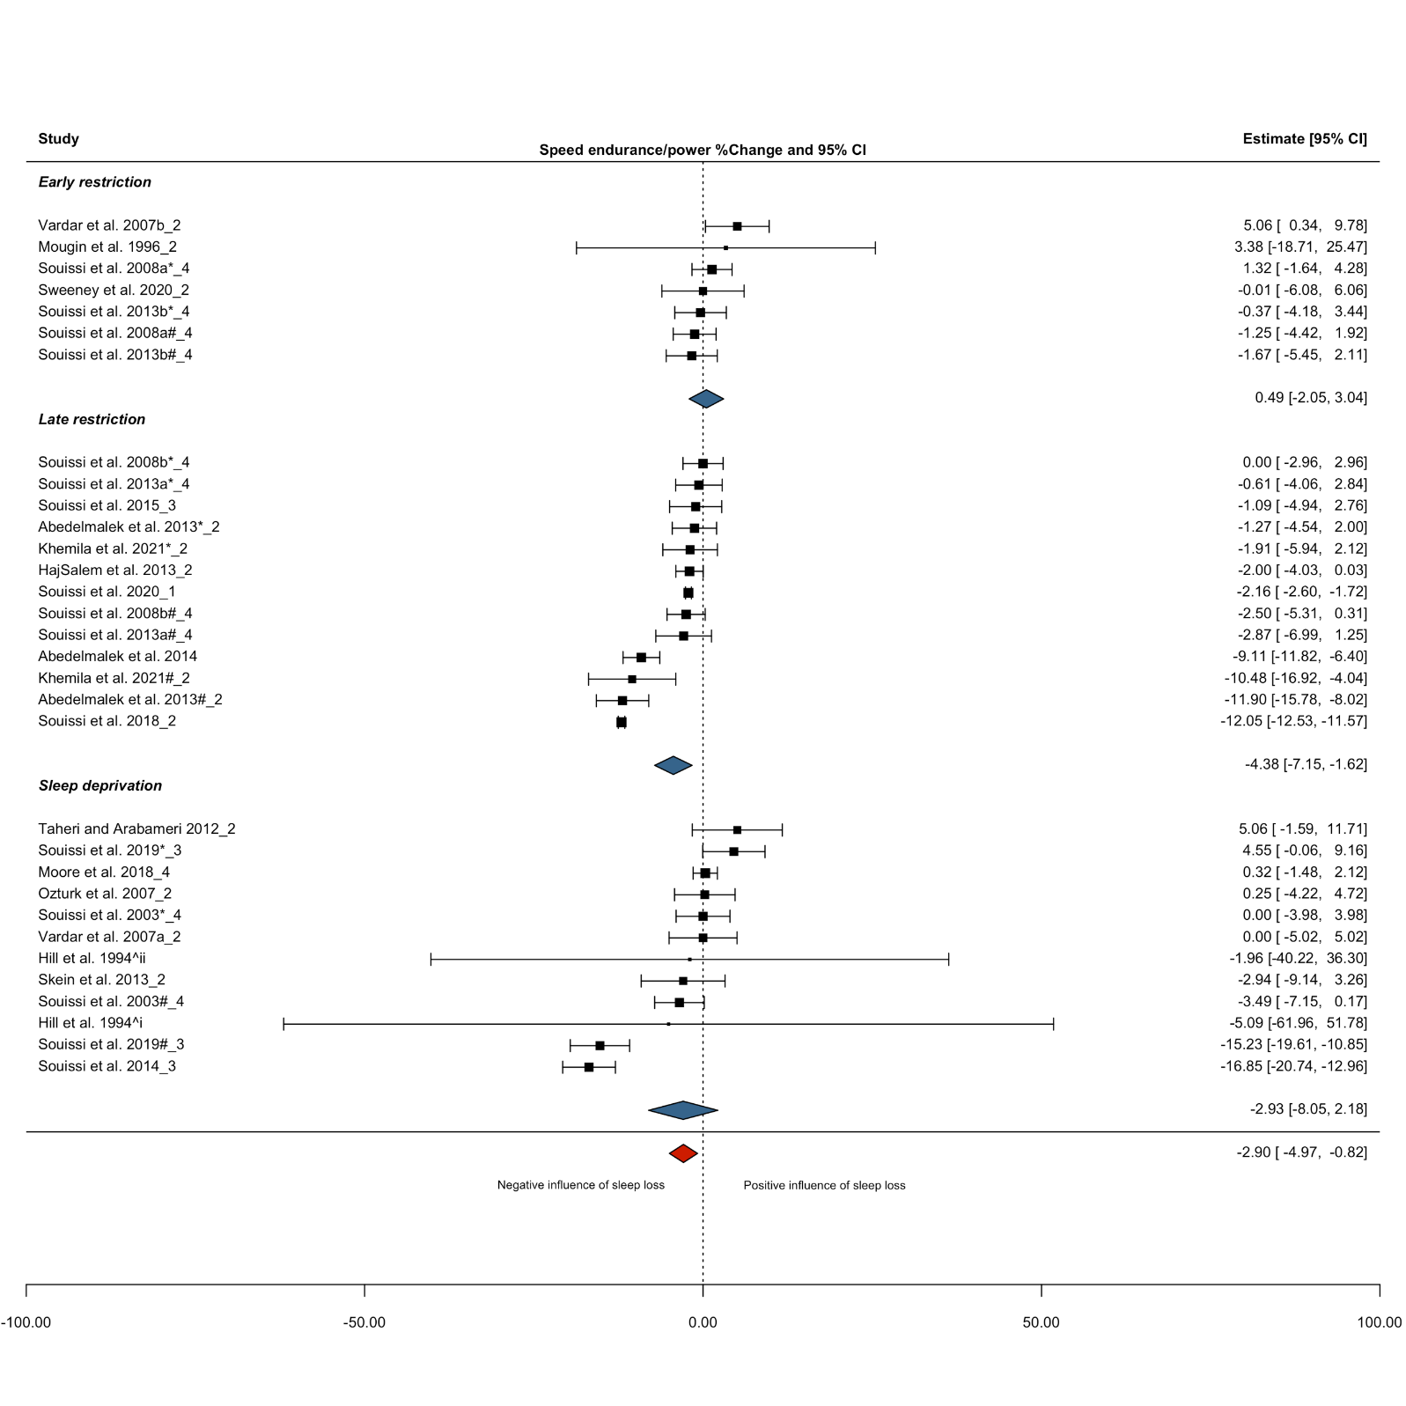
Supplementary Figure S3: Forest plot displaying the effect of sleep loss vs. normal sleep on the percentage change in speed/power endurance performance. The size of the squares are proportional to the weight of the study. A negative effect estimate indicates a decrease in speed/power endurance performance under the intervention condition (‘sleep loss’). Individual participant pools from a single study are denoted by the addition of a caret followed by a roman numeral (i.e., ^i, ^ii, ^iii etc.) to the citation; different sleep loss protocols (i.e., deprivation and late-restriction or early-restriction) from a single research study are denoted by the addition of a lower-case letter (i.e., a, b) to the citation; * or # indicates task performed in the AM or PM, respectively. * or # followed by a roman numeral value (i.e., *i, *ii, *iii) indicates that the same task was performed at multiple times during AM or PM; underscore numerical value (i.e., _1, _2, _3 etc.) identifies the different tasks performed at a given time. Deprivation: participants did not sleep for an extended period of time (i.e., whole night); restriction: total sleep time ≤6 h in any 24 h period – this category is a combination of early-restriction, late-restriction, fragmented sleep and sleep restriction protocols not specified; Early restriction: participants delayed sleep (i.e., went to sleep at a later time); Late restriction; participants awakened earlier than normal.

Supplementary Table S9: Sensitivity analysis of alternative levels of correlation coefficient (R) on speed/power endurance performance meta-analysis results
 |  |  | Exercise performance % change |  | Heterogeneity |  |  |  | Sensitivity analysis – one out
Exercise category | Outcomes, n | R | Mean (95% CI) | p | I²-value | p | σ²effect | σ²study | Range (EP%_{Δ}) | CI crossed (y or n)
Speed/power endurance
Overall | 32 | 0.71 | -2.90 (-4.97 to -0.82) | 0.008 | 96.3 | <0.001 | 26.4 | <0.001 | -3.72 to -2.43 | n
 |  | 0.80 | -2.86 (-4.94 to -0.78) | 0.009
 |  | 0.30 | -3.07 (-5.17 to -0.98) | 0.005
Sleep condition
Deprivation | 12 | 0.71 | -2.93 (-8.05 to 2.18) | 0.233 | 91.1 | <0.001 | 49.6 | 0.012 | -3.98 to -1.39 | y
 |  | 0.80 | -2.91 (-8.02 to 2.19) | 0.235
 |  | 0.30 | -3.03 (-8.20 to 2.13) | 0.224
Restriction | 20 | 0.71 | -3.23 (-5.94 to -0.53) | 0.022 | 96.4 | <0.001 | 9.33 | 9.86 | -3.82 to -2.41 | y
 |  | 0.80 | -3.16 (-5.85 to -0.47) | 0.024
 |  | 0.30 | -3.57 (-6.41 to -0.73) | 0.017
Early restriction | 7 | 0.71 | 0.49 (-2.05 to 3.04) | 0.652 | 24.4 | 0.366 | 0.115 | 1.35 | -0.29 to 1.05 | y
 |  | 0.80 | 0.67 (-2.18 to 3.52) | 0.584
 |  | 0.30 | 0.27 (-2.68 to 3.21) | 0.833
Late restriction | 13 | 0.71 | -4.38 (-7.15 to -1.62) | 0.005 | 97.3 | <0.001 | 18.2 | <0.001 | -5.00 to -3.58 | n
 |  | 0.80 | -4.34 (-7.09 to -1.60) | 0.005
 |  | 0.30 | -4.54 (-7.44 to -1.64) | 0.005
Am vs. PM
Overall AM | 14 | 0.71 | 0.11 (-0.94 to 1.16) | 0.823 | <0.001 | 0.721 | <0.001 | <0.001 | -0.09 to 0.24 | y
 |  | 0.80 | 0.12 (-0.80 to 1.03) | 0.788
 |  | 0.30 | 0.10 (-1.52 to 1.72) | 0.894
Overall PM | 15 | 0.71 | -6.78 (-10.8 to -2.80) | 0.003 | 98.5 | <0.001 | <0.001 | 38.2 | -7.39 to -5.87 | n
 |  | 0.80 | -6.79 (-10.8 to -2.79) | 0.003
 |  | 0.30 | -6.75 (-10.7 to -2.83) | 0.002
Sleep condition
Deprivation AM | 5ª | 0.71 | 0.90 (-0.89 to 2.69) | 0.323 | 14.0 | 0.203 |  |  | 0.33 to 1.64 | y
 |  | 0.80 | 1.19 (-1.01 to 3.38) | 0.290
 |  | 0.30 | 0.72 (-1.53 to 2.97) | 0.530
Deprivation PM | 5ª | 0.71 | -7.11 (-14.4 to 0.20) | 0.057 | 93.9 | <0.001 |  |  | -8.94 to -4.65 | y
 |  | 0.80 | -7.11 (-14.4 to 0.20) | 0.057
 |  | 0.30 | -7.17 (-14.5 to 0.14) | 0.055

Supplementary Table S9: continued
 |  |  | Exercise performance % change |  | Heterogeneity |  |  |  | Sensitivity analysis – one out
 | Outcomes, n | R | Mean (95% CI) | p | I²-value | p | σ²effect | σ²study | Range (EP%_{Δ}) | CI crossed (y or n)
Restriction AM | 9 | 0.71 | -0.36 (-1.84 to 1.12) | 0.588 | <0.001 | 0.964 | <0.001 | <0.001 | -0.73 to -0.20 | y
 |  | 0.80 | -0.37 (-1.65 to 0.92) | 0.530
 |  | 0.30 | -0.36 (-2.65 to 1.93) | 0.726
Restriction PM | 10 | 0.71 | -5.58 (-10.4 to -0.76) | 0.028 | 98.8 | <0.001 | <0.001 | 33.4 | -6.91 to -4.55 | y
 |  | 0.80 | -5.54 (-10.4 to -0.68) | 0.030
 |  | 0.30 | -5.74 (-10.4 to -1.07) | 0.021
Early restriction AM | 4ª | 0.71 | 0.62 (-1.55 to 2.79) | 0.575 | 0.00 | 0.902 |  |  | -0.19 to 1.10 | y
 |  | 0.80 | 0.61 (-1.28 to 2.50) | 0.525
 |  | 0.30 | 0.63 (-2.73 to 3.99) | 0.713
Early restriction PM | 3ª | 0.71 | 0.43 (-3.51 to 4.37) | 0.832 | 68.3 | 0.056 |  |  | -1.42 to 1.65 | y
 |  | 0.80 | 0.51 (-3.53 to 4.56) | 0.804
 |  | 0.30 | -0.09 (-3.41 to 3.23) | 0.957
Late restriction AM | 5ª | 0.71 | -0.86 (-2.40 to 0.68) | 0.275 | 0.00 | 0.954 |  |  | -1.18 to -0.68 | y
 |  | 0.80 | -0.86 (-2.20 to 0.48) | 0.209
 |  | 0.30 | -0.86 (-4.23 to 2.52) | 0.519
Late restriction PM | 7ª | 0.71 | -7.17 (-10.7 to -3.66) | <0.001 | 98.5 | <0.001 |  |  | -8.15 to -6.17 | n
 |  | 0.80 | -7.14 (-10.6 to -3.65) | <0.001
 |  | 0.30 | -7.23 (-10.9 to -3.62) | <0.001
Abbreviations/definitions: AM: ante meridiem; PM: post meridiem; Deprivation: participants did not sleep for an extended period of time (i.e., whole night); restriction: total sleep time ≤6 h in any 24 h period – this category is a combination of early-restriction, late-restriction, fragmented sleep and sleep restriction protocols not specified; Early restriction: participants delayed sleep (i.e., went to sleep at a later time); Late restriction; participants awakened earlier than normal. ª All outcomes were from independent studies and meta-analysis was run without dependency levels (i.e., simple meta-analysis).

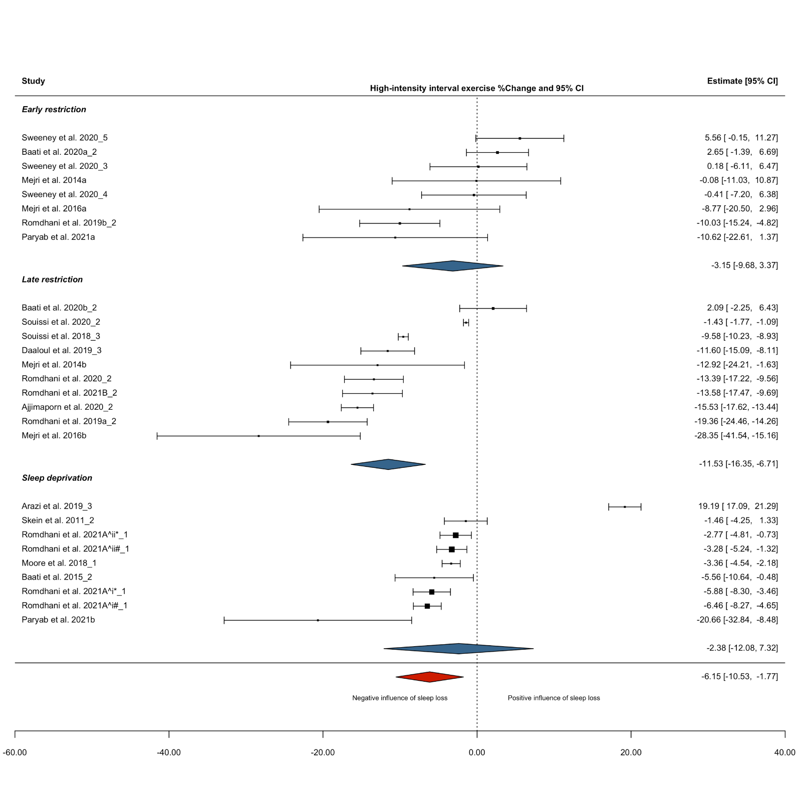Supplementary Figure S4: Forest plot displaying the effect of sleep loss vs. normal sleep on the percentage change in high-intensity interval exercise (HIIE) performance. The size of the squares are proportional to the weight of the study. A negative effect estimate indicates a decrease in HIIE performance under the intervention condition (‘sleep loss’). Individual participant pools from a single study are denoted by the addition of a caret followed by a roman numeral (i.e., ^i, ^ii, ^iii etc.) to the citation; different sleep loss protocols (i.e., deprivation and late-restriction or early-restriction) from a single research study are denoted by the addition of a lower-case letter (i.e., a, b) to the citation; * or # indicates task performed in the AM or PM, respectively. * or # followed by a roman numeral value (i.e., *i, *ii, *iii) indicates that the same task was performed at multiple times during AM or PM; underscore numerical value (i.e., _1, _2, _3 etc.) identifies the different tasks performed at a given time. Deprivation: participants did not sleep for an extended period of time (i.e., whole night); restriction: total sleep time ≤6 h in any 24 h period – this category is a combination of early-restriction, late-restriction, fragmented sleep and sleep restriction protocols not specified; Early restriction: participants delayed sleep (i.e., went to sleep at a later time); Late restriction; participants awakened earlier than normal.

Supplementary Table S10: Sensitivity analysis of alternative levels of correlation coefficient (R) on high-intensity interval exercise performance meta-analysis results
 |  |  | Exercise performance % change |  | Heterogeneity |  |  |  | Sensitivity analysis – one out
Exercise category | Outcomes, n | R | Mean (95% CI) | p | I²-value | p | σ² effect | σ²study | Range (EP%_{Δ}) | CI crossed (y or n)
HIIE
Overall | 27 | 0.71 | -6.15 (-10.5 to -1.77) | 0.008 | 98.9 | <0.001 | <0.001 | 77.4 | -7.54 to -5.57 | n
 |  | 0.80 | -6.22 (-10.6 to -1.88) | 0.007
 |  | 0.30 | -5.89 (-10.3 to -1.48) | 0.011
Sleep condition
Deprivation | 9 | 0.71 | -2.38 (-12.1 to 7.32) | 0.587 | 99.0 | <0.001 | <0.001 | 118 | -4.21 to -0.04 | y
 |  | 0.80 | -2.52 (-12.3 to 7.25) | 0.568
 |  | 0.30 | -1.76 (-11.0 to 7.46) | 0.671
Restriction | 18 | 0.71 | -8.77 (-13.3 to -4.27) | 0.001 | 98.3 | <0.001 | 12.1 | 38.7 | -9.50 to -8.11 | n
 |  | 0.80 | -8.77 (-13.3 to -4.23) | 0.001
 |  | 0.30 | -8.71 (-13.2 to -4.23) | 0.001
Early restriction | 8 | 0.71 | -3.15 (-9.68 to 3.37) | 0.291 | 73.2 | 0.001 | 2.52 | 28.4 | -4.78 to -0.24 | y
 |  | 0.80 | -3.28 (-9.71 to 3.14) | 0.266
 |  | 0.30 | -2.42 (-9.34 to 4.50) | 0.436
Late restriction | 10ª | 0.71 | -11.5 (-16.3 to -6.71) | <0.001 | 99.2 | <0.001 |  |  | -12.9 to -10.4 | n
 |  | 0.80 | -11.7 (-16.6 to -6.79) | <0.001
 |  | 0.30 | -10.9 (-15.5 to -6.27) | <0.001
AM vs. PM
Overall AM | 11 | 0.71 | -1.51 (-10.4 to 7.42) | 0.714 | 97.7 | <0.001 | 6.85 | 101 | -4.32 to -0.60 | y
 |  | 0.80 | 1.65 (-10.5 to 7.25) | 0.689
 |  | 0.30 | -1.02 (-9.99 to 7.96) | 0.806
Overall PM | 16 | 0.71 | -8.34 (-12.2 to -4.47) | 0.001 | 98.5 | <0.001 | 14.1 | 27.1 | -8.94 to -7.72 | n
 |  | 0.80 | -8.41 (-12.4 to -4.47) | 0.001
 |  | 0.30 | -8.02 (-11.7 to -4.38) | 0.001
Sleep condition
Deprivation AM | 5ª | 0.71 | -2.06 (-14.1 to 10.0) | 0.737 | 99.3 | <0.001 |  |  | -4.34 to 1.79 | y
 |  | 0.80 | 2.20 (-14.4 to 9.95) | 0.722
 |  | 0.30 | 1.32 (-12.9 to 10.3) | 0.824

Supplementary Table S10: continued
 |  |  | Exercise performance % change |  | Heterogeneity |  |  |  | Sensitivity analysis – one out
 | Outcomes, n | R | Mean (95% CI) | p | I²-value | p | σ² effect | σ²study | Range (EP%_{Δ}) | CI crossed (y or n)
Deprivation PM | 4ª | 0.71 | -4.13 (-6.50 to -1.76) | <0.001 | 81.2 | 0.013 |  |  | -5.01 to -2.94 | y
 |  | 0.80 | -4.20 (-6.46 to -1.94) | <0.001
 |  | 0.30 | -4.33 (-6.62 to -2.04) | <0.001
Restriction AM | 6 | 0.71 | -3.39 (-13.3 to 6.55) | 0.421 | 66.5 | 0.074 | 5.94 | 26.9 | -5.78 to -1.10 | y
 |  | 0.80 | -3.60 (-13.4 to 6.23) | 0.390
 |  | 0.30 | -1.99 (-12.1 to 8.12) | 0.634
Restriction PM | 12 | 0.71 | -10.2 (-15.4 to -4.97) | 0.001 | 99.0 | <0.001 | 16.8 | 33.3 | -11.3 to -9.44 | n
 |  | 0.80 | -10.3 (-15.6 to -4.93) | 0.001
 |  | 0.30 | -9.95 (-14.9 to -4.94) | 0.001
Early restriction AM | 5 | 0.71 | -1.10 (-10.7 to 8.53) | 0.767 | 57.2 | 0.176 | 2.54 | 17.4 | -2.87 to 1.92 | y
 |  | 0.80 | -1.47 (-11.3 to 8.40) | 0.700
 |  | 0.30 | 0.97 (-6.23 to 8.18) | 0.762
Early restriction PM | 3ª | 0.71 | -4.79 (-13.6 to 3.98) | 0.284 | 83.6 | <0.001 |  |  | -9.82 to -1.68 | y
 |  | 0.80 | -4.89 (-13.5 to 3.73) | 0.266
 |  | 0.30 | -4.32 (-13.7 to 5.09) | 0.368
Late restriction AM | 1
Late restriction PM | 9ª | 0.71 | -11.5 (-16.7 to -6.24) | <0.001 | 99.4 | <0.001 |  |  | -12.9 to -10.2 | n
 |  | 0.80 | -11.6 (-16.9 to -6.28) | <0.001
 |  | 0.30 | -10.8 (-15.7 to -5.97) | <0.001
Abbreviations/definitions: HIIE: high-intensity interval exercise; AM: ante meridiem; PM: post meridiem; Deprivation: participants did not sleep for an extended period of time (i.e., whole night); restriction: total sleep time ≤6 h in any 24 h period – this category is a combination of early-restriction, late-restriction, fragmented sleep and sleep restriction protocols not specified; Early restriction: participants delayed sleep (i.e., went to sleep at a later time); Late restriction; participants awakened earlier than normal. ª All outcomes were from independent studies and meta-analysis was run without dependency levels (i.e., simple meta-analysis).

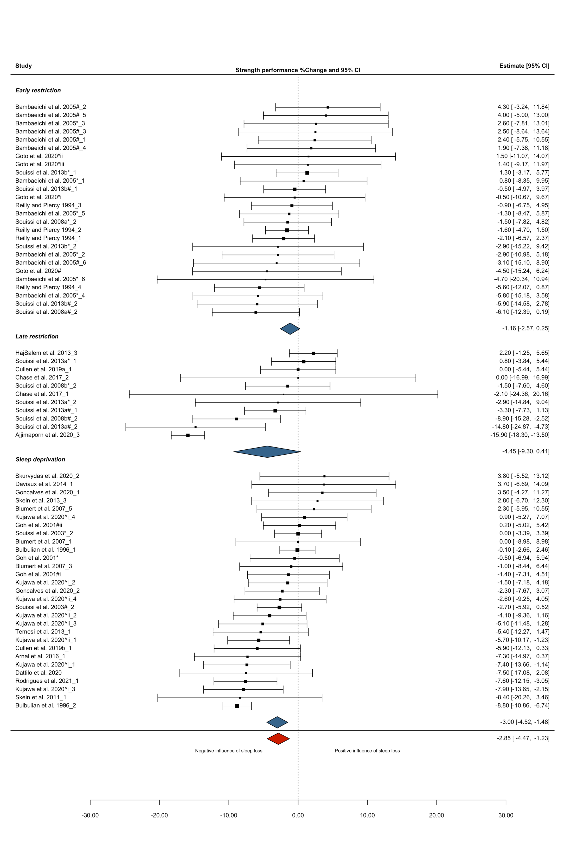
Supplementary Figure S5: Forest plot displaying the effect of sleep loss vs. normal sleep on the percentage change in strength performance. The size of the squares are proportional to the weight of the study. A negative effect estimate indicates a decrease in strength performance under the intervention condition (‘sleep loss’). Individual participant pools from a single study are denoted by the addition of a caret followed by a roman numeral (i.e., ^i, ^ii, ^iii etc.) to the citation; different sleep loss protocols (i.e., deprivation and late-restriction or early-restriction) from a single research study are denoted by the addition of a lower-case letter (i.e., a, b) to the citation; * or # indicates task performed in the AM or PM, respectively. * or # followed by a roman numeral value (i.e., *i, *ii, *iii) indicates that the same task was performed at multiple times during AM or PM; underscore numerical value (i.e., _1, _2, _3 etc.) identifies the different tasks performed at a given time. Deprivation: participants did not sleep for an extended period of time (i.e., whole night); restriction: total sleep time ≤6 h in any 24 h period – this category is a combination of early-restriction, late-restriction, fragmented sleep and sleep restriction protocols not specified; Early restriction: participants delayed sleep (i.e., went to sleep at a later time); Late restriction; participants awakened earlier than normal

Supplementary Table S11: Sensitivity analysis of alternative levels of correlation coefficient (R) on strength performance meta-analysis results
 |  |  | Exercise performance% change |  | Heterogeneity |  |  |  | Sensitivity analysis – one out
Exercise category | Outcomes, n | R | Mean (95% CI) | p | I²-value | p | σ²effect | σ²study | Range (EP%_{Δ}) | CI crossed (y or n)
Strength
Overall | 66 | 0.71 | -2.85 (-4.47 to -1.23) | <0.001 | 62.2 | <0.001 | 6.45 | 6.83 | -3.20 to -2.27 | n
 |  | 0.80 | -2.84 (-4.41 to -1.27) | <0.001
 |  | 0.30 | -3.10 (-4.95 to -1.25) | 0.001
Sleep condition
Deprivation | 29 | 0.71 | -3.00 (-4.52 to -1.48) | <0.001 | 49.2 | <0.001 | 6.58 | 0.003 | -3.53 to -2.53 | n
 |  | 0.80 | -3.05 (-4.55 to -1.56) | <0.001
 |  | 0.30 | -3.29 (-5.15 to -1.44) | 0.001
Restriction | 37 | 0.71 | -2.77 (-6.75 to 1.21) | 0.167 | 74.9 | <0.001 | <0.001 | 29.3 | -3.44 to -1.08 | y
 |  | 0.80 | -2.74 (-6.62 to 1.14) | 0.161
 |  | 0.30 | -2.96 (-7.17 to 1.25) | 0.163
Early restriction | 26 | 0.71 | -1.16 (-2.57 to 0.25) | 0.102 | 0.02 | 0.952 | 0.001 | 0.001 | -1.41 to -0.93 | y
 |  | 0.80 | -1.14 (-2.59 to 0.31) | 0.119
 |  | 0.30 | -1.20 (-3.36 to 0.96) | 0.264
Late restriction | 11 | 0.71 | -4.45 (-9.30 to 0.41) | 0.068 | 83.7 | <0.001 | 36.2 | <0.001 | -5.37 to -2.36 | y
 |  | 0.80 | -4.45 (-9.20 to 0.30) | 0.064
 |  | 0.30 | -4.38 (-11.2 to 2.46) | 0.184
AM vs. PM
Overall AM | 39 | 0.71 | -1.78 (-3.23 to -0.33) | 0.017 | 17.6 | 0.570 | <0.001 | 2.53 | -1.96 to -1.45 | n
 |  | 0.80 | -1.74 (-3.22 to -0.27) | 0.022
 |  | 0.30 | -2.01 (-3.73 to -0.30) | 0.022
Overall PM | 26 | 0.71 | -4.58 (-7.59 to -1.58) | 0.004 | 79.5 | <0.001 | 7.90 | 14.6 | -5.20 to -3.15 | n
 |  | 0.80 | -4.60 (-7.54 to -1.66) | 0.004
 |  | 0.30 | -4.55 (-7.79 to -1.31) | 0.008
Sleep condition
Deprivation AM | 21 | 0.71 | -2.43 (-4.47 to -0.38) | 0.022 | 31.8 | 0.115 | 0.87 | 3.80 | -2.81 to -1.94 | y
 |  | 0.80 | -2.42 (-4.51 to -0.34) | 0.025
 |  | 0.30 | -2.84 (-5.02 to -0.65) | 0.014
Deprivation PM | 8 | 0.71 | -3.79 (-7.27 to -0.32) | 0.037 | 71.5 | <0.001 | 10.3 | <0.001 | -5.06 to -2.01 | y
 |  | 0.80 | -3.83 (-7.20 to -0.45) | 0.032
 |  | 0.30 | -3.82 (-7.81 to 0.18) | 0.058

Supplementary Table S11: continued
 |  |  | Exercise performance% change |  | Heterogeneity |  |  |  | Sensitivity analysis – one out
 | Outcomes, n | R | Mean (95% CI) | p | I²-value | p | σ²effect | σ²study | Range (EP%_{Δ}) | CI crossed (y or n)
Restriction AM | 18 | 0.71 | -0.43 (-2.41 to 1.54) | 0.650 | <0.001 | 0.999 | <0.001 | <0.001 | -0.78 to -0.22 | y
 |  | 0.80 | -0.40 (-2.14 to 1.34) | 0.636
 |  | 0.30 | -0.47 (-3.50 to 2.56) | 0.747
Restriction PM | 18 | 0.71 | -5.20 (-11.0 to 0.59) | 0.075 | 82.3 | <0.001 | <0.001 | 39.5 | -5.54 to -2.61 | y
 |  | 0.80 | -5.18 (-10.9 to 0.53) | 0.073
 |  | 0.30 | -5.29 (-11.4 to 0.82) | 0.085
Early restriction AM | 12 | 0.71 | -0.55 (-3.21 to 2.11) | 0.659 | <0.001 | 0.985 | <0.001 | <0.001 | -1.26 to -0.19 | y
 |  | 0.80 | -0.49 (-2.84 to 1.86) | 0.656
 |  | 0.30 | -0.61 (-4.69 to 3.47) | 0.747
Early restriction PM | 14 | 0.71 | -1.51 (-4.41 to 1.39) | 0.281 | 27.1 | 0.631 | <0.001 | 3.86 | -2.13 to -0.86 | y
 |  | 0.80 | -1.60 (-4.60 to 1.39) | 0.268
 |  | 0.30 | -1.48 (-4.23 to 1.28) | 0.267
Late restriction AM | 6 | 0.71 | -0.26 (-4.06 to 3.54) | 0.867 | <0.001 | 0.989 | <0.001 | <0.001 | -0.90 to 0.11 | y
 |  | 0.80 | -0.26 (-3.60 to 3.08) | 0.848
 |  | 0.30 | -0.26 (-6.08 to 5.57) | 0.915
Late restriction PM | 4 | 0.71 | -10.5 (-20.6 to -0.39) | 0.046 | 84.0 | <0.001 | 31.3 | <0.001 | -13.6 to -7.77 | y
 |  | 0.80 | -10.5 (-20.4 to -0.59) | 0.043
 |  | 0.30 | -10.6 (-21.5 to 0.41) | 0.055
Upper- vs. lower body strength
Overall upper-body | 18 | 0.71 | -1.63 (-3.30 to 0.04) | 0.056 | 32.7 | 0.069 | 3.42 | <0.001 | -1.99 to -0.96 | y
 |  | 0.80 | -1.72 (-3.45 to -0.00) | 0.049
 |  | 0.30 | -1.44 (-3.42 to 0.55) | 0.145
Overall lower-body | 46 | 0.71 | -3.42 (-5.54 to -1.31) | 0.002 | 65.6 | <0.001 | 7.68 | 8.44 | -3.96 to -2.64 | n
 |  | 0.80 | -3.41 (-5.48 to -1.34) | 0.002
 |  | 0.30 | -3.82 (-6.22 to -1.42) | 0.003
Sleep condition
Upper-body Deprivation | 6 | 0.71 | -3.18 (-9.13 to 2.77) | 0.228 | 58.9 | 0.104 | <0.001 | 13.2 | -4.37 to -1.41 | y
 |  | 0.80 | -3.06 (-9.16 to 3.03) | 0.253
 |  | 0.30 | -2.91 (-7.58 to 1.76) | 0.170

Supplementary File S11: continued
 |  |  | Exercise performance% change |  | Heterogeneity |  |  |  | Sensitivity analysis – one out
 | Outcomes, n | R | Mean (95% CI) | p | I²-value | p | σ²effect | σ²study | Range (EP%_{Δ}) | CI crossed (y or n)
Upper-body Restriction | 12 | 0.71 | -0.73 (-2.67 to 1.22) | 0.428 | 11.5 | 0.186 | <0.001 | 0.84 | -1.49 to -0.54 | y
 |  | 0.80 | -1.11 (-2.91 to 0.68) | 0.199
 |  | 0.30 | -0.90 (-3.32 to 1.52) | 0.432
Early restriction | 6 | 0.71 | -1.21 (-3.71 to 1.29) | 0.268 | <0.001 | 0.752 | <0.001 | <0.001 | -1.76 to -0.98 | y
 |  | 0.80 | -1.17 (-3.38 to 1.04) | 0.232
 |  | 0.30 | -1.25 (-5.08 to 2.58) | 0.440
Late restriction | 6 | 0.71 | -1.13 (-6.07 to 3.81) | 0.583 | 61.6 | 0.035 | 7.75 | 2.31 | -2.72 to 0.12 | y
 |  | 0.80 | -1.76 (-7.18 to 3.66) | 0.442
 |  | 0.30 | -0.42 (-4.98 to 4.13) | 0.824
Lower-body Deprivation | 21 | 0.71 | -3.25 (-5.09 to -1.41) | 0.002 | 54.7 | <0.001 | 7.34 | <0.001 | -3.65 to -2.43 | n
 |  | 0.80 | -3.36(-5.16 to -1.56) | 0.001
 |  | 0.30 | -3.53 (-5.77 to -1.30) | 0.004
Lower-body Restriction | 25 | 0.71 | -4.50 (-10.2 to 1.17) | 0.114 | 72.8 | <0.001 | <0.001 | 37.8 | -4.94 to -1.86 | y
 |  | 0.80 | -4.42 (-10.0 to 1.16) | 0.115
 |  | 0.30 | -4.81 (-10.9 to 1.27) | 0.116
Early restriction | 20 | 0.71 | -1.36 (-3.81 to 1.09) | 0.259 | 6.97 | 0.892 | <0.001 | 1.41 | -1.48 to -0.62 | y
 |  | 0.80 | -1.44 (-3.85 to 0.97) | 0.226
 |  | 0.30 | -1.15 (-4.25 to 1.95) | 0.446
Late restriction | 5 | 0.71 | -8.26 (-20.4 to 3.90) | 0.132 | 81.7 | <0.001 | 15.1 | 34.2 | -10.5 to -4.45 | y
 |  | 0.80 | -8.03 (-20.0 to 3.98) | 0.137
 |  | 0.30 | -9.43 (-22.4 to 3.51) | 0.113
Abbreviations/definitions: AM: ante meridiem; PM: post meridiem; Deprivation: participants did not sleep for an extended period of time (i.e., whole night); restriction: total sleep time ≤6 h in any 24 h period – this category is a combination of early-restriction, late-restriction, fragmented sleep and sleep restriction protocols not specified; Early restriction: participants delayed sleep (i.e., went to sleep at a later time); Late restriction; participants awakened earlier than normal.

Supplementary Table S12: Effect of time of day following sleep loss on body-limb strength
 |  | Exercise performance
 |  | % change
Exercise category | Outcomes, n | Mean (95% CI) | p
Upper-body Am vs. PM
Overall upper-body (exercise AM) | 9 | -1.85 (-5.97 to 2.26) | 0.329
Overall upper-body (exercise PM) | 8 | -2.10 (-4.16 to -0.05) | 0.046
Sleep condition
Deprivation (exercise AM) | 4ª | -3.54 (-8.22 to 1.16) | 0.139
Deprivation (exercise PM) | 2 | -0.54 (-26.0 to 24.9) | 0.831
Restriction (exercise AM) | 5 | 0.41 (3.33 to 4.14) | 0.777
Restriction (exercise PM) | 6 | -2.47 (-4.94 to 0.01) | 0.051
Early restriction (exercise AM) | 2 | 0.78 (-26.4 to 28.0) | 0.778
Early restriction (exercise PM) | 4 | -1.73 (-5.20 to 1.74) | 0.211
Late restriction (exercise AM) | 3 | 0.17 (-7.28 to 7.61) | 0.933
Late restriction (exercise PM) | 2 | -8.09 (-80.4 to 64.2) | 0.390
Lower-body Am vs. Pm
Overall (exercise AM) | 28 | -2.16 (-3.53 to -0.79) | 0.003
Overall (exercise PM) | 18 | -5.27 (-9.04 to 1.49) | 0.009
Sleep condition
Deprivation (exercise AM) | 15 | -2.01 (-4.41 to 0.39) | 0.094
Deprivation (exercise PM) | 6 | -4.81 (-9.33 to -0.28) | 0.041
Restriction (exercise AM) | 13 | -1.22 (-4.06 to 1.62) | 0.368
Restriction (exercise PM) | 12 | -5.84 (-13.2 to 1.49) | 0.107
Early restriction (exercise AM) | 10 | -1.17 (-4.48 to 2.14) | 0.445
Early restriction (exercise PM) | 10 | -1.07 (-3.97 to 1.83) | 0.424
Late restriction (exercise AM) | 3 | -1.40 (-13.6 to 10.8) | 0.670
Late restriction (exercise PM) | 2 | -13.0 (-19.7 to -6.31) | <0.001
Abbreviations/definitions: AM: ante meridiem; PM: post meridiem; CI: confidence interval; Deprivation: participants did not sleep for an extended period of time (i.e., whole night); restriction: total sleep time ≤6 h in any 24 h period – this category is a combination of early-restriction, late-restriction, fragmented sleep and sleep restriction protocols not specified; Early restriction: participants delayed sleep (i.e., went to sleep at a later time); Late restriction; participants awakened earlier than normal. ª Outcome was from independent study and meta-analysis was run without dependency levels (i.e., simple meta-analysis).

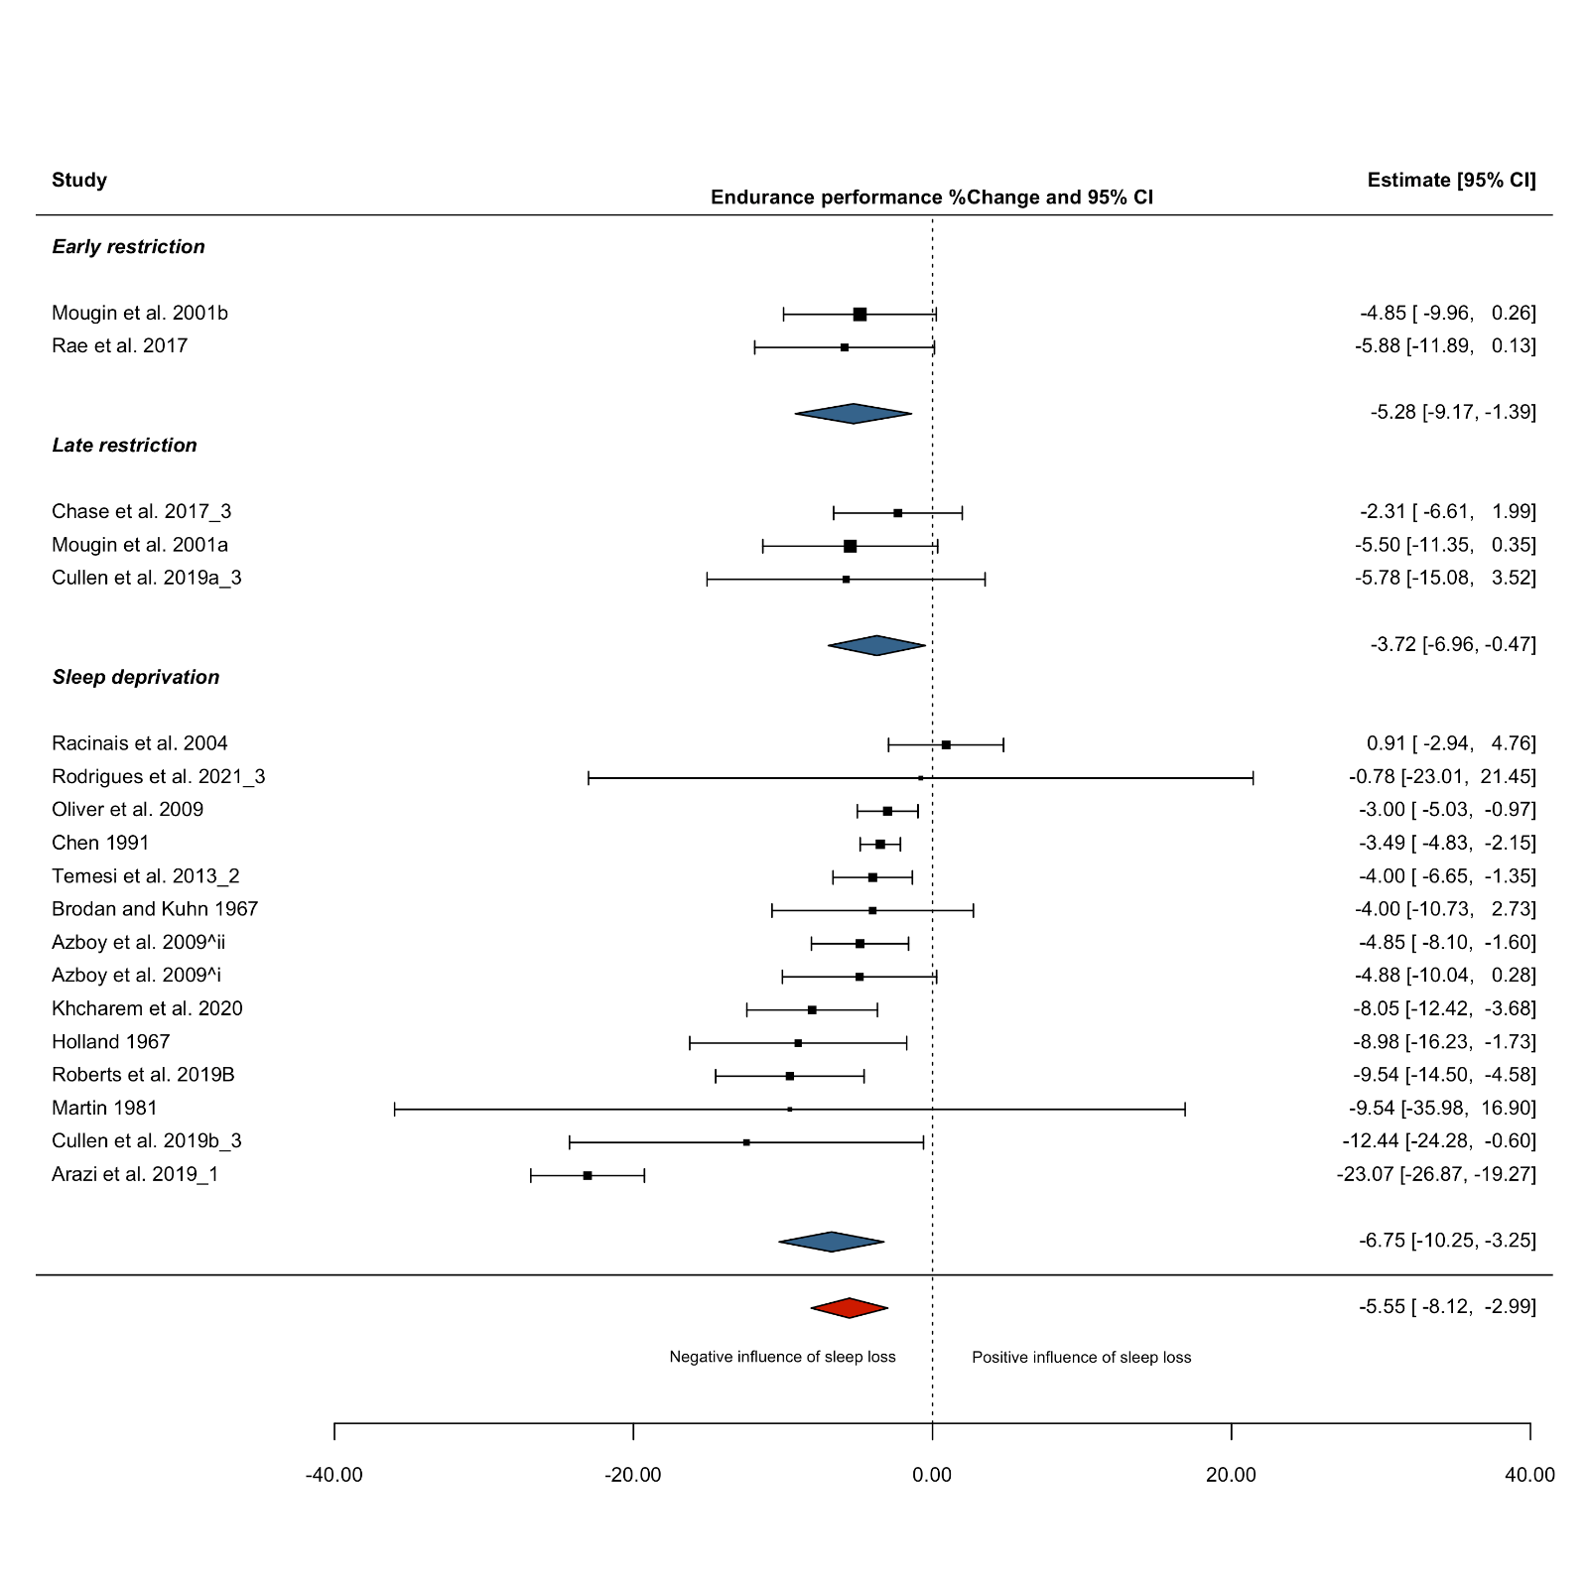
Supplementary Figure S6: Forest plot displaying the effect of sleep loss vs. normal sleep on the percentage change in endurance performance. The size of the squares are proportional to the weight of the study. A negative effect estimate indicates a decrease in endurance performance under the intervention condition (‘sleep loss’). Individual participant pools from a single study are denoted by the addition of a caret followed by a roman numeral (i.e., ^i, ^ii, ^iii etc.) to the citation; different sleep loss protocols (i.e., deprivation and late-restriction or early-restriction) from a single research study are denoted by the addition of a lower-case letter (i.e., a, b) to the citation; * or # indicates task performed in AM or PM, respectively. * or # followed by roman numeral value (i.e., *i, *ii, *iii) indicates that the same task was performed at multiple times during AM or PM; underscore numerical value (i.e., _1, _2, _3 etc.) identifies the different tasks performed at a given time; studies conducted by the same author in the same year are denoted by the addition of a capital ‘a or ‘b’ (i.e., A, B) to the citation. Deprivation: participants did not sleep for an extended period of time (i.e., whole night); restriction: total sleep time ≤6 h in any 24 h period – this category is a combination of early-restriction, late-restriction, fragmented sleep and sleep restriction protocols not specified; Early restriction: participants delayed sleep (i.e., went to sleep at a later time); Late restriction; participants awakened earlier than normal. Note, trials from Mougin 1991 [49] (fragmented sleep), Omiya et al. 2009 [128] (type of sleep restriction not stated), and Roberts et al. 2019 [51] (type of sleep restriction not stated) are included in overall effect estimate.

Supplementary Table S13: Sensitivity analysis of alternative levels of correlation coefficient (R) on endurance performance meta-analysis results
 |  |  | Exercise performance % change |  | Heterogeneity |  |  |  | Sensitivity analysis – one out
Exercise category | Outcomes, n | R | Mean (95% CI) | p | I²-value | p | σ²effect | σ²study | Range (EP%_{Δ}) | CI crossed  (y or n)
Endurance
Overall | 22 | 0.71 | -5.55 (-8.12 to -2.99) | <0.001 | 86.5 | <0.001 | <0.001 | 22.6 | -5.94 to -3.72 | n
 |  | 0.80 | -5.64 (-8.26 to -3.01) | <0.001
 |  | 0.30 | -5.63 (-8.43 to -2.83) | <0.001
Sleep condition
Deprivation | 14ª | 0.71 | -6.75 (-10.3 to -3.25) | <0.001 | 91.2 | <0.001 |  |  | -7.46 to -4.53 | n
 |  | 0.80 | -6.89 (-10.5 to -3.32) | <0.001
 |  | 0.30 | -6.93 (-10.8 to -3.05) | <0.001
Restriction | 8 | 0.71 | -3.27 (-5.06 to -1.47) | 0.004 | <0.001 | 0.914 | <0.001 | <0.001 | -3.80 to -3.09 | n
 |  | 0.80 | -3.32 (-4.96 to -1.68) | 0.002
 |  | 0.30 | -3.21 (-5.85 to -0.56) | 0.024
Early restriction | 2ª | 0.71 | -5.28 (-9.17 to -1.39) | 0.008 | 0.00 | 0.798 |  |  | -5.88 to -4.85 | y
 |  | 0.80 | -5.30 (-8.71 to -1.90) | 0.002
 |  | 0.30 | -5.28 (-11.3 to 0.74) | 0.086
Late restriction | 3ª | 0.71 | -3.72 (-6.96 to -0.47) | 0.025 | <0.001 | 0.620 |  |  | -5.58 to -2.92 | y
 |  | 0.80 | -3.77 (-6.75 to -0.80) | 0.013
 |  | 0.30 | -3.68 (-8.53 to 1.17) | 0.137
AM vs. PM
Overall AM | 12 | 0.71 | -6.50 (-11.1 to -1.86) | 0.010 | 88.6 | <0.001 | <0.001 | 39.9 | -7.35 to -4.41 | n
 |  | 0.80 | -6.48 (-11.1 to -1.88) | 0.010
 |  | 0.30 | -6.56 (-11.4 to -1.74) | 0.012
Overall PM | 9 | 0.71 | -3.56 (-4.67 to -2.45) | <0.001 | <0.001 | 0.976 | <0.001 | <0.001 | -3.71 to -3.49 | n
 |  | 0.80 | -3.63 (-4.79 to -2.48) | <0.001
 |  | 0.30 | -3.64 (-5.71 to -1.58) | 0.004
Sleep condition
Deprivation AM | 9ª | 0.71 | -7.83 (-12.9 to -2.72) | 0.003 | 88.5 | <0.001 |  |  | -9.17 to -5.27 | n
 |  | 0.80 | -7.79 (-12.8 to -2.73) | 0.003
 |  | 0.30 | -7.93 (-13.3 to -2.54) | 0.004
Deprivation PM | 4ª | 0.71 | -3.45 (-4.48 to -2.42) | <0.001 | 0.00 | 0.905 |  |  | -3.61 to -3.35 | n
 |  | 0.80 | -3.49 (-4.61 to -2.37) | <0.001
 |  | 0.30 | -3.49 (-5.50 to -1.48) | <0.001

Supplementary Table S13: continued
 |  |  | Exercise performance % change |  | Heterogeneity |  |  |  | Sensitivity analysis – one out
Exercise category | Outcomes, n | R | Mean (95% CI) | p | I²-value | p | σ²effect | σ²study | Range (EP%_{Δ}) | CI crossed  (y or n)
Restriction AM | 3ª | 0.71 | -2.67 (-4.62 to -0.73) | 0.007 | 0.00 | 0.794 |  |  | -2.92 to -2.53 | y
 |  | 0.80 | -2.69 (-4.51 to -0.87) | 0.004
 |  | 0.30 | -2.66 (-5.43 to 0.12) | 0.061
Restriction PM | 5 | 0.71 | -4.11 (-7.40 to -0.82) | 0.026 | <0.001 | 0.855 | <0.001 | <0.001 | -4.57 to -3.80 | y
 |  | 0.80 | -4.11 (-7.00 to -1.22) | 0.017
 |  | 0.30 | -4.12 (-9.18 to 0.94) | 0.087
Early restriction AM | 0
Early restriction PM | 2ª | 0.71 | -5.28 (-9.17 to -1.39) | 0.008 | 0.00 | 0.798 |  |  | -5.88 to -4.85 | y
 |  | 0.80 | -5.30 (-8.71 to -1.90) | 0.002
 |  | 0.30 | -5.28 (-11.3 to 0.74) | 0.086
Late restriction AM | 2ª | 0.71 | -2.92 (-6.83 to 0.98) | 0.143 | 0.00 | 0.507 |  |  | -5.78 to -2.31 | y
 |  | 0.80 | -2.98 (-6.57 to -0.61) | 0.103
 |  | 0.30 | -2.88 (-8.71 to 2.94) | 0.333
Late restriction PM | 0
Abbreviations/definitions: AM: ante meridiem; PM: post meridiem; Deprivation: participants did not sleep for an extended period of time (i.e., whole night); restriction: total sleep time ≤6 h in any 24 h period – this category is a combination of early-restriction, late-restriction, fragmented sleep and sleep restriction protocols not specified; Early restriction: participants delayed sleep (i.e., went to sleep at a later time); Late restriction; participants awakened earlier than normal. ª All outcomes were from independent studies and meta-analysis was run without dependency levels (i.e., simple meta-analysis).

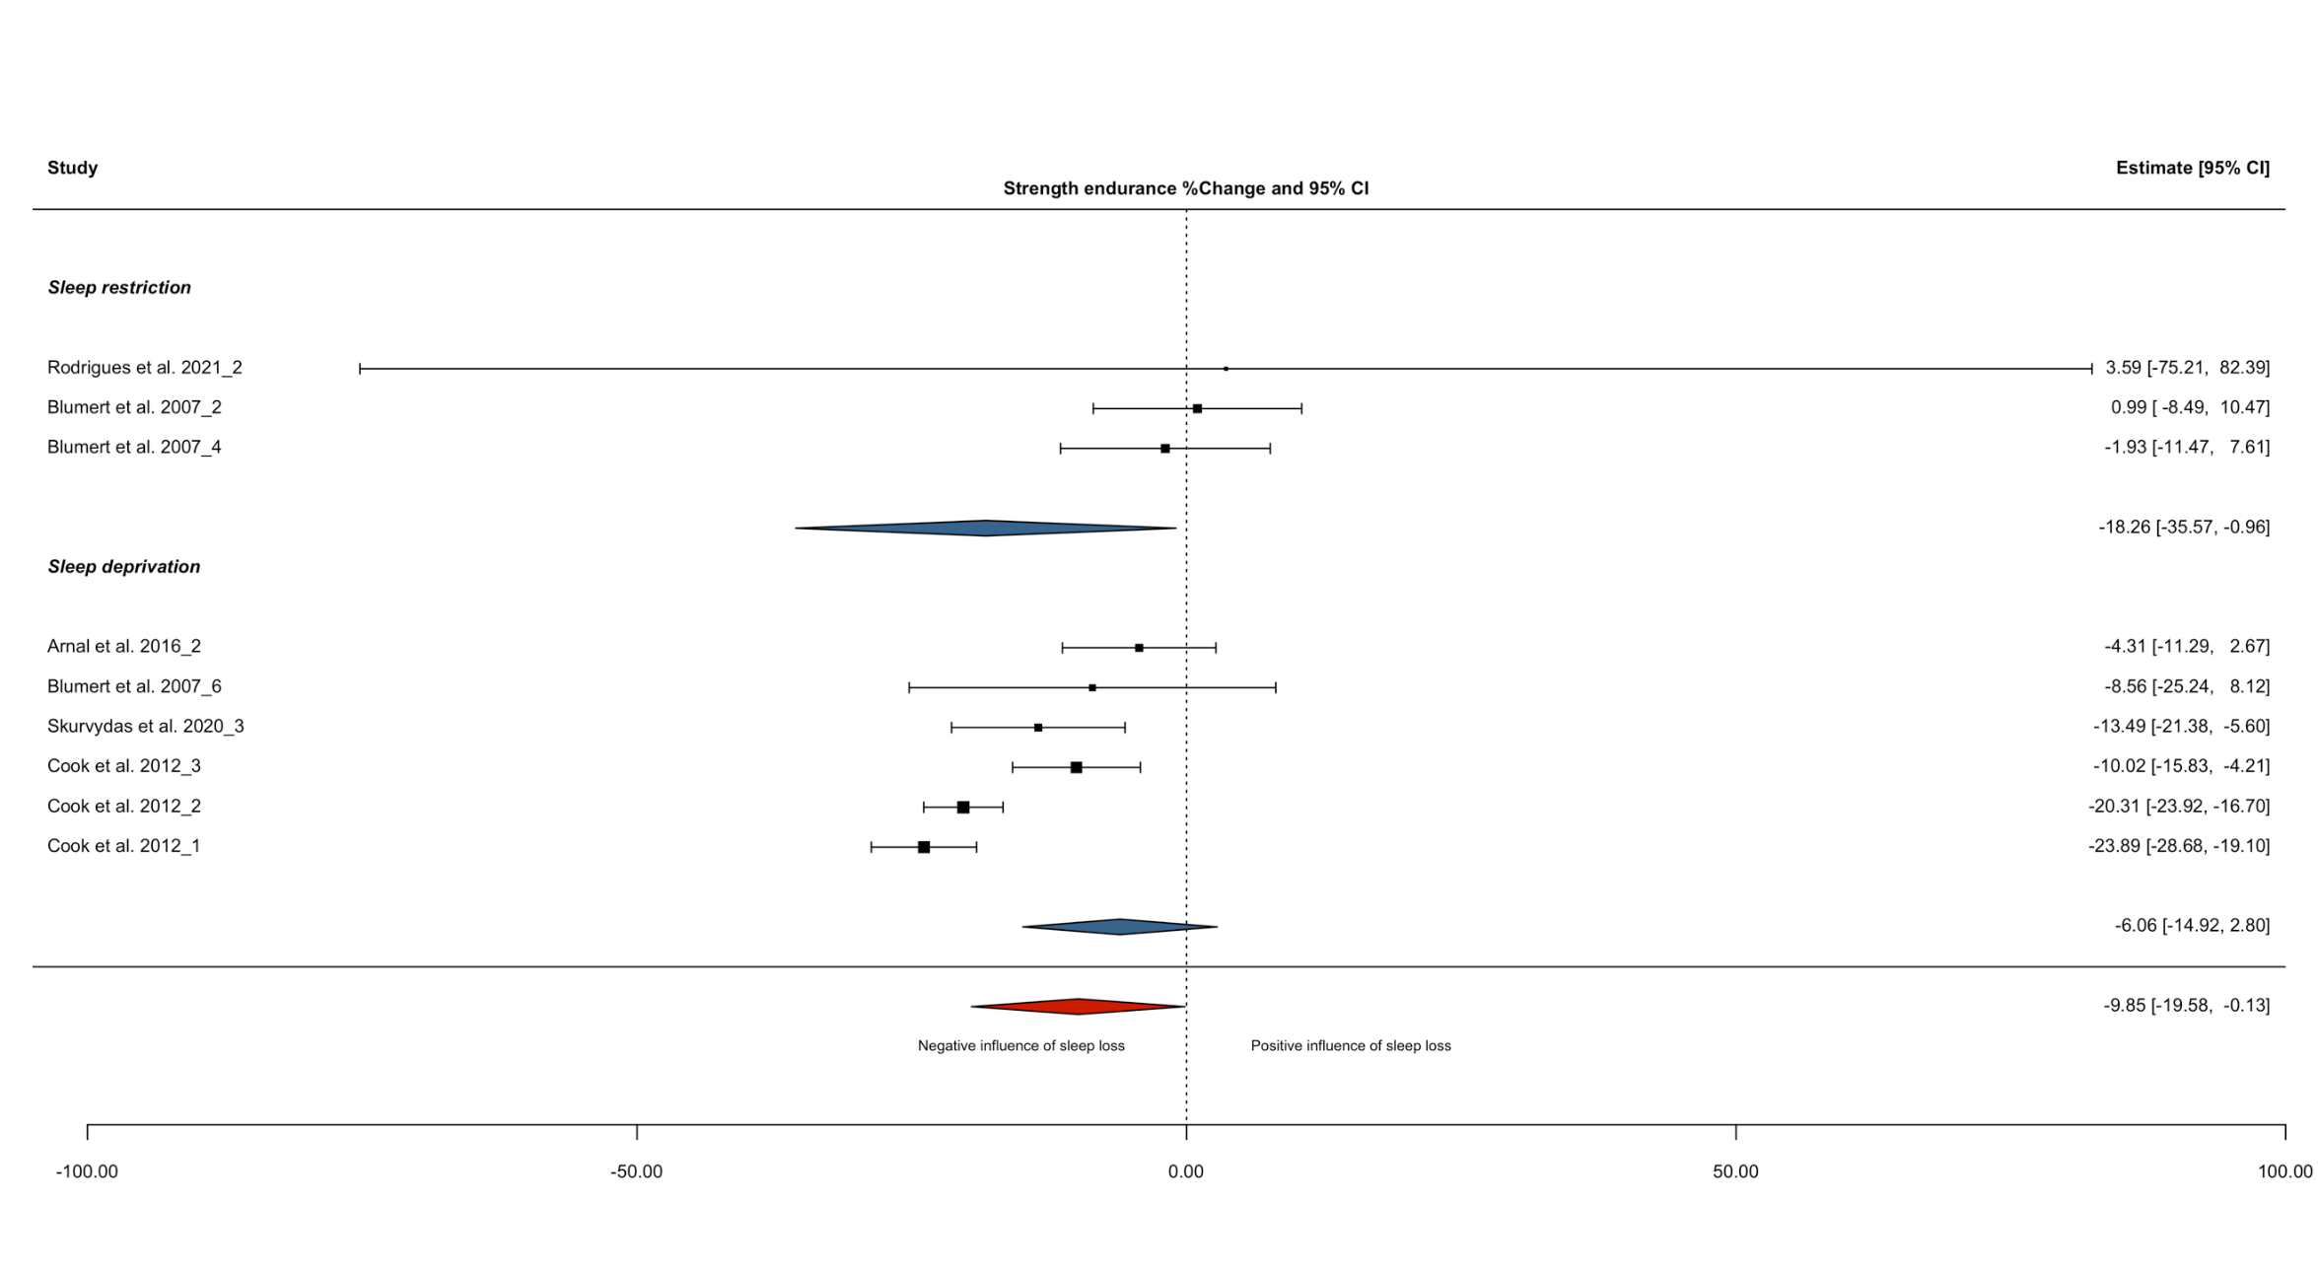
Supplementary Figure S7: Forest plot displaying the effect of sleep loss vs. normal sleep on the percentage change in strength-endurance performance. The size of the squares are proportional to the weight of the study. A negative effect estimate indicates a decrease in strength-endurance performance under the intervention condition (‘sleep loss’). Underscore numerical value (i.e., _1, _2, _3 etc.) identifies the different tasks performed at a given time; studies conducted by the same author in the same year are denoted by the addition of a capital ‘a or ‘b’ (i.e., A, B) to the citation. Deprivation: participants did not sleep for an extended period of time (i.e., whole night); sleep restriction: total sleep time ≤6 h in any 24 h period – this category is sleep restriction protocols not specified.

Supplementary Table S14: Sensitivity analysis of alternative levels of correlation coefficient (R) on strength-endurance performance meta-analysis results
 |  |  | Exercise performance % change |  | Heterogeneity |  |  |  | Sensitivity analysis – one out
Exercise category | Outcomes, n | R | Mean (95% CI) | p | I²-value | p | σ²effect | σ²study | Range (EP%_{Δ}) | CI crossed  (y or n)
Strength-endurance
Overall | 9 | 0.71 | -9.85 (-19.6 to -0.13) | 0.048 | 85.4 | <0.001 | 26.7 | 46.1 | -11.2 to -8.71 | y
 |  | 0.80 | -9.81 (-19.4 to -0.19) | 0.047
 |  | 0.30 | -10.3 (-20.5 to -0.06) | 0.049
Deprivation | 6 | 0.71 | -6.06 (-14.9 to 2.80) | 0.139 | 45.6 | 0.255 | <0.001 | 23.0 | -6.92 to -2.78 | y
 |  | 0.80 | -6.11 (-15.0 to 2.78) | 0.138
 |  | 0.30 | -5.74 (-13.7 to 2.23) | 0.123
Restriction | 3 | 0.71 | -18.3 (-35.6 to -0.96) | 0.045 | 88.3 | 0.001 | 42.6 | <0.001 | -21.7 to -15.4 | y
 |  | 0.80 | -18.2 (-35.7 to -0.77) | 0.046
 |  | 0.30 | -18.5 (-34.9 to -2.22) | 0.039
AM vs. PM
Overall AM | 8 | 0.71 | -11.2 (-23.3 to 0.85) | 0.064 | 87.0 | <0.001 | 27.7 | 56.6 | -12.8 to -10.1 | y
 |  | 0.80 | -11.2 (-23.2 to 0.79) | 0.010
 |  | 0.30 | -11.7 (-24.2 to 0.82) | 0.063
Overall PM | 1
Sleep condition
Deprivation AM | 5 | 0.71 | -7.06 (-22.9 to 8.82) | 0.285 | 60.5 | 0.172 | <0.001 | 53.7 | -8.44 to -1.56 | y
 |  | 0.80 | -7.11 (-23.1 to -8.83) | 0.283
 |  | 0.30 | -6.90 (-22.8 to 8.98) | 0.294
Deprivation PM | 1
Restriction AM | 3 | 0.71 | -18.3 (-35.6 to -0.96) | 0.045 | 88.3 | 0.001 | 42.6 | <0.001 | -21.7 to -15.4 | y
 |  | 0.80 | -18.2 (-35.7 to -0.77) | 0.046
 |  | 0.30 | -18.5 (-34.9 to -2.22) | 0.039
Restriction PM | 0
Definitions: Deprivation: participants did not sleep for an extended period of time (i.e., whole night); restriction: total sleep time ≤6 h in any 24 h period – this category is sleep restriction protocols not specified.

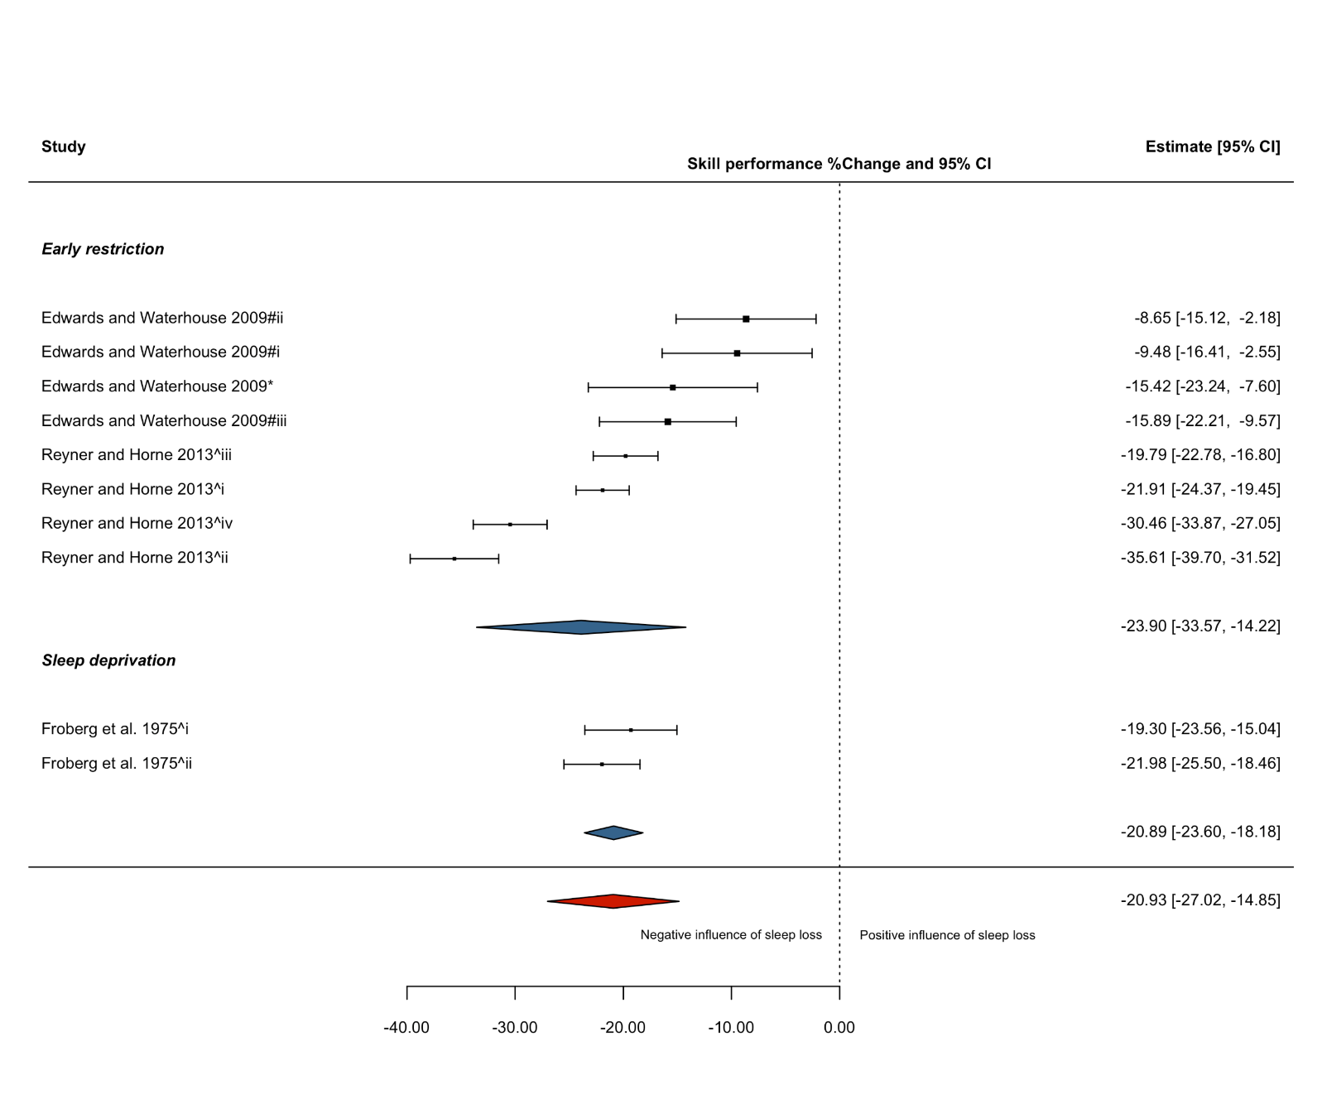
Supplementary Figure S8: Forest plot displaying the effect of sleep loss vs. normal sleep on the percentage change in skill performance. The size of the squares are proportional to the weight of the study. A negative effect estimate indicates a decrease in skill performance under the intervention condition (‘sleep loss’). Individual participant pools from a single study are denoted by the addition of a caret followed by a roman numeral (i.e., ^i, ^ii, ^iii etc.) to the citation; different sleep loss protocols (i.e., deprivation and late-restriction or early-restriction) from a single research study are denoted by the addition of a lower-case letter (i.e., a, b) to the citation; * or # indicates task performed in the AM or PM, respectively. * or # followed by a roman numeral value (i.e., *i, *ii, *iii) indicates that same task was performed at multiple times during AM or PM; underscore numerical value (i.e., _1, _2, _3 etc.) identifies the different tasks performed at a given time. Deprivation: participants did not sleep for an extended period of time (i.e., whole night); restriction: total sleep time ≤6 h in any 24 h period – this category is a combination of early-restriction, late-restriction, fragmented sleep and sleep restriction protocols not specified; Early restriction: participants delayed sleep (i.e., went to sleep at a later time). Note, the trials from Filipas et al. 2021 [109] (late restriction) and Cook et al. 2012 [63] (sleep restriction) are included in overall effect estimate.

Supplementary Table S15: Sensitivity analysis of alternative levels of correlation coefficient (R) on skill performance meta-analysis results
 |  |  | Exercise performance % change |  | Heterogeneity |  |  |  | Sensitivity analysis – one out
Exercise category | Outcomes, n | R | Mean (95% CI) | p | I²-value | p | σ²effect | σ²study | Range (EP%_{Δ}) | CI crossed (y or n)
Skill
Overall | 13 | 0.71 | -20.9 (-27.0 to -14.9) | <0.001 | 94.1 | <0.001 | <0.001 | 66.7 | -22.6 to -19.2 | n
 |  | 0.80 | -20.9 (-27.0 to -14.8) | <0.001
 |  | 0.30 | -21.1 (-27.0 to -15.2) | <0.001
Sleep condition
Deprivation | 2ª | 0.71 | -20.9 (-23.6 to -18.2) | <0.001 | 0.00 | 0.342 |  |  | -22.0 to -19.3 | n
 |  | 0.80 | -20.9 (-23.5 to -18.3) | <0.001
 |  | 0.30 | -20.9 (-25.1 to -16.7) | <0.001
Restriction | 11 | 0.71 | -21.0 (-29.1 to -12.9) | <0.001 | 95.4 | <0.001 | <0.001 | 90.2 | -23.2 to -18.6 | n
 |  | 0.80 | -20.1 (-29.1 to -12.8) | <0.001
 |  | 0.30 | -21.1 (-29.1 to -13.2) | <0.001
Early restriction | 8 | 0.71 | -23.9 (-33.6 to -14.2) | <0.001 | 94.8 | <0.001 | 2.84 | 78.5 | -25.0 to -21.0 | n
 |  | 0.80 | -23.8 (-33.6 to -14.1) | <0.001
 |  | 0.30 | -24.0 (-33.4 to -14.5) | <0.001
Late restriction | 1
AM vs. PM
Overall AM | 4 | 0.71 | -14.2 (-26.7 to -1.68) | 0.037 | 87.0 | <0.001 | <0.001 | 38.6 | -19.2 to -13.5 | y
 |  | 0.80 | -14.1 (-26.2 to -2.10) | 0.033
 |  | 0.30 | -14.6 (-27.2 to -2.07) | 0.034
Overall PM | 9 | 0.71 | -22.9 (-29.7 to -16.0) | <0.001 | 93.8 | <0.001 | 3.67 | 55.6 | -23.4 to -20.8 | n
 |  | 0.80 | -22.8 (-29.7 to -15.8) | <0.001
 |  | 0.30 | -22.9 (-29.7 to -16.2) | <0.001
Sleep condition
Deprivation AM | 0
Deprivation PM | 2ª | 0.71 | -20.9 (-23.6 to -18.2) | <0.001 | 0.00 | 0.342 |  |  | -22.0 to -19.3 | n
 |  | 0.80 | -20.9 (-23.5 to -18.3) | <0.001
 |  | 0.30 | -20.9 (-23.5 to -16.7) | <0.001

Supplementary Table S15: continued
 |  |  | Exercise performance % change |  | Heterogeneity |  |  |  | Sensitivity analysis – one out
 | Outcomes, n | R | Mean (95% CI) | p | I²-value | p | σ²effect | σ²study | Range (EP%_{Δ}) | CI crossed  (y or n)
Restriction AM | 4 | 0.71 | -14.2 (-26.7 to -1.67) | 0.037 | 87.0 | <0.001 | <0.001 | 38.6 | -19.1 to -13.5 | y
 |  | 0.80 | -14.1 (-26.2 to -2.10) | 0.033
 |  | 0.30 | -14.6 (-27.2 to -2.07) | 0.034
Restriction PM | 7 | 0.71 | -23.7 (-34.0 to -13.4) | 0.001 | 95.5 | <0.001 | 4.40 | 82.0 | -24.7 to -20.8 | n
 |  | 0.80 | -23.7 (-34.1 to -13.3) | 0.001
 |  | 0.30 | -23.8 (-33.9 to -13.7) | 0.001
Early restriction AM | 1
Early restriction PM | 7 | 0.71 | -23.7 (-34.0 to 13.4) | 0.001 | 95.5 | <0.001 | 4.40 | 82.0 | -24.7 to -20.8 | n
 |  | 0.80 | -23.7 (-34.1 to -13.3) | 0.001
 |  | 0.30 | -23.8 (-33.9 to -13.7) | 0.001
Late restriction AM | 1
Late restriction PM | 0
Abbreviations/definitions: AM: ante meridiem; PM: post meridiem; Deprivation: participants did not sleep for an extended period of time (i.e., whole night); restriction: total sleep time ≤6 h in any 24 h period – this category is a combination of early-restriction, late-restriction, fragmented sleep and sleep restriction protocols not specified; Early restriction: participants delayed sleep (i.e., went to sleep at a later time); Late restriction; participants awakened earlier than normal. ª All outcomes were from independent studies and meta-analysis was run without dependency levels (i.e., simple meta-analysis).

Title: Effects of acute sleep loss on physical performance: A systematic and meta-analytical review
Journal name: Sports Medicine
Authors: Jonathan Craven, Danielle McCartney, Ben Desbrow, Surendran Sabapathy, Phillip Bellinger, Llion Roberts and Christopher Irwin
Corresponding author:
Jonathan Craven
School of Health Sciences and Social Work, Griffith University, Queensland, Australia, 4222.
Email: jonathan.craven@griffithuni.edu.au

