Main findings of the re-analysis:
Whereas Seitz et al. estimates a correlation between squat ES and sprint ES of -.77, p=.0001, 95% CI: -.847 to -.670, we get r=-0.56, p=.0005, 95% CI: -.75, -.26.

Whereas Seitz. et al. estimate a sprint ES of -0.87 for experimental and 0.02 for control, p<.001 for the difference, we get -0.54 for experimental and -0.01 for control, p=0.007 for the difference.

Detailed findings and code:
For the meta-analysis, we fit a multi-level random effects model with groups nested within studies using the metafor package in R.

- Overall sprint effect size across 14 studies/33 groups: -0.41, p=0.0001, 95% CI: (-0.61, -0.22)
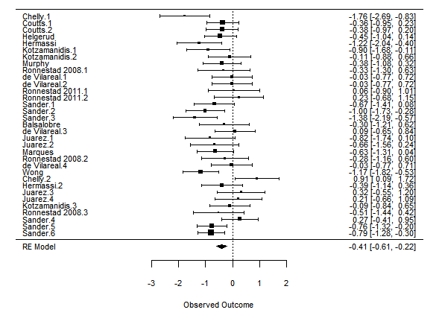
R Code:
#load packages
library(metafor)
library(tidyverse)
library(scales)
library(readxl)

#read data and prepare
data2 <- read_excel('./Supplemental1.xlsx')
head(data2)
labels <- data2$labels

#overall model and forest plot
fit1 <- rma.mv(sprintg,
sprintvarg,
random = ~ 1 |Study/group,
tdist = TRUE,
data = data2,
method = "REML")
summary(fit1)
forest(fit1, slab=labels)

R Output:
Multivariate Meta-Analysis Model (k = 33; method: REML)
logLik Deviance AIC BIC AICc
-25.8109 51.6217 57.6217 62.0189 58.4789
Variance Components:
estim sqrt nlvls fixed factor
sigma^2.1 0.0109 0.1044 14 no Study
sigma^2.2 0.1134 0.3367 33 no Study/group
Test for Heterogeneity:
Q(df = 32) = 60.1415, p-val = 0.0019
Model Results:
estimate se tval pval ci.lb ci.ub
-0.4119 0.0953 -4.3224 0.0001 -0.6061 -0.2178

- Estimates of sprint ES from experimental (n=24) and control groups (n=9).
Control: ES= -0.01, p= 0.95, 95% CI= (-0.37, 0.35)
Experimental ES: -0.54, p=<.0001, 95% CI= (-0.78, -0.30)
P-value for the difference between groups: .0069

R Code:
#model including experimental group as a predictor
fit2 <- rma.mv(sprintg,
sprintvarg,
random = ~ 1 |Study/group,
tdist = TRUE,
data = data2,
method = "REML", mods=isexp)
summary(fit2)
forest(fit2, slab=labels)

R Output:
Multivariate Meta-Analysis Model (k = 33; method: REML)
logLik Deviance AIC BIC AICc
-22.5678 45.1355 53.1355 58.8715 54.6740

Variance Components:

estim sqrt nlvls fixed factor
sigma^2.1 0.0743 0.2725 14 no Study
sigma^2.2 0.0396 0.1990 33 no Study/group

Test for Residual Heterogeneity:
QE(df = 31) = 56.6096, p-val = 0.0033

Test of Moderators (coefficient 2):
F(df1 = 1, df2 = 31) = 8.3912, p-val = 0.0069

Model Results:

estimate se tval pval ci.lb ci.ub
intrcpt -0.0104 0.1766 -0.0590 0.9534 -0.3706 0.3497
mods -0.5313 0.1834 -2.8968 0.0069 -0.9054 -0.1572 *

- Estimate of correlation between squat and sprint effect sizes.

r=-0.56, p=.0005, 95% CI: -.26, -.75
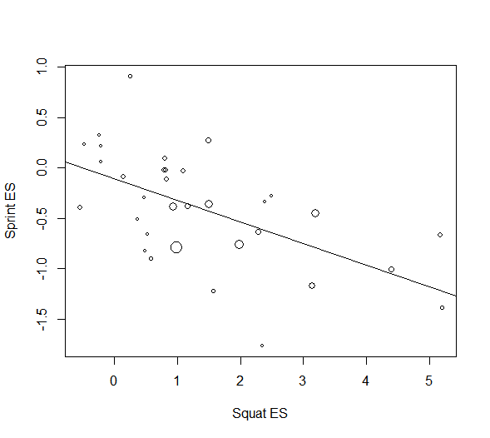

C1. Using multi-level random effects model:
R-squared (from residual heterogeneity) = (60.1415-41.3096)/60.1415=0.313
R=sqrt(.313)=-0.56
p-value = .0005

R code:
fit3 <-rma.mv(sprintg,
sprintvarg,
random = ~ 1 |Study/group,
tdist = TRUE,
data = data2,
method = "REML", mods=squatg)
summary(fit3)
size=rescale(1/data2$sprintvarg,c(0.5,2))
plot(sprintg~squatg,data=data2,cex=size, xlab="Squat ES",
ylab="Sprint ES")
abline(lm(data2$sprintg ~ data2$squatg))

corr=-sqrt((fit1$QE-fit3$QE)/fit1$QE)
print(corr)

R output:
Multivariate Meta-Analysis Model (k = 33; method: REML)

logLik Deviance AIC BIC AICc
-19.2430 38.4859 46.4859 52.2219 48.0244
Variance Components:

estim sqrt nlvls fixed factor
sigma^2.1 0.0000 0.0000 14 no Study
sigma^2.2 0.0443 0.2104 33 no Study/group

Test for Residual Heterogeneity:
QE(df = 31) = 41.3096, p-val = 0.1021
Test of Moderators (coefficient 2):
F(df1 = 1, df2 = 31) = 15.0395, p-val = 0.0005
Model Results:
estimate se tval pval ci.lb ci.ub
intrcpt -0.1213 0.1089 -1.1142 0.2737 -0.3434 0.1007
mods -0.2043 0.0527 -3.8781 0.0005 -0.3118 -0.0969

[1] -0.5595766

C2. Using bivariate random effects model (technically this is more correct because it incorporates the within-study variance for both squat ES and sprint ES, not just sprint ES, but it depends on our estimate of within-study correlation). We get in the same ballpark as above, giving us reassurance that our estimate is reasonable:
Assuming within-study correlation of 0.2: -.45
Assuming within-study correlation of 0.5: -.51
Assuming within-study correlation of 0.8: -.57

R code:
library(metaSEM)

#Add covariances assuming three different within-study correlations
data2$cov1=0.2*sqrt(data2$sprintvarg)*sqrt(data2$squatvarg)
data2$cov2=0.5*sqrt(data2$sprintvarg)*sqrt(data2$squatvarg)
data2$cov3=0.8*sqrt(data2$sprintvarg)*sqrt(data2$squatvarg)

#Run bivariate random effects models assuming different covariance structures
fita <- meta(y=cbind(sprintg, squatg),
v=cbind(sprintvarg, cov1, squatvarg),
data=data2,
model.name="Multi MA")
summary(fita)
VarCorr(fita)
fitb <- meta(y=cbind(sprintg, squatg),
v=cbind(sprintvarg, cov2, squatvarg),
data=data2,
model.name="Multi MA")
summary(fitb)
VarCorr(fitb)
fitc <- meta(y=cbind(sprintg, squatg),
v=cbind(sprintvarg, cov3, squatvarg),
data=data2,
model.name="Multi MA")
summary(fitc)
VarCorr(fitc)

R output:

Number of studies (or clusters): 33
Number of observed statistics: 66
Number of estimated parameters: 5
Degrees of freedom: 61
-2 log likelihood: 155.2282
OpenMx status1: 0 ("0" or "1": The optimization is considered fine.
Other values may indicate problems.)
> VarCorr(fita)
[,1] [,2]
[1,] 0.1341394 -0.4491071
[2,] -0.4491071 1.6021

Number of studies (or clusters): 33
Number of observed statistics: 66
Number of estimated parameters: 5
Degrees of freedom: 61
-2 log likelihood: 155.6512
OpenMx status1: 0 ("0" or "1": The optimization is considered fine.
Other values may indicate problems.)
> VarCorr(fitb)
[,1] [,2]
[1,] 0.1485469 -0.5130042
[2,] -0.5130042 1.6311512

Number of studies (or clusters): 33
Number of observed statistics: 66
Number of estimated parameters: 5
Degrees of freedom: 61
-2 log likelihood: 156.2731
OpenMx status1: 0 ("0" or "1": The optimization is considered fine.
Other values may indicate problems.)
> VarCorr(fitc)
[,1] [,2]
[1,] 0.1641595 -0.5748028
[2,] -0.5748028 1.6715426

