Online Resource 5
Title: Heat Adaptation for Females: A Systematic Review and Meta-Analysis of Physiological Adaptations and Exercise Performance in the Heat.
Journal: Sports Medicine.
Authors: Monica K. Kelly¹*, Steven J. Bowe^{2,3}, William T. Jardine¹, Dominique Condo¹, Joshua H. Guy⁴, Rodney J. Snow⁵, and Amelia J. Carr¹
¹ Centre for Sport Research, Deakin University, 221 Burwood Highway, Burwood, VIC, 3125, Australia
² Deakin Biostatistics Unit, Faculty of Health, Deakin University, 221 Burwood Highway, Burwood, VIC, 3125, Australia
³ Faculty and School of Health, Victoria University of Wellington, Kelburn Parade, Kelburn, Wellington, 6140, New Zealand
⁴ School of Health, Medical and Applied Sciences, Central Queensland University, Cairns, QLD, Australia
⁵ Institute for Physical Activity and Nutrition, Deakin University, 221 Burwood Highway, Burwood, VIC, 3125, Australia
Corresponding author: Monica Kelly (monica.kelly@research.deakin.edu.au)

Electronic Supplementary Material Appendix S5. Risk of bias plots for publication bias

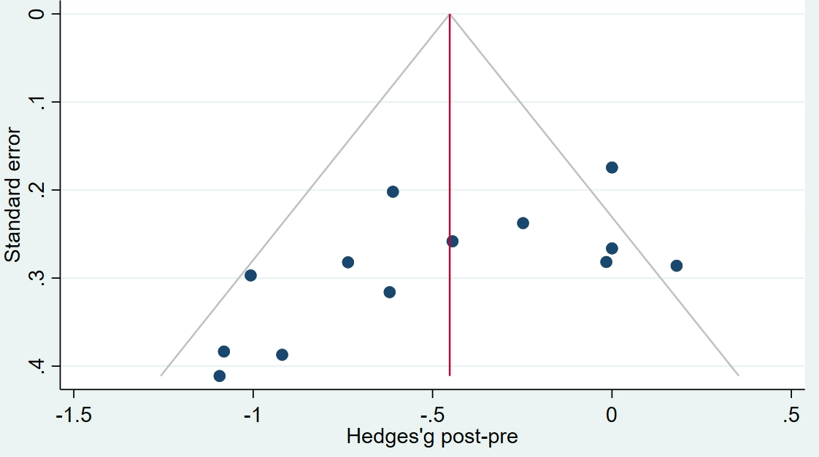Fig. S1 Risk of bias plot for measures of resting core temperature

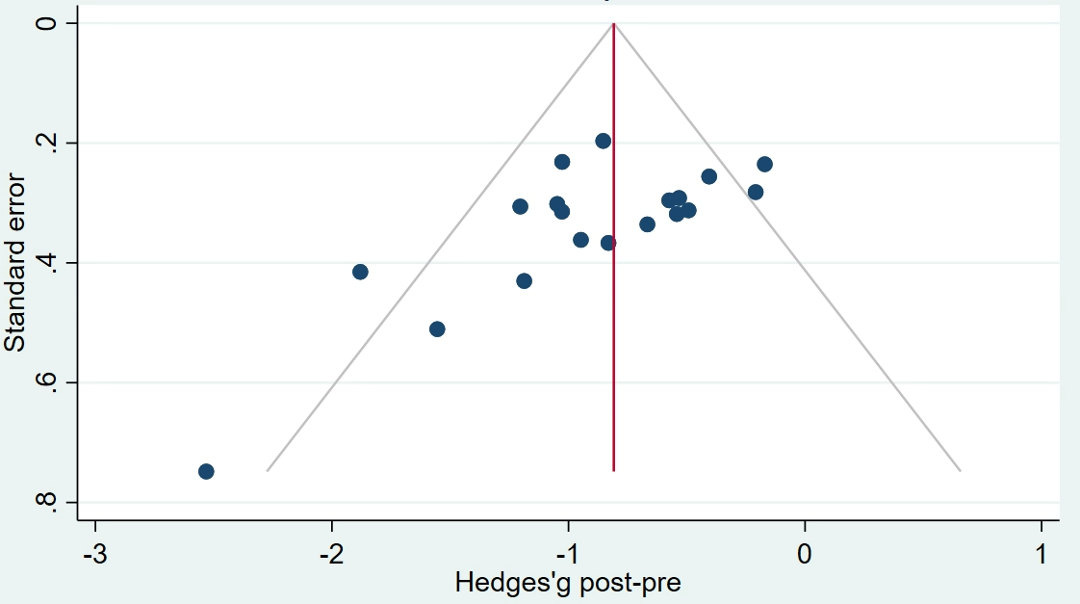
Fig. S2 Risk of bias plot for measures of exercise core temperature

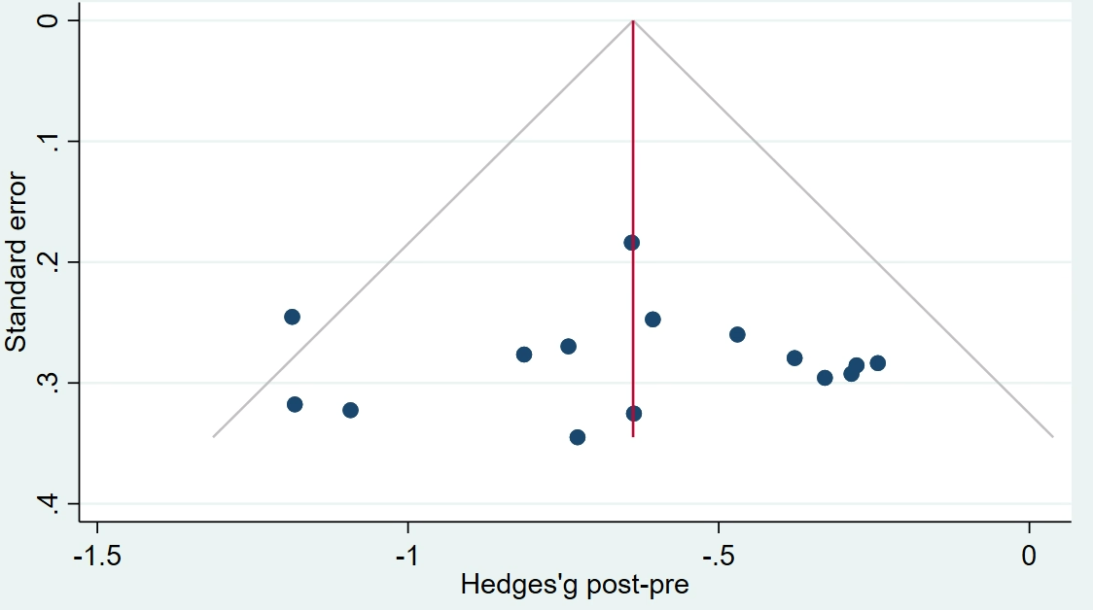
Fig. S3 Risk of bias plot for measures of skin temperature

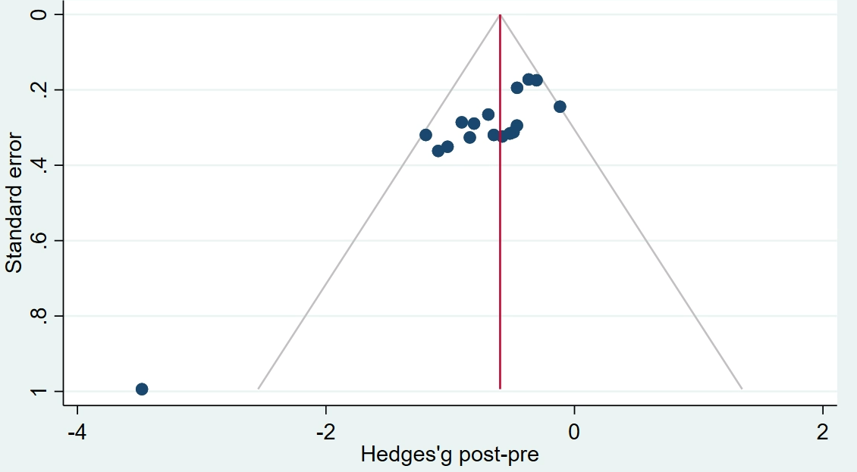
Fig. S4 Risk of bias plot for measures of heart rate

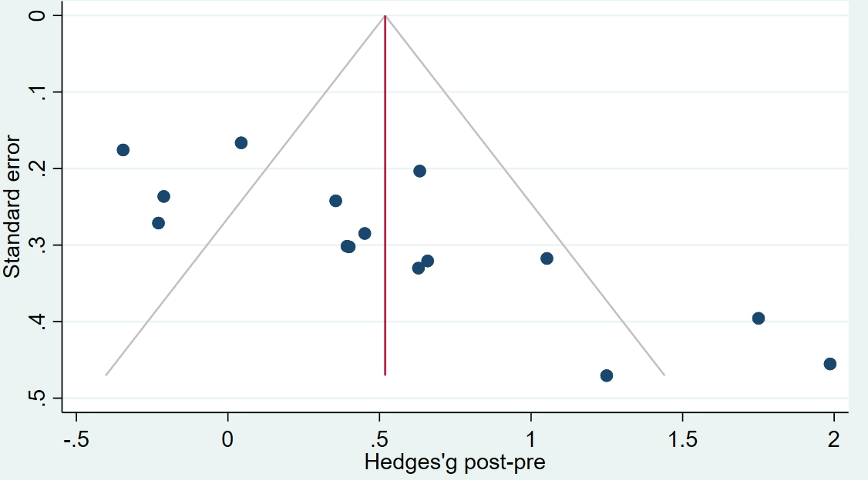
Fig. S5 Risk of bias plot for measures of sweat rate

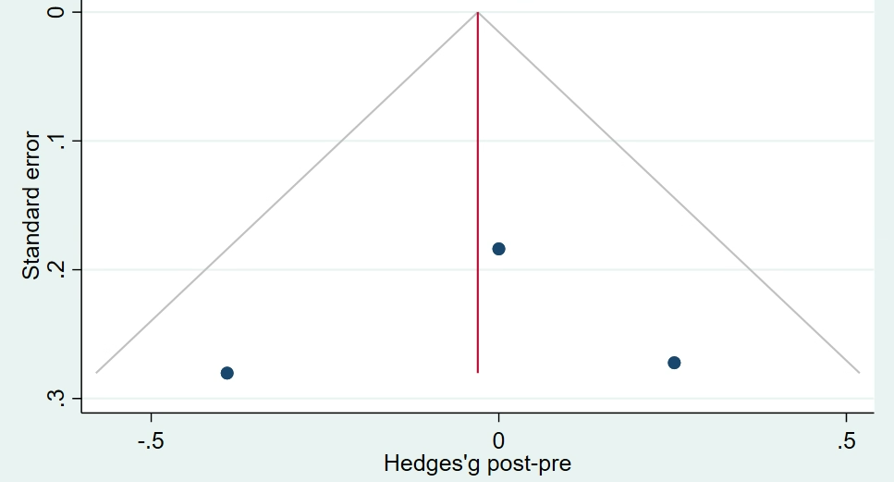
Fig. S6 Risk of bias plot for measures of plasma volume

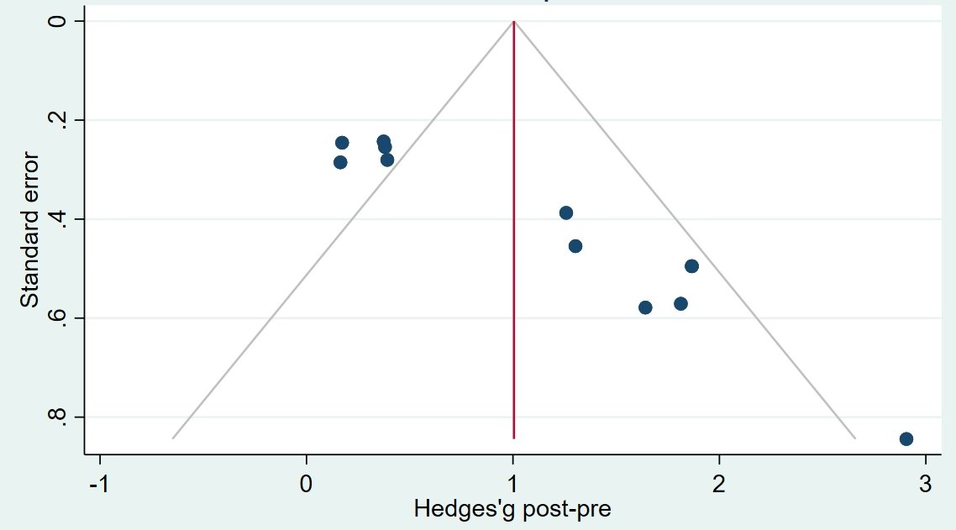
Fig. S7 Risk of bias plot for performance

