Online Resource 7
Title: Heat Adaptation for Females: A Systematic Review and Meta-Analysis of Physiological Adaptations and Exercise Performance in the Heat.
Journal: Sports Medicine.
Authors: Monica K. Kelly¹*, Steven J. Bowe^{2,3}, William T. Jardine¹, Dominique Condo¹, Joshua H. Guy⁴, Rodney J. Snow⁵, and Amelia J. Carr¹
¹ Centre for Sport Research, Deakin University, 221 Burwood Highway, Burwood, VIC, 3125, Australia
² Deakin Biostatistics Unit, Faculty of Health, Deakin University, 221 Burwood Highway, Burwood, VIC, 3125, Australia
³ Faculty and School of Health, Victoria University of Wellington, Kelburn Parade, Kelburn, Wellington, 6140, New Zealand
⁴ School of Health, Medical and Applied Sciences, Central Queensland University, Cairns, QLD, Australia
⁵ Institute for Physical Activity and Nutrition, Deakin University, 221 Burwood Highway, Burwood, VIC, 3125, Australia
Corresponding author: Monica Kelly (monica.kelly@research.deakin.edu.au)
Electronic Supplementary Material Appendix S7.
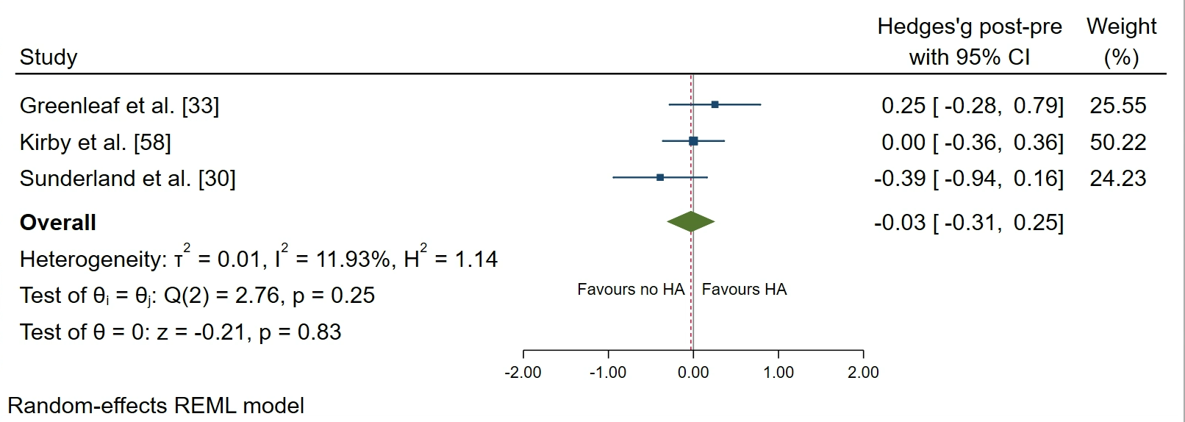
Fig. S1 Plasma volume forest plot. Data are presented as Hedges’ g and 95% confidence intervals. Effects to the left of 0 (solid line) indicate a reduction in plasma volume, whereas effects to the right of 0 indicate an increase in plasma volume with heat adaptation regimens. The red dotted line indicates the effect line of included studies within the Forest plot

