Online supplementary file S6 Additional figures

Figure S1. Random-effects meta-analysis of the correlation between vertical oscillation and running economy. Positive correlations indicate that higher vertical oscillation is associated with a higher oxygen or energy cost of running or that lower vertical oscillation is associated with a lower oxygen or energy cost (i.e., higher is higher or lower is lower), while negative correlations indicate that a lower vertical oscillation is associated with a higher oxygen or energy cost or that a higher vertical oscillation is associated with lower oxygen or energy cost (i.e., higher is lower or lower is higher). Note that the correlation coefficients are depicted on a non-linear scale to ensure symmetric confidence intervals after the back transformation procedure. CI = confidence interval; COM = center of mass; abs. = absolute; norm. = normalized to height
Figure S2. Random-effects meta-analysis of the correlation between vertical stiffness and running economy. Positive correlations indicate that a higher vertical stiffness is associated with a higher oxygen or energy cost of running or that lower stiffness is associated with a lower oxygen or energy cost (i.e., higher is higher or lower is lower), while negative correlations indicate that a lower vertical stiffness is associated with a higher oxygen or energy cost or that a higher vertical stiffness is associated with lower oxygen or energy cost (i.e., higher is lower or lower is higher). Note that the correlation coefficients are depicted on a non-linear scale to ensure symmetric confidence intervals after the back transformation procedure. CI confidence interval.
Figure S3. Random-effects meta-analysis of the correlation between leg stiffness and running economy. Positive correlations indicate that a higher leg stiffness is associated with a higher oxygen or energy cost of running or that lower leg stiffness is associated with a lower oxygen or energy cost (i.e., higher is higher or lower is lower), while negative correlations indicate that a lower leg stiffness is associated with a higher oxygen or energy cost or that a higher leg stiffness is associated with lower oxygen or energy cost (i.e., higher is lower or lower is higher). Note that the correlation coefficients are depicted on a non-linear scale to ensure symmetric confidence intervals after the back transformation procedure. CI confidence interval.

Figure S4. Random-effects meta-analysis of the correlation between ankle angle at toe-off and running economy. Positive correlations indicate that a more plantar flexed ankle at toe-off is associated with a higher oxygen or energy cost of running or that smaller plantar flexed ankle at toe-off is associated with a lower oxygen or energy cost (i.e., higher is higher or lower is lower), while negative correlations indicate that a smaller plantar flexed ankle at toe-off is associated with a higher oxygen or energy cost or that a larger plantar flexed ankle at toe-off is associated with lower oxygen or energy cost (i.e., higher is lower or lower is higher). Note that the correlation coefficients are depicted on a non-linear scale to ensure symmetric confidence intervals after the back transformation procedure. CI confidence interval.

Figure S5. Random-effects meta-analysis of the correlation between peak knee angle during stance and running economy. Positive correlations indicate that higher peak knee flexion during stance is associated with a higher oxygen or energy cost of running or that smaller peak knee flexion during stance is associated with a lower oxygen or energy cost (i.e., higher is higher or lower is lower), while negative correlations indicate that a smaller peak knee flexion during stance is associated with a higher oxygen or energy cost or that a larger peak knee flexion during stance is associated with lower oxygen or energy cost (i.e., higher is lower or lower is higher). Note that the correlation coefficients are depicted on a non-linear scale to ensure symmetric confidence intervals after the back transformation procedure. CI confidence interval.

Figure S6. Random-effects meta-analysis of the correlation between hip angle at footstrike and running economy. Positive correlations indicate that higher hip flexion at footstrike is associated with a higher oxygen or energy cost of running or that smaller hip flexion at footstrike is associated with a lower oxygen or energy cost (i.e., higher is higher or lower is lower), while negative correlations indicate that a smaller hip flexion at footstrike is associated with a higher oxygen or energy cost or that a larger hip flexion at footstrike is associated with lower oxygen or energy cost (i.e., higher is lower or lower is higher). Note that the correlation coefficients are depicted on a non-linear scale to ensure symmetric confidence intervals after the back transformation procedure. CI confidence interval.
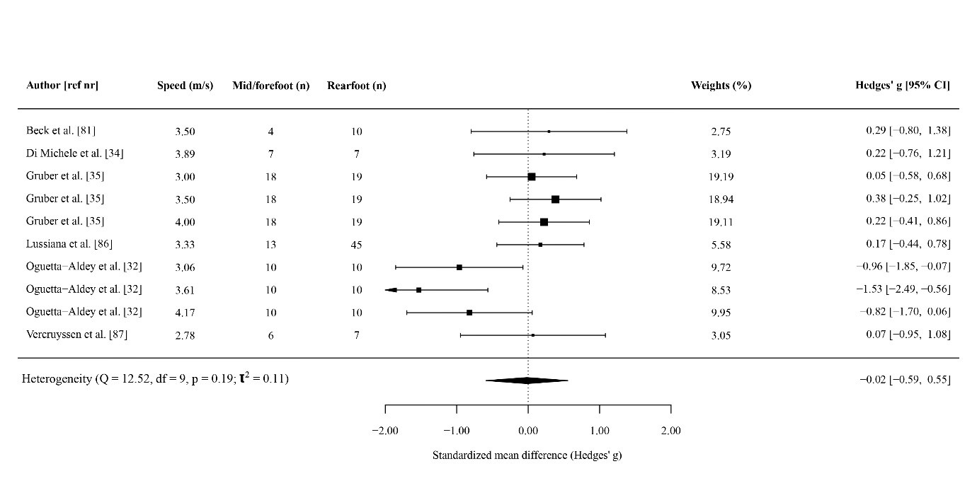
Figure S7. Random-effects meta-analysis of the difference in running economy between rearfoot and non-rearfoot strikers. Note that the units are standardized mean differences as opposed to correlation coefficients. Positive values indicate a higher energy cost for rearfoot strikers. CI confidence interval.

