Online Resource 3
Title: Comparison of Polarized vs Other Types of Endurance Training Intensity Distribution on Athletes Endurance Performance: A Systematic Review with Meta-Analysis
Journal: Sports Medicine.
Authors: Pedro Oliveira^{1,2}, Giorjines Boppre^{1,2,3}, Hélder Fonseca^{1,2}
¹ Research Centre in Physical Activity, Health and Leisure (CIAFEL), Faculty of Sport, University of Porto, Portugal
² Laboratory for Integrative and Translational Research in Population Health (ITR), Porto, Portugal
³ Human Motricity Research Center, University Adventista, Chillan, Chile
Corresponding author: Pedro Oliveira (up201807240@fade.up.pt)

Electronic Supplementary Material Appendix S3. Sensitivity analysis

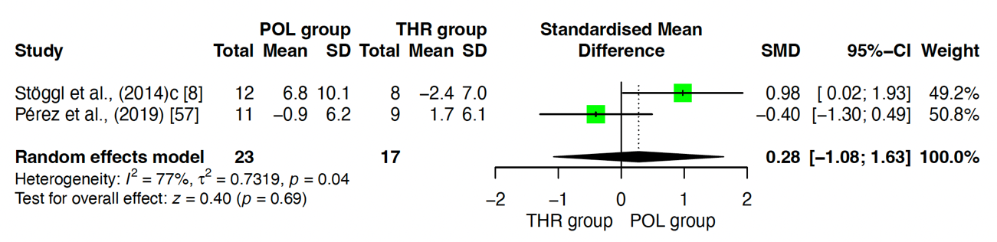
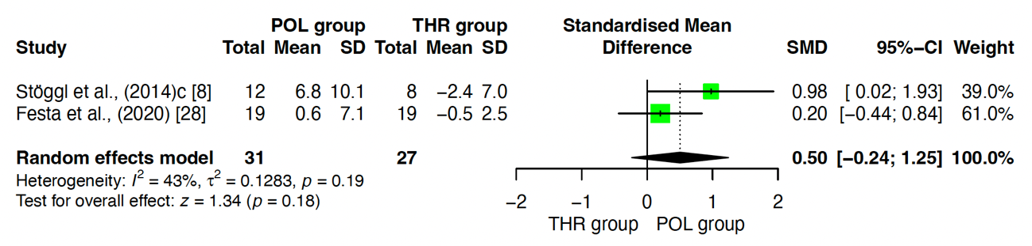
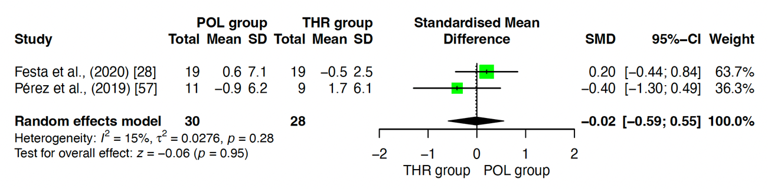
a*
b*
c*

Fig. S1 Sensitivity analysis of POL vs THR regarding VO₂peak

Note: A sensitivity analysis for this comparison was performed by removing one study at a time. The study that was shown to contribute the most to heterogeneity was the one by Stoggl et al., (2014)c [7]. Nevertheless, removal of this study did not affect the results (p= 0.95), c*.

