Supplementary material
Table S1. Search strategy used in Web of Science and PubMed.
("Diabetes 1" OR "diabetes type 1" OR "type 1 diabetes" OR T1D) AND ("glycemic parameter" OR glycemic OR glycaemia OR glycemia OR "glycemic variability" OR "glycemic control" OR "blood-sugar" OR "cardiorespiratory fitness" OR "cardiopulmonary fitness" OR "cardiovascular fitness" OR fitness OR exercise OR CRF OR VO2max OR VO2peak OR "maximal oxygen consumption") AND (HIIT OR "high-intensity interval training" OR high-intensity OR interval training AND effect* OR intervention*) NOT "diabetes type 2" NOT "type 2 diabetes" NOT "diabetes 2" NOT review NOT animal NOT cancer

Table S2. PEDro scores of included studies.
 | Criterion
Study | 1 | 2 | 3 | 4 | 5 | 6 | 7 | 8 | 9 | 10 | 11 | ∑ | Qualitative evaluation
Alarcón-Gómez et al. [27] | Y | Y | Y | Y | N | N | N | N | Y | Y | Y | 6 | Good
Boff et al. [25] | Y | Y | Y | Y | N | Y | Y | N | Y | Y | Y | 8 | Good
Farinha et al. [29] | Y | Y | Y | Y | N | N | Y | Y | Y | Y | Y | 8 | Good
Lee et al. [31] | Y | Y | Y | Y | N | N | N | Y | Y | Y | Y | 7 | Good
Marin-San Agustin et al. [41] | Y | N | N | N | N | N | N | Y | Y | Y | Y | 4 | Fair
Minnebeck et al. [32] | Y | N | N | Y | N | N | N | Y | Y | Y | Y | 5 | Fair
Murillo et al. [40] | Y | Y | Y | Y | N | N | N | Y | Y | Y | Y | 7 | Good
Scott et al. [26] | Y | Y | Y | Y | N | N | N | Y | Y | Y | Y | 7 | Good
Scott et al. [42] | Y | N | N | Y | N | N | N | Y | Y | N | Y | 4 | Fair
Zinn et al. [28] | Y | N | N | N | N | N | N | Y | Y | Y | Y | 6 | Good
Criterion 1—eligibility criteria; 2—random allocation; 3—concealed allocation; 4—baseline comparability; 5—blind subject; 6—blind clinician; 7—blind assessor; 8—adequate follow-up; 9—intention-to-treat analysis; 10—between-group analysis; 11 —point estimates and variability; Y—criterion is satisfied; N—criterion is not satisfied; ∑—total awarded points.

Table S3. Meta-regression of changes in cardiorespiratory fitness.
Covariate | Coefficient  (β) | 95% CI | Standard error | p value
Intervention duration (weeks) | -0.022 | -0.115 to 0.072 | 0.048 | 0.646
Session duration (min) | 0.011 | -0.027 to 0.049 | 0.019 | 0.566
Work time (s) | -0.002 | -0.006 to 0.003 | 0.002 | 0.445
Rest time (s) | 0.001 | -0.003 to 0.005 | 0.002 | 0.631
Number of bouts | 0.004 | -0.055 to 0.063 | 0.030 | 0.895
Intensity | 0.005 | -0.033 to 0.043 | 0.019 | 0.791
β – beta coefficient; 95% CI – confidence interval.

Table S4. Meta-regression of changes in glycated hemoglobin (HbA1C).
Covariate | Coefficient  (β) | 95% CI | Standard error | p value
Intervention duration (weeks) | 0.012 | -0.100 to 0.124 | 0.057 | 0.837
Session duration (min) | 0.007 | -0.040 to 0.055 | 0.024 | 0.769
Work time (s) | 0.004 | -0.005 to 0.014 | 0.005 | 0.407
Rest time (s) | 0.001 | -0.004 to 0.006 | 0.002 | 0.741
Number of bouts | -0.017 | -0.124 to 0.090 | 0.055 | 0.757
Intensity | -0.001 | -0.050 to 0.047 | 0.025 | 0.953
β – beta coefficient; 95% CI – confidence interval.

Table S5. Meta-regression of changes in 24-h mean glucose.
Covariate | Coefficient  (β) | 95% CI | Standard error | p value
Intervention duration (weeks) | -0.035 | -0.134 to 0.064 | 0.051 | 0.488
Session duration (min) | -0.013 | -0.040 to 0.067 | 0.028 | 0.624
Work time (s) | -0.002 | -0.006 to 0.003 | 0.002 | 0.457
Rest time (s) | -0.001 | -0.007 to 0.006 | 0.003 | 0.900
Number of bouts | 0.041 | -0.059 to 0.141 | 0.051 | 0.421
Intensity | 0.013 | -0.040 to 0.067 | 0.027 | 0.624
β – beta coefficient; 95% CI – confidence interval.

Table S6. Meta-regression of changes in fasting glucose.
Covariate | Coefficient  (β) | 95% CI | Standard error |  | p value
Intervention duration (weeks) | 0.064 | -0.236 to 0.365 | 0.153 | 0.675
Session duration (min) | -0.001 | -0.073 to 0.070 | 0.036 | 0.969
Work time (s) | 0.012 | -0.022 to 0.046 | 0.017 | 0.497
Rest time (s) | 0.002 | -0.004 to 0.008 | 0.003 | 0.507
Number of bouts | -0.032 | -0.114 to 0.051 | 0.042 | 0.453
Intensity | -0.023 | -0.148 to 0.101 | 0.064 | 0.715
β – beta coefficient; 95% CI – confidence interval

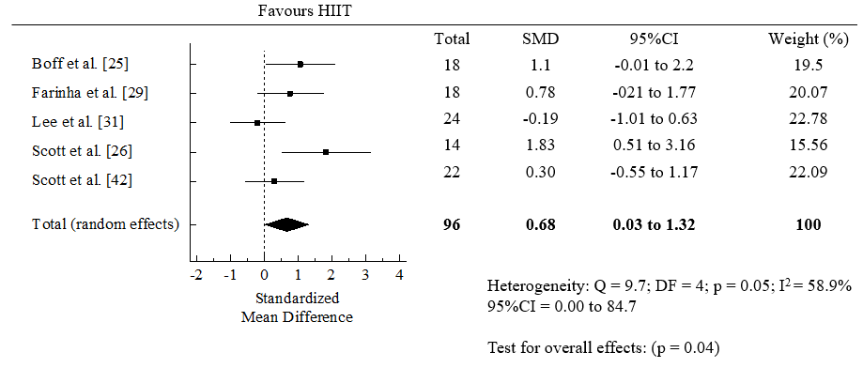
Figure S1. Forest plot for change in cardiorespiratory fitness measured by peak oxygen uptake (VO_{2peak}, ml/kg/min) before and after (within-group) high-intensity interval training (HIIT).
CI: confidence intervals; DF: degree of freedom; SMD: standardized mean difference.

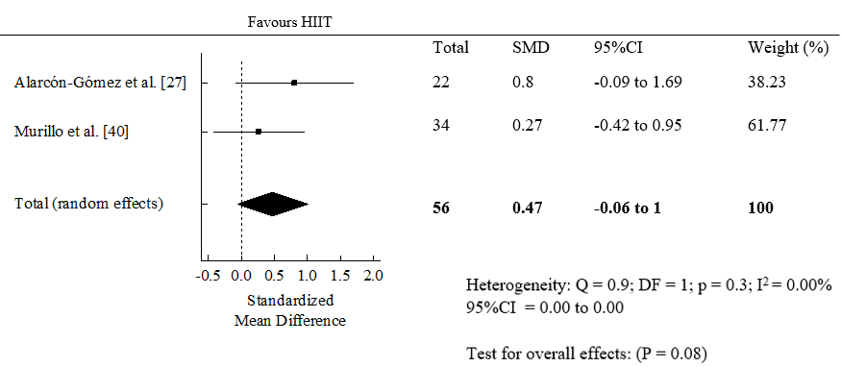

Figure S2. Forest plot for change in cardiorespiratory fitness measured by maximum oxygen uptake (VO_{2max}, ml/kg/min) before and after (within-group) high-intensity interval training (HIIT).
CI: confidence intervals; DF: degree of freedom; SMD: standardized mean difference.

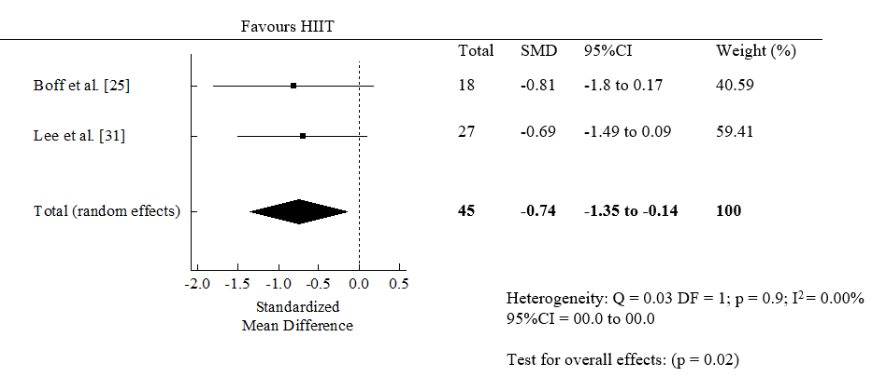
Figure S3. Forest plot for change in glycated hemoglobin (HbA1C) between high-intensity interval training (HIIT) and control groups.
CI: confidence intervals; DF: degree of freedom; SMD: standardized mean difference.

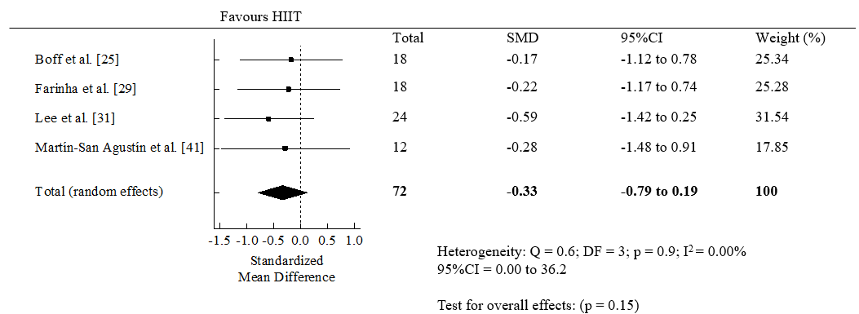

Figure S4. Forest plot of within-group effect (> 8 weeks of intervention) of high-intensity interval training (HIIT) on glycated hemoglobin (HbA1C).
CI: confidence intervals; DF: degree of freedom; SMD: standardized mean difference.

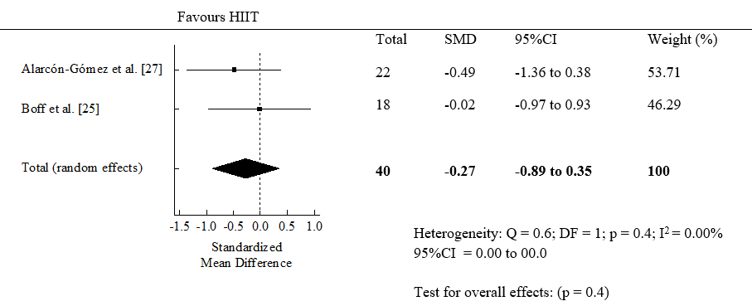
Figure S5. Forest plot for change in fasting glucose between high-intensity interval training (HIIT) and control groups.
CI: confidence intervals; DF: degree of freedom; SMD: standardized mean difference.

