Article title: Associations Between Instrumented Mouthguard-Measured Head Acceleration Events and Post-Match Biomarkers of Astroglial and Axonal Injury in Male Amateur Australian Football Players

Journal name: Sports Medicine

Authors: Lauren J. Evans*¹, William T. O’Brien*¹, Gershon Spitz^{1,2}, Steven Mutimer¹, Becca Xie¹, Lauren P. Giesler¹, Brendan P. Major¹, James W. Hickey¹, Spencer S. H. Roberts³, Biswadev Mitra^{4,5}, Terence J. O’Brien^{1,6,7}, Sandy R. Shultz^{1,6, 8}, Stuart J. McDonald^^{1, 6}
Affiliations:
1 Department of Neuroscience, Central Clinical School, Monash University, 99 Commercial Road, Melbourne, VIC, Australia
2 Monash-Epworth Rehabilitation Research Centre, School of Psychological Sciences, Monash University, Clayton, VIC, Australia
3 School of Exercise and Nutrition Sciences, Deakin University, Burwood, VIC, Australia
4 Emergency & Trauma Centre, The Alfred Hospital, Melbourne, VIC, Australia
5 School of Public Health and Preventive Medicine, Monash University, Melbourne, VIC, Australia
6 Department of Neurology, The Alfred Hospital, Melbourne, VIC, Australia
7 Department of Medicine, Royal Melbourne Hospital, The University of Melbourne, Parkville, VIC, Australia
8 Centre for Trauma & Mental Health Research, Vancouver Island University, Nanaimo, BC, Canada
* Co-first authors ^ Corresponding author
Corresponding Author: Stuart J. McDonald, Department of Neuroscience, Central Clinical School, Monash University, 99 Commercial Road, Melbourne, VIC, 3004, Australia. Phone: +61 3 9903 0203; Fax: +61 3 9903 0843; E-mail: stuart.mcdonald@monash.edu

2022 | Apr  2 | Apr  9 | Apr 23 | Apr  30 | May 7 | May 14 | May  21 | May  28 | Jun  4 | Jun  11 | Jun  18 | Jun 25 | Jul  2 | Jul  9 | Jul  16 | Jul  23 | Jul  30 | Aug  6 | Aug  13 | Aug  20 | Aug  27 | Sept 3 | Sept 10 | Sept 17
P1 |  |  | MG | MG | MG | MG | MG |  | MG |  | MG | MG |  |  | MG | MG |  | MG | W
P2 | P | P | MG | MG | MG | MG |  |  |  |  | MG
P3 | P | P | MG | MG | MG | MG | MG |  | MG |  | MG | MG |  |  | MG | MG |  | MG | MG | MG |  | MG | MG | MG
P4 | P | P | MG | MG | MG | P | MG |  | MG |  |  |  |  |  |  |  |  | MG
P5 | P | P | MG | MG | MG |  | MG |  |  |  |  |  |  |  |  |  |  |  | MG | MG | MG
P6 | P | P | MG | MG | MG | MG | MG | MG | MG |  | MG | MG |  |  | MG | MG |  | MG | MG |  | MG
P7 | P | P | MG | P | MG | P | MG | MG | MG |  | MG | MG |  |  | MG |  |  |  |  |  | MG
P8 | P | P | MG | MG | W
P9 | P | P | MG | MG |  |  | MG |  | MG |  | MG | P
P10 | P | P | MG | MG | MG | P | MG | MG | MG |  | MG | MG |  |  | MG | MG | MG | MG | MG |  | MG
P11 | P | P | MG | MG | MG | MG | MG | MG | MG |  | MG |  |  |  | MG | MG | MG | MG | MG | P | MG
P12 | P | P |  | MG | P | MG | MG | MG | MG |  | MG | MG |  |  | MG | MG | MG | P | MG | P | MG
P13 | P | P |  |  | MG | MG | MG | MG |  |  |  |  |  |  | MG | MG | MG | MG | MG | P | P
P14 |  |  |  |  | MG | MG | MG |  | MG |  | MG | MG |  |  | MG | MG |  | MG | MG |  | MG
P15 |  | P | MG | MG | MG | MG |  | MG | MG |  | MG | MG |  |  | MG | MG |  |  | MG |  |  | MG | MG | MG
P16 | P | P | P | MG | MG | MG | MG |  | MG |  | MG | MG |  |  | MG | MG |  | MG | MG | MG | MG
P17 | P | P | MG |  | MG | MG | MG | W
P18 | P | P |  |  | P | P | P | P | P |  | P | P | P |  | P |  |  |  | P | P
P19 |  | P | P | P | P | P | P |  | P |  | P | P |  |  | P | P | P | P |  | P
P20 | P | P | P | P |  | P | P | P | P |  | P | P |  |  | P | P | P | P | P | P
P21 |  |  |  |  |  | MG | MG |  | MG |  | MG | MG |  |  | MG | MG |  | MG | MG | MG | MG | MG | MG | MG
P22 | P | P | P | P | P | P | P | P | P |  | P | P | P |  | P | P | P | P | P | P
P23 | P | P | P |  | P | P |  | P | P |  | P |  | P |  |  | P | P |  | P
P24 |  |  |  |  |  |  |  | P | P |  | P |  |  |  |  | P | P | P | P | P | P
P25 | P | P |  | P |  | P | MG | MG | MG |  | MG |  |  |  |  | MG | MG | MG | MG | P | MG
P26 |  |  |  |  |  |  | MG |  | MG |  | MG |  |  |  |  |  |  | MG | MG | MG | MG | MG | MG | MG
P27 | P | P | MG |  |  |  | MG | MG | MG |  |  |  |  |  | MG | MG | MG | MG | MG | P | MG
P28 |  |  |  |  |  |  |  |  |  |  |  |  |  |  |  |  |  |  | P | P
P29 | P | P | P | P | P | P | P | P |  |  |  |  |  |  | P | P | P | P | P | P
P30 |  |  |  | MG | MG | MG | MG |  |  |  |  |  |  |  | MG | MG
P31 |  |  | MG |  | MG |  | MG | MG | MG |  | MG | MG |  |  | MG | MG | MG | MG | MG | P | MG

Online Resource 1. Participant post-match collections across 2022 VAFA season.

P1-31: Participant 1-31.
P: Played a match, but either did not wear iMG or data was not recorded. (No player wore the MG before Apr 23).
MG: Played a match wearing iMG and data recorded.
W: Player withdrawn from this point onwards.
Pink shading: Post-match blood collection (pre-organised as part of BIOREC study - O’Brien et al 2024; https://jamanetwork.com/journals/jamanetworkopen/fullarticle/2819700)
Dark red shading: Aim 2 in-season post-match blood collection.
Date represents the Saturday of each week.

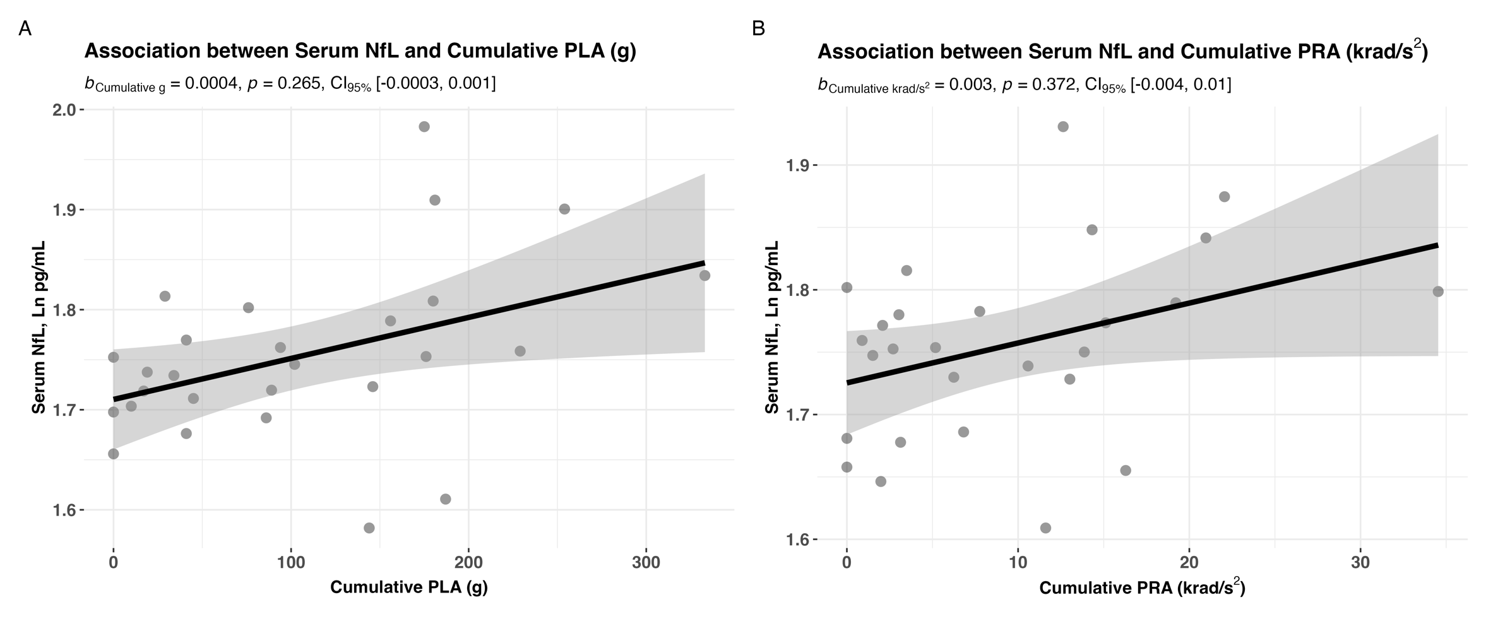

Online Resource 2. Cumulative peak linear and peak rotational acceleration exposure in a single game was not associated with post-match serum NfL levels.

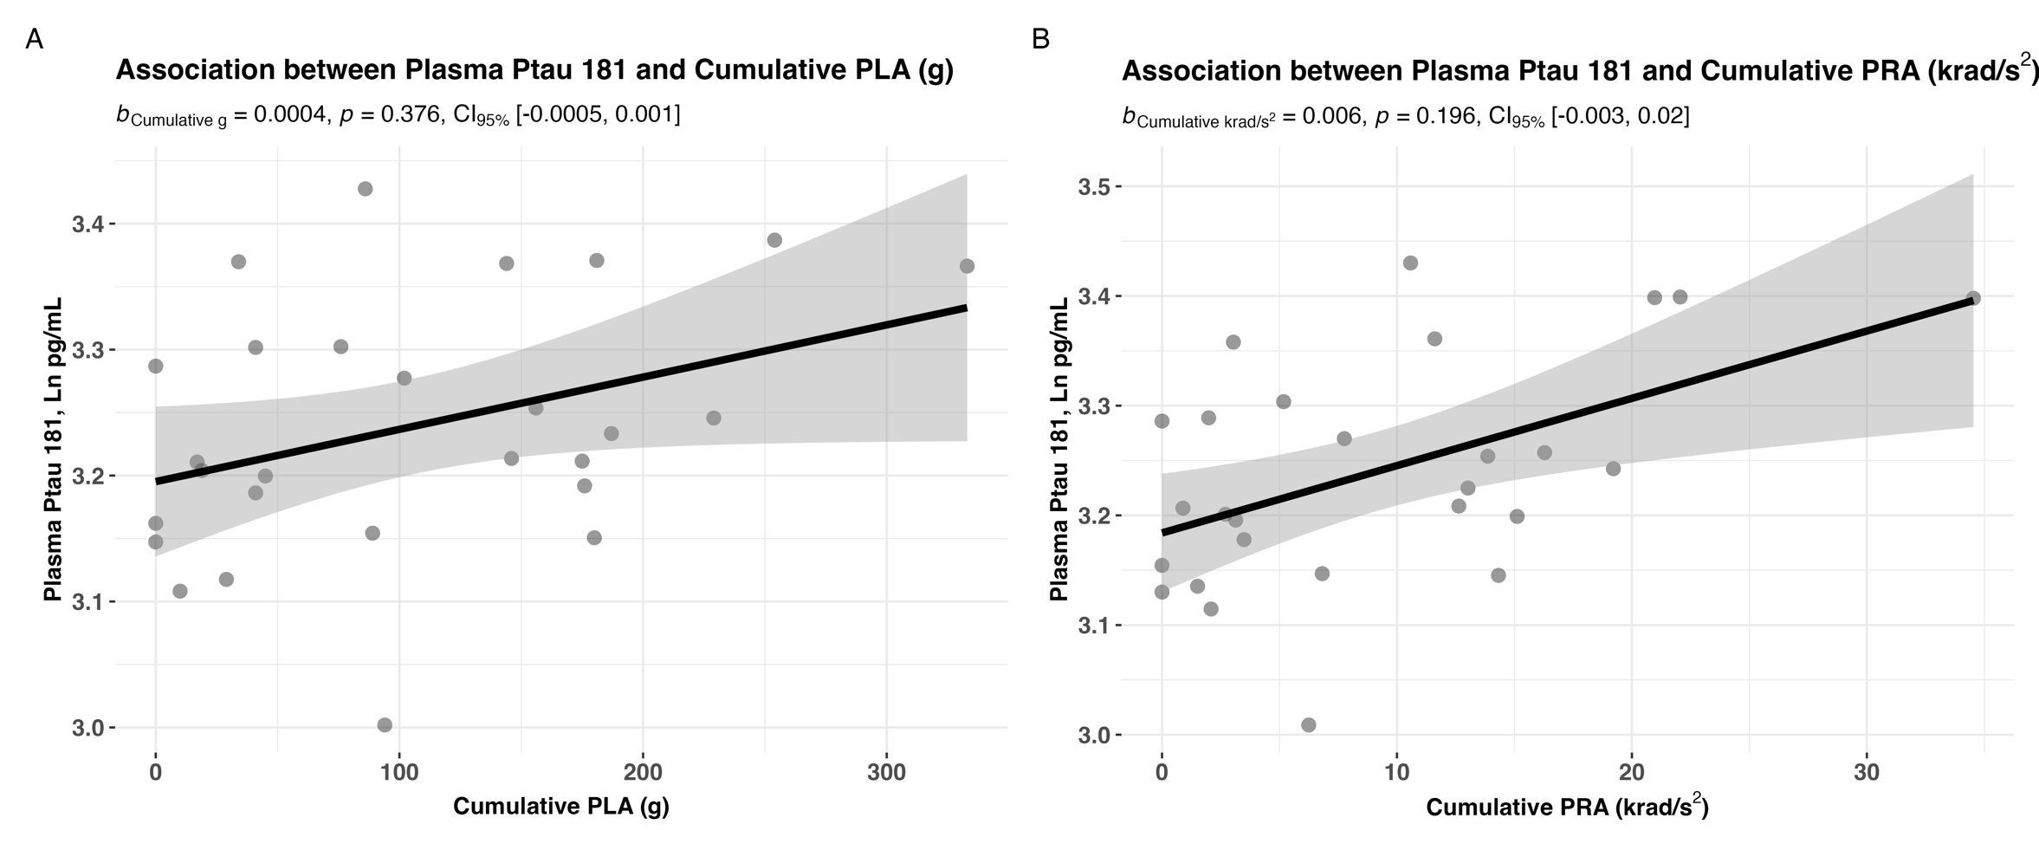

Online Resource 3. Cumulative peak linear and peak rotational acceleration exposure in a single game was not associated with post-match plasma p-tau-181 levels.

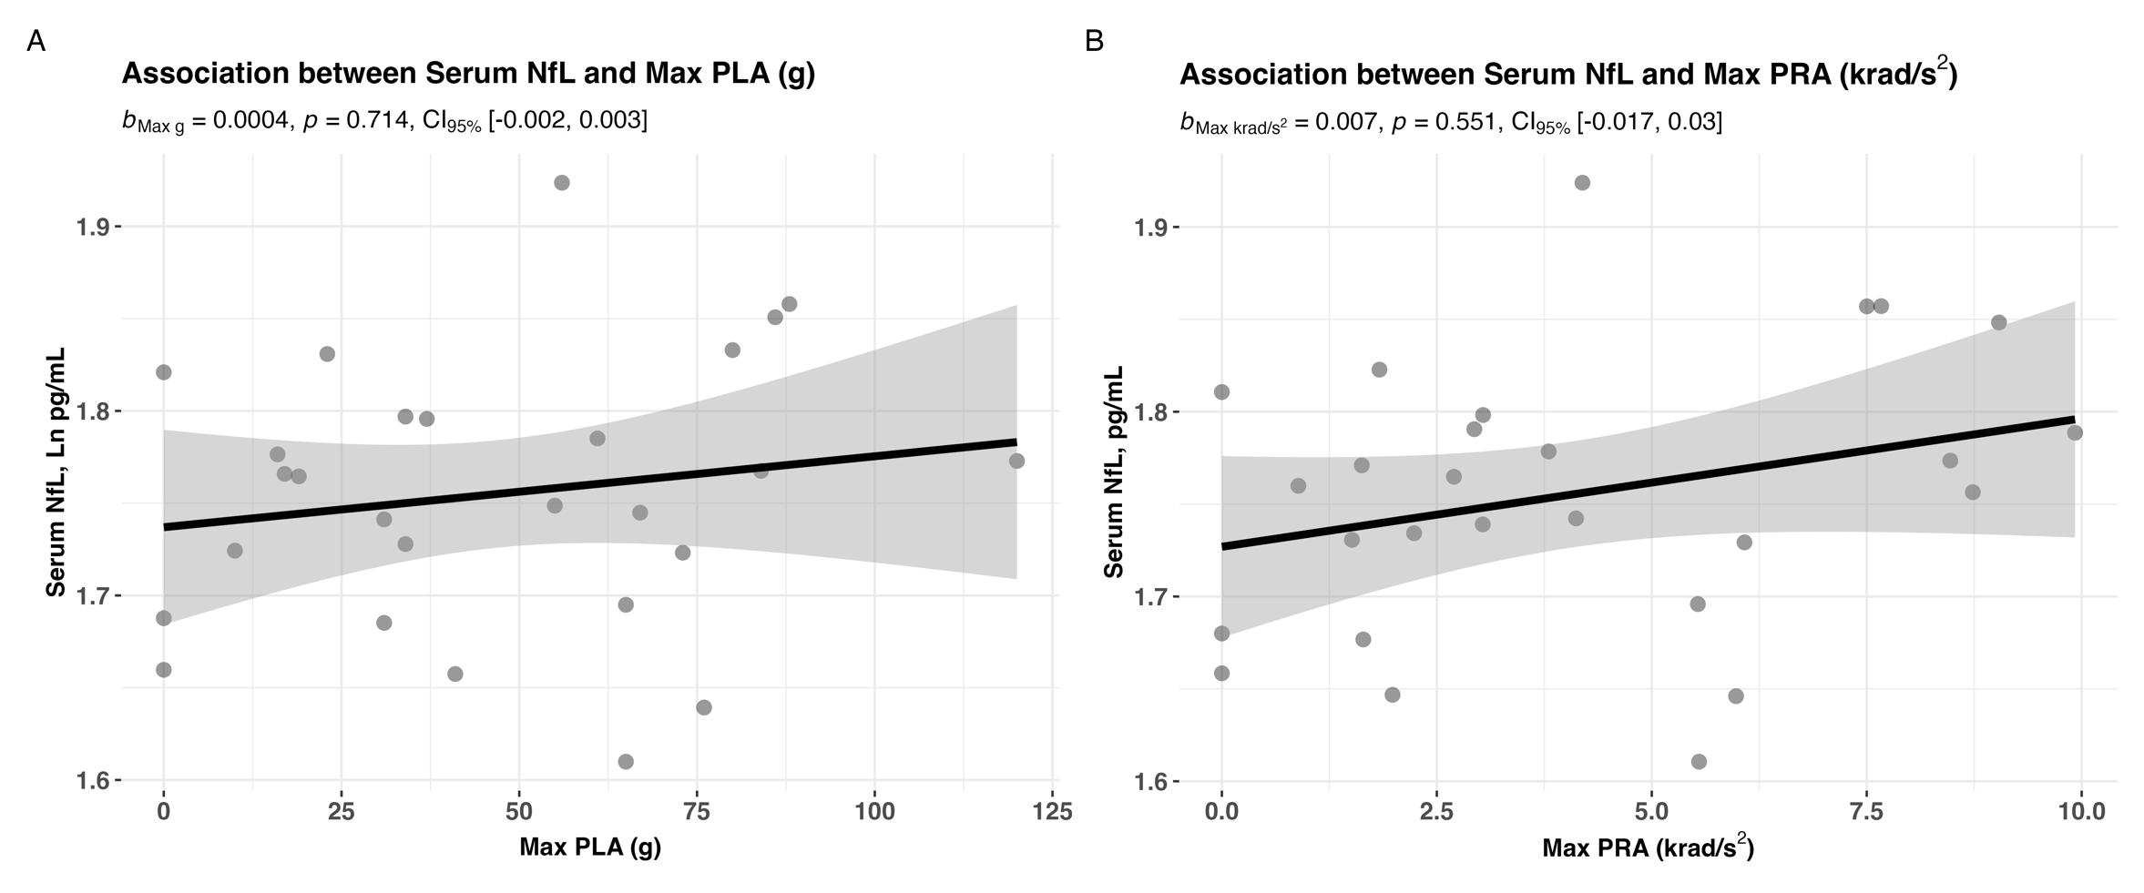

Online Resource 4. Maximum peak linear and peak rotational acceleration exposure in a single game was not associated with post-match serum NfL levels.

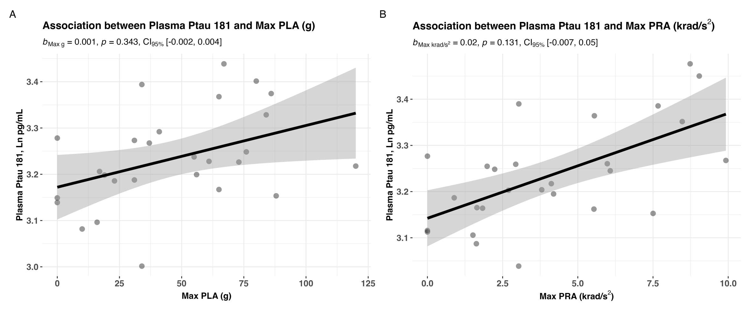

Online Resource 5. Maximum peak linear and peak rotational acceleration exposure in a single game was not associated with post-match plasma p-tau-181 levels.
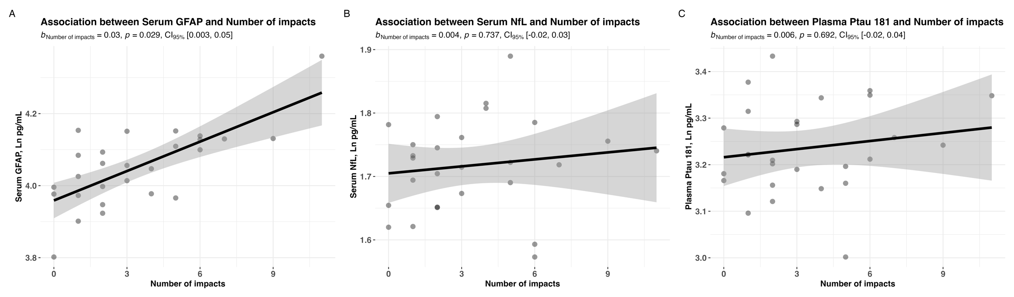

Online Resource 6. A significant association was observed between post-match serum GFAP (A), but not serum NfL (B) nor plasma p-tau-181 (C), and the number of impacts sustained during a single game of amateur Australian football.

