Effects of anticipation and dual-tasking on lower limb biomechanics while performing change-of-direction tasks in physically active individuals: A systematic review with meta-analysis
Clara Ebner*¹, Urs Granacher¹, Dominic Gehring¹
¹ Department of Sport and Sport Science, Exercise and Human Movement Science, University of Freiburg, Freiburg, Germany
* Corresponding author:
Prof. Dr. Urs Granacher
University of Freiburg
Department of Sport and Sport Science
Exercise and Human Movement Science
Sandfangweg 4
79102 Freiburg
Germany
Email: urs.granacher@sport.uni-freiburg.de
ORCID: https://orcid.org/0000-0002-7095-813X
Supplement A: Search Strategy
As an example, we present our initial search strategy in Web of Science:
# | Search syntax
1 | team sport*
2 | soccer OR football OR handball OR basketball OR rugby OR hockey
3 | athlet*
4 | sport*
5 | Active
6 | 1 OR 2 OR 3 OR 4 OR 5
7 | “change of direction” OR “changes of direction” OR “change-of-direction”
8 | cut OR cuts OR cutting
9 | “side-step*” OR sidestep
10 | Shear
11 | “run-and-cut”
12 | “side-cut”
13 | Agility
14 | 7 OR 8 OR 9 OR 10 OR 11 OR 12 OR 13
15 | “cognitive load” OR neurocognit* OR cognit*
16 | “decision making” OR “decision-making”
17 | “dual task*“ OR “dual-task*“ OR “multiple task*” OR “multiple-task*”
18 | complexit*
19 | unanticipat* OR unplan* OR un-plan*
20 | 15 OR 16 OR 17 OR 18 OR 19
21 | biomechanic* OR mechanic* OR kinetic* OR kinematic*
22 | sagittal OR frontal OR transvers*
23 | “lower extremity” OR “lower limb*”
24 | ACL OR “ anterior cruciate ligament*”
25 | knee* OR trunk
26 | 21 OR 22 OR 23 OR 24 OR 25
27 | 6 AND 14 AND 20 AND 26

Supplement B: Study quality assessment - Methods
Adapted Downs and Clack checklist (Downs & Black, 1998; Giesche et al., 2021; Wilke et al., 2020)
Item | Criteria (1 point awarded, if criterium met)
Reporting
Aim/hypothesis | The aim/hypothesis of the study are clearly described.
Outcomes | The main outcomes and their calculation are clearly described in the introduction or methods section.
Sample characteristics | The following characteristics of the included participants are reported: sex, age, height, weight, sports/activity level. Inclusion and exclusion criteria should be specified.
Motor task/conditions | The motor task and test conditions are described in sufficient detail to allow replication of the study (e.g., type and timing of stimulus, approach speed).
Confounders | Potential confounders are clearly described (e.g., approach speed, timing of stimulus, cutting angle)
Findings | The results are comprehensibly reported and enable the reader to follow the main conclusions.
Variability estimates | Standard deviations or confidence intervals are reported.
Actual p-values | Actual p-values are reported rather than thresholds (e.g., p < 0.05), except of p-values < 0.001.
Funding | External funding/grants are reported.
External validity
Participant representativeness | The participants in the study were representative of the in the population defined as part of the objectives, i.e., the target population was defined in the objectives (e.g., sex, sports).
Setting representativeness | The selected motor task, i.e. cutting movement, is usually performed in the sports of the selected population and included a decision making component or dual-task.
Internal validity (bias)
Data dredging | If the reporting of findings was in line with the predefined aims and outcome measures, the criterium was met.
Adequate statistics | Adequate inference statistical analyses were performed to assess the main outcomes. In case of post-hoc analyses, alpha error inflation is controlled for (e.g. Bonferroni correction).
Internal validity (confounding)
Accurate measurement tools | Appropriate measurement tools with good test quality (objective/valid/reliable) were used to assess the main outcomes.
Randomness of conditions | The order of test conditions (anticipated/unanticipated) and cutting directions were randomized.
Adjustment for confounders | Previously described confounders were considered as covariates in analyses or were found to be irrelevant if they did not differ significantly between conditions.
Statistical power | An a priori sample size calculation was performed and reported in methods section or the sample size was justified on the basis of previous research.

Supplement C: List of excluded studies, that were read in full-text form
Authors | Year | Title | Journal | DOI | Exclusion Reason(s)
Akbari et al. | 2023 | Effect of Heading a Soccer Ball as an External Focus During a Drop Vertical Jump Task | Orthopaedic journal of sports medicine | 10.1177/23259671231164706 | wrong task
Almonroeder et al. | 2015 | THE EFFECTS OF ANTICIPATION ON THE MECHANICS OF THE KNEE DURING SINGLE-LEG CUTTING TASKS: A SYSTEMATIC REVIEW | International journal of sports physical therapy | NA | wrong study type
Alimoradi et al. | 2024 | The effects of two different fatigue protocols on movement quality during anticipated and unanticipated change of directions in female soccer players | Plos One | 10.1371/journal.pone.0302144 | wrong outcome
Arumugam et al. | 2020 | A novel test reliably captures hip and knee kinematics and kinetics during unanticipated/anticipated diagonal hops in individuals with anterior cruciate ligament reconstruction. | Journal of biomechanics | 10.1016/j.jbiomech.2019.109480 | wrong population
Beaulieu et al. | 2008 | Gender differences in time-frequency EMG analysis of unanticipated cutting maneuvers | Medicine and science in sports and exercise | 10.1249/MSS.0b013e31817b8e9e | no/wrong comparator
Boey et al. | 2023 | The Association Between Functional Movement Screen Scores and Knee Valgus Moments During Unplanned Sidestep Cutting in Netball | International journal of sports physical therapy | 10.26603/001c.57678 | no/wrong comparator
Bosio et al. | 2022 | Biomechanics of planned and unplanned change of direction in subjects with and without anterior cruciate ligament reconstruction: a case study | Gait & Posture | NA | wrong publication type
Brown et al. | 2014 | Knee mechanics during planned and unplanned sidestepping: a systematic review and meta-analysis | Sports medicine | 10.1007/s40279-014-0225-3 | wrong study type
Bruce et al. | 2021 | Whole-Body Reactive Agility Metrics to Identify Football Players With a Core and Lower Extremity Injury Risk | Frontiers in sports and active living | 10.3389/fspor.2021.733567 | wrong task
Chinnasee et al. | 2018 | A Biomechanical Comparison of Single-Leg Landing and Unplanned Sidestepping | INTERNATIONAL JOURNAL OF SPORTS MEDICINE | 10.1055/a-0592-7422 | no fulltext available
Cortes et al. | 2013 | Changes in lower extremity biomechanics due to a short-term fatigue protocol | Journal of athletic training | 10.4085/1062-6050-48.2.03 | no/wrong comparator
Cortes et al. | 2011 | Pivot task increases knee frontal plane loading compared with sidestep and drop-jump. | Journal of Sports Sciences | 10.1080/02640414.2010.523087 | no/wrong comparator
David et al. | 2024 | Characterization of movement patterns using unsupervised learning neural networks: Exploring a novel approach for monitoring athletes during sidestepping | JOURNAL OF SPORTS SCIENCES | 10.1080/02640414.2023.2300570. | no/wrong exposure
DiStefano et al. | 2009 | The effects of a pediatric ACL injury prevention program. | NA | NA | wrong task
Donnelly et al. | 2017 | Joint dynamics of rear- and fore-foot unplanned sidestepping | JOURNAL OF SCIENCE AND MEDICINE IN SPORT | 10.1016/j.jsams.2016.06.002 | no/wrong comparator
Donnelly et al. | 2021 | Prescribing joint co-ordinates during model preparation in OpenSim improves lower limb unplanned sidestepping kinematics | JOURNAL OF SCIENCE AND MEDICINE IN SPORT | 10.1016/j.jsams.2020.07.009 | no/wrong comparator
Donnelly et al. | 2024 | The inter-laboratory equivalence for lower limb kinematics and kinetics during unplanned sidestepping | Sports Biomech | 10.1080/14763141.2020.1860254 | no/wrong comparator
Friebe et al. | 2021 | Effects of Open Skill Visuomotor Choice Reaction Time Training on Unanticipated Jump-Landing Stability and Quality: A Randomized Controlled Trial | Frontiers in human neuroscience | 10.3389/fnhum.2021.683909 | wrong task
Ghasemi et al. | 2023 | Boys demonstrate greater knee frontal moments than girls during the impact phase of cutting maneuvers, despite age-related increases in girls | KNEE SURGERY SPORTS TRAUMATOLOGY ARTHROSCOPY | 10.1007/s00167-023-07340-z | no/wrong exposure
Giesche et al. | 2021 | Effect of unplanned athletic movement on knee mechanics: a systematic review with multilevel meta-analysis | BRITISH JOURNAL OF SPORTS MEDICINE | 10.1136/bjsports-2021-103933 | wrong study type
Heidarnia et al. | 2022 | Comparing the effect of a simulated defender and dual-task on lower limb coordination and variability during a side-cut in basketball players with and without anterior cruciate ligament injury | Journal of Biomechanics | 10.1016/j.jbiomech.2022.110965 | wrong outcome
Hosseini et al. | 2021 | The effects of fatigue on knee kinematics during unanticipated change of direction in adolescent girl athletes: a comparison between dominant and non-dominant legs | Sports biomechanics | 10.1080/14763141.2021.1925732 | wrong outcome
Hughes et al. | 2023 | The influence of decision making and divided attention on lower limb biomechanics associated with anterior cruciate ligament injury: a narrative review | Sports Biomechanics | 10.1080/14763141.2021.1898671 | wrong study type
Iwata Shō et al. | 2015 | Effects of Knee Joint Movement during Side-step Cutting Maneuvers in the Unanticipated Condition | Rigakuryoho Kagaku | NA | language
James et al. | 2004 | Gender differences among sagittal plane knee kinematic and ground reaction force characteristics during a rapid sprint and cut maneuver | Research quarterly for exercise and sport | 10.1080/02701367.2004.10609131. | no/wrong exposure
Khalid et al. | 2015 | Effects of neuromuscular fatigue on perceptual-cognitive skills between genders in the contribution to the knee joint loading during side-stepping tasks | Journal of sports sciences | 10.1080/02640414.2014.990485 | wrong outcome
Kiefer et al. | 2017 | Sport-Specific Virtual Reality to Identify Profiles of Anterior Cruciate Ligament Injury Risk During Unanticipated Cutting | INTERNATIONAL CONFERENCE ON VIRTUAL REHABILITATION | NA | no/wrong comparator
King et al. | 2018 | Biomechanical but not timed performance asymmetries persist between limbs 9 months after ACL reconstruction during planned and unplanned change of direction | Journal of biomechanics | 10.1016/j.jbiomech.2018.09.021 | wrong population
King et al. | 2019 | Back to Normal Symmetry? Biomechanical Variables Remain More Asymmetrical Than Normal During Jump and Change-of-Direction Testing 9 Months After Anterior Cruciate Ligament Reconstruction | The American journal of sports medicine | 10.1177/0363546519830656 | wrong outcome
Kipp et al. | 2013 | Decision Making and Experience Level Influence Frontal Plane Knee Joint Biomechanics During a Cutting Maneuver | Journal of Applied Biomechanics | 10.1123/jab.29.6.756 | wrong task
Lee et al. | 2019 | Different visual stimuli affect muscle activation at the knee during sidestepping. | Journal of sports sciences | 10.1080/02640414.2018.1545276 | wrong outcome
Lempke et al. | 2021 | Single- Versus Dual-Task Functional Movement Paradigms: A Biomechanical Analysis | Journal of sport rehabilitation | 10.1123/jsr.2020-0310 | wrong task
Liew et al. | 2020 | Mechanical work performed by distal foot-ankle and proximal knee-hip segments during anticipated and unanticipated cutting. | Journal of Biomechanics | 10.1016/j.jbiomech.2020.109839 | wrong outcome
Lucas et al. | 2018 | Decision Making Influences Tibial Impact Accelerations During Lateral Cutting | Journal of applied biomechanics | 10.1123/jab.2017-0397 | wrong outcome
Lynall et al. | 2018 | Reaction Time and Joint Kinematics During Functional Movement in Recently Concussed Individuals. | Archives of Physical Medicine & Rehabilitation | 10.1016/j.apmr.2017.12.011 | wrong task
Ma et al. | 2024 | Effect of Unanticipated Tasks on Side-Cutting Stability of Lower Extremity with Patellofemoral Pain Syndrome | Sensors (Basel) | 10.3390/s24196427 | wrong population
Mai et al. | 2022 | Unanticipated fake-and-cut maneuvers do not increase knee abduction moments in sport-specific tasks: Implication for ACL injury prevention and risk screening | Frontiers in sports and active living | 10.3389/fspor.2022.983888 | secondary data analyses (redundant)
McLean et al. | 2004 | Effect of gender and defensive opponent on the biomechanics of sidestep cutting | Medicine and science in sports and exercise | 10.1249/01.MSS.0000128180.  51443.83. | no/wrong exposure
Meinerz et al. | 2015 | Anticipatory Effects on Lower Extremity Neuromechanics During a Cutting Task | Journal of athletic training | 10.4085/1062-6050-50.8.02 | wrong task
Morral-Yepes | 2023 | Are change of direction speed and agility different abilities from time and coordinative perspectives? | Plos one | 10.1371/journal.pone.0295405 | wrong outcome
Munro et al. | 2007 | Split-step vs side-step evasive running maneuvers: which is more protective of the ACL? | NA | NA | no fulltext available
Needham et al. | 2022 | Cutting Movement Assessment Scores during Anticipated and Unanticipated 90-Degree Sidestep Cutting Manoeuvres within Female Professional Footballers | Sports (Basel, Switzerland) | 10.3390/sports10090128 | wrong outcome
Ness et al. | 2020 | DUAL-TASK ASSESSMENT IMPLICATIONS FOR ANTERIOR CRUCIATE LIGAMENT INJURY: A SYSTEMATIC REVIEW | International Journal of Sports Physical Therapy | 10.26603/ijspt20200840 | wrong study type
Niering et al. | 2023 | Changes After a Conventional vs. an Alternative Therapy Program on Physical, Psychological, and Injury-Related Parameters in Male Youth Soccer Players With Patellar Tendinopathy During Return to Competition | Journal of Strength & Conditioning Research | NA | no/wrong exposure
Nijmeijer et al. | 2023 | How to improve movement execution in sidestep cutting? Involve me and I will learn | Human movement science | 10.1016/j.humov.2023.103115 | wrong outcome
Picot et al. | 2024 | Lack of Proprioceptive Strategy Modulation Leads to At-Risk Biomechanics for Anterior Cruciate Ligament in Healthy Athletes | Med Sci Sports Exerc | 10.1249/MSS.0000000000003378 | wrong outcome
Porter et al. | 2020 | The Relationship Between Neurocognitive Function and Biomechanics: A Critically Appraised Topic | Journal of sport rehabilitation | 10.1123/jsr.2020-0103 | wrong study type
Richwalski et al. | 2019 | Anticipatory effects on lower extremity kinetics during a land and cross step maneuver in female volleyball players | The Journal of sports medicine and physical fitness | 10.23736/S0022-4707.18.08996-X | wrong task
Robins et al. | 2023 | The Association of Age and Sex With Joint Angles and Coordination During Unanticipated Cutting in Soccer Players | Motor control | NA | no/wrong comparator
Robbins et al. | 2024 | The relationship between executed cut angle and speed with lower extremity joint angles during unanticipated side-step cutting in soccer players | Gait Posture | 10.1016/j.gaitpost.2024.09.006 | no/wrong comparator
Schroeder et al. | 2021 | Type of unanticipated stimulus affects lower extremity kinematics and kinetics during sidestepping | Journal of sports sciences | 10.1080/02640414.2020.1837481. | no/wrong comparator
Sigward et al. | 2012 | The influence of sex and maturation on knee mechanics during side-step cutting | Medicine and science in sports and exercise | 10.1249/MSS.0b013e31824e8813. | no/wrong comparator
Smith et al. | 2020 | Field hockey sport-specific postures during unanticipated sidestepping: Implications for anterior cruciate ligament injury prevention | Journal of Sports Sciences | 10.1080/02640414.2020.1794264 | no/wrong comparator
Spiteri et al. | 2014 | Offensive and Defensive Agility: A Sex Comparison of Lower Body Kinematics and Ground Reaction Force | Journal of Applied Biomechanics | 10.1123/jab.2013-0259 | no/wrong exposure
Staynor et al. | 2020 | By failing to prepare, you are preparing your anterior cruciate ligament to fail | Scandinavian Journal of Medicine & Science in Sports | 10.1111/sms.13571 | no/wrong comparator
Thompson et al. | 2017 | Biomechanical Effects of an Injury Prevention Program in Preadolescent Female Soccer Athletes. | The American journal of sports medicine | 10.1177/0363546516669326 | no/wrong comparator
Thompson-Kolesar et al. | 2018 | Age Influences Biomechanical Changes After Participation in an Anterior Cruciate Ligament Injury Prevention Program | The American journal of sports medicine | 10.1177/0363546517744313 | wrong outcome
Weir et al. | 2019 | A Reliable Video-based ACL Injury Screening Tool for Female Team Sport Athletes | INTERNATIONAL JOURNAL OF SPORTS MEDICINE | 10.1055/a-0756-9659 | no/wrong comparator
Wheeler et al. | 2010 | Modification of agility running technique in reaction to a defender in rugby union. | Journal of sports science & medicine | NA | wrong outcome
Whyte et al. | 2018 | Investigation of the Effects of High-Intensity, Intermittent Exercise and Unanticipation on Trunk and Lower Limb Biomechanics During a Side-Cutting Maneuver Using Statistical Parametric Mapping | Journal of strength and conditioning research | 10.1519/JSC.0000000000002567 | wrong task
Whyte et al. | 2017 | The effect of high intensity exercise and anticipation on trunk and lower limb biomechanics during a crossover cutting manoeuvre | Journal of Sports Sciences | 10.1080/02640414.2017.1346270 | wrong task
Wilke et al. | 2020 | Perceptual-Cognitive Function and Unplanned Athletic Movement Task Performance: A Systematic Review | International journal of environmental research and public health | 10.3390/ijerph17207481 | wrong study type
Wyatt et al. | 2019 | Whole-body control of anticipated and unanticipated sidestep manoeuvres in female and male team sport athletes | Journal of sports sciences | 10.1080/02640414.2019.1627982 | wrong outcome
Yom et al. | 2019 | The effects of an unanticipated side-cut on lower extremity kinematics and ground reaction forces during a drop landing | Sports Biomechanics | 10.1080/14763141.2017.1409795 | wrong task
Zeff et al. | 2022 | Head control and head-trunk coordination as a function of anticipation in sidestepping | Journal of sports sciences | 10.1080/02640414.2021.2021683 | wrong outcome
Zou et al. | 2024 | Influences of fatigue and anticipation on female soccer players' biomechanical characteristics during 180° pivot turn: implication for risk and prevention of anterior cruciate ligament injury | Front Physiol | 10.3389/fphys.2024.1424092 | wrong task
Zhu et al. | 2024 | Effects of Fatigue and Unanticipated Factors on Knee Joint Biomechanics in Female Basketball Players during Cutting | Sensors | 10.3390/s24144759 | outlier analysis, insufficient methodological transparency, reporting of results
邹利民 et al. | 2019 | Sports Biomechanics Characteristic of Knee Joint During Sidestep-cutting Maneuver among Female Football Players on Unanticipated Condition | Journal of Shanghai Physical Education Institute | NA | language

Supplement D: Study quality assessment - Results
 | Reporting |  |  |  |  |  |  |  |  | External validity |  | Internal validity |  | Internal validity (confounding)
 | Aim/hypothesis | Outcomes | Sample Characteristics | Motor task/conditions | Confounders | Findings | Variability estimates | Actual p-values | Funding | Participant representativeness | Setting representativeness | Data dredging | Adequate statistics | Accurate measurement tools | Randomness of conditions | Adjustment of confounders | Statistical power | Total score
Quantitatively analyzed studies (meta-analyses)
Bedo et al., 2021 | 1 | 0 | 1 | 1 | 1 | 1 | 1 | 1 | 1 | 1 | 1 | 1 | 1 | 1 | 0 | 0 | 0 | 13
Besier et al., 2001 | 1 | 1 | 1 | 1 | 1 | 1 | 1 | 0 | 0 | 0 | 1 | 1 | 1 | 1 | 1 | 0 | 0 | 12
Brown et al., 2014 | 1 | 1 | 1 | 1 | 0 | 1 | 1 | 0 | 0 | 1 | 0 | 1 | 1 | 1 | 1 | 0 | 1 | 12
Byrne et al., 2022 | 1 | 1 | 1 | 1 | 0 | 1 | 1 | 0 | 1 | 0 | 1 | 1 | 1 | 1 | 1 | 0 | 0 | 12
Collins et al., 2016 | 1 | 1 | 1 | 1 | 1 | 1 | 1 | 1 | 1 | 1 | 1 | 1 | 1 | 1 | 1 | 0 | 0 | 15
Cortes et al., 2011 | 1 | 1 | 1 | 1 | 0 | 1 | 1 | 1 | 0 | 0 | 1 | 1 | 1 | 1 | 0 | 0 | 0 | 11
Dempsey et al., 2009 | 1 | 1 | 0 | 1 | 1 | 1 | 1 | 1 | 1 | 0 | 1 | 1 | 1 | 1 | 0 | 0 | 1 | 13
Kim et al., 2016 | 1 | 0 | 0 | 1 | 0 | 1 | 1 | 1 | 1 | 1 | 1 | 1 | 0 | 1 | 1 | 0 | 0 | 11
Kim et al., 2014 | 1 | 0 | 0 | 1 | 0 | 1 | 1 | 1 | 1 | 0 | 1 | 1 | 0 | 1 | 1 | 0 | 0 | 10
Lee et al., 2013 | 1 | 1 | 1 | 1 | 0 | 1 | 1 | 0 | 1 | 1 | 1 | 1 | 1 | 1 | 1 | 0 | 1 | 14
Lei et al., 2022 | 1 | 1 | 1 | 1 | 1 | 1 | 1 | 1 | 1 | 0 | 1 | 1 | 1 | 1 | 1 | 0 | 1 | 15
Mornieux et al., 2014 | 1 | 1 | 1 | 1 | 1 | 1 | 1 | 1 | 0 | 1 | 1 | 1 | 1 | 1 | 1 | 1 | 1 | 16
Park et al., 2011 | 1 | 1 | 1 | 1 | 0 | 1 | 1 | 1 | 0 | 0 | 1 | 1 | 1 | 1 | 1 | 0 | 0 | 12
Rolley et al., 2023 | 1 | 1 | 1 | 1 | 0 | 1 | 1 | 1 | 1 | 1 | 1 | 1 | 1 | 1 | 1 | 0 | 0 | 14
Seymore et al., 2017 | 1 | 1 | 1 | 1 | 1 | 1 | 1 | 1 | 1 | 1 | 1 | 1 | 1 | 1 | 1 | 0 | 1 | 16
Stoffel et al., 2010 | 1 | 1 | 1 | 1 | 0 | 1 | 1 | 1 | 1 | 1 | 1 | 1 | 1 | 1 | 1 | 0 | 1 | 15
Weinhandl et al., 2013 | 1 | 1 | 1 | 1 | 0 | 1 | 1 | 1 | 1 | 0 | 1 | 1 | 1 | 1 | 1 | 0 | 0 | 13
Qualitatively analyzed studies
Bill et al., 2022 | 1 | 1 | 1 | 1 | 1 | 1 | 1 | 1 | 1 | 0 | 1 | 1 | 1 | 1 | 1 | 1 | 0 | 15
Chan et al., 2009 | 1 | 1 | 1 | 1 | 0 | 1 | 1 | 1 | 0 | 1 | 1 | 1 | 1 | 1 | 1 | 0 | 0 | 13
Fedie et al., 2010 | 1 | 1 | 1 | 1 | 0 | 1 | 1 | 1 | 0 | 1 | 1 | 1 | 1 | 1 | 1 | 0 | 1 | 14
Monfort et al., 2019 | 1 | 1 | 1 | 1 | 1 | 1 | 1 | 1 | 1 | 1 | 1 | 1 | 1 | 1 | 0 | 1 | 0 | 15
Norte et al., 2020 | 1 | 1 | 1 | 1 | 1 | 1 | 1 | 0 | 0 | 1 | 1 | 1 | 1 | 1 | 1 | 0 | 1 | 14
Weir et al., 2019 | 1 | 1 | 1 | 1 | 1 | 1 | 1 | 1 | 0 | 0 | 1 | 1 | 1 | 1 | 1 | 1 | 1 | 15
Supplement E: Evaluation of publication or small-study effects by funnel plots
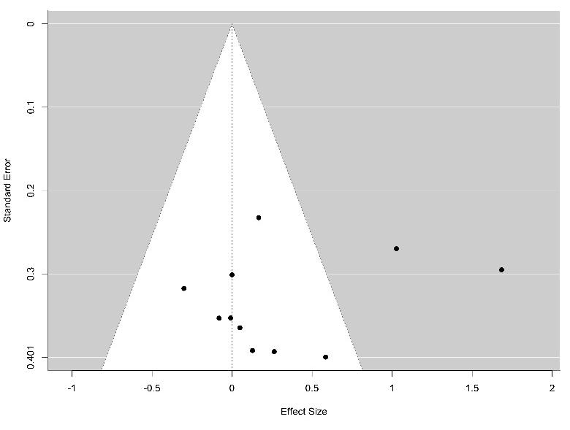
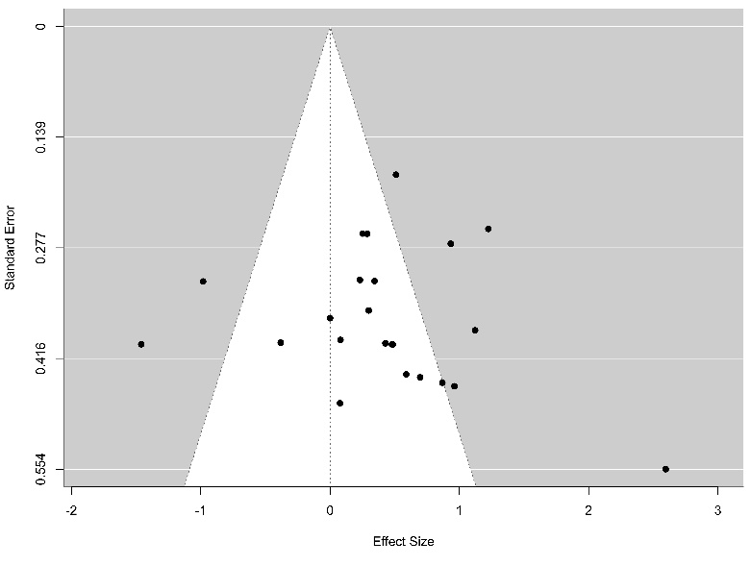

Figure 2: Funnel Plot Knee abduction angle.
Figure 1: Funnel Plot Knee abduction moment.
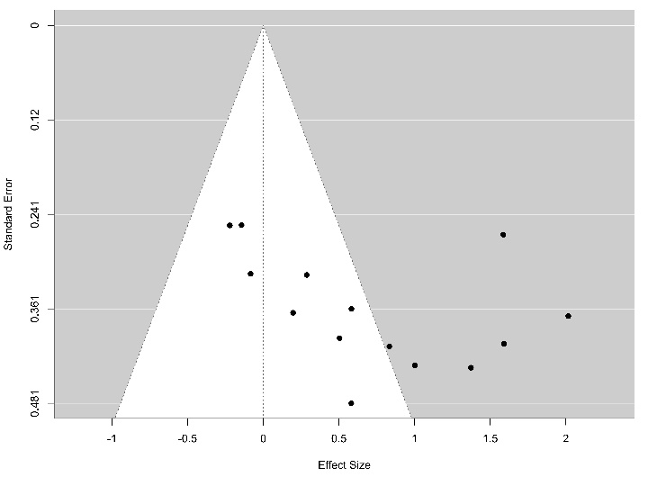
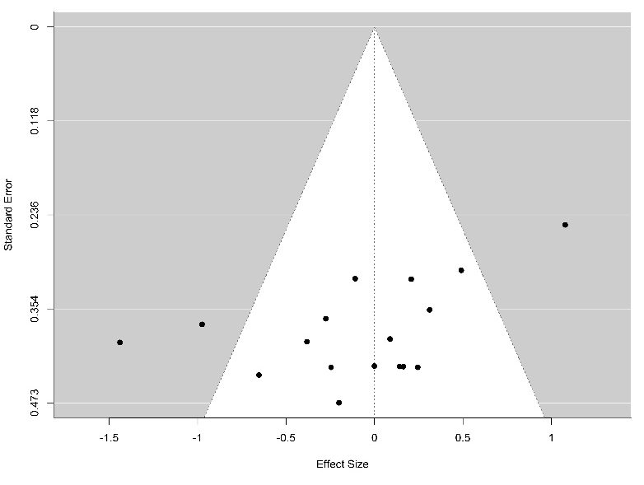

Figure 4: Funnel Plot Knee flexion angle.
Figure 3: Funnel Plot Knee flexion moment.

