Supplementary Figure S7 Forest plots of the effect of NO3- supplementation on each performance outcome

Forest plot of time-to-exhaustion (TTE)
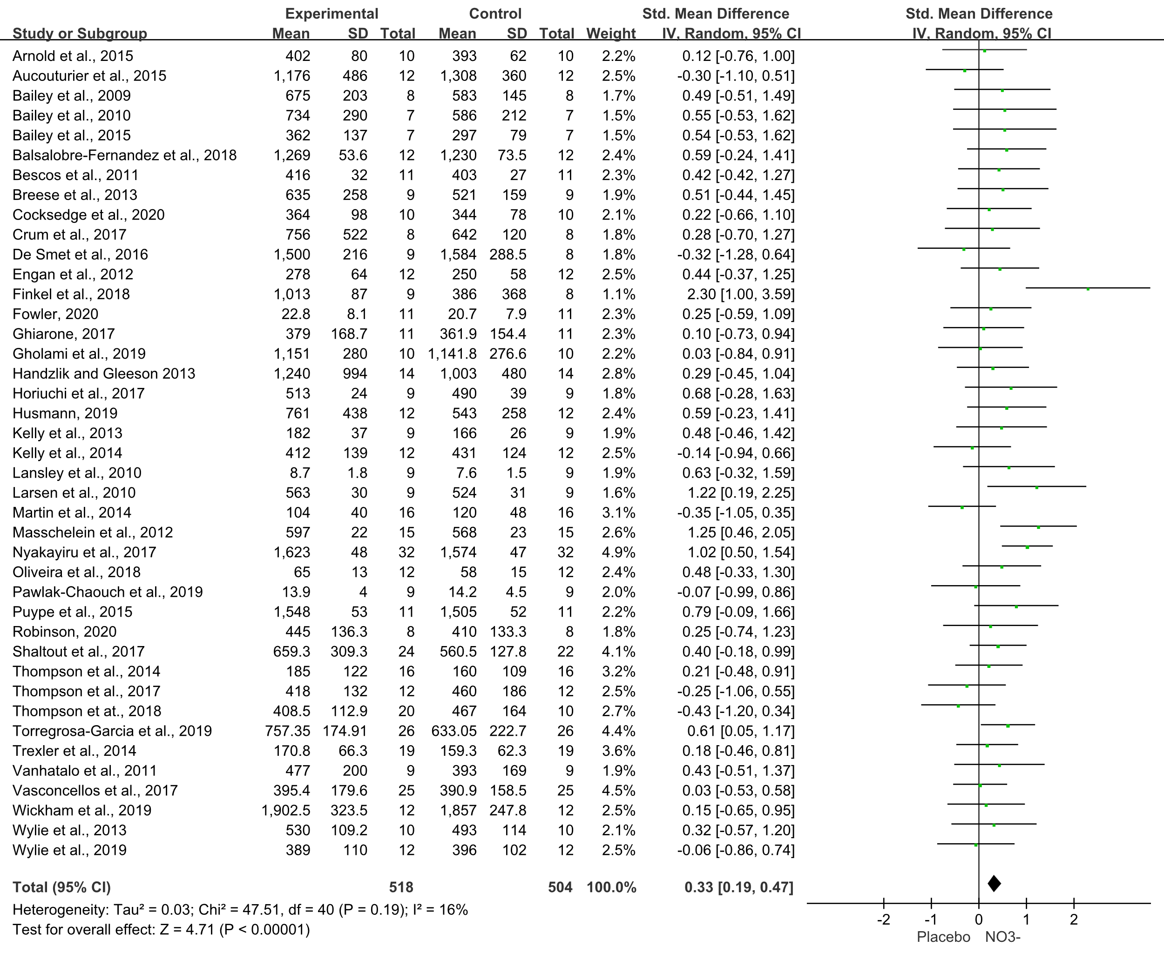

Forest plot of time trial (TT)
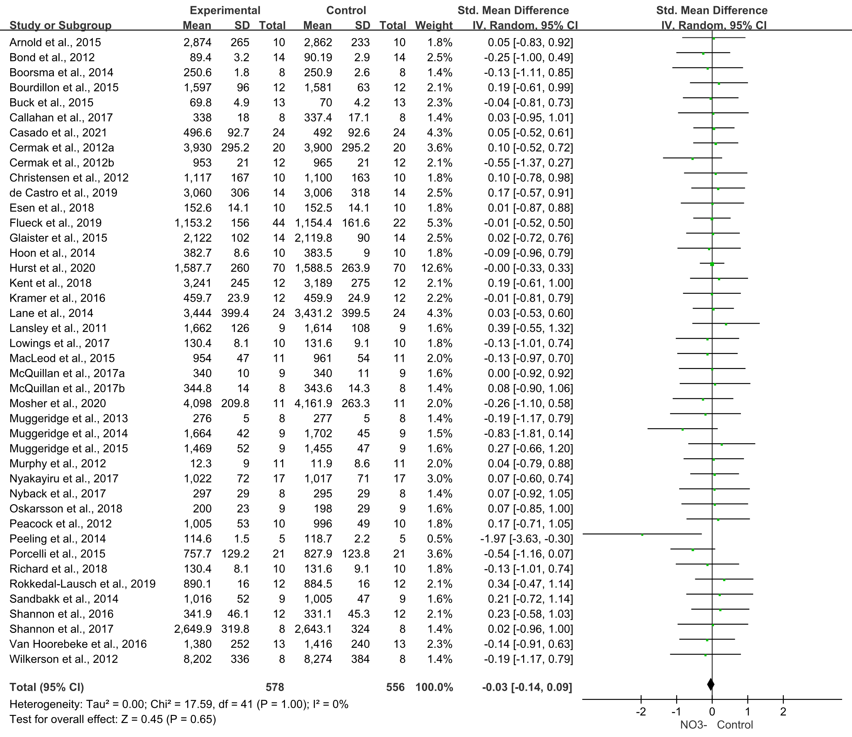

Forest plot of graded exercise test (GXT)
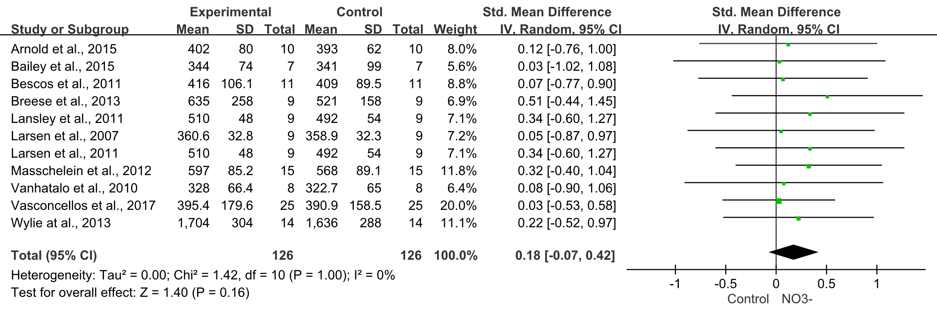

Forest plot of total work done
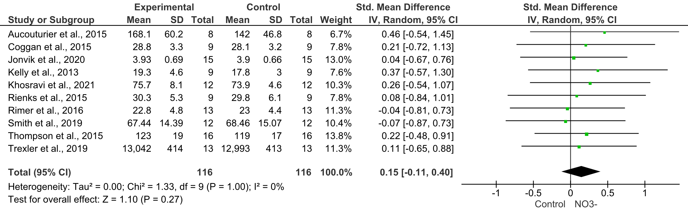
Forest plot of total distance covered
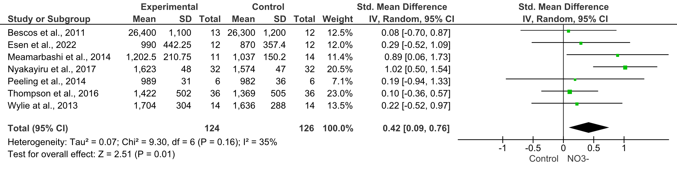

Forest plot of maximal oxygen uptake (VO₂max)
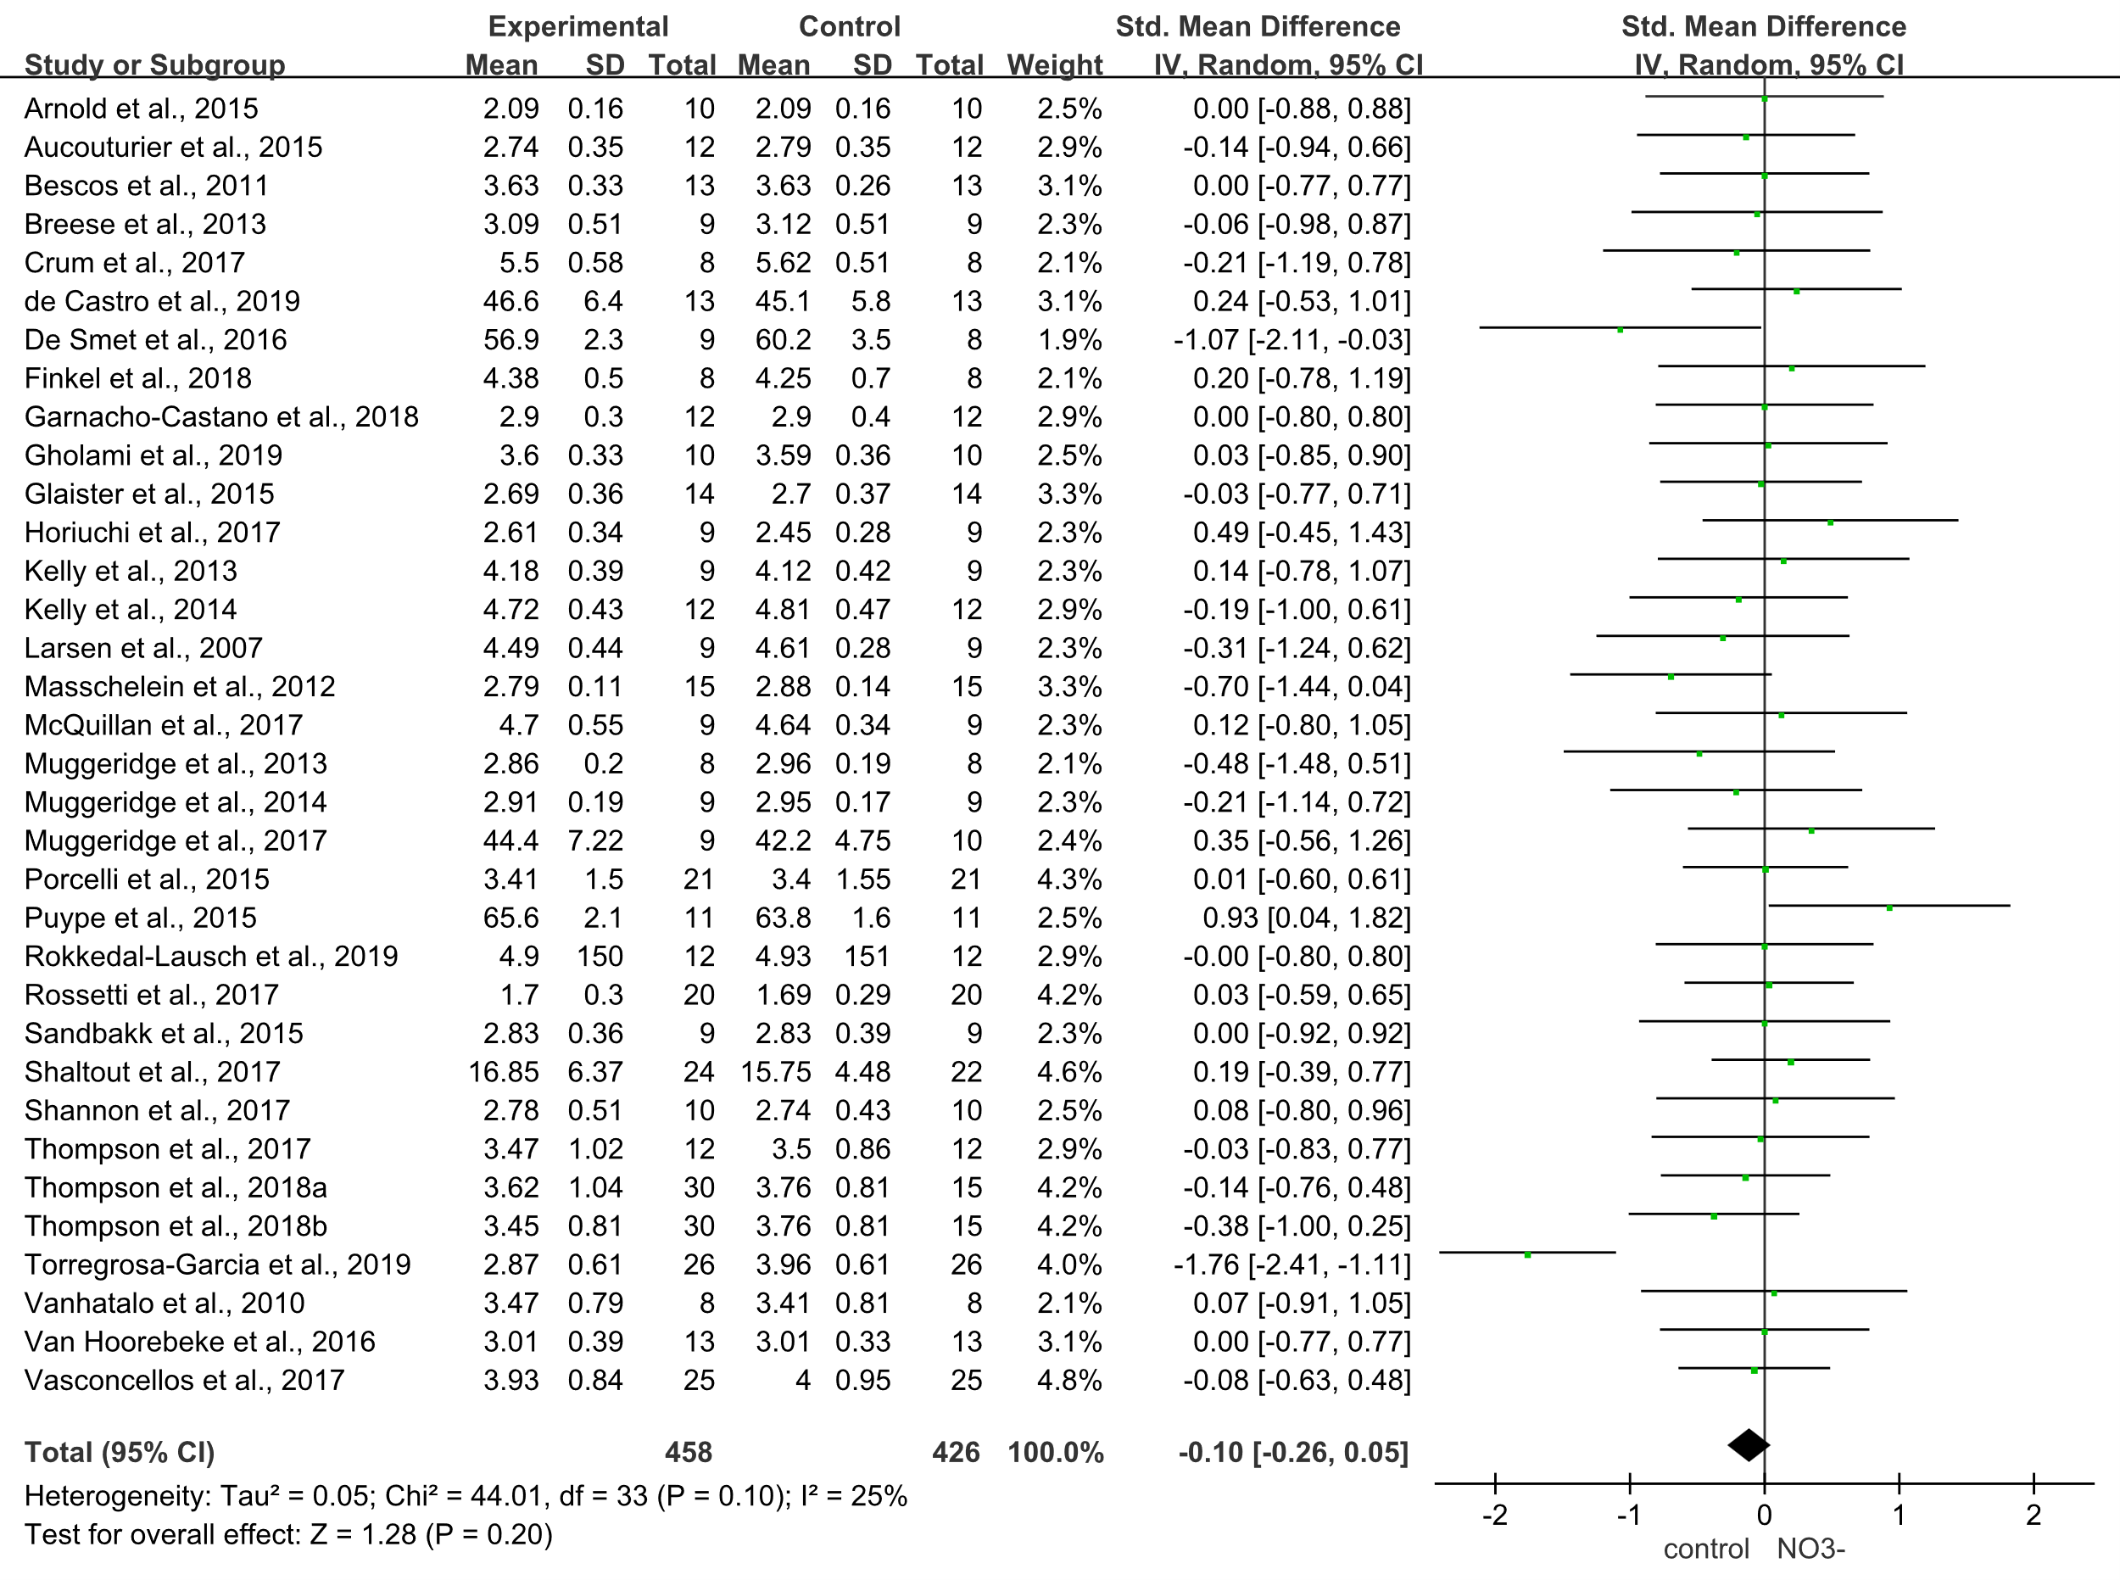

Forest plot of muscular strength
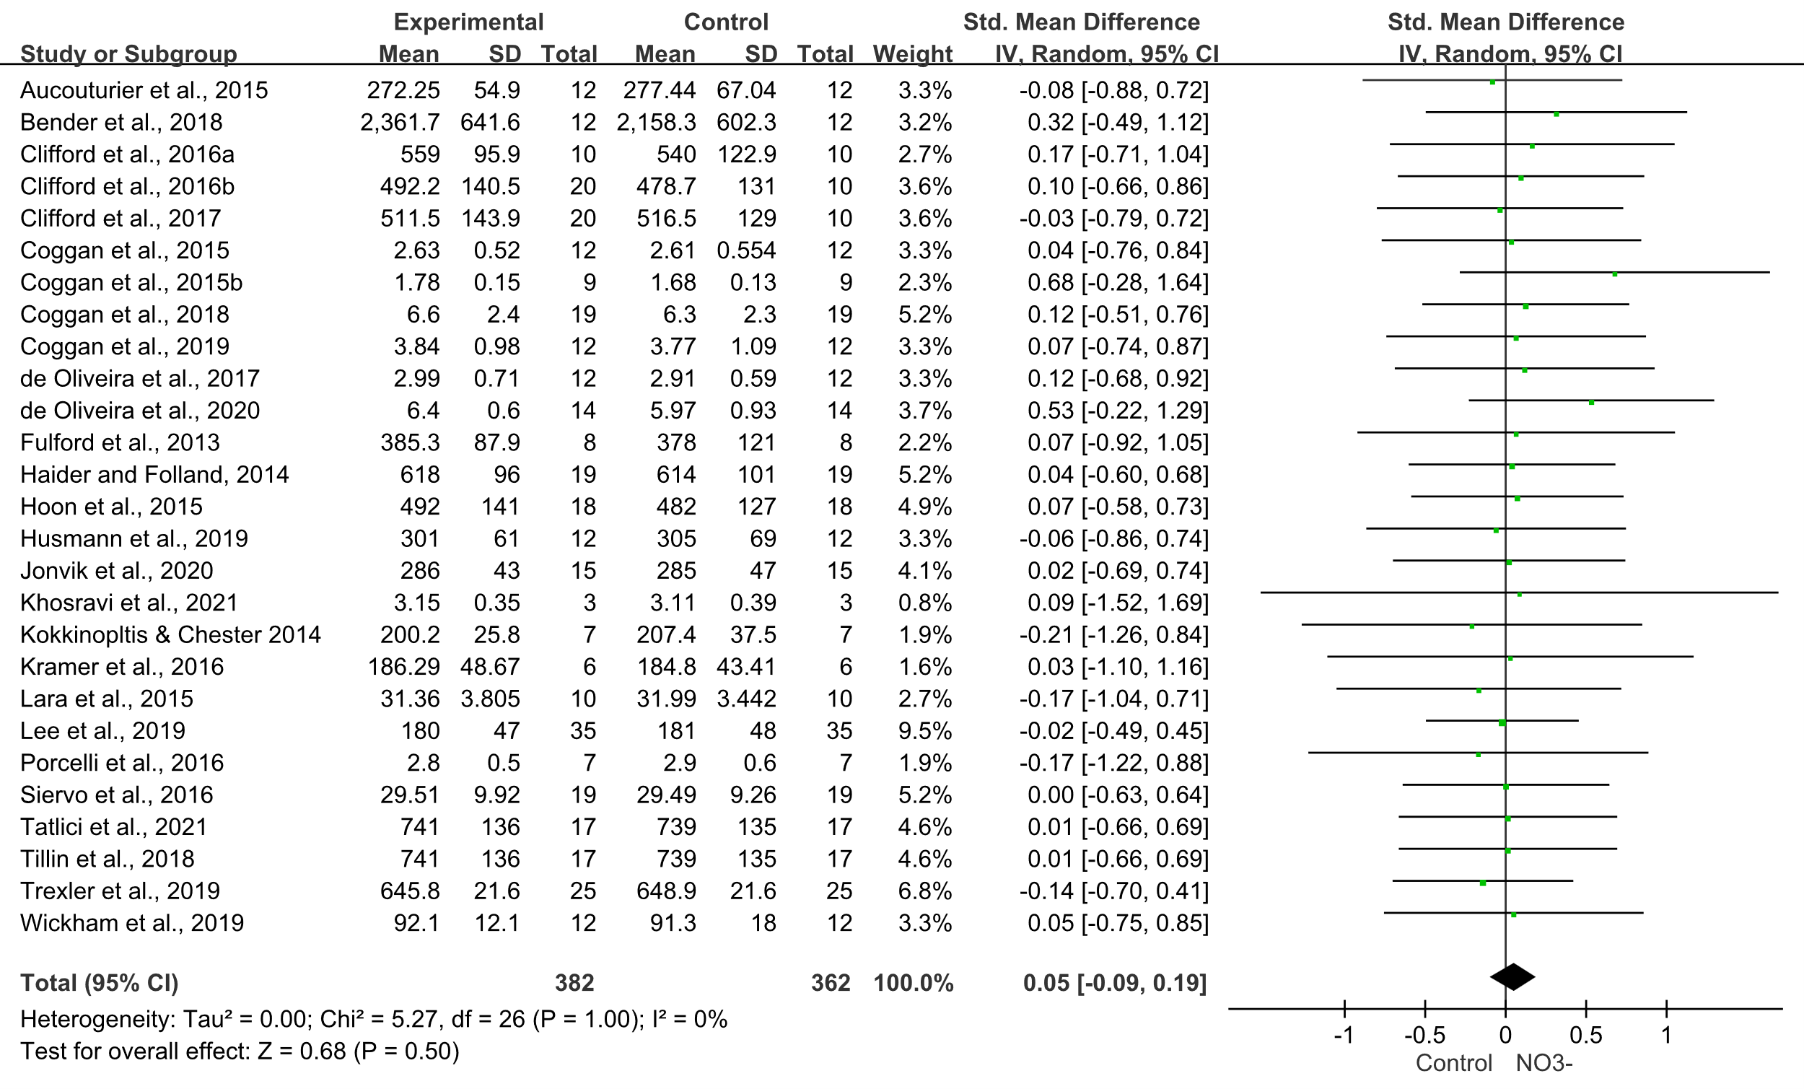
Forest plot of muscular endurance
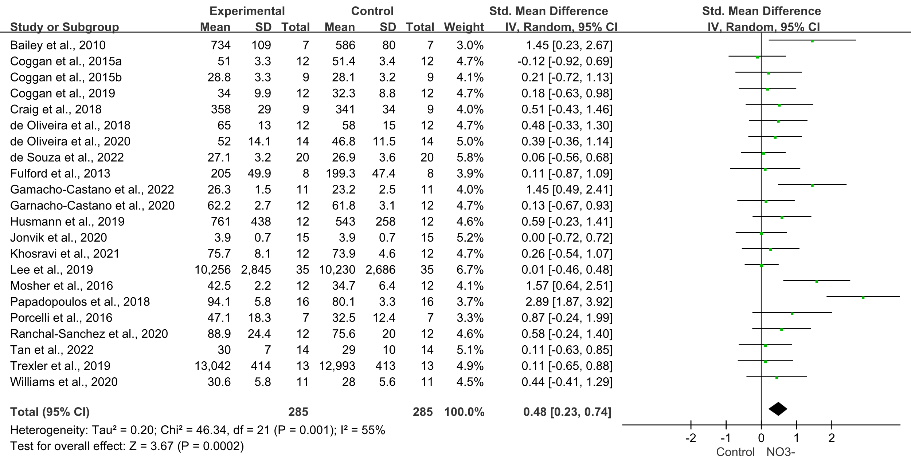

Forest plot of peak power output (PPO)
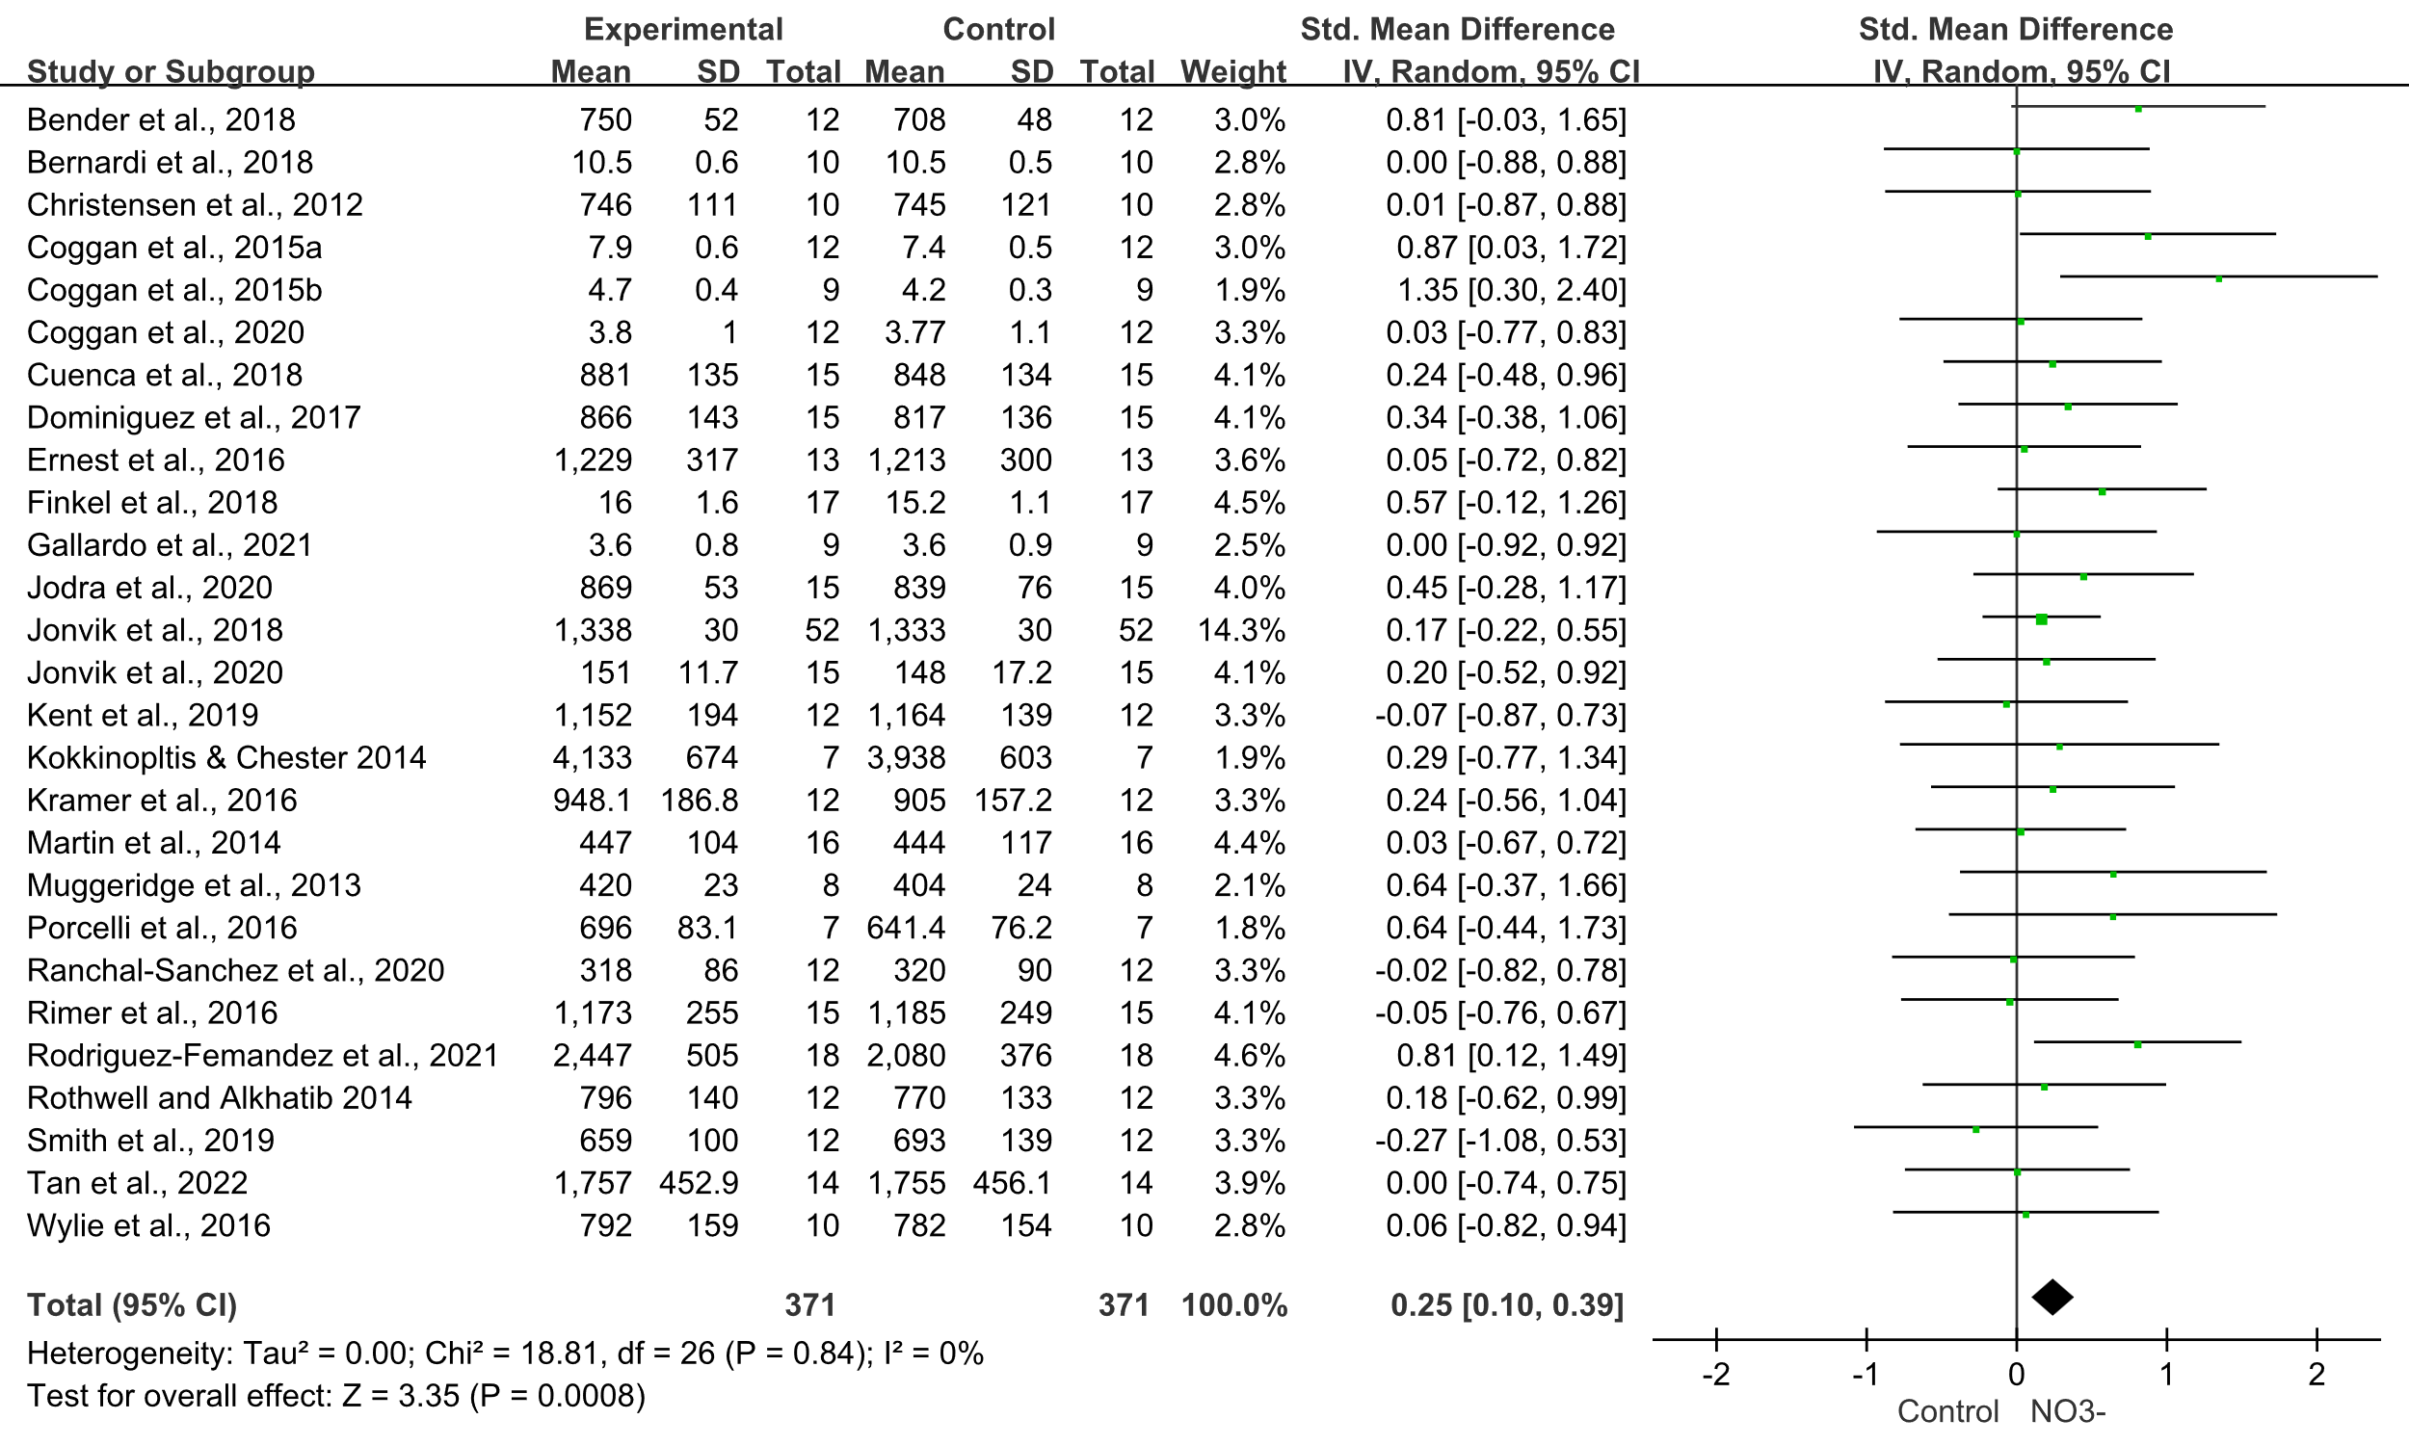
Forest plot of mean power output (MPO)
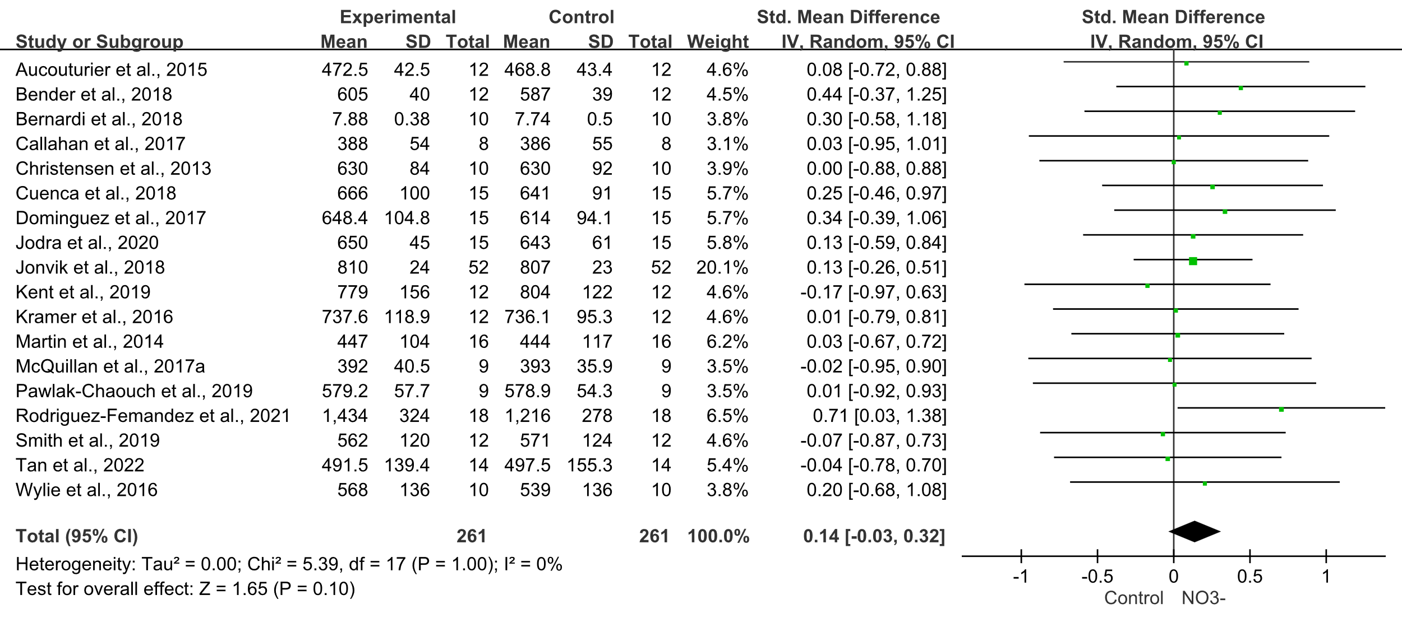
Forest plot of time to PPO 