Supplementary File for “Cardiovascular and Respiratory Responses During Graded Exercise in Adolescents after Sport-Related Concussion”

This supplement file presents additional analysis of cardiovascular and respiratory exercise in a sample of concussed adolescents and matched controls. The hypothesis is that there will be some evidence of limitations to exercise acutely after injury. All statistical analysis is performed on SPSS Version 29 and graphs are made on Prism GraphPad Version 10.

Contents
Missing data 1
Figure e1. Sample inclusion flow chart 2
Table e1. List of sports played by groups 3
Table e2. Cardiovascular variables 3
Figure e2. Cardiovascular variables plotted against time on BCBT 6
Table e3. Respiratory variables 7
Figure e3. Respiratory variables plotted against time on BCBT 8

Missing data

Concussed adolescents went for a mean of 8.12 stages (16.24 minutes), however, the percentage of missing data up to Stage 9 of the BCBT is around 34%. Apart from some missing variables in between, majority of missing data is at Stage 6 and beyond when the acutely concussed group ended the test due to symptom exacerbation. Unlike a repeated measures model, a generalized linear model can handle missing data. However, any results we obtain with this much missing data will be considered hypothesis generating as opposed to hypothesis testing.¹ Hence, we will only compare groups up to Stage 5 which is 10 minutes of exercise on the BCBT since all concussed participants had reached this stage and there was minimal missing data.

- Clark TG, Altman DG. Developing a prognostic model in the presence of missing data: an ovarian cancer case study. J Clin Epidemiol. 2003;56(1):28–37.

Figure e1. Sample inclusion flow chart

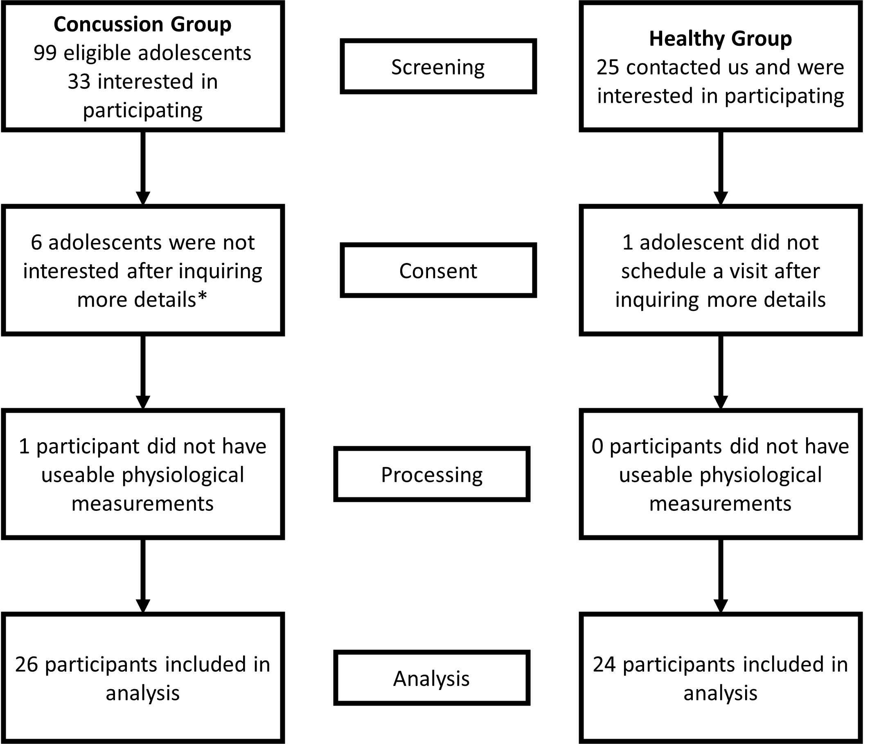

*all participants/parents said they were unable to schedule a 4-hour long research visit within a couple of days of first doctor’s appointment

Table e1. Cardiovascular variables
 | Concussion Group |  | Healthy Group
 | Mean | Standard Deviation | Mean | Standard Deviation
Cardiac Output (L/minute)
Baseline | 7.28 | 1.21 | 7.19 | 1.47
Stage 1 | 11.03 | 1.75 | 10.34 | 2.00
Stage 2 | 11.45 | 1.83 | 11.12 | 2.00
Stage 3 | 12.13 | 1.83 | 12.22 | 2.25
Stage 4 | 12.64 | 2.01 | 13.02 | 2.17
Stage 5 | 13.43 | 2.22 | 13.95 | 2.20
Diastolic Blood Pressure (mmHg)
Baseline | 72.72 | 11.02 | 74.64 | 6.96
Stage 1 | 75.10 | 8.89 | 77.62 | 7.79
Stage 2 | 77.42 | 8.98 | 79.30 | 6.77
Stage 3 | 78.43 | 9.20 | 81.47 | 6.54
Stage 4 | 77.90 | 10.35 | 81.96 | 7.25
Stage 5 | 76.53 | 10.02 | 81.83 | 7.49
Heart Rate (beats/minute)
Baseline | 75.36 | 9.00 | 73.85 | 9.73
Stage 1 | 99.30 | 13.75 | 95.70 | 11.13
Stage 2 | 100.86 | 12.92 | 101.39 | 11.93
Stage 3 | 106.70 | 10.67 | 108.86 | 14.58
Stage 4 | 115.40 | 12.92 | 112.66 | 12.10
Stage 5 | 116.66 | 10.79 | 119.30 | 12.80
Mean Arterial Pressure (mmHg)
Baseline | 94.05 | 11.03 | 95.79 | 7.638
Stage 1 | 99.12 | 10.96 | 100.67 | 9.585
Stage 2 | 101.78 | 10.67 | 102.52 | 9.124
Stage 3 | 102.77 | 10.78 | 105.82 | 8.903
Stage 4 | 101.64 | 12.62 | 106.56 | 9.494
Stage 5 | 100.77 | 12.05 | 107.05 | 9.435
Systolic Blood Pressure (mmHg)
Baseline | 124.03 | 15.34 | 124.08 | 11.83
Stage 1 | 135.89 | 14.79 | 133.16 | 15.13
Stage 2 | 139.73 | 14.55 | 135.96 | 14.65
Stage 3 | 141.62 | 14.86 | 141.11 | 13.88
Stage 4 | 140.35 | 17.41 | 143.82 | 13.99
Stage 5 | 140.20 | 18.26 | 146.25 | 14.06
Stroke Volume (cm³)
Baseline | 97.33 | 13.85 | 98.38 | 19.56
Stage 1 | 114.88 | 16.28 | 109.61 | 22.81
Stage 2 | 115.93 | 17.10 | 110.53 | 22.60
Stage 3 | 115.71 | 17.02 | 113.43 | 23.49
Stage 4 | 111.66 | 17.74 | 115.11 | 22.68
Stage 5 | 114.24 | 18.27 | 116.87 | 22.09
Systemic Vascular Resistance
Baseline | 13.13 | 1.80 | 13.83 | 2.77
Stage 1 | 9.19 | 1.80 | 10.07 | 2.02
Stage 2 | 9.09 | 1.69 | 9.50 | 1.83
Stage 3 | 8.65 | 1.58 | 8.94 | 1.71
Stage 4 | 8.26 | 1.87 | 8.42 | 1.64
Stage 5 | 7.75 | 2.10 | 7.86 | 1.38
Figure e2. Cardiovascular variables plotted against time on BCBT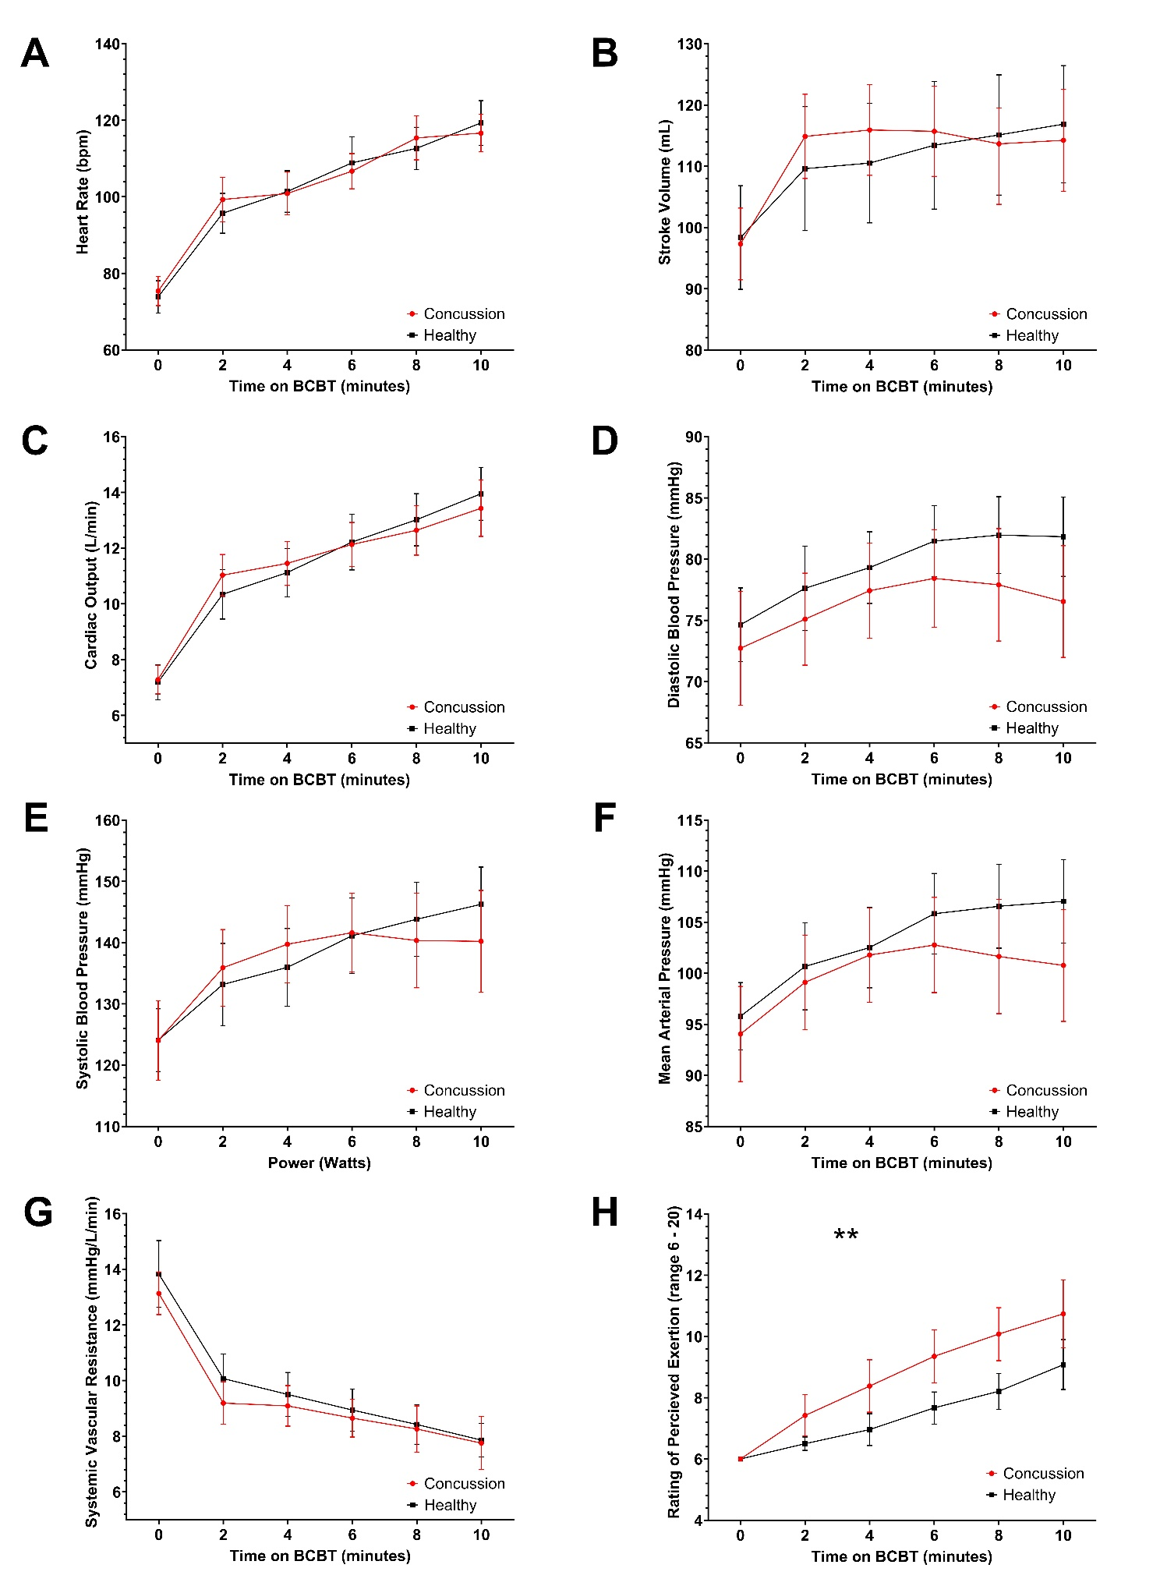

Table e2. Respiratory variables
 | Concussion Group |  | Healthy Group
 | Mean | Standard Deviation | Mean | Standard Deviation
Minute Ventilation (cm³/minute)
Baseline | 8325 | 2035 | 8287 | 2207
Stage 1 | 16245 | 4228 | 15172 | 3275
Stage 2 | 18684 | 4334 | 17576 | 3570
Stage 3 | 21312 | 4446 | 19447 | 4080
Stage 4 | 23391 | 5239 | 21508 | 4972
Stage 5 | 25665 | 6230 | 24250 | 5500
FeCO₂
Baseline | 0.016 | 0.0083 | 0.015 | 0.0054
Stage 1 | 0.025 | 0.0075 | 0.026 | 0.0064
Stage 2 | 0.029 | 0.0077 | 0.030 | 0.0051
Stage 3 | 0.031 | 0.0074 | 0.033 | 0.0055
Stage 4 | 0.031 | 0.0068 | 0.034 | 0.0057
Stage 5 | 0.032 | 0.0065 | 0.035 | 0.0061
FeO₂
Baseline | 0.18 | 0.0075 | 0.18 | 0.0052
Stage 1 | 0.17 | 0.0059 | 0.17 | 0.0054
Stage 2 | 0.16 | 0.0063 | 0.17 | 0.0040
Stage 3 | 0.16 | 0.0056 | 0.17 | 0.0039
Stage 4 | 0.17 | 0.0046 | 0.17 | 0.0040
Stage 5 | 0.17 | 0.0044 | 0.17 | 0.0047
Respiratory Rate (breaths/minute)
Baseline | 18.94 | 2.99 | 18.20 | 5.25
Stage 1 | 22.79 | 5.85 | 21.97 | 3.23
Stage 2 | 24.73 | 4.65 | 22.59 | 3.78
Stage 3 | 26.01 | 4.92 | 23.10 | 3.88
Stage 4 | 26.88 | 5.16 | 23.83 | 4.77
Stage 5 | 28.16 | 4.67 | 25.11 | 5.16
Tidal Volume (cm³)
Baseline | 431.82 | 142.47 | 450.23 | 111.34
Stage 1 | 664.32 | 182.79 | 709.40 | 164.03
Stage 2 | 739.96 | 190.10 | 788.27 | 187.58
Stage 3 | 813.49 | 252.71 | 848.09 | 194.48
Stage 4 | 888.66 | 222.75 | 910.91 | 197.30
Stage 5 | 915.04 | 191.23 | 978.20 | 196.22
VO₂
Baseline | 3.57 | 1.16 | 3.64 | 1.29
Stage 1 | 9.04 | 1.58 | 8.81 | 1.92
Stage 2 | 10.17 | 1.64 | 10.47 | 1.74
Stage 3 | 11.83 | 1.86 | 11.73 | 1.64
Stage 4 | 12.81 | 1.80 | 12.86 | 1.69
Stage 5 | 13.84 | 1.61 | 14.38 | 1.56
End Tidal CO₂ (mmHg)
Baseline | 35.144 | 4.411 | 32.066 | 7.189
Stage 1 | 38.627 | 4.283 | 37.921 | 5.572
Stage 2 | 39.371 | 4.318 | 38.277 | 7.030
Stage 3 | 39.590 | 4.095 | 40.151 | 6.335
Stage 4 | 40.033 | 4.147 | 39.859 | 6.906
Stage 5 | 39.711 | 4.319 | 39.991 | 7.053

Figure e3. Respiratory variables plotted against time on BCBT
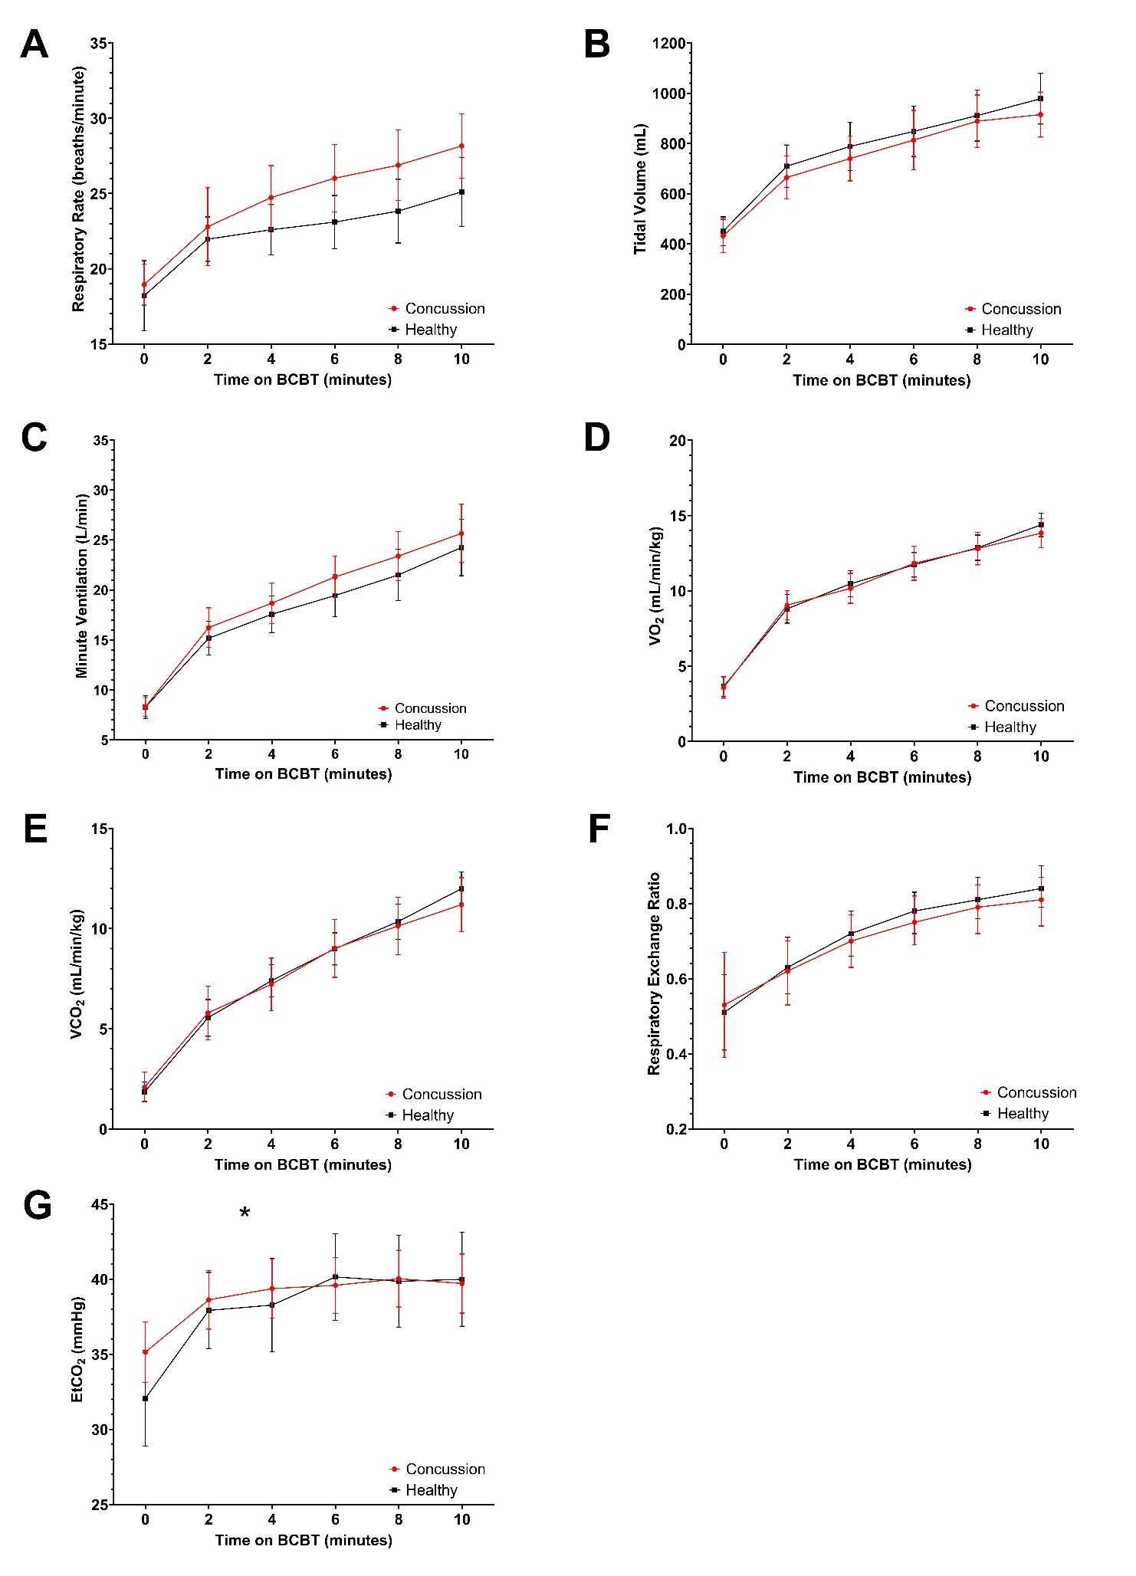
Table e3. Groupwise cardiovascular and respiratory responses during the final minute of exercise
 | Concussion Group | Healthy Group | p-value
Rating of Perceived Exertion | 14.81 ± 3.24 | 17.42 ± 1.95 | 0.001
Power output (watts) | 112.26 ± 30.80 | 150.12 ± 32.08 | < 0.001
Cardiovascular
Heart Rate (beats/minute) | 138.03 ± 30.56 | 165.35 ± 18.18 | < 0.001
Stroke Volume (mL) | 111.10 ± 23.69 | 115.36 ± 22.47 | 0.531
Cardiac Output (L/minute) | 15.18 ± 3.79 | 17.77 ± 2.44 | 0.008
Diastolic Blood Pressure (mmHg) | 78.57 ± 10.20 | 82.24 ± 9.58 | 0.211
Systolic Blood Pressure (mmHg) | 141.40 ± 20.11 | 148.54 ± 19.27 | 0.221
Mean Arterial Pressure (mmHg) | 105.35 ± 12.25 | 112.47 ± 15.14 | 0.082
Systemic Vascular Resistance (mmHg/L/min) | 7.75 ± 4.25 | 6.55 ± 1.99 | 0.222
Respiratory
Respiratory Rate (breaths/minute) | 35.12 ± 8.17 | 38.59 ± 8.37 | 0.167
Tidal Volume (mL) | 1094.26 ± 324.79 | 1259.99 ± 292.70 | 0.105
Minute Ventilation (L/minute) | 39.23 ± 12.04 | 48.66 ± 15.46 | 0.039
VO₂ (mL/min/kg) | 20.02 ± 4.28 | 25.58 ± 7.90 | 0.029
VCO₂ (mL/min/kg) | 17.45 ± 4.68 | 23.06 ± 8.08 | 0.022
RER (ratio) | 0.87 ± 0.11 | 0.89 ± 0.12 | 0.543
EtCO₂ (mmHg) | 37.20 ± 4.88 | 35.07 ± 6.63 | 0.230
Bolded values indicate a significant finding; EtCO₂: end-tidal CO₂; VO₂: oxygen consumption; VCO₂: carbon dioxide consumption; RER: respiratory exchange ratio.

Table e4. Medians and interquartile range for Table 2
 | Concussion |  |  | Healthy
 | Median | Percentile 25 | Percentile 75 | Median | Percentile 25 | Percentile 75
HR | 75.94 | 69.08 | 80.07 | 72.88 | 67.93 | 79.91
SV | 94.97 | 88.99 | 106.28 | 99.46 | 86.55 | 113.45
CO | 7.04 | 6.40 | 8.15 | 6.94 | 6.28 | 7.97
DBP | 72.06 | 69.16 | 74.56 | 74.23 | 69.95 | 81.44
SBP | 120.25 | 115.12 | 127.49 | 126.79 | 112.63 | 132.59
MAP | 93.32 | 89.17 | 95.89 | 95.16 | 90.44 | 102.26
SVR | 13.47 | 11.91 | 14.34 | 13.89 | 12.85 | 15.14
RR | 17.84 | 16.99 | 20.37 | 19.05 | 16.77 | 20.67
TV | 468.06 | 329.36 | 550.53 | 458.68 | 387.63 | 495.95
MV_in_L | 8.67 | 7.23 | 9.93 | 8.34 | 7.08 | 9.30
VO2 | 4.00 | 2.63 | 4.318 | 4.032 | 2.90 | 4.55
VCO2mlminkg | 2.01 | 1.23 | 3.05 | 1.88 | 1.19 | 2.46
RER | 0.54 | 0.40 | 0.64 | 0.50 | 0.44 | 0.61
EtCO2 | 33.31 | 32.59 | 38.11 | 34.06 | 31.23 | 35.69

