Leave-one-out Analysis
Removed study | IRR Estimate | 95% CI for IRR (lower) | 95% CI for IRR (lower) | Tau-square ($τ^{2}$) | I-square ($I^{2}$)
Al Attar et al. | 1.427 | 0.943 | 2.158 | 2.431 | 98.497
Bizzini et al. 1 | 1.359 | 0.911 | 2.027 | 2.268 | 98.41
Bizzini et al. 1 | 1.451 | 0.961 | 2.192 | 2.411 | 98.482
Bizzini et al. 1 | 1.41 | 0.933 | 2.131 | 2.423 | 98.488
Bizzini et al. 1 | 1.383 | 0.919 | 2.082 | 2.371 | 98.403
Bizzini et al.2 | 1.418 | 0.937 | 2.144 | 2.429 | 98.487
Bizzini et al.2 | 1.439 | 0.952 | 2.176 | 2.424 | 98.505
Bizzini et al.3 | 1.392 | 0.924 | 2.098 | 2.39 | 98.489
Bizzini et al.3 | 1.425 | 0.943 | 2.154 | 2.425 | 98.513
Bizzini et al.3 | 1.511 | 1.017 | 2.245 | 2.228 | 98.387
Bizzini et al.3 | 1.477 | 0.983 | 2.219 | 2.356 | 98.468
Bizzini et al.3 | 1.434 | 0.954 | 2.154 | 2.389 | 98.494
Bizzini et al.3 | 1.436 | 0.956 | 2.159 | 2.39 | 98.495
Bizzini et al.3 | 1.464 | 0.972 | 2.204 | 2.385 | 98.489
Bizzini et al.3 | 1.518 | 1.023 | 2.253 | 2.207 | 98.367
Bizzini et al.3 | 1.515 | 1.019 | 2.251 | 2.223 | 98.375
Bizzini et al.3 | 1.52 | 1.025 | 2.255 | 2.199 | 98.358
Bizzini et al. 4 | 1.367 | 0.914 | 2.044 | 2.302 | 98.435
Bizzini et al. 4 | 1.38 | 0.919 | 2.072 | 2.352 | 98.468
Bizzini et al. 4 | 1.5 | 1.004 | 2.241 | 2.282 | 98.407
Bizzini et al. 4 | 1.48 | 0.986 | 2.224 | 2.348 | 98.437
Bizzini et al. 4 | 1.447 | 0.959 | 2.183 | 2.41 | 98.505
Bizzini et al. 4 | 1.447 | 0.958 | 2.184 | 2.413 | 98.506
Da Silva et al. | 1.426 | 0.943 | 2.157 | 2.431 | 98.381
Da Silva et al. | 1.444 | 0.956 | 2.183 | 2.421 | 98.444
De Oliveiar et al. | 1.456 | 0.965 | 2.198 | 2.404 | 98.458
De Oliveiar et al. | 1.427 | 0.943 | 2.158 | 2.431 | 98.386
Gabrilo et al. | 1.394 | 0.924 | 2.103 | 2.398 | 98.455
Gabrilo et al. | 1.397 | 0.926 | 2.109 | 2.405 | 98.451
Gabrilo et al. | 1.392 | 0.923 | 2.1 | 2.394 | 98.469
Gabrilo et al. | 1.392 | 0.923 | 2.099 | 2.394 | 98.467
Kordi et al. | 1.354 | 0.909 | 2.016 | 2.245 | 98.384
Kordi et al. | 1.4 | 0.927 | 2.114 | 2.41 | 98.477
Kordi et al. | 1.375 | 0.916 | 2.064 | 2.341 | 98.452
Kordi et al. | 1.395 | 0.925 | 2.105 | 2.401 | 98.459
Matute-Llorente et al. | 1.43 | 0.946 | 2.162 | 2.429 | 98.506
Matute-Llorente et al. | 1.446 | 0.958 | 2.184 | 2.416 | 98.504
Matute-Llorente et al. | 1.4 | 0.927 | 2.113 | 2.409 | 98.466
Matute-Llorente et al. | 1.426 | 0.943 | 2.157 | 2.43 | 98.505
Matute-Llorente et al. | 1.402 | 0.928 | 2.118 | 2.413 | 98.473
Matute-Llorente et al. | 1.46 | 0.969 | 2.201 | 2.393 | 98.493
Matute-Llorente et al. | 1.467 | 0.975 | 2.208 | 2.377 | 98.484
Matute-Llorente et al. | 1.45 | 0.961 | 2.189 | 2.411 | 98.502
Matute-Llorente et al. | 1.467 | 0.975 | 2.208 | 2.377 | 98.484
Matute-Llorente et al. | 1.45 | 0.961 | 2.189 | 2.411 | 98.502
Moen et al. | 1.378 | 0.917 | 2.07 | 2.353 | 98.455
Paes et al | 1.416 | 0.937 | 2.141 | 2.427 | 98.506
Paes et al | 1.416 | 0.936 | 2.141 | 2.428 | 98.464
Senisik et al. | 1.411 | 0.933 | 2.132 | 2.423 | 98.501
Senisik et al. | 1.426 | 0.943 | 2.157 | 2.431 | 98.444
Szymski et al. | 1.437 | 0.951 | 2.172 | 2.424 | 98.51
Szymski et al. | 1.42 | 0.939 | 2.147 | 2.429 | 98.5
Szymski et al. | 1.407 | 0.931 | 2.125 | 2.42 | 98.419
Szymski et al. | 1.447 | 0.958 | 2.186 | 2.417 | 98.494
Szymski et al. | 1.453 | 0.962 | 2.193 | 2.409 | 98.488
Szymski et al. | 1.454 | 0.963 | 2.195 | 2.408 | 98.431
Viera et al. | 1.403 | 0.929 | 2.119 | 2.414 | 98.474
Viera et al. | 1.404 | 0.93 | 2.121 | 2.416 | 98.477
Wilson et al. New | 1.383 | 0.919 | 2.081 | 2.37 | 98.467
Wilson et al. New | 1.378 | 0.917 | 2.071 | 2.353 | 98.444

Publication Bias Funnel Plots
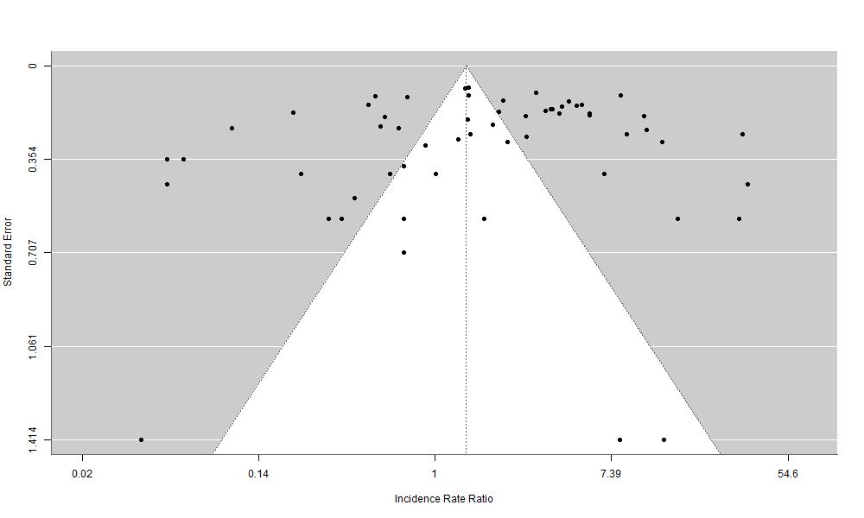
Funnel plot from original model

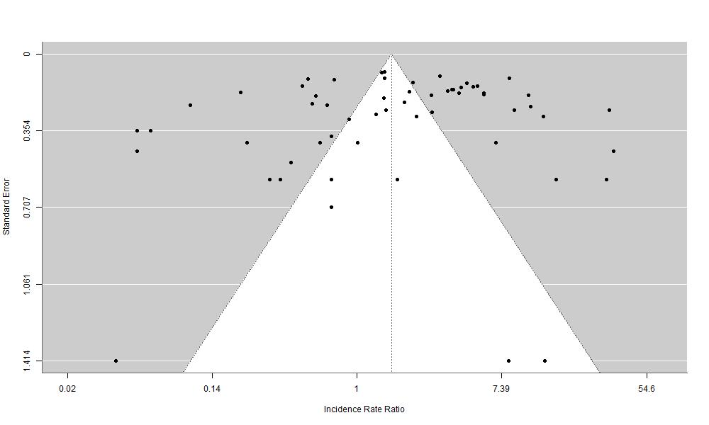
Funnel plot using mixed effect linear model on log incidence rate

Outliers Analysis
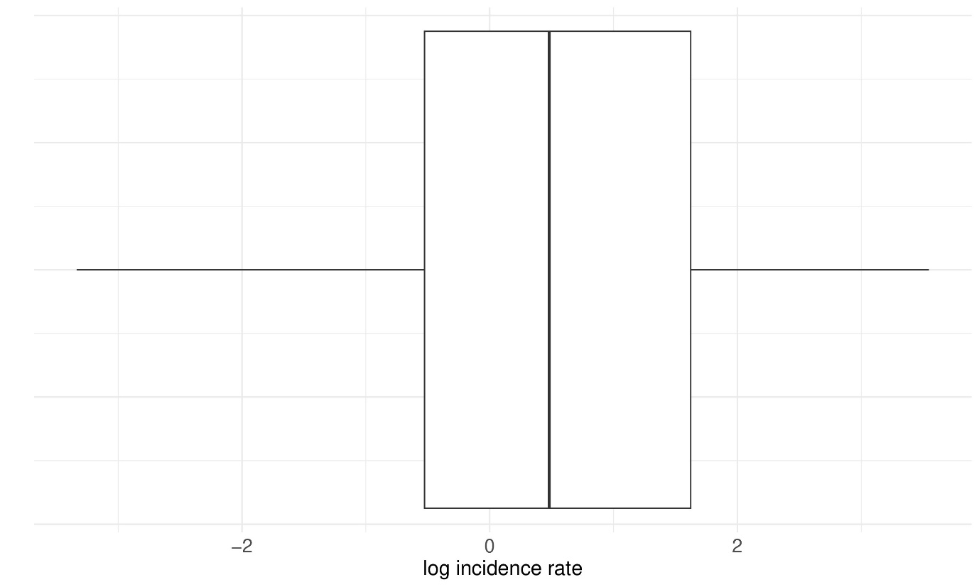
Box plot of log incidence rates

