Supplemental Figure 1. Probabilistic NCAA Women’s Volleyball simulation framework.
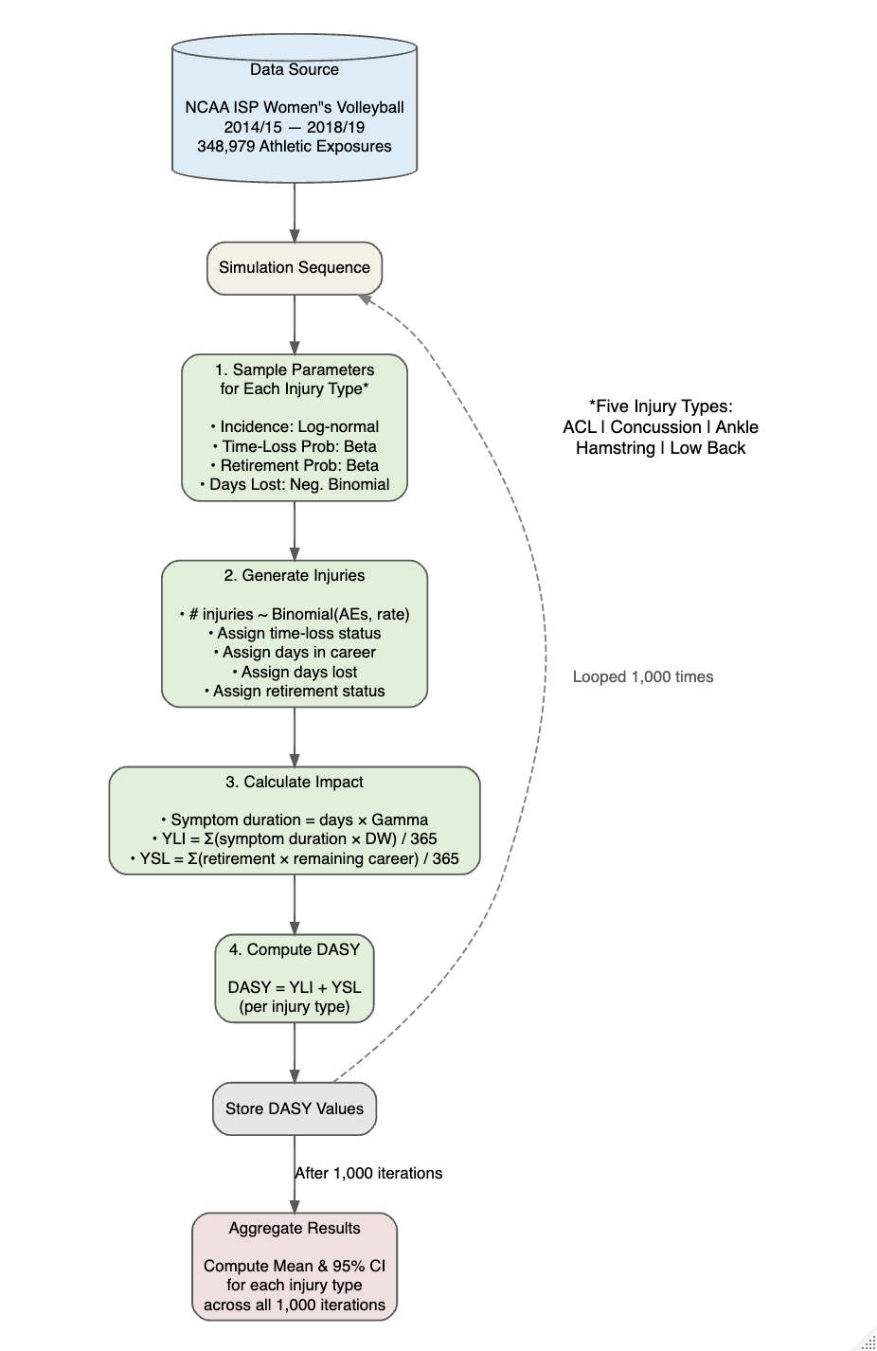
Supplemental Figure 2. A visual representation of the actuarial data used in the simulations.
