Supplementary materials
Title: 35 years of Joyner’s endurance performance model: Assessing the contribution of physiological determinants of performance proxies in 888 individuals ranging from recreational to world-class

Running heading: 35 years of Joyner’s endurance model: physiological determinants in 888 athletes

Authors: Loïs Mougin^{1 *#}, Stephen J. Bailey¹, Andrew M. Jones², Michael J. Joyner³, Stephen A. Mears¹, Rhona Pearce⁴, Michele Zanini^{1,5 *}

Affiliations
¹School of Sport, Exercise and Health Sciences, Loughborough University, Loughborough, UK
²Department of Public Health and Sport Sciences, University of Exeter, Exeter, UK
³Department of Anesthesiology & Perioperative Medicine, Mayo Clinic, Rochester, Minnesota, USA
⁴Loughborough Sport, Loughborough University, Loughborough, UK
⁵School of Education, Childhood, Youth and Sport, The Open University, Milton Keynes, UK

* Shared first authorship

# Correspondence
Loïs Mougin (L.m.b.h.mougin@lboro.ac.uk); +44 1509 226391; School of Sport, Exercise and Health Sciences, Loughborough University, Loughborough, Leicestershire LE11 3TU, UK.

Figure S1. Correlations between absolute power output at LT or LTP and V̇O₂max (A, B). The dotted line represents the linear regression (and 95% confidence intervals), blue dots represent males (n=351), and red dots represent females (n=42).
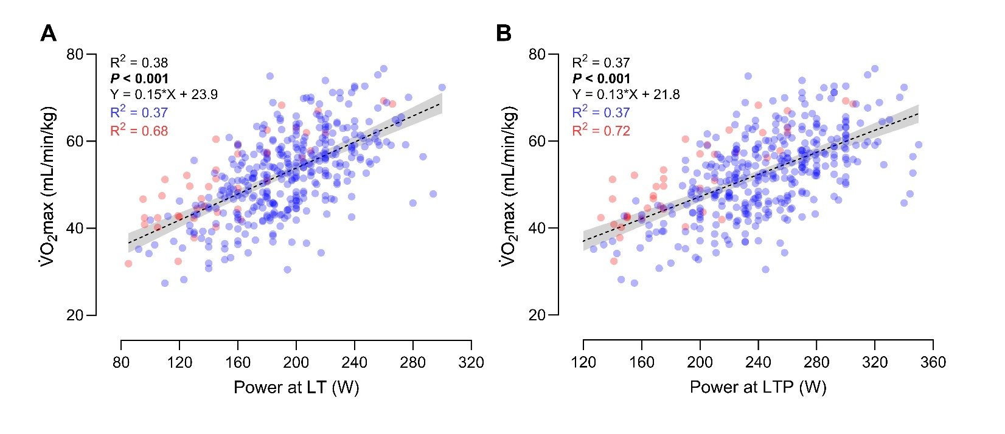
Table S1. Equation coefficients and R² of the multiple linear regression models to estimate speed or power at lactate threshold or lactate turnpoint from physiological determinants of endurance performance for each performance tertile.
 |  | Speed or Power at LT |  |  |  | Speed or Power at LTP
 |  | Coeff. | 95% CI |  | R² | Coeff. | 95% CI |  | R²
Running  (Lowest tertile) | C | 0.41 | -0.23 | 1.05 | 0.98 | 0.09 | -1.70 | 1.85 | 0.92
Running  (Lowest tertile) | V̇O₂max | 0.19 | 0.19 | 0.20 | 0.98 | 0.23 | 0.22 | 0.24 | 0.92
Running  (Lowest tertile) | RE | -0.040 | -0.042 | -0.039 | 0.98 | -0.042 | -0.045 | -0.038 | 0.92
Running  (Lowest tertile) | FU_{LT} - FU_{LTP} | 0.12 | 0.11 | 0.13 | 0.98 | 0.11 | 0.10 | 0.13 | 0.92
Running  (Middle tertile) | C | 1.74 | 0.83 | 2.65 | 0.93 | 2.40 | 0.64 | 4.17 | 0.86
Running  (Middle tertile) | V̇O₂max | 0.19 | 0.18 | 0.20 | 0.93 | 0.21 | 0.19 | 0.22 | 0.86
Running  (Middle tertile) | RE | -0.051 | -0.054 | -0.049 | 0.93 | -0.050 | -0.055 | -0.046 | 0.86
Running  (Middle tertile) | FU_{LT} - FU_{LTP} | 0.14 | 0.13 | 0.15 | 0.93 | 0.13 | 0.11 | 0.14 | 0.86
Running  (Highest tertile) | C | -0.14 | -1.00 | 0.71 | 0.98 | -0.81 | -2.68 | 1.07 | 0.93
Running  (Highest tertile) | V̇O₂max | 0.22 | 0.21 | 0.23 | 0.98 | 0.23 | 0.22 | 0.25 | 0.93
Running  (Highest tertile) | RE | -0.06 | -0.06 | -0.58 | 0.98 | -0.060 | -0.065 | -0.055 | 0.93
Running  (Highest tertile) | FU_{LT} - FU_{LTP} | 0.17 | 0.16 | 0.18 | 0.98 | 0.17 | 0.15 | 0.18 | 0.93
Cycling  (Lowest tertile) | C | 3.41 | -5.78 | 12.60 | 0.98 | 2.40 | -24.82 | 29.62 | 0.92
Cycling  (Lowest tertile) | V̇O₂max | 0.042 | 0.041 | 0.043 | 0.98 | 0.051 | 0.048 | 0.054 | 0.92
Cycling  (Lowest tertile) | CE | -9.18 | -9.55 | -8.81 | 0.98 | -8.74 | -9.66 | -7.82 | 0.92
Cycling  (Lowest tertile) | FU_{LT} - FU_{LTP} | 2.15 | 2.03 | 2.27 | 0.98 | 1.84 | 1.56 | 2.12 | 0.92
Cycling  (Middle tertile) | C | 6.35 | -0.51 | 13.20 | 0.98 | 21.15 | -12.82 | 55.13 | 0.84
Cycling  (Middle tertile) | V̇O₂max | 0.046 | 0.045 | 0.047 | 0.98 | 0.054 | 0.050 | 0.058 | 0.84
Cycling  (Middle tertile) | CE | -12.69 | -13.13 | -12.25 | 0.98 | -13.45 | -15.20 | -11.70 | 0.84
Cycling  (Middle tertile) | FU_{LT} - FU_{LTP} | 2.63 | 2.54 | 2.71 | 0.98 | 2.40 | 2.03 | 2.73 | 0.84
Cycling  (Highest tertile) | C | -4.40 | -13.73 | 4.73 | 0.97 | -12.59 | -52.58 | 27.39 | 0.84
Cycling  (Highest tertile) | V̇O₂max | 0.052 | 0.050 | 0.053 | 0.97 | 0.054 | 0.050 | 0.059 | 0.84
Cycling  (Highest tertile) | CE | -16.80 | -17.29 | -16.32 | 0.97 | -14.00 | -15.80 | -12.21 | 0.84
Cycling  (Highest tertile) | FU_{LT} - FU_{LTP} | 3.32 | 3.22 | 3.41 | 0.97 | 2.93 | 2.58 | 3.27 | 0.84

Correlation Matrix
Figure S2. Correlation matrix of running performance proxies and physiological determinants.
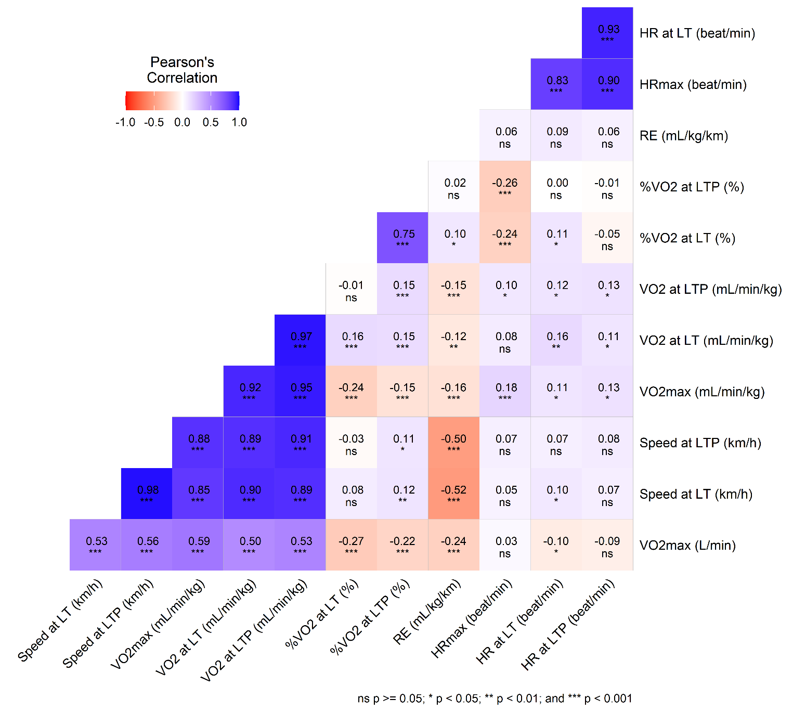

Figure S3. Correlation matrix of cycling performance proxies and physiological determinants
