Electronic Supplementary Material

Title:
Effects of Resistance Training on Muscle Hypertrophy in Children and Adolescents: A Systematic Review and Meta-Analysis

Running heading: Resistance Training and Muscle Growth in Youth

Journal:
Sports Medicine

Authors:
Yannik Komm¹, Linda Zeiler¹, Steffen Held², Paul Comfort³, Avery Faigenbaum⁴, Stephan Geisler⁵ & Claudia Augste¹
Corresponding Author: Yannik Komm; yannikkomm98@gmx.de

Affiliations:
[1] Institute for Sport Science, University of Augsburg, Augsburg, Germany
[2] Department of Sport and Management, IST University of Applied Sciences, Düsseldorf, Germany
[3] Human Performance Laboratory, Directorate of Psychology and Sport, University of Salford, Salford, UK
[4] Department of Kinesiology and Health Sciences, The College of New Jersey, Ewing, NJ, USA
[5] Department of Fitness and Health, IST University of Applied Sciences, Düsseldorf, Germany

Online Resource 1. Full electronic search strategies for each database

Scopus: TITLE-ABS-KEY
TITLE-ABS-KEY(("resistance training" OR "strength training" OR "weight training" OR "exercise training" OR "neuromuscular training") AND ("muscle hypertrophy" OR "muscle growth" OR "muscle mass" OR "muscle development" OR "muscle cross-sectional area" OR "muscle strength" OR "strength") AND ("children" OR "adolescents" OR "youth" OR "prepubertal" OR "pubertal" OR "puberty" OR "boy" OR "girl" OR "boys" OR "girls")) AND NOT TITLE-ABS-KEY("disease" OR "disorder" OR "syndrome" OR "pathology" OR "patients" OR "therapy" OR "rehabilitation" OR "injury" OR "cerebral palsy" OR "diabetes" OR "muscular dystrophy" OR "cancer" OR "growth hormone deficiency") -> 1880 documents
⎝ subject area exluded: Biochemistry, Genetics and Molecular Biology, Health Professions, Business,
Management and Accounting, Computer Science, Earth and Planetary Sciences, Arts and Humanities, Chemical Engineering, Engineering, Psychology, Immunology and Microbiology, Chemistry, Pharmacology, Toxicology and Pharmaceutics, Environmental Science, Social Sciences, Neuroscience, Agricultural and Biological Sciences, Nursing (accepted: medicine, multidisciplinary) -> 295 documents
⎝ limited to: English -> 272 documents

Pubmed (Advanced Search): All Fields
(“resistance training" OR "strength training" OR "weight training" OR "exercise training“ OR "neuromuscular training“) AND ("muscle hypertrophy" OR "muscle growth" OR "muscle mass" OR "muscle development" OR "muscle cross-sectional area" OR "muscle strength" OR "strength")
AND ("children" OR "adolescents" OR "youth" OR "prepubertal" OR "pubertal" OR "puberty" OR "boy" OR "girl" OR "boys" OR "girls") NOT ("disease" OR "disorder" OR "syndrome" OR "pathology" OR "patients" OR "therapy" OR "rehabilitation" OR "injury" OR "cerebral palsy" OR "diabetes" OR "muscular dystrophy" OR "cancer" OR „growth hormone deficiency")
-> 502 documents
⎝ subject area excluded: preprints -> 502 documents
⎝ limited to: English -> 497 documents
⎝ limited to: child-18 years -> 313 documents

Web of Science (Advanced Search): Topic
TS=((“resistance training" OR "strength training" OR "weight training" OR "exercise training“ OR
"neuromuscular training“) AND ("muscle hypertrophy" OR "muscle growth" OR "muscle mass" OR "muscle development" OR "muscle cross-sectional area" OR "muscle strength" OR "strength") AND ("children" OR "adolescents" OR "youth" OR "prepubertal" OR "pubertal" OR "puberty" OR "boy" OR "girl" OR "boys" OR "girls") NOT ("disease" OR "disorder" OR "syndrome" OR "pathology" OR "patients" OR "therapy" OR "rehabilitation" OR "injury" OR "cerebral palsy" OR "diabetes" OR "muscular dystrophy" OR "cancer" OR "growth hormone deficiency"))
-> 809 documents/results
⎝ subject area excluded: Review Article, Meeting Abstract, Early Access, Editorial Material, Letter, Proceeding Paper, Book Chapters, Book Review, Retracted Publication
-> 659 documents (accepted: articles)
⎝ limited to: English -> 629 documents

Google Scholar:
(intitle:"resistance training" OR intitle:"strength training" OR intitle:"weight training" OR intitle:"exercise training" OR intitle:"neuromuscular training") AND (intitle:"muscle hypertrophy" OR intitle:"muscle growth" OR intitle:"muscle mass" OR intitle:"muscle development" OR intitle:"muscle cross-sectional area" OR intitle:"muscle strength" OR intitle:"strength") AND (intitle:"children" OR intitle:"adolescents" OR intitle:"youth" OR intitle:"prepubertal" OR intitle:"pubertal" OR intitle:"puberty" OR intitle:"boy" OR intitle:"girl" OR intitle:"boys" OR intitle:"girls") -disease -disorder -syndrome -pathology - patients -therapy -rehabilitation -injury -cerebral palsy -diabetes -muscular dystrophy -cancer -growth hormone deficiency
-> ~ 722 documents „710 after verification“
⎝ specialized areas and limiting not possible! -> 710 documents

⎝ all together 1924 documents (3rd April 2025)
⎝ 674 duplicates (3rd of April 2025)
⎝ after duplicates removed: 1552 documents (6th of April 2025)

Online Resource 2. PEDro scale ratings for the methodological quality of the included studies

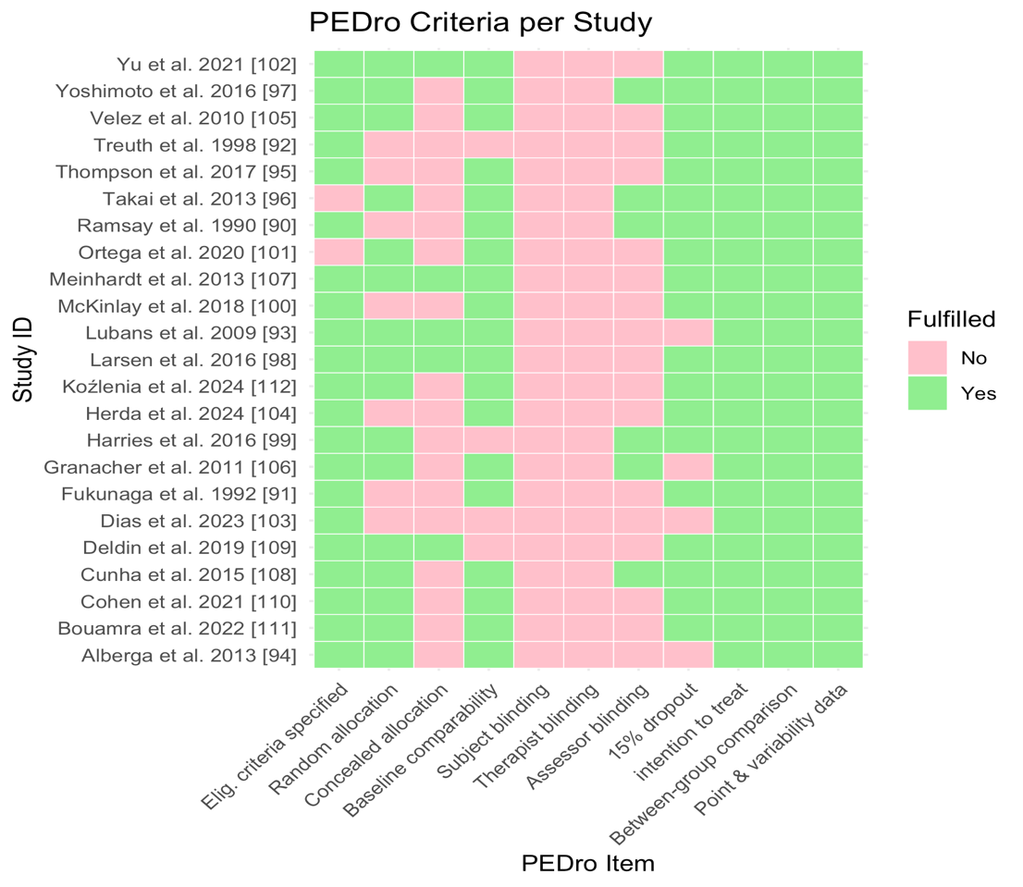

Online Resource 3. Funnel plot for studies with passive control groups
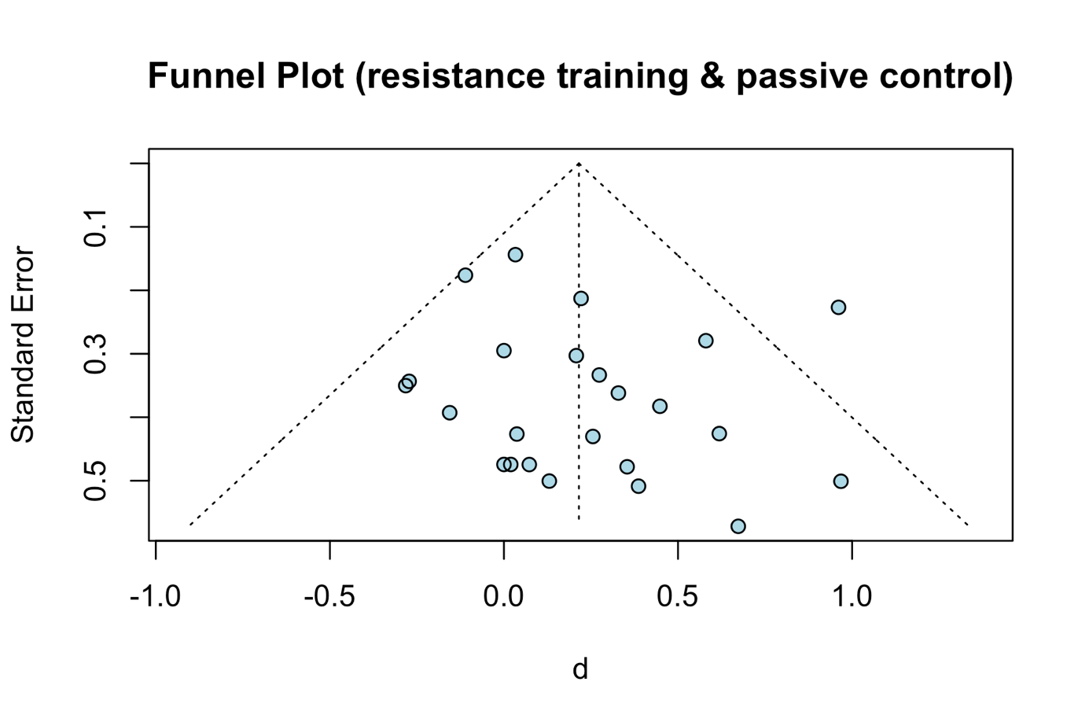
Online Resource 4. Funnel plot for studies with active control groups
