Online Resource 7. Splicing analyses of candidate variants

DNAH11:c.11497-6T>G
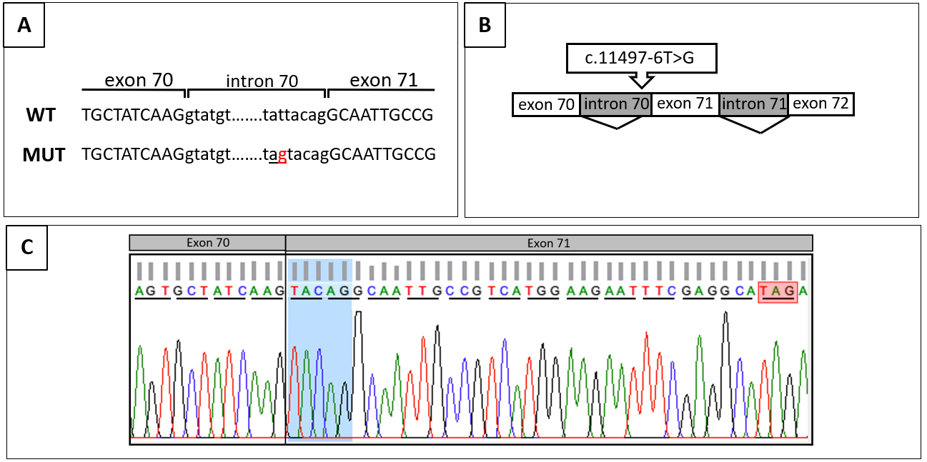
Analysis of the c.11497-6T>G variant in the DNAH11 gene found in patient 42241 in homozygosis. (A) Partial wild-type (WT) genomic sequence of DNAH11 (top) in comparison to the mutated (MUT) sequence (bottom). The red nucleotide indicates the point mutation found in this patient, and the underlined nucleotides indicate the new acceptor splicing site created because of the mutation. (B) Schematic representation of the aberrant splicing in DNAH11 gene caused by the c.11497-6T>G variant. (C) Electropherogram showing the cDNA assay results. The open reading frame (underlined) is conserved until the end of exon 70. Biallelic inclusion of the last five nucleotides of intron 70 (shadowed in blue) leads to a frameshift, creating a premature stop codon thirteen amino acids downstream of the mutation (red box).

DNAH9:c.2596-2dup
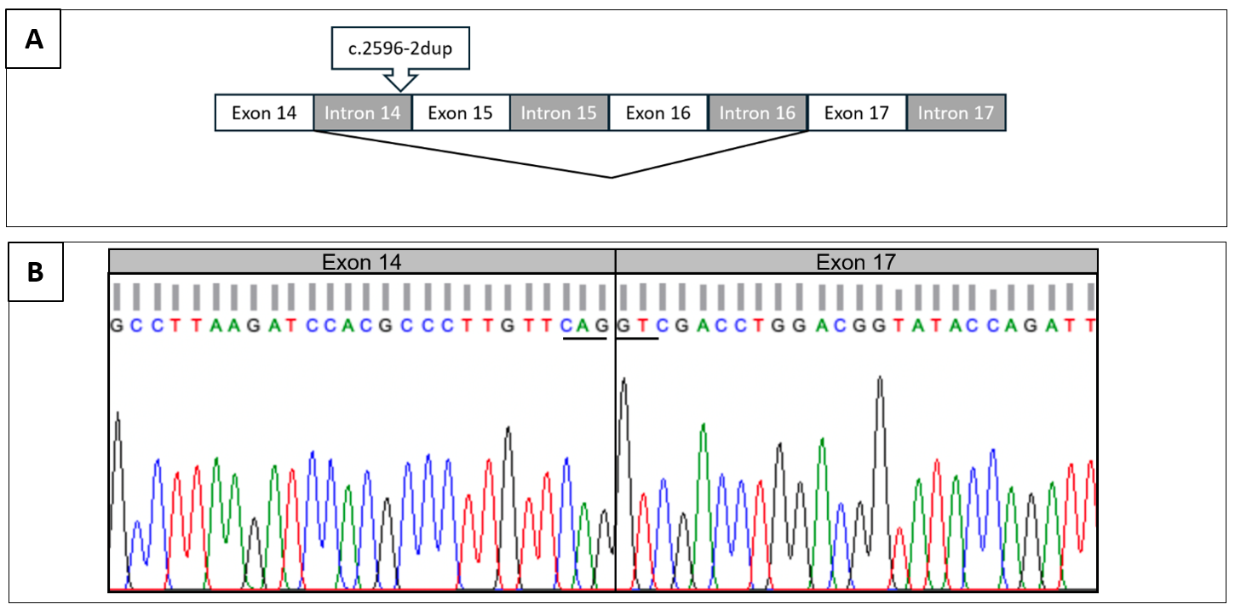
Analysis of the c.2596-2dup variant in the DNAH9 gene found in patient 43611 in heterozygous state. (A) Schematic representation of the aberrant splicing in the DNAH9 gene caused by the c.2596-2dup mutation. (B) Electropherogram showing the cDNA results (only the sequence of the mutated allele is shown). Total skipping of exons 15 and 16 occurred as a consequence of the detected variant. Given that exon 14 ends coding for a full triplet (glutamine, CAG, underlined) and that exon 17 starts coding for another complete triplet (valine, GTC, underlined), the reading frame is conserved.

CCDC40:c.2597A>G and CCDC40:c.2832G>A
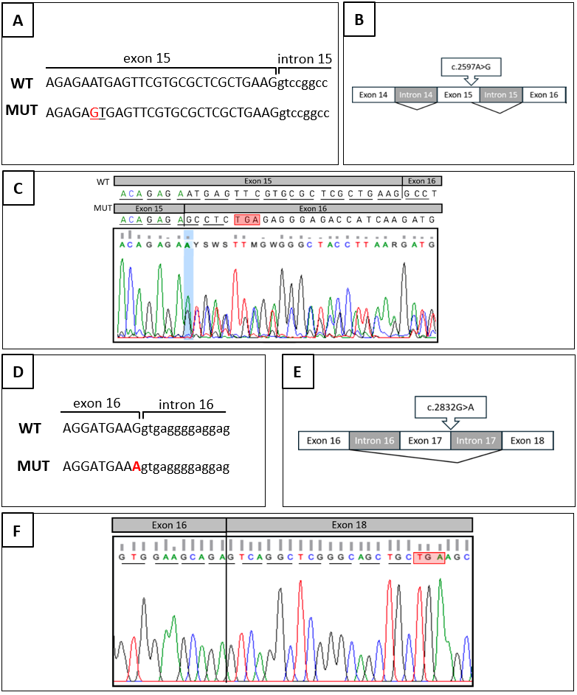
Analysis of the c.2597A>G (A-C) and c.2832G>A (D-F) variants in the CCDC40 gene found in patients 93733 and 93734. (A) Partial wild-type genomic sequence of exon 15 of CCDC40 (top) in comparison to the mutated sequence (bottom). The red nucleotide indicates the c.2597A>G mutation found in this family, and capital letters inside exon 15 indicate the donor splicing site created because of the mutation. (B) Schematic representation of the aberrant splicing of the CCDC40 gene caused by the c.2597A>G variant. (C) Electropherogram of cDNA analysis showing the effect of the c.2597A>G mutation. Owing to the small difference in length between the wild-type allele and the mutated one, both alleles were sequenced together and manually deciphered. The open reading frame is underlined on both alleles. The premature stop codon in the mutated allele is highlighted with a red box. (D) Partial wild-type genomic sequence of exon 16 of CCDC40 (top) in comparison to the mutated sequence (bottom). The red nucleotide indicates the c.2832G>A variant found in this family, and capital letters inside exon 15 indicate the donor splicing site created because of the mutation. (E) Schematic representation of the aberrant splicing in the CCDC40 gene caused by the c.2832G>A mutation. (F) Electropherogram result of the cDNA analysis showing the frameshift created by the c.2597A>G mutation. The open reading frame is underlined. A premature stop codon is created (red box) seven amino acids downstream of the mutation. Only the sequence of the mutated allele is shown.

