Supplementary table 1. Population characteristics of the patients with available lipoprotein(a) values compared to those without.
 | Patients WITH available Lp(a) levels | Patients WITHOUT available Lp(a) levels | p
n | 747 | 1188 | -
Demography
Male sex (n, %) | 474 (63.5) | 732 (61.6) | 0.445
Age (years) (mean (SD)) | 50.8 (13.0) | 50.1 (13.4) | 0.266
Cardiovascular risk factors
Hypertension, N (%) | 283 (37.9) | 473 (39.8) | 0.424
Hypertension duration, years (median [I-III QUARTILES]) | 10 [5, 15] | 7 [4, 15] | 0.105
Dyslipidaemia, N (%) | 358 (67.2) | 541 (58.1) | 0.001
Sedentary lifestyle, N (%) | 36 (33.0) | 190 (26.7) | 0.209
Smoking, N (%) | 133 (17.8) | 208 (17.6) | 0.327
Diabetes mellitus (n, %) | 65 ( 8.7) | 102 ( 8.6) | 0.989
Family history of CV events, N (%) | 111 (14.9) | 366 (30.8) | <0.001
Chronic kidney disease, N (%) | 14 ( 2.4) | 47 ( 4.4) | 0.068
Clinical parameters
WC, mg/dL (mean (SD)) | 90.8 (12.4) | 90.6 (12.99) | 0.734
BMI, Kg/m2 (mean (SD)) | 26.1 (3.9) | 25.8 (4.0) | 0.240
SBP, mmHg (mean (SD)) | 130.4 (17.5) | 134.1 (19.4) | <0.001
DBP, mmHg (mean (SD)) | 79.3 (13.6) | 82.9 (10.9) | <0.001
HR, bpm (mean (SD)) | 65.8 (10.4) | 66.0 (10.8) | 0.717
Biochemical variables
Total cholesterol, mg/dL (mean (SD)) | 195.6 (33.7) | 196.4 (35.1) | 0.634
HDL cholesterol, mg/dL (mean (SD)) | 55.4 (14.0) | 55.3 (14.6) | 0.875
LDL cholesterol, mg/dL (mean (SD)) | 120.6 (29.5) | 118.9 (32.2) | 0.344
Triglycerides, mg/dL (median [I-III QUARTILES]) | 90 [66, 127] | 93 [68, 133] | 0.117
Glucose, mg/dL (median [I-III QUARTILES]) | 88 [81, 98] | 86.00 [79, 95] | 0.001
Creatinine, mg/dL (median [I-III QUARTILES]) | 0.88 [0.80, 1] | 0.83 [0.71, 1] | 0.171
GFR, mL/min (mean (SD)) | 93.1 (17.5) | 93.7 (17.2) | 0.533
Cardiovascular drug therapies
ACE-I, N (%) | 173 (23.2) | 219 (18.4) | 0.014
ARBs, N (%) | 141 (18.9) | 221 (18.6) | 0.928
β-blockers, N (%) | 112 (15.0) | 173 (14.6) | 0.846
Calcium channel blockers, N (%) | 124 (16.6) | 225 (18.9) | 0.214
α-blockers, N (%) | 53 ( 7.1) | 81 ( 6.8) | 0.887
Diuretics, N (%) | 127 (17.0) | 233 (19.6) | 0.168
Statins, N (%) | 73 ( 9.8) | 80 ( 6.7) | 0.020
Hypertension Mediated Organ Damage
PWV, m/s (mean (SD)) | 8.0 (1.8) | 8.3 (1.9) | 0.001
PWV HMOD, N (%) | 77 (10.3) | 160 (13.5) | 0.047
IMT, mm (mean (SD)) | 0.66 (0.19) | 0.63 (0.18) | <0.001
IMT HMOD, N (%) | 51 (7.2) | 78 (6.8) | 0.768
Carotid Plaque, N (%) | 148 (19.8) | 176 (14.8) | 0.005
LVMI, g/m² (mean (SD)) | 55.7 (13.9) | 56.0 (15.4) | 0.685
LVH, N (%) | 4 (0.7) | 14 (1.4) | 0.259
LVEF, % (mean (SD)) | 63.2 (4.5) | 63.4 (3.9) | 0.440
List of abbreviations: ACE-I = Angiotensin-Converting Enzyme Inhibitors; ARBs = Angiotensin Receptor Blockers; WC = Waist Circumference; BMI = Body Mass Index; PWV = Pulse Wave Velocity ; HMOD = Hypertension Mediated Organ Damage; SBP = Systolic Blood Pressure; DBP = Diastolic Blood Pressure; HR = Heart Rate; GFR = Glomerular Filtration Rate; HDL = High-Density Lipoprotein; LDL = Low-Density Lipoprotein; IMT = Intima-Media Thickness; LVMI = Left Ventricular Mass Index; LVH = Left Ventricular Hypertrophy; DecTime = Deceleration Time ; LVEF Left Ventricular Ejection Fraction= ; Lp(a) = Lipoprotein(a).

Supplementary table 2. Coefficient of variability (%) of the evaluated HMOD.
 | Intra-session within-operator | Intra-session between-operator | Inter-session within-operator
PWV | 2.1 | 4.2 | 4.0
LVMI | 2.3 | 2.9 | 2.8
IMT | 2.5 | 2.0 | 3.9

List of abbreviations: PWV = Pulse Wave Velocity ; HMOD = Hypertension Mediated Organ Damage; LVMI = Left Ventricular Mass Index; IMT = Intima-Media Thickness.

Supplementary table 3. incidence values (with 95% confidence interval) at 5 and 10 years for the three evaluated outcomes.
 | Lp(a)>50 | Lp(a)≤50 | p-value
5 years incidence values (with 95% confidence interval)
CV events | 6.2% (2.8%-9.6%) | 5.1% (3.2%-7.0%) | 0.701
Mortality | 1.0% (0%-2.5%) | 1.5% (0.5%-2.6%) | 0.910
Composite outcome | 6.7% (3.2%-10.3%) | 6.4% (4.3%-8.5%) | 1
10 years incidence values (with 95% confidence interval)
CV events | 10.2% (5.8%-14.6%) | 8.6% (6.2%-11.0%), | 0.717
Mortality | 3.8% (1.0%-6.5%) | 4.2% (2.5%-6.0%) | 1
Composite outcome | 12.3% (7.6%-17.1%) | 11.5% (8.8%-14.2%). | 0.934

List of abbreviations: Lp(a) = Lipoprotein(a); CV = cardiovascular.

Supplementary figure 1. Scatterplots with trend lines showing the relationship between Lipoprotein(a) and continuous hypertension-mediated organ damage variables in hypertensive subjects (panel A) and normotensive one (panel B). Spearman correlation index and p-value are shown.
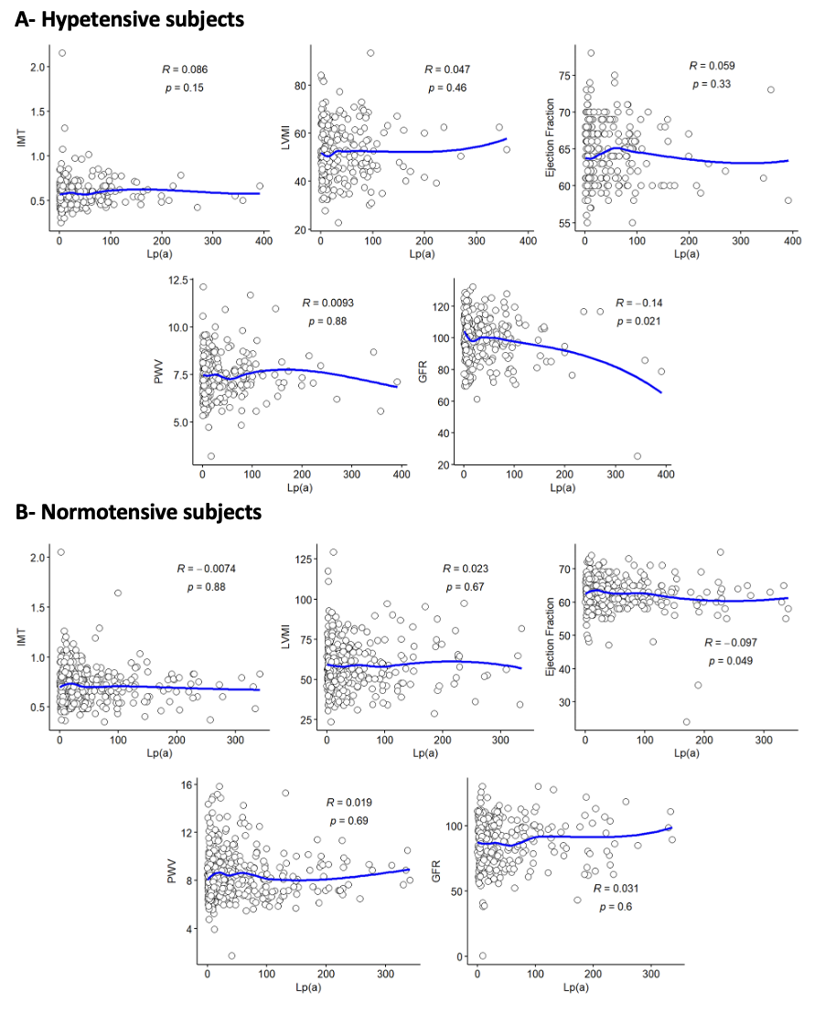
List of abbreviations: Lp(a) = Lipoprotein(a); PWV = Pulse Wave Velocity; LVMI = Left Ventricular Mass Index; GFR = Glomerular Filtration Rate; IMT = Intima-Media Thickness.

Supplementary figure 2. Boxplots showing the distribution of Lipoprotein(a) levels according to categorical hypertension-mediated organ damage outcomes in hypertensive subjects (panel A) and normotensive one (panel B). Mann-Whitney test p-values are shown. Point and error bars represent mean ± SD.
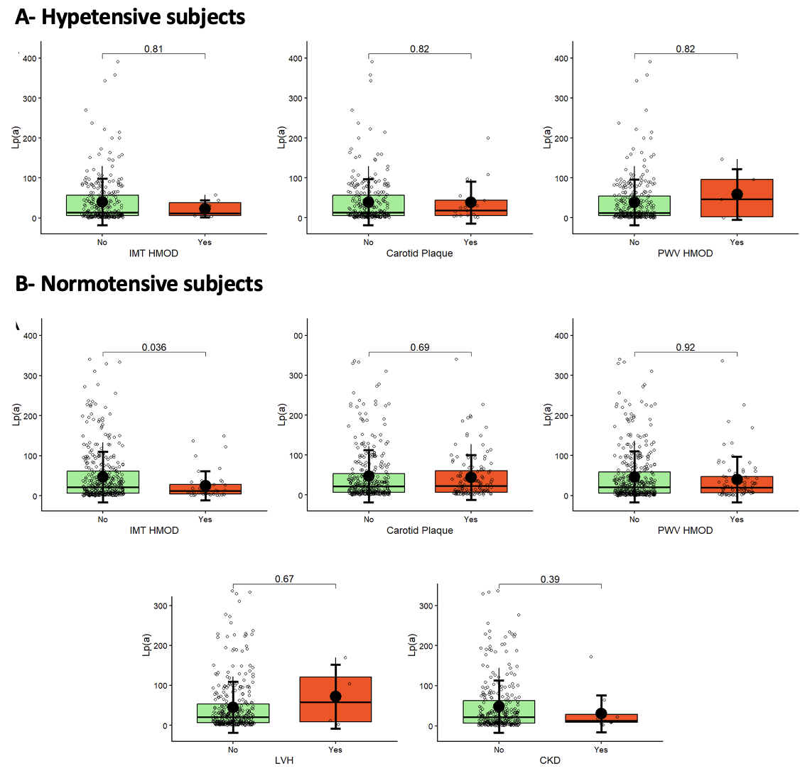
List of abbreviations: Lp(a) = Lipoprotein(a); IMT = Intima Media Thickness; HMOD = Hypertension Mediated Organ Damage; LVH = Left Ventricular Hypertrophy; PWV = Pulse Wave Velocity; CKD = Chronic Kidney Disease.

