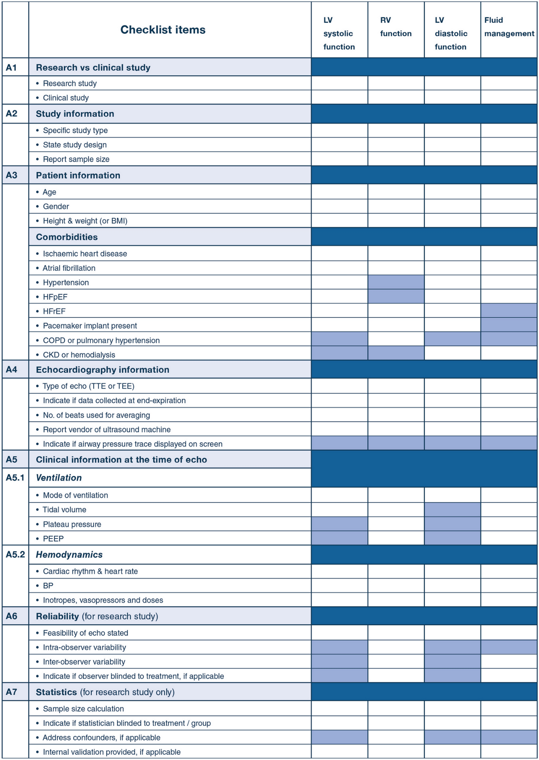
Not Applicable
Not Applicable
Not Applicable
Not Applicable
Not Applicable
Not Applicable

