Electronic Supplementary Material
Clinical Characteristics and Management of Children and Adults with Neurofibromatosis Type 1 and Plexiform Neurofibromas in Denmark:
A Nationwide Study

Cecilie Ejerskov¹, Stense Farholt², Flemming Secher Kromann Nielsen³, Ingunn Berg¹, Stine Bogetofte Thomasen¹, Aparna Udupi⁴, Trude Ågesen⁵, Sofie de Fine Licht⁵, Mette Møller Handrup¹

¹Centre for Rare Diseases, Paediatric and Adolescent Medicine, Aarhus University Hospital, Aarhus, Denmark
²Centre for Rare Diseases, Paediatric and Adolescent Medicine, Rigshospitalet, Copenhagen, Denmark
³Department of Radiology, Aarhus University Hospital, Aarhus, Denmark ⁴Biostatistical Advisory Service (BIAS), Faculty of Health, Aarhus University, Aarhus, Denmark
⁵AstraZeneca Nordic, Södertälje, Sweden

Correspondence to Dr Cecilie Ejerskov, Centre for Rare Diseases, Paediatric and Adolescent Medicine, Aarhus University Hospital, Aarhus, Denmark; cecilie@ejerskov.dk

Detailed methodology of MRI analysis of PN size
Plexiform neurofibroma (PN) tracking was performed using the Multi-Modality Tumor Tracking software (Philips Healthcare, Intellispace Portal). After having loaded the relevant sequence into Intellispace, the tumour tracking module was selected. Then, after locating a slice containing the PN, the ‘smart region of interest (ROI)’ function was chosen (Fig. S1a) and the PN was marked with the cursor (Fig. S1b), after which the software performed the initial PN demarcation (Fig. S1c). The ‘draw-to-add’ function was then chosen so that the initial outline of the PN could be expanded and adjusted (Fig. S1d) until the tumour segmentation corresponded with the visual assessment of PN (Fig. S1e).
The segmentation process was then performed on consecutive slices. As seen in Fig. S2a, the software segmentation performed on one slice included similar areas on consecutive slices (Fig. S2b–2d), meaning that part of the PN was already outlined. The ‘draw-to-add’ function was once again chosen to expand and adjust the PN volume correspondingly. This process was continued on all slices until the entire volume of PN was segmented.
Every step of the segmentation could be reversed using the ‘draw-to-remove’ function (Fig. S2b). In this example, the automated segmentation included healthy tissue without PN. The ‘draw-to-remove’ function was used to remove segmentation of healthy tissue (Fig. S2c) until the segmentation corresponded with the visual assessment of PN (Fig. S2d). The program yielded a volume (in cm³) and the widest length and height of the segmented area (in cm) (Fig. S1e).
Fluid sensitive sequences were preferred, especially Short Tau Inversion Recovery, proton density fat saturation (FS) or T2-weighted FS sequences since these are known to clearly demarcate NF. Fluid sensitive sequences were not available in a few patients and volume measurements were performed on T1-, T2- or proton density-weighted sequence (without FS).

Fig. S1
A patient with PN extending from the pelvis to the femur. The ‘smart ROI’ function is chosen (a) and the PN area is marked using the cursor (b) (faint green outline). The initial PN segmentation is outlined in red (c). The ‘draw-to-add’ function is then chosen to allow the initial PN outline to be expanded and adjusted (d), until the entire area is segmented

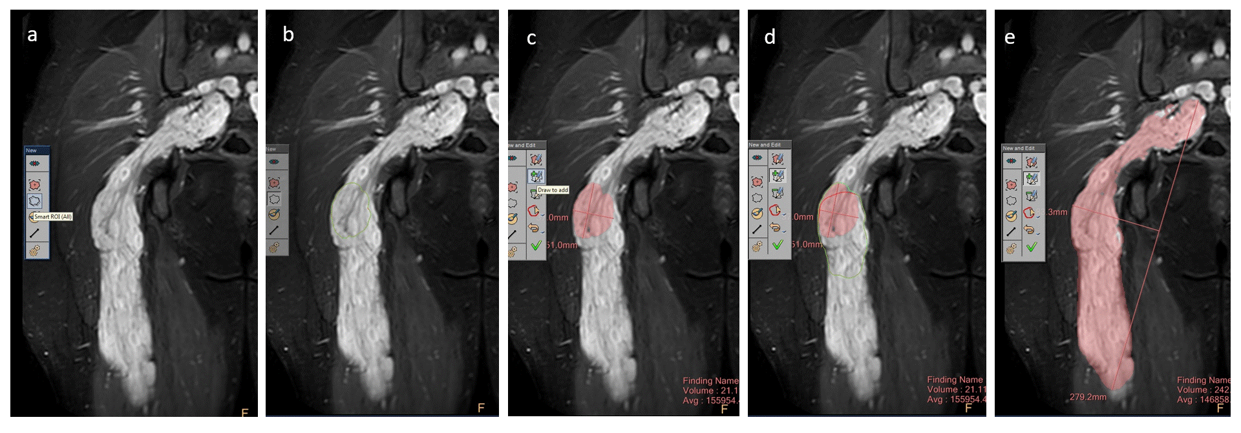

PN plexiform neurofibroma
Fig. S2
A neighbouring slice to that shown in Fig. S1 showing how the software segments similar areas on neighbouring slices yielding an acceptable fit (a). Automated segmentation is less accurate on consecutive slices (b). The ‘draw-to-remove’ function was chosen, and healthy tissue was subtracted from the segmentation (c) sequentially (d). The process of ‘draw to add’ and ‘draw to remove’ was continued until the segmentation corresponded to the original visual assessment of PN

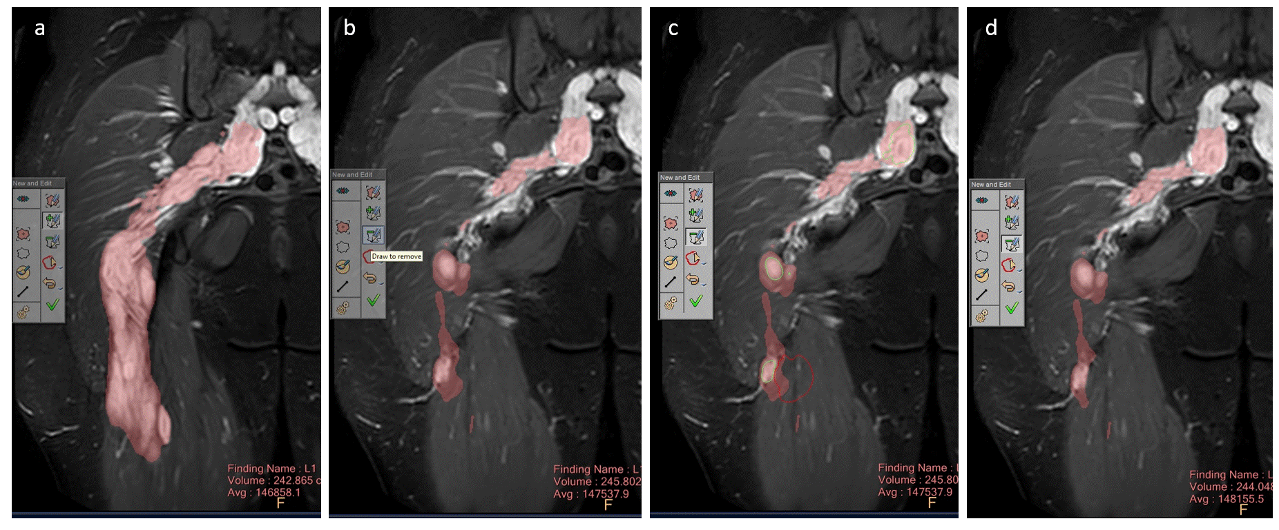
PN plexiform neurofibroma
Fig. S3
Medical chart review
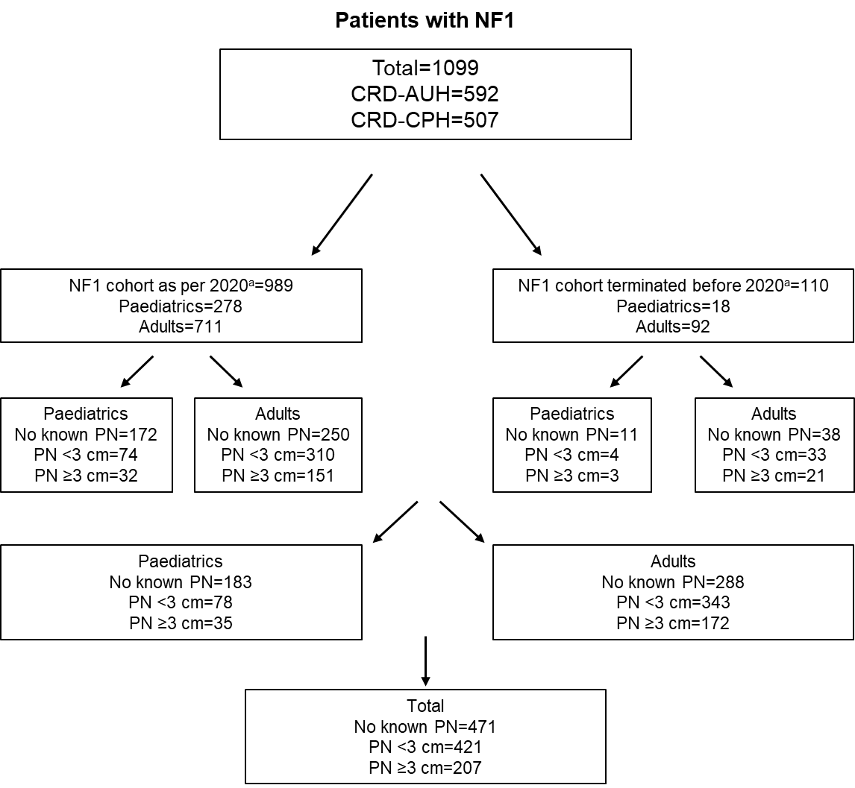
CRD-AUH Centre for Rare Diseases at Aarhus University Hospital, CRD-CPH Centre for Rare Diseases at Rigshospitalet Copenhagen, NF1 neurofibromatosis type 1, PN plexiform neurofibroma
ªAs per 1 July 2020

Fig. S4
Cumulative incidence of large plexiform neurofibromas (≥3 cm) in paediatric and adult patients after diagnosis of NF1
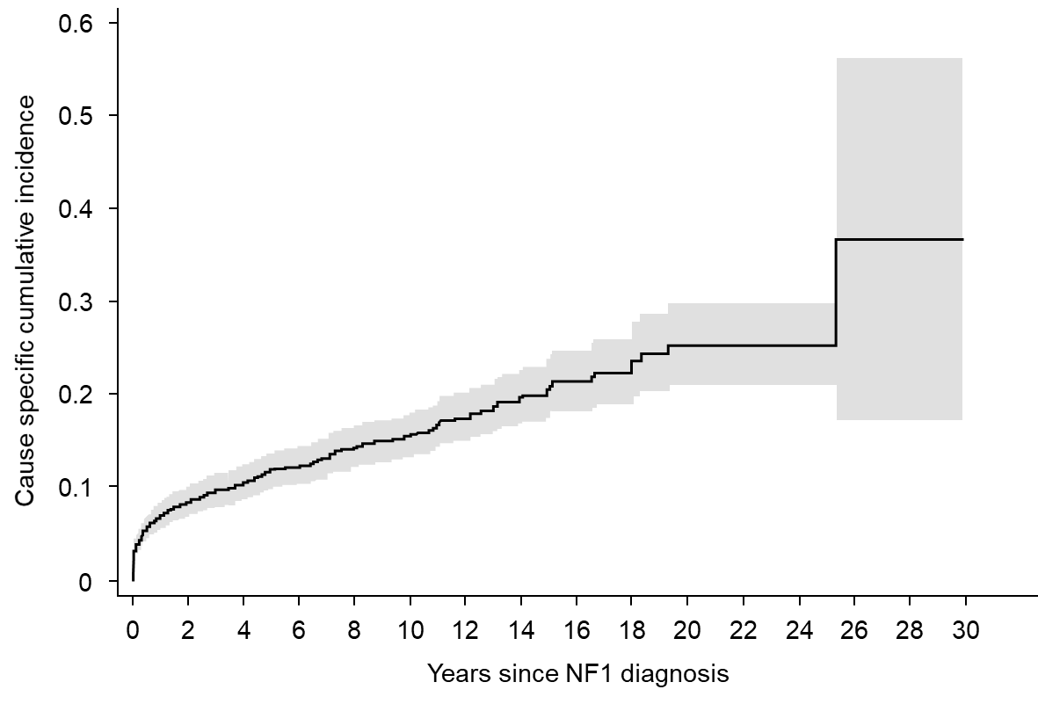
NF1 neurofibromatosis type 1

Table S1 Baseline characteristics of patients (paediatric and adult) with NF1 and PN with records closed prior to data cut-offª
Characteristic |  | Patients with small PN  (<3 cm,  n=37) | Patients with large PN  (≥3 cm,  n=24^{b}) | All patients with PN  (n=61)
Sex, n (%) | Female | 19 (51) | 15 (63) | 34 (56)
Sex, n (%) | Male | 18 (49) | 9 (38) | 27 (44)
Duration of follow-up,  median (range), years |  | 7.9  (0.1–16.5) | 11.6  (0.1– 27.7) | 9.2  (0.1–27.7)
Age at NF1 diagnosis,  median (range), years |  | 24.5  (3.0–62.0) | 19.9  (0.6–60.7) | 22.9  (0.6–62.0)
Age at diagnosis of first PN,  median (range), years^{b} |  |  | 17.4 (0–64.6)
Age at diagnosis of first PN, years, n (%)^{c} | 0–1 | — | 1 (4)
Age at diagnosis of first PN, years, n (%)^{c} | 2–5 | — | 1 (4)
Age at diagnosis of first PN, years, n (%)^{c} | 6–10 | — | 3 (13)
Age at diagnosis of first PN, years, n (%)^{c} | 11–17 | — | 5 (21)
Age at diagnosis of first PN, years, n (%)^{c} | 18–29 | — | 3 (13)
Age at diagnosis of first PN, years, n (%)^{c} | 30–39 | — | 1 (4)
Age at diagnosis of first PN, years, n (%)^{c} | 40–49 | — | 1 (4)
Age at diagnosis of first PN, years, n (%)^{c} | 50–59 | — | 2 (8)
Age at diagnosis of first PN, years, n (%)^{c} | 60–69 | — | 2 (8)
Number of large PN/patient, mean ± SD |  | — | 1.1 ± 0.3 | —
Number of large PN/patient,  n (%) | 1 | — | 17 (71) | —
Number of large PN/patient,  n (%) | 2 | — | 2 (8) | —
NF1 neurofibromatosis type 1, PN plexiform neurofibroma, SD standard deviation
ªReasons for records closure include not returning for follow-up for ≥5 years (7 paediatric and 26 adult patients); request to be terminated from follow-up (5 paediatric and 11 adult patients); death (2 paediatric and 46 adult patients); emigration (2 paediatric and 3 adult patients); transfer to the other centre for rare disease and subsequent loss to follow-up (2 paediatric and 6 adult patients)
^{b}Three paediatric and 21 adult patients
^{c}Data on age at first diagnosis of first PN are missing for five patients

