Electronic Supplementary Appendix
Internal Psychometric Validation of a Burden of Illness International Survey for Idiopathic Multicentric Castleman Disease

AUTHORS
Matthew Franklin¹, Francis Shupo², Grace Wayi-Wayi², Natasa Zibelnik², Emily Jones³, Nicola Mason³, John Brazier¹, Sudipto Mukherjee⁴

AFFILIATIONS
¹Sheffield Centre for Health and Related Research (SCHARR), University of Sheffield, Sheffield UK, ²EUSA Pharma, Hemel Hempstead, United Kingdom,³Lumanity, London, UK, ⁴Department of Hematology and Medical Oncology, Taussig Cancer Institute, Cleveland Clinic, Cleveland, OH, USA

CORRESPONDING AUTHOR
Dr Sudipto Mukherjee
Director of Rare Cancers and Blood Diseases
Assistant Professor, Lemer College of Medicine at Case Western Reserve University
Cleveland Clinic Taussig Cancer Institute
Department of Hematology and Medical Oncology
Address: 10201 Carnegie Avenue, Cleveland, Ohio 44195, USA
E-mail: mukher2@ccf.org
Tel: 216-444-0506

ORCID
Matthew Franklin 0000-0002-2774-9439
Francis Shupo 0000-0001-5063-574X
Grace Wayi-Wayi 0009-0007-9825-3987
Natasa Zibelnik 0009-0001-7011-6004
Emily Jones 0009-0005-4707-9152
Nicola Mason 0000-0002-8805-8631
John Brazier 0000-0001-8645-4780
Sudipto Mukherjee 0000-0002-8325-2603

Appendix S1: Overview of sections and questions used for psychometric analyses
The survey included specific sections such as:
- Introduction: i.e., an overview of the survey.
- About you: i.e., covering descriptive statistics about the patient responder such as age and gender.
- Symptoms: i.e., attributable to a person’s iMCD and affects such as on daily life.
- Treatment: i.e., if receiving treatment or not, and affects such as on daily life.
- Impact of iMCD on your daily life: e.g., overall aspects of daily life, activities, work or education.
- Looking to the future: e.g., thoughts and changes to improve their life in the future.
For the purpose of this psychometric analysis, the focus is on specific sections and questions:
- About you: for the purpose of generating descriptive statistics (e.g., age, gender, country of residence).
- Symptoms, Q12 “Over the past week, what symptoms have you experienced that you attribute to your iMCD”, for which 26 pre-defined symptoms are response options alongside stating ‘no symptoms’ or ‘other, please specify [as free text]’: abnormal pain, anxiety, bloating, cough, depression, dizziness, dry mouth, fever, forgetfulness, headaches, impaired cognitive function (learning, thinking, and reasoning), loss of appetite, nausea/vomiting, night sweats, numbness/tingling, persistent itching, shortness of breath, sluggishness, sores or rashes, stupor/feeling lethargic, sweating/hot flashes, swollen lymph nodes, tiredness, weakness (physical), weight gain, and weight loss.
- Symptoms, Q13 “Please rate how the symptoms you currently experience affect your daily life”, for which the person could respond to five severity options for any of the 26 pre-defined symptoms or ‘other’ symptoms the person reported.
- Symptoms, Q15 “How do the symptoms you attribute to your iMCD affect specific aspects of your life?”, across 11 aspects of daily life: ability to travel, diet, emotional and psychological wellbeing, financial wellbeing, general routine, mobility, pain/discomfort, personal relationships, sexual functioning, social life, work/education.
- Treatment, Q19 “What type(s) of treatment(s) do you currently receive to manage your iMCD?”, with four response options being specific types of treatment and one other option being ‘no treatment’.
- Impact of iMCD on your daily life, Q33 “How much of an effect does iMCD currently have on your daily life?”, across the same 11 aspects of daily life outlined for Q15.
Each of the five severity options (i.e., related to effects on daily life specific to Q13, Q15, and Q33) were retrospectively assigned a Likert scale numerical value from 0 to 4, assigned as follow:
- 0 = “Does not affect my daily life” (i.e., none);
- 1 = “Slightly affects my daily life” (i.e., slight);
- 2 = “Moderately affects my daily life” (i.e., moderate);
- 3 = “Severely affects my daily life” (i.e., severe);
- 4 = “Very severely affects my daily life” (i.e., very severe)
The aforementioned constitutes the specific questions and numerical coding for the psychometric analysis.
Hypothesis set 1, Fig. S1 shows the convergent hypotheses derived from symptoms prioritised based on the most common symptoms experienced and those links noted to be strongest by experts.

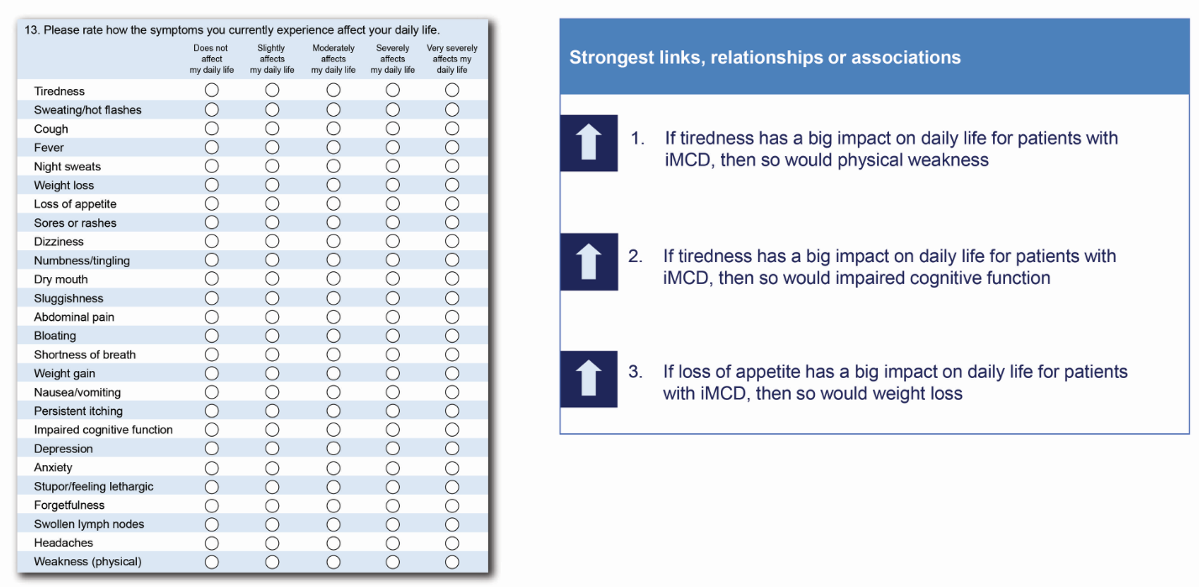
Fig. S1 Hypothesis set 1 – Convergent: specific paired symptoms’ related patient-reported effect on daily life
Hypothesis set 1, Fig. S2 shows the divergent/discriminant hypotheses derived from symptoms prioritised based on the most common symptoms experienced and those links noted to be weakest by experts. Including where no link is perceived to exist.
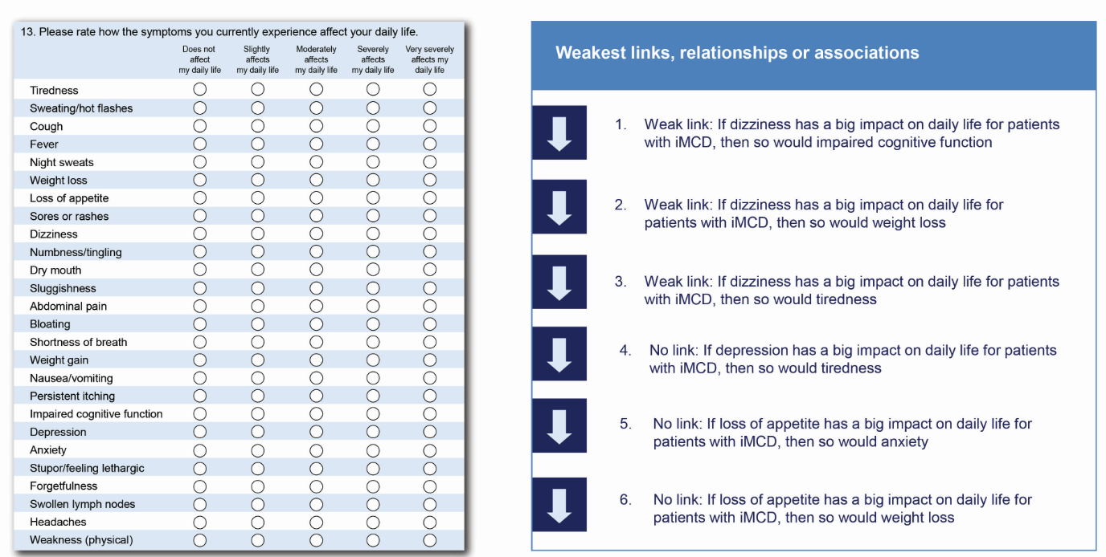
Fig. S2 Hypothesis set 1 – Divergent: specific paired symptoms’ related patient-reported effect on daily life

Hypothesis set 2 is depicted in Fig. S3 and explored the number of symptoms had on aspects of daily life.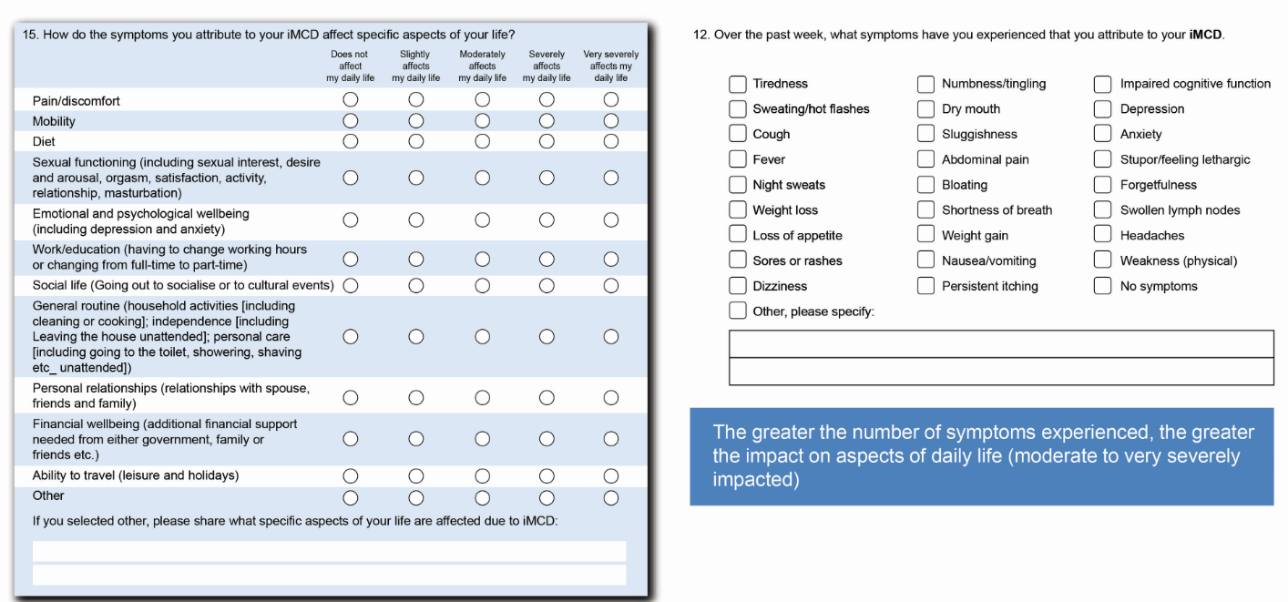
Fig. S3 Hypothesis set 2 – Number of symptoms and patient-reported effect of symptoms on aspects of daily life
Hypothesis set 3: Known group hypotheses derived from effect size between groups to indicate an expected direction i.e., being treated with IV infusions for iMCD or not affects an outcome score (e.g., summary score representing impact on daily life). This is shown in Fig. S4.
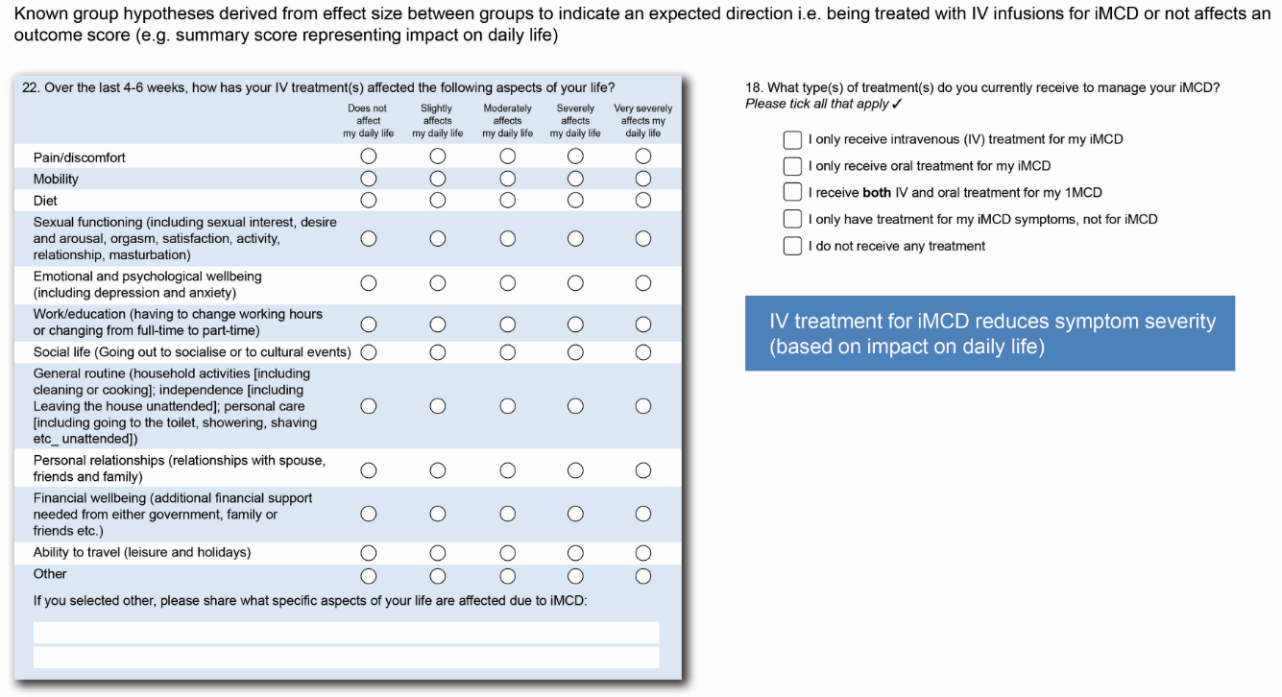
Fig. S4 Hypothesis set 3 – Receiving iMCD treatment or not and patient-reported effect of treatment on aspects of daily life

The symptoms experienced by patients is presented in Fig. S5. Five patients experienced no symptoms.
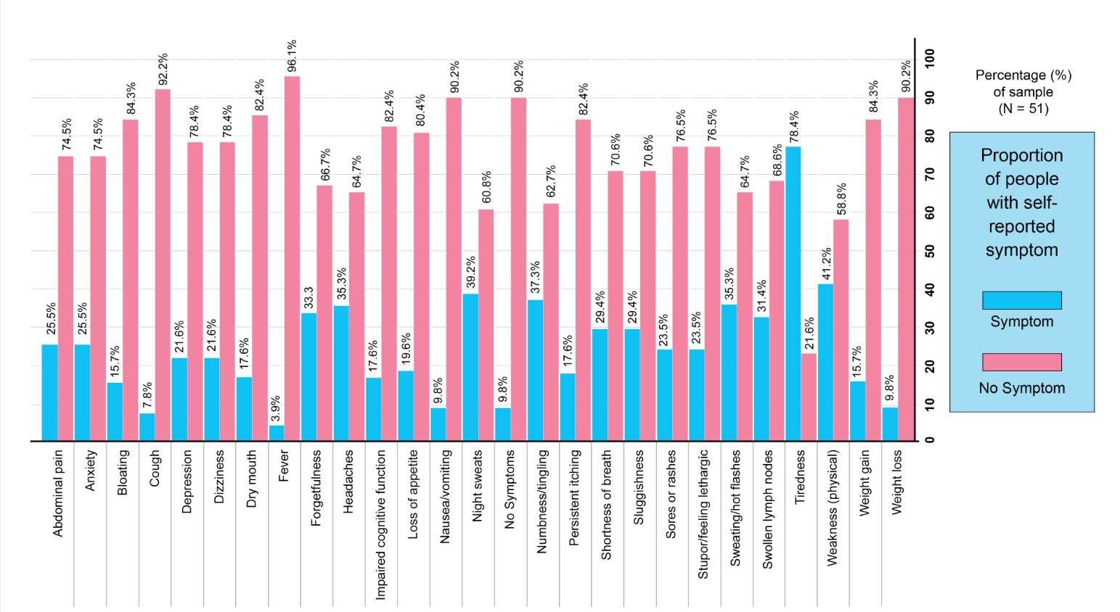
Fig. S5 iMCD patient-reported symptoms

