Supplementary Material
Figures
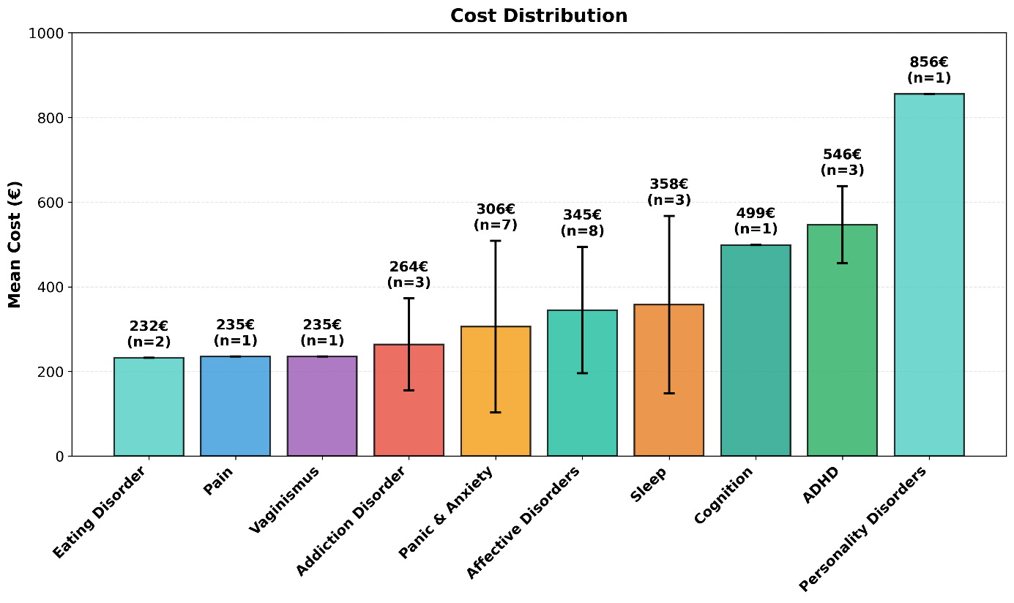
Figure S1: Cost Distribution of Digital Health Applications(DiGAs) by Condition
Mean cost distribution of DiGAs across different conditions. Error bars represent standard deviation.

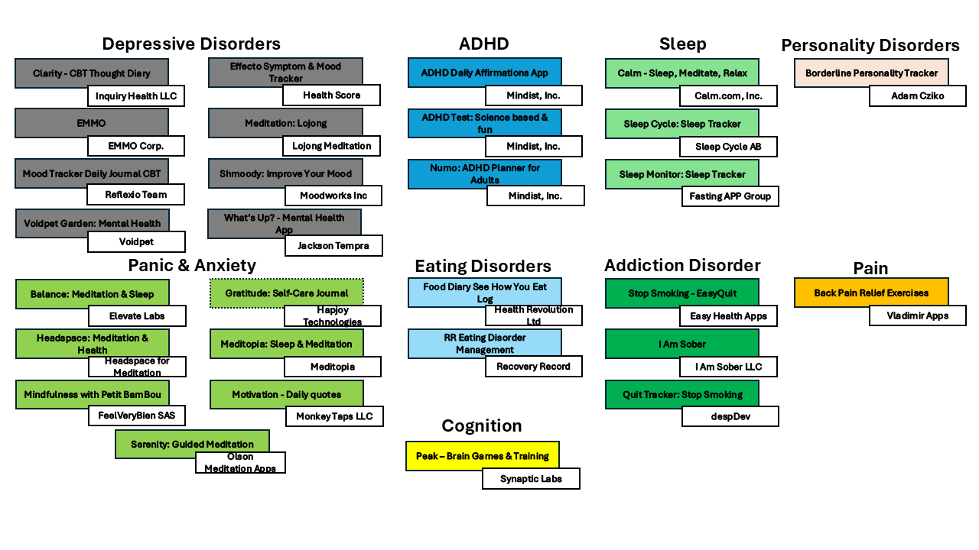
Figure S2: Selection of Commercial Benchmark Apps Matched to DiGA Indications
This overview displays the 29 commercial mental health applications selected from the MIND database as comparative benchmarks. Apps were identified using a condition-matched strategy, pairing the most downloaded commercial alternatives with conditions currently targeted by DiGAs (N=29). Boxes are categorized by indication and labeled with the app developer.

Tables

Table S1: Comparison of functionalities between DiGAs and the most downloaded commercial mental health apps across different condition categories
Functionality | Affective Disorders |  | Panic & Anxiety |  | ADHD |  | Eating Disorders |  | Cognition |  | Sleep |  | Addiction Disorder |  | Personality Disorders |  | Pain
 | DiGA (n=8) | Comm.  (n=8) | DiGA (n=7) | Comm.  (n=7) | DiGA (n=3) | Comm.  (n=3) | DiGA (n=2) | Comm.  (n=2) | DiGA (n=1) | Comm.  (n=1) | DiGA (n=3) | Comm.  (n=3) | DiGA (n=3) | Comm.  (n=3) | DiGA (n=1) | Comm.  (n=1) | DiGA (n=1) | Comm.  (n=1)
Features
Deep  Breathing | 3/8 | 6/8 | 7/7 | 5/7 | 0/3 | 0/3 | 2/2 | 1/2 | 1/1 | 0/1 | 3/3 | 3/3 | 2/3 | 0/3 | 1/1 | 0/1 | 1/1 | 0/1
Journaling | 5/8 | 7/8 | 7/7 | 4/7 | 3/3 | 1/3 | 2/2 | 2/2 | 0/1 | 0/1 | 3/3 | 2/3 | 2/3 | 2/3 | 1/1 | 1/1 | 1/1 | 0/1
Psycho-education | 7/8 | 3/8 | 7/7 | 3/7 | 3/3 | 1/3 | 2/2 | 1/2 | 1/1 | 0/1 | 3/3 | 1/3 | 2/3 | 1/3 | 1/1 | 0/1 | 1/1 | 0/1
Track Med. | 0/8 | 2/8 | 0/7 | 0/7 | 1/3 | 1/3 | 0/2 | 0/2 | 0/1 | 0/1 | 1/3 | 0/3 | 0/3 | 0/3 | 0/1 | 1/1 | 0/1 | 0/1
Goal Setting/Habits | 7/8 | 6/8 | 7/7 | 4/7 | 3/3 | 1/3 | 2/2 | 2/2 | 0/1 | 0/1 | 3/3 | 3/3 | 2/3 | 3/3 | 1/1 | 0/1 | 1/1 | 0/1
Peer Support | 1/8 | 1/8 | 0/7 | 0/7 | 0/3 | 1/3 | 0/2 | 1/2 | 0/1 | 0/1 | 1/3 | 0/3 | 1/3 | 1/3 | 0/1 | 0/1 | 1/1 | 0/1
Track Mood | 4/8 | 7/8 | 3/7 | 3/7 | 0/3 | 1/3 | 0/2 | 1/2 | 0/1 | 0/1 | 2/3 | 2/3 | 1/3 | 1/3 | 1/1 | 1/1 | 1/1 | 0/1
Track Sleep | 3/8 | 2/8 | 1/7 | 0/7 | 0/3 | 0/3 | 0/2 | 0/2 | 0/1 | 0/1 | 3/3 | 3/3 | 0/3 | 0/3 | 1/1 | 0/1 | 1/1 | 0/1
Engagements
Chat/Message | 5/8 | 2/8 | 7/7 | 0/7 | 1/3 | 0/3 | 2/2 | 1/2 | 1/1 | 0/1 | 2/3 | 0/3 | 1/3 | 1/3 | 1/1 | 0/1 | 1/1 | 0/1
AI Support | 3/8 | 3/8 | 5/7 | 1/7 | 1/3 | 0/3 | 2/2 | 0/2 | 0/1 | 0/1 | 2/3 | 0/3 | 1/3 | 0/3 | 1/1 | 0/1 | 1/1 | 0/1
Real Time Response | 0/8 | 1/8 | 0/7 | 0/7 | 0/3 | 0/3 | 0/2 | 0/2 | 0/1 | 0/1 | 0/3 | 0/3 | 0/3 | 0/3 | 0/1 | 0/1 | 0/1 | 0/1
Asynchronous Response | 3/8 | 0/8 | 6/7 | 0/7 | 2/3 | 0/3 | 0/2 | 0/2 | 1/1 | 0/1 | 2/3 | 0/3 | 0/3 | 0/3 | 1/1 | 0/1 | 1/1 | 0/1
Audio/Music/  Scripts | 6/8 | 5/8 | 6/7 | 6/7 | 3/3 | 1/3 | 2/2 | 2/2 | 1/1 | 0/1 | 3/3 | 3/3 | 1/3 | 0/3 | 1/1 | 0/1 | 1/1 | 1/1
Gamification | 3/8 | 5/8 | 1/7 | 7/7 | 1/3 | 1/3 | 0/2 | 1/2 | 1/1 | 1/1 | 1/3 | 2/3 | 1/3 | 3/3 | 0/1 | 1/1 | 0/1 | 0/1
Inputs
Camera | 0/8 | 2/8 | 5/7 | 3/7 | 0/3 | 0/3 | 0/2 | 2/2 | 0/1 | 0/1 | 0/3 | 0/3 | 0/3 | 2/3 | 0/1 | 0/1 | 0/1 | 0/1
Diary | 5/8 | 8/8 | 7/7 | 3/7 | 3/3 | 1/3 | 2/2 | 2/2 | 0/1 | 0/1 | 3/3 | 3/3 | 1/3 | 2/3 | 1/1 | 1/1 | 1/1 | 0/1
External Devices | 0/8 | 3/8 | 0/7 | 4/7 | 0/3 | 0/3 | 0/2 | 0/2 | 0/1 | 0/1 | 0/3 | 3/3 | 0/3 | 1/3 | 0/1 | 0/1 | 0/1 | 0/1
Geolocation | 0/8 | 2/8 | 0/7 | 0/7 | 0/3 | 0/3 | 0/2 | 0/2 | 0/1 | 0/1 | 0/3 | 0/3 | 0/3 | 0/3 | 0/1 | 0/1 | 0/1 | 0/1
Microphone | 0/8 | 0/8 | 1/7 | 0/7 | 0/3 | 0/3 | 0/2 | 1/2 | 0/1 | 0/1 | 0/3 | 2/3 | 0/3 | 0/3 | 0/1 | 0/1 | 0/1 | 0/1
Surveys | 7/8 | 5/8 | 7/7 | 4/7 | 2/3 | 2/3 | 2/2 | 2/2 | 1/1 | 0/1 | 3/3 | 3/3 | 1/3 | 1/3 | 1/1 | 1/1 | 1/1 | 0/1
Outputs
Graphs of Data | 5/8 | 3/8 | 7/7 | 2/7 | 0/3 | 0/3 | 2/2 | 1/2 | 1/1 | 1/1 | 3/3 | 3/3 | 1/3 | 2/3 | 1/1 | 1/1 | 1/1 | 0/1
Notifications | 5/8 | 7/8 | 7/7 | 7/7 | 3/3 | 2/3 | 2/2 | 2/2 | 1/1 | 1/1 | 2/3 | 3/3 | 1/3 | 3/3 | 1/1 | 1/1 | 0/1 | 1/1
Summary of Data | 4/8 | 8/8 | 7/7 | 6/7 | 3/3 | 2/3 | 2/2 | 2/2 | 1/1 | 1/1 | 3/3 | 3/3 | 1/3 | 3/3 | 1/1 | 1/1 | 1/1 | 1/1
References/ Information | 7/8 | 6/8 | 7/7 | 3/7 | 3/3 | 1/3 | 2/2 | 2/2 | 1/1 | 0/1 | 3/3 | 3/3 | 1/3 | 2/3 | 1/1 | 0/1 | 1/1 | 0/1
Reminders | 5/8 | 5/8 | 7/7 | 7/7 | 3/3 | 1/3 | 2/2 | 1/2 | 1/1 | 1/1 | 2/3 | 3/3 | 0/3 | 2/3 | 1/1 | 1/1 | 1/1 | 1/1
Values represent the number of apps with each feature (numerator) out of the total number of apps analyzed (denominator). Comm. = commercial mental health apps

Table S2: Aggregate analysis comparing functionalities of the DiGAs and the leading commercial apps
Functionality | DiGA count (%)  N=29 | Commercial App count (%)  N=29 | Statistic | p-value
Features
Deep Breathing | 20 (69%) | 15 (51.7% | χ²=1.153 | 0.283
Journaling | 24 (82.8%) | 19 (65.5%) | χ²=1.439 | 0.230
Psychoeducation | 27 (93.1%) | 10 (34.5%) | χ²=19.109 | < 0.001***
Track Medication | 2 (6.9%) | 4 (13.8%) | OR=0.463 | 0.670
Goal Setting/Habits | 26 (89.7%) | 19 (65.5%) | χ²=3.569 | 0.059
Peer Support | 4 (13.8%) | 4 (13.8%) | OR=1.000 | 1.000
Track Mood | 12 (41.4%) | 16 (55.2%) | χ²=0.621 | 0.431
Track Sleep | 9 (31%) | 5 (17.2%) | χ²=0.847 | 0.357
Engagements
Chat/Message | 21 (72.4%) | 4 (13.8%) | χ²=17.998 | < 0.001***
AI Support | 16 (55.2%) | 4 (13.8%) | χ²=9.234 | 0.002**
Real Time Response | 0 (0%) | 1 (3.4%) | OR=0.000 | 1.000
Asynchronous Response | 16 (55.2%) | 0 (0%) | χ²=19.420 | < 0.001***
Audio/Music/Scripts | 24 (82.8%) | 18 (62.1%) | χ²=2.158 | 0.142
Gamification | 8 (27.6%) | 21 (72.4%) | χ²=9.931 | 0.002**
Inputs
Camera | 5 (17.2%) | 9 (31.0%) | χ²=0.847 | 0.357
Diary | 23 (79.3%) | 20 (69%) | χ²=0.360 | 0.549
External Devices | 0 (0%) | 11 (37.9%) | χ²=11.219 | < 0.001***
Geolocation | 0 (0%) | 2 (6.9%) | OR=0.000 | 0.491
Microphone | 1 (3.4%) | 3 (10.3%) | OR=0.310 | 0.612
Surveys | 25 (86.2%) | 18 (62.1%) | χ²=3.237 | 0.072
Outputs
Graphs of Data | 21 (72.4%) | 13 (44.8%) | χ²=3.483 | 0.062
Notifications | 22 (75.9%) | 27 (93.1%) | OR=0.233 | 0.144
Summary of Data | 23 (79.3%) | 27 93.1%) | OR=0.284 | 0.253
References/Information | 26 (89.7%) | 17 (58.6%) | χ²=5.755 | 0.016*
Reminders | 22 (75.9%) | 22 (75.9%) | χ²=0.000 | 1.000
Chi-square tests were used when all expected frequencies in 2×2 contingency tables were ≥5; Fisher's exact tests were used when any expected frequency was <5. Larger χ² values for chi-square tests indicate greater differences; odds ratios (OR) for Fisher's exact tests >1 indicate DiGAs are more likely to have the functionality, OR<1 indicates commercial apps are more likely to have functionality.

