De novo transcriptome assembly of Dendrobium Sonia
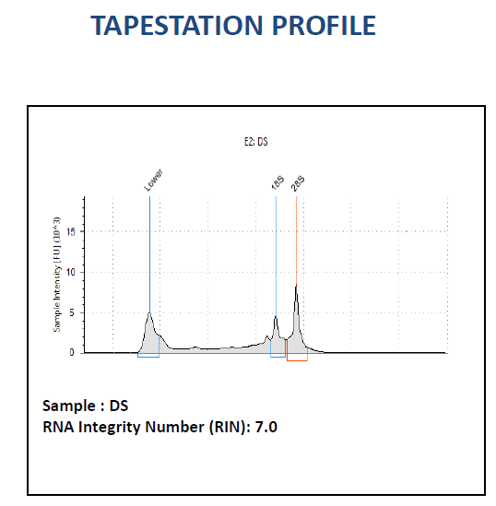
Figure 1:-Tapestation profile for the sample.
Sample_Name | No_of_reads | No_of_bases(Mb) | GC_per(%) | Q30 | Read Length
DS | 205,142,240 | 20,514.22 | 44.785 | 94.55 | 100 x 2
Table 1: Raw read summary.
Table 2: Clean data summary.
Sample_Name | No_of_reads | No_of bases(Mb) | GC_per(%) | Q_30 | Read_length
DS | 137,043,312 | 13,373.87 | 46.48 | 94.79 | 100 x 2
Table 3:Assembled Transcript Summary.
Description | # of Assembled Transcripts | # of Assembled Transcripts after cd-hit-est
Number of assembled transcripts | 534,524 | 432,420
Longest transcript length (bp) | 17,403 | 17,403
Mean GC % of transcripts | 37.69% | 37.29%
Transcript of length >= 200 bp were found and considered for transcript expression estimation and downstream annotations.
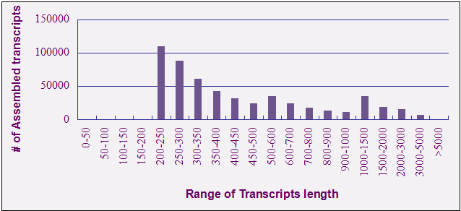
Figure 2: Assembled transcript length distribution

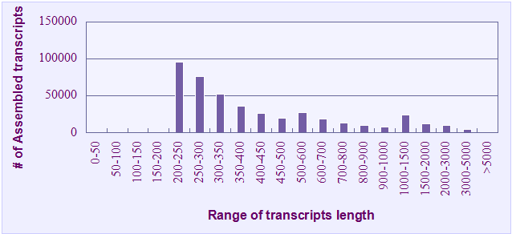
Figure 3:Assembled transcript length distribution after cd-hit-est(default)

 | DS
No. of filtered reads(paired-end) | 68,521,656
Number of reads aligned | 63,923,853
Alignment Percentage | 93.29%
Number of transcripts with FPKM >= 1.0 | 75,231
Table 4: Read alignment and expression summary.

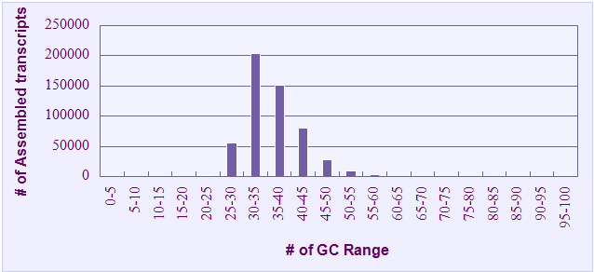
Figure 4: GC content distribution of all assembled transcripts

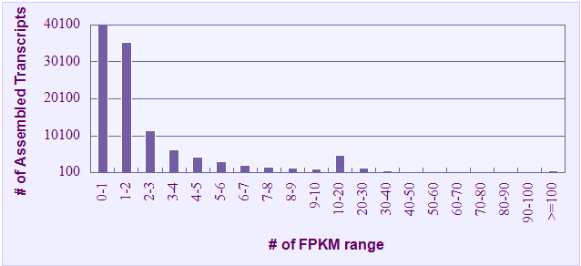
Figure 5: Transcript expression distribution of all the samples

Table 5: Transcript expression and total number of transcripts (length >= 200bp)
FPKM_range | Sample_DS
0-1 | 357,189
1-2 | 35,304
2-3 | 11,454
3-4 | 6,316
4-5 | 4,232
5-6 | 2,981
6-7 | 2,091
7-8 | 1,723
8-9 | 1,420
9-10 | 1,073
10-20 | 4,738
20-30 | 1,482
30-40 | 677
40-50 | 402
50-60 | 256
60-70 | 188
70-80 | 107
80-90 | 100
90-100 | 86
>=100 | 601

Description | Transcripts
Number of transcripts after cd-hit-est | 432,420
Number of transcripts got annotation with Araport | 67,496
Table 6:BLASTX and UniProt summary

Number of transcripts with no BLASTX hit | 364,924
Number of transcripts with a significant BLASTX hit but no UniProt information(See Supplementary file NGS_P4655_Without_Uniprot.txt ) | 278
Number of transcripts with a significant BLASTX hit and UniProt information(See Supplementary file NGS_P4655_Uniprot_Annotation.txt) | 67,218
Table 7:Transcript annotation summary
GO terms | # of Transcripts got GO Annotation
Biological process | 45,378
Cellular component | 52,906
Molecular function | 49,341
Table 8: Gene Ontology terms identified in each category

