Appendix 1 – Food Pictures
Food Picture | Food Picture Number | Food Picture | Food Picture Number
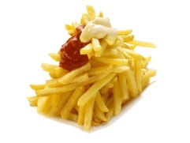 | 0022 | 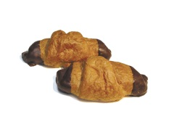 | 0184
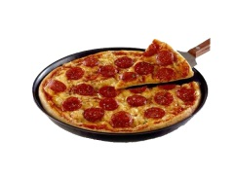 | 0061 | 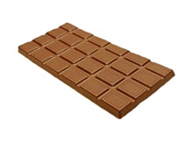 | 0286
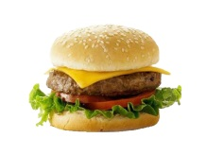 | 0065 | 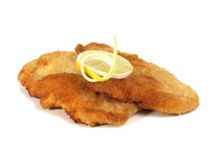 | 0309
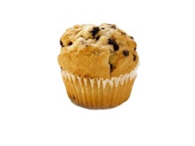 | 0080 | 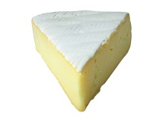 | 0519
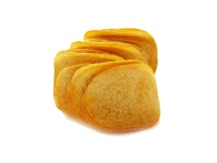 | 0117 | 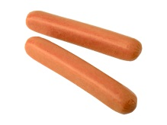 | 0535
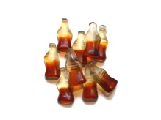 | 0153 | 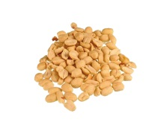 | 0183
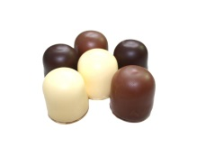 | 0161

Figure A1. Thirteen high-caloric foods that were used in the laboratory measures of emotional food cue reactivity, derived from the foodpics_dataset extended [1].

1. Blechert, J., et al., Food-Pics_Extended—An Image Database for Experimental Research on Eating and Appetite: Additional Images, Normative Ratings and an Updated Review. Frontiers in Psychology, 2019. 10.

