Appendix 4 – Model with Subjective BMI Values
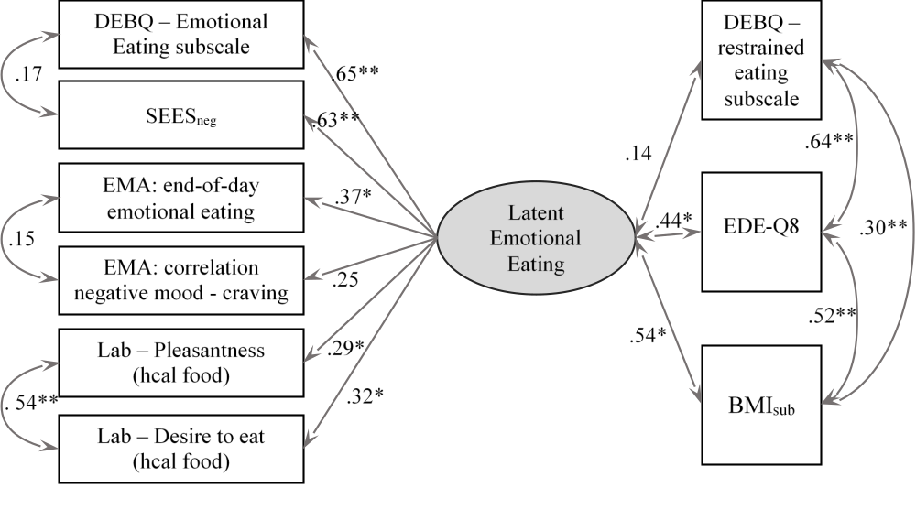
Figure A4. Standardized factor loadings of the confirmatory factor analysis linking each of the two measures of each of the three methods (questionnaires, EMA, laboratory; left side) to the latent emotional eating (EE_{lat}) factor (middle). Relationships of EE_{lat} with variables of theoretical (restrained eating) and clinical (EDEQ, BMI_{sub}) importance (right side). Note: hcal = high calorie; EMA = ecological momentary assessment; DEBQ = Dutch Eating Behavior Questionnaire; SEES_{neg} = Salzburg Emotional Eating Scale (subscales sadness, anger, anxiety); BMI_{sub} = body mass index based on subjective weight; EDE-Q8 = Eating Disorder Examination Questionnaire; * = p < .05; ** = p < .001

