Supplementary Materials

Query |  | Results
PubMed
#1 | "glp-1 receptor"[Title/Abstract] OR "glp1r"[Title/Abstract] OR "glucagon-like peptide-1 receptor"[Title/Abstract] OR "glucagon-like peptide-1"[Title/Abstract] OR "glp1"[Title/Abstract] OR "glp-1r"[Title/Abstract] OR "glp-1"[Title/Abstract] OR "glucagon-like peptide receptors"[Title/Abstract] OR "glp-1 agonists"[Title/Abstract] OR "glp-1 receptor agonists"[Title/Abstract] OR "glucagon-like peptide-1 receptor agonists"[Title/Abstract] OR "glucagon-like peptide receptor agonists"[Title/Abstract] OR "glp-1 analogs"[Title/Abstract] OR "exenatide"[Title/Abstract] OR "lixisenatide"[Title/Abstract] OR "liraglutide"[Title/Abstract] OR "dulaglutide"[Title/Abstract] OR "semaglutide"[Title/Abstract] | 24,119
#2 | "weight gain"[Title/Abstract] OR "weight regain"[Title/Abstract] OR "regain weight"[Title/Abstract] OR "increase weight"[Title/Abstract] OR "decrease weight"[Title/Abstract] OR "weight loss"[Title/Abstract] | 183,017
#3 | "bariatric surgery"[Title/Abstract] OR "bariatric surgeries"[Title/Abstract] OR "bariatric surg*"[Title/Abstract] OR "laparoscopic sleeve gastrectomy"[Title/Abstract] OR "body mass index procedure"[Title/Abstract] OR "obesity surgery"[Title/Abstract] OR "roux-en-y gastric bypass"[Title/Abstract] OR "weight reduction surgery"[Title/Abstract] OR "sleeve surg*"[Title/Abstract] OR "sleeve"[Title/Abstract] | 39,083
#4 | #1 AND #2 And #3 | 652
SCOPUS
#1 | (TITLE-ABS-KEY ("glp-1 receptor" OR glp1r OR "glucagon-like peptide-1 receptor" OR "the glucagon-like peptide-1" OR glp1 OR glp-1r OR glp-1 OR "glucagon-like peptide receptors" OR "glp-1 agonists" OR "glp-1 receptor agonists" OR "glucagon-like peptide-1 receptor agonists" OR "glucagon-like peptide receptor agonists" OR "glp-1 analogs")) | 119,615
#2 | (TITLE-ABS-KEY (("weight gain" OR "weight regain" OR "regain weight")) | 490,722
#3 | (TITLE-ABS-KEY ("bariatric surgery" OR "bariatric surgeries" OR "bariatric surg*" OR "laparoscopic sleeve gastrectomy" OR lsg OR "body mass index procedure" OR obesity AND surgery OR "weight reduction surgery" OR gastric AND bypass AND surgery OR gastric AND sleeve OR sleeve AND gastrectomy AND surgery OR "roux-en-y gastric bypass")) | 180,236
#4 | #1 AND #2 AND #3 | 1,780
Web of Science
#1 | (TS=("glp-1 receptor" OR glp1r OR "glucagon-like peptide-1 receptor" OR "the glucagon-like peptide-1" OR glp1 OR glp-1r OR glp-1 OR "glucagon-like peptide receptors" OR "glp-1 agonists" OR "glp-1 receptor agonists" OR "glucagon-like peptide-1 receptor agonists" OR "glucagon-like peptide receptor agonists" OR "glp-1 analogs")) | 35,574
#2 | (TS=("weight gain" OR "weight regain" OR "regain weight")) | 918,149
#3 | (TS=("bariatric surgery" OR "bariatric surgeries" OR "bariatric surg*" OR "laparoscopic sleeve gastrectomy" OR lsg OR "body mass index procedure" OR obesity AND surgery OR "weight reduction surgery" OR gastric AND bypass AND surgery OR gastric AND sleeve OR sleeve AND gastrectomy AND surgery OR "roux-en-y gastric bypass")) | 89,028
#4 | #1 AND #2 AND #3 | 1,523
Total |  | 3,955
Total without duplicates |  | 2,823

Supplementary Table 1. Search strategy for each database

Study | D1 | D2 | D3 | D4 | D5 | Overall
Coelho et al 2023 | 🟢 | 🟢 | 🟢 | 🟢 | 🟢 | 🟢
Hany et al 2023 | 🟢 | 🟢 | 🟢 | 🟢 | 🟢 | 🟢
Miras et al 2019 | 🟢 | 🟢 | 🟢 | 🟢 | 🟢 | 🟢
Mok et al 2024 | 🟡 | 🟢 | 🟢 | 🟢 | 🟢 | 🟡
Thakur et al 2020 | 🟢 | 🟡 | 🟢 | 🟢 | 🟢 | 🟡

RCT

Study | D1 | D2 | D3 | D4 | D5 | D6 | D7 | Overall
Badurdeen et al. (1), 2020 | 🟢 | 🟢 | 🟡 | 🟢 | 🟢 | 🟢 | 🟢 | 🟡
Badurdeen et al. (2), 2021 | 🟢 | 🟢 | 🟡 | 🟢 | 🟢 | 🟢 | 🟢 | 🟡
Gazda et al., 2021 | 🔴 | 🟢 | 🟢 | 🟢 | 🟢 | 🟢 | 🟡 | 🔴
Horber et al., 2020 | 🟢 | 🟢 | 🟢 | 🟢 | 🟢 | 🟢 | 🟢 | 🟢
Mosli et al., 2017 | 🟢 | 🟢 | 🟢 | 🟢 | 🟡 | 🟢 | 🟢 | 🟡

Cohort

Supplementary Table 2. Risk of bias assessment of the included studies conducted using Rob2 for RCTs and ROBINS-I for observational studies. Green color stands for low risk of bias, yellow color for some concerns and red color for high risk of bias.

Variable | estimate | se | zval | pval | ci.lb | ci.ub
Weight loss after therapy (overall analysis)
Intrcpt  Case.age | -0.2402  0.0172 | 2.7562  0.0588 | -0.0872  0.2920 | 0.9305  0.7703 | -5.6423  -0.0981 | 5.1619  0.1325
Intrcpt  Control.age | -0.7262  0.0277 | 2.7178  0.0581 | -0.2672  0.4769 | 0.7893  0.6334 | -6.0531  -0.0862 | 4.6007  0.1417
Intrcpt  Case.male | 1.0167  -0.0136 | 0.8845  0.0234 | 1.1494  -0.5834 | 0.2504  0.5596 | -0.7169  -0.0594 | 2.7504  0.0322
Intrcpt  Control.male | 0.6692  -0.0033 | 0.9243  0.0242 | 0.7240  -0.1364 | 0.4691  0.8915 | -1.1424  -0.0508 | 2.4808  0.0442
Weight loss after therapy (subgroup analysis of treatment duration (>6 months)
Intrcpt  Case.age | 2.8199  -0.0619 | 4.9193  0.1084 | 0.5732  -0.4268 | 0.5665  0.6695 | -6.8217  -0.2588 | 12.4616  0.1663
Intrcpt  Control.age | 3.4106  -0.0619 | 5.8110  0.1337 | 0.5869  -0.4627 | 0.5573  0.6436 | -7.9788  -0.3239 | 14.8000  0.2002
Intrcpt  Case.male | 1.3603  -0.0167 | 1.3058  0.0310 | 1.0418  -0.5410 | 0.2975  0.5885 | -1.1990  -0.0774 | 3.9196  0.0439
Intrcpt  Control.male | 1.1701  -0.0118 | 1.2797  0.0302 | 0.9143  -0.3895 | 0.3606  0.6969 | -1.3381  -0.0710 | 3.6783  0.0475
Intrcpt  Case.weight | -0.0622  0.0071 | 4.7499  0.0419 | -0.0131  0.1702 | 0.9895  0.8648 | -9.3718  -0.0751 | 9.2473  0.0893
Intrcpt  Control.weight | -0.4515  0.0106 | 3.8575  0.0338 | -0.1170  0.3129 | 0.9068  0.7544 | -8.0121  -0.0556 | 7.1092  0.0767
Intrcpt  Case.BMI | 2.5517  -0.0432 | 5.4649  0.1293 | 0.4669  -0.3342 | 0.6406  0.7382 | -8.1592  -0.2967 | 13.2626  0.2103
Intrcpt  Control.BMI | 0.9373  -0.0048 | 4.5612  0.1097 | 0.2055  -0.0441 | 0.8372  0.9649 | -8.0025  -0.2199 | 9.8770  0.2102
Weight loss after therapy (subgroup analysis of treatment duration (≤6 months)
Intrcpt  Case.age | -1.6205  0.0427 | 3.2316  0.0663 | -0.5014  0.6445 | 0.6161  0.5193 | -7.9543  -0.0872 | 4.7134  0.1727
Intrcpt  Control.age | -2.0561  0.0520 | 3.0939  0.0637 | -0.6646  0.8157 | 0.5063  0.4147 | -8.1201  -0.0729 | 4.0078  0.1769
Intrcpt  Case.male | 0.8782  -0.0153 | 1.1228  0.0363 | 0.7822  -0.4224 | 0.4341  0.6727 | -1.3223  -0.0865 | 3.0788  0.0558
Intrcpt  Control.male | 0.3061  0.0048 | 1.1846  0.0385 | 0.2584  0.1252 | 0.7961  0.9003 | -2.0157  -0.0707 | 2.6278  0.0804
Weight loss after surgery before therapy initiation
Intrcpt  Case.age | 2.7055  -0.0576 | 1.4973  0.0342 | 1.8070  -1.6835 | 0.0708  0.0923 | -0.2291  -0.1246 | 5.6401  0.0095
Intrcpt  Control.age | 1.9142  -0.0391 | 1.6954  0.0387 | 1.1290  -1.0116 | 0.2589  0.3117 | -1.4088  -0.1150 | 5.2373  0.0367
Intrcpt  Case.male | -0.0373  0.0068 | 0.8648  0.0205 | -0.0431  0.3322 | 0.9656  0.7397 | -1.7323  -0.0334 | 1.6576  0.0471
Intrcpt  Control.male | 0.0127  0.0054 | 0.7523  0.0170 | 0.0168  0.3189 | 0.9866  0.7498 | -1.4619  -0.0280 | 1.4872  0.0388
Weight regains after surgery before therapy initiation
Intrcpt  Case.age | 0.2124  0.0026 | 1.3139  0.0282 | 0.1616  0.0938 | 0.8716  0.9253 | -2.3628  -0.0526 | 2.7875  0.0579
Intrcpt  Control.age | -0.0581  0.0086 | 1.3179  0.0285 | -0.0441  0.3023 | 0.9648  0.7625 | -2.6412  -0.0473 | 2.5250  0.0645
Intrcpt  Case.male | 0.3668  -0.0009 | 0.5231  0.0124 | 0.7012  -0.0739 | 0.04832  0.9411 | -0.6585  -0.0252 | 1.3922  0.0233
Intrcpt  Control.male | 0.2082  0.0030 | 0.5767  0.0123 | 0.3610  0.2410 | 0.7181  0.8096 | -0.9222  -0.0212 | 1.3386  0.0271
Intrcpt  Case.Weight | 2.4325  -0.0178 | 1.6499  0.0139 | 1.4744  -1.2884 | 0.1404  0.1976 | -0.8012  -0.0450 | 5.662  0.0093
Intrcpt  Control.weight | 1.9269  -0.0134 | 1.4066  0.0116 | 1.3700  -1.1520 | 0.1707  0.2493 | -0.8299  -0.0361 | 4.6837  0.0094

Supplementary Table 3. Meta-regression of outcomes with age, gender, baseline weight, and baseline body mass index

Author/year | Country | Design | Participants total number | Mean age | Male% | DM% | Baseline weight | Baseline BMI
Colbourne/  2023 | Australia | Cohort | 68 | 40.8±10.2 | 16.2 | 5.9 | 120.2±31.8 | 44.1±10.1
Jamal/  2023 | Kuwait | Retrospective analysis | 57 | 36.7±9.8 | 26.3 | 30.5 | 121.5±34.5 | N/A
Jensen/  2023 | Switzerland | Observational study | 50 | 45.1±11.0 | 18 | 22 | 114±16.0 | 42.7±5.5
Lautenbach/  2023 | Germany | Observational study | 29 | 48.5±8.4 | 17.2 | N/A | 145.7±31.8 | 50.4±9.5
Lautenbach/  2022 | Germany | Observational study | 44 | 46.4±8.8 | 27 | N/A | 145.7±33.5 | 49.4±8.9
Wharton/  2019 | USA | Observational study | 53 | 49.9±9.1 | 5.7 | N/A | N/A | 50.8±11.2
Wharton/  2019 | USA | Observational study | 50 | 52.5±9.5 | 16 | N/A | N/A | 47.6±13.1
Wharton/  2019 | USA | Observational study | 14 | 51.4±10.3 | 28.6 | N/A | N/A | 52.2±11.9
Murvelashvili/  2023 | USA | Observational study | 92 | 56.7±10 | 8.7 | 9.78 | 136.7±31.7 | 50.2±10.6
Murvelashvili/  2023 | USA | Observational study | 115 | 53.8±11 | 11.3 | 6.09 | 134±30.8 | 48.5±10.2
Rubio/  2021 | Spain | Cohort | 23 | 55.1±7.9 | 30.4 | N/A | 129.5±25.9 | 46.6±8.4
Vinciguerra/  2023 | Italy | Observational study | 59 | 38.6±11.8 | 29 | 0 | N/A | 47.7±5.8
Vinciguerra/  2024 | Italy | Observational study | 119 | 41±11.2 | 28.6 | 0 | N/A | N/A
Elhag/  2022 | Qatar | Observational study | 119 | 42.8±10.9 | 16 | 86.7 | 118.2±27.2 | 45.9±8.8
Elhag/  2022 | Qatar | Observational study | 26 | 45.4±7.9 | 23.1 | 13.3 | 131.9±53.6 | 49.2±13.6
Suliman/  2019 | United arabia | Observational study | 787 | 39 | 20 | 55 | N/A | N/A
Bonnet/  2023 | France | Observational study | 39 | 53.6±10.8 | 38.5 | 23.1 | N/A | N/A
Martinez/  2016 | Spain | Retrospective analysis | 15 | 53±9 | 33.3 | 80 | 107.7±26.3 | 40.3±9.2
Muratori/  2022 | Italy | Case series | 62 | 43.6±9.9 | 3.22 | N/A | N/A | 34.2±4.8
Rye/  2018 | Canada | Case series | 20 | 49.6±8.3 | 5 | 25 | 126.2 | N/A
Pajecki/  2012 | Brazil | Case series | 15 | 47.2±12.5 | 33.3 | N/A | 120.8±22.1 | 42.4±4.1

Supplementary Table 4. Baseline characteristic of one group studies
(DM=diabetes mellitus, BMI=body mass index)

Author/year | Surgery type | Time between surgery to drug initiation (months) | Weight before GLP-1  (kg) | BMI before GLP-1 | GLP-1 type and maximum dose (mg) | GLP-1 treatment duration (months)
Colbourne/  2023 | LSG or RYGB or LGB | At least 12 | 102.2±18.3 | 36±7.3 | Liraglutide 3.0 | 3
Jamal/  2023 | SG | N/A | 96.1±29.2 | N/A | Liraglutide 3.0 | 3
Jensen/  2023 | SG or RYGB | 70.6±39.8 | 93.9±18.7 | 34.8±5.3 | Liraglutide 3.0 or semaglutide 1.0 | 6
Lautenbach/  2023 | SG or RYGB | 64.5±51.9 | 110.8±22.2 | 38.3±6.1 | Semaglutide 1.0 | 12
Lautenbach/  2022 | SG or RYGB | 64.7±47.6 | 113.5±25.2 | 38.3±6.4 | Semaglutide 0.5 | 6
Wharton/  2019 | RYGB | 93.6±68.4 | N/A | 39±7 | Liraglutide 3.0 | 8±7.6
Wharton/  2019 | GB | 93.6±68.4 | N/A | 45.4±11 | Liraglutide 3.0 | 6.8±6.7
Wharton/  2019 | SG | 93.6±68.4 | N/A | 45.4±9.6 | Liraglutide 3.0 | 8.6±7.3
Murvelashvili/  2023 | RYGB or SG or GB | 98.8±85.2 | 114.4±27.56 | N/A | Liraglutide 3.0 | 12
Murvelashvili/  2023 | RYGB or SG or GB | 93.7±80.7 | 110.7±24.5 | N/A | Semaglutide 1.0 | 12
Rubio/  2021 | BS | 84±66.3 | 101.7±15.8 | 36.6±4.6 | Liraglutide 3.0 | 12
Vinciguerra/  2023 | SG or one-anastomosis gastric bypass | 20±6 | 101.8±17.9 | 38.2±5.7 | Liraglutide 2.4 | 6
Vinciguerra/  2024 | SG or AGB or RYGB or one-anastomosis gastric bypass | N/A | 100.9±17.2 | 37.6±5.3 | Liraglutide 3.0 | 6
Elhag/  2022 | primary RYGB or LSG or LAGB | 56.4±32.3 | 96.7±18.6 | 37.6±6.4 | Liraglutide 3.0 | 12
Elhag/  2022 | revisional RYGB or LSG or LAGB | 42.5±26 | 101.7±31.1 | 38.3±9.7 | Liraglutide 3.0 | 12
Suliman/  2019 | RYGB or SG or other bariatric surgery | 48 | 97.9 | 37.5 | Liraglutide 3.0 | 10
Bonnet/  2023 | SG or gastric bypass | 100.8±52.8 | 125.2±23.6 | 45.7±7.8 | Semaglutide 2.4 | 6
Martinez/  2016 | RYGB or BPD or VBG or SG | 67.2±66 | 106±7.2 | 40.3 | Liraglutide 1.8 | 6
Muratori/  2022 | RYGB or LGB or LSG | 70.7±43.7 | N/A | 34.2±4.8 | Liraglutide 3.0 | 10.5±4.4
Rye/  2018 | RYGB or AGB or VBG or LSG | 76.3±72.9 | 109.55 | N/A | Liraglutide 3.0 | 7
Pajecki/  2012 | GB or RYGB or BPD or longitudinal gastrectomy | 63.6±39.6 | 100.9±18.3 | N/A | Liraglutide 1.8 | 4.1±1.5

Supplementary Table 5. Baseline characteristics of one group studies (continued)
(GLP-1RAs=glucagon like peptide 1 receptor agonists, LSG=laparoscopic sleeve gastrectomy, RYGB=Roux-en-Y gastric bypass, LGB=laparoscopic adjustable gastric band, SG=sleeve gastrectomy, GB=gastric banding, BS=bariatric surgery, AGB=adjustable gastric band, LAGB=laparoscopic adjustable gastric banding, BPD=biliopancreatic diversion with duodenal switch, VBG=vertical banded gastroplasty)

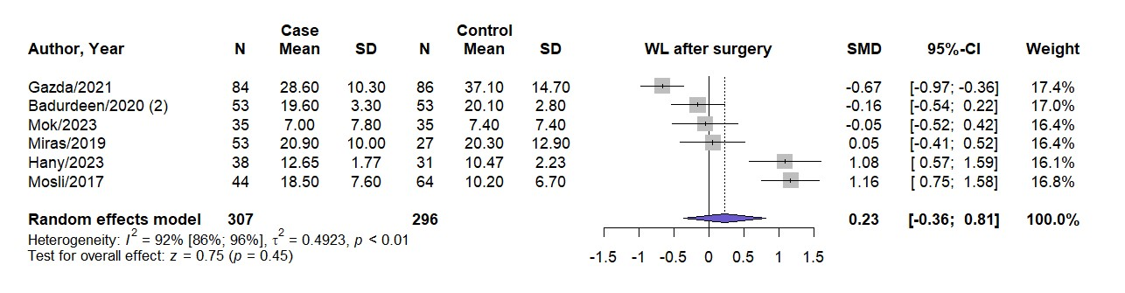
Supplementary Figure 1. Comparison of weight loss after bariatric surgery and before therapy initiation between GLP-1RAs and placebo treated groups

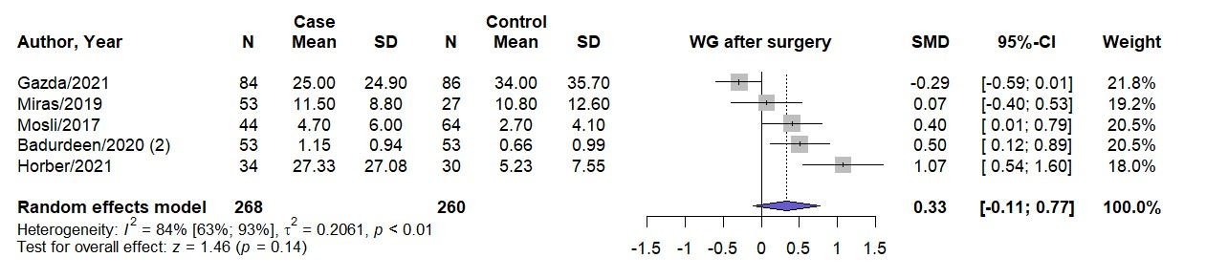
Supplementary Figure 2. Comparison of weight regain after bariatric surgery and before therapy initiation between GLP-1RAs and placebo treated groups
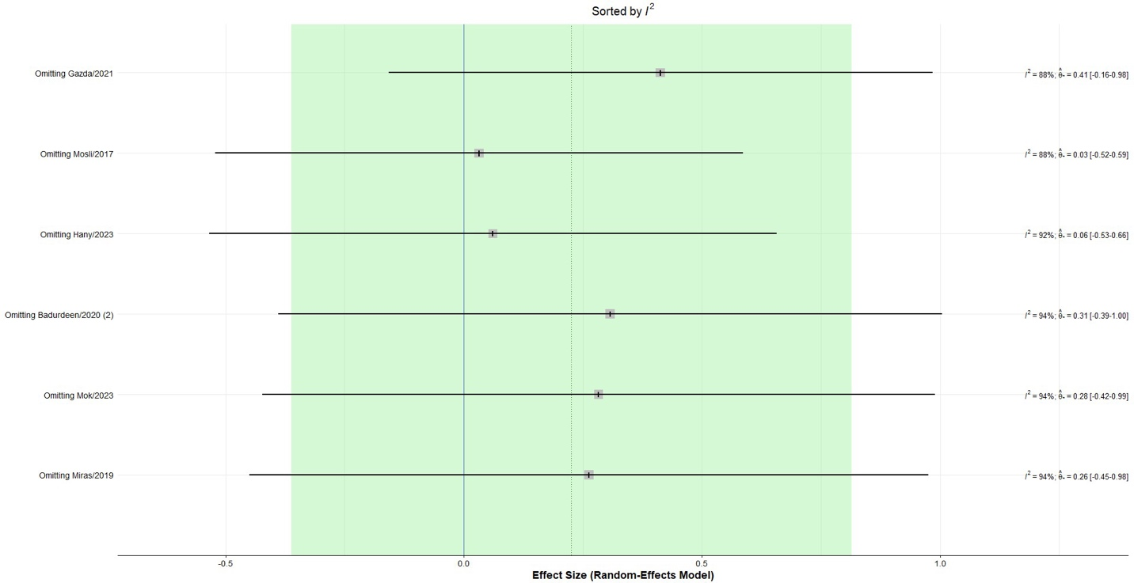
Supplementary Figure 3. Sensitivity analysis by omitting each individual study for comparison of weight loss after bariatric surgery and before therapy initiation between GLP-1RAs and placebo treated groups

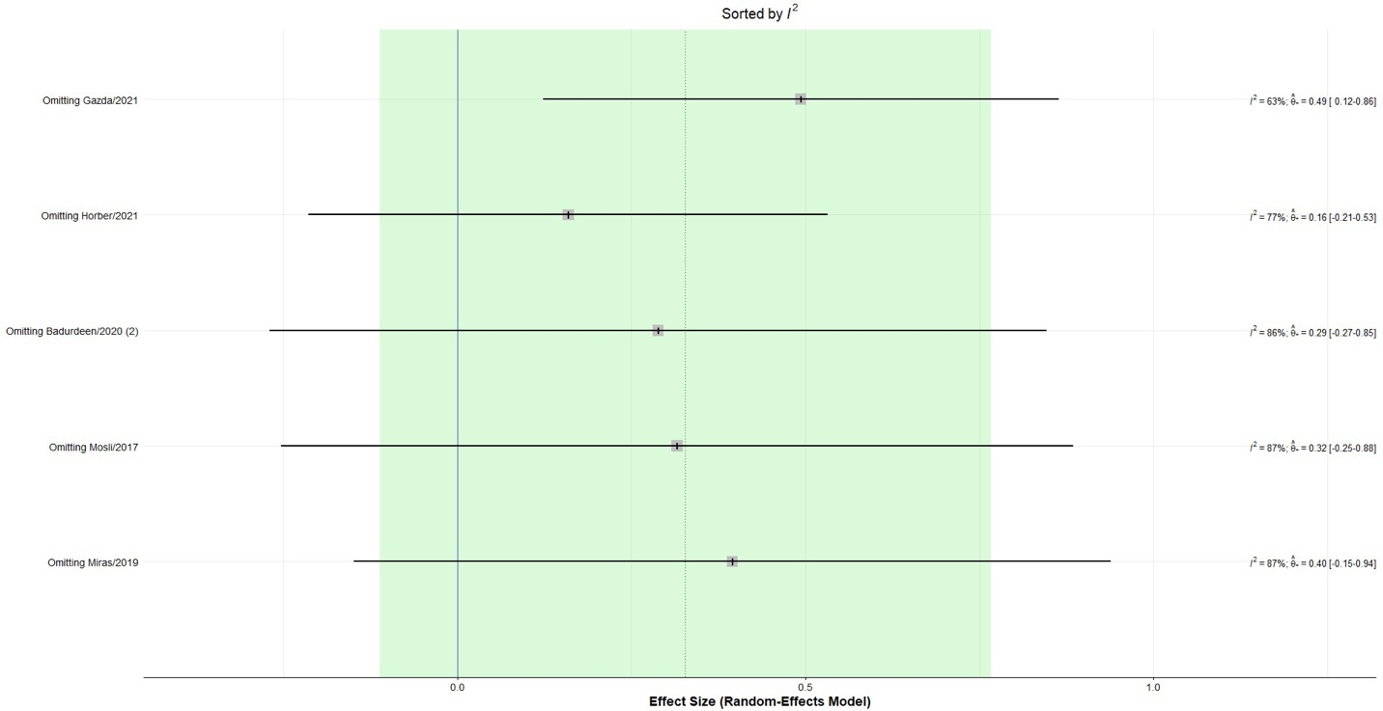
Supplementary Figure 4. Sensitivity analysis by omitting each individual study for comparison of weight regain after bariatric surgery and before therapy initiation between GLP-1RAs and placebo treated groups

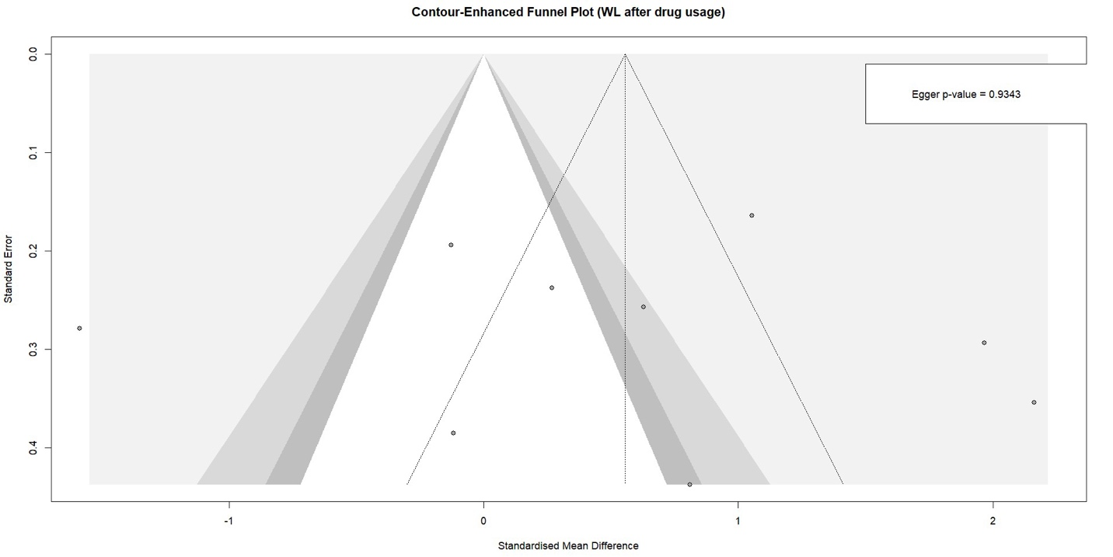
Supplementary Figure 5. Funnel plot for comparison of weight loss after therapy between GLP-1RAs and placebo treated groups

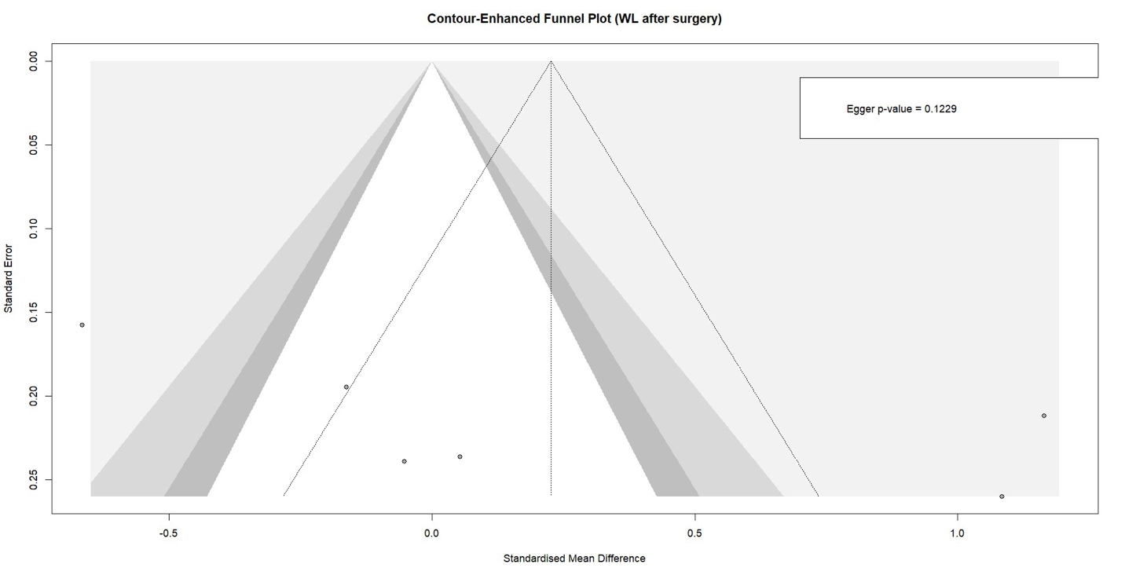
Supplementary Figure 6. Funnel plot for comparison of weight loss after bariatric surgery and before therapy between GLP-1RAs and placebo treated groups

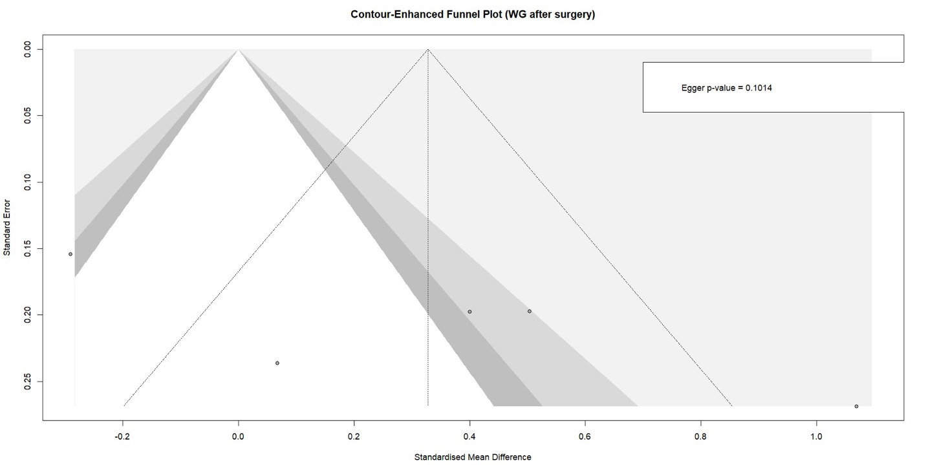

Supplementary Figure 7. Funnel plot for comparison of weight regain after bariatric surgery and before therapy between GLP-1RAs and placebo treated groups

