 | Exercise | Figure | Series, repetitions | Advanced form
Coordination exercises | Normal walking with obstacles | 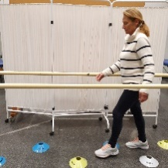 | 3, 3 | Higher speed
Coordination exercises | Lateral walking with obstacles | 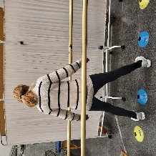 | 3, 3 | Higher speed
Coordination exercises | Backward walking | 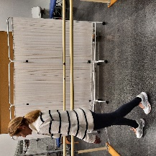 | 3, 3 | Higher speed
Strength exercises | Squat | 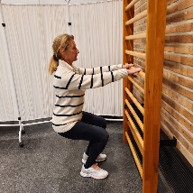 | 3, 10 | Adding a Bosu
Strength exercises | Ankle flexion-extension with body weight | 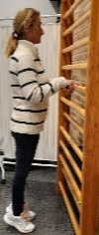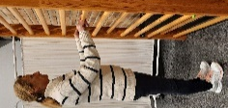 | 3, 10 | Adding weight
Strength exercises | Hip abduction | 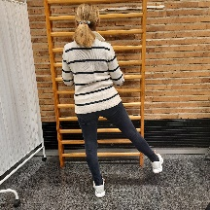 | 3, 10 | Adding weight
Strength exercises | Knee flexion in prone position with weights | 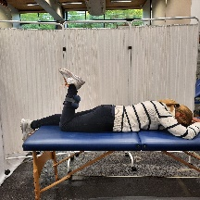 | 3, 10 | Adding weight
Balance exercise | Monopodal balance | 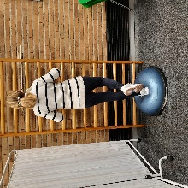 | 3, 1min | With a Bosu
Stretching exercises | Lower-limb passive stretching | 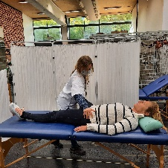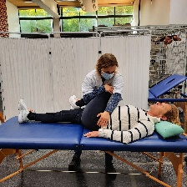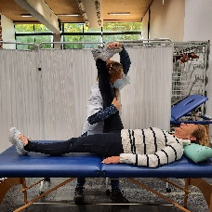 | 1, 30 s | NA

All the exercises were performed guaranteeing a regular effort perception corresponding with a score of 12-13 on the Borg scale.

